14 October 2024
Mr Kurt Fearnley AO
Chairman
National Disability Insurance Agency
GPO Box 700
CANBERRA ACT 2601

Dear Kurt
JUNE 2024 FINANCIAL SUSTAINABILITY REPORT
I am writing as the Reviewing Actuary of the NDIS to summarise my review of the 30 June 2024 Financial Sustainability Report (2024 FSR) provided on 11 October 2024. Subsection 180E(2) of the National Disability Insurance Scheme (NDIS) Act 2013 (the Act) requires that I review each FSR and report my findings to the Board. Subsection 180E(4) of the Act requires that I report any significant concerns about the sustainability of the NDIS to the Board as soon as is practical.

Review of the Financial Sustainability Report
Subsection 180B(1) of the Act requires the Scheme Actuary to prepare a FSR, at least annually. The FSR provides a projection of the Scheme expenses (the total amount spent by participants). Part 3 of the NDIS Rules for the Scheme Actuary sets out the required content of the FSR.
The Agency has provided me with the material required to undertake a review of the 2024 FSR. I have been provided with: [1] the Scheme Actuary’s paper to the Sustainability Committee on 4 September, setting out draft projection results; [2] the Original Cohort Model (OCM) used to derive the June 2024 projection, supplied on 6 September 2024; [3] spreadsheets setting out the expected financial impact of a number of initiatives and some tracking of the experience to date, [4] the 2024 FSR, supplied on 11 October 2024; [5] summarised experience of the Scheme that enables me to examine the reasonableness of some assumptions underpinning the unadjusted June 2024 projection; and [6] the microsimulation model (MSM) and supporting spreadsheets. I have discussed these materials with members of the Agency’s actuarial team.
The projections included in this FSR allow for experience to moderate over time, largely a result of the expected impact of recent and proposed reforms. This review considers whether the adjustments made to past experience are proportionate to the expected impacts of these reforms.
For this review, commentary on the short term refers to the four-year Budget period; the medium term refers to the balance of the ten-year projection presented in the FSR; the long term refers to the period beyond the medium term.

Cohort Projection Model
The 2024 FSR presents a ten-year projection of the expected Scheme expenses. The projection has been developed in the Original Cohort Model (OCM). The OCM comprises an assumptions spreadsheet that is used by a SAS model to project the Scheme population and cash flows. These results are then formatted in spreadsheets. In reviewing earlier projections, we have verified the accuracy of the SAS model, relative to the original spreadsheet models. We have performed spot checks for consistency during this review.
The projection presented in the FSR has been developed in two steps.
- The first step uses assumptions that are guided by recent Scheme experience, the Scheme Actuary’s judgement, and the impact of 2023-24 Budget initiatives and other operational improvements being rolled out by the Agency. This is broadly comparable to the projection in the 2023 FSR. The FSR presents Scheme expenses before recent and proposed reforms for four projection years. This is referred to as the “initial June 2024” projection in this letter.
- The above projection is then adjusted for the expected impact of the National Disability Insurance Scheme Amendment (Getting the NDIS Back on Track No. 1) Act 2024 aimed at improving the sustainability of the Scheme. This is the projection after recent and proposed reforms, or the “final June 2024” projection.
Graphs of population movements and expenditure are constructed on a financial year basis, with, for example, 2024 representing the 2023-24 financial year.

Projection of Scheme expenses - Initial June 2024 projection

Comment on key population assumptions

Starting population
The starting population is the actual Scheme population on 30 June 2024. The starting population of 661,267 on 30 June 2024 is 1.1% lower than the population that was expected in the June 2023 FSR and 3.4% lower than expected in the December 2023 projection.

New entrants
Figure 1 shows that the actual number of new entrants for the full 2023-24 financial year was 20% below what was expected in the 2023 FSR. Attachment A shows the same information broken down by age band and by disability type.
The FSR notes that new entrant experience changed significantly from November 2023. Between
1 July 2023 and 30 November 2023, the number of new entrants exceeded that which was expected in the 2023 FSR. This was attributable to new entrants below age 14 with developmental delay. New entrant assumptions were increased in the December 2023 projection, which I reviewed and regarded as prudent. However, from December 2023 to June 2024, the number of new entrants reduced significantly and were lower than expected. This followed the rollout of a new computer system.
New entrant experience is more difficult to interpret than in prior years. When coupled with changes in experience expected due to NDIS initiatives, setting new entrant assumptions is a more difficult than in previous projections.
New entrant assumptions in 2023-24 have been set having regard to the pipeline of access requests, Agency workforce capacity and initiatives to improve access decisions for children with developmental delay. Numbers are then assumed to decline for two years, before increasing with population growth. The decline in the initial June 2024 projection over 2025-26 and 2026-27 is attributed to declining numbers of new entrants with a previously unmet need (PUN) and the effect of NDIS initiatives. The higher number of new entrants assumed in the initial June 2024 projection, compared with the 2023 FSR, is driven by higher numbers of new entrants in the first half of 2023-24 (i.e. the lower number of new entrants in the second half of 2023-24 has been viewed as not representative of the underlying trend in this metric, but rather an outcome of adjusting to new processes associated with the rollout of the new computer system).
Figure 1: Actual & initial projected total number of new entrants
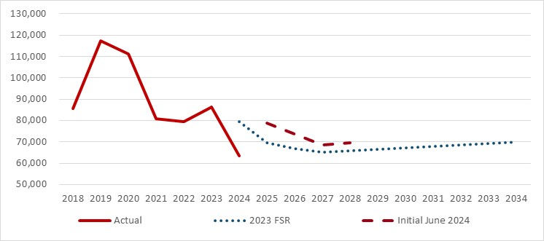
End of Figure
The projected reduction in children entering the scheme appears proportionate to the planned impact of improvements to the access process for children with developmental delay. However, this element of the initiatives has not yet commenced. Further, the modelling and monitoring of experience is less developed than for other initiatives. As a result, there is greater uncertainty in this part of the forecast. Nevertheless, it is important to recognise the steps taken by the Scheme Actuary to strengthen links between Agency capacity and the projection assumptions. Going forward, workforce capacity and outcomes of access decisions should be monitored against these assumptions. This will help refine the projection over time.
Assumed reductions in the number of new adult participants are attributable to the assumed reduction in the population with previously unmet needs (as for previous projections). This is not directly linked to a specific 2023-24 Budget initiative. Assumptions that the number of new entrants with previously unmet needs will reduce have exhibited material levels of uncertainty in the past.
Uncertainty in this year’s new entrant assumptions is therefore attributable to the assumed moderation in new entrant numbers with a PUN, the uncertain effect of 2023-24 Budget initiatives and the immaturity of experience after the introduction of the new computer system.
The National Disability Insurance Scheme Amendment (Getting the NDIS Back on Track No. 1) Act 2024 will change the way foundational supports are provided to children. This is expected to further reduce the number of children joining the Scheme. No allowance has been made for this in this initial June 2024 projection. This is allowed for in the final June 2024 projection and is discussed later in this letter, under Sustainability.

Transition from Delay to Autism and Intellectual Disability
After considering resource plans, the number of children transitioning from developmental delay to autism or intellectual disability in the first three projection years has been reduced from that which was included in the 2023 FSR. Transition rates are assumed to increase steadily over the next four years before settling to a long-term rate. Transition rates from 2027-28 onwards are unchanged.
The Scheme Actuary has recommended that operational capacity and the activity of the eligibility reassessment team continue to be monitored to better inform expectations for the long-term projections. I concur with this recommendation.

Leaving the Scheme
The projection assumes a proportion of participants will leave the Scheme to live independently. Attachment B compares recent and projected experience.
The 2023 FSR assumed the rate of exits would increase in 2023-24 due to a 2023-24 Budget initiative to resource eligibility reassessments. Resourcing this activity has taken longer than expected. Whilst the number of participants leaving the scheme increased in 2023-24, numbers were lower than what was assumed in the 2023 FSR in all categories of disability.
This year, the Scheme Actuary has modelled the number of exits arising from eligibility reviews in line with the expected resourcing of this activity. This is a welcome development. Exit rates in the initial June 2024 projection are assumed to gradually increase over the short term, resulting in 12,384 exits in 2024-25, increasing to 15,630 in 2025-26.
Whilst the assumptions in the initial June 2024 projection appear consistent with the 2023-24 Budget initiative, it is more important that the progress against these assumptions is monitored, with either resources adjusted to meet expectations, or assumptions adjusted, as is appropriate. Enhancing the monitoring of resources and productivity against the projection assumptions is a welcome development to the actuarial management of the Scheme.

Deaths
The projection incorporates assumptions of the proportion of participants that will die. Attachment B compares recent and projected experience. This shows that the rate of exits due to mortality is close to that which was expected in the 2023 FSR. The 2024 FSR makes no change to the mortality assumptions. I agree with this approach.

Supported Independent Living (SIL) population projection
The number of participants with SIL supports grew by 9.5% in the year to 30 June 2024. This was 1.7% below what was expected in the 2023 FSR. Figure 2 shows that the net intake to SIL moderated over 2023-24.
After considering the pipeline of requests and operational capacity, the Scheme Actuary increased the expected net intake to SIL in 2024-25 in the initial June 2024 projection. As noted above, I support improving the connections between operational capacity and projection assumptions and monitoring the resources applied and the progress against those assumptions.
Figure 2: Participants with SIL supports (LHS) and net intake (RHS)
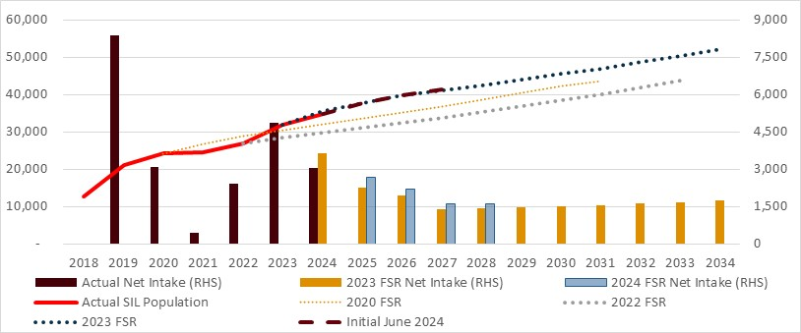
End of Figure
The main cause of exit for participants with SIL supports is death. 909 participants with SIL supports died in 2022-23 and 1,050 died in 2023-24. The 2023 FSR assumed 786 deaths would occur in 2023-24. Whilst evidence may be emerging to support increasing the expected number of deaths, I regard it as reasonable to maintain the same mortality assumptions that were used in the 2023 FSR, particularly given the broader impact of COVID-19 on mortality in the last 2-3 years. 905 deaths are expected in 2024-25 in the initial June 2024 projection. Continued monitoring of the mortality experience of this cohort is prudent.
The projection expects growth in the number of participants with SIL supports will moderate to 7.7% in 2024-25, slowing to 3.7% in 2033-34. This is supported by a 2023-24 Budget initiative. As historical experience in the SIL net intake has been volatile, until the new approval process matures, it is prudent to exercise caution when considering this aspect of the projection.

Comment on the total NDIS population projection
Prior to allowance for the recent and proposed reforms, the Scheme population is projected to grow at an average rate of 6.7% per annum to June 2028. The two fastest growing age groups are those aged 65 and over (growing at 12.7% per annum) those aged 15 to 34 (growing at 12.5% per annum), reflecting a combination of new entrants and ageing in the Scheme.
Figure 3: Actual & initial projected number of all participants at 30 June
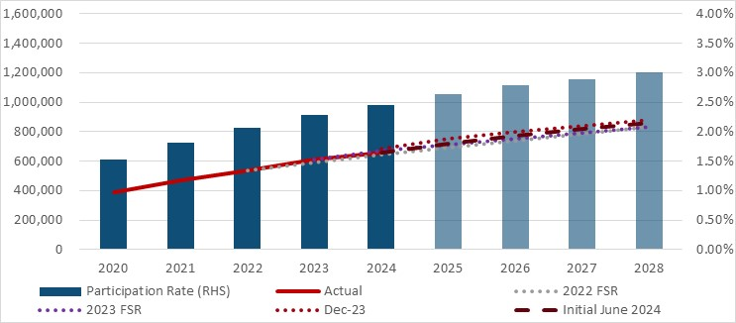
Note: Participation rate = NDIS participants expressed as a percentage of the Australian population
End of Figure
I have previously pointed to greater uncertainty where projection assumptions were assumed to moderate over time as the Scheme matured and that moderation was not supported by any change in the Scheme. The development of a program of 2023-24 Budget initiatives now means that a significant proportion of the assumed moderation in experience in the initial June 2024 projection is supported by these initiatives. This increases the level of confidence in this projection. The main element of the population projection that is not directly supported by a 2023-24 Budget initiative is the assumed decline in new adult participants with a previously unmet need.
The modelling and monitoring of the various 2023-24 Budget initiatives are at different levels of maturity, typically depending on when the initiative commenced. The increasing level of detail in the modelling and monitoring of initiatives is a welcome development. It is recommended this be extended across all initiatives at the appropriate time. This should be used to monitor progress and either adjust the resourcing, or adjust the projection assumptions, accordingly. This will help to manage uncertainty.
The key areas of uncertainty in this population projection are the rate at which new entrants will stabilise, the rate at which participants leave the Scheme, the moderation in SIL participants over the next three years, and the timing and effectiveness of the 2023-24 Budget initiatives.
Noting the above uncertainty, my view is that this projection provides a reasonable central estimate before any allowance for recent and proposed reforms. To reach this conclusion it is critical that the timing and effectiveness of the program of initiatives occurs as assumed. This underlines the importance of extending the monitoring of the resourcing of each initiative and the experience that results to a detailed level, across all areas where experience is assumed to moderate.

Comment on key participant spend assumptions

Average payments
Average payments in 2023-24 were 2.2% higher than expected in the 2023 FSR and 7.0% higher than average payments in 2022-23. The starting average payments in the initial June 2024 projection are derived from data in the three months to April 2024 and are also 2.2% higher than what was expected in the 2023 FSR.
Future average payments are then impacted by inflation. This is discussed below.

Inflation
Payments increase over time due to inflation. As inflation assumptions compound year on year, projection results are increasingly sensitive to the inflation assumptions with each projection year.
Inflation is modelled in two components. The first is normal wage and price inflation. The second is additional growth that is Scheme specific. The projection models the impact of inflation on each payment type. Assumptions quoted in this letter are averages and are provided to assist the reader understand the trends in the projection.

Normal Inflation
The projection assumes that normal inflation reflects the Scheme’s price increases and then follows broader economic forecasts. This is set out in Table 1. Assumptions in this projection are within 0.1% from that which was assumed in the 2023 FSR. The Scheme Actuary has explained the rationale for the normal inflation assumptions. I regard them as reasonable.
Table 1: Comparison of normal inflation assumptions
 | 2024-25 | 2025-26 | 2026-27 | 2027-28
2023 FSR | 2.7% | 4.0% | 3.5% | 3.5%
Initial June 2024 | 2.8% | 3.9% | 3.6% | 3.6%
Difference | +0.1% | -0.1% | +0.1% | +0.1%
End of Table

Additional growth
Selecting assumptions for additional growth has been challenging. Figure 4 illustrates the historical volatility in this assumption, ranging from 1% (2019) to 14% (2020 and 2021) with more recent years between 5% and 7%. This is a key source of uncertainty in the projection. Figure 4 shows that additional growth in 2023-24 (5.6%) was higher than assumed in the 2023 FSR. Successive FSR’s have assumed additional growth would taper towards 2% over time. This is yet to occur.
Plan growth is a leading indicator of additional growth. The Scheme Actuary has noted that the recent annualised plan growth rate of 13.0% (for active participants) includes an amount of 7.2% that is attributable to additional growth. He also notes that this rate may be lower than usual due to an increase in plan continuations. Plan growth rates above the recent rate of additional growth suggest that it is less likely additional growth will reduce in the near term.
In the initial June 2024 projection, additional growth of 6.2% is assumed in 2024-25, slightly above that which was experienced in 2023-24. I regard this as reasonable given recent plan growth.
Figure 4: Observed & initial projected additional growth
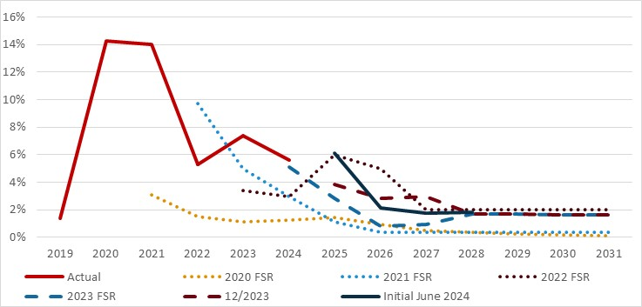
End of Figure
The development of the additional growth assumptions is stepped out in Table 2.
Table 2: Development of additional growth assumptions
 | 2024-25 | 2025-26 | 2026-27 | 2027-28
Base | 7.0% | 6.0% | 4.0% | 2.0%
Initial 2024 projection | 6.2% | 2.2% | 1.8% | 1.8%
Final 2024 projection | 2.5% | -1.2% | -1.6% | 0.0%
End of Table
Additional growth is assumed to reduce to 1.8% per annum in 2026-27 in the initial projection. This reduction in additional growth is expected to arise through a combination of [1] a natural reduction in additional growth over time (in the base assumption), and [2] further reductions due to 2023-24 Budget initiatives.
- Natural reduction: The initial June 2024 projection assumes that there will be a natural reduction in additional growth before allowance for 2023-24 Budget initiatives. This is illustrated in the “Base” row in Table 2.
Natural tapering of additional growth is an assumption made in past projections that has not materialised. This risk remains. It is appropriate that the Scheme Actuary has highlighted this risk and provided sensitivity analysis should this reduction not occur.
- NDIS initiatives: The Scheme Actuary expects additional growth will further reduce because of the 2023-24 Budget initiatives. Additional work has been done this year to quantify the impact and timing of these initiatives. This is welcome. The adjustments made to the additional growth assumptions for these impacts appear proportionate to the changes expected for the relevant initiatives.
There is uncertainty in the implementation of any reform. This contributes to uncertainty in the projection. Careful monitoring of the implementation and impact of these initiatives has commenced for some initiatives, and this is important to inform future projections. The adjustments made assume the 2023-24 Budget initiatives are implemented within the modelled timeframe and are fully effective as modelled.
Some consideration of the medium-term expectations of additional growth is also warranted. Recent FSRs have assumed a medium-term rate of 1.8% per annum. Reasons why some level of additional growth is likely to be required in the OCM include:
- Within each cohort, those joining the Scheme have lower average payments than established participants. This year, it has been identified that participants leaving the scheme also tend to have lower average payments than participants that remain. A declining number of new entrants and a growing number of exits will likely contribute to additional growth in the OCM.
No allowance has been made in past models for the fact that those leaving have lower average payments. To allow for this, within the limitations of the OCM, the Scheme Actuary has removed the 8.4% discount that was previously applied to new entrant average payments. The Scheme Actuary has demonstrated that this indirect adjustment is reasonable for the short term. I regard this allowance as pragmatic, however further consideration of how this dynamic may affect medium term assumptions of additional growth may help further inform the understanding of additional growth in due course.
- Ageing in the Scheme can be accompanied by a deterioration in participants’ level of function. Whilst ageing is modelled in the OCM, changes in level of function are not. The projected rate of growth in average payment in the initial June 2024 projection in the medium term is roughly 5% per annum across all age groups, except those aged 25-34. This contrasts with Figure 4.18 in the FSR, which shows that the rate of plan growth has been consistently higher for older age cohorts. There is a risk that the effects of ageing on the Scheme are not fully modelled in the initial June 2024 projection. In the absence of modelling this with greater granularity in the OCM, this will be accounted for in the additional growth assumption.
These dynamics illustrate that some level of additional growth is to be expected in the OCM through the medium term.

SIL
Figure 5 shows the historical rates of growth in average SIL payments and those which are included in the initial June 2024 projection. Average SIL payments grew by around 7% in 2023-24.
The initial June 2024 projection assumes average SIL payments will grow by over 10% in 2024-25. Growth is then assumed to slow to just over 5% per annum by 2026-27. 2023-24 Budget initiatives support this assumption.
As the rate of growth in average SIL payments has been volatile in the past, caution is required when considering this component of the projection. Until the recent reduction in growth is sustained in the data, the risk that this projection understates the expenditure that may arise remains. Nevertheless, the slower growth rate experienced in the last 12 months, and the support offered by the 2023-24 Budget initiatives, supports the assumptions selected by the Scheme Actuary. I regard the Scheme Actuary’s assumptions as reasonable.
Figure 5: Historical and projected rate of growth in average SIL payments
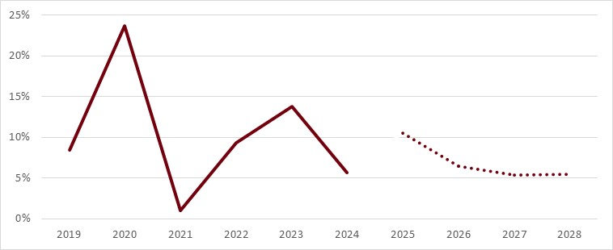
End of Figure
The long-term growth in the SIL population is 3.7% per annum (as shown earlier in Figure 2). When combined with growth in the average payment in the long-term of 5.2%, growth in SIL is expected to be close to 9.0% per annum. I note that this is above the sustainability target rate. Sustainability is discussed later in this letter.

Initial June 2024 projection
Figure 6 shows that the resulting initial June 2024 projection (solid black line) is higher than the projections in all earlier FSRs.
Figure 6: Actual & initial projected total participant spend
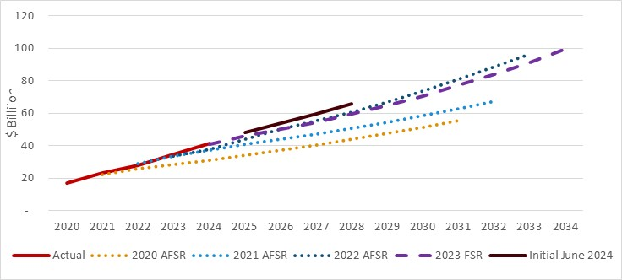
End of Figure

Sustainability
The initial June 2024 projection implies that Scheme expenses will grow by 16.5% in 2024-25, 12.2% in 2025-26, reducing to just over 10% in the following two years. This does not meet the sustainability framework. The NDIS Financial Sustainability Framework provides for annual growth in Scheme expenses of 8% by 1 July 2026, with further moderation of growth as the Scheme matures. This has been interpreted as meaning that the total participant expenses (excluding Agency costs) in 2026-27 are no more that 8% higher than those incurred in 2025-26.
Reflecting this, further reforms to the Scheme have been passed by Parliament. The effect of these reforms has been estimated by the Scheme Actuary for the first four projection years. These are reflected in the final June 2024 projection.
The final June 2024 projection allows for the expected impact of recent and proposed reforms by reducing the additional growth assumption from 2024-25 and reducing the expected number of new children with developmental delay or autism from 2025-26. This is partially offset by a small increase in the number of new entrants with an intellectual disability from 2026-27. No changes have been made to the assumed starting average Scheme expenses or exit rates. At the time of writing, planning and design of the reforms is still progressing. It is possibly best to interpret the final June 2024 projection as one scenario by which the Scheme may achieve the NDIS Financial Sustainability Framework.
The impact on the projected Scheme expenses is set out in Figure 7. The orange columns show the rate of growth slowing in the short term to levels that are close to those envisaged by the sustainability target (black columns). Detailed modelling of the effects of these reforms is not yet available for the medium term. Detailed modelling of the medium-term effects of the reforms is required to ensure the reforms will keep growth within the sustainability framework.
Figure 7: Actual and projected participant spend after recent and proposed reforms
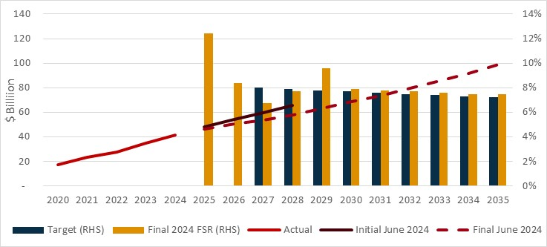
End of Figure
These reforms comprise changes to budgeting, reduction in intra-plan inflation, improved eligibility reassessments, reduced fraud and the introduction of foundational supports outside the Scheme. Most of the modelled reduction in cost in the projection is from the first two reforms.
The impact of any reform is uncertain. It is not yet realistic to expect the same granularity in the modelling of these reforms, compared to initiatives that have been fully designed and have commenced. I make the following broad observations in respect of the short term:
- The reduction (from the initial June 2024 projection) is commensurate with the published impact of the legislation, after allowing for a two-month delay in the passing of legislation (i.e. from end June to end August). The final June 2024 projection assumes the legislation will progressively take effect from September, with some phasing in over 2024-25. I have not reviewed the implementation plans. Users of this projection should carefully review any dependencies (for example, the finalisation of Scheme rules) that may impact the timing of these reforms.
- Changes to budgeting, intra-plan inflation and reducing fraud are all expected to reduce the rate of additional growth in the Scheme. This is critical to achieving the NDIS Financial Sustainability Framework. To meet this projection, additional growth is assumed to reduce to 2.5%, -1.2%, -1.6% and 0.0% in 2024-25 through 2027-28. These are material reductions and underline the importance of implementing the changes effectively and monitoring the emerging experience closely. In 10 years, additional growth is assumed to be 0.1%. Noting my earlier comments about the impact ageing can have on additional growth in the Scheme, I expect close management of additional growth will be required in the medium term.
Given the higher level of uncertainty associated with any reform, it is recommended the Scheme Actuary continue to develop the models that estimate the impacts of the reforms and regularly monitor progress against experience.
Focusing on the annual growth target for NDIS participant expenses of no more than 8% by 1 July 2026 may risk exclusively focusing on the short term. It is also important to consider the medium, and longer-term outlook.
- Subject to resourcing and effective implementation, the planned reforms are expected to reduce the Scheme’s rate of growth in the short term and the modelling has focussed on that timeframe. Given the demographic momentum in a relatively young scheme, it is recommended the Scheme Actuary continue to enhance the modelling of these reforms to consider the longer-term implications for the Scheme. Medium term sustainability pressures may remain on the Scheme as the population ages.
- Discussion of Scheme sustainability in the context of Scheme reforms and an 8% targeted growth rate may be interpreted as focussing solely on aggregate Scheme expenditure. While Scheme expenditure is clearly a key element to ensuring sustainability, it is timely to remind ourselves that the NDIS Rules requires that the FSR also report on participant outcomes. This means that the sustainability of the Scheme is supported by both the quantity and quality of the Scheme expenditure. A maturing microsimulation model (MSM), implementation of the National Disability Data Asset and further development of the Investment Effectiveness Program may all increase the Scheme’s capacity to identify and encourage a growing proportion of Scheme expenditure that delivers improved outcomes. Utilising these tools, I believe the FSR will be able to increase its focus on participant outcomes over time.
This projection does not include the costs of foundational supports that may be provided in future. It is envisaged that these costs are separate to the NDIS. Whilst this is appropriate for this FSR, broader financial sustainability pressures may arise from the costs of all supports that are provided. Further, the use of linked data sets to better inform future participation in the Scheme (transitions from foundational supports) are likely to be required.

Operating Expenses
The FSR discusses the Scheme’s operating expenses. As there is no projection of expenses, I have not undertaken a review of any operating expense models.
The Scheme Actuary draws attention to the reduction in budgeted operating expenses in 2025-26. As I have noted earlier in this letter, for the projected Scheme expenses to occur, the operational activity expected by the assumptions needs to occur with the effect that is assumed. This activity includes eligibility assessments, re-assessments, and plan reviews. If the activity does not occur at the level assumed, then it is reasonable to expect that the projected Scheme expenses will also differ. The Scheme Actuary has made the same point in the FSR.

Uncertainty
Future experience will differ from, and may exceed, that which has been projected. Uncertainty in the projection is, in part, demonstrated by variations in successive projections in recent years.
Key areas of risk in this projection include assumptions of reducing rates of additional growth, new entrants, and transitions to SIL, coupled with increased rates of exit. Further, the impacts of recent and proposed reforms are yet to emerge in the data. In line with recommendations in the 2023 FSR, a governance structure has been established to monitor the implementation of these initiatives.
The Scheme Actuary has illustrated the effect of uncertainty in the sensitivity tests set out in Section 6 of the FSR.

Microsimulation Model (MSM)
This year, the sensitivity tests have been supplemented with the results from a new microsimulation model (MSM). The MSM projects Scheme expenses based on assumptions derived semi-independently to those used in the OCM. It applies those assumptions to different mathematical processes. Contrasting the two models is expected to identify opportunities to improve both models. I regard the MSM as a healthy development to the actuarial management of the Scheme. I encourage the Scheme Actuary to continue the development of the MSM model as a contrasting methodology to the OCM model.

Conclusion
Past Financial Sustainability Reports have assumed that aspects of Scheme experience would moderate in the short term. However, the assumed moderation in additional growth, new entrants and the expected increase in exits often failed to materialise. Where it did, it was not sustained.
The June 2024 FSR also assumes that new entrants and additional growth will moderate and that exits will increase. The important difference in this projection is that there are now tangible actions supporting most (but not all) of the expected moderation. These are the 2023-24 Budget initiatives incorporated in the initial June 2024 projection and recent and proposed reforms included in the final June 2024 projection. The Scheme Actuary has reasonably sought to ensure that the moderation, or adjustments made to experience when setting the assumptions, are proportionate to the expected impact of the reforms. A program of reforms that support the expected changes in experience increase the level of confidence in this projection.
Nevertheless, when the Scheme is changing, there is increased uncertainty in the projections. To manage this, the Scheme Actuary has commenced a process of monitoring the drivers of the emerging experience against that which is expected. Enhancing the monitoring of resources and productivity against the projection assumptions is a welcome development to the actuarial management of the Scheme.
Taking all of the above into consideration, I believe the projections set out in the FSR are within the range of reasonably likely outcomes. However:
- The Scheme is undergoing a complex reform process. Detailed modelling of the reforms and monitoring should continue to be enhanced to cover all key areas of changing experience. This can be used on a continuous basis to inform the Agency of progress against expectations. It should also inform the Agency of any adjustments to resourcing, or projection assumptions, that may be required.
- The projection assumes that additional growth will moderate over time, in addition to reductions attributable to recent and proposed reforms. Similarly, there is a level of assumed moderation in adult new entrants with a previous unmet need. Neither of these assumptions is new for the current FSR, but we note that they are not directly supported by initiatives. This adds uncertainty to the projection and should be monitored in the same manner as assumptions impacted by the NDIS initiatives.
The initial June 2024 projection grows by more than 8% in 2025-26 and growth does not reduce below this level, as one expects of a maturing scheme, in the medium term. The National Disability Insurance Scheme Amendment (Getting the NDIS Back on Track No. 1) Act 2024 is expected to result in further moderation of the rate of growth from that which is included in the initial June 2024 projection. These reforms are expected to further slow the rate of growth in the short term. However, the impacts of the reforms and the degree to which the Scheme will meet the sustainability framework in the medium-term is less clear. Whilst it is understood that the immediate focus is on the short term, modelling the medium-term impacts in more detail is warranted.
Yours sincerely

Guy Thorburn
Australian Government Actuary

Attachment A: Distribution of new entrants in the Initial June 2024 projection

Distribution by age

Actual and expected experience
Figure 8 sets out the actual number of new entrants by age, and that projected in the 2023 FSR and the initial June 2024 projection.
Figure 8: Actual and projected new entrants by age
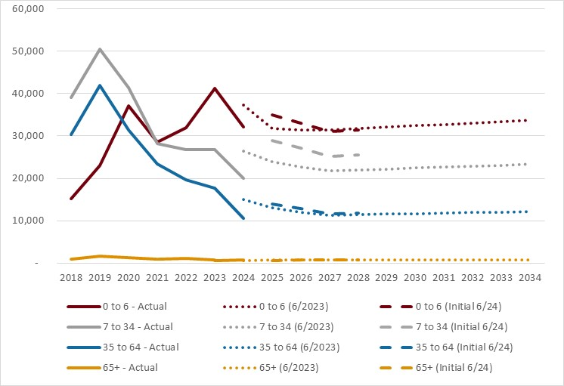
End of Figure

New entrants, age 0-6, 7-34 and 35-64
The actual number of new entrants in 2023-24 in each of these age groups was lower than assumed in the 2023 FSR. The initial June 2024 projection assumes that the number of new entrants in these age groups increases in 2024-25. This follows the Scheme Actuary’s assessment of the pipeline of access requests, workforce capacity and initiatives to improve access decisions for children with developmental delay. I support steps taken by the Scheme Actuary to strengthen links between Agency capacity and the projection assumptions. Going forward, workforce capacity and outcomes of access decisions should be monitored against these assumptions.
Numbers are then assumed to decline for two years, before increasing with population growth. The decline in the initial June 2024 projection over 2025-26 and 2026-27 is attributed to declining numbers of new entrants with a PUN and the effect of 2023-24 Budget initiatives. The initiatives support the assumption that the number of children entering the scheme will reduce over time. As this initiative has not yet commenced, modelling of this initiative is not as developed as for other initiatives. Whilst the assumed reduction in children joining the scheme appears broadly proportionate with the initiative, I expect that the modelling (and monitoring) of the initiative will develop as the experience emerges. This should provide a basis for refining the projection over time.
Increased uncertainty arises in any projection during a period of change. Normal uncertainty in the underlying rate of new entrants is compounded by uncertainty of the impact of the initiatives on children joining the scheme. Seeking to mitigate this risk, commencing with increased monitoring, is appropriate.

New entrants, age 65+
The projected number of new entrants aged 65 and over is small and is similar to the previous projection.

Distribution by disability
Figure 9 sets out actual number of new entrants by disability, and that projected in the 2023 FSR and the initial June 2024 projection.
Figure 9: Actual and projected number of new entrants for major disability types
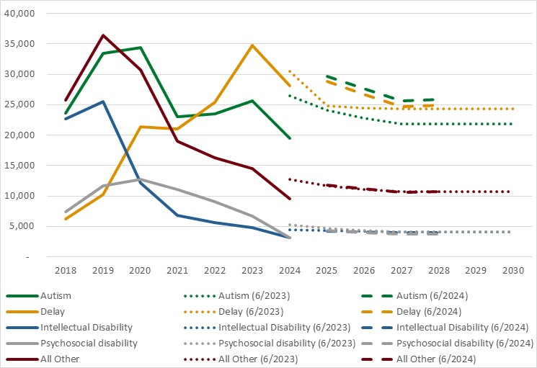
End of Figure
Figure 9 shows that the number of new entrants in 2023-24 was lower than expected across all categories of disability. The change in experience halfway through 2023-24 makes setting new entrant assumptions more challenging. This is most pronounced for new entrants with developmental delay and autism, which comprise around 75% of all new entrants to the scheme. The revised assumptions significantly increase the expected number new entrants with developmental delay and autism in 2024-25 (again, due to the Scheme Actuary’s assessment of the pipeline of access requests, workforce capacity and initiatives to improve access decisions for children with developmental delay). Actual experience of these cohorts will need to be monitored closely.
The impact of the 2023-24 Budget initiatives in the short term is expected to be most pronounced for new entrants with autism and developmental delay, as indicated by the reduction in new entrants in these groups over the first three projection years. However, for autism, the assumed new entrants are significantly higher than in the 2023 FSR for all future years.

Attachment B: Mode of departure

Leaving the scheme
Participants can leave the scheme for reasons other than mortality. Figure 10 compares recent rates of leaving the Scheme with recent projections. The rate of exit increased in 2023-24, but remained well below that which was expected in the 2023 FSR. The expected increase in the rate of exit is underpinned by 2023-24 Budget initiatives. The Scheme Actuary has reviewed the progress of this initiative and reset the projected exit rate in line with the resourcing of this initiative. Modelling the initiatives to ensure their projected impacts are commensurate with the available resourcing improves the evidence supporting this year’s FSR. It also provides a basis against which progress is being tracked. These are welcome developments.
Figure 10: Actual and projected crude rate of leaving (for reasons other than death)
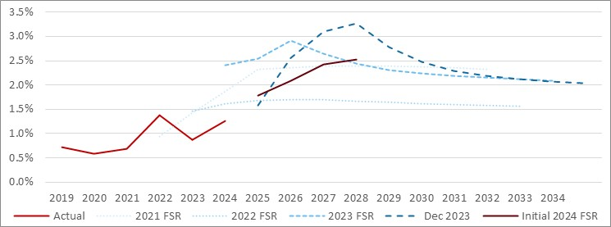
End of Figure

Mortality
Participants may also cease to participate in the scheme due to their death. The actual number of deaths in 2023-24 was 5,631. This is almost identical to the expected number of 5,616 projected in the 2023 FSR.
Figure 11 compares the recent crude mortality rate for the scheme to recent projections. Historical experience will exhibit significant volatility in a population of this size.
Mortality assumptions are set by age, disability type, level of function and SIL status. The mortality assumptions themselves have not changed from those adopted in the 2023 FSR, but the resultant average projected mortality rate is a little lower due to the change in mix of future participants.
Figure 11: Actual and projected crude mortality exit rate
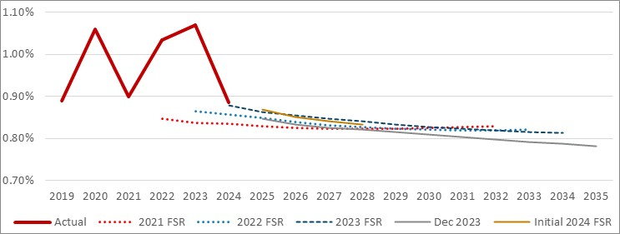
End of Figure
Whilst the total number of deaths in the Scheme is relatively small, the distribution of deaths is important. For example, very few participants receiving SIL leave for reasons other than mortality. As a result, the mortality of participants receiving SIL has a material impact on projected SIL expenses.
Figure 12 shows that expected mortality rates for SIL are slightly below the recent experience of the scheme. Should this experience persist, it may justify a small increase in mortality assumptions for participants receiving SIL in the future.
Figure 12: Actual and projected crude mortality rate for SIL participants
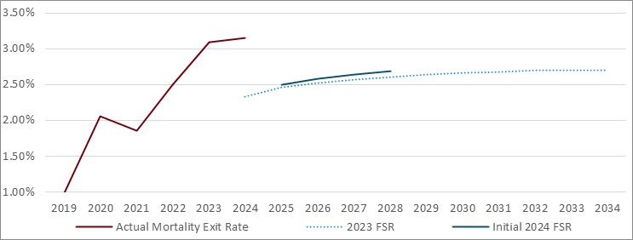
End of Figure
Mortality assumptions have not been altered for this projection. I concur that there is insufficient new evidence to justify a review at this time.

Attachment B: Microsimulation model
This year, the sensitivity tests have been supplemented with the results from a new microsimulation model (MSM). I have reviewed this model and will provide the results of that review in a separate letter to the Scheme Actuary. The MSM projects Scheme expenses based on assumptions derived semi-independently to those used in the OCM. It applies those assumptions to different mathematical processes. Contrasting the two models is expected to identify opportunities to improve both models. I regard the MSM as a healthy development to the actuarial management of the Scheme.
A benefit of the MSM is to test the assumptions used in both models. The MSM can derive population assumptions at a more granular level using a wider variety of predictive variables. In theory, this will allow the MSM to target key movements in the population more easily than the OCM. This provides a useful contrast that could help inform the overall view for the benefit of both models. In the short term, there are limits to this benefit as many important population movements will be influenced by the reform program than by experience. Both models must also rely on judgement.
The MSM model also provides functionality that is not present in the OCM model. Modelling transitions in the level of function is the most obvious example. The impact of changes in level of function are modelled implicitly in the additional growth rate in the OCM. This is an example of where assumptions should differ between the two models. As the MSM model can quantify the effect of deteriorating levels of function, it is also an example of where the MSM can be used to inform more granular analysis in a manner where the OCM cannot.
The MSM is a new model that is still maturing. It is appropriate to present the results as an alternate projection at this stage. Further enhancing the predictive variables used for some transition probabilities and enhancing the underlying national population projection will provide a stronger base for longer term projections. The design of the recent and proposed reforms will also inform enhancement of the model. For example, it may be possible to model new plan budget processes in a manner that reflects the co-design outcomes.

National Disability Insurance Scheme—Rules for the Scheme Actuary 2013, rule 9, 25 June 2103

