# Family governance in Supported Independent Living (SIL)

**Case Study – Supporting Independent Living Cooperative**

September 2024

**The Evidence and Practice Leadership Branch**

**ndis.gov.au**



**This document**

This document presents a family governance model case study of Supported Independent Living (SIL) supports in the National Disability Insurance Scheme (NDIS), delivered by Supporting Independent Living Cooperative (SILC).

This case study forms part of evaluation analysis activities for Round 1 of the National Disability Insurance Agency’s (NDIA’s) Home and Living Demonstration Projects.

**Contributors**

The NDIA’s Evidence and Practice Leadership Branch delivered this work. The Branch is responsible for ensuring that trustworthy and robust evidence informs NDIA policies, practices, and priorities.

**Disclaimer**

The NDIA disclaims all liability to any person in respect of anything, and of the consequences of anything, done or not done by any such person in reliance, whether wholly or partly, upon any information in this report.

Material in this report is available on the understanding that the future decision-making or changes to NDIS processes are subject to information additional to this report.

Views and recommendations of NDIA staff and NDIS participants included in this report, do not necessarily reflect the views of the NDIA, or indicate a commitment to a particular course of action.

**Acknowledgements**

The NDIA acknowledges the Traditional Owners and Custodians throughout Australia and their continuing connection to the many lands, seas, and communities. The NDIA pays respect to Elders past and present and extends this acknowledgement and respect to any First Nations people who may be reading this report.

The NDIA Evidence and Practice Leadership team would also like to acknowledge the NDIS participants and their families, and SILC management and staff who assisted in the development of this case study by participating in interviews/focus groups and providing data.

**Contents**

1. Introduction 2

2. Key elements of SILC’s family governance model 10

3. Outcomes for participants and families 12

4. Considerations for establishing a family governance model 16

5. Benefits to the NDIS 21

6. The replicability of family governance models in the NDIS 23

Appendix A: Data 24

Appendix B: Matching procedure and balance 25

**Abbreviations**

ACNC Australian Charities and Not-for-profits Commission

APS Australian Public Service

CALD Culturally and Linguistically Diverse

COOP Cooperative

ILO Individualised Living Options

NDIA National Disability Insurance Agency

NDIS National Disability Insurance Scheme

NFP Not for Profit

SDA Specialist Disability Accommodation

SFOF Short Forms Outcome Framework

SIL Supported Independent Living

SILC Supporting Independent Living Cooperative

## Introduction

This case study outlines an approach to Supported Independent Living (SIL) run by Supporting Independent Living Cooperative (SILC) using a family governance model.

The SILC family governance model uses a Primary and Secondary Cooperative model to support participants living together and receiving SIL supports and their families to maximise choice and control in the governance and operational decisions of the home. SILC is the Secondary Cooperative and provides support to help families and participants set up Primary Cooperative Boards.

SILC provides a framework and a shared service to Primary Cooperatives to operate their homes where SIL participants live and receive SIL supports. Primary and Secondary Cooperatives work together to ensure the needs of the participants are met, in line with the regulatory requirements of the NDIS Quality and Safeguard Commission as well as the vision and direction of the person with disability.

Each Primary Cooperative Board (House Operators) are made up of a committee of family members. They are the directors of the cooperative and are responsible for making governance decisions on how they run their Cooperative, as well as working with SILC to deliver operations of the home.

There are a small number of National Disability Insurance Scheme (NDIS) providers that use a family governance model. These include Fighting Chance[1], Benambra Intentional Community[2] and Supporting Independent Living Cooperative (SILC). This case study focuses on SILC and describes what factors are important to the family governance model, some of the key considerations in its use and whether it can be made available to more NDIS participants and their families.

### The Home and Living Demonstration Projects

The National Disability Insurance Agency (NDIA) has been working with providers and participants to design and deliver improved ways of delivering home and living supports. The program is called the Home and Living Demonstration Projects and aims to look at different ways of delivering home and living supports that give greater flexibility to participants and providers, are outcomes-focused, encourage better practice and ensure Scheme sustainability. The first round of the Home and Living Demonstration Projects aims to find and develop new ways of delivering SIL supports that help to improve participant outcomes. In particular, they seek to support better approaches to the delivery of SIL. The SILC Home and Living Demonstration Project focuses on the use of a family governance model to support SIL participants.

### Supporting Independent Living Cooperative (SILC)

#### About SILC

SILC was set up in New South Wales in 2016 and aims to support families to develop their own independent housing model under the NDIS.

At the time of the study, SILC had 12 cooperative houses in the northern and western suburbs of Sydney, housing 25 participants. The average age of SILC residents is 27 years and mostly includes people living with autism (64%), severe intellectual disability (20%), moderate intellectual disability (8%) and cerebral palsy (8%). Overall, the NDIA classifies 18 of SILC’s 25 residents as having intensive support needs, with the remaining seven classified as having complex support needs.

#### The family governed cooperative model

SILC was set up to support families of NDIS participants establish and run homes where SIL participants live and receive SIL supports, under a family governance model. The family governance model works as a cooperative and is run by a primary and secondary cooperative board.

##### Cooperative Model

A cooperative model was chosen because of the approach to ownership and control. Many businesses are owned and controlled by people who invest money in them. Such businesses are referred to as “publicly listed companies” and they focus on making money for investors. This is the case with many traditional SIL providers.

In a cooperative model, ownership and control is shared equally among members. The cooperative’s primary purpose is to benefit these members. At SILC, members are people with disability and their families who have set up a family governed cooperative. These are called Primary Cooperatives.

SILC is known as the Secondary Cooperative. As the NDIS registered provider, SILC provides a shared central service to Primary Cooperatives. SILC manages all the important legal and regulatory requirements for how the Primary Cooperative homes work. This includes meeting the NDIS Quality and Safeguards Commission’s requirements (see Participant story 1 below). Figure 1 gives details on what SILC as the Secondary Cooperative is responsible for, including the systems, procedures and supports.

**Figure 1: SILC responsibilities**

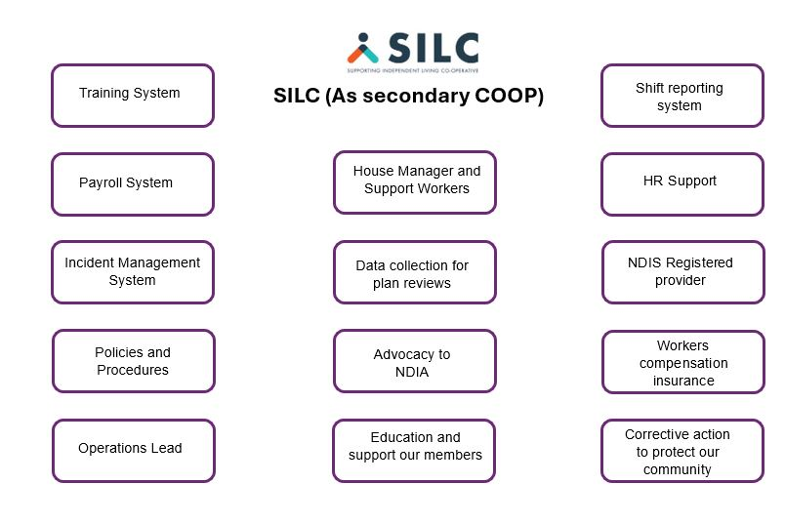

##### The Primary Cooperative Board

The Board of the Primary Cooperative is made of up of the family members of those living in the house (the residents). If appropriate, residents can also be part of the board. When residents need substituted decision making, these family members provide that support for residents at Board level. If the resident can make decisions through a supported decision process, a micro-board structure is set up to support this.

The Primary Cooperative Board can make decisions about:

* Where residents live
* Who residents live with
* How much to spend on food and utilities
* Who supports residents
* When residents receive supports 1:1
* When residents receive shared supports

Legally, the Primary Cooperative is also in charge of all reporting responsibilities to the Australian Charities and Not-for-profits Commission (ACNC) and needs to have board meetings every three months. The member families are also responsible for choosing the board chairperson, treasurer, and secretary. Figure 2 shows what the Primary Cooperative is responsible for including the house roster, the budget, following policies and procedures, recommending staff and undertaking maintenance.

**Figure 2: Primary Cooperative accountabilities**

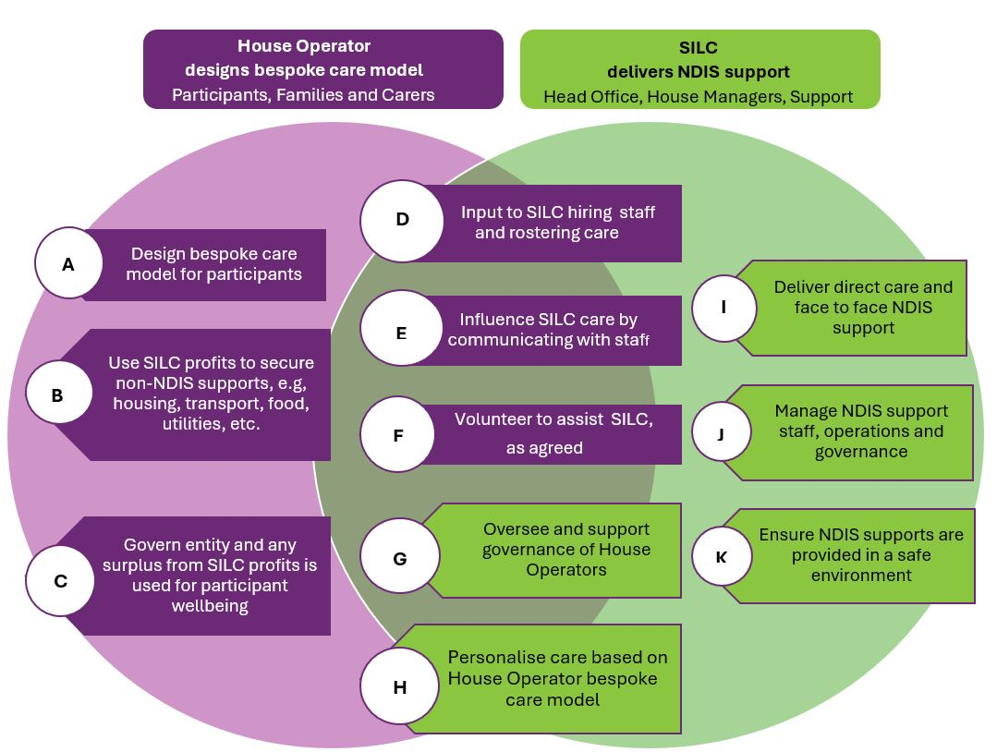

##### Relationship between Primary Cooperative and Secondary Cooperative (SILC)

When the Primary Cooperative makes decisions about who to hire and who should be the House Manager, they let SILC know this information. SILC then provides support by doing pre-employment checks and then hiring a House Manager to make sure residents get the support they need in their daily lives and to achieve their goals. The House Manager needs to be a good communicator and manage the opinions of the different people involved in supporting residents. This includes managing the day-to-day involvement of family members, house staff, and therapists.

SILC as the Secondary Cooperative provides an Operations Lead to support the House Manager and the Primary Cooperative Board. The Operations Lead has industry experience in working with participants in a highly regulated environment.

##### Current SILC houses

Most houses are rented by the Primary Cooperative, with residents contributing 75% of their disability support pension and 100% of their Commonwealth Rental Assistance. This pays for the normal costs of living, like food and electricity. Staff, assistive technology needs, and in some cases, specialist disability accommodation (SDA), are funded by the NDIS.

##### The difference between SILC and other SIL providers

SILC operates differently to some other SIL providers. In some other SIL models, it is often the provider who decides how the house will operate, including the staff working in the home, the roster, and the overall household budget. Sometimes a provider will also make choices about things like food, showering and bedtimes. Resident choice and family involvement are key to decision making in the SILC family governance model.

**Participant story 1: SILC ensures legal and regulatory compliance.**

Jimmy's story
Jimmy has needed medicine from quite a young age to help him stay calm. At the time when this was first recommended, Jimmy’s parents had to get a special medical clearance because he was so young. Since then, there has been changes to rules and standards which means that Jimmy’s medicine would now be classified as a restrictive practice. SILC recognised this and worked with the family to make sure the correct processes were followed with the medicine. This included getting a guardianship order, and Jimmy having a psychiatric diagnostic review. This made sure the proper processes had been followed and that a medical professional had reviewed and confirmed that Jimmy’s medicine was appropriate for his diagnosed condition and therefore not a restrictive practice. 

### Information used for this case study

#### Data sources

Interviews and focus groups were held with SILC participants, their family members, staff, and management to learn about their experiences with the SILC family governance model. Table 1 shows how many people took part in interviews and focus groups.

**Table 1: Number and type of respondent that took part in interviews and focus groups**

|  |  |  |
| --- | --- | --- |
| Informant type | Interview numbers | Focus group numbers |
| Participants | - | 2 |
| Family members | 5 | 10 |
| Staff | 3 | 9 |
| Management | 3 | 2 |

NDIS administrative data about SILC’s participants and their families was also analysed. This included the SIL, and other NDIS supports they use. Self-reported information about how participants are progressing in different areas of their life from the NDIS Short Form Outcomes Framework (SFOF) was also analysed. Appendix A gives more detail about the data collected.

#### Comparing outcomes for SILC’s participants and families

This case study uses information from the SFOF about how participants and their families are progressing in different areas of their life. We included 339 SIL providers (including SILC) who all had at least 10 participants with a similar NDIS disability severity score to SILC participants (11 or higher) and had at least 10 responses to the SFOF questions of interest.

We ranked participant responses to compare how participants and families using SILC are progressing in their lives compared to those using other SIL providers. By ranking all the responses, we can work out a percentile for where SILC’s participants and families sit among all participants using SIL.

A percentile describes the percentage of values that fall below a given value. For example, if we rank a group of people by height, we can work out the percentile where each person sits in terms of their height (see Figure 3). In the example, the person labelled ‘Izzy’ is at the 80th percentile for height in the group. This means 80% of the group are shorter than Izzy.

**Figure 3:** Percentile ranking of a group of people by height

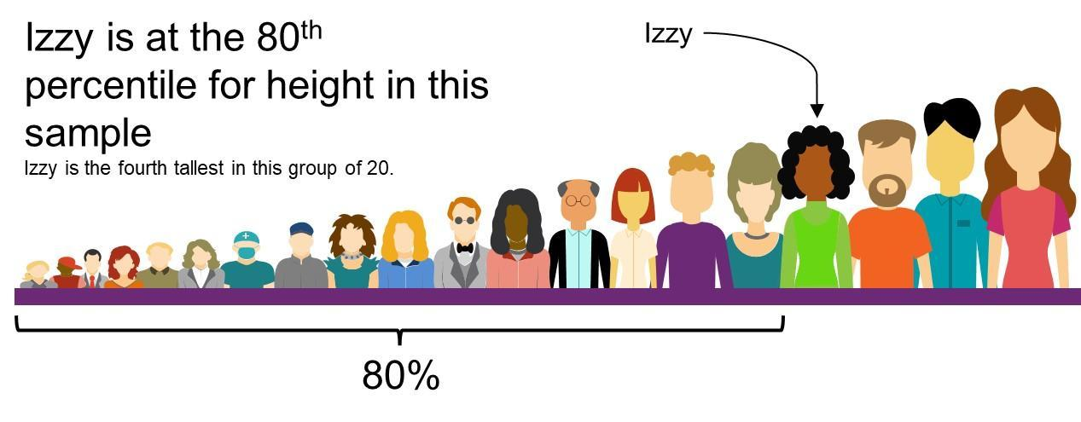

#### Comparing the NDIS supports SILC participants use

To understand how SILC participants use their NDIS funding compared to other NDIS participants receiving SIL supports, this case study used a matching algorithm. The matching algorithm looks at the features of SILC participants such as age, type of disability, the severity of disability, where they live and how long they have been in the NDIS. The algorithm then finds other NDIS participants that are like SILC participants. These matches make up the group used to compare how SILC’s participants use their NDIS supports. The process matched 25 SILC participants to 25 participants who are receiving SIL supports from other providers. Appendix B describes the matching process in detail.

### Limitations of this case study

At the time of this case study, SILC were providing SIL supports to 25 participants. This is a relatively small number of participants from which to draw conclusions about the benefits and challenges of a family governance model of SIL. This can impact on the reliability of the analyses and the confidence we can have in the findings, especially about their generalisability to other providers and participants.

### Results from this case study

The next sections describe some of the factors that are important to the family governance model and some of the key considerations when using this model. The final section looks at whether more participants could potentially get their SIL supports under a family governance model given some of the key considerations.

## Key elements of SILC’s family governance model

Parents, staff, and SILC management saw several key parts of the family governance model that when combined, help to make it work. These include common values, shared support, ongoing communication and the not-for-profit (NFP) model with financial oversight from SILC management. The financial oversight helps to make sure each home has enough money to continue to operate over time (see Figure 4).

**Figure 4:** The key parts of the SILC family governance model

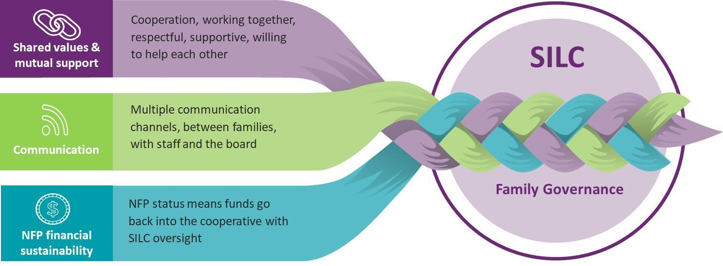

### Shared values and mutual support

SILC management have a focus on making sure the families that come together as a cooperative have shared values, particularly around their beliefs and approaches to support, and act in the “spirit of the cooperative”. They do this with careful and thorough membership testing and assessment. They look to see if the families want to collaborate, cooperate, and compromise as it is likely that there will be times when one resident must take priority over another resident. It is important that families can recognise this and continue to support one another.

*“So, it was important to find a good match for [participant], but also a match for the (Primary Cooperative) board as well. So, for us, in our model, the participant matters and is really, really important. But the match of the board is equally important because if the board doesn’t have an aligned vision and strategy moving forward, then there’s discontent. We’ve seen that. We’ve had boards fall apart because of the relationships.”* – SILC management.

The family members of SILC participants said these shared values also include a willingness to help the other families in the home. This is in the “spirit of the cooperative”, where they can rely on each other as a source of support, and many said they saw each other as part of an extended family. There is generally a hands-on approach to helping at the house, with some doing simple household repairs or chores like lawn mowing, while others help with transport, organise family dinners or coordinate activities.

### Communication channels

There is a high level of communication between family members and staff under the SILC family governance model. The Primary Cooperative communicates with the House Manager about the overall approach to the day to day running of the home and supports for the residents. The House Manager is the main contact for staff and therapists, as well as family members. This makes sure there is no confusion or misunderstandings, which can happen when family members speak directly with individual staff members. Telephone chat groups using platforms such as WhatsApp and Viber are common between parents and staff and serve to keep everyone up to date. These help to build relationships and encourage openness and trust.

*“A key factor comes down to that circle of trust. Like the parents, we’ve got a WhatsApp group for all the residents. So, the parents and all the staff are on each WhatsApp group and the parents get to see photos and videos that each resident are doing. They see the incident reports, they see the shift notes, they see the photos. So, they get the whole picture.” –* SILC House Manager

### A not-for-profit model and sustainability

SILC is a NFP provider, which means the focus is mainly on how to support participants to live their best lives, and less focus on financial outcomes. Although SILC helps to make sure each house is financially sustainable, the Primary Cooperative makes most of the financial decisions based on what the house needs and values.

*“Part of the way we [maintain transparency with families] is … having some increased financial transparency and control through direct liaison with us, their staff, the House Managers, through direct decision-making opportunities in terms of recruitment and governance. What the offering essentially is in the houses is entirely crafted with them. We do that because we think having participants and their families involved makes us a better service for them.” –* SILC management.

## Outcomes for participants and families

SILC’s participants, families, staff, and management discussed some of the benefits of a family governance model. We also compared how SILC’s participants and their families are progressing with different aspects of their lives compared to those who get their SIL supports from other providers.

### Participant engagement in activities, interests and community

SILC family members and staff often spoke about the benefits of the family governance model on the day-to-day lives of participants (see Participant story 2). Having families lend a hand with scheduling and sometimes even helping with activities meant that participants had more opportunities to do the things they enjoy. The overall operations from the Primary Cooperative also helps as it is always working towards resident and house goals, building skills and community participation to enrich participants’ lives.

*“Previously we would drop our kids off to a facility and have no interaction or say about the activities. Now at SILC we know that [participant] loves water – and with other parents, we’ll schedule with staff to take him to a water park. If they’re doing something they love, they’re going to grow in independence – now they take [participant] on a train using money. He then comes home and makes his lunch. So, we can incorporate a whole lot of goals into one day.” –* SILC family member.

NDIS data supports the findings from the interviews and focus groups. Figure 5 shows that compared to all participants using SIL, SILC’s participants report being at the 99th percentile for taking part in education, training, and skill development and at the 92nd percentile for getting opportunities to learn new things.

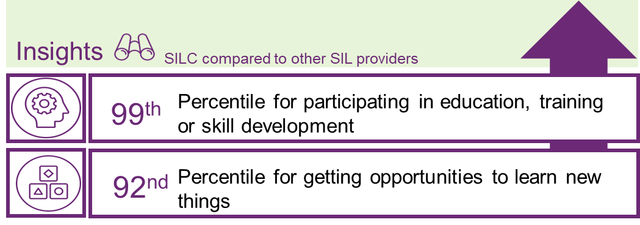**Figure 5: SILC resident engagement outcomes compared to those using other SIL models**

Source: Evidence and Practice Leadership analysis of NDIS SFOF data compared to 339 other SIL providers.

Participant story 2 below gives an example of how SILC’s participants are engaging in activities that interest them and their community.

**Participant story 2: SILC family governance model supports participant engagement**

Participant story 2: The SILC family governance model supports participant engagement.
Tim has been sharing a house with Emma under the SILC model for around eight months. They’re both in their early 20s and love participating in all manner of sports including tennis, basketball, football, netball, swimming, soccer and cricket. Throw in some surfing, video games, television and hip hop dancing and the schedule is overflowing! Their carers work together with family members to engage them both in these multiple activities and keep their busy lives organised. This is complimented by ongoing development of independence and daily life skills, such as working, cooking, shopping, public transport and what to do in an emergency. One of the parents spoke about Tim’s ongoing development as he looks forward to an opportunity to work and learn in hospitality, while Emma’s confidence has been growing with her own successful parttime employment.

The way SILC’s participants use their NDIS funding reflects their greater participation in activities and the community. Figure 6 shows that across the last year, the average SILC participant claimed considerably more on community and civic participation supports (+$13,686), and slightly more on capacity building daily activity supports (+$1,355) and transport (+$741) than participants with other SIL providers.

**Figure 6: SILC participants made more 2022 claims versus those with other SIL support providers**

+$13,686

More spent on community and civic participation by SILC participants

+$1,355

More spent on capacity building daily activities by SILC participants

+$741

More spent on transport supports by SILC participants



Source: Evidence and Practice Leadership analysis of NDIS payments data (25 SILC vs 25 comparison participants).

### Participant and family choice and control

Family members who are active in the lives of participants contribute in many positive ways. There may be times however, when SILC participants feel they make fewer individual decisions, as many choices are made with family and other members of the Primary Cooperative. This was seen in the results from the SFOF, where SILC participants were in the bottom 10% of participants who use SIL supports in different aspects of decision making and feeling able to stand up for themselves. However, when considering that most SILC participants have intensive support needs, substituted decision making is necessary in many situations, including answering the questions in the SFOF.

Figure 7 below shows that SILC participants rank in the 99th percentile for having mothers or fathers as the survey respondent, and at the 27th percentile for selecting “other” as the SFOF survey respondent. This suggests that while SILC participants make fewer choices and advocate less for themselves on their own, they are strongly supported by their mothers and fathers when answering questions and making decisions.

**Figure 7: SILC participant advocacy outcomes versus participants with other SIL support providers**

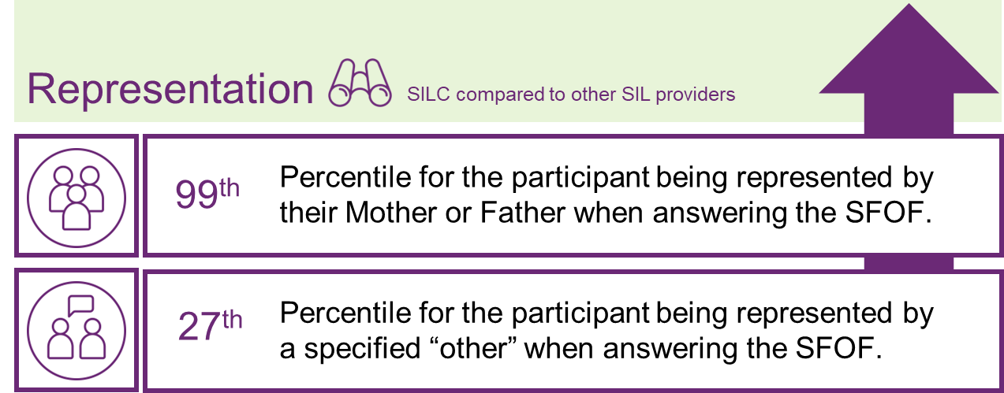

Source: Evidence and Practice Leadership analysis of NDIS SFOF data compared to 339 other SIL providers.

### Family wellbeing

The tailored strategy and approach that the Primary Cooperative develop, the level of communication and collaboration between family members, and the high engagement of SILC staff builds strong trust in the family governance model. Everyone is “in the loop” and knows about planned activities, the strategy to support participants, and any incidents that may have happened. SILC management rules about compliance and maintaining standards, and a clear path to put in complaints and/or voice concerns also builds trust.

*“Every shift … the family get the shift notes. [Participant’s] grandma gets the shift notes as well and they can talk about what he got up to in his day. And, you know, [the family can discuss it] amongst themselves, so they get a lot of transparency about what is actually going on in the houses.” –* SILC staff.

Families also noted how the influence of the Primary Cooperative on all aspects of house management, combined with the high level of day-to-day family involvement and frequent engagement with staff, gave them peace of mind about the safety of their family members.

*“For us to have this kind of connection with the house and the staff [is important]. I think, anecdotally, the more involvement families have, the lower the chance of abuse in this vulnerable population group. So, for me, that’s really important.” –* SILC family member.

The family’s responses to the NDIS SFOF questions support this sentiment (Figure 8). Based on their responses, SILC participant families rank in the highest percentiles of all families with participants getting SIL supports in:

* Getting the support they need to care for their family member (89th percentile),
* Feeling in control in selecting services and supports for their family member (98th percentile), and
* Saying the NDIS has improved their family’s health and wellbeing (99th percentile).

**Figure 8: SILC family outcomes vs families of participants with other SIL support providers**

Figure shows SILC family outcomes compared to other SIL providers using percentiles. SILC is ranked in the 89th percentile for getting the supports they need to care for their family member, 98th percentile for feeling in control in selecting 
services and supports, and 99th percentile for saying the NDIS improved the family's health and wellbeing.
 



Source: Evidence and Practice Leadership analysis of NDIS SFOF questionnaire data compared to 339 other SIL providers.

Together these results suggest that the close connection SILC families have within the house empowers them to support their family member and puts their minds at ease that staff are looking after their family member well.

## Considerations for establishing a family governance model

The SILC family governance model has potential benefits for participants and families, however it requires a high commitment from families, good matching between families (as well as participants), an acknowledgement that it is a new way of working with support staff, and other possible challenges.

The Primary and Secondary Cooperative model has potential to also be transferable to participants with physical support needs, who would like to be a Primary Cooperative Board director, and make decisions about how their shared supports are being delivered.

The families of SILC participants, staff and management noted several factors to be mindful of when in relation to the family governance model.

### Matching families as well as participants

SILC management said that one of the most important challenges when starting a new house was not just making sure the participants were a good match, but that the families were well matched too. This means that SILC focus on shared values, such as a willingness to collaborate, compromise, support each other, communicate and resolve disagreements in a productive way. There have been many times when SILC have not continued with a house because the families were not well-matched. While such setbacks can be frustrating and time consuming, this cautious approach is thought to be for the best in the long term.

*“Matching families is as much about matching values, as anything else because those families have to work together as a board of directors and make good governance decisions on behalf of their children.” –* SILC management.

### Substantial family time commitment

The SILC family governance model relies on a lot of involvement from family members. This includes establishing the Primary Cooperative, and all the administration and legal requirements with the help of the shared service provided by SILC, as the Secondary Cooperative.

Not only are families responsible for the way the house runs, but they can choose to also help with house activities and maintenance. They support each other and help with other participants in the house when possible. They are often in contact with the other families and staff, and have meetings with Primary Cooperative board members, clinicians, and therapists. SILC management recognises the work involved and given other life commitments, makes sure that families can take on the responsibility.

*“It can be a lot of work. There’s one house where there isn’t a lot of work to do, but families still have to be involved somehow. They have to be a part of decision making. That in itself, the meetings with myself and House Managers, and clinicians, even on the lower end, is still a “part time job” as some would call it. Then there’s another house where everything is left up to the House Manager to work out. They trust the House Manager so deeply that they trust they’ll be able to make all the decisions appropriately.” –* SILC management.

### Conflict resolution between families

SILC family members recognise there is a chance they could disagree, for example, over the level of support their family member receives in comparison to others in the house, how money is spent, or how much each family member contributes to the house. In some cases, SILC management has had to mediate and if issues have been too big, the Primary Cooperative has broken up. However, family members have usually worked together to resolve issues and have been able to move past the problem.

*“We've managed to work through all manner of things. Early on in the COVID situation, there was one family that were very particular about vaccination levels and others, who weren't, but we respected each other’s opinions and worked through things. We're quite united as a bunch of parents and we're pretty committed to being together and for our boys to be together. And so I guess we've always put that first instead of trying to force our own way with something. We've all tried to look out for what's best for each boy, whether it's our own son or somebody else in their house.”-* SILC family member.

### Getting a suitable house

Family members understand that in recent times, there has been a shortage of rental properties in many parts of Australia. Therefore, finding a suitable house for participants to live in has been a big challenge. Parents have noted that possible discrimination against people with a disability in the rental market has made this worse.

Moving house can also be challenging for some participants, who may have difficulty understanding why they need to move, become upset by a change in environment and/or find the disruption to their routine upsetting.

*“Before we found this house, we had challenges looking for a rental property – and it’s clear there is discrimination. We applied for about 20 houses. But the real estate agents wanted to keep options open and didn’t really want to give us a go.”-* SILC parent.

### Ageing families

A common concern expressed by many parents who have a family member living with disability is who will care for their family member when they are gone. This is a particular concern with SILC’s family governance model, which relies on strong family involvement. As parents age, they may not be able to do as much for their child and the house Primary Cooperative. This means there is a need for some type of “succession planning” for family members, friends or other people who agree to take on the support role in the SILC house (see Participant story 3).

As parents age, SILC management are beginning to have conversations with the Primary Cooperatives to find solutions that work for each individual house.

*“In the long term we do have three other siblings [that can take on the support role] and I guess that was part of my consideration when we chose this model. We felt we have, not just the siblings, but extended family as well. If we needed them to be, say, on the board or to step in as overseers. So, I guess that was something that we thought was our backup.” –* SILC family member.

**Participant story 3: Planning for ongoing support as parents age**

A family story:
Matt and Ann know that right now, their son Stuart is having a great life in a SILC house with their active support. But they worry. What will happen when they’re too old to be so active in the house? What happens when they’re gone? Matt knows this is a common problem for everyone who has a child with a disability and says, “My role in life is to make myself redundant.” He thinks the answer may be to bring in external directors or people from the community. Ann has been keen to have the conversation at the House Operator Board level. She believes that by bringing it up with the other parents, they can work out a succession plan that’s right for them and the whole house. She said that SILC management have encouraged these conversations and she’s confident that a sensible solution that gives everyone peace of mind will be found. 



### Considerations for staff and management

#### Close working relationships

The Primary Cooperative directors interview and make recommendations on who to employ as house staff members. SILC then carry out the necessary pre-employment checks as the employer and hire the staff. In some situations, the house staff have worked with a particular participant for many years and move with the participant into the SILC household. Where this is the case, and with family members involved in staff selection, there is a closer relationship and a more collaborative approach to supporting participants. Often parents see the staff as part of their extended family. Staff reported that this close bond, mutual respect and understanding between families and staff leads to a positive workplace experience.

*“I like how with SILC family members of participants in the home interview the staff members, and we tend to become a part of the family. That feeling of safety and knowing that we’re all working towards achieving the same goals. Seeing how much [Participant] has grown since entering SILC. We just didn’t have the capacity to push him towards those goals.” –* SILC family member of a SILC participant.

#### A new way of working with support workers

Although there are many benefits of the close relationships that support staff develop with participants and their families, it can be complicated at times. For example, the relationship can become quite casual. This means that sometimes support staff do not follow standard procedures, such as doing their shift notes before they leave the house. This can make family members uncomfortable, as they do not want to upset the close personal relationship with support staff, but they also need staff to complete agreed administration tasks such as shift notes. Similarly, if staff have worked with the participant for a long time, sometimes they are not as open to considering new strategies or different approaches to support the participant, which can cause tension.

*“Sometimes we've had issues where the staff have come from a family's home prior to coming into the SILC home. It's almost too close sometimes, and we've had to have SILC help us negotiate. It can be challenging when somebody corrects them or changes things … if they are very close. They’re almost like a family friend, because they’ve worked with them since they were little, it can cause conflict.” –* SILC family member.

The people involved in supporting participants may disagree on the best approach to support the participant strategy. While SILC handles legal, compliance and quality issues, the Operations Leads work with the House Manager, to troubleshoot day-to-day operations. This means that sometimes family members, staff and/or therapists might have different opinions, which can be tricky for staff to manage, and will require guidance from SILC.

*“I think it’s great that they (parents) have a high level of involvement, it does sometimes become challenging because you have to weigh up what House Managers have told you, what therapists have told you, and parents too. Especially when you receive a direct message from a parent who tells you what they want for their child that day. And that happens a lot.” –* SILC staff.

#### The need for ongoing staff training

The nature of a family governance model working as a small individual entity means staff rosters give less opportunity for staff to do extra training or professional development. It is difficult to release staff to give them the time off for training due to the small staff pool available. There is a need, however, to make sure that staff feel confident in managing the different situations they face and can build their “toolkit” of strategies and techniques to help participants live their best lives.

*“When you've got a roster, and you've got eight staff on a day, and you need them to take two days off to do a training course, it can be very difficult to get that happening. So, that I think that is the challenge. I don't think it's the content of the training. I think the training is good. I think it's just the challenge around being a much smaller organisation and it not being really able to do as much training” –* SILC staff.

### Time and funds required to establish governance arrangements

Transitions can be challenging for participants moving into any home. Establishing a SILC family-governed home requires sensitively managed conversations with staff and families to ensure the governance structure in place is going to be the best for participants in the long term.

*“There is a lot of behind-the-scenes work to ensure that when we set this up we set this up right. We don’t want to move someone into a house just because we can. We want to make sure the fit is right and make sure this is going to be their forever home”* SILC management.

## Benefits to the NDIS

Figure 9 shows in 2022, SILC participants claimed $1,790,988 less in NDIS supports than other, similar participants receiving SIL supports from other providers. This is an average of $71,640 less per participant.

Overall, SILC participants claimed $375,679 less SIL supports than participants with other providers. This is an average of $15,023 less per SILC participant. SILC participants also claimed less support coordination (-$109,643 or -$4,388 per participant) and home modifications (-$111,917 or -$4,477 per participant).

**Figure 9: SIL claims by SILC participants vs participants with other SIL providers**

Figure shows SIL claims by SILC participants vs participants with other SIL providers. $1.8 million less spent per year on all NDIS supports, $71k less spent per year on all supports per SILC participant, $375k less spent per year on SIL supports, $15k less spent per year on SIL supports per SILC participant, $112k  less spent per year on home modifications, and $109k less spent per year on support coordination supports.


Source: Evidence and Practice Leadership analysis of NDIS payments data (25 SILC vs 25 comparison participants). Table 3 in Appendix B illustrates the derivations of the differences shown above.

Less spending on SIL and support coordination reflects the greater involvement of families in house operations and supports. It is unclear whether lower spending on home modifications shows that SILC’s family governance model supports better matching of participants to homes or whether it is more difficult to make modifications to rental properties than provider-owned properties.

The lower overall NDIS spending by SILC participants, when compared to similar participants with other SIL providers, is despite greater spending on Social, Community and Civic Participation supports (see Figure 6 and Table 3 in Appendix B). However, the higher involvement of SILC participants in education, training and skill development, and the opportunity to learn new things (see Figure 5), reflects the benefits of greater spending on these supports.

## The replicability of family governance models in the NDIS

SILC’s family governance model appears to be achieving good outcomes for participants and supporting the financial sustainability of the NDIS. However, this analysis is based on a relatively small number of participants. This reduces the level of confidence in these findings and whether other SIL providers who use a family governance model would achieve the same outcomes. Nevertheless, the case study highlights the benefits of greater family involvement in the delivery of SIL supports.

Based on SILC’s success, family governance models of SIL would ideally be available to more NDIS participants. However, this model is not without challenges. In particular, successful family governance relies on a high commitment from families, participants who have complementary support needs, and Primary Cooperatives that are in agreement about their goals, strategy and values.

It may also be difficult to make this model work for a large number of participants and/or with ‘for profit’ providers. Each Primary Cooperative is unique and tailored to the needs of the participants who live there. There is no efficient “one size fits all” strategy or approach that a provider could copy across all their houses.

*“Everything we do is very tailored. So, there are no two houses exactly the same. You might want to roll out a policy or procedure, but how it looks in every single one of our houses is slightly different and that is dependent on the residents and the families.”-* SILC management.

SILC’s NFP model also relies on a lean management structure and strong commitment from families and staff. Commitment is critical as the model depends on considerable ‘pro bono’ support from families to support house operations. To an extent, the need for ‘pro bono’ support to make the model work also extends to SILC’s management in supporting Primary Cooperatives and house staff to work with families on an individual basis.

Considering the factors that are essential for the success of SILC’s model, there are limits on the extent SILC can extend the model beyond their current number of participants. These factors also mean that family governance models of SIL are unlikely to be significantly scalable in the NDIS, explaining why there is not many in the current market. Nonetheless, for suitably committed families, SILC shows how a family governed model of SIL can lead to positive outcomes for participants and their families.

## Appendix A: Data

There are several forms of data used in this case study. Qualitative data was collected from focus groups and interviews held with SILC participants, their family members, staff, and management. The interviews and focus groups aimed to learn about experiences with the SILC family governance model.

The case study also used quantitative data about the SILC participants across three main areas:

1. **Demographics:** Demographic data about SILC participants came from the NDIS data warehouse and was used to develop a comparison group for SILC participants. Demographic data included age, First Nations status, Australian citizen status, Culturally and Linguistically Diverse (CALD) status, disability group, NDIS stream type, Australian state/territory and disability severity score.
2. **Finance:** Financial data on SIL claims made by SILC participants came from the NDIS data warehouse. This data helped create the comparison group and to see if there were any financial savings from using the SILC family governance model. The data collected was from the 2022 calendar year and included the number of NDIS claims made, the amount claimed, the number and amount of SIL claims, the dollar amount of each support type claimed, the allocated budget of participants’ latest NDIS plan, and how the budget was allocated.
3. **Outcomes:** Outcomes data for each SILC participant and the comparison group came from the short form outcome framework (SFOF) questionnaire. The SFOF is a questionnaire that the NDIS use to collect information from participants and their families at planning meetings about how they are doing in different areas of their lives. This includes daily living, choice and control, health and wellbeing, relationships, community participation, work, and learning. Using the outcomes listed in each participant’s latest NDIS plan review, we compared the outcomes of SILC participants to the outcomes of participants using other SIL providers. Analyses used the most recent SFOF answers available for participants.

## Appendix B: Matching procedure and balance

To make a sound comparison group for the SILC participants, this case study used the propensity score matching technique. The propensity score matching technique uses characteristics in the data to give a score to participants. Using these scores, we can then find statistically similar participants by finding other participants with the same score.

For this case study we used several key participant demographics and SIL characteristics to work out the propensity scores. The demographic variables include age, First Nations status, Australian citizen status, CALD status, disability group, NDIS stream type, and disability severity score. The SIL characteristics variable included the average number of days from coming into the NDIS until the first SIL claim, the average number of SIL claims made in 2022, the average SIL amount claimed in 2022, the total number of supports claimed in 2022, and the number of NDIS plans the participant has had since entering the NDIS.

Using the variables listed above and a logistic regression, we worked out a propensity score for every active participant in the NDIS. Using these propensity scores, we then used a “nearest neighbour” matching approach so that each SILC participant matched to an exclusive non-SILC participant who has a similar or the same propensity score.

We found 25 SILC participants to include in our quantitative analysis. Table 2 shows the key matching variables of the 25 SILC participants against their 25 non-SILC comparisons. It shows the success of the matching process where, except for residential state/territory, the distribution of participants across the variables is similar. By creating this sound comparison group, which is statistically like the SILC participants, we can conclude that any remaining difference (be it outcome, budget, financial etc) is largely due to SILC and the family governance model.

**Table 2: SILC matching table results**

| **Variable** | **Comparison** | **SILC** |
| --- | --- | --- |
| Number of participants | 25 | 25 |
| Demographics | Count | Count |
| First Nation (not stated) | 10 | 11 |
| Australian citizen | 14 | 13 |
| Non-CALD | 19 | 21 |
| Male | 18 | 20 |
| Intellectual disability | 9 | 7 |
| Autism | 13 | 16 |
| Average age | 28 | 27 |
| State | Count | Count |
| NSW | 14 | 25 |
| Other | 9 | 0 |
| Stream | Count | Count |
| Complex | 8 | 7 |
| Intensive | 9 | 13 |
| Super Intensive | 8 | 5 |
| Severity Score | Count | Count |
| <13 | 12 | 9 |
| ≥13 | 13 | 16 |
| Average severity score | 12 | 12 |
| NDIS plans | 28 | 27 |
| Average number of NDIS plans | 10 | 10 |
| Average number of days to first SIL claim | 1,418 | 1,482 |

Source: Evidence and Practice Leadership Branch analysis of participant demographic data: propensity score matching procedure.

Table 3 shows the similarities and differences in budgets and claims for NDIS supports between the SILC and non-SILC (comparison) groups.

**Table 3: NDIS claims of SILC and comparison differences following matching**

| **Variable** | **Comparison** | **SILC** | **Difference** |
| --- | --- | --- | --- |
| **All supports (2022)** | Control | SILC | Difference |
| Ave. claim count per participant | 544 | 405 | -139 |
| Ave. claim per participant $ | $574,858 | $503,218 | -$71,640 |
| Total claim $ | $14,371,440 | $12,580,456 | -$1,790,984 |
| **SIL supports (2022)** | Control | SILC | Difference |
| Ave. SIL claim count per participant | 136 | 147 | $11 |
| Ave. SIL claim per participant $ | $327,193 | $312,170 | -$15,023 |
| Total SIL claim $ | $8,179,820 | $7,804,241 | -$375,579 |
| **NDIS budgets** | Control | SILC | Difference |
| Total funded support | $669,022 | $518,042 | -$150,980 |
| Core budget (annualised) | $514,402 | $484,723 | -$29,679 |
| Capacity building budget (annualised) | $41,652 | $37,237 | -$4,415 |
| Capital budget (annualised) | $19,535 | $17,006 | -$2,529 |
| **Support types (average claims per participant in 2022)** | Control | SILC | Difference |
| Assistive Technology | $5,114 | $831 | -$4,283 |
| CB Choice and Control | $1,116 | $689 | -$427 |
| CB Daily Activity | $9,077 | $10,432 | $1,355 |
| CB Health and Wellbeing | $0 | $223 | $223 |
| CB Relationships | $13,294 | $13,468 | $174 |
| Consumables | $1,413 | $1,457 | $44 |
| Daily Living | $450,239 | $375,923 | -$74,316 |
| Home Modifications | $4,618 | $141 | -$4,477 |
| Social. Community and Civic Participation | $79,211 | $92,897 | $13,686 |
| Support Coordination | $8,979 | $4,593 | -$4,386 |
| Transport | $1,682 | $2,422 | $740 |

Source: Evidence and Practice Leadership Branch analysis of participant budget and claim data: propensity score matching. References to Figure 9 from the table above are as follows:

* -$1.8m less per year on all NDIS supports (row 4 total claim $: -$1,790,984).
* -71k less spent per year on all support per SILC participant (row 3 Ave. claim per participant $: -$71,640).
* -375k less spent per year on SIL supports (row 9 Total SIL claim $: -$375,579).
* -15k less spent per year on SIL supports per SILC participant (row 8 Ave. SIL claim per participant $: -$15,023).
* -112k less per year on modifications (row 23 Home Modifications: -$4,477 times 25 participants equal -$111,925).
* -109k less spent per year on support coordination supports (row 25 Support Coordination: -$4,386 times 25 participants equal -$109,650).

1. Details available at: <https://www.fightingchance.org.au/wp-content/uploads/sites/3/2020/09/Fighting-Chance-FY19-Annual-Report-WEB_72dpi.pdf#:~:text=Opening%20%E2%80%98Casa%20Mia%E2%80%99%2C%20the%20first%20Fighting%20Chance%20house,weeks%20after%20the%20close%20of%20our%20Financial%20Year>.
2. Details available at: <http://burnside.slimlib.com.au:81/docs/BenambraBook_A_place_to_call_your_own.pdf>