National Disability Insurance Scheme

Annual Financial Sustainability Report

2022-23

David Gifford BEc MBA FIAA
Scheme Actuary

Table of Contents
Annual Financial Sustainability Report 1
Executive Summary 5
1. Introduction 32
1.1 Purpose of the NDIS 32
1.2 Definition of financial sustainability 33
1.3 Context for 2022-23 AFSR 34
1.4 Reliance and limitations 35
2. Information and data integrity 36
2.1 Information and data used for analysis 36
2.2 Information systems overview 38
3. Modelling approach 40
3.1 Participant numbers 41
3.2 Scheme Expenses relating to participant supports 41
3.3 Projected plan budgets 42
3.4 Stochastic Model 42
4. Scheme experience 45
4.1 Participant numbers 45
4.2 Actual versus expected participant numbers 45
4.3 Participants in Supported Independent Living 56
4.4 Total Scheme expense 60
4.5 Average payments per participant 61
4.6 Growth in average payments 66
4.7 Plan budgets 67
4.8 Utilisation 73
5. Projections 76
5.1 Total Scheme expense projections 76
5.2 Comparison with previous AFSR 79
5.3 Plan Budget projections 81
5.4 Participant projections 85
5.5 Participants with SIL supports 95
5.6 Base average payment assumptions 98
5.7 Inflation and additional growth assumptions 102
5.8 Average payments per participant after inflation 106
5.9 Lifetime expense for care and support 108
5.10 Operating expenses 110
6. Uncertainty and comparisons to previous projections 113
6.1 Scenario analysis 113
6.2 Stochastic modelling 120
6.3 Judgement and materiality of assumptions 125
6.4 Historic AFSR projections 127
7. Participant outcomes and investment effectiveness 132
7.1 Outcomes and financial sustainability 132
7.2 The outcomes framework questionnaires 133
7.3 Reporting on outcomes 136
7.4 Participant outcomes – results 137
7.5 “Has the NDIS helped?” 142
7.7 Results – “Has the NDIS helped?” 150
7.8 Investment Effectiveness Analysis 152
8. Risk management 153
8.1 Introduction 153
8.2 Risk Management Arrangements & Responsibilities 154
8.3 Responsibilities of the Scheme Actuary 156
8.4 Corporate Plan Strategic Risks 158
8.5 Modelling Risks 165
8.6 Business continuity and Risk management system 166
8.7 Assessment of the Risk Management Framework 166
9. Recommendations 167
9.1 Key themes and progress since previous review 168
9.2 Recommendations from this review 171
Appendix 181
Appendix A Comparison to previous review – detailed tables 182
Appendix B Reconciliation to previous review 189
Appendix C State and territory breakdown 191
Appendix D Scheme experience —participants 193
Appendix E Scheme experience — payments 196
Appendix F Scheme experience – plan budgets 200
Appendix G Analysis of Scheme new entrant rates 202
Appendix H Review of Scheme mortality 215
Appendix I Participants with SIL supports 228
Appendix J Average payment assumption setting details 241
Appendix K Projections – Plan budgets 246
Appendix L Scenario analysis from previous AFSRs 247
Appendix M Scenario analysis of participant numbers 251
Appendix N Historic average participant payments by SIL type 254

Executive Summary
An annual financial sustainability report (AFSR) is required under section 180B of the NDIS Act and provides an assessment of the financial sustainability of the National Disability Insurance Scheme (“the Scheme”, or NDIS). The AFSR is produced using data at 30 June each year and a summary of each year’s AFSR has been included in the NDIA annual report. This 2022-23 AFSR uses data to 30 June 2023 to project future Scheme expenses and these results are referred to as the “June 2023 projections”.
The previous report was the AFSR released on 7 November 2022 (the “2021-22 AFSR”). It was based on data to 30 June 2022, with commentary about experience to 30 June 2022 (the “previous review”). References to the previous review refer to results contained within that report, referred to as the “June 2022 projections”.

Financial sustainability
The NDIS Insurance Principles and Financial Sustainability Manual outlines the NDIS’ insurance model in detail and defines financial sustainability as the state where:
- The Scheme is successful on the balance of objective measures and projections of economic and social participation and independence, and on participants’ views that they are getting enough money to buy enough goods and services to allow them reasonable access to life opportunities - that is, reasonable and necessary support.
- Contributors think that the cost is and will continue to be affordable, under control, represents value for money and, therefore, remain willing to contribute.

Context for 2022-23 AFSR
Since the previous review, mid-year Scheme projections were undertaken, and are referred to as the “December 2022 projections”. These were used as the basis for the 2023-24 Budget and included allowances for the expected impact of the measures announced to lift the NDIA’s capability, capacity, and systems to better support participants (“Budget measures”). The 2023-24 Budget differs from the December 2022 projections in 2026-27 and later, as the Budget assumes growth in Scheme expenses from 2025-26 to 2026-27 of 8%, moderating thereafter. The NDIS Financial Sustainability Framework, which is outside the scope of the 2022-23 AFSR, was agreed by National Cabinet as part of the 2023-24 Budget to achieve this 8% growth target.
The Budget measures are aimed to support participant outcomes and the effective and sustainable operation of the Scheme, with the NDIA to implement a program of initiatives (“Budget initiatives”) designed to: improve early intervention outcomes for children in the Scheme, improve participant planning processes, and improve consistency in Home and Living eligibility decisions for participants with complex and high support needs. The NDIA is using a co-design approach to develop the initiatives, working closely with participants, the Independent Advisory Council, Disability Representative and Carer Organisations and the disability sector more broadly. The initiatives are expected to drive moderated numbers of participants with developmental delay, greater participant trust in the NDIS supporting them over time, in turn leading to a moderation of future growth in participant plans, and stabilisation of numbers of participants with Supported Independent Living arrangements.
Separately, the 2023 Intergenerational Report (IGR) was published in August 2023, which is based on the 2023-24 Budget projections, allowing for the growth target of 8% in 2026-27, moderating thereafter.
In October 2022, the Minister for the NDIS announced a review of the Scheme (“NDIS Review”) to be conducted by an Independent Review Panel. The scope of the NDIS Review includes the design, operations, and sustainability of the NDIS as well as ways to build a more responsive, supportive, and sustainable market and workforce. The Independent Review Panel provided a final report to the Disability Reform Ministers' Meeting in November 2023. This AFSR, and the projections documented in it, do not allow for the impact of any future changes to the Scheme as a result of the recommendations made by the Independent Review Panel. It is noted changes in legislative and policy settings arising from NDIS Review recommendations are anticipated to lead to further moderation in Scheme growth relative to those shown in this report from 2026-27 onwards, to achieve the target set by National Cabinet which is consistent with the 2023 IGR.

June 2023 projection of Scheme expenses
Table 1 shows projected Scheme expenses on an accrual basis are $41.4 billion in 2023-24, increasing to $92.3 billion in 2032-33. Total projected Scheme expenses are $193.7 billion for the four years to June 2027. The June 2023 projection of Scheme expenses incorporates revisions to assumptions and changes in future expectations since the previous review, and the December 2022 projections. These updated projections allow for the expected impact of the Budget initiatives, aimed to improve participant outcomes, and overall effectiveness and sustainability of the Scheme.
It is important to recognise that the projected Scheme expenses are shown in nominal terms, i.e., future dollars of estimated Scheme expenses include the effects of inflation over time. This impact of inflation increases over the longer term and is particularly significant for the result in 2032-33. Scheme expenses are estimated to be 1.6% of GDP in 2023-24, increasing to 2.3% in 2032-33. In considering longer-term projections it is recommended users refer to expenses as a percentage of GDP rather than nominal dollar figures as these provide a more meaningful measure of Scheme expenses.

Table 1: June 2023 projection of Scheme expenses
Scheme Expenses ($m) | 2023-24 | 2024-25 | 2025-26 | 2026-27 | 2032-33 | Total 2023-27
Participants (0-64)  (cash basis) | 37,229 | 41,228 | 44,645 | 48,026 | 77,991 | 171,128
Participants (65+)  (cash basis) | 3,685 | 4,647 | 5,594 | 6,583 | 13,331 | 20,510
Total Scheme Expenses  (cash basis) | 40,914 | 45,875 | 50,239 | 54,609 | 91,322 | 191,638
Participants (0-64) (accrual basis) | 37,635 | 41,678 | 45,133 | 48,553 | 78,865 | 172,999
Participants (65+)  (accrual basis) | 3,725 | 4,698 | 5,655 | 6,655 | 13,476 | 20,732
Total Scheme Expenses  (accrual basis) | 41,360 | 46,376 | 50,788 | 55,207 | 92,341 | 193,731
Total Scheme Expenses (% of GDP) | 1.61% | 1.76% | 1.83% | 1.89% | 2.33% | 1.77%

Table 2 shows that projected Scheme expenses are approximately $3.1 billion higher in the four years to June 2027 and about $1.8 billion lower in 2032-33, compared to the December 2022 projections. They are $5.6 billion higher in the four years to June 2027 and $4.6 billion lower in 2032-33, compared to the June 2022 projections in the previous review.

Table 2: Comparison with previous projections
Scheme Expenses ($m) (accrual basis) | 2023-24 | 2024-25 | 2025-26 | 2026-27 | 2032-33 | Total 2023-27
June 2023  projections (a) | 41,360 | 46,376 | 50,788 | 55,207 | 92,341 | 193,731
December 2022  projections (b) | 39,977 | 45,315 | 50,348 | 55,007 | 94,172 | 190,648
June 2022  projections (c) | 38,133 | 44,116 | 50,344 | 55,510 | 96,966 | 188,103
Difference ($) (a – b) | 1,383 | 1,060 | 440 | 200 | -1,831 | 3,083
Difference (%) (a/b -1) | 3% | 2% | 1% | 0% | -2% | 2%
Difference ($) (a – c) | 3,227 | 2,260 | 444 | -303 | -4,625 | 5,628
Difference (%) (a/c -1) | 8% | 5% | 1% | -1% | -5% | 3%
Table 3 shows the changes in the projected Scheme expenses since the previous review, due to external factors, experience and updated assumptions.
After allowing for factors influenced by forces external to the Agency, including immigration policy, pricing and normal inflation updates, revised Scheme expenses for the four years to June 2027 are projected to be $190.8 billion, or $2.7 billion (1.4%) higher compared to the previous review.
Updates for actual experience and other assumption changes since the previous review, has increased projected Scheme expenses by a further $2.9 billion (1.6%) for the four years to 30 June 2027, with a reduction of $7.8 billion (8.0%) in financial year 2032-33. Actual experience for the 12 months to 30 June 2023, accounts for $2.4 billion of the total $2.9 billion increase in projected Scheme expenses for the four years to 30 June 2027, with assumption changes accounting for the remaining $0.5 billion.
The moderation of assumptions in the medium to longer-term, in particular relating to participants entering the Scheme, participants transitioning to complex and/or higher support needs and growth in participant plans, is a reflection of the expected impact of maturing of the Scheme in the medium to longer-term, with continued improvements in operational processes and effectiveness.

Table 3: Movements in projected Scheme expenses since previous review
Scheme Expenses ($m)  (accrual basis) | 2023-24 | 2024-25 | 2025-26 | 2026-27 | 2032-33 | Total 2023-27
June 2022 projections | 38,133 | 44,116 | 50,344 | 55,510 | 96,966 | 188,103
Immigration changes | 15 | 69 | 147 | 212 | 618 | 445
Pricing and normal inflation | 607 | 394 | 542 | 709 | 2,530 | 2,251
Projections updated for external factors | 38,755 | 44,579 | 51,033 | 56,431 | 100,113 | 190,799
Updates for experience | 696 | 526 | 574 | 571 | 721 | 2,368
Updates for assumption changes | 1,908 | 1,270 | -819 | -1,795 | -8,494 | 565
Total movement for experience and assumptions changes | 2,605 | 1,797 | -245 | -1,224 | -7,773 | 2,932
June 2023 projections | 41,360 | 46,376 | 50,788 | 55,207 | 92,341 | 193,731
Table 4 shows the movement in Scheme expenses, from the previous to this review, compared with the December 2022 projections.
The June 2023 projections are $3.1 billion higher than the December 2022 projections in the four years to June 2027 due to the higher-than-expected price increases in 2023 (reflecting the Fair Work Commission’s decision on the National Minimum Wage), and increases to normal inflation assumptions.

Table 4: Movement in projected Scheme expenses compared with December 2022 projections
Scheme expenses ($m) (accrual basis) | 2023-24 | 2024-25 | 2025-26 | 2026-27 | 2032-33 | Total 2023-27
June 2022 projections | 38,133 | 44,116 | 50,344 | 55,510 | 96,966 | 188,103
Impact of Immigration | 15 | 69 | 147 | 212 | 618 | 445
Impact of price changes and normal inflation | -176 | -208 | -239 | -263 | -428 | -885
Other experience and assumption changes | 2,004 | 1,338 | 95 | -452 | -2,983 | 2,986
December 2022 projections | 39,977 | 45,315 | 50,348 | 55,007 | 94,172 | 190,648
Impact of price changes and normal inflation | 783 | 601 | 781 | 972 | 2,958 | 3,137
Other updates for experience and assumption changes | 600 | 459 | -340 | -772 | -4,789 | -53
June 2023 projections | 41,360 | 46,376 | 50,788 | 55,207 | 92,341 | 193,731

Information and data used for analysis
Table 5 summarises the sources of data used for the actuarial analyses underpinning this AFSR, which relies upon the Agency’s case management system, finance system and data warehouse, as well as external sources. The analysis in this report is based on data at 30 June 2023, unless stated otherwise.
The main update to data sources for this year is in relation to the roll-out of PACE, a new Client Relationship Management (CRM) system, which captures details about participants and participants’ plans. PACE has been piloted in Tasmania since November 2022, with an expected national roll-out by the end of 2023. The transition to the new CRM system for Tasmania participants had no material impact to Scheme experience analyses for the 12 months ending 30 June 2023, or the June 2023 Scheme projections.
Where data is used to conduct actuarial analyses, (which in turn provides an evidence base for setting of assumptions), it is important to acknowledge any limitations associated with the data that could give rise to uncertainty in the results. One particular area identified in this AFSR relates to participants with Supported Independent Living (SIL) arrangements, where there is no single flag of SIL usage available to accurately identify participants with SIL supports.
A combination of participants’ prior access to SIL supports, and their recent payments experience, is used to estimate numbers of participants with SIL supports. Imperfections exist with this solution, introducing systemic variability in the number of participants with SIL arrangements in a given month, and the analyses used to inform the transition of participants to SIL arrangements. Despite this variability, the numbers of participants with SIL and associated experience analyses, used to inform setting of assumptions for Scheme projections are robust.

Table 5: Summary of data utilised for actuarial analysis
Data | Description
Access requests to the NDIS | - Demographic information (age, gender, disability, geographic location, living arrangements and other participant profile information)  - Contact details  - Access request date  - Outcome of request (for example: eligible, ineligible)
Payments to service providers | - Service provider submitting the claim for payment  - Participant for whom the support was provided  - The support item and cost of support provided  - Dates of when the support was provided  - Method of plan management used
Payments to participants | - Participant submitting the claim for payment  - The support category provided  - Total amount spent by support category  - Period of reimbursement
NDIS participant plans | - Plan approval date  - Length of plan  - All plan budgets included in the plan  - Level of function
In-kind supports data | - Unit record in-kind support details from State/Territory programs including details on support type, level and duration of coverage.
Data on outcomes | - Information collected from surveys of participants and their families and carers about how they are doing in different areas of their lives and how they are progressing over their time in the NDIS.
Financial information | - Data from the SAP CRM systems were reconciled with financial information in SAP.
ABS Survey of Disability, Ageing and Carers | - Prevalence of disability in Australia, including demographic and socioeconomic profile of people with disabilities.
Economic information | - Government economic forecasts for GDP  - Inflation indicators
Demographic information | - Australian Life Tables 2018-2020 – published in November 2021  - Budget 2023-24: population projections, Australia, 2022-23 to 2033-34 from the Centre for Population Projections  - Population forecasts beyond 2033-34 - 2023 Intergenerational Report  - Estimated Resident Population data up to 30 June 2022 – published by the Australian Bureau of Statistics (ABS), and information on immigration changes from the Department of Home Affairs  - New Zealand residents in Australia projections provided by the Department of Social Services as part of 2023-24 Federal Budget.

Projection models
An experience-based projection model, based on average payments per participant, continues to be used to project total Scheme expenses. Observed experience of the Scheme is used to determine assumptions about future expected experience, with different assumptions having varying degrees of certainty (refer Section 6). A plan budgets model projecting average plan budgets per participant and total plan budgets for the Scheme, is used to determine the implied utilisation. The implied utilisation is the proportion of total plan budgets used, expressing total projected Scheme expenses from the payments model as a percentage of total plan budgets.
As with previous AFSRs, the projection of total Scheme expenses reported in the 2022-23 AFSR is based on projecting average payments made for supports for 2,052 participant cohorts. Total projected Scheme expenses are based on the average payments for each cohort, multiplied by projected participant numbers, and summed across all cohorts to arrive at total projected Scheme expenses. The projected total plan budgets for the Scheme are similarly calculated, based on projecting average plan budget amounts for each of the same participant cohorts, and summing across all cohorts.
Since last year, enhancements were made to the projection models to reflect the ongoing maturing of the Scheme, as well as developments in Scheme experience and refinements to operational processes. There was a refinement of the modelling of participants with Supported Independent Living (SIL) arrangements. Further, the projection models were completely replicated using two independent statistical programming languages: not only acting as an independent validation of projection results, but also to improve modelling capabilities, including the ability to project Scheme expenses beyond 11 years.
Uncertainty exists in any projection, and the level of uncertainty generally increases in the longer term. As the Scheme matures, and becomes more complex in nature, the expected trajectory of Scheme experience and projected expenses can change materially, resulting from the decisions and actions of the Government and Agency and the Australian and global economic climate. Two approaches continue to be used to illustrate the drivers of uncertainty and the estimated impacts those have on the projection results:
- Testing the sensitivity of projected Scheme expenses to changes in specific key assumptions via construction of a number of scenarios, included in Section 6.1.
- Projecting Scheme expenses using a stochastic model providing a quantification of the interaction between material risks facing the Scheme and the variability in these risk factors. The approach and results of this model are included in Section 6.2.

Number of participants
Figure 1 shows the number of actual participants in the Scheme each year, and the projected number of future participants at this review (2022-23 AFSR) compared to those from the previous review (2021-22 AFSR). At 30 June 2027 it is estimated there will be 792,200 participants in the Scheme, increasing to 1,030,337 by 30 June 2033. This is 0.6% more participants at 30 June 2027 and 3.1% fewer by 30 June 2033, compared to the previous review.

Figure 1: Comparison of participant numbers to previous review at 30 June
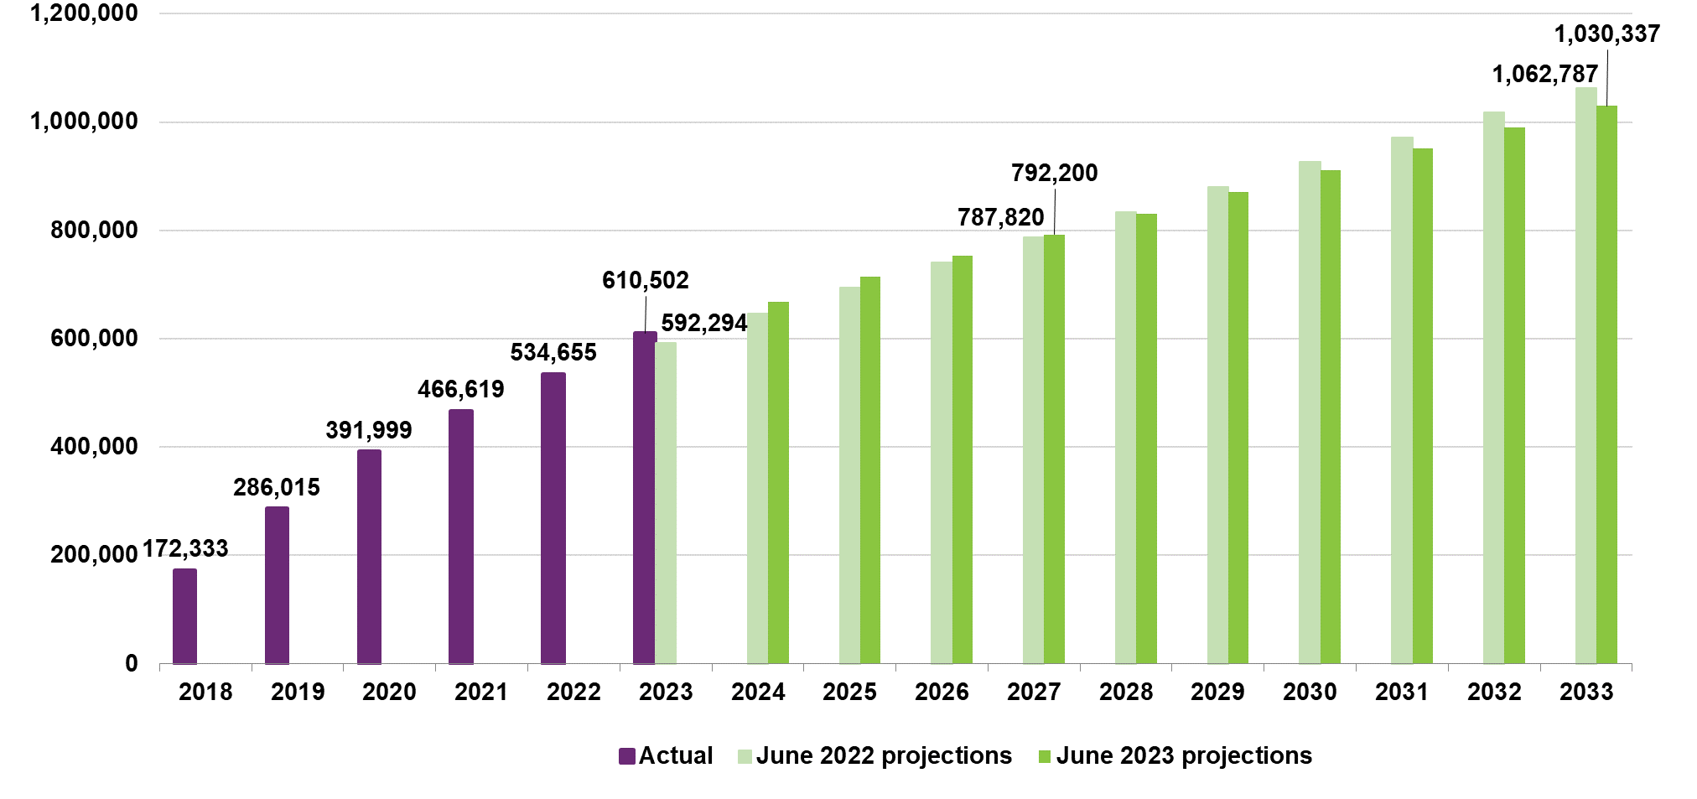
Projections of future expected participant numbers are impacted by the starting population of participants at 30 June 2023 and assumptions about future expected number of new entrants and number of participants leaving the Scheme. The short-term increase in projected future participant numbers in the Scheme at this review, reflects a higher number of participants in the Scheme at 30 June 2023, combined with an assumed higher new entrant rate in the short-term, (particularly for children aged 0 to 14 with developmental delay), compared to the previous review. The reduction in future participant numbers in the medium to longer term reflects the lower new entrant rates for older children and adults aged 15 and above, with disabilities other than autism and developmental delay, and an increase to longer term expectations about the rate of participants leaving the Scheme.
As for the previous review, the mix of participants in the Scheme continues to change impacting the overall average payment per participant of the Scheme. For participant cohorts where the average payment per participant is significantly lower or higher than the overall average payment across all participants, the increase in total projected number of participants does not necessarily lead to an increase in Scheme expenses of the same magnitude. At this review, there are two distinct and opposing cohorts of participants influencing the overall change in mix of participants of the Scheme:
- A continued higher proportion of new entrants to the Scheme who are children with a high reported level of function and tend to have lower support needs; resulting in a lower average payment per participant, compared to existing participants.
- A significant increase in number of participants with Supported Independent Living (SIL) arrangements, reflected in the starting population at 30 June 2023, who typically have more complex/ higher support needs and hence a higher average payment per participant.

New entrants
The total number of new entrants to the Scheme in the twelve months to 30 June 2023 was 86,400, which is 22% (15,653) higher than the 70,747 new entrants expected from the previous review. The Scheme continues to experience higher-than-expected numbers of new entrants with developmental delay and autism, respectively 12,932 and 4,737 more than expected. This is partly offset by lower-than-expected numbers of new entrants with disabilities other than developmental delay and autism which was 2,016 fewer than expected in the previous review.
Comparing actual experience for 2022-23, to the actual experience for 2021-22, total new entrants to the Scheme increased by 8%, with 20% more children aged 0 to 14 years (Figure 2), 19% more new entrants with autism aged 15 and above (Figure 3), and 16% fewer new entrants with disabilities other than autism aged 15 and above (Figure 4). New entrants with developmental delay and autism accounted for 70% of total new entrants in 2022-23.
Figure 2 shows increasing numbers of children aged 0 to 14, entering the Scheme over the most recent two years. Anecdotal evidence suggests that the higher proportion of new entrants with developmental delay can be attributed to a combination of waiting times to obtain an autism diagnosis, increased awareness of developmental delay, lack of capacity within mainstream services to support children, and COVID-19 related impacts.

Figure 2: Numbers of new entrants (aged 0 to 14)
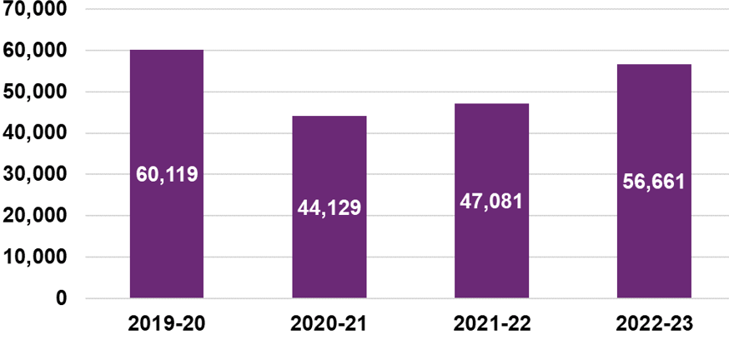
Figure 3 similarly shows increasing numbers of older children and adults with autism aged 15 and above, entering the Scheme over the most recent two years. Anecdotal evidence indicates that the continued increase may be related to a greater awareness of autism in older children and adults not being diagnosed as a child, or adults who enter the Scheme with multiple disabilities or health conditions, including autism.

Figure 3: Numbers of new entrants (aged 15+) with autism
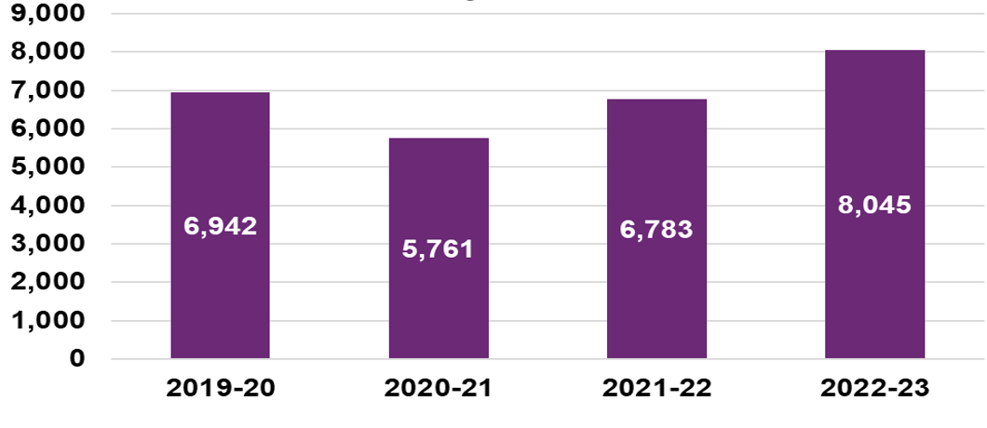
Figure 4 shows a continued decline in numbers of new entrants aged 15 and above, with disabilities other than autism entering the Scheme in 2022-23, suggesting these rates have not yet stabilised at a long-term rate.

Figure 4: Numbers of new entrants (aged 15+) with disabilities other than autism
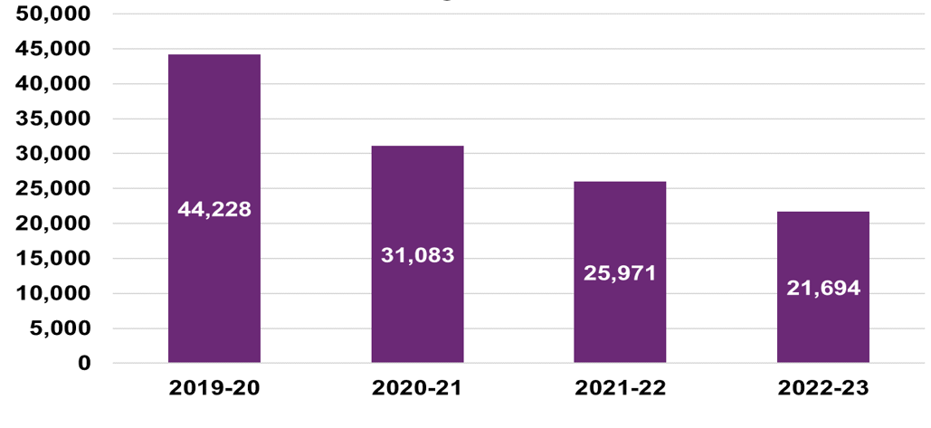
For the June 2023 projections new entrant rate assumptions were updated to reflect higher new entrant rates for children aged 0 to 14, higher rates for new entrants with autism aged 15 and above, and lower rates for new entrants aged 15 and above with disabilities other than autism. Adjustments were also made to reflect updated views on the extent to which short-term rates of new entrants to the Scheme are expected to be different from the medium to long term experience.
Tables 6a and 6b show the updated long-term new entrant rates assumed for the June 2023 projections, both before and after adjustments made for Budget initiatives, compared to those assumed for the previous review by disability and age group respectively. A new entrant rate of 314.7 (per 100,000 population aged 0 to 64), in aggregate across all disability types, was assumed for the June 2023 projections after factoring in Budget initiatives. This is 2.0% higher than the new entrant rate assumed in the previous review, including an assumed rate that is 2.3% higher for new entrants with autism, 21.2% higher for new entrants with developmental delay, and a reduction of 18.6% in the rate of new entrants with disabilities other than developmental delay and autism. Rates are 17.3% higher for children aged 0 to 14 entering the Scheme, and 17.8% lower for older children and adults aged 15 and above.

Table 6a: Comparison of new entrant rate assumptions (per 100,000 population aged 0 to 64) to previous review, by disability group
Disability group | June 2023 projections (before Budget initiatives) | June 2023 projections  (after Budget initiatives) | June 2022 projections | Absolute Change | % Change
Autism | 96.3 | 96.3 | 94.1 | 2.2 | 2.3%
Developmental Delay | 148.8 | 133.9 | 110.5 | 23.5 | 21.2%
All Other | 84.5 | 84.5 | 103.9 | -19.4 | -18.6%
Total All Disabilities | 329.6 | 314.7 | 308.4 | 6.3 | 2.0%

Table 6b: Comparison of new entrant rate assumptions (per 100,000 population aged 0 to 64) to previous review, by age group
Age Group | June 2023 projections (before Budget initiatives) | June 2023 projections  (after Budget initiatives) |  | June 2022 projections | Absolute Change | % Change
0 to 14 | 1,072.9 | 1,005.9 | 857.4 |  | 148.5 | 17.3%
15+ | 117.7 | 117.7 | 143.2 |  | -25.4 | -17.8%
Total All Disabilities | 329.6 | 314.7 | 308.4 |  | 6.3 | 2.0%
Figure 5 shows the June 2023 projections of future expected numbers of new entrants, based on the updated new entrant rate assumptions, after allowing for Budget initiatives, compared to the previous review. The numbers of new entrants to the Scheme are projected to be higher in the short-term, over the three years 2023-24 to 2025-26, reducing to slightly lower levels for years 2026-27 and beyond, compared to the previous review.

Figure 5: Comparison of new entrant numbers to previous review
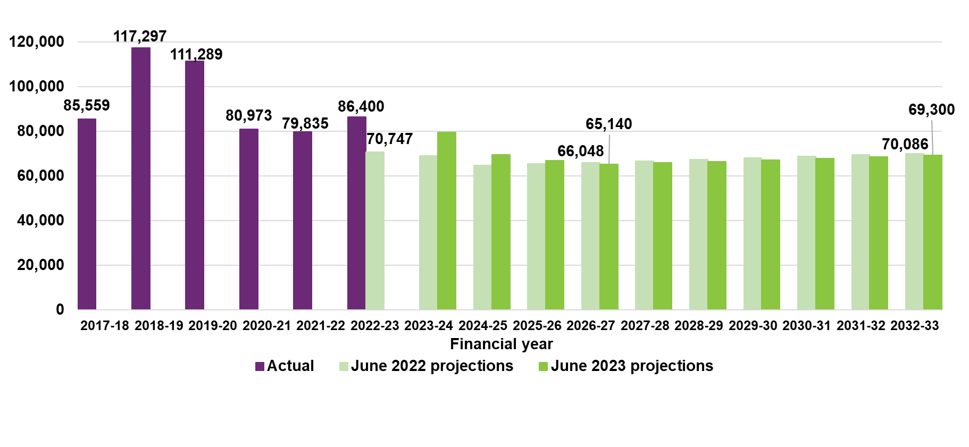
Participants leaving the Scheme
One of the Scheme’s objectives is early investment and intervention which should lead to capacity building and greater social and economic participation where support from the NDIS is no longer required. This is the primary driver for participants leaving the Scheme, with higher rates observed for children leaving the Scheme than adults. The actual overall rate of participants leaving the Scheme of 0.9% in June 2023 projections was lower than the expected rate of 1.6% assumed in the June 2022 projections.
The lower-than-expected number of participants leaving the Scheme since June 2022, reflects a short-term shift in focus of the National Access and Reassessment Branch in 2022-23, with priority given to initial access decisions which limited activity in regard to eligibility reassessments for people in the Scheme. Recruitment of new staff and a recommencement of reassessments in 2023-24 is expected to increase future rates of participants leaving the Scheme. It is assumed that once operational capacity to perform eligibility reassessments has been re-established, rates of participants leaving the Scheme will return to previously observed levels. The assumed rates of participants leaving the Scheme at this review include an allowance for the estimated impact of the Budget initiatives.

Participants with Supported Independent Living
The number of active participants at 30 June 2023 with Supported Independent Living (SIL) arrangements was 31,818, or 12% (3,507) more than expected in the previous review. This reflects a higher-than-expected number of participants transitioning to SIL arrangements in 2022-23, which was influenced by changes in the Agency’s Home and Living (H&L) application process in 2022. Of the total increase in participants with SIL arrangements, over and above expected, 63% are participants aged 45 and above, and 53% have a primary disability of either intellectual disability, other neurological disability, or psychosocial disability.
With the significant increase in the number of participants with SIL arrangements emerging during 2022-23, together with the enhancements made to modelling of participants with SIL arrangements (detailed in Section 5.5), detailed analyses were undertaken to understand:
- The composition of participants transitioning into SIL arrangements (by primary disability type, age, level of function) for the first time, based on actual experience over the past two years.
- The number of participants expected to transition into SIL arrangements, based on the number of Home and Living decisions for SIL eligibility as a leading indicator, and considering the length of time between participants receiving a SIL eligibility decision and accessing SIL supports for the first time (participants new to SIL supports), which on average takes six months (Figure 6).

Figure 6: Home and Living decisions for SIL eligibility, and number of participants new to SIL supports
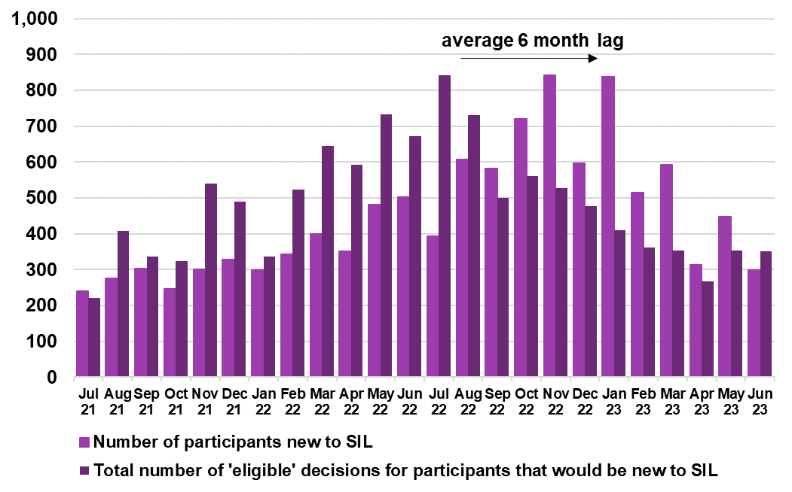Transition rates for participants new to SIL supports were assumed to reduce over the next four years from the current level of 2.2% (of participants aged 15+ not in SIL arrangements) experienced for the twelve months ending 30 June 2023, before reaching a long-term steady rate of transition into SIL of 0.6% for the financial year ending 30 June 2027. This is equivalent to approximately 2,500 participants per annum, transitioning into SIL for the first time from 2026-27 onwards before allowing for any form of leaving the Scheme.
Figure 7 shows the projection of number of participants with SIL arrangements, both before and after factoring in Budget initiatives, compared to the previous review. The projected number of participants with SIL arrangements, reflects a higher number of participants having moved into SIL arrangements in 2022-23, and the expectation of a reduction in the transition rates over the following four years before reaching the long-term level of transitions in financial year 2026-27.

Figure 7: Comparison of number of participants with SIL to previous review, at 30 June

Participant payments experience in 2022-23
From 1 July 2022 to 30 June 2023, $34.7 billion Scheme expenses were made on a cash basis. This was $1.2 billion or 3.4% higher than the 2022-23 estimate of $33.5 billion in the June 2022 projections. Scheme expenses on an accrual basis were $35.1 billion, 3.2% higher than the 2022-23 estimate of $34.0 billion in the June 2022 projections but in line with the December 2022 projections.
Variance in payments over the twelve months ending 30 June 2023, was driven by a higher-than-expected total number of participants in the Scheme, combined with a significant increase in number of participants transitioning into SIL arrangements. Participants with SIL arrangements having a relatively higher need for supports, resulted in increased payments per participant, compared to participants not in SIL arrangements.
Table 7 shows the variance in payments over the twelve months to 30 June 2023, for participants with SIL arrangements and those not in SIL arrangements. The payment variance for participants with SIL arrangements is $1.1 billion, or 10.9% higher than expected.

Table 7: Variance in total Scheme expenses for 2022-23, split for participants in (and not in) SIL arrangements
Participant Cohort | Actual ($m) | Expected  ($m) | Difference ($m) | Difference (%)
Participants with SIL arrangements | 11,481 | 10,350 | 1,131 | 10.9%
Participants not in SIL arrangements | 23,117 | 23,125 | 52 | 0.2%
Total participant expenses | 34,658 | 33,475 | 1,183 | 3.4%

Average payments per participant experience
The average payment per participant, for the twelve months ending 30 June 2023 was $60,700, or 2.0% higher than the projected 2022-23 average payment per participant of $59,600 in the previous review.
Table 8 shows the variance in average payments per participant over the twelve months to 30 June 2023, for participants with SIL arrangements and those not in SIL arrangements. The 2022-23 annual average payment per participant was $12,700, or 3.4% higher than expected for participants with SIL arrangements, and $500 or 1.2% lower than expected for participants not in SIL arrangements.

Table 8: Variance in annual average payments per participant for 2022-23, split for participants in (and not in) SIL arrangements
Participant Cohort | Actual ($) | Expected ($) | Difference ($) | Difference (%)
Participants with SIL arrangements | 387,700 | 375,000 | 12,700 | 3.4%
Participants not in SIL arrangements | 42,700 | 43,200 | -500 | -1.2%
Total annual average payment per participant | 60,700 | 59,600 | 1,100 | 2.0%
Figure 8 shows the actual growth in average payments per participant increased at a rate of 6.0% per annum, on average, over the last three years. The increase in average payments per participant for 2022-23 was higher than in previous years, increasing by 9.9% over the twelve months ending 30 June 2023. Two main factors were identified in explaining this growth, namely: the higher growth in average payments for participants with SIL arrangements (increasing by 15.2% in 2022-23), and the previously anticipated labour supply shortage for attendant care not appearing to have constrained the provision of Scheme supports as expected.

Figure 8: Average annualised payments per participant over time ($)
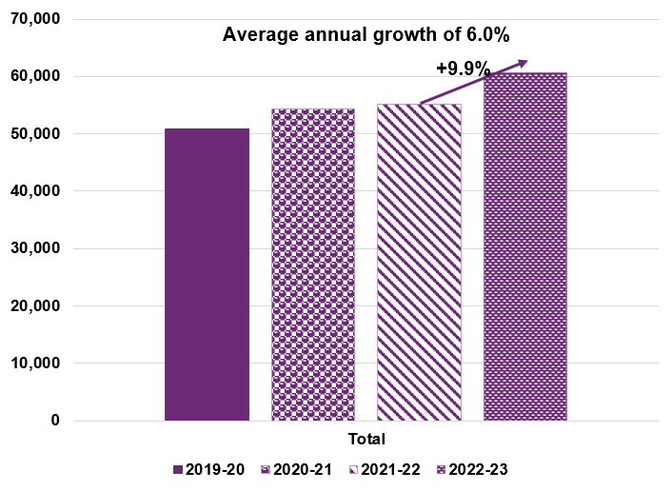
Figure 9 shows the actual growth in average payments per participant increased at a higher rate on average over the last three years, for participants with SIL arrangements (9.8%), compared to those not in SIL arrangements (8.6%). In 2022-23 the increase in average payments was higher, at 15.2% for participants with SIL and 8.1% for participants not in SIL arrangements, compared to 9.9% overall.

Figure 9: Average annualised payments per participant over time by SIL status ($)
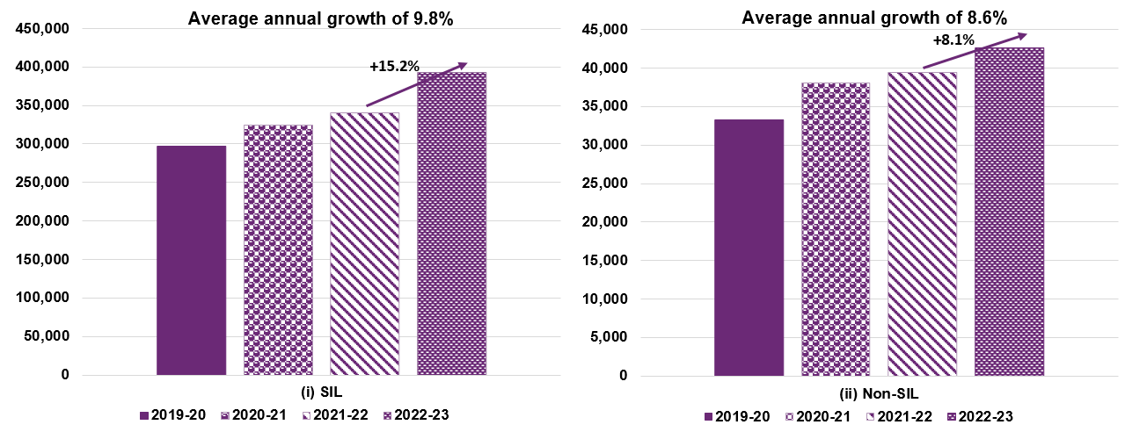

Average payment growth experience
Scheme expenses increase over time with growth in the average payments per participant, both from normal inflationary sources (i.e., general increases in wages and consumer prices) and from additional sources, referred to as additional growth.
Table 9 shows a breakdown of the observed annual growth in average payments per participant from 2019-20 to 2022-23. After allowing for pricing impacts and changes in participant mix, the actual growth in average payments per participant for the year ending 30 June 2023 was 7.4%, an increase of 2.1% compared to 2021-22.

Table 9: Breakdown of past observed growth in average payments per participant
Item of inflation | 2019-20 | 2020-21 | 2021-22 | 2022-23 | 3 Year  Average  2020-23
Observed inflation | 19.6% | 6.9% | 1.6% | 9.9% | 6.0%
less pricing impact | 12.0% | 2.1% | 2.4% | 6.8% | 3.7%
less change in mix | -6.7% | -9.2% | -6.2% | -4.3% | -6.6%
Additional growth | 14.3% | 14.0% | 5.3% | 7.4% | 8.9%
There is some evidence showing additional growth experience of 5.3% in 2021-22 was impacted by labour supply constraints observed in the market for attendant care as well as COVID-19 related factors. Despite continued evidence of shortages of disability support workers in 2022-23, the expected dampening of growth in the provision of Scheme supports and therefore in payments growth has not eventuated as anticipated. The additional growth rate of 7.4% in 2022-23 is higher than the assumed rate for 2022-23 of 3.4% in the June 2022 projections.
Figure 10 sets out a comparable breakdown of the observed growth in average plan budgets, on a rolling 12-month basis from 2020-21 to 2022-23. The observed growth in plan budgets is a leading indicator of the future expected growth in average payments. Growth in average payments is also impacted by changes in the rate at which participants utilise their plan budget.
Total growth in plan budgets per participant for the twelve-month period to 30 June 2023 was 19.4%. This included 6.3% due to pricing changes, 2.7% due to participants transitioning to SIL arrangements, and 1.4% attributable to participants who were in the Scheme for less than a year: these three components being explicitly allowed for in the Scheme projections. The remaining component of additional growth in plan budgets was 9.1% for the 12 months to 30 June 2023. This is significantly higher than the additional growth for the previous two years, 4.0% for 2020-21 and 3.7% for 2021-22 respectively.

Figure 10: Breakdown of past observed growth in plan budgets per participant
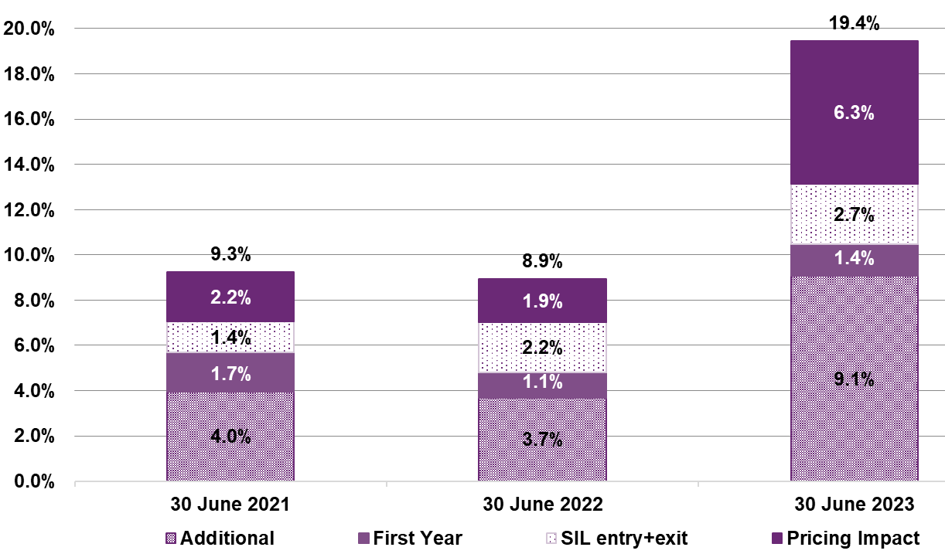

Growth in average payments per participant assumptions
Normal inflation rate assumptions have been selected based on the increases in price limits from the 2022-23 Annual Pricing Review (APR) and on recent economic forecasts about inflationary expectations. The normal inflation assumptions for 2023-24 directly reflect the 2022-23 APR changes including an increase to attendant care supports based on the Fair Work Commission’s (FWC) decisions regarding the National Minimum Wage, and no change to the price limits for therapy supports, plan management and support coordination. For 2024-25 onwards, normal inflation assumptions are based on the most recent forecasts of the Wage Price Index (WPI) for attendant care supports, and the Consumer Price Index (CPI) for therapy supports, consumables and capital items.
Table 10 shows the normal information assumptions used for the 2022-23 Scheme expense projections, compared to those assumed for the previous review. The assumed rate of normal inflation assumed for 2023-24 reflects the 2022-23 change in NDIS price limits which resulted from the FWC decision to increase minimum award wages by 5.75%.

Table 10: Comparison of normal inflation assumptions to previous review
 | 2023-24 | 2024-25 | 2025-26 | 2026-27 | 2032-33
June 2023 projections | 4.4% | 3.2% | 3.9% | 3.5% | 3.5%
June 2022 projections | 2.6% | 3.6% | 3.6% | 3.2% | 3.3%
Difference (%) | 1.8% | -0.4% | 0.3% | 0.3% | 0.3%
Additional growth rate assumptions, before allowance for Budget initiatives, were selected taking account of both the observed increase in additional growth in average payments per participant for 2022-23 of 7.4%, compared to 5.3% for 2021-22 (Table 9), and the significantly higher observed increase in additional growth in plan budgets per participant for 2022-23 of 9.1%, compared to 3.7% for 2021-22 (Figure 10).
Table 11 shows the additional growth rate assumptions, before and after adjusting for Budget initiatives compared to those assumed for the previous review. The change in rates of additional growth assumed reflects:
- A dampening of the expected impact of labour supply constraints (in the short-term).
- A subsequent expectation of a ‘catch-up’ (in the medium-term) on growth in provision of supports and payments.
- The Budget initiatives reducing the additional growth, which would otherwise be expected, by between 1% and 3% p.a. in the short-term.

Table 11: Comparison of additional growth assumptions, to previous review
 | 2023-24 | 2024-25 | 2025-26 | 2026-27 | 2032-33
June 2023 projections (Before Budget initiatives) | 7.0% | 5.8% | 4.0% | 2.0% | 2.0%
June 2023 projections  (After Budget initiatives) | 5.1% | 2.8% | 1.2% | 0.9% | 1.6%
June 2022 projections | 3.0% | 6.0% | 5.0% | 2.0% | 2.0%
Difference (%) | 2.1% | -3.2% | -3.8% | -1.1% | -0.4%
Normal inflation has been combined with additional growth rates to calculate total growth in average payments per participant. Table 12 details the underlying normal and additional growth assumptions assumed for each projection year, after adjusting for the estimated impact of planned for Budget initiatives, with a comparison made to actual experience for the previous three-year period (2020-23). The assumed normal inflation and additional growth rate assumptions, compared with those prior to adjusting for the Budget initiatives are shown in Figure 11.

Table 12: June 2023 projections, total growth assumptions
June 2023 projections | Actual Average  2020-23 | 2023-24 | 2024-25 | 2025-26 | 2026-27 | 2032-33
Normal inflation | 3.7% | 4.4% | 3.2% | 3.9% | 3.5% | 3.5%
Additional growth | 8.9% | 5.1% | 2.8% | 1.2% | 0.9% | 1.6%
Total growth  (excluding change in mix) | 12.6% | 9.6% | 6.1% | 5.1% | 4.4% | 5.1%
Change in mix | -6.6% | -4.1% | -2.4% | -2.0% | -1.2% | -1.3%
Total growth  (including change in mix) | 6.0% | 5.5% | 3.7% | 3.2% | 3.3% | 3.8%

Figure 11: Comparison of June 2023 projections, assumed normal inflation and additional growth, before and after allowance for Budget initiatives
There is considerable uncertainty regarding these future levels of additional growth rate assumptions, and the impact of different scenarios is quantified in Section 6.1.

Risks and uncertainty inherent in Scheme projections
A wide range of factors contribute to the overall Scheme experience in any given year, and can be dependent on participant behaviours, Agency operational processes, current legislation, and policy regarding accessibility to the Scheme. For these reasons and given the relative immaturity, complexity and significant growth in the Scheme, many aspects remain difficult to interpret. As a result, estimation of future expenditure based on experience is inherently challenging and there is significant uncertainty in the projection. Furthermore, at this time the Budget initiatives are subject to co-design and therefore the estimated impacts of the initiatives create additional uncertainty in relation to future Scheme experience. This level of uncertainty increases over the longer term.
As for the previous review, stochastic modelling of Scheme expense projection outcomes has been used to estimate the level of uncertainty, by varying key assumptions. Key risks determined as part of the risk analysis were additional growth, model specification risk the number of new entrants to the Scheme, the numbers of participants transitioning to Supported Independent Living arrangements, and normal inflation.
Figure 12 shows the results of the stochastic simulation of Scheme expenses, with varying confidence intervals. It is noted that these results do not consider the possibility of legislative or major policy interventions by government.
The 90% confidence interval for the range of projected Scheme expense outcomes is:
- $39.0 billion to $45.6 billion, for the year to 30 June 2024, a range of $6.6 billion (16% of the June 2023 projection).
- $176.1 billion to $221.1 billion, for the 4 years to 30 June 2027, a range of $45.0 billion (23% of the June 2023 projection).
- $70.9 billion to $121.5 billion, for the year to 30 June 2033, a range of $50.6 billion (55% of the June 2023 projection).
For a given level of confidence, the range of expected outcomes widens with the duration of the projection, reflecting the increased uncertainty of assumptions and future experience in the longer term.

Figure 12: Ranges of uncertainty in June 2023 projected Scheme expenses ($bn)

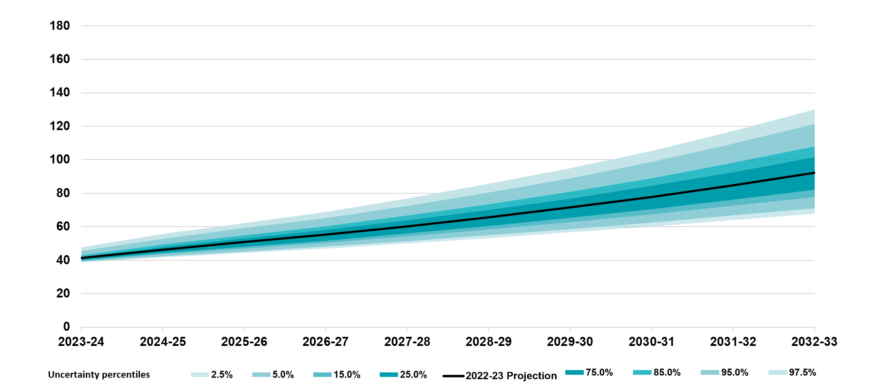 Judgement and materiality regarding main assumptions
Tables 13 and 14 set out the relative level of judgement involved and materiality associated with each of the main assumptions underlying the projection of future Scheme expenses, both in the short-term (four years 2023-24 to 2026-27) and the medium to long term (years 2027-28 and beyond). The level of judgement reflects the extent to which assumptions about future experience of the Scheme are based on evidence and data that is known, or influenced by other factors where there is less certainty. The materiality of the respective assumptions is informed by the scenario analysis results (Section 6.1).
In both the short and medium to long term, a high degree of judgment is involved in setting the additional growth assumptions which are influenced by a number of factors. By contrast, mortality rates which are derived from experience and not impacted by changes to decisions and actions of the Government and Agency involve little judgement. New entrant assumptions are split between children (aged 0 to 14) and older children and adults (aged 15 and above), as different factors influence the respective group of new entrants.

Table 13: Short-term relative level of judgement and impact on Scheme expense projections of main assumptions
Level of Judgement | Materiality: Short Term (2023-27) Low | Materiality: Short Term (2023-27) Medium | Materiality: Short Term (2023-27) High
High |  |  | Additional Growth rates
Medium | New Entrants (0-14)  Leaving and Transition rates | New Entrants (15+)  SIL Transition rates  Future Price Increases
Low | Mortality rates
Whilst the relative level of judgement associated in setting the various assumptions remains consistent over the long-term, compared to the short-term, the level of materiality increases over the long-term. As the Scheme continues to grow from year to year, the cumulative impact on the projected Scheme expenses becomes greater in the medium to long-term (Table 14).

Table 14: Long-term relative level of judgement and impact on Scheme expense projections of main assumptions
Level of Judgement | Materiality: Long Term (2027-28 and beyond) Low |  | Materiality: Long Term (2027-28 and beyond) Medium |  | Materiality: Long Term (2027-28 and beyond) High
High |  |  |  | Additional Growth rates
Medium |  | SIL Transition rates  Future Price Increases  Leaving and Transition rates |  | New Entrants (0 to 14)  New Entrants (15+)
Low | Mortality rates
Additional growth assumptions involve significant judgment, demonstrating a much higher level of variability than all other assumptions, and results in the greatest impact on the projected future Scheme expenses. Whilst more data and information is available to assess new entrant experience, the significant variability in number of new entrants from year to year makes it more challenging to set assumptions with confidence.
The level of judgement and materiality associated with each of the main assumptions, is consistent with the material risks, and variability in these risk factors, included in the Stochastic Model used to assess the uncertainty inherent in the projection of Scheme expenses (Section 6.2).

Operating Expenses
Actual operating expenses in 2022-23 of $1,830 million, or 5.2% of Scheme expenses, were $2 million lower than the estimated actual for 2022-23 of $1,832 million (in the 2023-24 Budget). Additional operating expenses of $732.9 million, over four years starting from 2023-24, are included in the 2023-24 Budget to support participant outcomes and the effective sustainable operation of the Scheme.
Projected operating expenses, assuming fixed real cost per participant, and allowing for the Budget measures, would reduce from 5.2% ($2,156 million) of Scheme expenses in 2023-24 to 4.2% ($2,326 million) in 2026-27. The 2023-24 Budget includes Agency operating costs of $1,680 million in 2024-25, approximately $500 million lower than projected costs in 2024-25 of $2,166 million. The Scheme projections included in this report assume Agency resourcing remains relatively constant in real terms, and if they do not then Scheme expenses would be expected to be higher than those shown in this report.

Outcomes
A holistic assessment of Scheme financial sustainability requires consideration of both the costs of participant funding and the associated benefit the funding provides for participants in enabling them to achieve their desired goals and outcomes.
In the NDIS Corporate Plan 2022-23, Aspiration 1 is “a quality experience and improved outcomes for participants”. Aligned to Aspiration 1 are specific performance metrics, such as the proportion of participants in work and the proportion of participants involved in community and social activities. The NDIA had a target of 26 per cent of working-age participants in paid employment by June 2023, with the achieved result of 23 per cent slightly below this target. For participants aged 15 and over, the percentage of participants actively involved in the community was 42% compared to the 2022-23 target of 46%.
The NDIS Outcomes Framework also measures outcomes for the families and carers of participants, recognising that the outcomes for people with a disability and the people who support them are likely to be closely linked. The percentage of parents/carers of participants in a paid job is 50% meeting the 2022-23 target of 50%.
On the whole, perceptions of the Scheme have been positive, with participants and their families/carers more likely to report that the Scheme had helped them in various areas of their lives the longer the participant was in the Scheme. Participant outcomes and family and carer outcomes are further discussed in Section 7.

Investment Effectiveness Analysis
The Investment Effectiveness Program (IEP) is being undertaken by the NDIA to better understand the link between government-funded supports and the attainment of participant outcomes. A pilot was established during 2022-23 to test analytical approaches, using a single cohort of participants aged 15-24 with intellectual disability (ID) and/or Down syndrome when they joined the NDIS. This cohort was selected following a process of internal consultation and prioritisation.
Initial models from the pilot group have uncovered several positive relationships between certain payment categories and outcomes. Some were obvious, for example more Capacity Building payments for Daily Activity is associated with a better daily living outcome. While others were less so, for example more Core Transport payments are associated with better ‘Home’ outcomes. Further work is ongoing to validate the findings of the analysis.

Introduction
An annual financial sustainability report (AFSR) is required under section 180B of the NDIS Act and provides an assessment of the financial sustainability of the National Disability Insurance Scheme (“the Scheme”, or NDIS).
The AFSR is produced using data at 30 June each year and a summary of each year’s AFSR has been included in the NDIA annual report. This 2022-23 AFSR uses data to 30 June 2023 to project future Scheme expenses and these results are referred to as the “June 2023 projections”.
The previous report was the AFSR released on 7 November 2022 (the “2021-22 AFSR”). It was based on data to 30 June 2022, with commentary about experience to 30 June 2022 (the “previous review”). References to the previous review refer to results contained within that report, referred to as the “June 2022 projections”.

Purpose of the NDIS
The purpose of the NDIS is to provide reasonable and necessary funding to people with a permanent and significant disability allowing them to have choices and control over the supports and services they need to pursue an ordinary life. A key cornerstone underlying the operation of the Scheme is strong insurance principles, where evidence-based decisions on access and planning are made by drawing on objective information on individuals and the longitudinal data that is collected on participants in the Scheme. Experience is closely and regularly monitored to allow emerging risks and issues to be identified and where required, remediation strategies to be implemented.
The Scheme has a lifetime, person-centric approach to its model of support for people with disability, where early investment in core, capacity building and capital supports are anticipated to drive better outcomes for participants and their family/carers over their lifetime.
Since inception, the National Disability Insurance Agency (“the Agency”, or NDIA) has had an increasing focus on improving participant experience. The Participant Service Charter sets out what participants can expect from the NDIA. It is being actioned under the Participant Service Improvement Plan 2022-23 which sets out how the Agency works towards increased consistency and transparency of decision making with better operational procedures, guidelines and controls. The Agency is designing and building a new Information and Communication Technology (ICT) system to provide an enhanced Customer Relationship Management system and improve the end-to-end participant pathway.

Definition of financial sustainability
The NDIS Insurance Principles and Financial Sustainability Manual outlines the insurance model in detail and defines financial sustainability as the state where:
- The Scheme is successful on the balance of objective measures and projections of economic and social participation and independence, and on participants’ views that they are getting enough money to buy enough goods and services to allow them reasonable access to life opportunities - that is, reasonable and necessary support.
- Contributors think the cost is and will continue to be affordable, under control, represents value for money and, therefore, remain willing to contribute.
The current government expectation of Scheme expenses is included in the annual Portfolio Budget Statements (the Budget), noting it is not only the financial cost of the Scheme that is important within the context of financial sustainability, but also the outcomes for participants achieved by the Scheme.
Outcomes for participants and their families/carers are reported regularly in the NDIA’s Quarterly Reports to Disability Ministers, and more detailed analysis and data is available on the NDIA Data and Insights website. Section 7 of this report contains key information relating to outcomes measurement and recent results of the outcomes being achieved by Scheme participants, their families and carers.
The NDIS has operated since 1 July 2013. The first three years of the Scheme were a trial period, and this was followed by the transition period which commenced on 1 July 2016, with the Scheme progressively rolled out across the country over four years. While the Scheme has now operated in all regions of Australia for three years, it is still relatively immature. The numbers of participants entering the Scheme each year have not stabilised, and growth in expenses for participant supports continue to grow at a rate higher than general inflation. Pressures on the financial sustainability of the Scheme remain which is reflected in the upward revision of projected Scheme expenses in previous AFSRs and Budget estimates.

Context for 2022-23 AFSR
Since the previous review, mid-year Scheme projections were undertaken, and are referred to as the “December 2022 projections”. These were used as the basis for the 2023-24 Budget and included allowances for the expected impact of the measures announced to lift the NDIA’s capability, capacity, and systems to better support participants (“Budget measures”). The 2023-24 Budget differs from the December 2022 projections in 2026-27 and later, as the Budget assumes growth in Scheme expenses from 2025-26 to 2026-27 of 8%, moderating thereafter. The NDIS Financial Sustainability Framework, which is outside the scope of the 2022-23 AFSR, was agreed by National Cabinet as part of the 2023-24 Budget to achieve this 8% growth target.
The Budget measures are aimed to support participant outcomes and the effective and sustainable operation of the Scheme, with the NDIA to implement a program of initiatives (“Budget initiatives”) designed to: improve early intervention outcomes for children in the Scheme, improve participant planning processes, and improve consistency in Home and Living eligibility decisions for participants with complex and high support needs. The NDIA is using a co-design approach to develop the initiatives, working closely with participants, the Independent Advisory Council, Disability Representative and Carer Organisations and the disability sector more broadly. The initiatives are expected to drive moderated numbers of participants with developmental delay, greater participant trust in the NDIS supporting them over time, in turn leading to a moderation of future growth in participant plans, and stabilisation of numbers of participants with Supported Independent Living arrangements.
Separately, the 2023 Intergenerational Report (IGR) was published in August 2023, which is based on the 2023-24 Budget projections, allowing for the growth target of 8% in 2026-27, moderating thereafter.
In October 2022, the Minister for the NDIS announced a review of the Scheme (“NDIS Review”) to be conducted by an Independent Review Panel. The scope of the NDIS Review includes the design, operations, and sustainability of the NDIS as well as ways to build a more responsive, supportive, and sustainable market and workforce. The Independent Review Panel provided a final report to the Disability Reform Ministers' Meeting in November 2023. This AFSR, and the projections documented in it, do not allow for the impact of any future changes to the Scheme as a result of the recommendations made by the Independent Review Panel. It is noted changes in legislative and policy settings arising from NDIS Review recommendations are anticipated to lead to further moderation in Scheme growth relative to those shown in this report from 2026-27 onwards, to achieve the target set by National Cabinet which is consistent with the 2023 IGR.

Reliance and limitations
It is the responsibility of the Agency and other parties to ensure recipients of copies of, or extracts from, this document understand the reliances on which any conclusions in this document are based.
Given the long-term nature of the Scheme, experience continues to be relatively immature, and many aspects remain difficult to interpret. Specifically, estimation of future expenditure based on experience is inherently challenging given the relative size, complexity, and immaturity of the Scheme, meaning there is significant uncertainty in the projection. In addition, within emerging experience to date, issues have been identified with the current resource allocation process, and in particular the lack of a mechanism for robust assessments of support need. As the Scheme continues to mature, and staff, operational and governance capabilities improve, there is an expectation the Scheme experience will change, perhaps materially, and this would affect the eventual trajectory of Scheme Expense.
Future events cannot be predicted, and they may lead to unexpected impacts on Scheme experience which differ from the projections in this report. Examples of events with the potential to have a significant impact on future Scheme experience include another pandemic, unexpected changes in global inflationary pressures and changes to economic conditions which cause further workforce shortages in the disability sector.
Lastly, more data on Scheme experience is available in NDIA quarterly reports and on the NDIA Data and Insights website.

Information and data integrity
An integral part of an insurance model is the collection of accurate data in a timely manner. This is because quality data drives the ability of the Agency to monitor emerging experience, perform meaningful analyses, project the financial position of the Scheme and, hence make consistent evidence-based decisions to support Scheme objectives. The success of the Scheme is dependent on the availability and quality of the data and information collected.
The data collected by the Agency is varied and broad-reaching and covers information across each step of the participant pathway, from Scheme access and eligibility to participant plan approval, plan implementation and plan reassessment. Payments for disability supports and the outcomes for participants and their family/carers are also collected regularly to track progress of participants and the Scheme. The information being collected enables the Agency to continually build one of the most comprehensive, longitudinal data sources on disability in the world.

Information and data used for analysis
Table 2.1 summarises the sources of data used for the actuarial analysis underpinning this AFSR, which relies upon the Agency’s case management system, finance system and data warehouse, as well as external sources. The analysis in this report is based on data at 30 June 2023, unless stated otherwise.
The Client Relationship Management (CRM) system provides a substantial amount of participant data, including details about participant plans. This year a new CRM system, PACE, has been piloted in Tasmania since November 2022, with an expected national roll-out by the end of 2023. The transition to the new CRM system for Tasmania participants had no material impact to Scheme experience analyses for the 12 months ending 30 June 2023, or the June 2023 Scheme projections.
Where data is used to conduct actuarial analyses, it is important to acknowledge any limitations associated with the data that could give rise to uncertainty in the results. One particular area relates to participants with Supported Independent Living (SIL) arrangements, where there is no single flag of SIL usage available to accurately identify participants with SIL supports.
A combination of participants’ prior access to SIL supports, and their recent payments experience, is used to estimate numbers of participants with SIL supports. Imperfections exist with this solution, introducing systemic variability in the number of participants with SIL arrangements in a given month, and the analyses used to inform the transition of participants to SIL arrangements. Despite this variability, the numbers of participants with SIL and associated experience analyses, used to inform setting of assumptions for Scheme projections are robust.

Table 2.1: Summary of data utilised for actuarial analysis
Data | Description
Access requests to the NDIS | - Demographic information (age, gender, disability, geographic location, living arrangements and other participant profile information)  - Contact details  - Access request date  - Outcome of request (for example: eligible, ineligible)
Payments to service providers | - Service provider submitting the claim for payment  - Participant for whom the support was provided  - The support item and cost of support provided  - Dates of when the support was provided  - Method of plan management used
Payments to participants | - Participant submitting the claim for payment  - The support category provided  - Total amount spent by support category  - Period of reimbursement
NDIS participant plans | - Plan approval date  - Length of plan  - All plan budgets included in the plan  - Level of function
In-kind supports data | - Unit record in-kind support details from State/Territory programs including details on support type, level and duration of coverage.
Data on outcomes | - Information collected from surveys of participants and their families and carers about how they are doing in different areas of their lives and how they are progressing over their time in the NDIS.
Financial information | - Data from the SAP CRM system was reconciled with financial information in SAP.
ABS Survey of Disability, Ageing and Carers | - Prevalence of disability in Australia, including demographic and socioeconomic profile of people with disabilities.
Economic information | - Government economic forecasts for GDP  - Inflation indicators
Demographic information | - Australian Life Tables 2018-2020 – published in November 2021  - Budget 2023-24: population projections, Australia, 2022-23 to 2033-34 from the Centre for Population Projections  - Population forecasts beyond 2033-34 – 2023 Intergenerational Report  - Estimated Resident Population data up to 30 June 2022 – published by the Australian Bureau of Statistics (ABS), and information on immigration changes from the Department of Home Affairs  - New Zealand residents in Australia projections provided by the Department of Social Services as part of 2023-24 Budget

Information systems overview
The Agency’s Information systems (comprising case management, finance and data warehouse) are important infrastructure in the ongoing financial sustainability of the Scheme.

Case management systems
The Agency uses SAP Customer Relationship Management (CRM) as its case management system. The CRM system was deployed on 1 July 2016 and is hosted and maintained by Services Australia. The primary objective of this delivery was to enable critical operational activities, such as plan approvals and payments.
The Agency has launched a new CRM, PACE, replacing the existing SAP CRM over time. PACE is designed to save time, reduce the number of workarounds and off system processes, and give staff more time for quality interactions with participants. PACE is expected to deliver:
- A high-quality business system is provided, ensuring efficiency and effectiveness.
- Built-in quality and integrity controls incorporated into the system.
- Increased flexibility and capability to implement co-design and consultation outcomes.
- Simpler internal processes to assist the NDIA in supporting participants.
- Platforms and systems to facilitate the collaboration between planners and partners.
- The full implementation of the 2022 amendments to the NDIS Act.
PACE was launched in Tasmania in November of 2022. Improvements have been made to PACE based on the experience of Tasmanian participants, their families and carers, providers, NDIA and Partners in The Community staff.
National expansion of PACE to the rest of Australia is expected to commence before the end of 2023.

Finance systems
SAP Finance is the Agency’s finance system and was introduced on 1 July 2016. All payments to and from the Agency are made using SAP Finance. In line with Services Australia’s practice, the Agency uses the SAP Public Sector Collection and Disbursement (SAP PSCD) system as an intermediary between the SAP CRM and SAP Finance (operated by Services Australia as a shared service). Work is being undertaken to design and implement additions to the Agency’s claims and payment functionalities to include e-invoicing and real-time payments capabilities.

Data warehouse
The strategic Enterprise Data Warehouse (EDW) integrates and presents NDIS Scheme data across Person, Access, Plans, Budget, Claims, Payments and other domains. Data is sourced from operational Business systems and integrated into a single data model. The EDW supports legislated reporting, business operational reporting, analytics services, deep dive analysis, and ad hoc reporting requests.
The main areas of focus for the EDW team over 2023-24 are:
- Maintain integrated data and reporting service through the national transition to the new PACE CRM.
- Continued improvement to data governance systems and processes through the Data Management Committee (DMC).
- Embed the role of the Business Data Owner in the uplift of business data quality management.
- Review of current data architecture design to improve end-user experience and efficiency of the platform.
- Preparation for a move of data and reporting platform to cloud services.

Modelling approach
An experience-based projection model is used to project Scheme participant numbers and Scheme expenses. To reflect the ongoing maturing of the Scheme, the latest developments in Scheme experience, and refinements to operational processes, enhancements to modelling techniques have been undertaken since the previous AFSR.
As with previous AFSRs, the model used to produce the June 2023 projections documented in this 2022-23 AFSR is based on projecting average payments made for supports for 2,052 participant cohorts. The average payments for each cohort are then multiplied by projected participant numbers and summed across all cohorts to arrive at the total Scheme expenses.
Complementing the total payment projections, a separate similar projection model performs a projection of future plan budgets and is used to estimate future utilisation rates which are calculated as the ratio of the Scheme expense to these projected plan budgets.
Assumptions have been set considering factors both internal and external to the Scheme. External factors include broader macroeconomic factors, to the extent they impact the Scheme. Internal factors include trends in past numbers of participants and payments per participant as well as the estimated impacts of the Budget initiatives from 2023-24.
As with any projection, there is uncertainty in the results. This is particularly relevant given the systemic risk arising from the factors mentioned above. As the Scheme continues to mature, the expected trajectory of Scheme experience and projected expenses may change, possibly materially, resulting from the decisions and actions of the Government and Agency and the Australian and global economic climate. Two approaches have been used to illustrate the drivers of uncertainty and the estimated impacts those have on the projection results:
- Testing the sensitivity of projected Scheme expenses to changes in specific key assumptions via construction of a number of scenarios, included in Section 6.1.
- Projecting Scheme expenses using a stochastic model which provides a quantification of the interaction between material risks facing the Scheme and the variability in these risk factors. The approach and results of this model are included in Section 6.2.

Participant numbers
- Annual population projections are calculated by exact age and cohort by adding participant intake to the starting population at 30 June 2023, reducing intake due to mortality and participants leaving the Scheme, and ageing the remaining participants by one year.
- Each cohort is differentiated by age band (summarised into nine groups), primary disability and level of function (57 groups), gender (two groups) and whether a participant is accessing SIL supports (two groups). This leads to 2,052 unique cohorts.
- The number and profile of participants expected to enter the Scheme in each projection year is based on the historic profile of new entrants, split between:
  - New incidence to disability.
  - Previously unmet need for disability supports.
- Prior to the steady intake date of 30 June 2026, some allowance is made for participants with previous unmet need. Beyond the steady intake date, the projected number of new entrants is based on the assumed new incidence to disability rate.
- There is a transition model to explicitly allow for participants who enter the Scheme with developmental delay but are later determined to have autism or an intellectual disability. Some participants with developmental delay will transition to another disability once a diagnosis has been made. These transfers typically happen between the ages of 5 to 8.
There is also a transition model to explicitly allow for participants transitioning into SIL arrangements. This is a revised approach compared with the projection model used for the previous review. It is assumed participants do not leave SIL other than through death, apart from those aged 65 and over as they may leave the Scheme by entering Residential Aged Care. It is also assumed that no participants enter SIL in the first year of entering the Scheme. Although participants with SIL only represent 5% of Scheme participants they are modelled explicitly, as they contribute significantly to Scheme expenses (33% over 2022-23).

Scheme Expenses relating to participant supports
- Payments per participant are estimated by cohort using annualised payment levels for the three months to 30 April 2023 for “active and mature” participants, i.e., participants who were had an approved plan at both 31 January 2023 and 30 April 2023, and had their first plan approved on or prior to 31 January 2022. Allowance is made for monthly seasonality typically observed and payments in May and June 2023 are checked to ensure that they do not vary substantially from those assumed.
- Explicit allowance is made for variance in average payment per participant for future new entrants, relative to the broader Scheme population.
- Expenses are projected on a cash flow basis, representing the estimated rate of outflows from the Scheme (noting in-kind supports are expected to be used evenly throughout a participant’s plan). Scheme expenses are split between 15 different support categories.
- Growth in payments per participant is applied in future years from both normal inflationary sources and sources of additional growth.
- Accrual factors are derived for each of the 15 different support categories to convert the Scheme expenses from a cash basis to an accrual basis.
- The sensitivity of results is tested by varying key assumptions and recalculating the estimated total Scheme expenses. A stochastic projection model also varies assumptions relating to key risks to determine a distribution of total Scheme expenses.

Projected plan budgets
- Projected plan budgets are estimated by cohort using annualised plan budget levels for the month of 30 June 2023 for “active and mature participants”.
- Explicit allowance is made for variance in average plan budgets for future new entrants, relative to the broader Scheme population.
- Projected plan budgets are split between 15 different support categories.
- Growth in plan budgets per participant is added in future years from both normal inflationary sources and sources of additional growth.

Stochastic Model
In addition to the deterministic projections in this report, a stochastic projection model (‘Stochastic Model’) was developed to quantify the level of overall uncertainty inherent in the Scheme projections by allowing for random variation in key risks over time.
The risks underlying the projected expenses of the Scheme are continually monitored and analysed and the Stochastic Model is used as a tool to measure the level of uncertainty relating to Scheme expenses. The Stochastic Model generates 20,000 randomly varied assumptions of the June 2023 projection model relating to the key risks. These simulations were then combined to determine the probability distribution of expected future Scheme expense outcomes.
The methodology underlying the Stochastic Model can be described as follows:
- The accuracy of the Stochastic Model has been enhanced since the previous review, as it no longer uses a condensed set of model points. The projection methodology underlying the Stochastic Model is a replication of the projection methodology in the June 2023 projection model.
- Stochastic variation has then been applied to assumptions related to the key risks. The mean for each key assumption was calibrated to its future expectation in the June 2023 projections. The assumptions have been allowed to vary stochastically around the mean, based on a level of variation for each future projection year, which was set based on a combination of analysis of historical levels of volatility in Scheme experience, comparable historical indices, and actuarial judgement.
- The addition of incremental volatility each year increases the overall uncertainty of Scheme expenses over time.
- The Stochastic Model does not assume any explicit correlation between the stochastically modelled risks, noting any such correlations are likely to be relatively immaterial.
Figure 3.1 on the next page summarises the modelling approach in graphical format.

Figure 3.1: Schematic of modelling approach using the average payment-based model

Scheme experience
This section includes trends in Scheme experience to 30 June 2023. Comparisons of actual experience are made to projections from the previous review relating to key drivers of Scheme expenses including participant numbers, average payment per participant, plan budgets, inflation experience and utilisation rates.

Participant numbers
The Scheme population continues to grow at a rapid rate, considerably more than population growth, with an increase of 14.2% in active participants compared to the Scheme population at 30 June 2022. The increase reflects the net effect of new entrants and participants leaving the Scheme over the past 12 months as shown in Figure 4.1.

Figure 4.1: Active participants in the Scheme over the past 3 years at 30 June
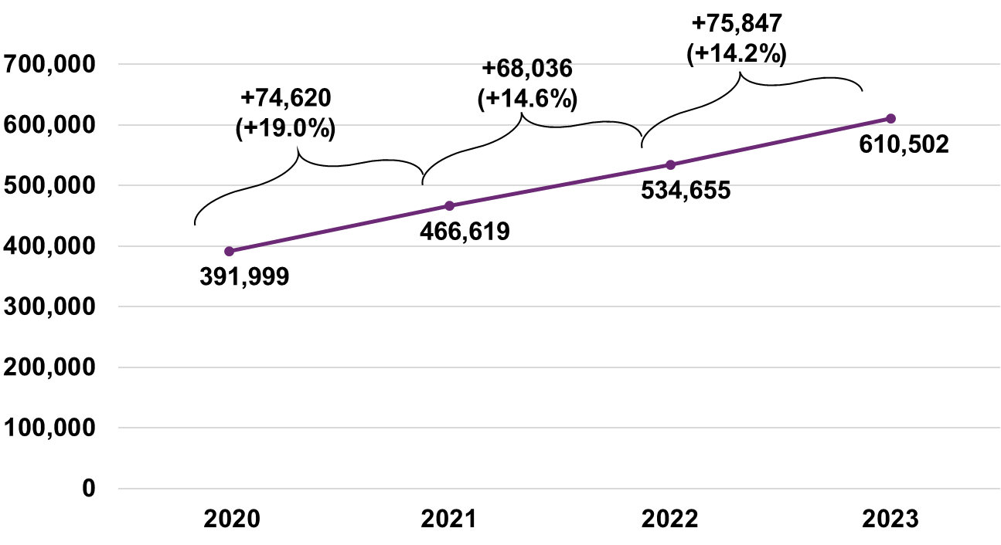

Actual versus expected participant numbers

The net increase in Scheme participants was higher than expected
As shown in Table 4.1 Scheme population of 610,502 active participants as at 30 June 2023 was 18,208 (3.1%) higher than expected from the previous review. The net increase in participants over the 12 months to 30 June 2023 was 75,847 (31.6%) higher than expected.

Table 4.1: Actual versus expected total participant numbers and net increase at 30 June 2023
As at 30 June 2023 | Actual | Expected | Difference | % Difference
Participant Numbers | 610,502 | 592,294 | 18,208 | 3.1%
Net Increase over past 12 months | 75,847 | 57,639 | 18,208 | 31.6%
The comparison of actual net increase in participants to that expected from the previous review is shown in Table 4.2, Table 4.3, Table 4.4 and Table 4.5 by key participant characteristics (participants with SIL and without SIL supports, age group, primary disability group and reported level of function respectively).
Table 4.2 illustrates:
- The net increase of participants with SIL supports was 3,507 greater than expected from the previous review (or 257.8%). The high number of participants with SIL was driven by changes to the Agency’s processes, resulting in a large number of applications for Home and Living supports and resulting increases in the number of eligible SIL decisions. This is further discussed in Section 4.3.
- The net increase of participants without SIL supports was 14,701 (26.1%) greater than expected. This reflects the high number of children that entered with developmental delay in 2022-23 as well as lower than expected numbers of children leaving the Scheme.

Table 4.2: Actual versus expected net increase in participant numbers at 30 June 2023 by SIL status
SIL Status | Actual | Expected | Difference | % Difference
SIL | 4,868 | 1,361 | 3,507 | 257.8%
Non SIL | 70,979 | 56,278 | 14,701 | 26.1%
Total | 75,847 | 57,639 | 18,208 | 31.6%
Table 4.3 compares the net increase in participants over 2022-23 against expectations from the previous review by age group and shows that:
- The net increase in participants was greater than expected across all age groups except for ages 35 to 64.
- The biggest differences were in the cohort aged 0 to 6, where the net increase was 13,321 more than expected (414.9% higher), followed by participants aged 7 to 14 where the net increase was 4,917 more than expected (28.5% higher). This reflects the high intake of children with developmental delay that was observed in 2022-23.

Table 4.3: Actual versus expected net increase in participants in 2022-23 by age group
Age Group | Actual | Expected | Difference | % Difference
0 to 6 | 16,532 | 3,211 | 13,321 | 414.9%
7 to 14 | 22,192 | 17,275 | 4,917 | 28.5%
15 to 18 | 8,859 | 8,486 | 373 | 4.4%
19 to 24 | 5,840 | 5,594 | 246 | 4.4%
25 to 34 | 5,825 | 5,148 | 677 | 13.2%
35 to 44 | 3,768 | 3,801 | -33 | -0.9%
45 to 54 | 3,451 | 3,796 | -345 | -9.1%
55 to 64 | 3,892 | 5,234 | -1,342 | -25.6%
65+ | 5,488 | 5,094 | 394 | 7.7%
Total | 75,847 | 57,639 | 18,208 | 31.6%
Table 4.4 shows the primary disability groups where the net increase in participants differed significantly from that expected in the previous review:
- The largest deviation arose from participants with developmental delay, where there was a net increase of 18,326 more than expected (336.9% higher).
- The net increase in participants with autism was 3,066 greater than expected (10.5% higher).
- The net increase in participants was lower than expected for psychosocial disability by 1,963 (26.5% lower) and for intellectual disability by 1,335 (24.0% lower).

Table 4.4: Actual versus expected net increase in participant numbers in 2022-23 by primary disability
Primary Disability | Actual | Expected | Difference | % Difference
Autism | 32,386 | 29,320 | 3,066 | 10.5%
Developmental Delay | 23,766 | 5,440 | 18,326 | 336.9%
Intellectual Disability | 4,223 | 5,558 | -1,335 | -24.0%
Other Neurological | 1,348 | 1,474 | -126 | -8.5%
Psychosocial Disability | 5,452 | 7,415 | -1,963 | -26.5%
Other | 8,672 | 8,433 | 239 | 2.8%
Total | 75,847 | 57,639 | 18,208 | 31.6%
Table 4.5 shows while the net increases in participants at all reported levels of function were higher than expected, participants with high levels of function accounted for most of the difference. Again, this was largely driven by the high number of participants with developmental delay entering the Scheme in 2022-23.

Table 4.5: Actual versus expected net increase in participants in 2022-23 by reported level of function
Reported Level of Function | Actual | Expected | Difference | % Difference
High | 32,143 | 20,269 | 11,874 | 58.6%
Medium | 32,686 | 30,908 | 1,778 | 5.8%
Low | 10,648 | 6,725 | 3,923 | 58.3%
Missing | 370 | -263 | 633 | -240.7%
Total | 75,847 | 57,639 | 18,208 | 31.6%

Reported levels of function continue to show a deteriorating trend in the first couple of years in the Scheme
Figure 4.2 shows the reported functional distribution for participants who entered the Scheme prior to 30 June 2017.
Over time, the proportion of participants with a high level of function has decreased, and the proportion with lower levels of function has increased. The shift in distribution was most significant in the initial years after participants entered the Scheme. It is likely to reflect inconsistent assessments over time as well as general deterioration in level of function due to ageing for some cohorts. The shift has been associated with increasing Scheme expenses, as participants with lower level of function on average have higher support packages and hence higher average payments.

Figure 4.2: Change in distribution of reported level of function at 30 June from 2017 to 2023
Participants that entered the Scheme after 30 June 2017 also exhibit the same trend. Refer to Appendix D.
The deterioration of level of function is observed in all disability groups, and in most age groups (children or adults). However, the pace and extent of deterioration varies across disabilities.

Scheme participants as a proportion of the general population continue to increase
Participation rate refers to the proportion of the Australian population who are NDIS participants. The rate varies by age and gender, reflecting the prevalence of different disability groups.
Figure 4.3 shows participation rates for all age bands increased since the previous review. Participation rates are high for children and peak around age 5, reflecting the large numbers of children that entered the Scheme with developmental delay. The increase in participation rates for children was also higher than other age bands. Appendix D presents a further breakdown of participation rates by gender.

Figure 4.3: Proportion of Australian population in the Scheme by age
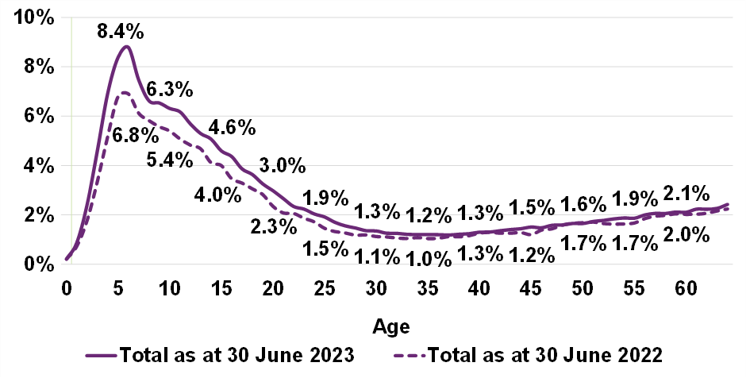The participation rates for mature regions exceed benchmark levels assumed in the original Scheme design. Figure 4.4 presents the participation rate for each phasing cohort by the number of quarters since phasing into the Scheme commenced. The development curves show the proportion of active participants aged from 0 to 64 (compared to the general population) in the Scheme at specific development points in time. Increases over time reflect participants entering the Scheme while reductions reflect participants leaving the Scheme, passing away or turning age 65.
It would originally have been expected that these participation curves would “flatten out” over time. However, the Scheme population in these regions continues to increase above general population growth. Participation rates for ages 0 to 64 continue to rise even in more “mature” geographical areas, with little sign of slowing. As an example, the unbroken dark purple line represents the participation rate of the regions that phased into the Scheme in the September 2013 quarter (i.e., Barwon in Victoria and Hunter in NSW). The lines appear almost parallel with one another, suggesting that the rates are similar across geographies. It is evident even after 39 quarters (almost ten years), there remains an upward trend in participants entering the Scheme.

Figure 4.4: Participants as a proportion of Australian population – aged 0 to 64
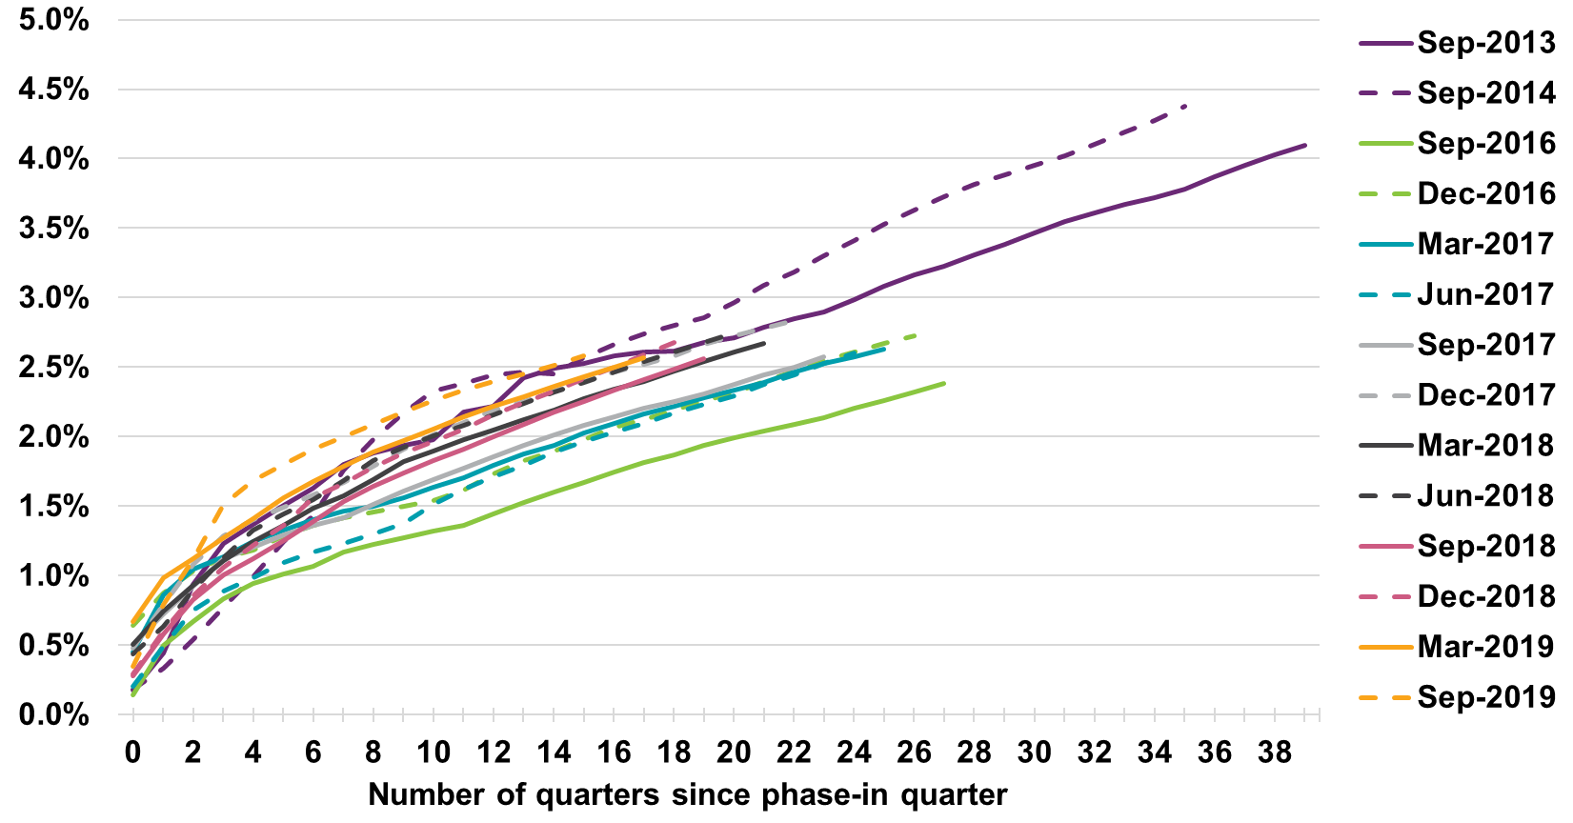Figure 4.5 presents the participation rate for all participants with autism or developmental delay by phase-in quarter. It shows the same trends as Figure 4.4 (i.e., the participation rate curves do not flatten out over time). These curves are steeper than those in Figure 4.4, indicating the participation rate for all participants with autism or developmental delay is increasing faster than that of the Scheme as a whole.

Figure 4.5: Total of participants with autism or developmental delay as a proportion of Australian population – aged 0 to 64
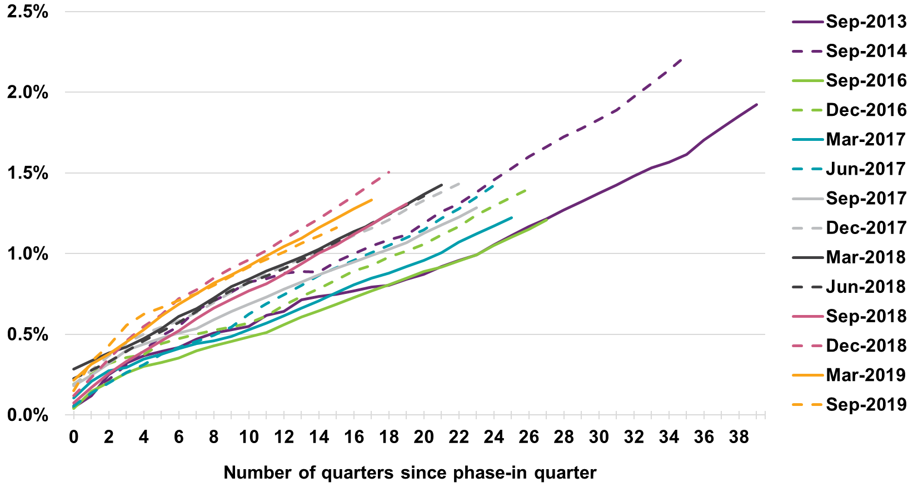
Figure 4.6 presents the equivalent rates for participants with a disability other than autism or developmental delay. The curves are notably steeper in the first twelve quarters, reflecting the rapid increase that occurred during the roll-out of the NDIS and transition of participants from State/Territory and Commonwealth disability programs into the Scheme. The curves subsequently flatten to slopes that are less steep compared with the Scheme as a whole shown in Figure 4.4. The participation rates for participants with a disability other than autism or developmental delay remain higher than expected.

Figure 4.6: Participants with disability other than autism or developmental delay as a proportion of Australian population – aged 0 to 64
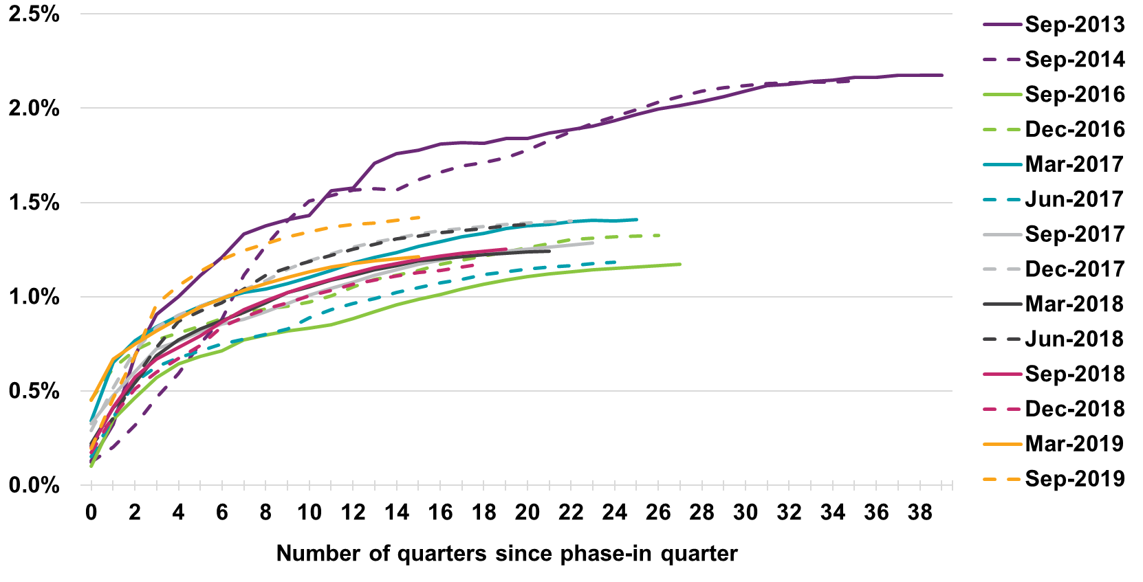

The number of new entrants to the Scheme has increased in 2022-23
The two drivers of growth in participant numbers are the rate of new entrants to the Scheme, and the rate at which participants are leaving the Scheme or passing away.
Figure 4.7 shows the total number of new entrants to the Scheme in the twelve months to 30 June 2023 was 86,400, which is 22% higher than the expected number of 70,747 from the previous review, and 8.2% higher compared to the total number of new entrants of 79,835 in the previous year ended 30 June 2022.

Figure 4.7: Number of new entrants to the Scheme by financial year
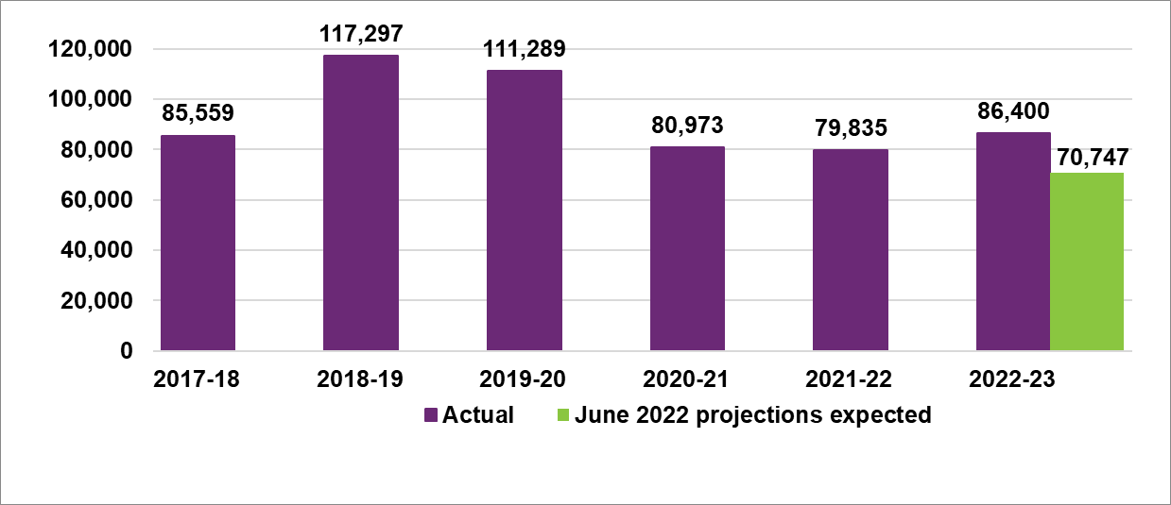
Table 4.6 shows the higher-than-expected number of new entrants in the 2022-23 financial year was driven by: 34,981 new entrants with developmental delay, 13,440 (62%) more than expected.
- 25,351 new entrants with autism, 4,247 (20%) more than expected.
- Lower than expected new entrants with psychosocial disability, intellectual disability, other neurological and the combined other disability types.

Table 4.6: Actual versus expected number of new entrants by primary disability
Disability Group | New Entrants Actual | New Entrants Expected | New Entrants Difference | New Entrants Difference (%)
Autism | 25,351 | 21,104 | 4,247 | 20.1%
Developmental Delay | 34,981 | 21,541 | 13,440 | 62.4%
Intellectual Disability | 4,824 | 5,043 | -219 | -4.3%
Other Neurological | 2,645 | 2,730 | -85 | -3.1%
Psychosocial Disability | 6,730 | 8,397 | -1,667 | -19.8%
Other | 11,869 | 11,932 | -63 | -0.5%
Total | 86,400 | 70,747 | 15,653 | 22.1%
Table 4.7 shows there were 16,227 (40%) more new entrants aged 0 to 14 than expected, and 574 less aged 15 and above, compared to the expected number of new entrants based on the previous review.

Table 4.7: Actual versus expected number of new entrants by age group
Age Group | New Entrants Actual | New Entrants Expected | New Entrants Difference | New Entrants Difference (%)
0 to 14 | 56,661 | 40,434 | 16,227 | 40.1%
15+ | 29,739 | 30,313 | -574 | -1.9%
Total | 86,400 | 70,747 | 15,653 | 22.1%
The number of new entrants with developmental delay or autism accounted for around 70% of all new entrants to the Scheme. This was primarily driven by children aged 0 to 14. Figure 4.8 shows there was a significant increase (20%) in the number of children entering the Scheme in 2022-23 compared to 2021-22.

Figure 4.8: New entrants aged 0 to 14
Several reasons for the high proportions of new entrants with developmental delay were identified including waiting times to obtaining an autism diagnosis for children, increased awareness of developmental delay, lack of capacity within mainstream services to support children with developmental delay and COVID-19 related impacts.
Figure 4.9 shows the number of new entrants with autism aged 15 and over for years ended 30 June. This demonstrates a continuing increase (of around 19% in 2022-23). The continuing increase in new entrants with autism may be due to factors such as greater awareness of autism in older children and adults who may have missed out on a diagnosis as a child, or adults who enter the Scheme with multiple disabilities or health conditions, including autism.

Figure 4.9: New entrants aged 15+ with autism
Figure 4.10 shows the number of new entrants aged 15 and over with disabilities other than autism for years ended 30 June. The graph demonstrates a continuing decline (of -16% in 2022-23) in adult new entrants with disabilities other than autism.

Figure 4.10: New entrants aged 15+ with disabilities other than autism

Recent experience of participants leaving the Scheme was lower than expected
Within the context of financial sustainability, it is important to understand the emerging experience of participants leaving the Scheme. Participants may leave the Scheme for various reasons and are analysed in two categories for projection purposes:
- Mortality: participants who have passed away.
- Participants leaving the Scheme:
  - No longer meet the Scheme’s eligibility criteria.
  - Have chosen to leave the Scheme of their own accord.
  - Have chosen to move into residential aged care if over the age of 65.
A proportion of participants leaving the Scheme was always expected within the original Scheme design, with one of the Scheme’s objectives being early investment and intervention to build capacity and engender greater social and economic participation where support from the NDIS is no longer required.
Figure 4.11 shows the experience of mortality and participants leaving the Scheme compared to expectations from the previous review. Experience of participants leaving the Scheme was well below expected in 2019-20 and 2020-21 due to low numbers of eligibility reassessments following a major review of the eligibility assessment process. There was a resumption of reassessment activities in the first half of 2022, when additional resources were deployed to clear backlogs. This led to the actual rate of participants leaving in 2021-22 increasing to be closer to the expected rate. In the period 2022-23, the rate of participants leaving the Scheme fell due to the Agency prioritising initial access requests and a shortage of staff in the National Assessment and Reassessment Branch. The Agency has undertaken targeted recruitment in early 2023, and it is expected the rate of reassessments and in turn participants leaving the Scheme will increase towards expected levels.
Mortality rates in 2021-22 and 2022-23 were marginally higher than expected in the June 2022 projections at 1.03% and 1.07% respectively, compared to 0.90% expected for the period 2022-23. The increase in Scheme mortality since early 2022 corresponds to trends observed in Australian population mortality, both in terms of “excess mortality” and COVID-19 mortality. However, it is not currently possible to fully identify Scheme mortality due to COVID-19 because cause-of-death information is not currently collected by the Scheme.

Figure 4.11: Actual versus expected – proportion of participants leaving the Scheme
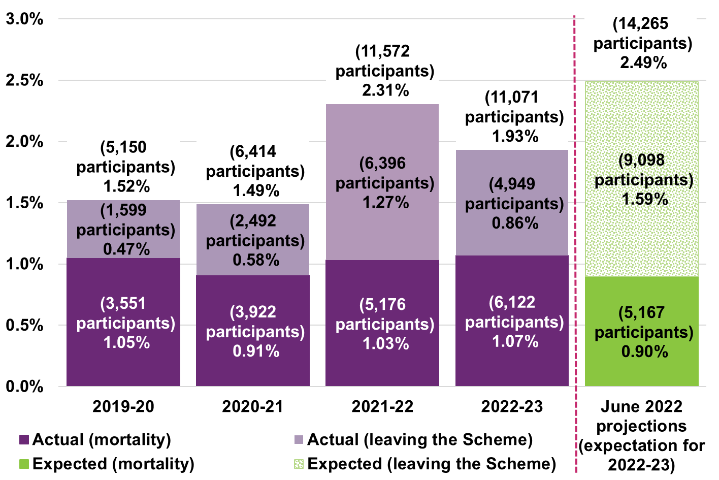

Participants in Supported Independent Living
Separately identifying and modelling participants with SIL supports is important for forecasting Scheme expenses because payments on plans with SIL are higher, averaging over $400,000 per participant. While the proportion of participants with SIL account for 5% of total participants, payments for participants with SIL make up around 33% of total payments. A small change to the expected the number of participants with SIL can have a material impact on the expected future expense of the Scheme.

The net increase in participants with SIL was higher than expected
The number of Scheme participants with SIL increased due to existing participants moving into SIL arrangements, and, to a lesser extent, new entrants requiring SIL supports. The increase in 2022-23 was higher than in 2021-22, as shown in Figure 4.12.

Figure 4.12: Net increase in participants with SIL over the past 4 years,
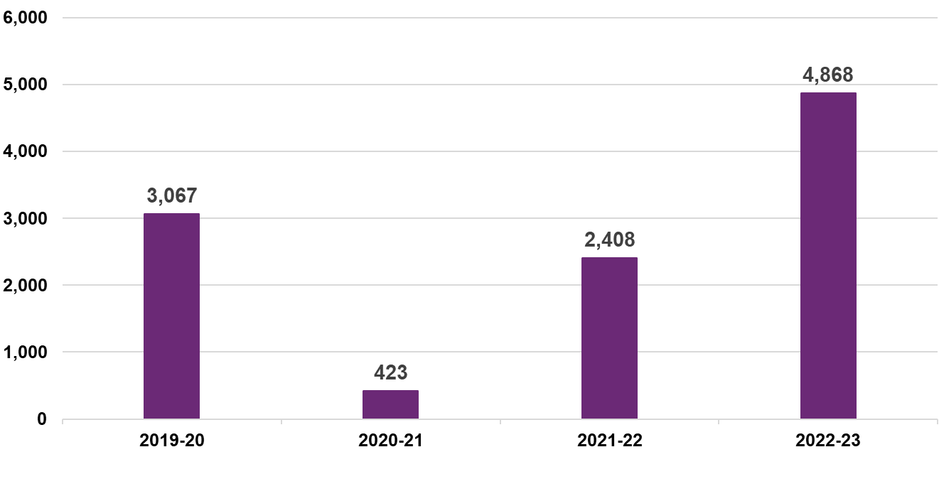
Table 4.8 shows at 30 June 2023 there were 31,818 active participants with SIL supports which was 12% (3,507) higher than expected in the previous review. This reflects a higher number of participants moving into SIL arrangements following changes to the Home and Living application process leading to an increase in the number of eligible SIL decisions.

Table 4.8: Actual versus expected total participant numbers and net increase in SIL
At 30 June 2023 | Actual | Expected | Difference | % Difference
Numbers of Participants with SIL | 31,818 | 28,311 | 3,507 | 12%
Net Increase in SIL | 4,868 | 1,361 | 3,507 | 258%
The higher-than-expected net increase in participants with SIL supports was observed at all ages but was primarily driven by those aged 45 to 64 as shown in Table 4.9

Table 4.9: Actual versus expected net increase in participants with SIL by age group at 30 June 2023
Age Group | Actual | Expected | Difference | % Difference
0 to 18 | 131 | 20 | 111 | 554%
19 to 24 | 432 | 134 | 298 | 221%
25 to 34 | 778 | 283 | 495 | 175%
35 to 44 | 634 | 239 | 395 | 165%
45 to 54 | 613 | 94 | 519 | 551%
55 to 64 | 1,395 | 144 | 1,251 | 868%
65+ | 885 | 446 | 439 | 99%
Total | 4,868 | 1,361 | 3,507 | 258%
The net increase was higher than expected across all main disability types as shown in Table 4.10.

Table 4.10: Actual versus expected net increase in participants with SIL by primary disability at 30 June 2023
Age Group | Actual | Expected | Difference | % Difference
Autism | 657 | 445 | 212 | 48%
Intellectual Disability | 1,066 | 375 | 691 | 184%
Other Neurological | 653 | 12 | 641 | 5509%
Psychosocial Disability | 845 | 296 | 549 | 186%
Other | 1,647 | 234 | 1,413 | 605%
Total | 4,868 | 1,361 | 3,507 | 258%
Overall, the higher-than-expected intake of participants with SIL in the 12 months to 30 June 2023 has increased the proportion of participants in the Scheme with SIL arrangements to 5.2% compared to 5.0% at 30 June 2022. The higher proportion of participants with SIL supports in 2022-23 contributed to higher overall, total Scheme level, average payments per participant.

Growth in SIL has been influenced by changes to the Home and Living application process
The large net increase in participants with SIL supports in 2022-23 was influenced by changes in the Agency’s Home and Living (H&L) application process.
Prior to July 2022 a H&L model was implemented that meant any participant could apply for a home and living decision at any time (not just at plan reassessment). This significantly increased the number of applications from participants seeking SIL supports for the first time. However, due to operational processes, there was often a delay of several months between approval of the H&L decision and implementation of a new participant plan which included SIL arrangements.
After July 2022, the SIL process was changed to require that H&L assessments be linked to a plan reassessment. Improvements to operational process were also introduced, with more rigour being applied to H&L decision making. This impacted decision rates and outcomes.
This is illustrated in Figure 4.13 which shows the monthly number of home and living decisions that were determined ‘eligible’ for participants new to SIL (SIL eligible decisions) as well as the number of participants new to SIL arrangements.
The volume of SIL eligible decisions peaked around July 2022. The number of participants new to SIL supports peaked around January 2023, reflecting a six-month lag between SIL eligibility and first receipt of supports. This lag is driven by a number of factors including the time taken to make appropriate adjustments to the participant’s plan, finding an appropriate SIL provider, delays in SIL providers lodging claims, and the payment made to providers for SIL supports being processed.
The number of home and living decisions on SIL eligibility has trended downwards since July 2022 and was stable in the 5 months to June 2023, indicating a reduction in outstanding decisions.

Figure 4.13: Monthly participants new to SIL supports and Home and Living SIL decisions that were ‘eligible’ over the past 2 years
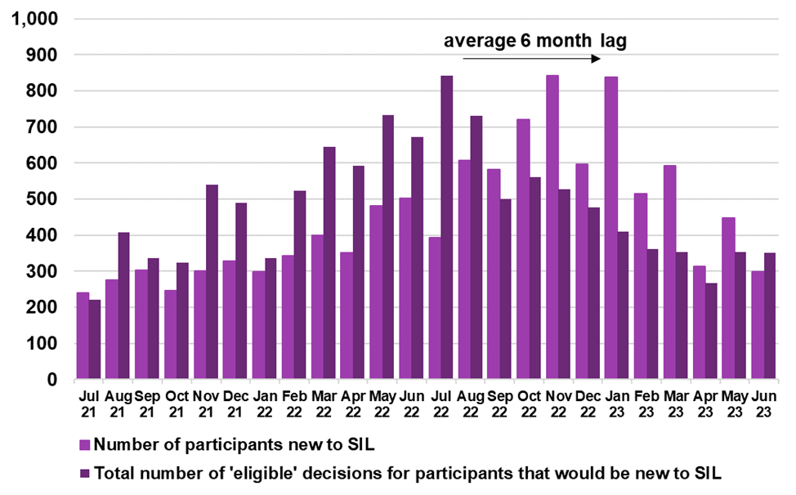

Total Scheme expense

Scheme expenses for the year were higher than expected
From 1 July 2022 to 30 June 2023, $34.7 billion in Scheme expenses were incurred on a cash basis across all participants. This was $1.2 billion or 3.7% higher than the estimate of $33.5 billion in the June 2022 projections. Scheme expenses on an accrual basis were $35.1 billion, 3.2% higher than the estimate of $34.0 billion in the June 2022 projections but in line with the December 2022 projections.
Table 4.11 compares Scheme expense experience in 2022-23 against expectations in the June 2022 projections by SIL status. Scheme expenses related to participants with SIL supports were $1.1 billion (10.9%) higher than expected.

Table 4.11: 2022-23 Scheme expense experience: participants with and without SIL supports ($m)
Scheme Expenses | Actual | Expected | Difference | % Difference
Participants with SIL | 11,481 | 10,350 | 1,131 | 10.9%
Participants without SIL | 23,177 | 23,125 | 52 | 0.2%
Total | 34,724 | 33,475 | 1,248 | 3.7%
Table 4.12 shows a breakdown of Scheme expenses related to participants with SIL by major primary disability groups. Scheme expenses for participants with SIL with a psychosocial disability or other neurological disability were each over $200 million higher than expected accounting for 39% of the total difference to expectations in the previous review. Scheme expenses for participants with SIL supports with autism or intellectual disability were around $100 million higher than expected accounting for a further 19% of the total difference compared to expected.

Table 4.12: Scheme expense experience: participants with SIL, by primary disability ($m)
Primary Disability | Actual | Expected | Difference | % Difference
Autism | 1,496 | 1,403 | 93 | 6.6%
Intellectual Disability | 4,968 | 4,850 | 119 | 2.4%
Other Neurological | 789 | 570 | 220 | 38.6%
Psychosocial Disability | 1,166 | 940 | 226 | 24.0%
Other | 3,061 | 2,587 | 474 | 18.3%
Total | 11,481 | 10,350 | 1,131 | 10.9%
Table 4.13 shows a breakdown of Scheme expenses related to participants without SIL by the main primary disability groups. Scheme expenses for participants with developmental delay were $148 million or 19% more than expected, driven by the high number of children entering the Scheme. Scheme expenses for participants without SIL and with autism were lower than expected, and differences for other disability types were relatively small.
Overall, in aggregate, the total payments for participants without SIL supports was close to expected, for the financial year 2022-23, as reflected in June 2022 projections. This is due to high-cost participants, initially without SIL supports, transitioning into SIL arrangements during the year.

Table 4.13: Scheme expense experience: participants without SIL, by primary disability ($m)
Primary Disability | Actual | Expected | Difference | % Difference
Autism | 5,233 | 5,374 | -141 | -2.6%
Developmental Delay | 907 | 759 | 148 | 19.4%
Intellectual Disability | 4,872 | 4,904 | -31 | -0.6%
Other Neurological | 1,932 | 1,908 | 24 | 1.3%
Psychosocial Disability | 3,088 | 3,000 | 88 | 2.9%
Other | 7,145 | 7,181 | -36 | -0.5%
Total | 23,177 | 23,125 | 52 | 0.2%

Average payments per participant

Average payments experience in 2022-23 was 2% higher than expected
Table 4.14 shows for participants with SIL supports, average payments per participant in 2022-23 were 3.4% higher than the estimate in the June 2022 projections, and 1.2% lower for participants without SIL supports, based on the expected mix of participants without SIL supports in the June 2022 projections. Adjusting for the actual mix of participants without SIL supports, average payments per participant were 1.5% higher than expected on a like for like basis.

Table 4.14: 2022-23 average payments experience: participants with and without SIL supports ($)
Average payment per participant | Actual | Expected | Difference | % Difference
Participants with SIL | 387,700 | 375,000 | 12,700 | 3.4%
Participants without SIL | 42,700 | 43,200 | - 500 | -1.2%
Participants without SIL - Mix adjusted | 42,700 | 42,000 | 700 | 1.5%
Total | 60,700 | 59,600 | 1,100 | 2.0%

Over the past three years, average payments per participant increased at a rate of 6.0% p.a. Figure 4.14 shows that between 2021-22 and 2022-23, average payments per participant increased by 9.9% to $60,700. The higher increase in 2022-23 was driven by the price increase of 9% on attendant care in July 2022, the experience of participants with SIL supports during 2022-23, and high non-price plan growth. It was also likely to have been impacted by a weakening of the constraints on the supply of disability support workers and COVID-19 related impacts which were observed in 2021-22.

Figure 4.14: Trend in average payments experience: all participants ($)
Figure 4.15 shows the trend in average payments experience for the three years 2019-20 to 2022-23. In 2022-23, average payments increased by 15.2% and 8.1% for participants with and without SIL supports respectively. Over the last three years, the average annual growth in payments was 9.8% and 8.6% for participants with and without SIL respectively.

Figure 4.15: Trend in average payments experience: participants with and without SIL supports status ($)

Higher average payment growth was observed at older ages for participants without SIL
Figure 4.16 shows the change in average payments per participant over time by age group for participants without SIL. The average annual increase over the last three years ranged between 4% and 12%. For participants without SIL, average payments per participant have increased at a faster rate for adults (aged over 25), reflecting a material increase in the hours of attendant care supports.

Figure 4.16: Trend in average payments experience: participants without SIL, by age band ($)
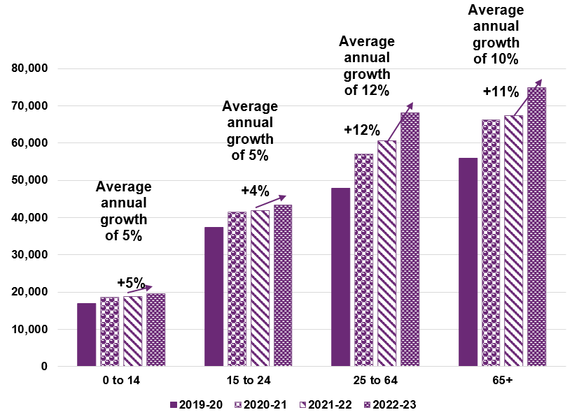

Higher average payment growth was observed in 2022-23 across all age groups for participants with SIL
Figure 4.17 shows the change in average payments per participant over time by age group for participants with SIL. Over the last three years, average payments per participant, for participants with SIL supports increased by at least 10% per annum across all age groups. Growth between 2021-22 and 2022-23 was particularly high, at over 15% across all age groups.

Figure 4.17: Trend in average payments experience: participants with SIL, by age band ($)
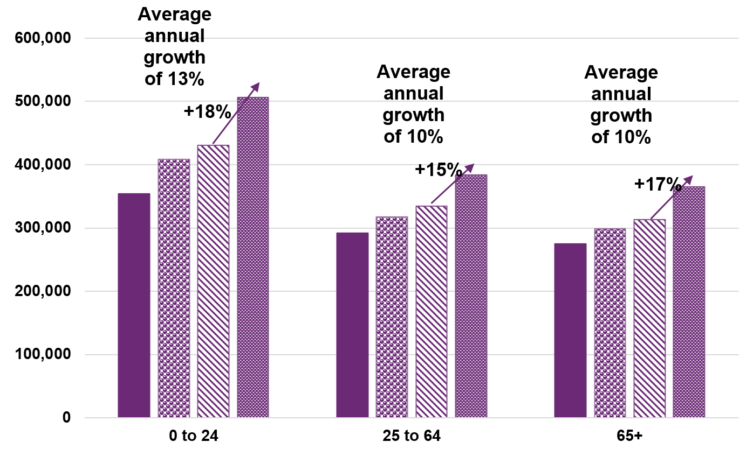

Average payments per participant continue to be lower for recent entrants
Figure 4.18 shows in 2022-23, average payments per participant, for participants without SIL who recently entered the Scheme were approximately 14% lower than the average annualised payments for all participants, on a mix-adjusted basis. This difference in average payments per participant is anticipated as a substantial proportion of new entrants are expected to be younger and with relatively lower average payments. It is a trend that was observed historically, particularly as the Scheme has matured.

Figure 4.18: Mix-adjusted average payments experience: participants without SIL ($)
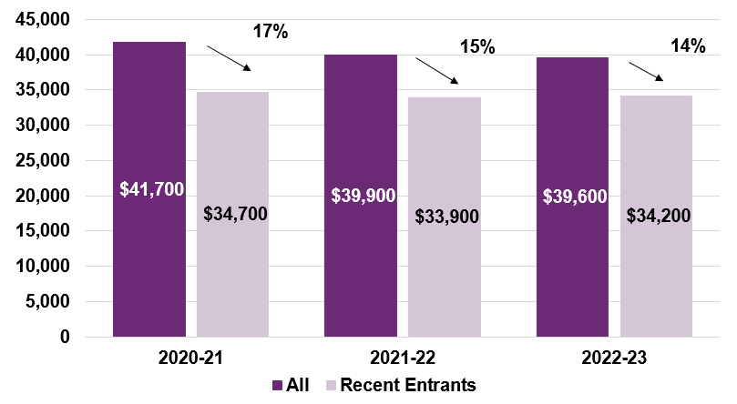

Growth in average payments
Scheme expenses increase over time with growth in average payments and plan budgets per participant, both from normal inflationary sources (such as general increases in wages and consumer prices) and from additional cost pressures, referred to as additional growth.

Growth in average payments per participant was 10% over 2022-23
Table 4.15 shows observed historic growth rates in average payments measured as the annual change in average payments per participant. This is further split into growth from pricing impacts, the impact of changes in mix of participants, and the additional growth above normal inflation.

Table 4.15: Breakdown of growth in payments per participant
Item of growth | 2019-20 | 2020-21 | 2021-22 | 2022-23 | Average
 |  |  |  |  | 2020-23
Observed growth | 19.6% | 6.9% | 1.6% | 9.9% | 6.0%
less pricing impact | 12.0% | 2.1% | 2.4% | 6.8% | 3.7%
less change in mix | -6.7% | -9.2% | -6.2% | -4.3% | -6.6%
Additional growth | 14.3% | 14.0% | 5.3% | 7.4% | 8.9%
The observed growth in average payments was 6.0% per annum over the last three years. This comprises three components:
- Average price changes of 3.7% per annum, i.e., changes to the NDIS price limits, resulting from general price and wage inflation as well as pricing decisions made by the Agency. Increases to wages for disability support workers have been the primary driver of these changes. Increases in prices in 2022-23 of 6.8% were higher than the previous two financial years.
- A reduction due to change in participant mix of 6.6% per annum. In particular, average payments for children are lower compared with adults, so the increasing proportion of children in the Scheme taken in isolation will reduce the average payment per participant.
- Residual additional growth of 8.9% per annum. This arises from various sources, such as deterioration in participants’ level of function, and more varied supports being provided. Significant components include participants receiving more hours of care from disability support workers and greater proportions of hours in higher intensity supports.
- Observed additional growth was 7.4% in 2022-23 and 5.3% in 2021-22. There is some evidence that additional growth in 2021-22 was constrained by the labour supply shortages, as well as COVID-19 related demand factors.
- Despite ongoing low unemployment across the Australian economy as a whole, the higher observed additional growth in 2022-23 may indicates a less material impact of labour supply shortages in 2022-23 compared with 2021-22

Plan budgets

Total annualised plan budgets increased by 24% over 2022-23
Total annualised plan budgets at 30 June 2023 were $45.7 billion, 24% higher than those at 30 June 2022. The overall growth in plan budgets over 2022-23 was higher than in 2021-22 due to higher price increases and more participants transitioning into SIL, and higher residual growth after allowing for these factors.

Figure 4.19: Total annualised plan budgets at 30 June over time
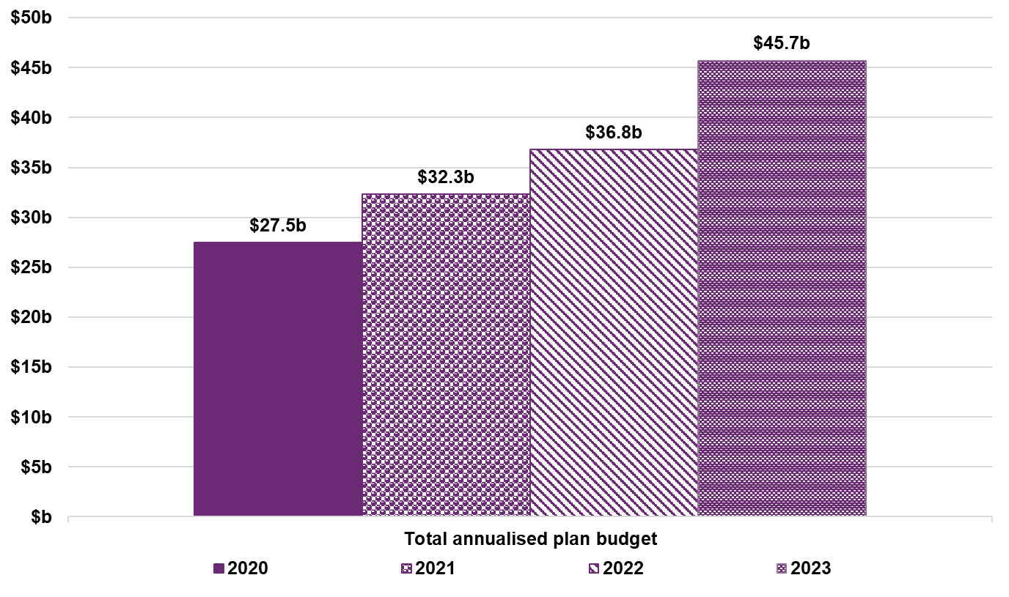

Plan growth was 19% over 2022-23, on a rolling 12-month basis
Additional growth observed in plan budgets is an indicator of future additional growth in average payments, hence it is considered when setting additional growth assumptions. Figure 4.20 shows a breakdown of the observed growth in plan budgets.

Figure 4.20: Plan budget growth for active participants (rolling 12 months)
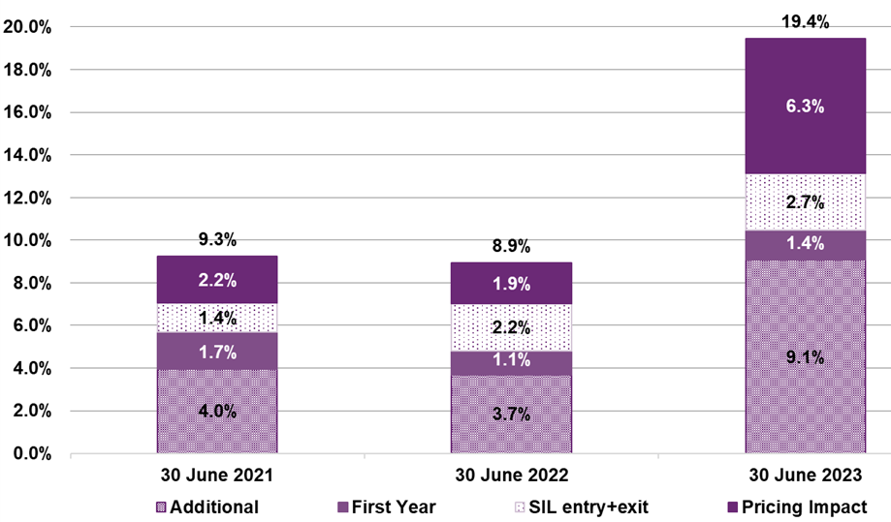
The total plan growth in the 12-month period ending 30 June 2023 was 19.4%, which included:
- 6.3% due to growth from changes to NDIS price limits (‘Pricing impact’).
- 2.7% due to growth in plan budgets from participants transitioning into, or out of, SIL arrangements (‘SIL entry + exit’).
- 1.4% due to growth in participant plans during the first 12 months (‘First Year’).
- 9.1% that is residual growth in participant plans budgets (‘Additional’). This component increased by 5.4% between June 2022 (3.7%) and June 2023 (9.1%).
The first three of these components are allowed for elsewhere in the projection with the residual growth being covered by the additional growth assumption.
Observed growth in annualised plan budgets across all active participants is lower than the plan growth metric because plan budgets for new participants are lower than those for existing participants. This is reflected in the results shown in Figure 4.20.

Average annualised plan budgets increased by 9% in 2022-23
The average annualised plan budgets at the end of the financial year increased in 2022-23 after being relatively stable over previous years as shown in Figure 4.21.

Figure 4.21: Average annualised plan budget at 30 June over time
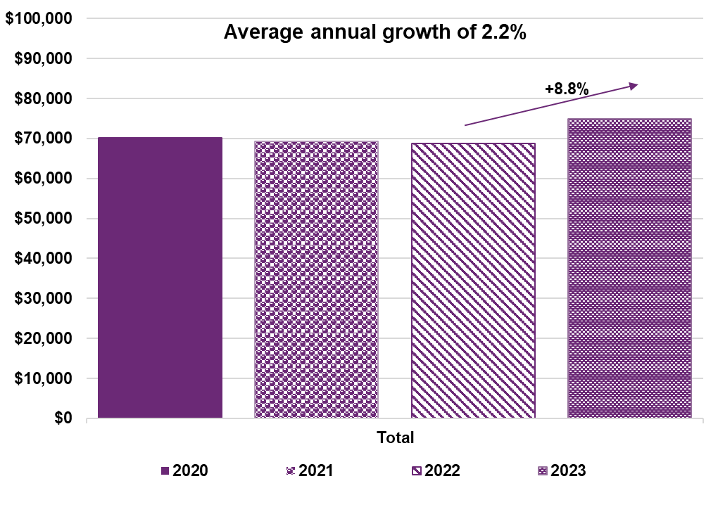Average plan budgets over time have continued to increase for both participants with and without SIL. Over the last three years, the average plan budget for participants with and without SIL have increased by 6.4% and 2.7% per annum respectively (Figure 4.22). This was more pronounced in 2022-23, where the average annualised plan budget increased by 15.9% compared to 1.1% in 2021-22 for participants with SIL, and 5.4% per annum in 2022-23 compared to 0.1% per annum in 2021-22 for participants without SIL.

Figure 4.22: Average annualised plan budgets over time by SIL status at 30 June
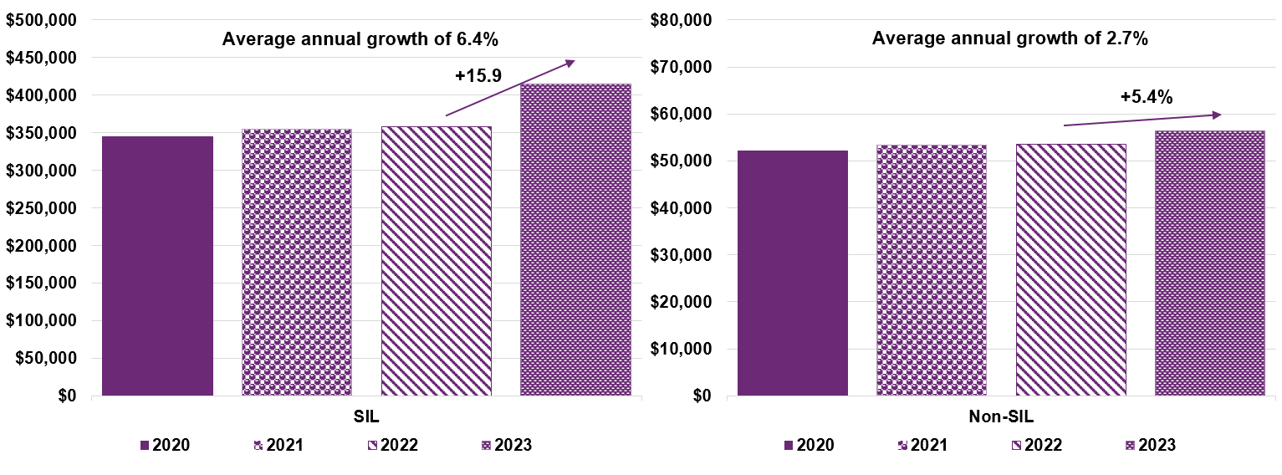

Between June 2020 and June 2023, average annualised plan budgets increased across most age groups (Figure 4.23). Between 2021-22 and 2022-23, average plan budgets for those aged 25 to 64 and 65 and over both increased by 13.2%. Lower growth in recent years for younger age groups was driven by the shift of the profile of participants due to new entrants and is expected to continue.

Figure 4.23: Average annualised plan budgets over time by age band at 30 June
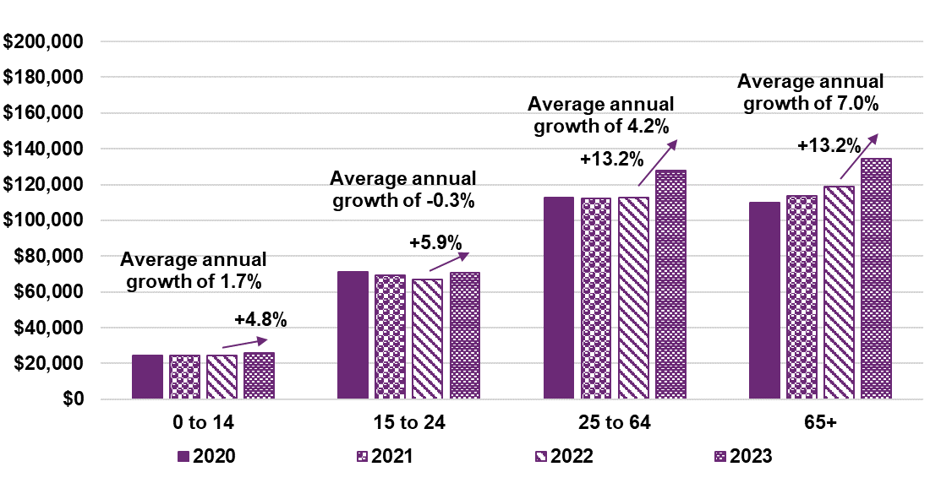
For participants without SIL, those aged 65 and over exhibited the highest growth in plan budgets over time at 5.6% per annum (Figure 4.24).

Figure 4.24: Average annualised plan budget over time for participants without SIL by age band at 30 June
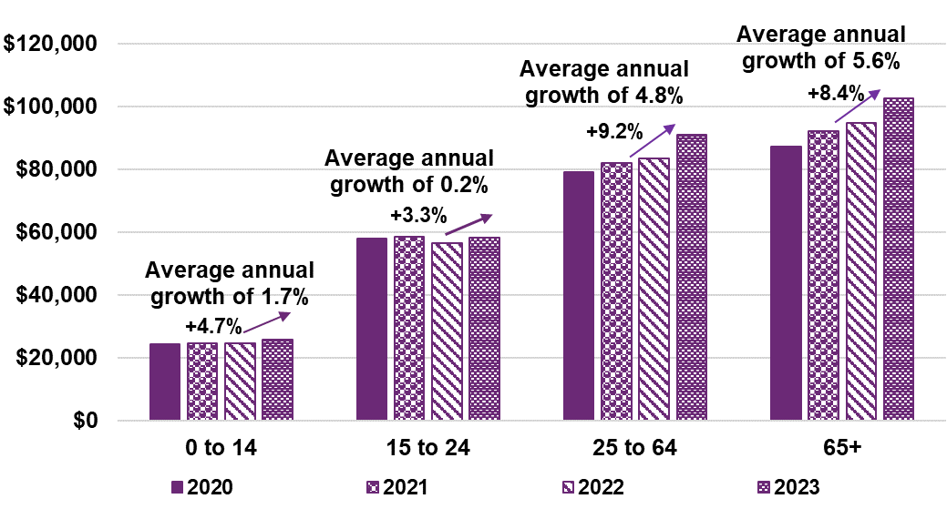

For participants with SIL, all age groups show a similar increase in average plan budget over time of between 6.5% to 6.9% per annum, and a relatively higher increase of at least 14.2% up to 16.7% between 2021-22 and 2022-23 (Figure 4.25).

Figure 4.25: Average annualised plan budget over time for participants with SIL by age band at 30 June
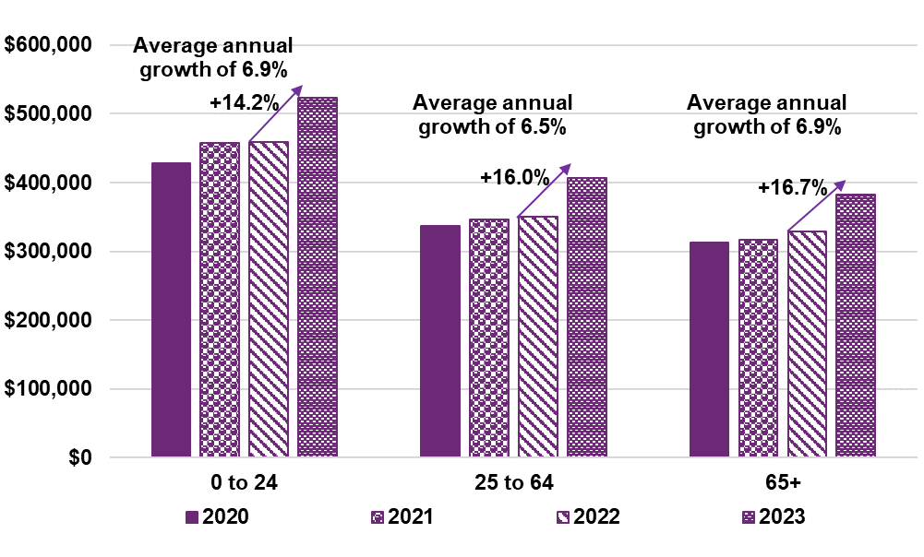

Plan budgets do not show signs of stabilising over a participant’s time in the Scheme
Increases in average plan budgets by duration in the Scheme are shown in Figure 4.26. Increases of around 20% were observed in plan values between first and second plans, increasing by approximately 15% to 16% per plan for participants with three or more plans.

Figure 4.26: Average annualised plan budget for participants over time
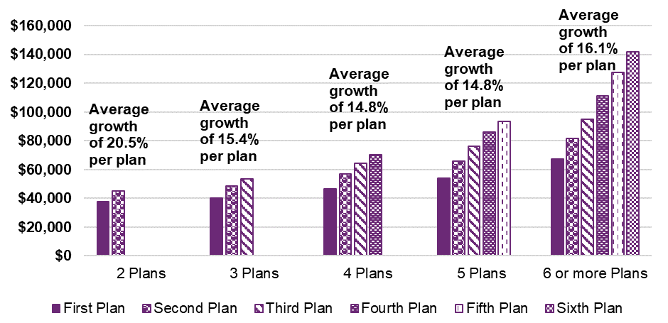

Utilisation
Plan budgets represent the total supports available to participants in their plans. The proportion of budgets resulting in actual payments is referred to as the utilisation rate.

Scheme utilisation was 77% for the 2022-23 financial year
Observed utilisation rates to 2019-20 were about 71%, increasing to 77% in 2022-23. Table4.16 provides an overview of “ultimate” utilisation rates by support year at 30 June 2023.

Table 4.16: Estimated utilisation rate by support year at 30 June 2023
Utilisation component | 2018-19 and prior | 2019-20 | 2020-21 | 2021-22 | 2022-23 | Total
Projected ultimate plan budgets ($m) | 27,150 | 24,358 | 32,282 | 37,014 | 45,955 | 166,759
Payments to date ($m) | 19,168 | 17,316 | 23,502 | 27,883 | 33,182 | 121,051
Estimated future payments ($m) | 0 | 2 | 8 | 63 | 2,209 | 2,282
Projected ultimate payments ($m) | 19,169 | 17,317 | 23,510 | 27,946 | 35,390 | 123,333
Utilisation to date (%) | 70.6% | 71.0% | 72.6% | 75.2% | 74.1% | 73.0%
Projected ultimate utilisation (%) | 70.6% | 71.1% | 72.8% | 75.5% | 77.0% | 74.0%

Utilisation rates increase with the number of plans participants have had since joining the Scheme
Utilisation has consistently increased, the longer participants are in the Scheme, as illustrated in Figure 4.27. Utilisation of plan budgets for participants on their first plan is 57%, compared to 81% for participants on their fifth (or greater) plan. Characteristics such as participants age or disability and increasing need for supports, could drive increasing utilisation over time. The effects of these factors are variously implied in each plan group (referred to as ’number of plans’ in Figure 4.27). This expected increase in plan utilisation, from these sources, is implicitly reflected in the allowance for additional growth when projecting future payments.

Figure 4.27: Utilisation of plan budgets by plan number from 1 October 2022 to 31 March 2023 based on data at 30 June 2023
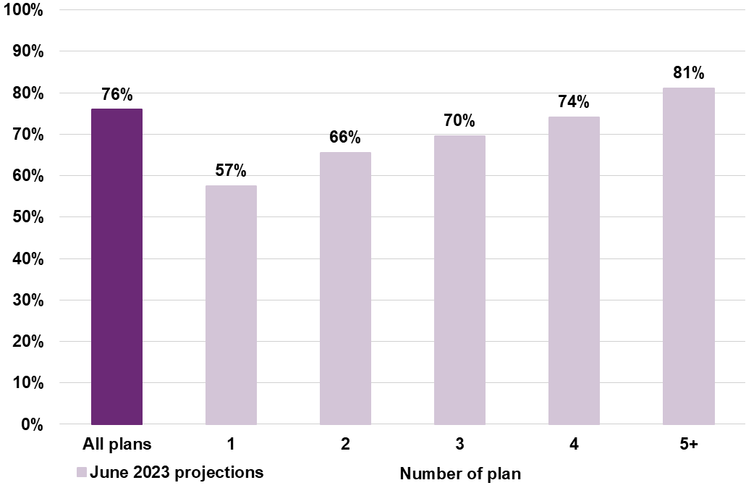

Utilisation rates by participants with/without SIL supports
Figure 4.28 shows participants with SIL are associated with higher levels of utilisation compared with participants without SIL supports.

Figure 4.28: Utilisation of plan budgets by participants with/without SIL supports from 1 October 2022 to 31 March 2023 based on data at 30 June 2023
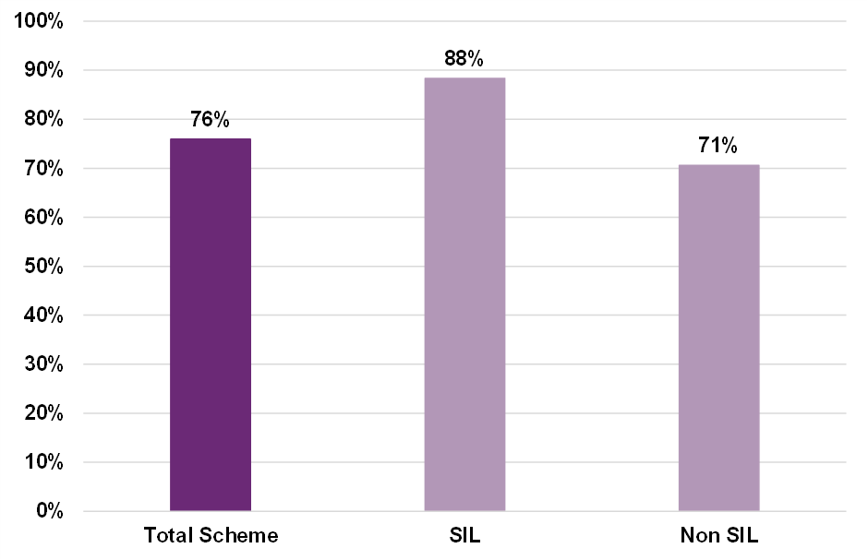

Projections
This section includes the projection of Scheme expense from 2022-23 to 2032-33. The methodology for the projection is included in Section 3. As outlined in Section 4 of this report, actual participant expense experience in 2022-23 was greater than the projections undertaken at the previous review. This was driven by higher-than-expected number of participants transitioning to SIL arrangements, high plan growth across the Scheme and greater new entrants than expected.

Total Scheme expense projections
Combining participant number projections with average payment assumptions result in total Scheme experience projections for each financial year on a cash basis. An allowance for support provided prior to 30 June 2023 but not yet paid adjusts the projected expenses from a cash basis to an accrual basis.

Participant number projections
Table 5.1 shows that the Scheme is projected to have a population of over 792,000 participants at 30 June 2027 of whom about 744,000 are expected to be aged 0 to 64. This is equivalent to a participation rate of 3.2% of the Australian general population aged 0 to 64.

Table 5.1: June 2023 projection of participant numbers at 30 June
Participant numbers | 2023 | 2024 | 2025 | 2026 | 2027 | 2033
0-64 years | 583,018 | 636,138 | 676,947 | 710,982 | 744,040 | 957,976
65+ years | 27,484 | 32,768 | 37,858 | 43,040 | 48,159 | 72,361
Total | 610,502 | 668,907 | 714,805 | 754,022 | 792,200 | 1,030,337
Participation rate (0-64) | 2.66% | 2.86% | 3.01% | 3.12% | 3.23% | 3.91%
Table 5.2 and Table 5.3 show the split in the projection between existing participants and future participants (i.e., new entrants post 30 June 2023). At 30 June 2033, 45% of projected participants are estimated to be current Scheme participants, with 55% being future new entrants to the Scheme.

Table 5.2: Split of participant numbers between existing and future participants at 30 June
Participant Numbers | 2023 | 2024 | 2025 | 2026 | 2027 | 2033
Existing Scheme participants | 610,502 | 589,498 | 567,783 | 546,505 | 529,269 | 462,068
Future participants | 0 | 79,408 | 147,022 | 207,517 | 262,930 | 568,269
Total | 610,502 | 668,907 | 714,805 | 754,022 | 792,200 | 1,030,337

Table 5.3: Proportional split of participants between existing and future participants 30 June
Participant numbers | 2023 | 2024 | 2025 | 2026 | 2027 | 2033
Existing Scheme participants | 100% | 88% | 79% | 72% | 67% | 45%
Future participants | 0% | 12% | 21% | 28% | 33% | 55%
Total | 100% | 100% | 100% | 100% | 100% | 100%

Scheme expense projection
Table 5.4 shows the June 2023 projection of Scheme expenses, incorporating revisions to assumptions and changes in future expectations since the June 2022 projections. It also allows for the expected impact of the measures announced in the 2023-24 Budget to lift the NDIA’s capability, capacity, and systems to better support participants (“Budget measures”). The projected total Scheme expenses on an accrual basis are $41.4 billion in 2023-24, increasing to $92.3 billion in 2032-33. Total projected Scheme expenses are $193.7 billion for the four years to 30 June 2027.
It is important to recognise that the projected Scheme expenses are shown in nominal terms, i.e., that future dollars of estimated Scheme expenses include the effects of inflation over time. This impact of inflation increases over the longer term and so is particularly significant for the result in 2032-33. Scheme expenses are estimated to be 1.6% of GDP in 2023-24, increasing to 2.3% in 2032-33. In considering longer-term projections it is recommended that users refer to expenses as a percentage of GDP rather than nominal dollar figures as these provide a more meaningful measure of Scheme expenses.

Table 5.4: June 2023 projection of Scheme expenses
Scheme Expenses ($m) | 2023-24 | 2024-25 | 2025-26 | 2026-27 | 2032-33 | Total 2023-27
Scheme Expenses (cash basis) (0-64) | 37,229 | 41,228 | 44,645 | 48,026 | 77,991 | 171,128
Scheme Expenses (cash basis) (65+) | 3,685 | 4,647 | 5,594 | 6,583 | 13,331 | 20,510
Total Scheme Expenses (cash basis) | 40,914 | 45,875 | 50,239 | 54,609 | 91,322 | 191,638
Scheme Expenses (accrual basis) (0-64) | 37,635 | 41,678 | 45,133 | 48,553 | 78,865 | 172,999
Scheme Expenses (accrual basis) (65+) | 3,725 | 4,698 | 5,655 | 6,655 | 13,476 | 20,732
Total Scheme Expenses (accrual basis) | 41,360 | 46,376 | 50,788 | 55,207 | 92,341 | 193,731
Total Scheme Expenses  (% of GDP) | 1.61% | 1.76% | 1.83% | 1.89% | 2.33% | 1.77%
Total Scheme Expenses (accrual basis) today's dollars | 41,103 | 45,238 | 47,686 | 49,249 | 60,701 | 183,276
Table 5.5 shows projected Scheme expenses on an accrual basis, split between existing Scheme participants and participants expected to join the Scheme after 30 June 2023. By 2032-33, 70% of projected expenses relate to current Scheme participants, with 30% relating to new entrants.

Table 5.5: Split of Scheme expenses by existing and new participants
Scheme expenses ($m) (accrual basis) | 2023-24 | 2024-25 | 2025-26 | 2026-27 | 2032-33
Existing Scheme participants | 40,597 | 43,635 | 45,638 | 47,596 | 64,168
Future participants | 763 | 2,741 | 5,150 | 7,611 | 28,173
Total Participant Costs | 41,360 | 46,376 | 50,788 | 55,207 | 92,341
Scheme Expenses (%)  (accrual basis) | 2023-24 | 2024-25 | 2025-26 | 2026-27 | 2032-33
%Existing Scheme participants | 98.2% | 94.1% | 89.9% | 86.2% | 69.5%
%Future participants | 1.8% | 5.9% | 10.1% | 13.8% | 30.5%

Comparison with previous AFSR
Table 5.6 shows projected Scheme expenses are approximately $5.6 billion higher in the four years to June 2027 and about $4.6 billion lower in 2032-33, compared to the previous review. They are $3.1 billion higher in the four years to June 2027 and $1.8 billion lower in 2032-33, compared to the December 2022 projections.

Table 5.6: Comparison of June 2023 projections with previous projections
Scheme Expenses ($m) | 2023-24 | 2024-25 | 2025-26 | 2026-27 | 2032-33 | Total  2023-27
June 2023 projections (a) | 41,360 | 46,376 | 50,788 | 55,207 | 92,341 | 193,731
December 2022 projections (b) | 39,977 | 45,315 | 50,348 | 55,007 | 94,172 | 190,648
June 2022 projections (c) | 38,133 | 44,116 | 50,344 | 55,510 | 96,966 | 188,103
Difference ($) (a – b) | 1,383 | 1,060 | 440 | 200 | -1,831 | 3,083
Difference (%) (a/b -1) | 3% | 2% | 1% | 0% | -2% | 2%
Difference ($) (a – c) | 3,227 | 2,260 | 444 | -303 | -4,625 | 5,628
Difference (%) (a/c -1) | 8% | 5% | 1% | -1% | -5% | 3%
The changes that have resulted in this movement from the June 2022 projections are presented in Table 5.7.
The June 2023 projections included updates to account for forces external to the Scheme. Over the four-year period to 30 June 2027, this included a $0.4 billion increase to allow for the impact of changes to immigration policy, and a $2.3 billion increase from changes to pricing and normal inflation.
Updates for the most recent Scheme experience, for the 12 months to 30 June 2023, resulted in a further $2.4 billion increase to projected Scheme expenses over the four-year period. This includes:
- a $0.9 billion increase due to higher-than-expected numbers of participants and a different mix of participants compared with expected. Participant projections are shown in Section 5.4.
- a $1.5 billion increase due to higher-than-expected average payments per participant in 2022-23, and hence a higher starting point for the projection. This is driven by plan growth which exceeded expectations, and the previously estimated labour supply shortage for attendant care not having constrained the provision of Scheme supports as expected.

- Changes to assumptions accounted for the remaining $0.6 billion, comprising:
- A $4.8 billion reduction due to changes in assumptions about future additional growth in average payments per participant, above normal inflationary sources. This significant reduction is anticipated to arise over the four years, resulting from Budget initiatives.
- A $5.9 billion increase due to an increase in the estimated future number of participants transitioning into SIL arrangements, noting they have relatively higher average payments per participant compared to participants not in SIL arrangements. This reflects higher assumptions about future expected number of participants transitioning into SIL arrangements than in the June 2022 projections (refer to Section 5.5).
- a $1.0 billion increase due to higher new entrant assumptions in the short-term for developmental delay and autism, dampened by a revision downwards of long-term rates of new entrants for older children and adults aged 15 and above with disabilities other than developmental delay and autism.

Table 5.7: Movements in projected Scheme expenses since previous review
Projected Scheme Expenses ($m) | 2023-24 | 2024-25 | 2025-26 | 2026-27 | 2032-33 | Total 2023-27
June 2022 projections | 38,133 | 44,116 | 50,344 | 55,510 | 96,966 | 188,103
Immigration changes | 15 | 69 | 147 | 212 | 618 | 445
Pricing and normal inflation | 607 | 394 | 542 | 709 | 2,530 | 2,251
Projections updated for external factors | 38,755 | 44,579 | 51,033 | 56,431 | 100,113 | 190,799
Updates for experience and assumption changes
Total: experience | 696 | 526 | 574 | 571 | 721 | 2,368
- Participant population at June 2023 | 387 | 162 | 172 | 179 | 450 | 898
- Average payments per participant at June 2023 | 310 | 364 | 403 | 392 | 271 | 1,469
Total: assumption changes | 1,908 | 1,270 | -819 | -1,795 | -8,494 | 565
- Additional growth | 950 | -221 | -2,374 | -3,183 | -6,124 | -4,827
- Transitions into SIL | 814 | 1,429 | 1,705 | 1,904 | 1,917 | 5,852
- New entrants | 217 | 300 | 289 | 148 | -1,619 | 955
- Other | -73 | -239 | -439 | -664 | -2,668 | -1,415
Total movement for experience and assumptions changes | 2,605 | 1,797 | -245 | -1,224 | -7,773 | 2,932
June 2023 projections | 41,360 | 46,376 | 50,788 | 55,207 | 92,341 | 193,731

Table 5.8 shows the movement in Scheme expenses on an accrual basis since the previous review, compared with the December 2022 projections.

Table 5.8: Movement in projected Scheme expenses compared with December 2022 projections
Scheme expenses ($m) (accrual basis) | 2023-24 | 2024-25 | 2025-26 | 2026-27 | 2032-33 | Total  2023-27
June 2022 projections | 38,133 | 44,116 | 50,344 | 55,510 | 96,966 | 188,103
Impact of Immigration | 15 | 69 | 147 | 212 | 618 | 445
Impact of price changes and normal inflation | -176 | -208 | -239 | -263 | -428 | -885
Other experience and assumption changes | 2,004 | 1,338 | 95 | -452 | -2,983 | 2,986
December 2022 projections | 39,977 | 45,315 | 50,348 | 55,007 | 94,172 | 190,648
Impact of price changes and normal inflation | 783 | 601 | 781 | 972 | 2,958 | 3,137
Other updates for experience and assumption changes | 600 | 459 | -340 | -772 | -4,789 | -53
June 2023 projections | 41,360 | 46,376 | 50,788 | 55,207 | 92,341 | 193,731

Plan Budget projections
The combination of projected numbers of participants and average plan budget assumptions gives the total expected plan budgets across the Scheme for each financial year. This is similar to the process used to project Scheme expenses using average payment assumptions. The utilisation rate is the proportion of the plan budget which is spent on supports and is calculated by dividing the expected participant expense (on an accrual basis) by the projected plan budget.
Average annualised plan budgets were selected for each participant cohort and support category based on recent experience as of June 2023, with assumptions applied to allow for future normal inflation and additional growth. As is the case for projected average payments and Scheme expenses, the changing mix of participants will affect the rate at which average and total plan budgets grow over time.

Scheme plan budget projections
Table 5.9 shows the total projected plan budgets, including the proportion of plan budgets estimated to be for participants with SIL supports and for those without SIL supports. Scheme-level plan budgets are expected to grow by 15.7% from $46.0 billion in 2022-23 to $53.2 billion in 2023-24. Approximately 30% of expected total plan budgets in 2023-24 relate to participants with SIL supports while 70% relate to participants without SIL supports. By 2026-27, Scheme annual plan budgets are projected to be about $70.1 billion, with an implied annual rate of growth of between 8% and 9% in the medium term.

Table 5.9: Total plan budget projection and proportions by participants with SIL
 | 2022-23 | 2023-24 | 2024-25 | 2025-26 | 2026-27 | 2032-33
Plan Budgets ($m) | 45,955 | 53,183 | 59,253 | 64,623 | 70,067 | 116,587
Implied Growth (%) |  | 15.7% | 11.4% | 9.1% | 8.4% | 8.9%
Proportion with SIL |  | 29.8% | 31.0% | 31.6% | 31.7% | 31.2%
Proportion without SIL |  | 70.2% | 69.0% | 68.4% | 68.3% | 68.8%
Table 5.10 shows projected Scheme plan budgets, split between existing Scheme participants and participants expected to join the Scheme after 30 June 2023. By 2032-33, 67.4% of projected expenses relate to current Scheme participants, with 32.6% relating to future new entrants.

Table 5.10: Split of projected Scheme plan budgets by existing and new participants
Scheme plan budgets ($m) | 2023-24 | 2024-25 | 2025-26 | 2026-27 | 2032-33
Existing Scheme participants | 51,855 | 54,927 | 57,028 | 59,169 | 78,627
Future participants | 1,328 | 4,327 | 7,595 | 10,899 | 37,960
Total Scheme plan budgets | 53,183 | 59,253 | 64,623 | 70,067 | 116,587
Scheme plan budgets (%) | 2023-24 | 2024-25 | 2025-26 | 2026-27 | 2032-33
Existing Scheme participants | 97.5% | 92.7% | 88.2% | 84.4% | 67.4%
Future participants | 2.5% | 7.3% | 11.8% | 15.6% | 32.6%
Total Scheme plan budgets | 100% | 100% | 100% | 100% | 100%

Average plan budget assumptions
Table 5.11 shows that the projected average annualised plan budget is expected to increase by 4.2% from about $79,800 in 2022-23 to $83,100 in 2023-24. This is driven by price limit changes from the 2022-23 Annual Pricing Review and additional growth due to increased use of supports over time. It is partially offset by the changing mix of participants, as the increasing proportion of participants in the Scheme who are children and/or have a high level of function has the effect of lowering the average plan budget over time. By 2026-27, the average plan budget is projected to be $90,600.

Table 5.11: Projected average plan budgets
 | 2022-23 | 2023-24 | 2024-25 | 2025-26 | 2026-27 | 2032-33
Average plan budgets ($) | 79,800 | 83,100 | 85,600 | 88,000 | 90,600 | 115,400
Table 5.12 displays the 2023-24 projected average annualised plan budgets for participants without SIL supports; broken down by disability and age band.
- Children have lower average annualised plan budgets than adults, reflecting a higher proportion of early intervention participants and more informal supports, primarily provided by parents.
- Participants with spinal cord injury, acquired brain injury and cerebral palsy have higher average plan budgets which reflects their higher support needs, while participants with hearing impairment, other sensory/speech, and developmental delay have lower average plan budgets.

Table 5.12: Average annualised plan budgets ($) for participants without SIL by age band and disability group in 2023-24 after inflation
Disability Group | 0 to 14 | 15 to 24 | 25 to 64 | 65+ | Total
Autism | 29,400 | 53,800 | 73,900 | 80,400 | 40,800
Developmental Delay | 21,300 | - | - | - | 21,300
Intellectual Disability | 44,400 | 84,400 | 103,600 | 118,800 | 84,100
Other Neurological | 74,300 | 128,300 | 145,900 | 159,600 | 139,600
Psychosocial disability | 37,400 | 81,800 | 85,300 | 94,600 | 85,800
Other | 35,600 | 67,200 | 102,600 | 110,100 | 87,500
Total | 28,900 | 64,300 | 97,500 | 116,200 | 61,600
Table 5.13 displays the 2023-24 projected average annualised plan budgets (in 2023-24 dollars) for participants with SIL supports, broken down by disability and age groups.
- Average plan budgets for participants with SIL supports are lower at higher ages.
- Participants with SIL supports with spinal cord injury, multiple sclerosis, or stroke have higher annualised average plan budgets, while participants with SIL supports with hearing impairment, other sensory/speech, and psychosocial disability have lower annualised average plan budgets.

Table 5.13: Average annualised plan budgets ($) for participant with SIL by age band and disability group in 2023-24 after inflation
Disability Group | 0 to 24 | 25 to 64 | 65+ | Total
Autism | 573,900 | 516,400 | 457,500 | 533,500
Intellectual Disability | 498,300 | 428,700 | 405,700 | 431,800
Other Neurological | 613,000 | 519,000 | 505,600 | 519,600
Psychosocial disability | 461,000 | 393,900 | 383,000 | 395,900
Other | 607,500 | 535,900 | 527,400 | 537,100
Total | 541,000 | 465,600 | 454,600 | 471,200

Projected utilisation
Figure 5.1 shows historical and projected utilisation rates for the Scheme in aggregate and depicts Scheme expenses as a proportion of total plan budgets.

Figure 5.1: Utilisation over time
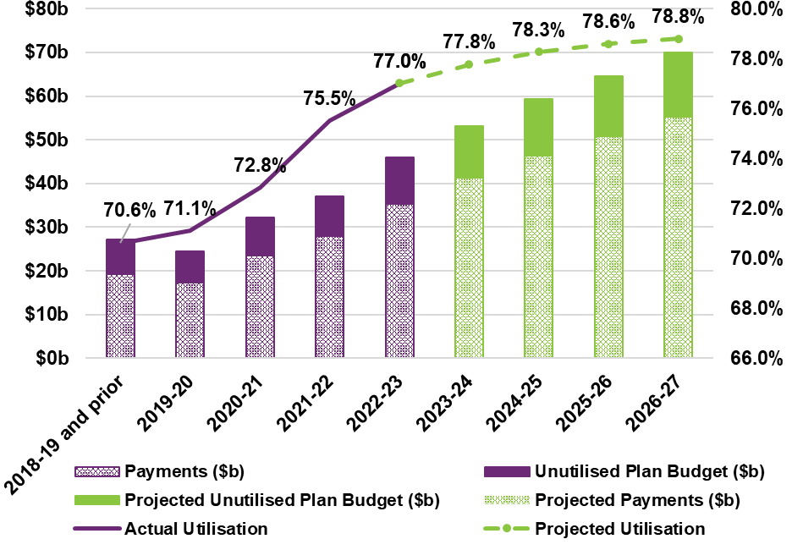
Utilisation has increased from around 70% during the trial and transition periods to 77% in 2022-23. The impact of the Budget initiatives on utilisation is highly uncertain. However, utilisation may increase further to the extent that improvements to planning processes better align participant supports with their goals.
In aggregate, utilisation is projected to continue to increase in the short term but at a reducing rate and gradually stabilise over the medium term. The overall Scheme utilisation rates are expected to be 77.8% and 78.3% for 2023-24 and 2024-25 respectively; and reaching 78.8% by 2026-27.
Figure 5.2 below shows the trajectory of utilisation split by participants’ usage of SIL supports. This split shows participants in SIL arrangements utilise a greater proportion of their plans and their utilisation increase has been historically slower than participants who are not in SIL arrangements. The projected utilisation for participants with and without SIL supports is 90% and 74% respectively by 2026-27.

Figure 5.2: Utilisation projections split by SIL arrangements
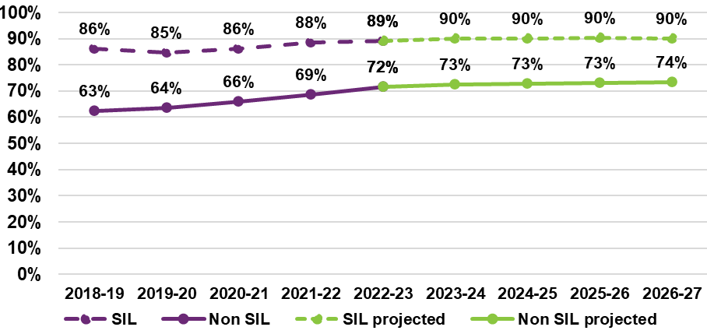

Participant projections
The number of participants expected in the Scheme at the end of each projection year is determined as a function of:
- The number of participants currently in the Scheme.
- The number of new participants expected to enter the Scheme each year.
- The rate at which participants are expected to leave the Scheme due to mortality.
- The rate at which participants are expected to leave the Scheme due to other reasons, such as no longer meeting eligibility requirements or no longer requiring disability supports.
Other dynamics related to the number of participants in the Scheme, which are known to influence Scheme expenses, are also considered:
- Children that joined the Scheme with developmental delay receiving a diagnosis, typically resulting in a change in reported primary disability to autism or an intellectual disability.
- The number of participants with SIL supports, discussed in Section 5.5.
The June 2023 projection forecasts a higher number of participants in the next four years, followed by a lower number of participants in subsequent years compared to the previous review. This is primarily a result of a higher number of new entrants expected in the short-term combined with an increase to longer-term expectations about the rate of participants leaving the Scheme.

Figure 5.3: Projected participant numbers (all ages) at 30 June
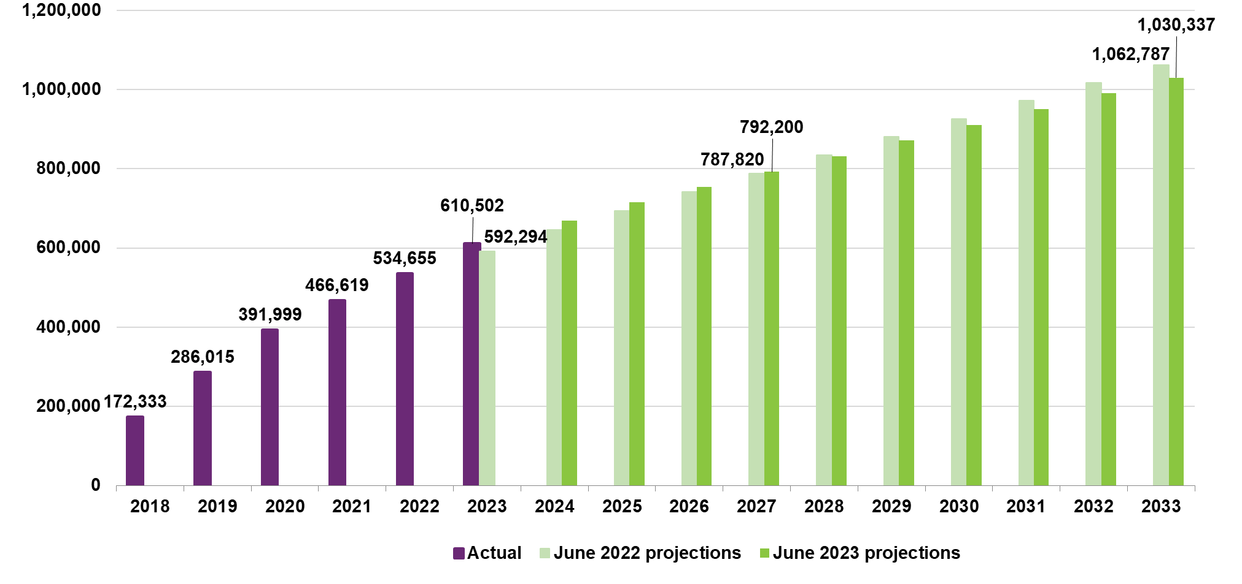

New entrants
The number of new participants expected to enter the Scheme each year are modelled based on assumed rates of new entrants. Expected new entrant rates are comprised of two components:
- New entrants in the short-term, resulting from the expected continuation of short-term trends. This includes participants with previously unmet needs (PUN), who acquired their disability some years prior and only accessed the Scheme recently (for various reasons).
- Long-term new entrant rates related to the steady intake of new participants beyond an assumed steady-intake date.
For the June 2023 projections, new entrant rate assumptions have been updated to take account of the latest observed Scheme experience compared to the June 2022 projections as follows:
- A revision to the expected rate of new entrants in the short-term with developmental delay and autism, anticipating that the current high rate of new entrants with developmental delay will gradually reduce. The rate of new entrants with autism is expected to peak in 2024 before reducing to steady long-term rates by June 2026.
- An increase in the proportion of new entrants that are assumed to be participants with previously unmet need (‘PUN’). This proportion is set based on the observed rate of decline in the number of new entrants, as well as findings from an internal review of a sample of participants. The increased proportion of participants with PUN means that a greater number of new entrants are expected in the short-term with PUN and as a result, lower numbers of new entrants are projected in the medium to long term.
- The timeframe over which participants with PUN are expected to reduce to zero has been extended to 30 June 2026 from 30 June 2024 in the previous review. This is to reflect the higher-than-expected number of new entrants with PUN, and the consequent likelihood that adults with a previously unmet need will continue to enter the Scheme for several years.
Table 5.14 presents the long-term new entrant rates assumed for the June 2023 projections, both before and after adjustments made for Budget initiatives, compared to those assumed from the previous review by key disability groups.
Taking a lifetime approach and ensuring plans are more transparent and flexible is expected to reduce the number of children entering with developmental delay. A new entrant rate of 133.9 (per 100,000 population aged 0 to 64) is expected for participants with developmental delay in the June 2023 projections compared with 148.8 without the impact of Budget initiatives.
A new entrant rate of 314.7 (per 100,000 population aged 0 to 64), in aggregate across all disability types, has been assumed for the June 2023 projections. This is 2.0% higher than the new entrant rate assumed in the previous review, including an assumed rate that is 2.3% higher for new entrants with autism, 21.2% higher for new entrants with developmental delay, and a reduction of 18.6% in the rate of new entrants with disabilities other than developmental delay and autism.

Table 5.14: Comparison of assumed new entrant rates (per 100,000 population) by disability group
Disability Group | June 2023 projections (before Budget initiatives) | June 2023 projections (after Budget initiatives) | June 2022 projections | Absolute Change | % Change
Autism | 96.3 | 96.3 | 94.1 | 2.2 | 2.3%
Developmental Delay | 148.8 | 133.9 | 110.5 | 23.5 | 21.2%
Intellectual Disability | 18.0 | 18.0 | 21.0 | -3.1 | -14.6%
Other Neurological | 7.8 | 7.8 | 9.9 | -2.1 | -21.0%
Psychosocial Disability | 19.4 | 19.4 | 24.4 | -5.0 | -20.5%
Other | 39.4 | 39.4 | 48.6 | -9.2 | -18.9%
Total All Disabilities | 329.6 | 314.7 | 308.4 | 6.3 | 2.0%
Table 5.15 shows updated long-term new entrant rates assumed by age before and after adjustments made for Budget initiatives compared to the previous review. The Budget initiatives reduce the expected number of new entrants with developmental delay and global developmental delay which impacts the 0 to 14 age band due to the age profile of the participants in this group. New entrant rates for ages 0 to 14 have increased significantly by 17.3%, and the long-term new entrant rates for new entrants aged 15 years and over has decreased by 17.8% compared to the previous review.
Overall, the revised assumptions reflect a future expected decline in the long-term new entrants in the adult population, as new entrants with PUN reduce over the next three years to 30 June 2026.

Table 5.15: Comparison of assumed new entrant rates (per 100,000 population) by age group
Age Group | June 2023 projections (before Budget initiatives) | June 2023 projections (after Budget initiatives) | June 2022 projections | Absolute Change | %  Change
0 to 14 | 1,072.9 | 1,005.9 | 857.4 | 148.5 | 17.3%
15+ | 117.7 | 117.7 | 143.2 | -25.4 | -17.8%
Total All Ages | 329.6 | 314.7 | 308.4 | 6.3 | 2.0%
Figure 5.4 shows the projected number of new entrants to the Scheme, compared to the previous review for each year from 2023-24 onwards. New entrant numbers are projected to be higher in the short-term to 30 June 2026, reducing to slightly lower levels for years 2026-27 and beyond.

Figure 5.4: Projected new entrant numbers
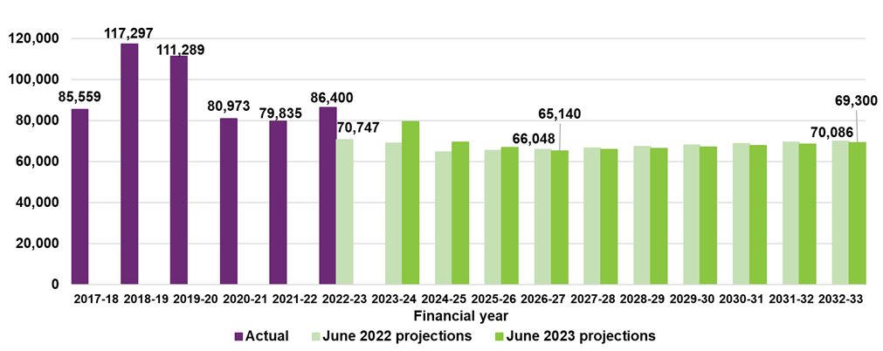

Participants leaving the Scheme
Figure 5.5 presents actual and projected rates of participants leaving the Scheme for reasons other than death, both before and after the expected impact of the Budget initiatives.
The assumed rates of participants leaving the Scheme (before considering potential impacts of Budget initiatives) were unchanged from the previous review. However, the rates before Budget initiatives shown in Figure 5.5 are higher, in aggregate, compared with the rates presented in the June 2022 projections, due to a change in projected mix of participants by disability type.
Experience has shown that the rate of participants leaving the Scheme is highly dependent on operational capability and resource allocation towards eligibility reassessment. The Budget initiatives, particularly the increased investment towards improving plan flexibility and transparency as well as improving the Agency’s approach to early childhood, are expected to lead to an increase in Agency efforts towards plan reassessment and other operational changes. The rate of participants leaving the Scheme is therefore expected to experience a short-term increase before reducing towards a stable rate in the long-term.

Figure 5.5: Projected annual rates of participants leaving the Scheme (all ages)
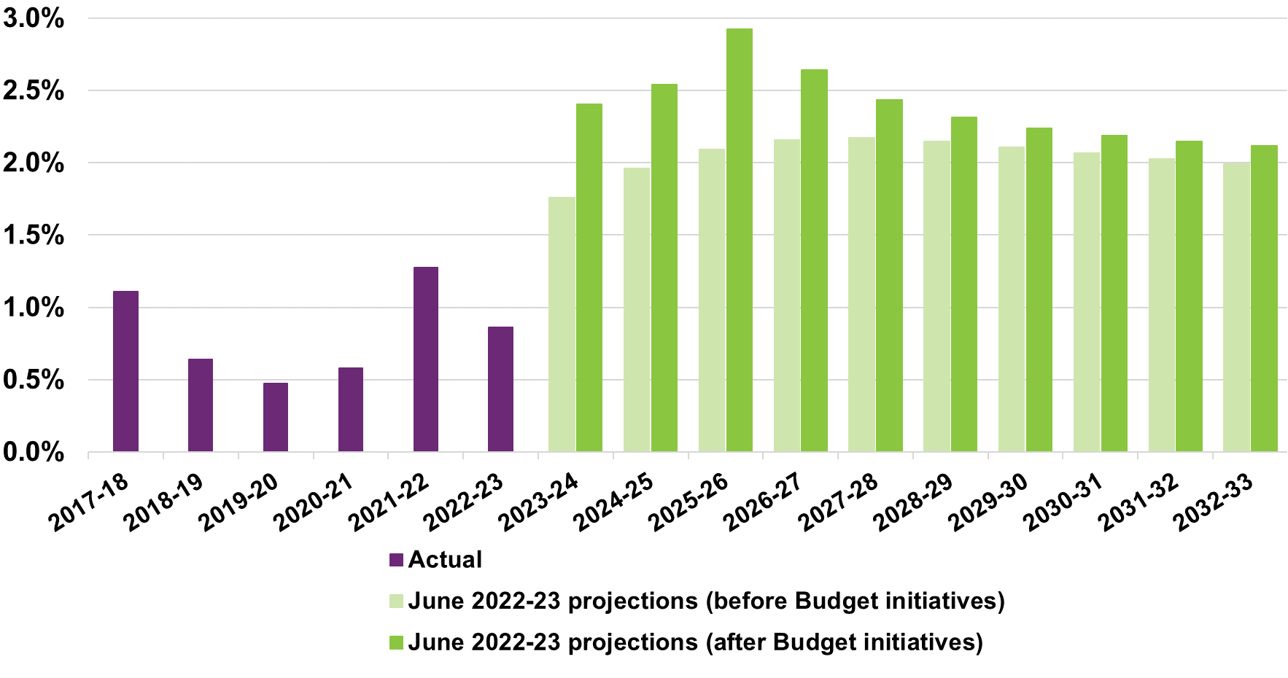
Figure 5.6 presents the equivalent rates for participants aged 0 to 14 years leaving the Scheme. Most participants leaving the Scheme are expected to be children. The rate of children leaving the Scheme is expected to increase from 4.5% in 2023-24 to a peak of almost 6.0% over the three years ending 30 June 2026, driven by the impact of initiatives related to early childhood. Longer term rates of children leaving are about 0.5 percentage points higher than the expected rate without Budget initiatives.

Figure 5.6: Projected annual rates of participants aged 0 to 14 leaving the Scheme
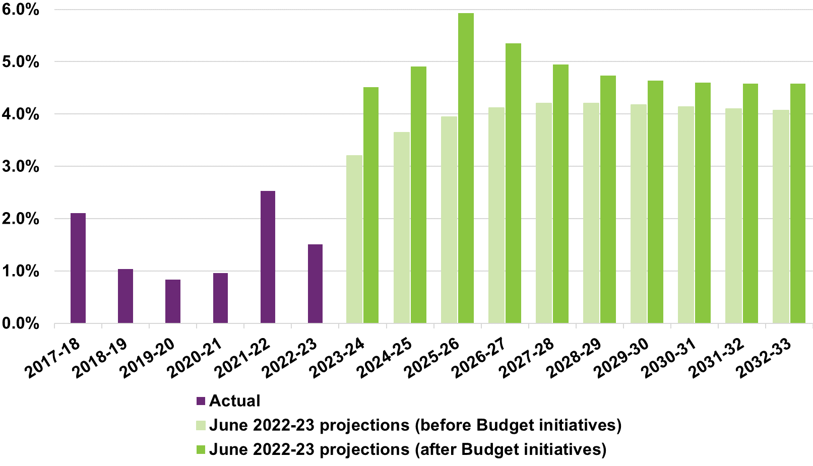
Figure 5.7 similarly shows the rates of participants aged 15 to 64 leaving the Scheme. This cohort makes up a small proportion of participants expected to leave the Scheme, with the impact of Budget initiatives expected to be more moderate of about a 0.1 percentage point increase to expected rates.

Figure 5.7: Projected annual rates of participants aged 15 to 64 leaving the Scheme
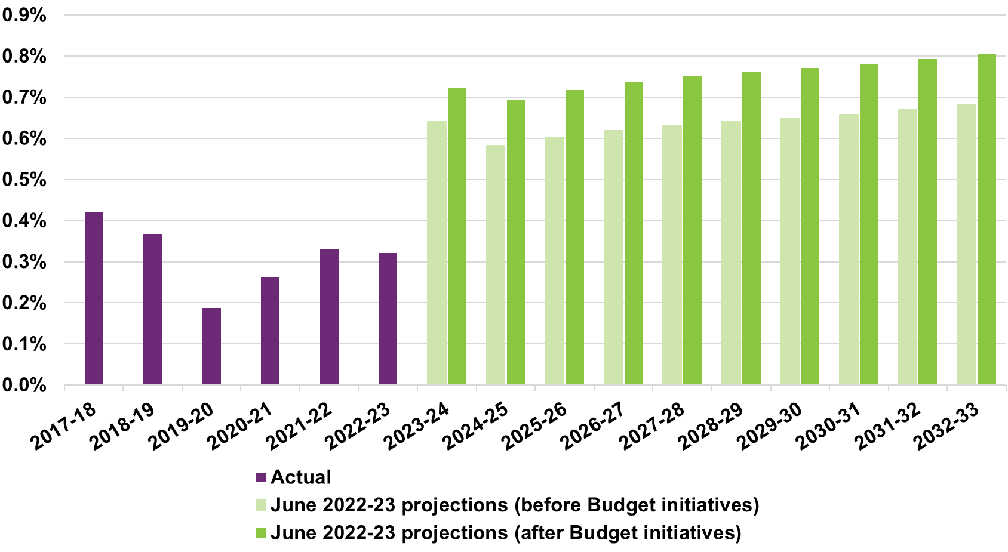

Changes to primary disability of children with developmental delay
Children who joined the Scheme with developmental delay will sometimes receive a diagnosis, resulting in a change to their reported primary disability. The most common transition observed is from developmental delay to a diagnosis of autism or an intellectual disability.
A proportion of children with developmental delay are assumed to change to a primary disability of autism or intellectual disability based on Scheme experience, which then impacts the projected Scheme expenses. Average payment for participants with autism are typically higher than those with developmental delay.
Figure 5.8 and Figure 5.9 shows the historical and assumed transition rates into autism and intellectual disability respectively. Both transition rates for the 12 months to 31 March 2023 saw a reduction, therefore, the expected transition rates were revised downwards slightly for the June 2023 projections.

Figure 5.8: Actual vs expected rates of participants transitioning from developmental delay to autism
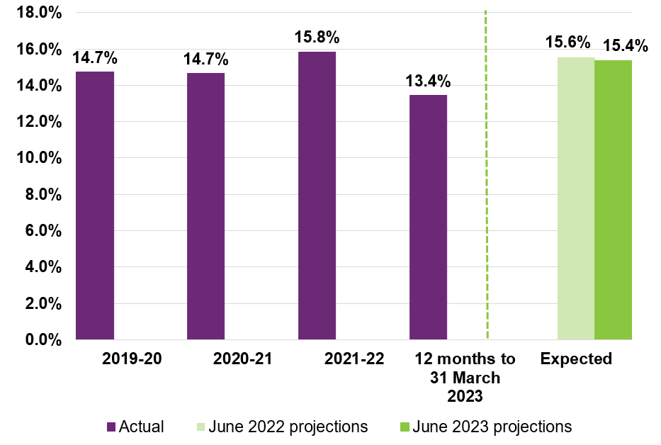

Figure 5.9: Actual vs expected rates of participants transitioning from developmental delay to intellectual disability
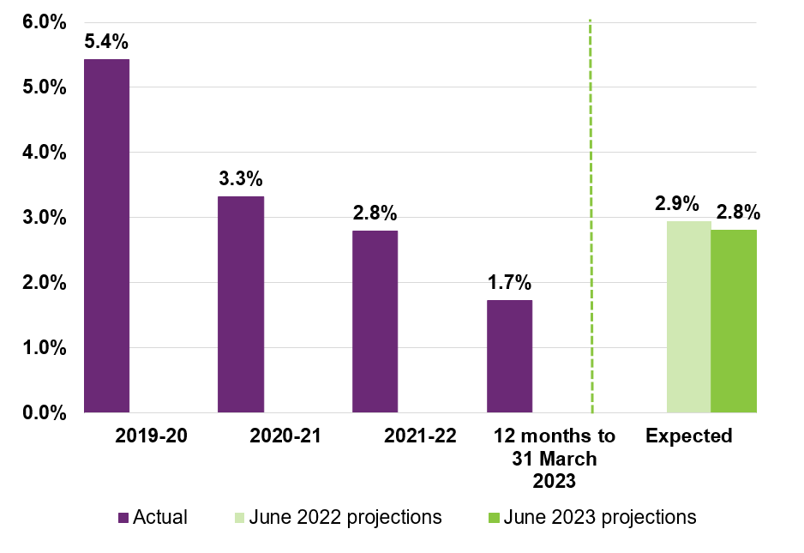

Mortality
Figure 5.10 shows mortality rates are trending upwards over the past six years. In particular, mortality rates since 2022 were higher than expected. Participant cohorts showing the greatest increase were participants aged over 35 and participants with psychosocial disability.

Figure 5.10: Actual vs expected rates of participant deaths
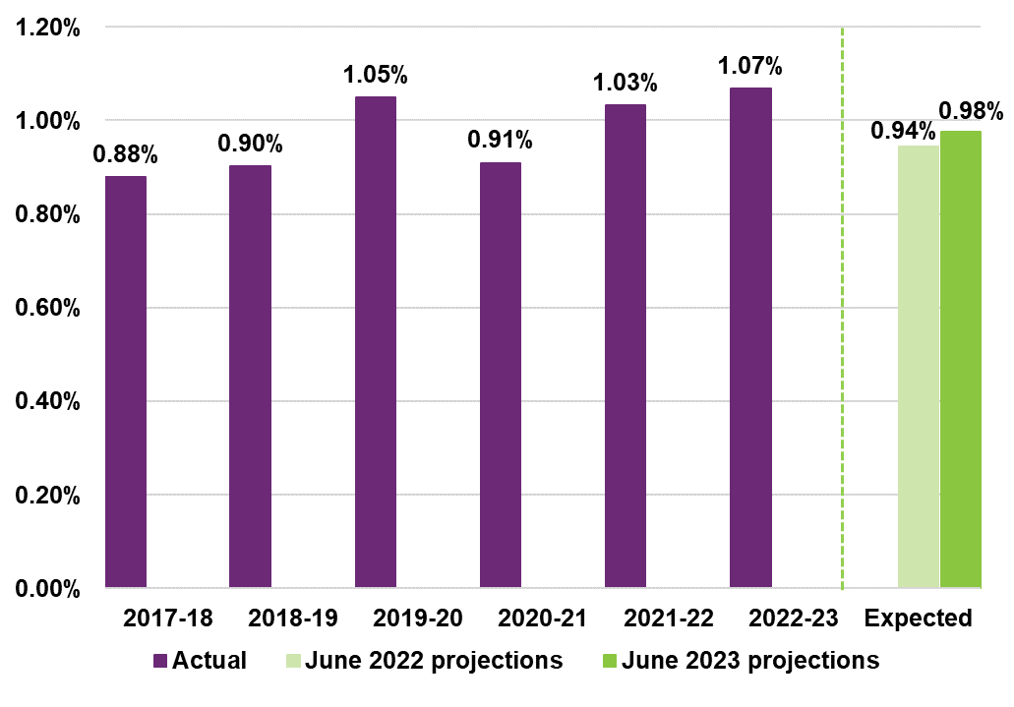
In response to this growing trend, a comprehensive review of mortality was conducted in early 2023. The expected rates of mortality were increased for the June 2023 projections from 0.94% to 0.98% at the Scheme level, taking into account five years of Scheme experience to February 2023 combined with expectations from the previous review. Mortality rates are constructed by applying disability specific loadings to standard population mortality rates from the Australian Life Tables.

Scheme population projections
The expected number of participants at the end of each year is calculated as the starting participant population, adding expected new participants and subtracting participants leaving the Scheme or passing away over the year. Table 5.16 shows the projected participant numbers resulting from these components, expressed in absolute terms as well as the proportion of change compared to the participant numbers at the start of the year.

Table 5.16: Projected participant numbers by components of new entrants, mortality and participants leaving
 | 2023-24 | 2024-25 | 2025-26 | 2026-27 | 2032-33
Starting participant population | 610,502 | 668,907 | 714,805 | 754,022 | 990,694
New entrants | 79,408 | 69,434 | 66,956 | 65,140 | 69,300
Mortality | -5,616 | -5,972 | -6,276 | -6,553 | -8,243
Participants leaving | -15,388 | -17,564 | -21,463 | -20,409 | -21,414
Expected participant population at end of year | 668,907 | 714,805 | 754,022 | 792,200 | 1,030,337
New entrants | 13.0% | 10.4% | 9.4% | 8.6% | 7.0%
Mortality | -0.9% | -0.9% | -0.9% | -0.9% | -0.8%
Participants leaving | -2.5% | -2.6% | -3.0% | -2.7% | -2.2%
Expected growth in participant population | 9.6% | 6.9% | 5.5% | 5.1% | 4.0%
The resulting participant projection by age group is shown in Table 5.17.

Table 5.17: Projected participant numbers by age group, at 30 June
 | 2023 | 2024 | 2025 | 2026 | 2027 | 2033
Children (0 to 14) | 260,674 | 284,202 | 296,741 | 302,671 | 306,657 | 325,288
Young adults (15 to 24) | 102,648 | 118,650 | 135,269 | 153,455 | 173,221 | 282,678
Adults (25 to 64) | 219,696 | 233,286 | 244,938 | 254,856 | 264,162 | 350,010
Older adults (65+) | 27,484 | 32,768 | 37,858 | 43,040 | 48,159 | 72,361
Total | 610,502 | 668,907 | 714,805 | 754,022 | 792,200 | 1,030,337
Children (0 to 14) | 42.7% | 42.5% | 41.5% | 40.1% | 38.7% | 31.6%
Young adults (15 to 24) | 16.8% | 17.7% | 18.9% | 20.4% | 21.9% | 27.4%
Adults (25 to 64) | 36.0% | 34.9% | 34.3% | 33.8% | 33.3% | 34.0%
Older adults (65+) | 4.5% | 4.9% | 5.3% | 5.7% | 6.1% | 7.0%
Total | 100.0% | 100.0% | 100.0% | 100.0% | 100.0% | 100.0%
Young adults represent a growing proportion of the Scheme’s participant numbers as the children entering the Scheme in earlier projection years transition into older age bands. Table 5.18 illustrates the projection split by disability group.

Table 5.18 Projected participant numbers by disability group, at 30 June
 | 2023 | 2024 | 2025 | 2026 | 2027 | 2033
Autism | 214,880 | 250,605 | 284,586 | 316,616 | 346,779 | 523,651
Developmental Delay | 82,484 | 89,589 | 88,006 | 83,235 | 80,490 | 81,994
Intellectual Disability | 100,692 | 105,360 | 109,929 | 114,317 | 118,469 | 142,128
Psychosocial Disability | 62,011 | 65,910 | 69,064 | 71,771 | 74,106 | 86,712
Other | 150,435 | 157,443 | 163,221 | 168,084 | 172,355 | 195,852
Total | 610,502 | 668,907 | 714,805 | 754,022 | 792,200 | 1,030,337
Autism | 35.2% | 37.5% | 39.8% | 42.0% | 43.8% | 50.8%
Developmental Delay | 13.5% | 13.4% | 12.3% | 11.0% | 10.2% | 8.0%
Intellectual Disability | 16.5% | 15.8% | 15.4% | 15.2% | 15.0% | 13.8%
Psychosocial Disability | 10.2% | 9.9% | 9.7% | 9.5% | 9.4% | 8.4%
Other | 24.6% | 23.5% | 22.8% | 22.3% | 21.8% | 19.0%
Total | 100.0% | 100.0% | 100.0% | 100.0% | 100.0% | 100.0%
Participants with autism continues to be the largest cohort of net increase for future projections. Over time, the proportion of participants with autism is expected to continue to increase, as participants with developmental delay are subsequently diagnosed with autism or intellectual disability.

Participants with SIL supports
The modelling of participants with SIL has been enhanced to capture the movements of participants into SIL. Previously, participants with SIL were modelled as an assumed proportion of the total number of participants (inclusive of participants with and without SIL). In the June 2023 projections, the number of participants in SIL are projected using an assumed rate of participants transitioning to newly accessing SIL supports. The revised approach also allows for a different mix of participants within a given primary disability group in comparison to those not accessing SIL.

Assumptions are derived based on recent experience combined with long term expectations.
The assumed rates of participants transitioning to SIL have been determined reflecting the profile of participants expected to access SIL supports for the first time within a projection year. Separate transition rates have been selected based on primary disability group and level of function as well as age group, denoting the different key life stages. For example, late teens (ages 15 to 18) transitioning into adulthood and living independently, late adulthood (ages 45 to 64) when informal supports may no longer be available.
Additionally, the projections assume participants with SIL to continue to remain in SIL arrangements once they have entered SIL. While experience shows that some participants do cease accessing supports, this is often offset by participants re-entering SIL with average plan budgets that are comparable to those who have left SIL.
The overall numbers of participants transitioning into SIL are projected based on modelled transition rates, taking into consideration recent Scheme experience related to new entrants into SIL, Home and Living eligibility decisions for SIL, operational changes related to accessing SIL supports, and discussions with Home and Living specialists in the Agency. The expected impact of Budget initiatives announced in May 2023 have also been considered, which includes initiatives to improve consistency across decision-making related to SIL with more up-to-date guidelines.
Further details on the approach to setting SIL transition rate assumptions can be found in Appendix I.

The net increase of participants with SIL is projected to reduce over the next four years and increase steadily following overall Scheme growth.
Table 5.19 presents the split of projected participants with SIL and without SIL.

Table 5.19 Projected participant numbers with SIL and without SIL, at 30 June
 | 2023 | 2024 | 2025 | 2026 | 2027 | 2033
Participants with SIL | 31,818 | 35,468 | 37,731 | 39,649 | 41,037 | 50,266
Participants without SIL | 578,684 | 633,438 | 677,175 | 714,372 | 751,163 | 980,071
Total Participants | 610,502 | 668,907 | 714,805 | 754,022 | 792,200 | 1,030,337
SIL transition rate  (Ages 15+ only) | 2.2% | 1.4% | 0.9% | 0.8% | 0.6% | 0.5%
The net increase to number of participants with SIL is projected to reduce in the next four years from the current level and increase in the longer term reflecting the long-term expectations of participants transitioning into SIL.
The existing pipeline of Home and Living applications assessed for SIL eligibility, related to participants new to SIL, suggests that the net increase in participants with SIL will reduce gradually at least in the short term. It is assumed the net increase in the number of participants with SIL will be at a slightly lower rate than the 12 months ending 30 June 2023, resulting in a net increase of about 4,000 participants.
After 2023-24, it is assumed that over a four-year period, the rate of net increase in participants with SIL will reduce to reach a ‘steady state’ long term level after 2025-26. The long-term net increases are initially just under 1,800 participants per year and results in a proportion of Scheme participants aged 15 and above without SIL assumed to transition to SIL arrangements of approximately 0.7% per annum for 2026-27 and beyond.
After allowing for the impact of Budget initiatives, the net increase in participants with SIL for ages 15 and above is projected to reduce from 3,600 in 2023-24 to about 1,400 by 2026-27 and results in an approximate 0.6% per annum long term transition rate for future years. This compares to a SIL transition rate of 2.2% observed over the 12 months ending 30 June 2023.
There remains a degree of uncertainty around the emerging experience relating to the net increase in participants with SIL supports and when the demand for SIL supports will reach ‘maturity’ (grow in line with the overall growth in the adult population of the Scheme). Moreover, there is also uncertainty as to which alternative, lower cost Home and Living options may be offered through the Scheme in the future. Similarly, there is a degree of uncertainty around the effectiveness and the implementation of the Budget initiatives.

Projected number of participants with SIL has been revised upwards reflecting recent experience with a slower year-on-year growth.
Figure 5.11 shows the June 2023 projection of the number of participants with SIL arrangements, both before and after factoring in the impact of Budget initiatives, compared to the previous review. The projected number of participants with SIL arrangements, after adjusting for the estimated impact of Budget initiatives, reflects a higher number of participants with SIL arrangements across all future years. This is a result of changes to the way Home and Living decisions for SIL eligibility were made in 2022-23 and is expected to continue into 2023-24 resulting in a faster growth of number of participants with SIL compared to the previous review in the short term.
In the medium to long term, the growth of participants with SIL is projected to slow down as a result of the planned Budget initiatives. The initiatives are intended to strengthen SIL decisions, including by introducing a Home and Living panel with highly trained staff to improve consistency across decisions and updating guidelines for planners to improve participants' ability to live independently. While the number of participants with SIL is expected to be higher than previous review, the difference is projected to reduce in the medium to long term.

Figure 5.11: Actual and projected participant numbers, at 30 June, before and after Budget initiatives, compared to previous review

Base average payment assumptions
Scheme experience over 2022-23 resulted in higher average payments per participant than expected when compared to assumptions from the June 2022 projections. These higher levels are reflected in the base average payment assumptions, which were derived from payments data in the three months to 30 April 2023
Base average payment assumptions (i.e., those before allowance for inflation) are set with reference to payments for participants who have been in the Scheme for at least 12 months (with a separate allowance being made for lower expected payments for participants in their first year).
Compared to expected average payments from the June 2022 projections, these assumptions are overall higher by 2% (1.1% lower for participants without SIL supports and 3.2% higher for participants with SIL supports) as shown in Table 5.20.
The increase in average payment assumptions for participants with SIL reflects the rising cost of participants transitioning to SIL throughout 2022-23. Participants who transition into SIL arrangements typically have plan budgets and associated payments which are high relative to other similar participants before they transition. Hence, the high number of transitions into SIL during the year also contributed to the decrease in average payments for participants without SIL supports.

Table 5.20: Changes in average payment assumptions by SIL status
 | Daily Activities | CB Daily Activities | Social Community Civic | Transport | Support Coordination | Other | Total
Non SIL | -6.2% | 3.6% | 12.7% | -18.4% | -4.2% | -8.1% | -1.1%
SIL | 0.3% | 18.7% | 20.3% | -12.1% | 4.1% | 2.9% | 3.2%
Total | -0.7% | 4.5% | 15.4% | -17.9% | -2.2% | -5.3% | 2.0%
Table 5.21 shows the average payment assumptions have increased since the June 2022 projections across most disability groups except for participants with autism where there has been a slight decrease.

Table 5.21: Changes in average payment assumptions by major support categories and disability group
 | Daily Activities | CB Daily Activities | Social Community Civic | Transport | Support Coordination | Other | Total
Autism | -4.9% | 2.0% | 12.2% | -20.8% | -2.1% | -4.3% | -1.0%
Intellectual Disability | 0.0% | 8.7% | 16.1% | -15.1% | 0.4% | -0.6% | 3.7%
Psychosocial Disability | 2.5% | 9.0% | 23.4% | -11.2% | 1.6% | -3.4% | 8.0%
Other Neurological | 5.1% | 9.5% | 20.8% | -13.0% | -4.1% | -3.9% | 6.2%
Other | -1.1% | 3.4% | 13.4% | -18.2% | -5.3% | -9.1% | 0.1%
Total | -0.7% | 4.5% | 15.4% | -17.9% | -2.2% | -5.3% | 2.0%
Average payment assumptions are set by support category, disability group, SIL status, level of function and age band and consists of a total of 2,052 cohorts. Tables 5.22 and 5.23 summarise the starting average payment assumptions for the June 2023 projections by main support categories and main disabilities for participants with and without SIL supports.
Daily Activities and Social Community Civic support categories generally have the highest average payment assumptions. The exception is for children with developmental delay, whose payments are dominated by Capacity Building Daily Activities (including therapy supports).
Average payment assumptions for participants with developmental delay are the lowest for participants without SIL, given this group mainly includes young children with low needs for Core supports. The highest average payment assumptions for participants without SIL are for those with other neurological disabilities; these tend to be older participants.

Table 5.22: Base average payment assumptions for participants without SIL
 | Daily Activities | Social Community Civic | CB Daily Activities | Transport | Support Coordination | Other | Total
Autism | 8,200 | 5,900 | 7,400 | 1,500 | 700 | 2,600 | 26,400
Intellectual Disability | 21,500 | 20,500 | 5,900 | 2,500 | 1,600 | 4,100 | 56,100
Delay | 1,300 | 200 | 8,700 | 300 | 200 | 1,200 | 11,800
Psychosocial Disability | 22,300 | 20,600 | 4,400 | 1,300 | 3,800 | 2,800 | 55,200
Other Neurological | 53,100 | 16,900 | 8,500 | 1,700 | 2,200 | 9,400 | 91,700
Other | 31,500 | 11,600 | 6,400 | 1,400 | 1,500 | 7,300 | 59,600
Total average | 16,700 | 10,200 | 6,900 | 1,400 | 1,300 | 3,800 | 40,300
Participants with SIL have significantly higher average payment assumptions across all disabilities compared to participants without SIL as they predominantly include participants with low level of function and therefore require more support. Participants with SIL with other neurological disabilities or autism have the largest average payment assumptions as shown in Table 5.23.

Table 5.23: Base average payment assumptions for participants with SIL
 | Daily Activities | Social Community Civic | CB Daily Activities | Transport | Support Coordination | Other | Total
Autism | 327,500 | 68,900 | 7,200 | 2,200 | 5,700 | 18,700 | 430,100
Intellectual Disability | 260,900 | 55,700 | 6,400 | 2,200 | 4,400 | 16,700 | 346,300
Psychosocial Disability | 249,700 | 45,100 | 6,000 | 1,600 | 6,000 | 12,100 | 320,600
Other Neurological | 336,500 | 45,000 | 12,400 | 1,800 | 6,000 | 32,800 | 434,400
Other | 332,100 | 52,400 | 13,800 | 2,000 | 5,500 | 27,700 | 433,500
Total average | 289,900 | 54,500 | 8,600 | 2,100 | 5,100 | 20,200 | 380,400
Table 5.24 shows the expected average payments grouped by disability and age band for the 2023-24 financial year. The following is noted:
- The base average payments for all Scheme participants in 2023-24 is $58,200. This is $4,500 (8%) higher than the assumed base average payment for 2023-24 in the previous review.
- Children have lower average payments than adults, reflecting a higher proportion of participants accessing early intervention supports, less usage of SIL arrangements and more informal supports, primarily provided by parents.
- Participants with intellectual disability and other neurological have the largest average payments.
- Participants with autism and developmental delay have the lowest average payments.

Table 5.24: Base average payment assumptions ($) by age band and disability group in 2023-24
Disability Group | 0 to 14 | 15 to 24 | 25 to 64 | 65+ | Total
Autism | 19,700 | 41,400 | 86,800 | 152,400 | 33,400
Intellectual Disability | 31,300 | 72,800 | 134,600 | 184,400 | 99,200
Psychosocial Disability | 24,800 | 81,600 | 70,900 | 78,000 | 71,700
Developmental Delay | 11,800 | - | - | - | 11,800
Other Neurological | 48,000 | 106,600 | 139,400 | 125,400 | 124,600
Other | 24,700 | 57,500 | 101,600 | 99,600 | 84,300
Total | 18,600 | 52,500 | 102,100 | 111,000 | 58,200
The expected average payment assumptions by support category and age band for the 2023-24 financial year are shown in Table 5.25. The table shows higher average payment assumptions for Daily Activities and Social Community Civic, the two largest support categories. Assumptions are also higher for participants aged 15 years and over. The highest average payments for participants aged 0 to 14 is for Capacity Building Daily Activities (including therapy supports).

Table 5.25: Base average payment assumptions ($) by age band and support category in 2023-24
Support Category | 0 to 14 | 15 to 24 | 25 to 64 | 65+ | Total
Daily Activities | 4,600 | 25,200 | 61,100 | 69,600 | 31,100
CB Daily Activities | 8,900 | 5,300 | 5,500 | 6,500 | 7,000
Social Community Civic | 1,300 | 13,900 | 24,200 | 21,500 | 12,500
Transport | 1,100 | 2,000 | 1,600 | 1,600 | 1,500
Support Coordination | 400 | 1,300 | 2,700 | 2,800 | 1,500
Other | 2,300 | 4,800 | 7,000 | 9,000 | 4,700
Total | 18,600 | 52,500 | 102,100 | 111,000 | 58,200

Inflation and additional growth assumptions
Scheme expenses increase over time with growth in the average payments per participant, both from normal inflationary sources (such as general increases in wages and consumer prices) and from additional cost pressures, referred to as additional growth.
The AFSR includes assumptions about expected future normal inflation rates and additional growth in payments. These assumptions, together with the projections of participants and base average payments presented in Sections 0 and 5.6, are used to arrive at a projection of future Scheme expenses.
This section presents the rates of normal inflation and additional growth that were used for the June 2023 projections, including the impact of price changes from the 2022-23 Annual Pricing Review (APR) and the impact of the Budget initiatives. Expectations about additional growth in payments are based on observed Scheme experience in both average plan budgets and payments, as well as future pricing decisions.

Annual Pricing Review
The changes to NDIS price limits as part of the 2022-23 Annual Pricing Review (APR) came into effect on 1 July 2023, and have been used to set normal inflation assumptions for the 2023-24 year of the June 2023 projections:
- Price limits for supports delivered by disability support workers and Level 1 support co-ordinators have increased by 5.3%. This includes:
- The Fair Work Commission’s (FWC) National Minimum Wage decision to increase award wages by 5.75%.
- An extension of the temporary loading for a further 12 months at 1% from 1 July 2023 with this ceasing on 30 June 2024.
- Inclusion of paid family and domestic violence leave into the Disability Support Worker Cost Model, up by 0.1% from 1 July 2023 to reflect the new entitlements for workers in the industry awarded by the FWC.
- The adjustment to price limits to reflect the increase in Superannuation Guarantee Charge of 0.5%.
- No increase to therapy, plan management and support coordination levels 2 and 3 price limits.
For other support categories, a 4.4% inflation assumption is assumed for the 2023-24 year. The rate is calculated by combining 80% of the movement in the Australian Bureau of Statistics (ABS) Wage Price Index (3.7%) and 20% of the movement in the ABS Consumer Price Index (7%) over the 12 months leading up to the March 2023 quarter.

Normal inflation
The normal inflation rates assumed for 2024-25 onwards reflect the most recent economic forecasts:
- For supports delivered by disability support workers, a rate of 3.2% per annum in 2024-25 is assumed followed by 4.3% until 2026-27 and 3.8% thereafter. This is based on the most recent forecasts of the Wage Price Index (WPI) and includes a gradual increase in the Superannuation Guarantee Charge as an additional 0.5% per annum until 2025-26. The rate assumed for 2024-25 is 1.0% lower than that based on the forecast WPI due to the reversal of the temporary loading applied as part of the 2021-22 APR. From 2026-27, a 3.8% per annum increase is assumed, reflective of long-term expected wage inflation.
- For all other support categories, a rate of 3.0% per annum in 2024-25 is assumed followed by 2.5% per annum for all years thereafter. This also reflects the most recent CPI forecasts.
Table 5.26 compares the overall normal inflation assumptions (including price changes) in the June 2023 projections to the rates assumed in the June 2022 projections. The rates shown are the weighted average of rates assumed across different support categories. The level of normal inflation assumed has reduced slightly in 2024-25 and increased thereafter. The change for 2023-24 reflects the impact of the 2022-23 APR decisions.

Table 5.26: Comparison of normal inflation assumptions to historic normal inflation assumptions
 | 2023-24 | 2024-25 | 2025-26 | 2026-27 | 2032-33
June 2023 projections | 4.4% | 3.2% | 3.9% | 3.5% | 3.5%
June 2022 projections | 2.6% | 3.6% | 3.6% | 3.2% | 3.3%
Difference (%) | 1.8% | -0.4% | 0.3% | 0.3% | 0.2%

Additional growth
Additional growth is defined as the increase in average payments above normal inflation. Sustained high levels of additional growth remains one of the most critical sustainability pressures for the Scheme given the material impact on projected Scheme expenses.
- The additional growth assumption in the June 2022 projections reflected an expectation that the perceived shortage of disability support workers would continue to constrain growth in supports and payments in the short term. However, the observed additional growth for 2022-23 was 7.4%, 4% higher than the expected additional growth of 3.4% for 2022-23 in June 2022 projections. This indicates the shortage of workers has not been as great as expected. Therefore, it has been assumed that the additional growth assumption in 2023-24 will not be impacted by constraints in the supply of workers.
- The additional growth assumption (before allowance for Budget initiatives) for financial year 2023-24 is 7%, 4% higher than the assumption of 3% in June 2022 projections. Further, this is consistent with the 5.4% increase in additional growth in plan budgets (Figure 4.20) over the last year, which is expected to flow through to average payments in 2023-24.
- The additional growth assumption for financial year 2024-25 is 5.8%, slightly lower than the assumption in the June 2022 projections, due to assumptions about future price increases that are different to economic forecasts.
- Given there is less evidence of labour supply constraints having a material short term impact on the utilisation of Scheme supports, there is also less evidence for a retrospective ‘catch-up’ in support/payments growth in the medium term. Therefore, the 2025-26 assumption was revised downwards by 1% (to 4%) with additional growth assumption moderating from observed rates (of 7.4% in payments and 9.1% in plan values) to the 2% long-term assumption.
- As the Scheme matures over time, it is reasonable to expect the additional growth rate to moderate to a stable level that remains above 0%, due to factors such as participants’ change in circumstances, deterioration in level of functioning, triggering more complex or costly support needs. There is a high degree of uncertainty associated with the long-term additional growth assumption, with a 1% increase in the long-term assumption (to 3%) expected to increase total Scheme expense by around $5 billion in financial year 2032-33.
The Budget initiatives include a number of investments towards improving the NDIA’s workforce capability and systems and supporting participants to better manage their plan within budget. These changes are expected to reduce the levels of additional growth observed in payments, below historic levels. Table 5.27 shows the impact of the Budget initiatives, as well as a comparison to the assumptions in the June 2022 projections.

Table 5.27: Comparison of additional growth assumptions
 | 2023-24 | 2024-25 | 2025-26 | 2026-27 | 2032-33
June 2023 projections  (Before Budget initiatives) | 7.0% | 5.8% | 4.0% | 2.0% | 2.0%
June 2023 projections  (After Budget initiatives) | 5.1% | 2.8% | 1.2% | 0.9% | 1.6%
June 2022 projections | 3.0% | 6.0% | 5.0% | 2.0% | 2.0%
Difference (%)  June 2023 (After Budget initiatives) vs June 2022 projections | 2.1% | -3.2% | -3.8% | -1.1% | -0.4%

Total expected growth in payments
Table 5.28 presents the total rates of growth assumed for the June 2023 projections, combining both normal inflation and expected additional growth in payments. The future growth assumptions are also compared to historic experience, both including and excluding impact from changes in participant mix.

Table 5.28: Total growth after the impact of Budget initiatives
June 2023 projections | Actual Average 2020-23 | 2023-24 | 2024-25 | 2025-26 | 2026-27 | 2032-33
Normal inflation | 3.7% | 4.4% | 3.2% | 3.9% | 3.5% | 3.5%
Additional growth | 8.9% | 5.1% | 2.8% | 1.2% | 0.9% | 1.6%
Total growth (excluding change in mix) | 12.6% | 9.6% | 6.1% | 5.1% | 4.4% | 5.1%
Change in mix | -6.6% | -4.1% | -2.4% | -2.0% | -1.2% | -1.3%
Total growth | 6.0% | 5.5% | 3.7% | 3.2% | 3.3% | 3.8%
(including change in mix)
Additionally, Figure 5.12 compares the total assumed growth in payments per participant with and without the impact of Budget initiatives.

Figure 5.12: Comparison of total expected growth with and without the impact of Budget initiatives

Average payments per participant after inflation
Table 5.29 shows the projected average payments and yearly growth rates by SIL status. Average payments are expected to grow by 5.5% over the next financial year and continue to experience an upward trend with yearly average growth of 3% to 4% thereafter.

Table 5.29: Average annual payments ($) and yearly growth rates by SIL status
Total Growth June  2023 projections | 2022-23 | 2023-24 | 2024-25 | 2025-26 | 2026-27 | 2032-33
Non SIL | 42,700 | 44,200 | 45,000 | 46,000 | 47,500 | 61,300
SIL | 392,800 | 420,300 | 447,400 | 470,800 | 491,200 | 656,200
Total | 60,600 | 64,000 | 66,300 | 68,400 | 70,600 | 90,400
Yearly growth rates Non SIL |  | 3.6% | 1.9% | 2.2% | 3.2% | 4.7%
Yearly growth rates SIL |  | 7.0% | 6.4% | 5.2% | 4.3% | 5.0%
Total |  | 5.5% | 3.7% | 3.2% | 3.3% | 4.6%
Table 5.30 details the projected average annual payments by age group. Older participants are linked to lower levels of function, higher support needs and less access to informal supports, and therefore higher payments on average.

Table 5.30: Average annual payments ($) by age group and projection year
Age group | 2023-24 | 2024-25 | 2025-26 | 2026-27 | 2032-33
Children (0 to 14) | 19,700 | 19,900 | 20,400 | 21,000 | 25,400
Young adults (15 to 24) | 57,600 | 57,700 | 57,000 | 56,500 | 66,200
Adults (25 to 64) | 112,500 | 117,600 | 121,300 | 124,900 | 151,300
Older adults (65+) | 122,300 | 131,600 | 138,300 | 144,400 | 188,600
Total | 64,000 | 66,300 | 68,400 | 70,600 | 90,400
Table 5.31 displays the projected average annual payments for 2026-27, after inflation, by disability group and age band. The expected average annual payment amount for all Scheme participants in 2026-27 is about $70,600. Children have lower average annualised payments than adults and participants with intellectual disability and other neurological have the largest average payments. Participants with autism and developmental delay have the lowest average payments across all ages.

Table 5.31: Average annual payments ($) by age band and disability group in 2026-27 after inflation
Disability Group | 0 to 14 | 15 to 24 | 25 to 64 | 65+ | Total
Autism | 22,100 | 47,100 | 101,000 | 177,200 | 41,000
Intellectual Disability | 34,600 | 83,500 | 164,400 | 235,600 | 121,300
Psychosocial Disability | 35,400 | 89,400 | 90,800 | 100,400 | 91,900
Developmental Delay | 12,700 | 11,500 | 8,800 | - | 12,700
Other Neurological | 61,000 | 120,800 | 169,200 | 160,700 | 154,200
Other | 25,300 | 61,900 | 127,600 | 135,200 | 105,700
Total | 21,000 | 56,500 | 124,900 | 144,400 | 70,600
Table 5.32 shows the projected average annual payments for 2026-27, after inflation, by support category and age band. At Scheme level, average payments per participant for Core Daily Activities and Social Community Civic are the largest by support category and are expected to comprise over 75% of total payments by 2026-27. For participants aged 0 to 14 years, Capacity Building Daily Activities is the largest support category by average payment.

Table 5.32: Average annual payments ($) by age band and support category in 2026-27 after inflation
Support Category | 0 to 14 | 15 to 24 | 25 to 64 | 65+ | Total
Daily Activities | 5,900 | 26,900 | 76,800 | 94,900 | 39,400
CB Daily Activities | 9,300 | 5,600 | 5,800 | 7,000 | 7,200
Social Community Civic | 1,800 | 16,000 | 31,300 | 28,500 | 16,300
Transport | 1,400 | 2,100 | 1,800 | 1,800 | 1,700
Support Coordination | 200 | 700 | 1,600 | 1,800 | 900
Other | 2,500 | 5,100 | 7,600 | 10,400 | 5,200
Total | 21,000 | 56,500 | 124,900 | 144,400 | 70,600

Lifetime expense for care and support
In addition to annual projections, the AFSR is required to include estimates of the lifetime expense for care and support (lifetime expense) for participants. These are estimated Scheme expenses for care and support provided over the participant’s entire lifetime. They provide a useful benchmark to monitor the financial sustainability of the Scheme, as better outcomes for participants should generally result in lower long-term payments of disability support in the future. Therefore, as more experience emerges, the lifetime expense estimates for participants may be expected to reduce, on average.
Average participant lifetime expenses have been projected based on the assumptions underlying the June 2023 projections (including allowance for Budget initiatives), excluding operating expenses, and then discounted to a present value at 30 June 2023 assuming a long-term discount rate of 5.0% per annum for all future years.
The lifetime expense is projected separately for both the expected cohort of new entrants to the Scheme during 2023-24 as well as existing participants at 30 June 2023.
The lifetime expense projection for new entrants does not include participants who are expected to join the Scheme in 2023-24 due to a previously unmet need (PUN). It is intended to reflect the underlying profile, and associated expense, of new incidence to disability each year going forward once the Scheme reaches a steady intake state.
Table 5.33 shows the lifetime expenses for the estimated annual population of new entrants in 2023-24.
The average lifetime expenses are calculated by disability group, defined by the primary disability of the participant when they enter the Scheme, and then applied to the estimated annual population of new entrants in 2023-24 to get the total lifetime expenses. In particular, for participants who enter with developmental delay, lifetime expenses include the cost of supports for those who are later diagnosed with autism, intellectual disability or other permanent disability type and remain in the Scheme into adulthood.

Table 5.33: Average Payments & Total Lifetime Expenses for New Entrants in 2023-24
Disability group | New entrant population (2023-24) | Average Lifetime  Expense  ($m) | Total  Lifetime Expenses  ($m) | Total Lifetime Expenses  (%)
ABI | 1,312 | 2.58 | 3,387 | 3%
Autism | 21,186 | 2.41 | 51,113 | 44%
Cerebral Palsy | 449 | 3.17 | 1,421 | 1%
Hearing Impairment | 2,019 | 0.24 | 479 | 0%
Intellectual Disability | 3,987 | 3.06 | 12,183 | 10%
Multiple Sclerosis | 679 | 1.49 | 1,013 | 1%
Developmental Delay | 28,351 | 1.10 | 31,143 | 27%
Other | 1,394 | 1.50 | 2,094 | 2%
Other Neurological | 1,719 | 1.47 | 2,528 | 2%
Other Physical | 1,120 | 1.01 | 1,131 | 1%
Other Sensory Speech | 78 | 0.07 | 5 | 0%
Psychosocial disability | 3,918 | 1.68 | 6,597 | 6%
Spinal Cord Injury | 319 | 4.03 | 1,287 | 1%
Stroke | 832 | 2.17 | 1,807 | 2%
Visual Impairment | 472 | 1.02 | 483 | 0%
Total | 67,835 | 1.72 | 116,671 | 100%

Projected GDP (2023-24) | 2,576,444
% of GDP | 4.53%
The total lifetime expenses for the estimated annual population of new entrants in 2023-24 is projected to be $116.7 billion based on the current long-term assumptions, representing 4.53% of projected GDP for 2023-24. This doesn’t mean the government is required to set aside 4.53% of GDP to cover the lifetime expenses for these participants, as the Scheme is funded on an ongoing basis by the government.
Table 5.33 also shows about 81% of the total lifetime expenses are for participants with autism, developmental delay and intellectual disability.
The total lifetime expenses for the 610,502 current participants in the Scheme are estimated to be $1.76 trillion, representing 68.24% of the projected GDP for 2023-24.
The estimated average lifetime expense of these participants is $2.9 million per participant which is significantly higher than the average of $1.7 million for new entrants due to the different disability and age distributions of the two populations. In particular, the profile of current participants is skewed towards those with lower functional levels compared with new entrants. The new entrants’ cohort has a greater number of higher functioning children, many of whom enter the Scheme through the early intervention requirement (Section 25 of the NDIA Act), and who are expected to leave the Scheme and hence have a lower average lifetime expense.

Operating expenses
Agency costs, referred to as “operating expenses”, are costs associated with the operation of the NDIS, including resourcing costs related to participant eligibility assessments and planning, monitoring and reporting of Scheme performance, and governance activities. These costs are separate to Scheme expenses, which represent the total cost of supports and services provided to all participants in the Scheme, before allowance for Agency costs.
Table 5.34 shows actual operating expenses in 2022-23 of $1,830 million, or 5.2% of Scheme expenses, were $2 million lower than the 2023-24 Budget for 2022-23 of $1,832 million.

Table 5.34: Actual operating expenses compared to expectations
Operating expenses ($m) | 12 months ending 30 June 2023
Actual | 1,830
(2023-24 Budget) | 1,832
Difference (Actual – Budget) | -2
Additional operating expenses of $732.9 million, over four years from 2023-24, are included in the 2023-24 Budget for measures to support participant outcomes and the effective sustainable operation of the Scheme.
Table 5.35 shows projected operating expenses, assuming fixed real cost per participant compared with the 2023-24 budgeted expense, and after allowing for the Budget measures. On this basis, operating expenses would reduce as a percentage of Scheme expenses from 5.2% in 2023-24 to 4.2% in 2026-27. Projected operating expenses of $2,156 million in 2023-24 are $326 million (17.4%) higher than actual operating expenses in 2022-23, of which $280 million is funding related to the Budget measures. This investment from 2023-24 is focused on continuing to build frontline capability and capacity, to improve participants’ experience and associated outcomes.

Table 5.35: Operating expenses as a percentage of Scheme expenses
June 2023  projections ($m) | 2023-24 | 2024-25 | 2025-26 | 2026-27 | Total  2023-27
Scheme expenses | 41,360 | 46,376 | 50,788 | 55,207 | 193,731
Operating expenses – BAU | 1,875 | 1,983 | 2,067 | 2,191 | 8,117
Budget measures | 280 | 183 | 136 | 135 | 733
Operating expenses – incl. Budget measures | 2,156 | 2,166 | 2,203 | 2,326 | 8,850
% Scheme expenses | 5.2% | 4.7% | 4.3% | 4.2% | 4.6%
Table 5.36 shows projected operating expenses from 2024-25 onwards are higher compared to the budgeted expenses (in the 2023-24 Budget). The 2023-24 Budget includes Agency operating expenses of $1,680 million in 2024-25, approximately $500 million lower than projected expenses in 2024-25 of $2,166 million.

Table 5.36: Operating expenses compared to budgeted expenses
Forward  estimates ($m) | 2023-24 | 2024-25 | 2025-26 | 2026-27 | Total  2023-27
Operating expenses – incl. Budget measures | 2,156 | 2,166 | 2,203 | 2,326 | 8.850
Budgeted expenses (2023-24 Budget) | 2,156 | 1,680 | 1,682 | 1,701 | 7,218
Difference | 0 | 485 | 521 | 625 | 1,632
The projected operating expenses before Budget measures (Operating expenses – BAU in Table 5.35) are based on the June 2023 projections, reflecting higher projected participant numbers compared with the previous review, essentially assuming a consistent level of resources per participant supported each year. Any reduction in operating expenses below this level is consistent with reductions in resources, increased workloads and less capacity to support participants and manage risk, including fraud and integrity.
Further, in the 2017 Productivity Commission study report, a target operating expense range of 7% to 10% was recommended, and the projected level of expenses is therefore well below the recommended range. The projected expense rate is also at the lower end of, or below the range of expense rates seen in comparable injury support schemes around Australia, even allowing for the greater scale of the Scheme.
The June 2023 Scheme projections included in this report assume Agency resourcing remains relatively constant in real terms and if they do not then Scheme expenses would be expected to be higher than those shown in this report.

Uncertainty and comparisons to previous projections
This section includes scenario analyses where individual assumptions are varied compared with the assumptions used to arrive at the projected Scheme expenses presented in this report (referred to as the “baseline”). The scenarios demonstrate the sensitivity of results to changes in future expectations.
It also contains the results of a stochastic projection model. This model allows for the uncertainty of the most significant key risks to the estimation of Scheme expenses and the results provide a confidence interval for the range of expected projection outcomes.
Finally, a comparison of the June 2023 projection results with historical projection results and Productivity Commission estimates is shown, to illustrate how expectations of Scheme expenses have changed over time.

Scenario analysis
As noted throughout this report, there is considerable uncertainty in relation to these projections, and actual Scheme expenses may vary, possibly significantly.
To quantify the inherent uncertainty, an alternative set of projections have been calculated for several scenarios. These consider a range of plausible outcomes in relation to some of the key uncertainties. Specifically:
- The effectiveness in the implementation of Budget initiatives.
- Growth in average payments.
- Average payments expected for new entrants to the Scheme.
- The number of new entrants to the Scheme.
- The number of participants transitioning into SIL.

Scheme projections without the impact of Budget initiatives
The projections presented in this report make a number of assumptions about how the planned Budget initiatives will impact the underlying drivers of Scheme expenses. The assumptions which include an allowance for the Budget initiatives are the number of new entrants to the Scheme, the rate that participants are expected to leave the Scheme, growth in average payments and number of participants in SIL.
This scenario removes all assumptions made in relation to Budget initiatives, i.e., it is the Scheme projection without the impact of Budget initiatives. The result is an increase to Scheme expenses of $6.2 billion in 2026-27 and $15.4 billion in 2032-33 (Table 6.1).

Table 6.1: Scenario without the impact of Budget initiatives – Projected Scheme expenses and variance to the June 2023 projections
 | 2023-24 | 2024-25 | 2025-26 | 2026-27 | 2032-33 | Total 2023-27
Baseline June 2023 projections ($m) | 41,360 | 46,376 | 50,788 | 55,207 | 92,341 | 193,731
Scenario: Without the impact of Budget initiatives
Scheme expenses ($m) | 42,237 | 49,062 | 55,711 | 61,426 | 107,729 | 208,435
Variance to baseline ($m) | 877 | 2,686 | 4,923 | 6,218 | 15,388 | 14,704
Variance to baseline (%) | 2% | 6% | 10% | 11% | 17% | 8%

Growth in average payments
The average payments per participant have grown at rates exceeding normal inflation for several years. The additional growth in payments assumed for projecting Scheme expenses is an assumption that is based on a high level of judgement. This acknowledges that historic rates of growth only provide limited evidence regarding future rates of growth. The average payment growth assumption has a material effect on Scheme projections.
This scenario can also be used to gauge the impact of higher normal inflation assumptions compared with the baseline projection, noting that forecasts of economic inflation have increased since the previous review and there remains uncertainty about future general rates of inflation in Australia and internationally, including decisions passed down by the Fair Work Commission which are used directly to inform assumptions about future growth in the Scheme projections.
This is illustrated in Table 6.2 which presents the following scenarios:
- A one percentage point increase to additional growth rates in the short-term, for the four years from 2023-24 to 2026-27. This adds $2.2 billion to Scheme expenses in 2026-27 and $3.7 billion in 2032-33.
- A one percentage point increase to additional growth rates across all projection years. This adds $2.2 billion to Scheme expenses in 2026-27 and $9.0 billion in 2032-33.
- A one percentage point reduction to additional growth rates in the short-term, for the four years from 2023-24 to 2026-27. This reduces Scheme expenses in 2026-27 by $2.1 billion and in 2032-33 by $3.6 billion.
- A one percentage point reduction to additional growth rates across all projection years. This reduces Scheme expenses in 2026-27 by $2.1 billion and in 2032-33 by $8.2 billion.

Table 6.2: Scenarios with higher and lower additional growth rates – Projected Scheme expenses and variance to the June 2023 projections
 |  |  | 2023-24 |  | 2024-25 |  | 2025-26 |  | 2026-27 | 2032-33 | Total 2023-27
Baseline: June 2023 projections ($m) |  |  | 41,360 |  | 46,376 |  | 50,788 |  | 55,207 | 92,341 | 193,731
Scenario 1: Higher growth in the short-term (+1%)
Scheme expenses ($m) |  | 41,749 |  | 47,264 |  | 52,274 |  | 57,389 |  | 96,057 | 198,677
Variance to baseline ($m) |  | +389 |  | +889 |  | +1,486 |  | +2,182 |  | +3,716 | +4,946
Variance to baseline (%) |  | 1% |  | 2% |  | 3% |  | 4% |  | 4% | 3%
Scenario 2: Higher growth in the short and long term (+1%)
Scheme expenses ($m) |  | 41,749 |  | 47,264 |  | 52,274 |  | 57,389 |  | 101,306 | 198,677
Variance to baseline ($m) |  | +389 |  | +889 |  | +1,486 |  | +2,182 |  | +8,965 | +4,946
Variance to baseline (%) |  | 1% |  | 2% |  | 3% |  | 4% |  | 10% | 3%
Scenario 3: Lower growth in the short-term (-1%)
Scheme expenses ($m) |  | 40,970 |  | 45,494 |  | 49,328 |  | 53,084 |  | 88,722 | 188,876
Variance to baseline ($m) |  | -390 |  | -881 |  | -1,460 |  | -2,123 |  | -3,619 | -4,855
Variance to baseline (%) |  | -1% |  | -2% |  | -3% |  | -4% |  | -4% | -3%
Scenario 4: Lower growth in the short and long term (-1%)
Scheme expenses ($m) |  | 40,970 |  | 45,494 |  | 49,328 |  | 53,084 |  | 84,152 | 188,876
Variance to baseline ($m) |  | -390 |  | -881 |  | -1,460 |  | -2,123 |  | -8,189 | -4,855
Variance to baseline (%) |  | -1% |  | -2% |  | -3% |  | -4% |  | -9% | -3%

Average payments for new entrants to the Scheme
Experience has shown the average payments related to new entrants are lower than for existing participants in the Scheme. There is also evidence that average payments for participants tend to grow with the number of plans and time in the Scheme (Section 4.5). As more new entrants enter the Scheme average payments for new entrants may vary from those previously observed. To quantify the inherent uncertainty with the average payment for new entrants to the Scheme, the following scenarios were considered.
- Higher average payments for new entrants: The average payments for future new entrants are assumed to be the same as those for the corresponding cohorts of existing participants. This adds $0.7 billion in 2026-27 and $2.6 billion in 2032-33 to the total Scheme expenses.
- Lower average payments for new entrants: In this scenario, the average payments for future new entrants are assumed to be 14% lower than those for existing participants, compared with 8.4% lower in the baseline projections. This reduces Scheme expenses by $0.4 billion in 2026-27 and $1.6 billion in 2032-33.

Table 6.3: Scenarios with higher and lower average payments for new entrants – Projected Scheme expenses and variance to the June 2023 projections
 |  | 2023-24 |  | 2024-25 |  | 2025-26 |  | 2026-27 | 2032-33 | Total 2023-27
Baseline: June 2023 projections ($m) | 41,360 |  | 46,376 |  | 50,788 |  | 55,207 |  | 92,341 | 193,731
Scenario 1: Higher average payments for new entrants
Scheme expenses ($m) | 41,429 |  | 46,626 |  | 51,258 |  | 55,902 |  | 94,911 | 195,214
Variance to baseline ($m) | +70 |  | +250 |  | +470 |  | +694 |  | +2,570 | +1,484
Variance to baseline (%) | 0.2% |  | 1% |  | 1% |  | 1% |  | 3% | 1%
Scenario 2: Lower average payments for new entrants
Scheme expenses ($m) | 41,317 |  | 46,221 |  | 50,498 |  | 54,779 |  | 90,755 | 192,815
Variance to baseline ($m) | -43 |  | -154 |  | -290 |  | -428 |  | -1,586 | -915
Variance to baseline (%) | -0.1% |  | -0.3% |  | -1% |  | -1% |  | -2% | -0.5%

Number of new entrants to the Scheme
The number of new entrants to the Scheme in 2022-23 has increased compared to the previous year, with the rate of people entering the Scheme relative to the general population exceeding expectations. Participation rates (the proportion of the Australian population that are NDIS participants) continue to increase and it is uncertain as to when new entrant rates will stabilise. This trend is driven predominantly by children with developmental delay joining the Scheme and new participants with autism.
To illustrate the impact of current trajectories continuing, the following scenarios are presented in Table 6.4.
- Greater number of new entrants aged 0 to 14 with developmental delay or autism. The new entrant rates for participants aged 0 to 14 with developmental delay or autism are assumed to continue at the current level. This increases Scheme expenses by $0.4 billion in 2026-27 and $1.9 billion in 2032-33.
- Greater number of new entrants aged 15 and over with autism. The new entrant rates for male participants aged 15 and over with autism are assumed to continue at the current level, whilst the number of female participants entering the Scheme aged 15 and over is assumed to grow from its current level by 12.3% per annum (the assumed growth rate of 12.3% per annum is in-line with the average growth rate experienced over the 2020-21 and 2021-22 years for this cohort of participants). This increases Scheme expenses by $0.3 billion in 2026-27 and $3.2 billion in 2032-33.
- Greater number of new entrants aged 15 and over (excluding those with autism). The new entrant rates for participants aged 15 and over for all disability types excluding those with autism, are increased by 21.8%. This increase in new entrant rates represents the 90th percentile of new entrant outcomes for the 2023-24 year derived from the Stochastic Model (discussed in Section 6.2). This increases Scheme expenses by $0.7 billion in 2026-27 and $2.9 billion in 2032-33.
- Lower number of new entrants aged 15 and over (excluding those with autism). The new entrant rates for participants aged 15 and over for all disability types excluding those with autism, are decreased by 21.1%. This decrease in new entrant rates represents the 10th percentile of new entrant outcomes for the 2023-24 year derived from the Stochastic Model. This reduces Scheme expenses by $0.7 billion in 2026-27 and $2.8 billion in 2032-33.

Table 6.4: Scenarios with higher and lower new entrant rates – Projected Scheme expenses and variance to the June 2023 projections
 |  | 2023-24 |  | 2024-25 |  | 2025-26 |  | 2026-27 |  | 2032-33 | Total 2023-27
Baseline:  June 2023 projections ($m) | 41,360 |  | 46,376 |  | 50,788 |  | 55,207 |  | 92,341 |  | 193,731
Scenario 1: Higher rate of new entrants aged 0 to 14 with developmental delay or autism
Scheme expenses ($m) | 41,374 |  | 46,460 |  | 51,016 |  | 55,622 |  | 94,233 |  | 194,471
Variance to baseline ($m) | 14 |  | 84 |  | 228 |  | 414 |  | 1,892 |  | 741
Variance to baseline (%) | 0.03% |  | 0.2% |  | 0.4% |  | 1% |  | 2% |  | 0.4%
Scenario 2: Higher rate of new entrants aged 15 and over with autism
Scheme expenses ($m) | 41,364 |  | 46,416 |  | 50,928 |  | 55,520 |  | 95,559 |  | 194,228
Variance to baseline ($m) | 5 |  | 41 |  | 140 |  | 313 |  | 3,218 |  | 498
Variance to baseline (%) | 0.01% |  | 0.1% |  | 0.3% |  | 1% |  | 3% |  | 0.3%
Scenario 3: Higher rate of new entrants aged 15 and over, excluding those with autism
Scheme expenses ($m) | 41,424 |  | 46,617 |  | 51,264 |  | 55,940 |  | 95,246 |  | 195,245
Variance to baseline ($m) | 64 |  | 242 |  | 476 |  | 733 |  | 2,905 |  | 1,514
Variance to baseline (%) | 0.2% |  | 1% |  | 1% |  | 1% |  | 3% |  | 1%
Scenario 4: Lower rate of new entrants aged 15 and over, excluding those with autism
Scheme expenses ($m) | 41,298 |  | 46,141 |  | 50,327 |  | 54,497 |  | 89,525 |  | 192,263
Variance to baseline ($m) | -62 |  | -234 |  | -461 |  | -710 |  | -2,816 |  | -1,468
Variance to baseline (%) | -0.1% |  | -1% |  | -1% |  | -1% |  | -3% |  | -1%

Number of participants transitioning into Supported Independent Living
The number of participants with SIL supports has been greater than expected. Most participants in SIL are those that entered the Scheme and then subsequently transitioned to a plan with SIL. As such, anticipating the number of participants likely to require SIL supports is a challenge and is an area of significant uncertainty that also has a material impact on projected Scheme expenses.
To illustrate the impact of the number of participants with SIL on Scheme expenses, the following scenarios are presented in Table 6.5:
- Higher number of participants in SIL. This scenario adds $0.4 billion in 2026-27 and $1.7 billion in 2032-33.
- Lower number of participants in SIL. This scenario reduces Scheme expenses by $0.2 billion in 2026-27 and $0.7 billion in 2032-33.

Table 6.5: Scenarios with higher and lower number of participants in SIL – Projected Scheme expenses and variance to the June 2023 projections
 | 2023-24 | 2024-25 | 2025-26 | 2026-27 | 2032-33 | Total 2023-27
Baseline: June 2023  projections ($m) | 41,360 | 46,376 | 50,788 | 55,207 | 92,341 | 193,731
Scenario 1: Higher number of participants in SIL
Scheme expenses ($m) | 41,460 | 46,540 | 51,085 | 55,645 | 94,008 | 194,731
Variance to baseline ($m) | 101 | 165 | 297 | 438 | 1,667 | 1,000
Variance to baseline (%) | 0.2% | 0.4% | 1% | 1% | 2% | 0.5%
Scenario 2: Lower number of participants in SIL
Scheme expenses ($m) | 41,320 | 46,310 | 50,669 | 55,032 | 91,669 | 193,330
Variance to baseline ($m) | -40 | -66 | -119 | -176 | -672 | -401
Variance to baseline (%) | -0.1% | -0.1% | -0.2% | -0.3% | -1% | -0.2%

Rate of participants leaving the Scheme
The observed rates of participants leaving the Scheme, for reasons other than death, are lower than projected in previous reports and the level of participants leaving the Scheme in the future remains uncertain. In particular, the projected Scheme expenses presented in this report assume a higher rate of participants leaving the Scheme relative to the previous review. This is in response to expectations of the impact of the planned Budget initiatives.
To quantify the inherent uncertainty, Table 6.6 presents a scenario where the impact of Budget initiatives on the rate of participants leaving the Scheme is removed. The result is an additional $0.3 billion in 2026-27 and $1.2 billion in 2032-33 to total Scheme expenses.

Table 6.6: Scenarios with a lower rate of participants leaving the Scheme – Projected Scheme expenses and variance to the June 2023 projections
Scheme expenses ($m) | 2023-24 | 2024-25 | 2025-26 | 2026-27 | 2032-33 | Total 2023-27
Baseline: June 2023 projections ($m) | 41,360 | 46,376 | 50,788 | 55,207 | 92,341 | 193,731
Scenario: Lower rate of participants leaving the Scheme
Scheme expenses ($m) | 41,394 | 46,477 | 50,976 | 55,503 | 93,553 | 194,350
Variance to baseline ($m) | 34 | 102 | 188 | 296 | 1,212 | 619
Variance to baseline (%) | 0.1% | 0.2% | 0.4% | 1% | 1% | 0.3%

Stochastic modelling

Approach
The risks underlying the projected expenses of the Scheme are continually monitored and analysed and the Stochastic Model is used as a tool to measure the level of uncertainty in relation to Scheme expenses. The Stochastic Model varies the assumptions of the June 2023 projections relating to the key risks to determine the probability distribution of expected future Scheme expense outcomes.
The material risks identified are additional growth, model specification risk, the number of new entrants to the Scheme, normal inflation and the number of participants transitioning to SIL arrangements. The impact of the 2023-24 Budget initiatives remains another key source of uncertainty. It is noted that these results do not consider the possibility of legislative or major policy interventions by government.

Summary of the key risks modelled stochastically
The following section provides an overview of the uncertainty relating to each of the key risks varied stochastically.

Additional growth
The historic escalation in average payments has remained above normal inflation. Sustained high levels of additional growth remains one of the most critical sustainability pressures for the Scheme given the material impact on projected Scheme expenses. Given the evolving nature of the Scheme, assumptions relating to additional growth involve considerable judgement and thus, remain highly uncertain.

Model specification risk
The deterministic projection model is an imperfect representation of the future payment process, leading to potential biases in the projection of Scheme expenses. The risk that actual outcomes vary from the projections remains high, given NDIS processes are still evolving. There is a limited history available for setting assumptions, as well as some limitations in the data available for analysis. However, this risk has reduced slightly compared to the previous review primarily driven by enhancements to the June 2023 projection model, inclusion of an additional year’s experience and building a replication of the projection model in SAS and R.

Transitions into Supported Independent Living (SIL)
There are a number of drivers of uncertainty relating to expenses for participants with SIL arrangements, one of which is the number of transitions of participants into SIL each year. A more explicit approach to modelling transitions into SIL has been implemented this year in the baseline projections, with transition rates set based on an experience analysis of participants gaining access to SIL supports. The number of participants with SIL supports has increased significantly over the last year and the level of transitions into SIL in the future remains uncertain.

New entrants
The Scheme continues to experience high levels of new entrants, particularly for participants with autism and developmental delay. There remains a high level of uncertainty in the new entrants assumption.

Normal inflation
Future increases in wages and consumer prices are key sources of uncertainty. The uncertainty reflects increased economic uncertainties, significant supply chain issues, the residual impacts of previous monetary policy initiatives and the impact of Fair Work Commission decisions.

Summary of results
Figure 6.1 illustrates the stochastic simulation of Scheme expense outcomes, with varying confidence intervals. Scheme expenses are expected to increase over time and the uncertainty associated with the Scheme expenses is also expected to increase over time as demonstrated by the increasing Coefficient of Variation (CoV) in Table 6.7. The compounding uncertainty over time reflects the challenges in projecting future outcomes in the long term.

Figure 6.1: Ranges of uncertainty in June 2023 projected Scheme expenses ($bn)
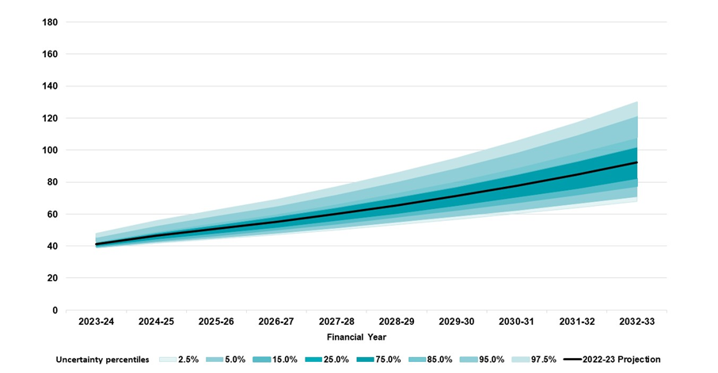Table 6.7 quantifies this increasing level of uncertainty in both absolute terms as well as a percentage of GDP. The table shows the deviation from the baseline projection is greater at the 95th percentile than at the 5th percentile. Therefore, the likelihood of extremely high values of Scheme expenses is greater than the likelihood of extremely low values of Scheme expenses, primarily driven by the skewed nature of uncertainty in additional growth. The average of all 20,000 simulations (which is equivalent to the baseline projection) is greater than the median result (50th percentile) as the more extreme high values increase the average.
The 5th percentile and 95th percentile results form a 90% confidence interval for the range of expected outcomes for projected Scheme expenses. The 90% confidence interval for the range of outcomes for Scheme expenses is:
- $39.0 billion to $45.6 billion for the year to 30 June 2024 (1.65% to 1.92% of GDP).
- $176.1 billion to $221.1 billion for the four years to 30 June 2027 (1.72% to 2.16% of GDP).
- $70.9 billion to $121.5 billion for the year to 30 June 2033 (1.93% to 3.30% of GDP).

Table 6.7: Scheme expenses as a proportion of projected GDP by projection year
Scheme expense ($m) for projection year Percentiles | 2023-24 | 2024-25 | 2025-26 | 2026-27 | 2032-33 | 2023-27
5.0% | 39,047 | 42,356 | 45,153 | 48,077 | 70,935 | 176,067
25.0% | 39,984 | 44,260 | 47,907 | 51,623 | 82,083 | 184,484
50.0% | 40,831 | 45,836 | 50,175 | 54,568 | 91,259 | 191,532
75.0% | 42,027 | 47,959 | 53,056 | 58,150 | 101,739 | 200,638
95.0% | 45,632 | 52,962 | 59,250 | 65,292 | 121,504 | 221,080
Standard Deviation | 2,469 | 3,652 | 4,694 | 5,699 | 16,093 | 15,384
Coefficient of Variation | 5.96% | 7.85% | 9.21% | 10.29% | 17.28% | 7.92%
Baseline | 41,360 | 46,376 | 50,788 | 55,207 | 92,341 | 193,731
Proportion of GDP
Baseline | 1.74% | 1.86% | 1.94% | 2.01% | 2.51% | 1.90%
5.0% | 1.65% | 1.70% | 1.73% | 1.75% | 1.93% | 1.72%
95.0% | 1.92% | 2.13% | 2.27% | 2.38% | 3.30% | 2.16%
Table 6.8 shows the projection results expressed as the difference between the projected Scheme expense and the baseline projection. The 90% confidence interval for the range of expected outcomes for projected Scheme expense is:
- From $2.3 billion below to $4.3 billion above the baseline projection, for the year to 30 June 2024, which is a range of $6.6 billion (16% of the baseline projection).
- From $17.7 billion below to $27.3 billion above the baseline projection, for the four years to 30 June 2027, which is a range of $45.0 billion (23% of the baseline projection).
- From $21.4 billion below to $29.2 billion above the baseline projection, for the year to 30 June 2033, which is a range of $50.6 billion (55% of the baseline projection).

Table 6.8: Scheme expense for percentiles less baseline projection ($m)
Percentiles | 2023-24 | 2024-25 | 2025-26 | 2026-27 | 2032-33 | 2023-27
5.0% | -2,313 | -4,019 | -5,635 | -7,130 | -21,405 | -17,664
25.0% | -1,376 | -2,116 | -2,881 | -3,584 | -10,258 | -9,247
50.0% | -529 | -540 | -613 | -639 | -1,082 | -2,199
75.0% | 667 | 1,583 | 2,268 | 2,943 | 9,398 | 6,907
95.0% | 4,273 | 6,587 | 8,462 | 10,085 | 29,164 | 27,350
Baseline | 41,360 | 46,376 | 50,788 | 55,207 | 92,341 | 193,731

Table 6.9 shows the results in Table 6.8 expressed as a percentage of the baseline projection. There is an equal 5% likelihood that the Scheme expense would be:
- at least 5.6% below, or at least 10.3% above the baseline projection for the year to 30 June 2024.
- at least 9.1% below, or at least 14.1% above the baseline projection for the four years to 30 June 2027.
- at least 23.2% below, or at least 31.6% above the baseline projection for the year to 30 June 2033.

Table 6.9: Difference in Scheme expense percentiles as a proportion of baseline projection (%)
Percentiles | 2023-24 | 2024-25 | 2025-26 | 2026-27 | 2032-33 | 2023-27
5.0% | -5.6% | -8.7% | -11.1% | -12.9% | -23.2% | -9.1%
25.0% | -3.3% | -4.6% | -5.7% | -6.5% | -11.1% | -4.8%
50.0% | -1.3% | -1.2% | -1.2% | -1.2% | -1.2% | -1.1%
75.0% | 1.6% | 3.4% | 4.5% | 5.3% | 10.2% | 3.6%
95.0% | 10.3% | 14.2% | 16.7% | 18.3% | 31.6% | 14.1%

Quantification of key risks
Table 6.10 shows the Coefficient of Variation (CoV) of the Scheme expense associated with each risk if it were modelled separately and independently of the other key risks. The largest contributor to risk is additional growth, however, in the longer term, model specification risk and new entrant risk become more significant.

Table 6.10: CoV assessment of each individual component of risk
Risk Type | 2023-24 | 2024-25 | 2025-26 | 2026-27 | 2032-33 | 2023-27
Additional growth | 5.5% | 7.0% | 8.0% | 8.5% | 11.7% | 7.0%
Model specification risk | 1.8% | 2.8% | 3.6% | 4.3% | 8.1% | 2.9%
New entrants | 0.2% | 0.7% | 1.4% | 2.2% | 7.6% | 1.2%
Normal inflation | 0.0% | 0.8% | 1.4% | 2.0% | 4.6% | 1.1%
Supported Independent Living | 0.4% | 0.8% | 1.2% | 1.2% | 1.4% | 0.9%
The key observations for each risk are as follows:
- Additional growth has the highest CoV compared to the other risks for each projection year. Assumptions relating to additional growth remain highly uncertain, given the evolving nature of the Scheme, and the level of judgement involved in determining the additional growth assumptions.
- Model specification risk has a high CoV, increasing over time, reflecting the inherent complexity in modelling and projecting Scheme expenses.
- New entrant risk increases over time due to the number of new entrants in earlier years impacting the Scheme expense in future years, and the uncertainty in estimating the incremental number of new entrants in future years.
- Normal inflation risk is zero in the first projection year. Assumptions relating to normal inflation are deterministic in the first projection year as they are based on the 2022-23 Annual Pricing Review. Normal inflation risk has lower CoV compared to most of the other risks during the period from 2023-27. The CoV in later years reflects increasing uncertainty in the level of wage and consumer prices over time.
- SIL transitions risk is reduced during the first projection year since a proportion of the participants who are expected to transition into SIL in that year already have a finalised Home and Living decision. In later years, the level of uncertainty relating to SIL transitions, as measured by its impact on total Scheme expenses, is expected to increase only slightly. This is because the uncertainty in total Scheme expenses will increasingly be driven by younger new entrants, who are less likely to require SIL supports compared to existing, older, participants.

Judgement and materiality of assumptions
A level of judgement is required in setting assumptions about future experience of the Scheme, where the level of judgment varies depending on the extent to which there is supporting evidence, based on credible and reliable data (lower degree of judgement), or other factors where there is less certainty (higher degree of judgement). Further, different assumptions impact Scheme projections to a greater or lesser degree, referred to as the materiality of the respective assumptions, which is informed by the scenario analysis results (Section 6.1).
Tables 6.11 and 6.12 set out the relative level of judgement involved and materiality associated with each of the main assumptions underlying the projection of future Scheme expenses, both in the short-term (four years 2023-24 to 2026-27) and the medium to long term (years 2027-28 and beyond).
In both the short and medium to long term, a high degree of judgment is involved in setting the additional growth assumptions which are influenced by a number of factors. By contrast, mortality rate assumptions, which are derived from experience and not impacted by changes to decisions and actions of the government and Agency involve little judgement. New entrant assumptions are split between children (aged 0 to 14) and older children and adults (aged 15 and above), as different factors influence the respective group of new entrants.

Table 6.11: Short-term relative level of judgement and impact on Scheme expense projections of main assumptions
Level of Judgement | Materiality: Short Term (2023-27) Low | Materiality: Short Term (2023-27) Medium | Materiality: Short Term (2023-27) High
High |  |  | Additional Growth rates
Medium | New Entrants (0-14)  Leaving and Transition rates | New Entrants (15+)  SIL Transition rates  Future Price Increases
Low | Mortality rates
Whilst the relative level of judgement associated in setting the various assumptions remains consistent over the long-term, compared to the short-term, the level of materiality increases over the long-term. As the Scheme continues to grow from year to year, the cumulative impact on the projected Scheme expenses becomes greater in the medium to long-term (Table 6.12).

Table 6.12: Long-term relative level of judgement and impact on Scheme expense projections of main assumptions
Level of Judgement | Materiality: Long Term (2027-28 and beyond) Low |  | Materiality: Long Term (2027-28 and beyond) Medium |  | Materiality: Long Term (2027-28 and beyond) High
High |  |  |  | Additional Growth rates
Medium |  | SIL Transition rates  Future Price Increases  Leaving and Transition rates |  | New Entrants (0 to 14)  New Entrants (15+)
Low | Mortality rates
Additional growth assumptions involve significant judgment, demonstrating a much higher level of variability than all other assumptions, and results in the greatest impact on the projected future Scheme expenses. Whilst more data and information is available to assess new entrant experience, the significant variability in number of new entrants from year to year makes it more challenging to set assumptions with confidence.
The level of judgement and materiality associated with each of the main assumptions, is consistent with the material risks, and variability in these risk factors, included in the Stochastic Model used to assess the uncertainty inherent in the projection of Scheme expenses (Section 6.2).

Historic AFSR projections
With each update of the AFSR, projection assumptions balance both the emerging experience (considering the significance and duration of the trends), and future expectations which continue to change over time. Updates to assumptions consider the significant growth in the Scheme over the past seven years, the relative immaturity of the Scheme and, in the most recent projection, Budget initiatives. As more data becomes available and as the Scheme continues to evolve, so too does the projection of Scheme expenses.
The changes in estimates of Scheme expenses as well as participant numbers and average payments per participants are set out below. The Scheme expense estimates by the Productivity Commission in 2017 (PC estimates) are also included for comparison.
Figure 6.2 shows the change in projected future Scheme expenses, for the four-year forward estimates at the specified projection date. Forward estimates of Scheme expenses have varied at each projection date, based on updated actual experience and future expectations at the projection date. This demonstrates the variability in actual experience, compared to expected, related to the inherent uncertainty in setting assumptions about future expected experience.

Figure 6.2: Change in forward estimates of Scheme expenses, by projection date
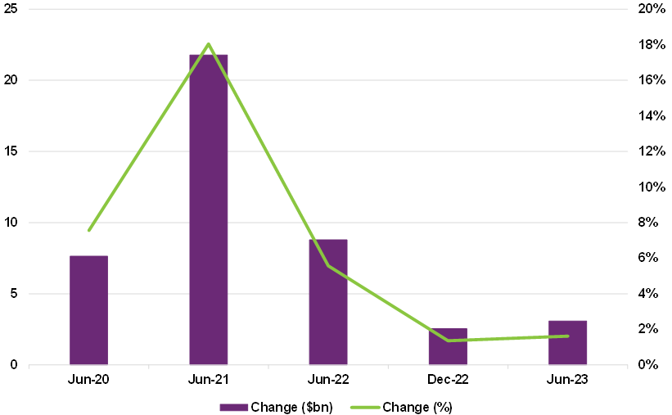
Table 6.13 shows total Scheme expense projections were revised upwards for each successive AFSR projection. Actual payments (on an accrual basis) since the 2017-18 financial year have exceeded the estimate from the most recent AFSR by amounts up to $1.1 billion, apart from the 2021-22 financial year. The actual payments for the 2021-22 financial year were $0.6 billion lower than the 30 June 2021 projections. These deviations highlight the challenge of accurately projecting participant payments, even in the short term.

Table 6.13: Scheme expenses – AFSR projections and 2017 PC estimates
Total Scheme expenses ($b) | 2017-18 | 2018-19 | 2019-20 | 2020-21 | 2021-22 | 2022-23 | 2023-24 | 2024-25 | 2025-26 | 2026-27
PC estimates
2017 Productivity Commission Estimates | 7.7 | 14.7 | 20.8 | 22.2 | 23.7 | 25.2 | 26.8 | 28.5 | 30.3 | 32.2
2017 Productivity Commission Estimates (including unanticipated costs) |  |  | 21.9 | 23.8 | 25.5 | 27.2 | 29.0 | 30.8 | 32.7 | 34.8
AFSR
30 June 2023 AFSR projection |  |  |  |  |  |  | 41.4 | 46.4 | 50.8 | 55.2
31 December 2022 projection |  |  |  |  |  |  | 40.0 | 45.3 | 50.3 | 55.0
30 June 2022 AFSR projection |  |  |  |  |  | 34.0 | 38.1 | 44.1 | 50.3 | 55.5
30 June 2021 AFSR projection |  |  |  |  | 29.2 | 33.9 | 38.0 | 41.4 | 44.6 | 47.9
31 December 2020 projection |  |  |  |  | 28.1 | 32.9 | 36.9 | 40.7 | 44.1 | 47.8
30 June 2020 AFSR projection |  |  |  | 22.3 | 26.1 | 28.9 | 31.4 | 34.3 | 37.4 | 40.7
31 December 2019 projection |  |  |  | 21.8 | 25.4 | 28.5 | 31.4 | 34.2 | 37.1 | 40.2
30 June 2019 AFSR projection |  |  | 16.7 | 21.1 | 24.2 | 26.9 | 28.9 | 30.8 | 33.3 | 35.8
30 June 2018 AFSR projection |  | 9.5 | 16.0 | 20.3 | 23.6 | 26.6 | 29.5 | 31.7 | 34.0 | 36.4
Comparison with actuals
Actual participant payments (accrual) | 5.4 | 10.5 | 17.6 | 23.3 | 28.6 | 35.1
Actual participant payments compared with June AFSR ($) |  | 0.9 | 0.8 | 1.0 | -0.6 | 1.1
Actual participant payments compared with June AFSR (%)  (Actual experience - AFSR projection)/(Actual experience) |  | 8.9% | 4.8% | 4.5% | -2.1% | 3.1%
While a component of the increases in the total expense projection over time is from a greater number of participants than previously expected, the main driver is the sustained growth in average payments per participant. The 30 June 2023 AFSR projection reflects both the emerging experience in participant intake and average payments per participant, as well as the successful delivery of the Budget initiatives. This further adds to the complexity in projecting participant payments. The components of the Scheme expenses are shown in further detail in Table 6.14.

Table 6.14: Participant numbers - AFSR projections and 2017 PC estimates
Total participant numbers | 2017-18 | 2018-19 | 2019-20 | 2020-21 | 2021-22 | 2022-23 | 2023-24 | 2024-25 | 2025-26 | 2026-27
PC estimates
2017 Productivity Commission Estimates | 264,100 | 447,300 | 473,700 | 485,900 | 497,700 | 509,300 | 520,800 | 532,000 | 542,900 | 553,200
AFSR
30 June 2023 AFSR projection |  |  |  |  |  |  | 668,900 | 714,800 | 754,000 | 792,200
31 December 2022 projection |  |  |  |  |  |  | 673,700 | 728,500 | 780,300 | 829,800
30 June 2022 AFSR projection |  |  |  |  |  | 592,300 | 646,000 | 693,900 | 741,100 | 787,800
30 June 2021 AFSR projection |  |  |  |  | 530,500 | 586,400 | 630,300 | 670,400 | 709,600 | 748,000
31 December 2020 projection |  |  |  |  | 537,900 | 596,600 | 643,200 | 682,800 | 721,600 | 759,700
30 June 2020 AFSR projection |  |  |  | 456,300 | 500,200 | 532,300 | 558,100 | 583,500 | 608,500 | 633,100
31 December 2019 projection |  |  |  | 443,200 | 485,200 | 518,400 | 544,000 | 568,500 | 592,500 | 616,300
30 June 2019 AFSR projection |  |  | 369,100 | 423,900 | 470,600 | 501,500 | 523,700 | 544,600 | 564,300 | 583,200
30 June 2018 AFSR projection |  | 306,200 | 380,500 | 426,600 | 465,100 | 499,300 | 521,000 | 541,700 | 561,700 | 581,100
Comparison with actuals
Actual participant numbers | 172,300 | 286,000 | 392,000 | 466,600 | 534,700 | 610,500
Actual participant numbers compared with June AFSR (#) |  | -20,200 | 22,900 | 10,300 | 4,200 | 18,200
Actual participant numbers compared with June AFSR (%)  (actual participants number - AFSR projection) / Actual participants number |  | -7.1% | 5.8% | 2.2% | 0.8% | 3.0%
The PC estimates assumed participants would initially enter the Scheme more rapidly than occurred prior to June 2019. Participant projections for each successive AFSR projection have been revised to reflect the pace at which participants have entered the Scheme. The projections have been generally revised upwards at successive AFSRs.
For the 30 June 2023 AFSR projection, participant assumptions have been revised downwards to reflect the recent lower participant numbers experience relative to the expectations at the 31 December 2022 projection. Despite the reduction, future projections remain well above earlier estimates as well as the PC estimates.

Table 6.15: Average payments per participant ($) - AFSR projections and 2017 PC estimates
Average payments per participant ($) | 2017-18 | 2018-19 | 2019-20 | 2020-21 | 2021-22 | 2022-23 | 2023-24 | 2024-25 | 2025-26 | 2026-27
PC estimates
2017 Productivity Commission Estimates | 39,900 | 41,300 | 45,100 | 46,400 | 48,200 | 50,100 | 52,100 | 54,100 | 56,400 | 58,700
2017 Productivity Commission Estimates (including unanticipated costs) |  |  | 47,500 | 49,500 | 51,900 | 54,100 | 56,300 | 58,500 | 60,900 | 63,400
AFSR
30 June 2023 AFSR projection |  |  |  |  |  |  | 64,000 | 66,300 | 68,400 | 70,600
31 December 2022 projection |  |  |  |  |  |  | 61,300 | 63,700 | 65,800 | 67,300
30 June 2022 AFSR projection |  |  |  |  |  | 59,400 | 60,700 | 64,900 | 69,100 | 71,500
30 June 2021 AFSR projection |  |  |  |  | 57,800 | 59,900 | 61,600 | 62,800 | 63,700 | 64,800
31 December 2020 projection |  |  |  |  | 55,000 | 57,200 | 59,100 | 60,900 | 62,400 | 64,100
30 June 2020 AFSR projection |  |  |  | 51,800 | 53,800 | 55,300 | 57,200 | 59,800 | 62,400 | 65,000
31 December 2019 projection |  |  |  | 51,800 | 53,900 | 56,200 | 58,700 | 61,100 | 63,500 | 66,000
30 June 2019 AFSR projection |  |  | 49,800 | 52,000 | 53,400 | 54,800 | 56,200 | 57,700 | 59,700 | 61,900
30 June 2018 AFSR projection |  | 38,800 | 45,500 | 49,500 | 52,400 | 55,100 | 57,900 | 59,700 | 61,600 | 63,600
Comparison with actuals
Actual average participant payments (accrual) | 38,900 | 42,500 | 50,800 | 54,300 | 55,200 | 60,600
Actual average participant payments compared with AFSR ($) |  | 3,700 | 1,000 | 2,500 | -2,600 | 1,200
Actual average participant payments compared with AFSR (%)  (Actual - AFSR projection) / Actual |  | 8.5% | 1.9% | 4.7% | -4.8% | 2.0%
Assumptions for average payments per participant have generally been revised upwards at successive AFSR projections. This reflects the emerging experience of sustained significant growth in actual average payments over an extended period. Despite these substantial increases, the AFSR projections have typically under-projected average payments in each following year. Projections have assumed operational initiatives would lead to reduced growth in average payments over time.
Average payments per participant in the 2022-23 financial year were higher than projected from the 30 June 2022 projections as discussed in Section 4.4. This experience has been considered in the increases made to the starting average payment assumptions during this review as discussed in Section 5.6.
Actual growth and assumed growth assumptions are included in Table 6.16. Compared to the 30 June 2022 projections, a higher growth rate is assumed in 2023-24 followed by lower growths after 2024-25. While normal inflation is assumed to be higher at this review for all financial years except the 2024-25 financial year, this is more than offset by reductions in the additional growth assumptions from the 2024-25 financial year onwards.

Table 6.16: Actual and assumed rates of growth in average payments per participant
Total growth rate | 2018-19 | 2019-20 | 2020-21 | 2021-22 | 2022-23 | 2023-24 | 2024-25 | 2025-26 | 2026-27
30 June 2023 AFSR projection |  |  |  |  |  | 5.5% | 3.7% | 3.2% | 3.3%
31 December 2022 projection |  |  |  |  |  | 1.0% | 3.9% | 3.3% | 2.4%
30 June 2022 AFSR projection |  |  |  |  | 7.7% | 2.1% | 6.9% | 6.6% | 3.5%
30 June 2021 AFSR projection |  |  |  | 6.5% | 3.5% | 2.9% | 1.9% | 1.5% | 1.8%
31 December 2020 projection |  |  |  | 1.3% | 3.9% | 3.3% | 3.1% | 2.5% | 2.7%
30 June 2020 AFSR projection |  |  | 1.9% | 3.8% | 2.9% | 3.6% | 4.4% | 4.4% | 4.3%
31 December 2019 projection |  |  | 2.0% | 3.9% | 4.4% | 4.5% | 4.0% | 3.8% | 3.9%
30 June 2019 AFSR projection |  | 17.4% | 4.2% | 2.8% | 2.5% | 2.7% | 2.6% | 3.5% | 3.8%
30 June 2018 AFSR projection | -0.1% | 17.3% | 8.8% | 5.8% | 5.2% | 5.0% | 3.1% | 3.2% | 3.3%
Actual experience as at 30 June | 9.2% | 19.7% | 6.9% | 1.6% | 9.9%
As noted in Table 6.16, the AFSR projection is not an extrapolation of past trends. Instead, assumptions have been set using a forward-looking approach. Hence, there is a high degree of uncertainty in the projection.

Participant outcomes and investment effectiveness

Outcomes and financial sustainability
Any assessment of Scheme financial sustainability needs to consider not only the costs of participant funding but also the extent to which this funding enables participants to achieve their goals and outcomes.
Underscoring the insurance-based principles upon which the Scheme rests, the National Disability Insurance Scheme Act 2013 (the NDIS Act) specifies that reasonable and necessary supports for people with disability should:
- Support people with disability to pursue their goals and maximise their independence.
- Support people with disability to live independently and to be included in the community as fully participating citizens.
- Develop and support the capacity of people with disability to undertake activities that enable them to participate in the community and in employment.
Hence, the NDIA has a responsibility to measure how participant funding impacts the achievement of outcomes related to maximising independence and inclusion in the community, including employment. This includes consideration of both amount and type of funding, for example, the types of supports that lead to good outcomes for participants.
In turn, analysis of how funded supports change in response to outcomes contributes to effective monitoring of Scheme financial sustainability. For example, achieving increased independence should lead to a decrease in funded core supports over time.
As the cost of the Scheme increases, it becomes increasingly important for the Agency to demonstrate how the Scheme is successfully building the capacity of participants to increase their independence and economic and social participation. A positive perception of the Scheme by the general public, who contribute through taxation, needs to be maintained to ensure their ongoing support. A positive benefit-cost analysis, where there is evidence of marginal gains being achieved with the funding, will help to demonstrate the success of, and engender trust in, the Scheme.
Ideally, this benefit-cost analysis should have wider scope than just the NDIS. The NDIS is expected to benefit the broader Australian economy, for example through increased participation in work for people with disability and their families and carers (with consequent reduction in government income support), reduced hospitalisations through improved support in the community, and reduced involvement with the justice system through improved community connections and health and wellbeing outcomes.
Hence, measurement of outcomes and costs, both to the NDIS and other mainstream service systems, is critical in understanding the success of the NDIS and is a legislative requirement.

Outcomes and the IEP
As discussed in section 8 of this report, the Investment Effectiveness Program (IEP) will formally examine the causal link between expenditure and outcomes. It will build on previous work undertaken to link outcomes and funding, and provide a framework for examining the benefit-cost questions outlined above. The longitudinal data collected on outcomes will be a key input to the IEP.

Families and carers
Families and carers play an important role in supporting NDIS participants. Improved outcomes for participants under the NDIS can be expected to facilitate this role, leading to improved outcomes for families and carers also, such as increased employment.
The NDIS Act also acknowledges the role of families and carers in participants’ lives:
- The role of families, carers and other significant persons in the lives of people with disability is to be acknowledged and respected.
- The relationship between people with disability and their families and carers is to be recognised and respected.

The outcomes framework questionnaires
The outcomes framework questionnaires collect information on how participants and their families and carers are progressing in different areas (domains) of their lives.
The questionnaires were developed to monitor individual and Scheme progress over time, and to benchmark (for example, to Australians without disability, and to other OECD countries). Longitudinal modelling of the data collected has also been used to investigate the link between outcomes and risk factors, including socio-demographic factors, as well as the supports received by participants. As described above and in section 8, the IEP will build on this modelling work in an attempt to explain the causal link between supports (including individual, community and mainstream) and the achievement of outcomes.

Development
Development of the questionnaires involved:
- A review of existing national and international frameworks.
- A review of available population data against which to benchmark performance, including Australian Bureau of Statistics (ABS) surveys as well as other sources.
- Consultation with a wide range of stakeholders, including the NDIA Independent Advisory Council (IAC), key stakeholder groups, disability researchers, participants and families/carers.
- A pilot of the questionnaires.

Questionnaires by life stage
Leveraging research conducted by the IAC, the outcomes framework takes a lifespan approach to the measurement of outcomes, recognising that different milestones are important for different age groups. Hence different versions of the questionnaires are used, for both participants and families/carers, depending on the age of the participant.
The four versions of the participant questionnaires are for participants aged:
- from birth to before starting school.
- from starting school to 14.
- 15 to 24.
- 25 and over.
The three versions of the family/carer questionnaires are for families and carers of participants aged:
- from birth to 14.
- 15 to 24.
- 25 and over.

Participant domains
Participant domains vary for children and adults. While most domains overlap, goals and outcomes may differ depending on the age group.

Figure 7.1: Participant domains by age group
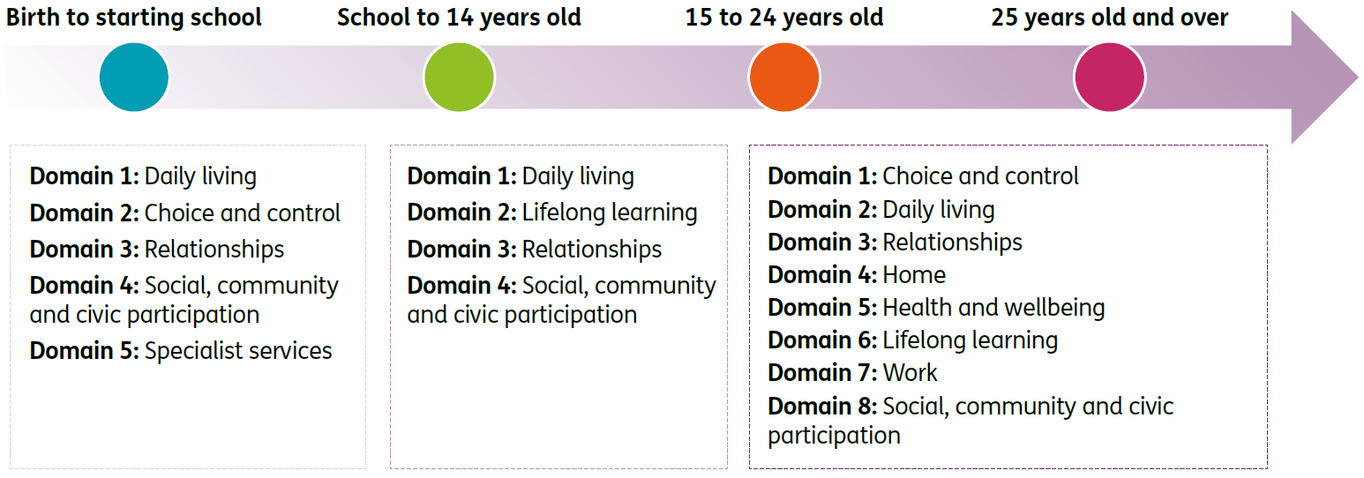

Family/carer domains
Overall, families and carers share many similar goals and challenges, regardless of participant age. As such, a number of the domains do indeed overlap.

Figure 7.2: Family/carer domains by participant age group
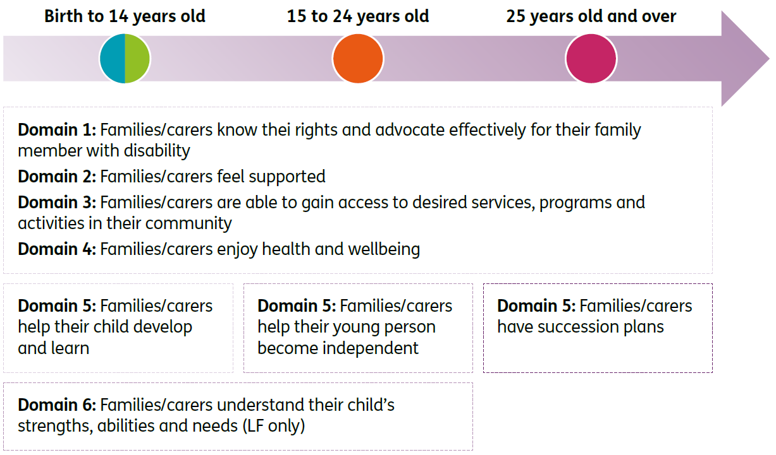

Short Form (SF) versus Long Form (LF)
The pilot was used to refine the questionnaires, including removing redundant questions and revising wording for clarity. It also led to the development of two versions of the questionnaires, a long form (LF), similar to the versions piloted, and a short form (SF).
The SF is completed by all participants and a family member or carer where possible and contains questions useful for planning as well as key indicators to monitor and benchmark over time.
The LF is completed for a subset of participants and includes all of the SF questions plus some additional questions allowing more detailed investigation of participant and family/carer experience, and additional benchmarking.

Baseline versus longitudinal
Participants and their families and carers are interviewed at baseline (Scheme entry), and approximately annually thereafter.
It is important to recognise that, with respect to how they are going in different areas of their lives, participants do not enter the Scheme on an equal footing. A range of individual and external factors will impact on the experiences of participants at baseline, including the extent to which their disability affects their life, where they live, and the extent of support they receive from family and friends.
Consequently, the success of the Scheme should be judged not on baseline outcomes, but on how far participants have come since they entered the Scheme, acknowledging their different starting points.
The longitudinal history built up from responses to the outcomes framework questionnaires is used to analyse progress at an individual and Scheme level, to provide insight into how the Scheme is making a difference and point to areas where improvements may be required.

Reporting on outcomes
Information collected from the questionnaires is used to contribute to a range of publicly available reports, including:
- Quarterly reports to disability ministers (Quarterly Reports | NDIS)
- Annual outcomes reports (Participant outcomes report | NDIS, Family and carer outcomes report | NDIS)
- Deep dives focusing on specific outcome areas, such as employment (Employment outcomes - participants, their families and carers | NDIS), health and wellbeing (Health and wellbeing of NDIS participants and their families and carers | NDIS) and the impact of the COVID-19 pandemic on participant and family/carer outcomes (COVID-19 impact on participant and family/carer outcomes 30 June 2020 | NDIS).

Participant outcomes – results
This section “Participant outcomes – results” and the next section “Has the NDIS helped?” show analyses of participant outcomes as at 30 June 2023, for participants entering the Scheme from 1 July 2016. It is worth bearing in mind that the global COVID-19 pandemic that took hold from early 2020 has had an impact on at least some participant and family/carer outcomes, such as employment and community participation. The initial impact (to 30 June 2020) on outcomes was considered in a publicly available report. The impact on employment outcomes to 31 December 2020 was further considered in the latest report on employment outcomes.

Economic and social participation
Analysing changes in participants’ economic and social participation is important for understanding whether the reasonable and necessary supports funded by the Scheme are resulting in better participant outcomes. In the NDIS Corporate Plan 2022-26, Aspiration 1 is “a quality experience and improved outcomes for participants”, and there are specific performance metrics and targets outlined, such as the proportion of participants in work and the proportion of participants involved in community and social activities. Changes in outcomes have been measured for participants who have been in the Scheme for at least two years, to allow sufficient time for the reasonable and necessary supports provided by the Scheme to have an influence on participant outcomes.

Employment
The NDIA recognises the critical role of employment in boosting the well-being, economic security and social inclusion of people with disability. From a sustainability perspective, when a NDIS participant works they contribute to the economy, use less support for other activities to fill their days, and family members and carers can also return to work and contribute to the economy. The NDIA had a target of 26 per cent of working-age participants in paid employment by June 2022, with the achieved result of 23 per cent slightly below this target.
The NDIS Participant Employment Strategy 2019-22 (the Strategy) which was released on 30 September 2019 sets out the NDIA’s vision, commitment, and plan for supporting participants to find and keep meaningful employment.
The current low unemployment rate in Australia offers increased opportunities for employment of people with disability, including NDIS participants, although the interruptions to employment preparation caused by COVID-19 lockdowns are yet to be fully overcome in some areas. The Employment Action Plan 2021-22 adapted the Strategy action plans to the current environment and contains 12 targeted actions that sit under six priority areas.
Overall, the Strategy has been aimed at improving employment outcomes for participants and people with disability more broadly, and to guide the Agency in becoming a leader and advocate of disability employment. A new Participant Employment Strategy 2023-2026, which builds on the achievements of the existing Strategy, is under development.
The updated Strategy will focus on:
- Achieving higher levels of employment for working age participants.
- Better information for providers and participants.
- Improving capability of planners and local area coordinators, particularly in guiding participant conversations about employment and linking them to appropriate services.
- Accurately measuring impact of these changes on employment outcomes.

Results – percentage in a paid job
The Corporate Plan employment metric for participants aged 15 and over is based on the SF question “Are you currently working in a paid job?” with response options “Yes”, “No, but I would like one” and “No and I don’t want one”. The indicator “percentage in a paid job” is the number answering “Yes” as a percentage of the total number answering the question, and hence the denominator includes people who are not interested in employment. From a benchmarking perspective, this is similar to the “employment to population ratio” reported in the ABS Labour Force statistics.
The percentage in a paid job for those in the Scheme for at least two years continues to be relatively stable overall, however, results differ by age group. While employment has increased for those in the 15-24 year age group, it has remained stable or declined for all other age bands. Specifically, comparing responses at the most recent plan reassessment (between two and six years after entry) with responses at Scheme entry, there was a:
- Eleven percentage point increase from 11% to 22% for participants aged 15-24 years.
- One percentage point increase from 27% to 29% for participants aged 25-34 years.
- One percentage point decrease from 28% to 27% for participants aged 35-44 years.
- Two percentage point decrease from 25% to 23% for participants aged 45-54 years.
- Four percentage point decrease from 19% to 15% for participants aged 55-64 years.
- Four percentage point decrease from 13% to 8% for participants aged 65 years and older.
Overall, for participants of working age (15-64 years) there has been a two percentage point increase, from 21% to 23%. This compares to a 2022-23 target of 26%.
Figure 7.3 provides more detail on these results, showing trends over time in the Scheme by age band for different duration cohorts (participants who have been in the Scheme for approximately six, five, four, three or two years at 30 June 2023).

Figure 7.3: Percentage of participants in a paid job – longitudinal trends for participants in the Scheme for two to six years.
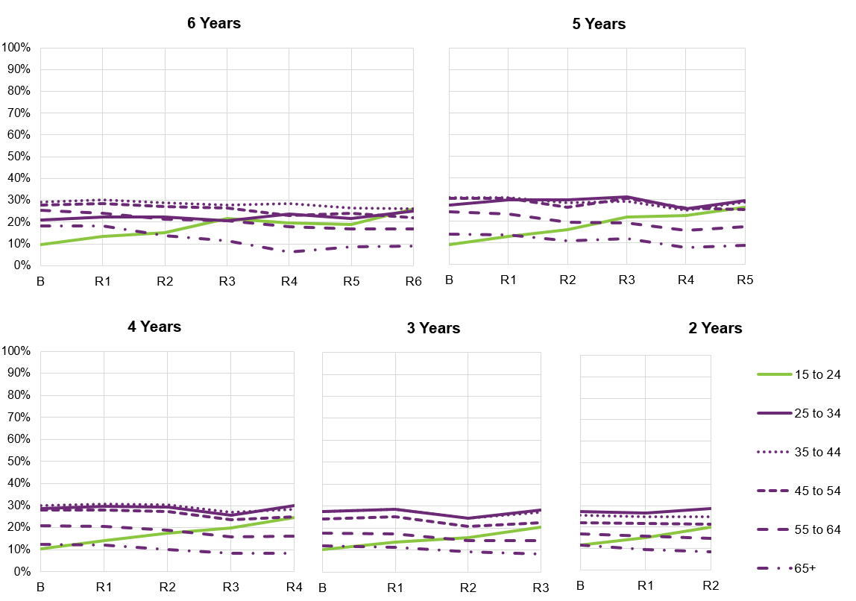
Figure 7.3 shows a strong increasing trend in the percentage with a paid job for the 15 to 24 age group for all duration cohorts, in part reflecting the transition from school to work. For participants in the Scheme for four or five years, those aged 25 to 54 are the most likely to have a paid job, and the level of employment and trend over time is similar for the three age groups within this range. For participants in the Scheme for two or three years, those aged 25 to 44 are more likely than those aged 45 to 54 to have a paid job. For all duration cohorts, the level of employment is lower for participants aged 55 to 64, and lowest for those aged 65 and over, and both of these age groups show a decreasing trend. Part of this decreasing trend is likely to be due to participants retiring from the workforce.
Further details about the employment outcomes for NDIS participants can be found in the publicly available report titled “Employment outcomes for NDIS participants as at 31 December 2020”. High level insights on employment outcomes are also published in the NDIA’s Quarterly Reports to Disability Ministers.

Social and community participation
Participation in the community has many benefits for participants, including fostering a sense of belonging and connection, developing social networks and reducing isolation, and increasing confidence and feelings of safety. It can also be a way to increase opportunities for employment or study. Participation in the community can lead to increased independence and reduced reliance on Scheme supports.

Results – percentage actively involved in the community
The Corporate Plan social and community engagement metric for participants aged 15 and over is based on the SF question “Have you been actively involved in a community, cultural or religious group in the last 12 months?” with response options “Yes, a general community group”, “Yes, a group for people with disability”, “No, but I would like to be” and “No and I don’t want to be”. The indicator for social and community engagement is the number answering “Yes” (regardless of setting) as a percentage of the total number answering the question.
Despite COVID-19, participation in community and social activities has continued to increase. Results tend to be more similar by age group than for employment. Specifically, the percentage actively involved in a community, cultural or religious group in the last 12 months showed a:
- Six percentage point increase from 34% to 40% for participants aged 15–24 years.
- Nine percentage point increase from 36% to 45% for participants aged 25-34 years.
- Seven percentage point increase from 36% to 43% for participants aged 35-44 years.
- Seven percentage point increase from 35% to 42% for participants aged 45-54 years.
- Five percentage point increase from 35% to 40% for participants aged 55-64 years.
- Six percentage point increase from 36% to 42% for participants aged 65 years and older.
Overall, for participants aged 15 and over, there has been a seven percentage point increase, from 35% to 42%. This compares to a 2022-23 target of 46%.
Figure 7.4 provides more detail on these results, showing trends over time in the Scheme by age band for different duration cohorts (participants who have been in the Scheme for approximately six, five, four, three or two years at 30 June 2023). Due to improvements persisting over time, the change from baseline is greater the longer participants have been in the Scheme, for all age groups.

Figure 7.4: Percentage of participants actively involved in the community – longitudinal trends for participants in the Scheme for two to six years.
Figure 7.4 shows that increases in social and community participation generally tend to level off slightly after approximately three years in the Scheme. Whilst differences by age are smaller than for employment, participants aged 25 to 34 tend to be slightly above other age groups whereas participants aged 15 to 24 tend to be slightly below. The extent of improvement is slightly lower for the oldest two age groups.

“Has the NDIS helped?”
Participants who have entered the Scheme since 1 July 2016 have been asked whether the NDIS has helped with areas related to each domain. Participants are asked at each plan reassessment, allowing the Agency to gain valuable longitudinal insights. Results for selected domains are shown in this section, and compare responses provided at the first plan reassessment with those from later reassessments, for participants who have been in the Scheme for at least two years.
On the whole, perceptions of the Scheme have been positive, with participants and their families/carers more likely to report that the Scheme had helped them in various areas of their lives the longer the participant was in the Scheme. These results suggest a growing level of support for the Scheme by its participants and the family members and carers of participants. These positive perceptions are another indication of Scheme effectiveness and in the long-term assist in strengthening the ongoing financial sustainability of the Scheme.

Results – Corporate Plan choice and control metric
The Corporate Plan choice and control metric for participants aged 15 and over is based on the SF question “Has the NDIS helped you have more choices and more control over your life?”
Positive perceptions of whether the NDIS has helped with choice and control have increased for the latest reassessment compared to the first reassessment across all age bands. Older participants tend to have higher levels of satisfaction. Specifically, the percentage who think that the NDIS has helped them have more choices and more control over their life showed a:
- Nine percentage point increase from 61% to 70% for participants aged 15-24 years.
- Eleven percentage point increase from 66% to 77% for participants aged 25-34 years.
- Ten percentage point increase from 69% to 79% for participants aged 35-44 years.
- Ten percentage point increase from 69% to 80% for participants aged 45-54 years.
- Ten percentage point increase from 71% to 81% for participants aged 55-64 years.
- Twelve percentage point increase from 71% to 82% for participants aged 65 years and older.
Overall, for participants aged 15 and over, there has been a ten-percentage point increase, from 67% to 77%. This compares to a 2022-23 target of 75%.
Figure 7.5 provides more detail on these results, showing trends over time in the Scheme by age band for different duration cohorts (participants who have been in the Scheme for approximately six, five, four, three or two years at 30 June 2023).

Figure 7.5: Percentage who think the NDIS has helped them have more choices and more control over their life – longitudinal trends for participants in the Scheme for two to six years, participants aged 15 and over.
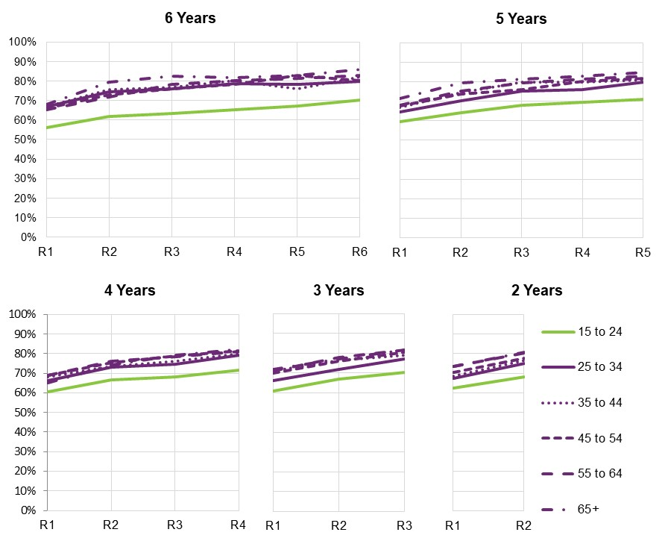
Figure 7.5 shows the generally lower levels of satisfaction for participants aged 15 to 24 compared to the older age groups.

Other results – “Has the NDIS helped?”
For children aged from birth to before starting school, results have improved across all domains.
Table 7.1 shows the percentages responding positively at first reassessment and at latest reassessment, as well as the change between the two time points.

Table 7.1: “Has the NDIS helped?” – participants aged from birth to before starting school
Domain | First reassessment % | Latest reassessment % | Percentage point change
Daily living: child’s development | 91 | 94 | +3
Daily living: access to specialist services | 92 | 95 | +3
Choice and control (child’s ability to communicate what they want) | 83 | 86 | +3
Relationships (fitting into family life) | 77 | 83 | +6
Social, community and civic participation (fitting into community life) | 63 | 70 | +6
Improvements were slightly stronger for fitting into family and community life (although results for these domains started off at a lower level and hence had more scope to improve).
Figure 7.6 provides more detail for two areas (development and access to specialist services), showing trends over time in the Scheme for different duration cohorts (participants who have been in the Scheme for approximately six, five, four, three or two years at 30 June 2023).

Figure 7.6: Percentage who think the NDIS has helped – longitudinal trends for participants in the Scheme for two to six years, age 0 to before starting school
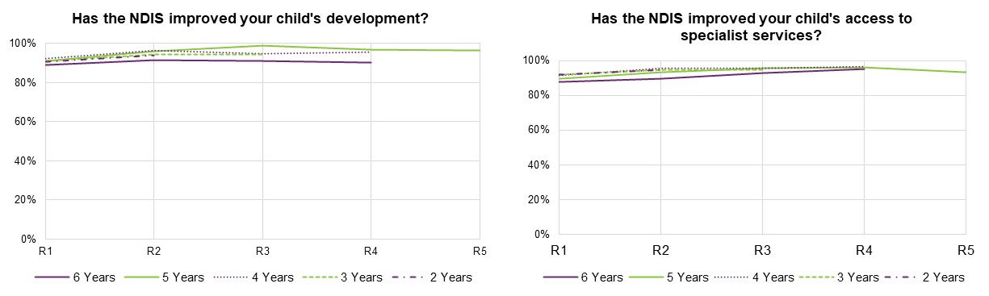
Figure 7.6 shows very high initial levels of satisfaction for these two areas. Nevertheless, an improving trend over time in the Scheme has been observed. Results for the different duration cohorts are generally similar.
For children aged from starting school to age 14, results are generally less positive than for the younger age group, but show stronger improvement over time.
Table 7.2 shows the percentages responding positively at first reassessment and at latest reassessment, as well as the change between the two time points.

Table 7.2: “Has the NDIS helped?” – participants from starting school to age 14
Domain | First reassessment % | Latest reassessment % | Percentage point change
Daily living (independence) | 61 | 73 | +12
Lifelong learning (access to education) | 41 | 51 | +9
Relationships (with family and friends) | 50 | 60 | +10
Social, community and civic participation (social and recreational life) | 45 | 53 | +7
Figure 7.7 provides more detail for two domains (gaining independence and relationships with family and friends), showing trends over time in the Scheme for different duration cohorts (participants who have been in the Scheme for approximately six, five, four, three or two years at 30 June 2023).

Figure 7.7: Percentage who think the NDIS has helped – longitudinal trends for participants in the Scheme for two to six years, age starting school to 14
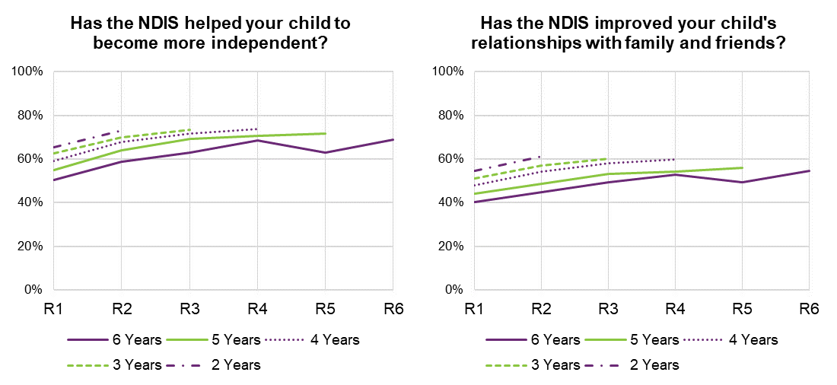
Figure 7.7 shows an increasing trend for these two indicators over time in the Scheme, apart from some volatility for those in the Scheme six years (where numbers are smaller). Participants entering more recently show higher levels of satisfaction than those entering earlier.
For young adults aged 15 to 24 years, Table 7.3 shows the percentages responding positively at first reassessment and at latest reassessment, as well as the change between the two time points.

Table 7.3: “Has the NDIS helped?” – participants aged 15 to 24
Domain | First reassessment % | Latest reassessment % | Percentage point change
Choice and control | 61 | 70 | +9
Daily living | 61 | 72 | +11
Relationships | 50 | 54 | +5
Home | 22 | 21 | -1
Health and wellbeing | 43 | 51 | +7
Lifelong learning | 36 | 37 | +1
Work | 18 | 17 | -1
Social, community and civic participation | 55 | 62 | +7

From Table 7.3, the largest improvement over time in the Scheme has been observed for the daily living domain (+11 percentage points). Strong improvements have also been observed for choice and control (+9 percentage points), relationships (+5), health and wellbeing (+7) and social, community and civic participation (+7). Lifelong learning showed a marginal increase (+1), and there were slight declines for home and work.
Figure 7.8 provides more detail for two domains (daily living and health and wellbeing), showing trends over time in the Scheme for different duration cohorts (participants who have been in the Scheme for approximately six, five, four, three or two years at 30 June 2023).

Figure 7.8: Percentage who think the NDIS has helped – longitudinal trends for participants in the Scheme for two to six years, age 15 to 24.
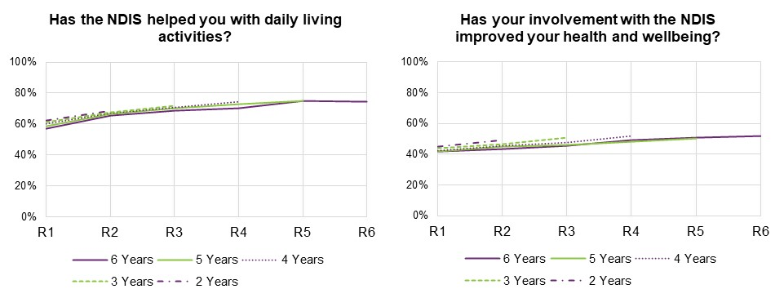
Figure 7.8 shows that improvements continue to occur over six years for the health and wellbeing domain. For daily living, improvement has levelled off in the sixth year.
For participants aged 25 years and over, perceptions tend to be more positive than for those aged 15 to 24, and the older adult group also shows a stronger improvement over time. Table 7.4 shows the percentages responding positively at first reassessment and at latest reassessment, as well as the change between the two time points.

Table 7.4: “Has the NDIS helped?” – participants aged 25 and over
Domain | First reassessment % | Latest reassessment % | Percentage point change
Choice and control | 69 | 80 | +11
Daily living | 72 | 84 | +11
Relationships | 52 | 62 | +9
Home | 31 | 35 | +5
Health and wellbeing | 52 | 61 | +9
Lifelong learning | 30 | 32 | +2
Work | 19 | 19 | 0
Social, community and civic participation | 59 | 70 | +10
From Table 7.4, the largest improvements over time in the Scheme have been observed for daily living (+11 percentage points) and choice and control (+11 percentage points). Strong improvements have also been observed for relationships (+9), health and wellbeing (+9) and social, community and civic participation (+10). By contrast with the younger adult group, there was an improvement for the home domain (+5 percentage points). Similar to the younger adult group, lifelong learning showed a marginal increase (+2), and there was no material change for work.
Figure 7.9 provides more detail for two domains (daily living and health and wellbeing), showing trends over time in the Scheme for different duration cohorts (participants who have been in the Scheme for approximately six, five, four, three or two years at 30 June 2023).

Figure 7.9: Percentage who think the NDIS has helped – longitudinal trends for participants in the Scheme for two to six years, age 25 and over.
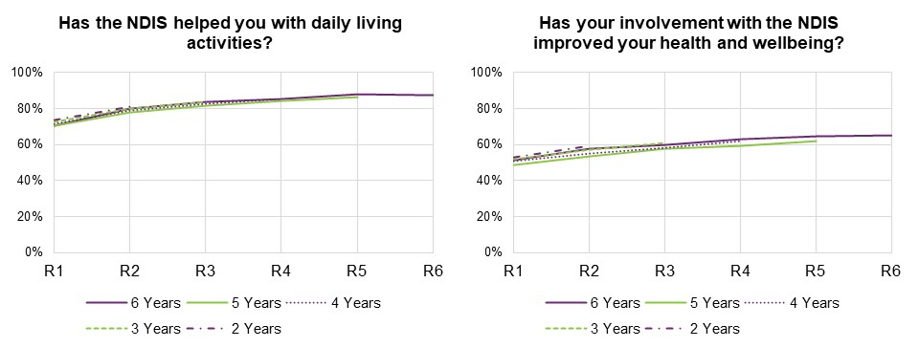
Figure 7.9 shows that improvements have continued to occur for these two domains, even after five years in the Scheme. However, improvements have levelled off in the sixth year.

Family and carer outcomes – results
The NDIS Outcomes Framework measures outcomes for the families and carers of participants as well as participants, recognising that the outcomes for people with a disability and the people who support them are likely to be closely linked. Families and carers of participants who are well supported under the Scheme and who are achieving greater independence and social and economic participation, are likely to find the caring role easier and to experience increased wellbeing and greater opportunities for social and economic participation themselves. This improved situation for families and carers should in turn translate into further improved outcomes for participants,.

Results – percentage of parents/carers in a paid job
The NDIA’s Corporate Plan metric for parent and carer employment is based on the SF question “Are you currently working in a paid job?” with response options “Yes” and “No”.
As for participants, it should be noted that the global COVID-19 pandemic that took hold from early 2020 has had an impact on family/carer employment (and other indicators).
The percentage of parents/carers in a paid job for participants who have been in the Scheme for at least two years has improved over time. Specifically, comparing responses at the most recent plan reassessment (between two and six years after entry) with responses at Scheme entry, there has been a:
- Six percentage point increase from 46% to 51% for parents/carers of participants aged 0-14 years.
- Two percentage point increase from 47% to 48% for participants aged 15 years and over.
Overall, for parents/carers of participants across all ages combined, there has been a four percentage point increase, from 46% to 50%. This compares to a 2022-23 target of 50%.
Figure 7.10 provides more detail on these results, showing trends over time in the Scheme for different duration cohorts (families/carers of participants who have been in the Scheme for approximately six, five, four, three or two years at 30 June 2023).

Figure 7.10: Percentage of parents/carers of participants in a paid job – longitudinal trends for participants in the Scheme for two to six years
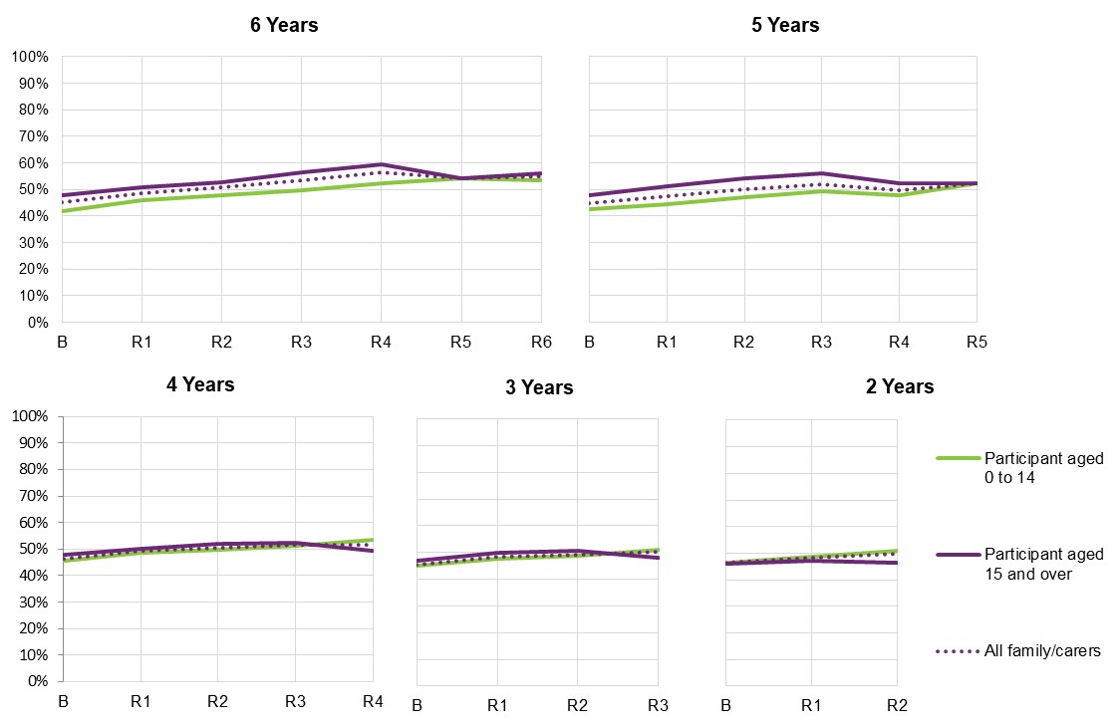
Figure 7.10 shows that for participants in the Scheme five or six years, families and carers of those aged 0 to 14 tend to have lower employment outcomes than families and carers of older participants. However, this difference is not apparent for families and carers of participants in the Scheme for shorter durations. For families and carers of participants aged 15 and over, improvements seem to have levelled off over the latest year or two.

Results – “Has the NDIS helped?”
Table 7.5 shows the percentages of families and carers responding positively at first reassessment and at latest reassessment, as well as the change between the two time points. Results are shown separately for participants aged 0 to 14 and those aged 15 and over.

Table 7.5: “Has the NDIS helped?” – families and carers
Participant aged 0 to 14
Domain | First reassessment % | Latest reassessment % | Percentage point change
Rights and advocacy | 63 | 72 | +8
Families feel supported | 69 | 76 | +8
Access to services, programs and activities | 71 | 78 | +7
Health and wellbeing | 44 | 48 | +4
Child’s development | 75 | 81 | +6
Participants aged 15 and over
Domain | First reassessment % | Latest reassessment % | Percentage point change
Rights and advocacy | 51 | 63 | +12
Families feel supported | 63 | 75 | +12
Access to services, programs and activities | 60 | 70 | +10
Health and wellbeing | 36 | 41 | +5
Child’s development | - | - | -
From Table 7.5, perceptions tend to be more positive for families/carers of participants aged 0 to 14 than for those of older participants. The largest improvements over time in the Scheme have been observed for “rights and advocacy” and “families feel supported” (+8 percentage points for families/carers of participants aged 0 to 14, and +12 percentage points for families/carers of participants aged 15 and over). Strong improvements have also been observed for access to services (+7 and +10 for families/carers of participants aged 0 to 14 and those aged 15 and over, respectively), and to a lesser extent health and wellbeing (+4 and +5, respectively).
Figure 7.11 provides more detail for the question “Has the NDIS improved the level of support for your family?”, showing trends over time in the Scheme for different duration cohorts (participants who have been in the Scheme for approximately six, five, four, three or two years at 30 June 2023).

Figure 7.11: Percentage of families/carers who think that the NDIS has improved the level of support for their family – longitudinal trends for participants in the Scheme for two to six years, age 0 to 14 and 15 and over.
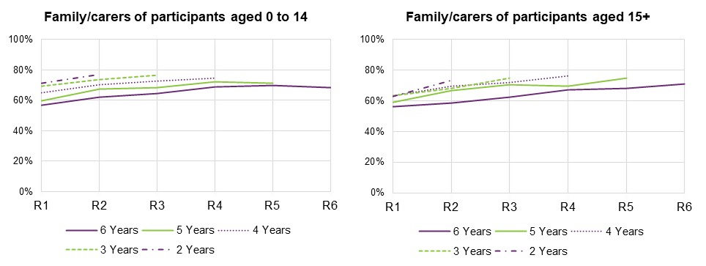
Figure 7.11 shows that families and carers increasingly feel that the NDIS has improved the level of support for their family, the longer the participant has been in the Scheme. Families and carers of participants entering more recently tend to have higher levels of satisfaction.

Investment Effectiveness Analysis
The Investment Effectiveness Program (IEP) is being undertaken by the NDIA to better understand the link between government-funded supports and the attainment of participant outcomes. The analysis has been designed so that in future, this evidence can be used by participants, their carers and planners to understand what types and combinations of funding have been effective for others in similar circumstances.
Understanding these links can better inform participants on how their decisions regarding potential supports impact their individual needs and help their ongoing choices under the Scheme. The IEP will produce two key deliverables:
- An analysis of outcomes quantifying the marginal effect of different types, levels and combinations of support payment for all NDIS participants.
- An effectiveness modelling report and dashboard that shows how findings could be used by participants and planners to shape plans which are closer to a theoretical ‘ideal’ payment mix, allowing for individuals’ preferences and goals.
A pilot has been established to test analytical approaches, using a single cohort of participants aged 15-24 with intellectual disability (ID) and/or Down syndrome when they joined the NDIS. This cohort was selected following a process of internal consultation and prioritisation.
Initial models from the pilot group have uncovered several positive relationships between certain payment categories and outcomes. Some were obvious, for example more Capacity Building payments for Daily Activity is associated with a better daily living outcome. While others were less so, for example more Core Transport payments are associated with better ‘Home’ outcomes. Further work is ongoing to validate the findings of the analysis.

Risk management

Introduction
Although the National Disability Insurance Scheme (NDIS) has been in operation for over 10 years, it has only been available to all States and Territories for 5 years, and to all Australians for 3 years. Given the long-term nature of the Scheme, experience continues to be relatively immature, and many aspects remain difficult to interpret. Specifically, estimation of future expenditure based on experience is inherently challenging given the relative size, complexity, and immaturity of the Scheme, meaning there is significant uncertainty in the projection. In addition, within emerging experience to date, issues have been identified with the current resource allocation process, and in particular the lack of a mechanism for robust assessments of support need.
As the Scheme continues to mature, and staff, operational and governance capabilities improve, there is an expectation the Scheme operations and experience will change, perhaps materially, and this would affect the eventual trajectory of Scheme expense. Decisions and actions of the Government and Agency and the Australian and global economic climate will also impact on the Scheme, including the existing Budget initiatives and potential upcoming changes to policy settings.
Future events cannot be predicted with certainty, and they may lead to unexpected impacts on Scheme experience which differ from the projections in this report. Examples of events with the potential to have a significant impact on future Scheme experience include another pandemic, unexpected changes in global inflationary pressures and changes to economic conditions which cause further workforce shortages in the disability sector.
With each update of the AFSR, projection assumptions balance both the emerging experience (considering the significance and duration of the trends), and future expectation which continue to change over time. Updates to assumptions consider the significant growth in the Scheme over the past seven years, the relative immaturity of the Scheme and, in the most recent projection, Budget initiatives. As more data becomes available and as the Scheme continues to evolve, so too does the projection of Scheme costs.
Significant pressures on the financial sustainability of the Scheme remain and have become more significant. This is reflected in the upward revision of projected Scheme expenses in past AFSRs.
There are a number of risks that impact on the financial sustainability of the Scheme. This chapter provides a commentary on these and the mitigation factors in place or being developed to reduce the likelihood or impact of these risks.

Risk Management Arrangements and Responsibilities
As set out in the NDIS Corporate Plan 23-27, the Agency’s approach to risk management is to embed an understanding of risks, controls and mitigations in every aspect of the organisation, across business planning, escalations and reporting, decision making, operations and strategic initiatives.
The NDIA’s risk governance and framework is underpinned by the:
- National Disability Insurance Scheme Act 2013
- National Disability Insurance Scheme Risk Management Rules 2013
- Public Governance, Performance and Accountability Act 2013
- related Commonwealth policies and frameworks.
The Board oversees this approach through the Risk Committee and Audit Committee, to ensure effective risk management, performance management and governance frameworks.
Senior executives are responsible for managing Agency risks through regular monitoring and reviewing of risks, controls and treatment plans.
Risk management roles and responsibilities are defined for staff at all levels and supported by guidance materials, training modules, and access to risk advisory services.
The proactive use of risk management enables the Agency to effectively manage its operational and strategic risks within the bounds of appetite set by the Board.
The Risk Management Strategy describes the Agency’s strategic approach to managing risks and is underpinned by risk management processes and procedural materials that guide all levels of the organisation to identify and manage risks and implement applicable strategies to minimise adverse consequences and maximise opportunities. Implementation of a positive risk culture within the Agency is supported through executive advocacy, risk training, and awareness activities.
The Agency has a structured approach to identifying, managing, escalating, and communicating key risks. Together the Board, Chief Risk Officer (CRO), and Strategic Leadership Team oversee the efficacy of risk management performance of the NDIA. The responsibilities of the Board to ensure effective implementation of a contemporary risk management framework is enabled through the Risk Committee and Audit Committee.
The CRO has responsibility to ensure:
- NDIA systems, reporting and processes have risk management embedded.
- Risk owners are supported by dedicated risk officers.
- Appropriate controls are in place to mitigate fraud and promote compliance, and manage risk associated with safeguarding public funds while concurrently supporting participant choice and control.
The Scheme Actuary also has certain risk management responsibilities as part of their role, with the primary focus relating to the financial sustainability of the Scheme.
Figure 8.1 illustrates how the role of the CRO and Scheme Actuary relate with respect to risk management.

Figure 8.1 – NDIS & NDIA Risk Management Ecosystem
The responsibilities of the Scheme Actuary in relation to the risk management of the Scheme are described in more detail in the Section 8.3.

Responsibilities of the Scheme Actuary
The responsibilities of the Scheme Actuary in relation to the risk management of the Scheme are broadly defined in legislation and more explicitly detailed in the documents which comprise the Scheme’s and Agency’s Risk Management Framework. These responsibilities are as follows:

NDIS Act
- If the scheme actuary has significant concerns about the financial sustainability of the National Disability Insurance Scheme, or the risk management processes of the Agency, he or she must report those concerns to the Board as soon as reasonably practicable.

NDIS Risk Management Rules
- The Board must also ensure that the scheme actuary is involved in decisions made by the Agency and the Board in relation to risk, to the extent that that involvement is appropriate and consistent with the scheme actuary’s duties and the National Disability Insurance Scheme—Rules for the Scheme Actuary 2013.

NDIS - Rules for the Scheme Actuary
- The scheme actuary must include the following matters in an annual financial sustainability report:
(a) an overall assessment of the financial sustainability of the NDIS that identifies the key risks and issues impacting on the financial sustainability of the NDIS.
(b) a discussion of the key risks and issues identified and, where these have an adverse impact on financial sustainability, recommendations designed to manage the risks or address the issues.
- The scheme actuary must advise the Agency on how processes, systems and tools of the NDIS relating to the NDIS risk management framework can best be developed and implemented to enable the scheme actuary to perform his or her duties under section 180B of the Act effectively, and in particular to allow the scheme actuary to be satisfied that the NDIS is financially sustainable.
- The scheme actuary must include the following matters in an annual financial sustainability report:
(a) a discussion of the Agency's administrative infrastructure, its administrative processes and risk management arrangements
Risk management arrangements, of the Agency, means all of the systems, structures, cultures, processes, policies and people that identify, assess, mitigate and monitor all sources of risk, both internal and external, to financial sustainability.

NDIA Risk Management Strategy
Risk management roles and responsibilities – responsibilities of the Scheme Actuary are to:
- Assess the financial sustainability of the Scheme and risks to that sustainability and identify recommendations to manage or address these risks.
- Include in an annual financial sustainability report a discussion of the Agency’s risk management arrangements and any recommendations in relation to inadequacies.

NDIS Insurance Principles and Financial Sustainability Manual
The NDIS Insurance Principles and Financial Sustainability Manual outlines the NDIS’ insurance model in detail and defines financial sustainability as the state where:
- The Scheme is successful on the balance of objective measures and projections of economic and social participation and independence, and on participants’ views that they are getting enough money to buy enough goods and services to allow them reasonable access to life opportunities - that is, reasonable and necessary support.
- Contributors think that the cost is and will continue to be affordable, under control, represents value for money and, therefore, remain willing to contribute.
To comprehensively consider the risks to financial sustainability faced by the Scheme, the two-fold definition above can be linked to the Strategic Risks identified in the most recent Corporate Plan and this analysis is provided in the next section.

Corporate Plan Strategic Risks
On an annual basis, the NDIA Board determines the strategic risks for the Agency, which are directly aligned to the Corporate Plan. The Board determined seven strategic risks for 2023-24 in the areas of:
- Scheme outcomes
- Participant experience
- Partner and provider performance
- Scheme sustainability
- People capability and capacity
- Scheme integrity
- Change delivery and capacity.
The Agency’s strategic risks are monitored against key performance indicators and reported to the Strategic Leadership Team and Risk Committee on a quarterly basis. The strategic risks are complemented by operational risks and controls which are owned and managed at group or initiative level.
A number of key risks to the financial sustainability of the Scheme have been identified:
- Inflationary effects, including additional growth
- New incidence of disability
- Agency capacity and funding
- Capability of disability sector to respond to demand
- Fraud and non-compliance
- Transitions into SIL
- 3P/PACE rollout implications
- Budget initiatives
Each of these key risks are expanded on in the commentary below, linking each of them to the strategic risks in the Corporate Plan.

Strategic risk 1 - Scheme outcomes
Ability to deliver consistent, high-quality plans to facilitate the achievement of identified goals
to enable participant social and economic outcomes.
Strategic Risk 1 closely mirrors the first component in the definition of financial sustainability in Section 8.3 above.
The mitigation strategies for this risk outlined in the Corporate Plan include a focus on, and being informed by, participant goals and outcomes in the delivery of the Scheme, investment in engagement with the disability sector, seeking co-design for Scheme changes and enhancing the quality and consistency of home and living decisions. All of these actions help to reduce risks to the financial sustainability of the Scheme. The NDIS Outcomes Framework, Investment Effectiveness Program and various Home and Living activities are key vehicles through which these mitigation strategies will be delivered.
The NDIS Outcomes Framework measures outcomes for the families and carers of participants, recognising that the outcomes for people with a disability and the people who support them are likely to be linked. Participant outcomes and family and carer outcomes are discussed in Section 7.
The Investment Effectiveness Program (IEP) is being undertaken by the NDIA to better understand the link between Government funded supports and the attainment of participant outcomes. It is discussed in Section 7.
Investigation has been undertaken into the volume and types of participants who are not currently in SIL arrangements but might be expected to transition into SIL supports at some point. This work will continue to evolve and help inform views of the future growth in numbers of participants with SIL or other Home and Living arrangements. The implementation of the Home and Living Framework which includes co-design of improved ways of delivering Home and Living supports that give greater flexibility to participants and providers, is outcomes-focused, encourages better practice and ensures Scheme sustainability. Over the medium to long term this will likely have an impact on future numbers of participants accessing SIL supports. Future uncertainty relating to transitions into SIL, as measured by its impact on total Scheme expenses, has been quantified in Section 6 and are also discussed in the context of the Scheme’s sustainability under Strategic Risk 4 below.
Section 9 of this report includes recommendations in relation to the Outcomes framework, Home and Living supports and the Investment Effectiveness Program which are aimed at further mitigation of the risks to Scheme outcomes discussed above.

Strategic risk 2 - Participant experience
Ability to provide a quality participant experience in access decisions and planning, including
timely reviews.
Strategic Risk 2 also ties in with the first component in the definition of financial sustainability and in particular focuses on participants’ views as to whether they are receiving reasonable and necessary support.
The mitigation strategies for this risk focus on participant experience and feedback, including through co-design, and enhancing responsiveness to critical incidents and complaints.
The Participant Service Charter being actioned under the Participant Service Improvement Plan 2022-23 sets out how the Agency works towards increased consistency and transparency of decision making with better operational procedures, guidelines and controls. The Agency has designed and built a new Information and Communication Technology (ICT) system, PACE, to provide an enhanced Customer Relationship Management system and improve the end-to-end participant pathway. This is discussed in more detail in Section 2.
The implementation of the Participant Safeguarding Policy from April 2023 details how the Agency will be more proactive in identifying, assessing, and managing risk of harm to participants including when responding to critical incidents and complaints, provides clarity on roles and responsibilities in the NDIS support system and improves safeguarding resources for people with disability and Agency staff.
Section 9 of this report includes a recommendation in relation to Participant Outcomes which at a high level suggests that the NDIA should seek to redesign its outcomes framework to include broader system and community outcomes, as well as more objective measures of some participant and family/carer outcomes that are currently self-reported. This recommendation seeks to directly address the risks to the first component in the definition of financial sustainability.

Strategic risk 3 - Partner and provider performance
Ability to enable partner and provider capacity and service delivery.
Strategic Risk 3 relates to both aspects of the Scheme’s financial sustainability, that is, participants’ views that they are receiving reasonable and necessary support and contributors’ views on the cost effectiveness of the Scheme.
A specific challenge in relation to this strategic risk is the capability of the disability provider market to respond to demand.
The mitigation strategies outlined in the Corporate Plan prioritise regular engagement with partner organisations and NDIS providers, monitoring of costs to help participants identify value for money services and collaboration with other government bodies (i.e., the Department of Social Services and the NDIS Quality and Safeguards Commission) in support of a robust provider sector.
As the cost of the Scheme increases, it becomes increasingly important to measure how successful the Scheme is in building the capacity of participants to increase their independence and economic and social participation. A positive perception of the Scheme by the public, who contribute through taxation, needs to be maintained to ensure their ongoing support and continued development of a robust provider market.
Ideally, this cost-benefit analysis should have wider scope than just the NDIS. The NDIS is expected to benefit the broader Australian economy, for example through reduced hospitalisations via improved support in the community.
Hence, measurement of outcomes and costs, both to the NDIS and other mainstream service systems, is critical in understanding the success of the NDIS and is a legislative requirement.
Further, the NDIS forms part of the broader Australia’s Disability Strategy 2021-2031. The strategy is a commitment from all governments to a shared vision of an inclusive Australian society that enables people with disability to fulfil their potential as equal citizens. In particular, the strategy emphasises the need for improved performance of mainstream services in delivering outcomes for people with disability.

Strategic risk 4 - Scheme sustainability
Scheme scope, growth and/or costs deviate significantly.
Strategic Risk 4 relates directly to the ongoing costs of the Scheme as referred to in the second component of the financial sustainability definition.

Inflationary effects
Section 5.7 sets out the inflation assumptions used for the June 2023 projections and shows the impact of the Budget initiatives which are expected to reduce the levels of additional growth observed in payments, below historical levels.
Sustained elevated levels of additional growth remains one of the most critical sustainability pressures for the Scheme given the material impact on projected Scheme expenses.
Given the evolving nature of the Scheme, assumptions relating to additional growth involve considerable judgement and thus, remain highly uncertain.
The scenario analysis in Section 6.1 can be used to gauge the impact of higher normal inflation and additional growth assumptions compared with the baseline projection.
The uncertainty around the additional growth assumption is also demonstrated in the stochastic modelling presented in Section 6.2 which includes a quantification of the substantial impact of this uncertainty on Scheme expenses.

New incidence of disability
Section 5.4 sets out the new entrant rate assumptions and details the revisions made to these to reflect the latest expectations of future Scheme experience. Overall, the revised assumptions reflect a future expected decline in the long-term new entrants in the adult population over the next three years to 30 June 2026.
However, participation rates (the proportion of the Australian population that are NDIS participants) have not shown signs of slowing down and it is uncertain as to when new entrant rates will stabilise. This trend is driven predominantly by children with developmental delay joining the Scheme and new participants with autism.
Greater than expected new entrants will result in additional growth of Scheme expenses beyond those projected in this report. To illustrate the impact of current trajectories continuing scenario analysis is presented in Section 6.1, and uncertainty around these assumptions is included in the stochastic modelling presented in Section 6.2.

Participants leaving the Scheme
Section 5.4 also discusses the rate of participants leaving the Scheme for reasons other than death and assume a higher rate of participants leaving the Scheme relative to the previous review.
The vast majority of participants leaving the Scheme are expected to be children and experience has shown that the rate of participants leaving the Scheme is highly dependent on operational changes and resource allocation towards eligibility reassessment and therefore remains uncertain.
To quantify this inherent uncertainty, the scenario analysis in Section 6.1 presents a scenario where the impact of Budget initiatives on the rate of participants leaving the Scheme is removed.

Transitions into SIL
Section 5.5 sets out the assumptions related to SIL participants used for the June 2023 projections, including enhancements to capture the rate of participants transitioning to newly accessing SIL supports.
While the SIL transition assumptions are derived based on recent experience combined with long term expectations, there remains a degree of uncertainty around the emerging experience relating to the net increase in participants with SIL supports and when the number of participants with SIL will reach ‘maturity’ (grow in line with the overall growth in the adult population of the Scheme). Moreover, there is also uncertainty as to which alternative, more flexible and more efficient Home and Living options may be used in the Scheme in the future. Similarly, there is a high degree of uncertainty around the effectiveness and the implementation of the Budget initiatives which also impact SIL transitions.
As anticipating the number of participants likely to require SIL supports is a challenge that also has a material impact on projected Scheme expenses, scenarios are presented in Section 6.1 that illustrate the impact of higher or lower numbers of participants in SIL compared with the baseline projection and the stochastic modelling of transitions into SIL is presented in Section 6.2.
There are three mitigation strategies listed in the Corporate Plan which are designed to address risks to the Scheme’s sustainability:
- Monitoring Scheme costs against allocated funding.
- Engaging across jurisdictions to promote increased access and inclusiveness in community and mainstream supports.
- Working closely with the disability community to implement the Budget initiatives and through this close collaboration identify other opportunities to moderate future growth. The Budget initiatives are discussed further under the commentary for Strategic risk 7 below.
Section 9 of this report includes recommendations in relation to additional growth, model enhancements and new entrants which aim to reduce uncertainty in these areas.

Strategic risk 5 – People, capability and capacity
Ability to attract and retain a highly capable, high-performing workforce.
Strategic Risk 5 relates, directly and indirectly, to both aspects of the Scheme’s financial sustainability, because the ability of the Scheme to maintain a high-performing workforce across all areas of its operations will impact participants’ access to reasonable and necessary supports and also the cost of the Scheme.
The projections presented in this report implicitly assume that labour supply constraints observed in previous years will not continue and that the Agency and disability sector more broadly will continue to be adequately resourced.
In Table 5.36 of Section 5.10 the projected operating expenses before Budget initiatives are shown based on the 2022-23 Scheme projections and reflect higher projected participant numbers compared with the previous review, assuming a consistent level of resources per participant supported each year. The 2023-24 Budget includes Agency operating expenses of $1,680 million in 2024-25, approximately $470 million lower than budgeted projected expenses in 2023-24. Such a proposed reduction in operating expenses would result in substantial reductions in resources, leading to increased workloads and less capacity to support participants and manage risk, including fraud and integrity.
The mitigation strategies outlined in the Corporate Plan aim to enhance the Agency’s workforce and culture strategies and put in place the right capability and capacity strategies, processes and supports to maintain a high performing workforce.

Strategic risk 6 – Scheme integrity
Ability to protect the Scheme and participants against fraud and non-compliance.
Fraud and non-compliance within the Scheme erode participant outcomes and inflate Scheme expenses and maintaining the Scheme’s integrity by addressing Strategic Risk 6 is therefore critical to its financial sustainability.
The mitigation strategies in the Corporate Plan which address risks to the Scheme’s integrity are as follows:
- Expanded and more sophisticated prevention, detection and treatment options for fraud and non-compliance.
- Implement enhancements identified through the efforts of the Fraud Fusion Taskforce.
- Recognise the threat of cyber-attack and commit to maintain appropriate cyber security measures according to the Australian Government Security Framework (AGSF) inclusive of the Protective Security Policy Framework (PSPF), Australian Government Information Security Manual (ISM) and the Australian Secret Intelligence Organisation’s (ASIO) Technical Notes.
While improvements to Agency processes are underway, as well as initiatives to address fraud and non-compliance, many of these are at an early stage. To the extent any such initiatives are already implemented they will be reflected in the experience used to set the assumptions at this review, but no additional future savings have been allowed for explicitly in the projections presented.
To further curtail fraud and non-compliance in the Scheme, Section 9 of this report includes a recommendation for the focus of the Agency, with the support of additional investment, to move from monitoring behaviour of providers to one of taking action to reduce non-compliant and fraudulent behaviours.

Strategic risk 7 – Change delivery and capacity
Ability to implement fast-paced strategic initiatives, with a high degree of operational and Scheme readiness.
The 2022-23 projection of Scheme expenses allows for the expected impact of the measures announced in the 2023-24 Budget to lift the NDIA’s capability, capacity, and systems to better support participants. Effective implementation of these and other strategic initiatives and mitigating risks to these initiatives is key to ensuring the Scheme’s financial sustainability.
The implementation of the Budget measures is still in its early stages and as such there is uncertainty around the level to which they will mitigate Scheme growth. In Section 6.1 a scenario is presented without the impact of the Budget initiatives resulting in an increase to Scheme expenses of $6.2 billion in 2026-27 and $15.4 billion in 2032-33 relative to the June 2023 projections documented in this 2022-23 AFSR.
Another significant initiative impacting the Scheme is the planned national roll-out of 3P (PACE). The transition to this new CRM system is intended to deliver medium and long-term improvements to the efficiency of planning processes for the Agency and improve the participant experience. However as with any material shift in information and communications technology, there could be short term implementation issues.
The mitigation strategies in the Corporate Plan which address Change delivery and capacity risks focus on:
- Investing in continuous improvement approaches for major project management capability.
- Working collaboratively with Scheme stakeholders to prepare for significant changes.
- Establishing a strategic change capability to ensure a coordinated and targeted effort towards effective implementation and monitoring of the NDIA’s strategic reform priorities.
- The establishment of a rapid policy implementation approach to deliver coordinated implementation of high priority, urgent operational changes.
Additionally, as mentioned under Strategic Risk 4 above, the Agency has included as a mitigation strategy, to work closely with the disability community to implement the measures announced by the Government as part of its Budget package on 9 May 2023 to improve outcomes for participants and ensure the sustainability of the NDIS for future generations. Through this close collaboration, other opportunities to moderate future growth will be identified.
Section 9 of this report includes recommendations in relation to both the Budget initiatives and 3P (PACE), which at a high level include monitoring of the effectiveness of the various initiatives contained within these programs and improve the data collection and quality to enhance future decision-making.

Modelling Risks
The decisions made in relation to the Scheme’s ongoing operations and financial sustainability are at least in part reliant upon the modelling provided to decision makers. NDIS payment processes are still evolving and there is a limited history available for setting assumptions, as well as some limitations in the data available for analysis.
Modelling imperfections exist, which relate to factors impacting the Scheme that are not reflected in the projections, or are indirectly captured in the projections but not explicitly allowed for in the structure of the modelling or the assumptions used. Examples include increases in plan utilisation with increased duration in the Scheme, the level of fraud and/or non-compliance within the Scheme, and the impacts of government policy or legislative changes to the Scheme’s operations.
These limitations give rise to model specification risk, which is the risk that the model is not an accurate representation of reality. The dynamically changing nature of the NDIS means that the actual outcomes of the Scheme may vary from the projections. Model specification risk is discussed in Section 6.2 and is explicitly included in the stochastic analysis presented in that section.

Business continuity and Risk management system
The Agency is committed to ensuring that participant supports, provider services, and other critical business functions are maintained or quickly restored in the event of a significant outage, incident or crisis event. The Agency has established business continuity management plans, maintained through regular review and scenario analysis, to ensure the rapid resumption of participant and provider services and critical business activities in emergency situations.
The Agency’s integrated risk management system provides a single platform for managing operational, strategic, fraud, project and regulatory risks, audit recommendations, incidents, and business continuity plans. The system gives accountable executives extended visibility to the risks and controls within their business area and the broader Agency and provides for a connected risk environment through which inter-dependencies can be identified and managed.

Assessment of the Risk Management Framework
While the Agency’s tools, processes and procedures are commensurate with an entity of this size and level of maturity, they will continue to evolve with the Scheme. Future advancement in risk maturity will focus on further embedding positive risk behaviours and culture within the Agency, continuing to improve the integration and digitisation of its risk ecosystem to enhance risk-based decision making and consistency (particularly around access and plan budgets), better governance and implementation of policy changes, and proactive management of financial sustainability risks.
Managing strategic and operational risks to remain at an acceptable level is fundamental to the success and longevity of the Scheme. While strategies to mitigate these risks are articulated in current risk reporting, it will be important to monitor the effectiveness of these strategies in real time to ensure that they are having the desired impact and to make the necessary adjustments to ensure they remain within acceptable tolerances.
The risk management processes of the Agency and the Scheme have been considered and, based on the information available, it is assessed that they are operating effectively to support the financial sustainability of the Scheme. However, in this report a number of key risks to the financial sustainability of the Scheme have been articulated and some areas of improvement to the risk management framework have been identified as set out in the recommendations in Section 9.

Recommendations
The AFSR is required to include “a discussion of the key risks and issues identified and, where these have an adverse impact on financial sustainability, recommendations designed to manage the risks or address the issues”.
It is important to recognise that measures to address financial sustainability risks do not just consider current and estimated future amounts of Scheme expenses or participant plan budgets. Many of the recommendations presented in this section are instead focused on reducing the level of uncertainty associated with future support needs and therefore payments made for supports, or on improving participant outcomes through the provision of supports funded by the Scheme. Reducing uncertainty and achieving positive outcomes from funded supports are both core components of financial sustainability.
Section 9.1 sets out a summary of the progress made during 2022-23 in relation to the recommendations made in the previous review. Section 9.2 includes new recommendations arising from the analysis undertaken in the development of this AFSR, that are intended to manage identified risks and achieve greater certainty in relation to the long-term financial sustainability of the Scheme.
As part of the Federal Budget delivered on 9 May 2023 (“the Budget”), the Government announced it will provide funding to the NDIS, over four years from 2023-24, to implement initiatives (“Budget initiatives”) aimed to support participant outcomes and address the effective and sustainable operation of the Scheme.
In October 2022, the Minister for the National Disability Insurance Scheme (NDIS) announced the Independent Review (“NDIS Review”) into the NDIS to improve the wellbeing of Australians with disability and ensure the Scheme’s sustainability so that future generations receive the benefit of the NDIS. A final report by the Independent Review Panel was provided to the Disability Reform Ministers in November 2023. It is expected that the NDIS Review will lead to changes in the NDIA’s work plan.
New recommendations described in this section have been determined independently of any changes that could arise from the NDIS Review, once the final report is delivered, and before the Budget initiatives have been fully designed and implementation commenced. Review recommendations may overlap to some extent with the recommendations detailed in Section 9.2 of this report and with the Budget initiatives and should be viewed in this context.

Key themes and progress since previous review
Table 9.1 shows the key themes encompassed by the recommendations, including a summary of the progress made during 2022-23 and the corresponding recommendation for this review.

Table 9.1: Key themes and progress made during 2022-23
Key Themes | Progress during 2022-23 | This review
- Participant and family/carer outcomes | No recommendation in previous review | Recommendation 1
- Additional growth in participant plans | The service delivery team continued to monitor growth in participant plans during 2022-23.  Additionally, analysis was undertaken to investigate and better understand the link between payment growth and plan inflation, and the different components of each.  Insights into the drivers of growth in plan budgets above pricing impacts will be used to inform the co-design of Budget initiatives to improve consistency in planning decisions. | Recommendation 2
- Participants with autism in the Scheme | Actual experience in 2022-23 shows an emergence of higher numbers, and proportion of female new entrants with autism, and a continued increase in the proportion of new entrants with autism aged 15 and above.  Work to better understand the drivers of the high numbers of participants with autism entering the Scheme is ongoing, as is the exploration of alternative scenarios relating to future experience. | Recommendation 3
- Participants with complex/high support needs | During 2022-23, Home and Living eligibility decisions for participants accessing SIL for the first time, were investigated to better understand the drivers for participants transitioning to SIL arrangements, the types of participants by disability, age and level of function, and time from eligibility decision being made, to services first being provided and payments made.  Using these insights, more explicit modelling of participants transitioning to SIL supports was developed, and has provided stronger evidence that the projected numbers of participants entering SIL arrangements in the future is reasonable. | Recommendation 4
- Participants with psychosocial disability in Scheme | Participants entering the Scheme with psychosocial disability as their primary disability continue to be lower than originally expected by the Productivity Commission. This is evidenced by the high proportion of participants with psychosocial disability with a previously unmet need. Participants can have trouble gaining access to the Scheme, as they often have multiple types of disability, getting access to the Scheme via secondary disabilities, or as their level of functioning deteriorates over time. | Recommendation 5
- Budget initiatives | Not applicable to previous review. | Recommendation 6
- Long term Scheme projections and maturity | Scheme expense projections have been replicated using a statistical modelling program to enable projections beyond 10 years, used to produce the lifetime cost estimates and provide projections over a forty-year period to inform the 2023 Intergenerational Report (IGR) forecasts. | Recommendation 7
- Compliance and Fraud | Fraud fusion taskforce being piloted. | Recommendation 8
- Information systems and Scheme data | A new participant CRM system (PACE) has been piloted in Tasmania during 2022-23, with a national roll-out planned starting from October 2023.  Continued to improve integrity of data collected and stored within the Enterprise Data Warehouse (EDW), uplifting data modelling standards, improving governance systems and processes, and adding new tools, collectively delivering standardisation of definitions, improved and simplified access to users, and flexibility to customise data sets. | Recommendation 9
- Participant data (PACE) | Not applicable to previous review. | Recommendation 10
- Investment Effectiveness Program | A preliminary analysis was undertaken for a pilot cohort of participants aged 15 to 24 with an intellectual disability including Down Syndrome, identifying “positive” relationships where funding leads to improved outcomes. | Recommendation 11

Recommendations from this review

Participant and family/carer outcomes
The existing NDIS Outcomes Framework for measuring outcomes for participants and their families and carers was developed during the trial period through an extensive consultation process, including with the Independent Advisory Council, disability organisations, disability researchers, and experts working with specific cohorts (such as Indigenous, Culturally and Linguistically Diverse (CALD), early childhood, psychosocial disabilities). Draft questionnaires were piloted with trial participants and their families and carers, and their feedback was also incorporated into revised versions of the questionnaires.
Longitudinal data from the existing framework has been collected since 1 July 2016, thus building up a rich longitudinal history covering seven years. Information collected from the questionnaires is used to contribute to a range of publicly available reports, including the results shown in Section 7 of this AFSR.
It is increasingly recognised that the NDIS is expected to have wider economic and societal benefits. Examples of the benefits may include increased participation in work for people with disability and their families and carers (with consequent reduction in government income support), reduced hospitalisations through improved support in the community, and reduced involvement with the justice system through improved community connections and health and wellbeing outcomes. In order to measure these broader benefits, an expanded outcomes framework will be required.
The NDIS has contributed to the Australia’s Disability Strategy (ADS) Outcomes Framework which was developed to measure progress under ADS 2021-31. It was developed in consultation with people with disability and currently includes a broad spectrum of system measures, population measures and community attitude measures across seven outcome areas. While the ADS Outcomes Framework is still evolving, it can be used to inform the redesign of an outcomes framework for the NDIS, to better reflect the maturing of the Scheme and its impacts on the broader economy and community as well as on NDIS participants and their families and carers.
Recommendation 1: The NDIA should seek to redesign its outcomes framework to include broader system and community outcomes, as well as more objective measures of some participant and family/carer outcomes that are currently self-reported. The redesign should include appropriate co-design and engagement to ensure that measurement of Scheme outcomes and effectiveness is trusted and ultimately owned by participants, their families and carers and the sector more broadly. The redesigned outcomes framework will enable a broader view of Scheme benefits and a better understanding of how these benefits can be maximised.

Additional growth in participant plan budgets
Additional growth in participant plan budgets (above normal inflation) has continued to increase in 2022-23, at a relatively higher rate compared to the average annualised growth rate over the past 3 years. This is true for participant cohorts with and without SIL supports, across all age groups, and irrespective of the length of time a participant has been in the Scheme. Additional growth in participant plan budgets translates into additional growth in average participants payments, to the extent participants use their budgets, and is a large source of the overall rate of growth in Scheme expenses.
There is a high degree of variability in observed additional growth in average participant payments from year to year as shown in Section 4.6, which introduces greater uncertainty in setting assumptions about future expected additional growth.
Monitoring of additional growth in plan budgets provides evidence of participants seeking increases to their plans ahead of plan re-assessments (intraplan inflation), and/or significant increases in plan budgets on re-assessment (interplan inflation), suggesting a potential lack of confidence that they will have funding available to meet their needs as reasonably required, including a change in circumstances over their lifetime.
Understanding of key drivers of additional growth in participant plan budgets, and how that translates to additional growth in average participant payments is important in addressing additional growth pressures and setting assumptions for Scheme expense projections. These drivers may be related to the Agency’s planning processes, changes in participants’ circumstances, such as a deterioration in level of function, or participants’ usage of their plans including the timing, the type and volume of supports.
Recommendation 2: The Agency should seek to understand the emerging impact of the introduction of lifecycle funding and better planning processes within the Budget initiatives, on changes to participant plan budgets, the type of and use of supports, and proportion of plan budget used. This will help the Agency understand the effectiveness of these Budget initiatives.

Participants with autism in the Scheme
Numbers of participants with autism entering the Scheme continues to grow year-on-year, representing 30% of total new entrants into the Scheme in 2022-23, with higher-than-expected numbers of females with autism and older children and adults with autism aged 15 and above accessing the Scheme for the first time in 2022-23. Numbers of older children and adults with autism entering the Scheme aged 15 and above has increased by 18% per year, over the past two years which may be due to factors such as greater awareness of autism in older children and adults who may have missed out on a diagnosis as a child, or adults who enter the Scheme with multiple disabilities or health conditions, including autism.
Further, given the numbers of participants with developmental delay transitioning to autism has been lower than expected in 2022-23, it is likely the numbers of participants with autism in the Scheme at June 2023 is understated. The lower-than-expected numbers of participants with developmental delay transitioning to autism, or intellectual disability, was driven by lower numbers of eligibility re-assessments, with service delivery resources prioritising eligibility assessments into the Scheme.
Rates of new entrants with autism, or transitioning from developmental delay to autism, do not appear to be stabilising as expected, making it challenging to determine when participation rates, for participants with autism, can reasonably be expected to stabilise in the medium to long term. This leads to uncertainty in the future projections of participant numbers and continued revisions to new entrant rates, making it difficult to provide an evidence base to recommend improvements to Scheme design and processes to better support individuals with autism.
Recommendation 3: The Agency should continue to better understand the drivers of the increasing prevalence of autism, specifically the increased rate of female participants entering the Scheme with autism, and higher than expected number of new entrants with autism aged 15 and above. This work will help gain insights, and lead to better informed decisions about older children and adult participants with autism, including expectations of future numbers of new entrants with autism.

Participants with complex/high support needs
Participants with Supported Independent Living (SIL) supports represented a relatively low percentage (5%) of total participants, yet accounted for a disproportionately higher percentage of total Scheme expenses (33% in 2022-23). Average payments for participants with SIL ($387,700 in 2022-23) are approximately 9 times that for participants without SIL supports ($42,700). A change in numbers of participants with SIL supports, even if it is small relative to Scheme numbers in aggregate, can have a material impact on total Scheme expenses, which was the case in 2022-23. Higher-than-expected numbers of participants transitioning into SIL arrangements for the first time in 2022-23, driven by changes to the Home and Living application process, was the main reason for the higher-than-expected Scheme expenses in 2022-23 (Table 4.11).
As such, for participants with SIL supports, it is critical to better understand changes in circumstances and/or level of function, secondary disabilities and other characteristics. There is also a need to better understand participants who are not currently receiving SIL supports but have complex/high-cost support needs and in many cases have similar characteristics to those currently in SIL. This would help the Agency build an evidence base to make better decisions related to home and living arrangements, and potentially to provide innovative solutions for participants with complex/high-cost support needs.
Additionally, variability in operational processes impacting the numbers of home and living eligibility decisions, makes it more challenging to analyse and draw robust conclusions from historical experience, used to set assumptions about future expected numbers of participants with SIL supports. This increases the uncertainty in future expected Scheme expense projections, making it difficult to assess sustainability of potential initiatives over time.
The Agency has undertaken extensive analysis during 2022-23, investigating:
- The time from the point of Home and Living SIL eligibility decisions being made, to the first time participants access SIL supports: to understand the link between numbers of home and living SIL eligibility decisions, as a leading indicator, and the timing and expected numbers of participants transitioning to SIL arrangements.
- Triggers/reasons for participants transitioning into SIL arrangements: to understand and build a potential pipeline of expected numbers of participants transitioning to SIL arrangements.
- The profile of participants transitioning to SIL arrangements, by primary disability group, level of function and age group: to establish a robust set of transition rates for participants new to SIL.
- Impacts of changes in Home and Living operational processes, introduced to drive consistency SIL eligibility decisions, on future expected numbers of participants transitioning to SIL.
- The volume and types of participants who are not currently in SIL arrangements but might be expected to transition into SIL supports at some point. This modelling has focused on participants who have similar characteristics and support needs to those who are already in SIL, and the pace at which those participants may transition into SIL arrangements in the future. The outputs from the modelling have been used as a reasonableness check on assumptions underlying the June 2023 projections and expected trajectory of the number of participants with SIL.
While this work has provided valuable insight into the experience of participants with SIL and other complex/ high support needs, it also provides the basis for further investigations to support better decision making going forward.
Recommendation 4: The Agency should continue to better understand the drivers/reasons for participants with complex/ high support needs to move into different types of living arrangements. Specifically, to understand the pathways and pace which participants move into Supported Independent Living, and other Home and Living arrangements. This will help the Agency make better decisions, and has the potential to provide innovative solutions for participants with complex/ high support needs.

Participants with psychosocial disability in the Scheme
The number of participants accepted into the Scheme, with psychosocial disability as their primary disability, remains considerably lower than the original expectations when the Scheme was designed. Previous investigations into new entrants indicates there is a higher proportion of participants entering the Scheme with a psychosocial disability that have a previously unmet need (PUN), compared with other disability types.
Investigations into new entrants, to distinguish participants entering the Scheme with a genuine new incidence or on-set of disability, compared to those with a PUN, suggests that new entrants with psychosocial disability have previously tried to gain access to the Scheme and been denied, or had a previous diagnosis and accessing the Scheme for the first time, as their level of function has deteriorated over time. Where access has previously been denied, this has related to the episodic nature of mental health illnesses such that it has not been considered a permanent disablement.
The extent to which participants with PUN will continue to enter the Scheme is highly uncertain and the time from when reasonable and necessary supports are required, to when they are likely to access the Scheme is unpredictable. This is seen in the variability of the numbers of new entrants with psychosocial disability from year-to-year, making it difficult to determine assumptions about future expected number of new entrants with psychosocial disability.
Recommendation 5: The Agency should seek to better understand the reasons why individuals with a psychosocial disability may not approach the Scheme or may not meet the eligibility criteria when applying for access to the Scheme. This will also inform estimates of longer-term rates of new entrants with a psychosocial disability to the Scheme.

Budget initiatives
As part of the Federal Budget delivered on 9 May 2023 (“the Budget”), the Government announced it will provide funding to the NDIS, over four years from 2023-24, to implement initiatives (“Budget initiatives”) aimed to support participant outcomes and address the effective and sustainable operation of the Scheme.
The NDIA is using a co-design approach to develop initiatives, working closely with participants, the Independent Advisory Council, Disability Representative and Carer Organisations and the disability sector more broadly. The initiatives are expected to drive moderated numbers of participants with developmental delay, greater participant trust in the NDIS supporting them over time, in turn leading to a moderation of future growth in participant plans, and stabilisation of numbers of participants with Supported Independent Living arrangements. Further, initiatives to mitigate from, or reduce fraudulent and non-compliant payments will help to alleviate pressures of additional growth on Scheme expenses.
An allowance has been made in the June 2023 Scheme projections, for the expected impact of the Budget initiatives, which was in line with the December 2022 Scheme projections used as the basis for the 2023-24 Budget. It is important the outcomes of the Budget initiatives can be measured, with progress tracked relative to the estimated impacts allowed for in the Scheme projections. Regular and timely reporting of progress is essential for management to make informed decisions about the overall effectiveness of the design and implementation of initiatives, and ultimately to drive the desired outcomes.
Recommendation 6: The Agency should develop and embed a framework and governance structure to effectively monitor the implementation of the Budget initiatives, and to measure and report on the overall effectiveness of the Budget initiatives. This will help the Agency make informed decisions, in a timely manner, to optimise the success of the Budget initiatives on improving the effectiveness and sustainability of the Scheme.

Long term Scheme projections and maturity
The AFSR sets out results of Scheme projections for a period of 10 years from 30 June 2023 to 30 June 2033. Over the 10-year period, the number of participants in the Scheme are projected to grow on average by 5.4% per annum, with Scheme expenses projected to grow on average by 8.4% per annum. As a percentage of GDP, projected Scheme expenses increase from 1.61% at June 2023 to 2.33% at June 2033, with Scheme expenses increasing at a greater rate than nominal GDP over the medium term. Applying the AFSR assumptions beyond 10 years, the rate of growth in participant numbers and Scheme expenses slows but does not stabilise over the foreseeable future.
Since the previous review, modelling of Scheme expenses beyond 10 years has been replicated using statistical modelling programs, which has improved robustness of projections used for the calculation of the Lifetime Cost Estimates in Section 5.10 of this AFSR. Additionally, this enabled the NDIA to provide Scheme expense projections over a 40-year period to Treasury, which have been used as input into the 2023 Intergenerational Report (IGR). The IGR projections of Scheme expenses are consistent with the NDIS Financial Sustainability Framework committed to by National Cabinet in April 2023, factoring in an annual growth target of 8% in 2026-27, moderating as the Scheme matures. The IGR defines Scheme maturity being the time when “NDIS participants are expected to grow in line with overall population growth and average support package costs would rise in line with broad-based wage and price rises”. On this basis, the IGR projects the Scheme will reach maturity by 2043 at 2.5% of nominal GDP.
Numbers of participants entering the Scheme continue to increase year-on-year, particularly numbers of children (aged 0-14) with developmental delay and autism, and older children and adults with autism (aged 15+), with no signs of new entrant rates for those cohorts stabilising in the short-to-medium term. Also, additional growth in participant plan budgets is expected to remain in excess of normal inflation. The high degree of unpredictability relating to both additional growth experience and numbers of new entrants, which drives uncertainty in setting assumptions, makes it is challenging to estimate when the Scheme will reach maturity.
Further work is needed to derive more robust long-term assumptions to use beyond 10 years, in particular related to new entrants to the Scheme, including ageing impacts of the Australian population and likelihood of entering the Scheme as functional capacity deteriorates with age, to better understand the trajectory of the Scheme and when it can reasonably be expected to reach a mature state. This in turn will enable the NDIA and other government agencies to make more informed decisions, and better understand how changes in projected nominal GDP and growth in Australian population might impact the longer-term financial sustainability of the Scheme.
Recommendation 7: The Agency should undertake investigations into the Scheme participation rates implied by the AFSR model and develop a better understanding of the long-term trajectory of the proportions of the Australian population who are supported by the NDIS. The scope of the investigation should also include Scheme expenses as a proportion of national GDP, the level at which the proportion stabilises and the point in time when it stabilises, depending on the assumptions underlying longer-term projections of the Scheme.

Compliance and Fraud
The NDIA's Claims & Payments Integrity (C&PI) team conduct regular payment assurance sampling to estimate the underlying error rate within the Scheme and undertake measures to mitigate, cancel and recover non-compliant payments. In 2022-23, 2,241 payments were reviewed as part of the payment assurance error rate sampling, which implied an underlying error rate of 4.17%. The processes followed by the C&PI team are increasingly mature and robust, and allow for a better understanding of trends, drivers and the financial impact of underlying non-compliance within the Scheme.
However, the reliance on highly manual processes for all pre- and post-payment validation means that only 0.02% of total Scheme expenses are reviewed pre-payment each year and 0.04% are reviewed post-payment. Significant investment is therefore required to scale up to a whole-of-Scheme solution, in particular investment in ICT capabilities and policy and legislative reform.
The review process also relies on independent information provided by participants and providers in relation to payment compliance, and hence it is reasonable to assume that few genuinely fraudulent payments are identified via this sampling.
Recommendation 8: Further investment should be made to enable the Agency to actively detect and address behaviours that are non-compliant and/ or fraudulent. This will help participants more effectively utilise their funding to meet their needs, potentially improving better outcomes. Reducing fraudulent behaviours also helps improve the sustainability of the Scheme.

Information systems and Scheme data
The full implementation of the new participant Customer Relationship Management (CRM) system (PACE) is still two years away, with the national roll-out planned to start by the end of 2023. Once fully implemented and integrated with other NDIS data in the Enterprise Data Warehouse (EDW), PACE will enable the NDIA to conduct deeper investigations, to better understand participant support needs over their lifecycle: the type of supports and how support needs change over time, the volume and frequency of supports, and help the NDIA better manage Scheme expenses.
It is important the integrity of Scheme data in the EDW is maintained during the period of national roll-out of PACE, which requires data across two participant CRM systems to be integrated with other operational business systems, to support legislated reporting, business operational reporting and analytical, deep dive analysis and ad-hoc reporting services. Reporting on Scheme expenses, participants and outcomes, is imperative to the operation and sustainability of the Scheme.
The EDW environment, including the integrity and quality of data, governance processes and data ownership, and efficiency of the platform for end-users, needs to continually evolve and improve over time. With increased focus on the effectiveness and sustainability of the Scheme, accuracy and integrity of data used to make decisions, undertake analyses for the NDIA to respond to requests for information in a timely manner, needs to uphold this higher level of scrutiny.
Recommendation 9: Further investments should be made in the Agency’s data assets and the quality of data collected including longer-term development of the EDW post national roll-out of the new PACE platform. This will enable more effective tracking of operational processes, monitoring of Scheme experience across participants, providers, the Agency, enabling consistency of decision making to address effectiveness of processes and longer-term sustainability of the Scheme.

Participant data
The type and quality of participant data collected is vital to building a robust evidence base, to monitor and track participant experience as it emerges, to analyse any emerging trends and outliers, to conduct deep dives to investigate causes/reasons to explain patterns seen in the data. Such an evidence basis is central to the management of the NDIS, providing an objective basis for the Agency to make informed decisions about policy design, how best to support participants and ultimately drive optimal outcomes for participants, whilst managing the sustainability of the Scheme.
Data collected from participants, captured in the existing Customer Relationship Management system (SAP_CRM), is dependent on the existing processes and the extent of the information requested from participants, and subsequently provided. Participant data generally is limited to mandatory information collected on participants accessing the Scheme and during the planning process, used to set up and manage participant plans. Information is limited, or not currently captured, where participants have a change in circumstance, their functioning deteriorates over time with age, or related to Home and Living arrangements.
There is an opportunity with the national roll-out of the new CRM system (PACE) to implement a new Agency process, referred to as a “control cycle”, identify new participant data items, build a case for capturing new data, through to implementing/ enabling capture of participant data, and ultimately to use the new data to deepen analyses and understanding of key drivers of participant pathways across their lifecycle in the Scheme.
Some examples of data improvements, to capture information/ data in the participants CRM related to:
- Change in circumstance – help better understand reason for change in needs and what is fair and reasonable.
- Change in level of function – better understand how level of function changes with age, which in turn may lead to a change in needs and also could impact the reason for entry into the Scheme as functionality deteriorates.
- Secondary disability – help better understand and gain insight into barriers to entry to Scheme, for example, potential participants with psychosocial disability are more likely to have multiple disabilities.
- Informal supports – help to understand what other supports participants have access to, and what is fair and reasonable supports.
- Living arrangements – help better understand the different types of living arrangements, across the different participants cohorts and gain insight into what is most effective in achieving desired outcomes.
Recommendation 10: With the planned national roll-out of PACE, the Agency should seek to implement a control-cycle, to improve the quality and type of participant data collected on the participant CRM system. This will enable a deeper analysis and understanding of drivers of participant needs over their lifetime, leading to improved insights and decision making, and reduce uncertainty in setting assumptions for Scheme projections.

Investment Effectiveness Program
The overarching objective set out in previous AFSR’s is to continue to develop understanding of links between NDIS funding and participant outcomes through the Investment Effectiveness Program (IEP). Understanding these links can better inform participants on how their decisions regarding potential supports impact their individual needs and help their ongoing choices under the Scheme.
The IEP commenced in early 2022 to better understand and establish links between funding and participant outcomes. This is a multi-year project and is being undertaken in consultation with participants, academics, and stakeholders from the disability sector, as well as the Department of Social Services.
Since the previous review, preliminary analysis has been undertaken, of a pilot cohort of participants aged 15 to 24 with an intellectual disability including Down Syndrome. Several positive relationships, where funding has resulted in improved participant outcomes have been identified and measured. The focus of the IEP in 2023-24 is to:
- Verify positive relationships through various methods, including peer review by internal subject matter experts, post-hoc statistical techniques enabling causal inference, and qualitative investigation with participants, sector practitioners and experts.
- Investigate negative relationships, where funding does not impact/ or detracts from participant outcomes, using data beyond the NDIS’ own. E.g., data from other federal government agencies (through the Multi-Agency Data Integration Project) may also shed more light on such relationships.
- Expand the IEP analysis to all participants within the Scheme.
- Explore other methodologies to best articulate the relationships between funding types and outcomes (or strengthen their causality) and understand the benefits of having the NDIS in the wider economy through counterfactuals.
- Publish findings on the pilot cohort of participants aged 15 to 24 with an intellectual disability including Down Syndrome.
Recommendation 11: The NDIA should continue work on measuring the impact of funding on participant outcomes through the IEP, to better support the Agency’s and other stakeholders’ understanding of the link between funding and participant outcomes, and its impact on the long-term effectiveness of the Scheme.

Appendix
Appendix A Comparison to previous review – detailed tables
Appendix B Reconciliation to previous review
Appendix C State and territory breakdown
Appendix D Scheme experience - participants
Appendix E Scheme experience – payments
Appendix F Scheme experience – plan budgets
Appendix G Analysis of Scheme new entrant rates
Appendix H Review of Scheme mortality
Appendix I Participants with SIL supports
Appendix J Average payment assumption setting details
Appendix K Projections – Plan budgets
Appendix L Scenario analysis from previous AFSRs
Appendix M Scenario analysis of participant numbers
Appendix N Historic average participant payments by SIL type

Appendix A Comparison to previous review – detailed tables

Scheme expenses

Table A.1: Projection of Scheme expenses (cash basis) – compared to the previous review
Projected Scheme expenses ($m) | 2023-24 | 2024-25 | 2025-26 | 2026-27 | 2032-33 | Total  2023-27
June 2023 projections (cash basis) 0-64 years | 37,229 | 41,228 | 44,645 | 48,026 | 77,991 | 171,127
June 2023 projections (cash basis) 65+ years | 3,685 | 4,647 | 5,594 | 6,584 | 13,331 | 20,510
Total (cash basis) | 40,914 | 45,875 | 50,239 | 54,609 | 91,322 | 191,638
June 2022 projections (cash basis) 0-64 years | 34,357 | 39,364 | 44,519 | 48,689 | 83,056 | 166,928
June 2022 projections (cash basis) 65+ years | 3,211 | 4,099 | 5,081 | 6,001 | 12,481 | 18,391
Total (cash basis) | 37,568 | 43,463 | 49,599 | 54,690 | 95,536 | 185,319
Difference (cash basis) 0-64 years | 2,872 | 1,864 | 126 | -663 | -5,065 | 4,199
Difference (cash basis) 65+ years | 475 | 549 | 514 | 582 | 851 | 2,119
Total (cash basis) | 3,346 | 2,413 | 640 | -80 | -4,214 | 6,319
% Difference (cash basis) 0-64 years | 8% | 5% | 0% | -1% | -6% | 3%
% Difference (cash basis) 65+ years | 15% | 13% | 10% | 10% | 7% | 12%
Total (cash basis) | 9% | 6% | 1% | 0% | -4% | 3%

Table A.2: Projection of Scheme expenses (accrual basis) – compared to the previous review
Projected Scheme expenses ($m) | 2023-24 | 2024-25 | 2025-26 | 2026-27 | 2032-33 | Total  2023-27
June 2023 projections (accrual basis) 0-64 years | 37,635 | 41,678 | 45,133 | 48,553 | 78,865 | 172,999
June 2023 projections (accrual basis) 65+ years | 3,725 | 4,698 | 5,655 | 6,655 | 13,476 | 20,732
Total (accrual basis) | 41,360 | 46,376 | 50,788 | 55,207 | 92,341 | 193,731
June 2022 projections (accrual basis) 0-64 years | 34,874 | 39,955 | 45,187 | 49,419 | 84,297 | 169,435
June 2022 projections (accrual basis) 65+ years | 3,259 | 4,160 | 5,157 | 6,091 | 12,668 | 18,667
Total (accrual basis) | 38,133 | 44,116 | 50,344 | 55,510 | 96,966 | 188,103
Difference (accrual basis) 0-64 years | 2,761 | 1,723 | -54 | -866 | -5,432 | 3,563
Difference (accrual basis) 65+ years | 466 | 537 | 498 | 563 | 808 | 2,065
Total (accrual basis) | 3,227 | 2,260 | 444 | -303 | -4,625 | 5,628
% Difference (accrual basis) 0-64 years | 8% | 4% | 0% | -2% | -6% | 2%
% Difference (accrual basis) 65+ years | 14% | 13% | 10% | 9% | 6% | 11%
Total (accrual basis) | 8% | 5% | 1% | -1% | -5% | 3%

Scheme expenses by participants with SIL and without SIL

Table A.3: Projection of Scheme expenses by SIL status (cash basis) – compared to previous review
Scheme expenses ($m, cash basis) | 2023-24 |  | 2024-25 | 2025-26 | 2026-27 | 2032-33 | Total  2023-27
June 2023 projections SIL | 14,141 |  | 16,375 | 18,216 | 19,816 | 32,436 | 68,549
June 2023 projections Non-SIL | 26,773 |  | 29,500 | 32,023 | 34,793 | 58,886 | 123,089
Total | 40,914 |  | 45,875 | 50,239 | 54,609 | 91,322 | 191,638
June 2022 projections SIL | 11,363 |  | 12,972 | 14,627 | 16,006 | 27,799 | 54,968
June 2022 projections Non-SIL | 26,205 |  | 30,491 | 34,972 | 38,684 | 67,737 | 130,351
Total | 37,568 |  | 43,463 | 49,599 | 54,690 | 95,536 | 185,319
Difference SIL | 2,778 |  | 3,403 | 3,589 | 3,811 | 4,637 | 13,580
Difference Non-SIL | 568 |  | -990 | -2,949 | -3,891 | -8,851 | -7,262
Total | 3,346 |  | 2,413 | 640 | -80 | -4,214 | 6,319
% Difference SIL | 24% |  | 26% | 25% | 24% | 17% | 25%
% Difference Non-SIL | 2% |  | -3% | -8% | -10% | -13% | -6%
Total |  | 9% | 6% | 1% | 0% | -4% | 3%

Scheme expenses by age band

Table A.4: Projection of Scheme expenses by age group (cash basis) – compared to previous review
Scheme expenses ($m, cash basis) | 2023-24 | 2024-25 | 2025-26 | 2026-27 | 2032-33 | Total  2023-27
June 2023 projections Children (0 to 14) | 5,376 | 5,782 | 6,114 | 6,398 | 8,242 | 23,669
June 2023 projections Young adults (15 to 24) | 6,372 | 7,325 | 8,231 | 9,221 | 18,211 | 31,150
June 2023 projections Adults (25 to 64) | 25,481 | 28,120 | 30,301 | 32,407 | 51,537 | 116,308
June 2023 projections Older adults (65+) | 3,685 | 4,647 | 5,594 | 6,584 | 13,331 | 20,510
Total | 40,914 | 45,875 | 50,239 | 54,609 | 91,322 | 191,638
June 2022 projections Children (0 to 14) | 5,161 | 5,875 | 6,557 | 7,019 | 9,495 | 24,612
June 2022 projections Young adults (15 to 24) | 6,085 | 7,261 | 8,591 | 9,861 | 20,625 | 31,799
June 2022 projections Adults (25 to 64) | 23,111 | 26,228 | 29,371 | 31,808 | 52,936 | 110,517
June 2022 projections Older adults (65+) | 3,211 | 4,099 | 5,081 | 6,001 | 12,481 | 18,391
Total | 37,568 | 43,463 | 49,599 | 54,690 | 95,536 | 185,319
Difference Children  (0 to 14) | 215 | -93 | -443 | -622 | -1,253 | -943
Difference Young adults (15 to 24) | 286 | 64 | -360 | -640 | -2,413 | -649
Difference Adults  (25 to 64) | 2,370 | 1,893 | 930 | 599 | -1,399 | 5,791
Difference Older adults (65+) | 475 | 549 | 514 | 582 | 851 | 2,119
Total | 3,346 | 2,413 | 640 | -80 | -4,214 | 6,319
% Difference Children  (0 to 14) | 4% | -2% | -7% | -9% | -13% | -4%
% Difference Young adults (15 to 24) | 5% | 1% | -4% | -6% | -12% | -2%
% Difference Adults  (25 to 64) | 10% | 7% | 3% | 2% | -3% | 5%
% Difference Older adults (65+) | 15% | 13% | 10% | 10% | 7% | 12%
Total | 9% | 6% | 1% | 0% | -4% | 3%

Scheme expenses by disability group

Table A.5: Projection of Scheme expenses by disability group (cash basis) – compared to previous review
Scheme expenses ($m, cash basis) | 2023-24 |  |  | 2024-25 | 2025-26 |  |  | 2026-27 | 2032-33 | Total  2023-27
June 2023  projections Autism |  | 8,430 |  | 10,089 | 11,777 |  |  | 13,584 | 30,399 | 43,880
June 2023 projections Developmental Delay |  |  | 1,046 | 1,082 | 1,062 |  | 1,038 |  | 1,293 | 4,227
June 2023 projections  Intellectual Disability |  |  | 11,266 | 12,310 | 13,230 |  | 14,113 |  | 21,110 | 50,919
June 2023 projections Other Neurological |  |  | 3,133 | 3,409 | 3,603 |  | 3,759 |  | 4,862 | 13,905
June 2023 projections  Psychosocial Disability |  |  | 5,047 | 5,691 | 6,171 |  | 6,700 |  | 10,689 | 23,609
June 2023  projections Other |  |  | 11,993 | 13,294 | 14,395 |  | 15,415 |  | 22,969 | 55,098
Total |  |  | 40,914 | 45,875 | 50,239 |  | 54,609 |  | 91,322 | 191,638
June 2022  projections Autism |  |  | 8,166 | 10,091 | 12,255 |  | 14,333 |  | 33,321 | 44,845
June 2022 projections Developmental Delay |  |  | 835 | 917 | 983 |  | 1,017 |  | 1,231 | 3,752
June 2022 projections  Intellectual Disability |  |  | 10,599 | 11,975 | 13,401 |  | 14,504 |  | 22,761 | 50,479
June 2022 projections Other Neurological |  |  | 2,661 | 2,948 | 3,225 |  | 3,412 |  | 4,765 | 12,246
June 2022 projections  Psychosocial Disability |  |  | 4,557 | 5,346 | 6,111 |  | 6,723 |  | 11,235 | 22,737
June 2022  projections Other |  |  | 10,750 | 12,186 | 13,624 |  | 14,700 |  | 22,223 | 51,260
Total |  |  | 37,568 | 43,463 | 49,599 | 54,690 |  |  | 95,536 | 185,319

Scheme expenses | 2023-24 | 2024-25 | 2025-26 | 2026-27 | 2032-33 | Total 2023-27
Difference - Autism | 264 | -2 | -478 | -749 | -2,922 | -965
Difference - Developmental Delay | 211 | 165 | 79 | 21 | 62 | 475
Difference - Intellectual Disability | 667 | 335 | -170 | -391 | -1,651 | 440
Difference - Other Neurological | 473 | 461 | 378 | 347 | 98 | 1,658
Difference - Psychosocial Disability | 490 | 346 | 60 | -23 | -547 | 872
Difference - Other | 1,243 | 1,108 | 771 | 716 | 746 | 3,838
Total | 3,346 | 2,413 | 640 | -80 | -4,214 | 6,319
% Difference - Autism | 3% | 0% | -4% | -5% | -9% | -2%
% Difference - Developmental Delay | 25% | 18% | 8% | 2% | 5% | 13%
% Difference - Intellectual Disability | 6% | 3% | -1% | -3% | -7% | 1%
% Difference - Other Neurological | 18% | 16% | 12% | 10% | 2% | 14%
% Difference - Psychosocial Disability | 11% | 6% | 1% | 0% | -5% | 4%
% Difference - Other | 12% | 9% | 6% | 5% | 3% | 7%
Total | 9% | 6% | 1% | 0% | -4% | 3%

Scheme expenses by support categories

Table A.6: Projection of Scheme expenses by support category (cash basis) – compared to previous review
Scheme expenses ($m, cash basis) | 2023-24 | 2024-25 | 2025-26 | 2026-27 | 2032-33 | 2023-27
June 2023 projections Core Daily Activities | 22,273 | 25,221 | 28,004 | 30,426 | 50,551 | 105,924
June 2023 projections Core Social Community Civic | 8,949 | 10,144 | 11,392 | 12,565 | 23,117 | 43,050
June 2023 projections Core Transport | 993 | 1,110 | 1,219 | 1,326 | 2,119 | 4,649
June 2023 projections Core Consumables | 681 | 739 | 787 | 833 | 1,179 | 3,040
June 2023 projections Capital | 1,120 | 1,212 | 1,282 | 1,339 | 1,807 | 4,954
June 2023 projections Capacity Building | 6,898 | 7,449 | 7,555 | 8,119 | 12,548 | 30,021
Total June 2023 projections | 40,914 | 45,875 | 50,239 | 54,609 | 91,322 | 191,638
June 2022 projections Core Daily Activities | 20,527 | 23,625 | 26,885 | 29,564 | 50,897 | 100,601
June 2022 projections Core Social Community Civic | 7,192 | 8,433 | 9,779 | 10,941 | 21,166 | 36,345
June 2022 projections Core Transport | 1,166 | 1,365 | 1,569 | 1,742 | 2,961 | 5,844
June 2022 projections Core Consumables | 714 | 811 | 907 | 981 | 1,535 | 3,412
June 2022 projections Capital | 1,171 | 1,316 | 1,455 | 1,560 | 2,324 | 5,503
June 2022 projections Capacity Building | 6,798 | 7,912 | 9,003 | 9,901 | 16,655 | 33,614
Total June 2022 projections | 37,568 | 43,463 | 49,599 | 54,690 | 95,536 | 185,319
Difference Core Daily Activities | 1,746 | 1,596 | 1,119 | 862 | -345 | 5,323
Difference Core Social Community Civic | 1,758 | 1,711 | 1,612 | 1,624 | 1,951 | 6,705
Difference Core Transport | -173 | -255 | -351 | -416 | -841 | -1,195
Difference Core Consumables | -33 | -72 | -119 | -148 | -355 | -372
Difference Capital | -51 | -104 | -173 | -221 | -517 | -549
Difference Capacity Building | 99 | -463 | -1,448 | -1,782 | -4,107 | -3,594
Total Difference | 3,346 | 2,413 | 640 | -80 | -4,214 | 6,319
% Difference Core Daily Activities | 9% | 7% | 4% | 3% | -1% | 5%
% Difference Core Social Community Civic | 24% | 20% | 16% | 15% | 9% | 18%
% Difference Core Transport | -15% | -19% | -22% | -24% | -28% | -20%
% Difference Core Consumables | -5% | -9% | -13% | -15% | -23% | -11%
% Difference Capital | -4% | -8% | -12% | -14% | -22% | -10%
% Difference Capacity Building | 1% | -6% | -16% | -18% | -25% | -11%
Total % Difference | 9% | 6% | 1% | 0% | -4% | 3%

Scheme expenses as proportion of Gross Domestic Product (GDP)
Total Scheme expenses (accrual basis) are estimated to represent 1.61% of GDP in 2023-24, increasing to 1.89% in 2026-27 and 2.33% in 2032-33. For ages 0 to 64, this is 1.46% of GDP in 2023-24, 1.66% of GDP in 2026-27 and 1.99% of GDP in 2032-33. Scheme expenses as a proportion of GDP are projected to be lower than the previous review (Figure A.1 and A.2).

Figure A.1: Comparison of Scheme expenses (accrual basis) as a proportion of GDP – all ages

Figure A.2: Comparison of Scheme expenses (accrual basis) as a proportion of GDP –ages 0 to 64
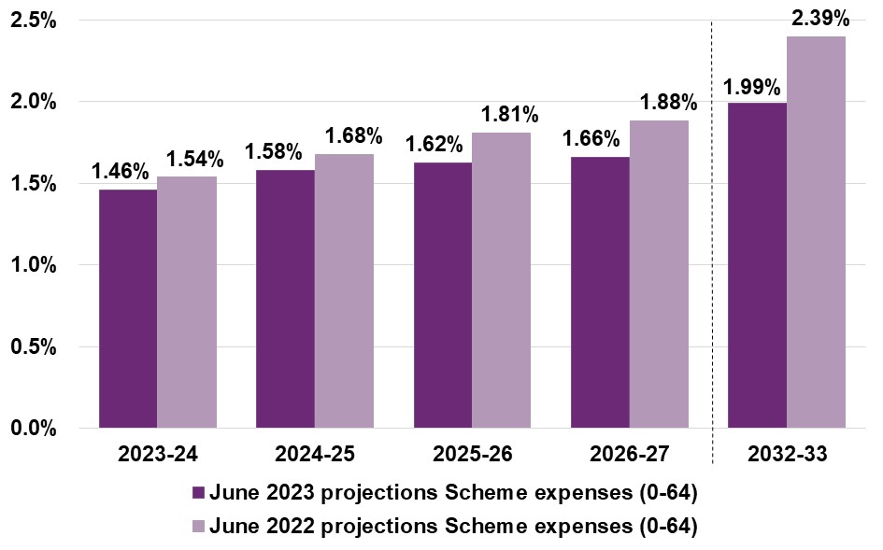

Appendix B Reconciliation to previous review
Projected participant numbers at 30 June 2024 are estimated to be around 22,900 higher than at the previous review. This is mainly driven by the higher expected number of new entrants joining the Scheme. At 30 June 2033, projected participant numbers are expected to be around 32,500 lower than at the previous review. This is due to the growing effect on the Scheme of an expected increased rate of participants leaving the Scheme.

Table B.1: Change in projected participant numbers compared to previous review
Change in projected participant numbers at 30 June | 2024 | 2025 | 2026 | 2027 | 2033
June 2022 projections | 646,012 | 693,889 | 741,077 | 787,820 | 1,062,787
a) Experience between June 2022 and June 2023 | +6,139 | +4,683 | +3,692 | +3,038 | +2,541
b) General population growth | +0 | +94 | +280 | +548 | +2,905
c) Change in mortality assumptions | -239 | -510 | -804 | -1,118 | -3,337
d) Change in assumptions relating to participants leaving the Scheme | -3,993 | -7,702 | -13,729 | -18,209 | -40,373
e) Change in new entrant assumptions | +19,373 | +21,732 | +20,835 | +18,031 | +8,801
f) Change in immigration assumptions | +1,426 | +3,091 | +4,233 | +4,952 | +9,010
g) Change in transition assumptions | +189 | -471 | -1,562 | -2,865 | -11,998
June 2023 projections | 668,907 | 714,805 | 754,022 | 792,200 | 1,030,337
Total movement from June 2022 projections to June 2023 projections | +22,895 (+3.5%) | +20,917 (+3.0%) | +12,945 (+1.7%) | +4,379 (+0.6%) | -32,450  (-3.1%)

For 2023-24, Scheme expenses are projected to be 8.5% higher than the previous review. This is mainly attributable to the additional growth assumptions relating to participants transitioning into SIL, and the increases to normal inflation based on the 2022-23 Annual Pricing Review. Scheme expenses are projected to be lower than the previous review from the 2026-27 projection year onwards, due to changes in the additional growth assumptions over the medium to long term.

Table B.2: Change in projected Scheme expenses (accrual basis) compared to previous review
Change in projected Scheme expenses ($m) | 2023-24 | 2024-25 | 2025-26 | 2026-27 | 2032-33 | Total  2023-27
June 2022 projections | 38,133 | 44,116 | 50,344 | 55,510 | 96,966 | 188,103
a) Experience between June 2022 and June 2023 | +387 | +162 | +172 | +179 | +450 | +898
b) General population growth | +0 | +1 | +5 | +13 | +147 | +19
c) Change in mortality assumptions | -10 | -36 | -71 | -111 | -525 | -228
d) Change in assumptions relating to participants leaving the Scheme | -42 | -132 | -246 | -379 | -1,532 | -798
e) Change in new entrant assumptions | +217 | +300 | +289 | +148 | -1,619 | +955
f) Change related to updates for immigration policy | +15 | +69 | +147 | +212 | +618 | +445
g) Change in developmental delay transition assumptions | -20 | -72 | -128 | -187 | -759 | -407
h) Change in assumptions relating to participant transitions into SIL | +814 | +1,429 | +1,705 | +1,904 | +1,917 | +5,852
i) Change to average payment assumptions | +310 | +364 | +403 | +392 | +271 | +1,469
j) Changes to normal inflation based on 2022-23 Annual Pricing Review | +526 | +254 | +280 | +308 | +631 | +1,368
k) Changes to other normal inflation assumptions | +81 | +140 | +262 | +401 | +1,899 | +883
l) Changes to additional growth assumptions | +950 | -221 | -2,374 | -3,183 | -6,124 | -4,827
June 2023 projections | 41,360 | 46,376 | 50,788 | 55,207 | 92,341 | 193,731
Total movement from June 2022 projections to June 2023 projections | +3,227  (+8.5%) | +2,260  (+5.1%) | +444  (+0.9%) | -303  (-0.5%) | -4,625  (-4.8%) | +5,628  (+3.0%)

Appendix C State and territory breakdown
The projection model projects participant numbers and support costs at a Scheme level. A separate model is used to allocate projected Scheme participant numbers and Scheme expenses by State and Territory. The resulting Scheme participant numbers and Scheme expenses by jurisdiction are shown in Tables C.1 and C.2.

Scheme participant numbers by jurisdiction

Table C.1: Projected participant numbers by jurisdiction 30 June
Participant numbers | 2024 | 2025 | 2026 | 2027 | 2033
NSW | 198,341 | 211,737 | 223,154 | 234,286 | 304,642
VIC | 179,406 | 191,265 | 201,236 | 210,923 | 272,040
QLD | 144,955 | 154,986 | 163,505 | 171,781 | 222,395
SA | 57,004 | 61,150 | 64,752 | 68,256 | 89,267
WA | 57,751 | 61,966 | 65,699 | 69,358 | 92,297
TAS | 14,417 | 15,460 | 16,387 | 17,297 | 23,116
ACT | 10,942 | 11,761 | 12,489 | 13,199 | 17,580
NT | 6,090 | 6,480 | 6,799 | 7,101 | 9,001
Total | 668,907 | 714,805 | 754,022 | 792,200 | 1,030,337

Scheme expenses by jurisdiction

Table C.2: Projected Scheme expenses by jurisdiction
Scheme expenses ($m) | 2023-24 | 2024-25 | 2025-26 | 2026-27 | 2032-33
NSW | 12,928 | 14,482 | 15,853 | 17,232 | 28,847
VIC | 10,262 | 11,522 | 12,604 | 13,692 | 22,867
QLD | 8,836 | 9,889 | 10,833 | 11,783 | 19,753
SA | 3,544 | 3,990 | 4,381 | 4,766 | 7,971
WA | 3,549 | 4,010 | 4,392 | 4,773 | 7,993
TAS | 967 | 1,050 | 1,155 | 1,259 | 2,122
ACT | 619 | 685 | 751 | 817 | 1,360
NT | 656 | 748 | 818 | 884 | 1,428
Total | 41,360 | 46,376 | 50,788 | 55,207 | 92,341

Participation rates by jurisdiction
Participation rates refer to the proportion of the general population that have a disability and are accessing Scheme supports. Table C.3 shows the projected participation rates by jurisdiction for people aged 0 to 64 years. Participation rates are projected to increase significantly over the short and medium to long term, across all states and territories. Participation rates are comparatively lower in WA and NT and highest in SA.

Table C.3: Projected participation rates by jurisdiction
Participation rate (%)
Participation rate (%) | 2023-24 | 2024-25 | 2025-26 | 2026-27 | 2032-33
NSW | 2.80% | 2.96% | 3.09% | 3.21% | 3.95%
VIC | 3.01% | 3.16% | 3.28% | 3.39% | 4.06%
QLD | 3.24% | 3.42% | 3.57% | 3.71% | 4.51%
SA | 4.06% | 4.34% | 4.59% | 4.82% | 6.20%
WA | 2.53% | 2.68% | 2.81% | 2.93% | 3.61%
TAS | 3.46% | 3.71% | 3.94% | 4.17% | 5.59%
ACT | 2.77% | 2.93% | 3.07% | 3.21% | 3.97%
NT | 2.57% | 2.71% | 2.81% | 2.90% | 3.43%
Total | 3.00% | 3.17% | 3.31% | 3.44% | 4.21%

Appendix D Scheme experience —participants

Movements in reported levels of function
Figure D.1 shows the reported functional distribution over time for participants who entered the Scheme between 1 July 2017 and 30 June 2019. Figure D.2 shows similar results for participants who entered the Scheme between 1 July 2019 and 30 June 2021.
Reported levels of function continue to show a deteriorating trend amongst recent entrants to the Scheme compared to participants who entered prior to 30 June 2017, for which results are set out in Figure 4.2.

Figure D.1: Change in distribution of reported level of function at 30 June from 2019 to 2023 (participants who entered between 1 July 2017 and 30 June 2019)

Figure D.2: Change in distribution of reported level of function at 30 June from 2021 to 2023 (participants who entered between 1 July 2019 and 30 June 2021)

Participation rates by gender
Figure D.3 and Figure D.4 shows participation rates for Australian male and female populations respectively. A higher proportion of the male population are NDIS participants compared with the female population across all age bands. The overall shape across ages is similar with a peak of 11.5% observed for males around age 5, compared to a peak of 4.9% observed within the female population. This is driven by the large number of children in the Scheme with autism that are male, particularly around the age of starting school when diagnosis commonly occurs.

Figure D.3: Proportion of the Australian male population that are NDIS participants, by age

Figure D.4: Proportion of the Australian female population that are NDIS participants, by age

Appendix E Scheme experience — payments

Further breakdowns of payments by other characteristics
Average annualised payments by other characteristics show a broadly consistent trend.

Average annualised payments by gender
The average annualised payments for female participants ($66,400) were 16% higher than male participants ($57,300) in 2022-23. The average annual growth in average payments over the 2 years was 5.8% for female participants and 5.5% for male participants as shown in Figure E.1.

Figure E.1: Average payment for female and male participants
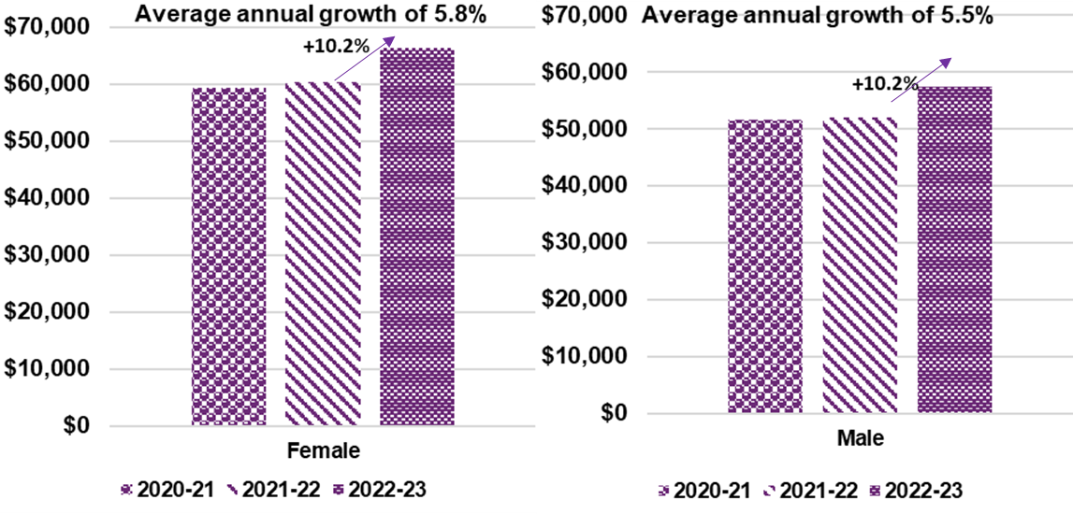

Average annualised payments by level of function
Over the past two years, average annualised payments have increased by 10.6% for participants with a high level of function, 7.4% for participants with a medium level of function, and 7.8% for participants with a low level of function (Figure E.2).

Figure E.2: Average annualised payments for participants with high, medium, and low levels of function
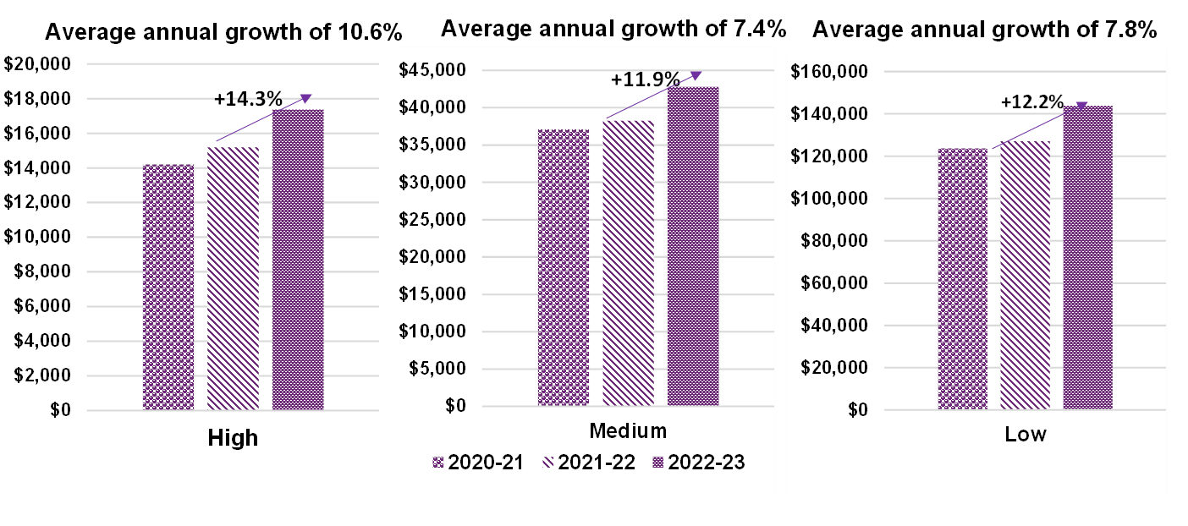

Average annualised payments by support category
Payments are distributed mainly in Daily Activities and Social Community Civic support categories; 65% and 21%. The proportion of payments in both categories from 2021-22 experienced growth of 2% for Daily Activities and 3% for Social Community Civic. Over the last 3 years, the average annualised payment for Daily Activities increased by 5.2% and 14.3% for Social Community Civic.

Figure E.3: Average annualised payments for participants in Daily Activities and Social Community Civic support categories
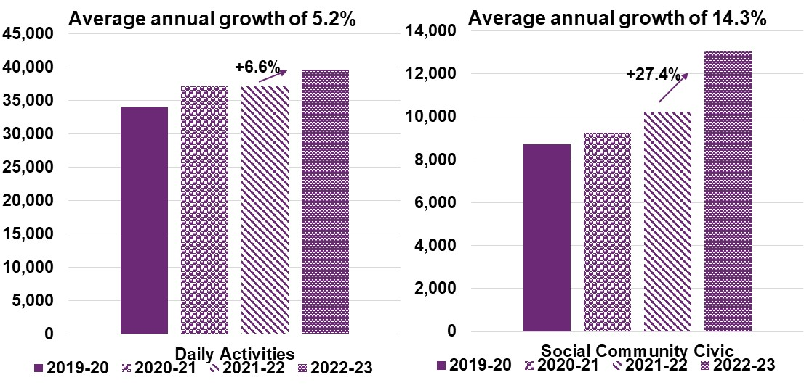

Average annualised payments by participants’ remoteness
68% of participants in the Scheme identify as living in major cities with the average annualised payments of t $58,500. Payments are generally higher in population-dense areas. The remote communities stand out with an average payment of $66,100 (ranging from 13%to 65% higher than payment in non-remote areas) at end of June 2023. See Figure E.4.

Figure E.4: Average annualised payments of participants by remoteness for 2022-23

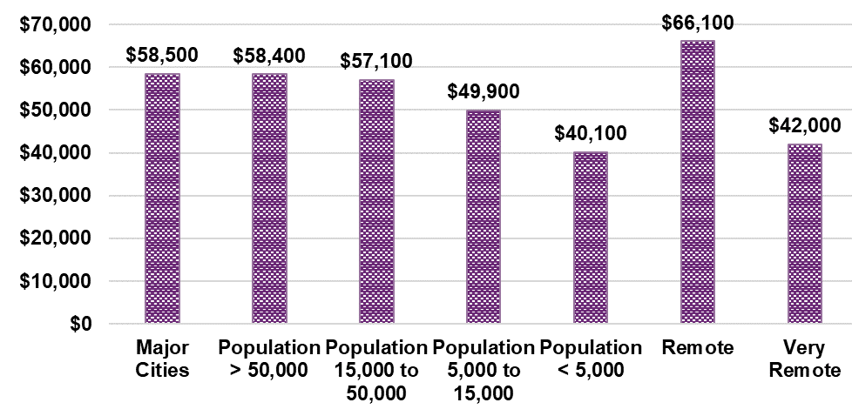Average annualised payments for First Nations peoples
8% of participants in the Scheme identify as First Nations peoples. There average annualises payments were $57,600 was lower than participants who do not identify as First Nations peoples totalling $59,600. Over the last two years, the average annualised payments increased by 5.2% for both participants identifying and not identifying as First Nations Peoples, as shown in Figure E.5.

Figure E.5: Average annualised payments of participants identifying as First Nations peoples

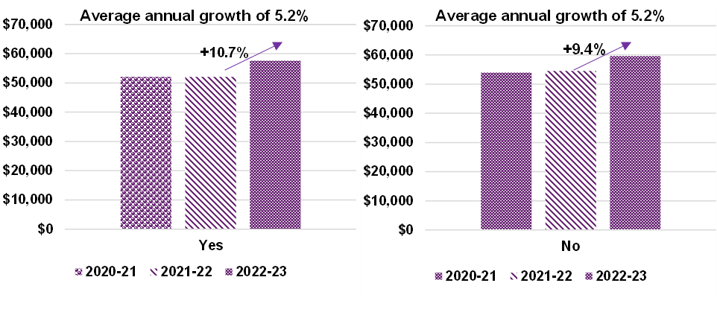Average annualised payments have increased across all primary disability groups
There was a greater increase in disability groups associated with older participants who acquired a brain injury or who developed a psychosocial disability, compared with other groups. Participants with autism tend to be younger on average, with lower growth in average annualised payments of 5%, compared to the overall increase of 6%, refer to Figure E.6.
Figure E.6: Shows the average annualised payments over time, from 2019-20 to 2022-23, by disability group.

Figure E.6: Average annualised payments over time by disability group ($)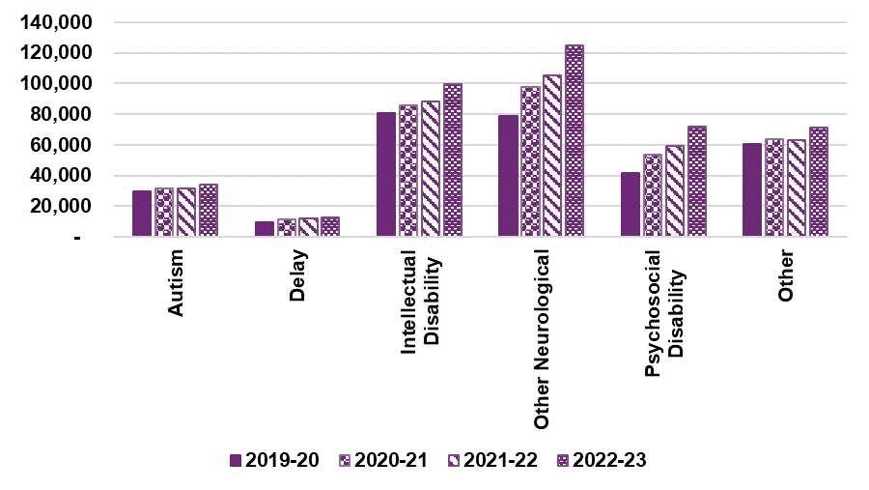

Appendix F Scheme experience – plan budgets

Average plan budgets by other characteristics
Table F.1 highlights the average annualised plan budgets by disability group, for the last four financial years.
Plan budgets have increased comparatively more across disability groups consisting of older participants and/or participants with lower reported levels of functioning, including participants with acquired brain injury, other neurological, stroke and psychosocial disabilities. Disability groups consisting of younger participants with autism, developmental delay and sensory related disabilities have experienced lower growth in plan budgets.

Table F.1: Average annualised plan budget by disability group ($)
Disability group | 30 June  2020 | 30 June  2021 | 30 June  2022 | 30 June  2023 | Average annual growth | 2022-23 growth
Acquired Brain Injury | 141,600 | 145,300 | 148,200 | 172,500 | 6.8% | 16.4%
Autism | 39,800 | 39,700 | 39,100 | 42,400 | 2.2% | 8.5%
Cerebral Palsy | 141,700 | 145,800 | 148,100 | 166,600 | 5.5% | 12.4%
Developmental delay | 18,500 | 19,200 | 20,000 | 20,700 | 3.7% | 3.2%
Hearing Impairment | 16,000 | 15,200 | 15,000 | 16,000 | 0.1% | 6.9%
Intellectual Disability | 102,000 | 101,600 | 102,700 | 115,900 | 4.3% | 12.8%
Multiple Sclerosis | 103,800 | 106,300 | 108,000 | 120,200 | 5.0% | 11.3%
Other | 94,600 | 86,100 | 90,200 | 110,100 | 5.2% | 22.0%
Other Neurological | 123,000 | 129,700 | 136,100 | 160,200 | 9.2% | 17.7%
Other Physical | 75,100 | 74,900 | 77,600 | 87,200 | 5.1% | 12.3%
Other Sensory/Speech | 14,000 | 14,600 | 16,200 | 17,400 | 7.4% | 7.0%
Psychosocial disability | 74,000 | 77,400 | 80,600 | 95,100 | 8.7% | 18.0%
Spinal Cord Injury | 158,200 | 161,600 | 162,700 | 187,400 | 5.8% | 15.2%
Stroke | 118,500 | 126,600 | 134,800 | 161,900 | 11.0% | 20.1%
Visual Impairment | 39,800 | 41,400 | 43,600 | 50,300 | 8.1% | 15.2%
An increase in average annualised plan budgets occurred across all age groups for the last four financial years ending 30 June. Participants aged between 55 to 64 had the largest increase of 16.5%.

Table F.2: Average annualised plan budget by age group ($)
Age Group | 30 June  2020 | 30 June  2021 | 30 June  2022 | 30 June  2023 | Average annual growth | 2022-23 growth
0 to 6 | 24,100 | 24,400 | 24,800 | 25,400 | 1.7% | 2.3%
7 to 14 | 24,600 | 24,500 | 24,300 | 25,900 | 1.7% | 6.4%
15 to 18 | 52,900 | 49,700 | 45,700 | 47,800 | -3.3% | 4.5%
19 to 24 | 87,500 | 87,800 | 87,600 | 94,800 | 2.7% | 8.2%
25 to 34 | 110,300 | 108,200 | 106,800 | 117,500 | 2.1% | 10.0%
35 to 44 | 112,800 | 111,100 | 110,800 | 124,500 | 3.3% | 12.4%
45 to 54 | 114,900 | 113,600 | 114,100 | 129,000 | 3.9% | 13.1%
55 to 64 | 112,800 | 114,900 | 118,000 | 137,500 | 6.8% | 16.5%
65+ | 109,700 | 113,900 | 118,800 | 134,600 | 7.0% | 13.2%

Appendix G Analysis of Scheme new entrant rates

Background
New entrants to the Scheme, both numbers and characteristics, are an important aspect of the overall Scheme experience and trajectory of Scheme expenses over the short and medium to long-term. New entrant rate assumptions, reflecting the expected new entrant numbers expressed as a proportion of the general population, are integral to the projection of total participants in the Scheme and estimates of Scheme expenses from 2023-24 onwards.
Actual experience of new entrant numbers entering the Scheme, has been analysed by primary disability type, age group and gender, to derive the new entrant rate assumptions to use in the June 2023 projections. This is consistent with the approach used in the previous review.

New entrant rate assumptions by disability type
Table G.1 shows the long-term new entrant rates assumed for the June 2023 projections, both before and after adjustments made for Budget initiatives, compared to those assumed from the previous review by primary disability type. This is a more detailed break-down of the new entrant rate assumptions by key disability group presented in Table 5.14 in Section 5.4.1 of the main report.

Table G.1: Comparison of assumed new entrant rates (per 100,000 population aged 0 to 64) by disability type
Primary Disability Type | June 2023 projections (before Budget initiatives) | June 2023 projections (after Budget initiatives) | June 2022 projections | Absolute Change | % Change
Acquired Brain Injury | 5.9 | 5.9 | 7.2 | -1.3 | -17.6%
Autism | 96.3 | 96.3 | 94.1 | 2.2 | 2.3%
Cerebral Palsy | 2.1 | 2.1 | 2.2 | -0.2 | -7.4%
Developmental Delay | 148.8 | 133.9 | 110.5 | 23.5 | 21.2%
Hearing Impairment | 9.3 | 9.3 | 11.2 | -1.9 | -16.8%
Intellectual Disability | 18.0 | 18.0 | 21.0 | -3.1 | -14.6%
Multiple Sclerosis | 3.0 | 3.0 | 4.0 | -0.9 | -23.5%
Other | 6.3 | 6.3 | 7.9 | -1.6 | -20.0%
Other Neurological | 7.8 | 7.8 | 9.9 | -2.1 | -21.0%
Other Physical | 5.1 | 5.1 | 6.7 | -1.7 | -24.6%
Other Sensory/Speech | 0.4 | 0.4 | 0.4 | 0.0 | -9.6%
Psychosocial Disability | 19.4 | 19.4 | 24.4 | -5.0 | -20.5%
Spinal Cord Injury | 1.4 | 1.4 | 1.7 | -0.2 | -14.4%
Stroke | 3.7 | 3.7 | 4.7 | -0.9 | -20.1%
Visual Impairment | 2.1 | 2.1 | 2.6 | -0.5 | -18.9%
Total All Disabilities | 329.6 | 314.7 | 308.4 | 6.3 | 2.0%

New entrant rates by gender and age group
Table G.2 shows the updated long-term new entrant rates (across all disability types), both before and after adjustments made for Budget initiatives, compared to those assumed from the previous review by gender and age group. This is a more detailed break-down of the new entrant rate assumptions by age group presented in Table 5.15 in Section 5.4.1 of the main report.
Table G.2 highlights the impact of emerging experience with new entrant rates significantly increasing for participants aged 0 to 6 years, and significantly decreasing for participants aged 15 to 64 years, compared to the new entrant rates used in the June 2022 projections.

Table G.2: Comparison of assumed new entrant rate (per 100,000 population aged 0 to 64) by gender and age group
Gender and age group | June 2023 projections (before Budget initiatives) | June 2023 projections (after Budget initiatives) | June 2022 projections | Absolute Change | % Change
Male / 0 to 6 years | 2,406.8 | 2,207.2 | 1,784.0 | 423.2 | 23.7%
Male / 7 to 14 years | 614.8 | 613.5 | 590.2 | 23.3 | 3.9%
Male / 15 to 64 years | 119.9 | 119.9 | 151.2 | -31.3 | -20.7%
Total Male | 420.2 | 399.1 | 387.7 | 11.4 | 2.9%
Female / 0 to 6 years | 1,067.9 | 982.3 | 783.5 | 198.8 | 25.4%
Female / 7 to 14 years | 350.9 | 350.4 | 345.3 | 5.1 | 1.5%
Female / 15 to 64 years | 115.6 | 115.6 | 135.2 | -19.6 | -14.5%
Total Female | 238.3 | 229.6 | 228.8 | 0.9 | 0.4%
All / 0 to 6 years | 1,756.1 | 1,611.9 | 1,298.2 | 313.7 | 24.2%
All / 7 to 14 years | 486.6 | 485.7 | 471.0 | 14.7 | 3.1%
All / 15 to 64 years | 117.7 | 117.7 | 143.2 | -25.4 | -17.8%
Total All Persons | 329.6 | 314.7 | 308.4 | 6.3 | 2.0%
New entrant rates used in the June 2023 projections increased by 24.2% for children aged 0 and 6 years, 3.1% for children aged 7 to 14 years and decreased by 17.8% for older children and adults aged 15 years and over, compared to the June 2022 projections. Comparisons between males and females show new entrants rates assumed have increased by slightly more for females aged 0 to 6 years, males aged 7 to 14 years, with a larger decrease for males aged 15 and over.
This represents a major shift in the age profile of new entrants compared to the previous review. Most of the increase in new entrants aged 0 to 6 relates to children with developmental delay entering the Scheme, with the decrease in new entrants aged 15 years and over relating to older children and adults with psychosocial disability, intellectual disability and other neurological disabilities.
Figures G.1 and G.2 show the aggregated new entrant rates, of all disabilities, across ages 0 to 6 years and ages 15 to 64 years, by gender. The solid lines show the new entrant rates used in the June 2023 projections, and the dashed lines show the new entrant rates used in the June 2022 projections. The purple and green lines show the new entrant rates for males and females respectively, and the dark grey line shows the combined result.
The figures show most people enter the Scheme during the first decade of childhood. The most common age to enter the Scheme is age 4. The new entrant rate decreases steeply after age 4 to age 7, decreasing slowly from age 8 to 29. After age 29, the new entrant rates begin to increase steadily. This reflects the increasing rates of new entry for most non-congenital disabilities.
The aggregated new entrant rate of all disabilities is 74% higher for males compared to females. The figure reflects a higher new entrant rate for a number of conditions, particularly autism and development delay, amongst males. In the June 2022 projections, the aggregated new entrant rate of all disabilities was 69% higher for males compared to females.

Figure G.1: New entrant rates (all disabilities), ages 0 to 14

Figure G.2: New entrant rates (all disabilities), ages 15 to 64

Projected new entrant numbers
This section includes a further break-down of the projected new entrant numbers shown Figure 5.4 of Section 5.4.1 of the main report.

Participants with autism aged 0 to 14
Figures G.3 and G.4 show the actual and projected number of new entrants to the Scheme with a primary disability of autism aged 0 to 14 years, for male and female participants, compared to the previous review for each year from 2023-24 onwards.
Male new entrant numbers entering the Scheme in 2022-23 was 11,001, 14.7% higher than the expected number of 9,592 from the June 2022 projections. Female new entrant numbers entering the Scheme for the same period were 6,305, 28.7% higher than the expected number of 4,899 estimated in the June 2022 projections. Actual new entrant numbers in 2022-23, compared to 2021-22, shows an increase of 1.4% for males and 14.7% for females.
The estimated new entrant numbers in the June 2023 projections are higher for all future years, for both males and females, compared to the June 2022 projections. The increase in projected new entrant numbers for females in the short term, compared to June 2022 projections, is higher than for males. Anecdotal evidence suggests there is a growing recognition of autism in females.

Figure G.3: Actual and projected new entrant numbers - participants with autism aged 0 to 14 years, males

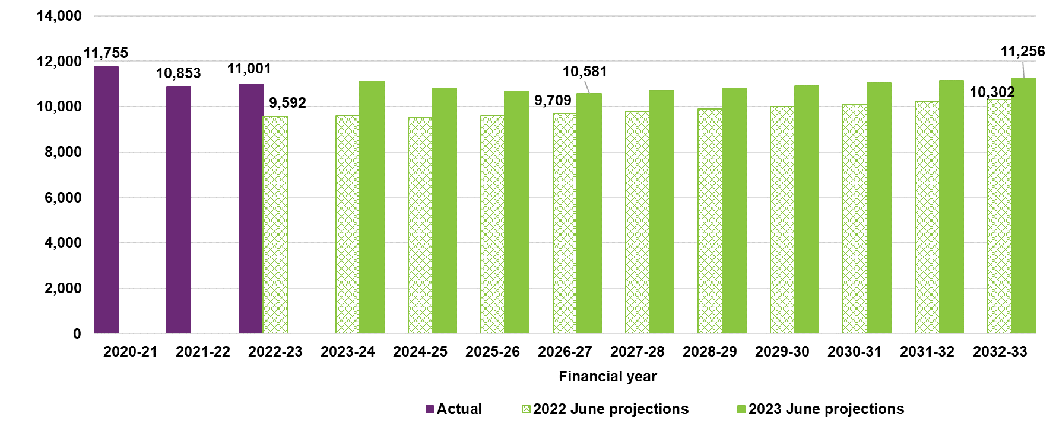Figure G.4: Actual and projected new entrant numbers - participants with autism aged 0 to 14 years, females
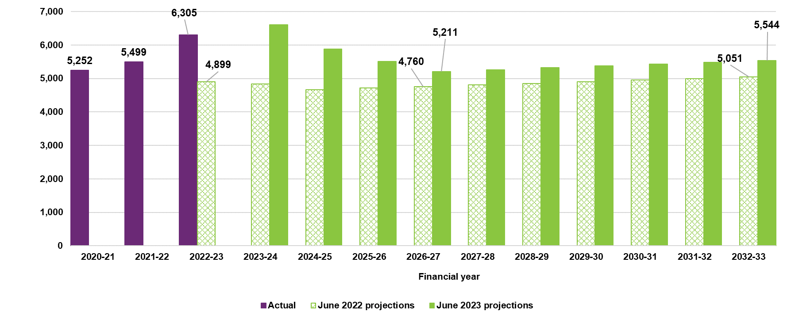

Participants with developmental delay aged 0 to 14
Figures G.5 and G.6 show the actual and projected number of new entrants to the Scheme with a primary disability of developmental delay aged 0 to 14 years, for male and female participants, compared to the previous review for each year from 2023-24 onwards.
Male new entrant numbers entering the Scheme in 2022-23 was 24,774, 60.7% higher than the expected number of 15,418 estimated in the June 2022 projections. Female new entrant numbers entering the Scheme for the same period were 10,207, 66.7% higher than the expected number of 6,123 estimated in the June 2022 projections. Actual new entrant numbers in 2022-23, compared to 2021-22, show an increase of 34.5% for males and 38.6% for females.
The estimated new entrant numbers in the June 2023 projections are higher for all future years, for both males and females, compared to those estimated in the June 2022 projections.

Figure G.5: Actual and projected new entrant numbers - participants with developmental delay aged 0 to 14 years, males
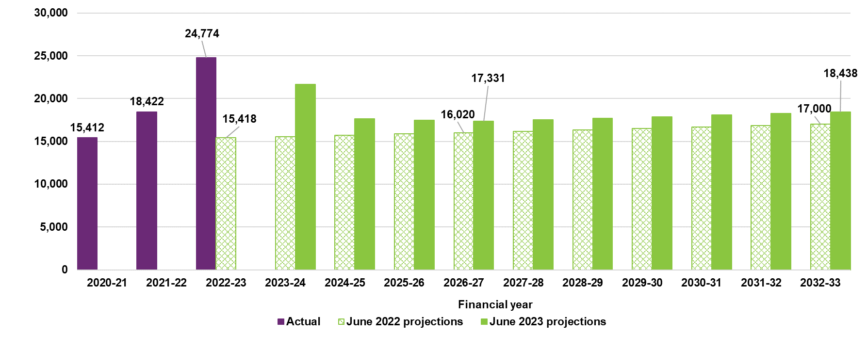

Figure G.6: Actual and projected new entrant numbers - participants with developmental delay aged 0 to 14 years, females
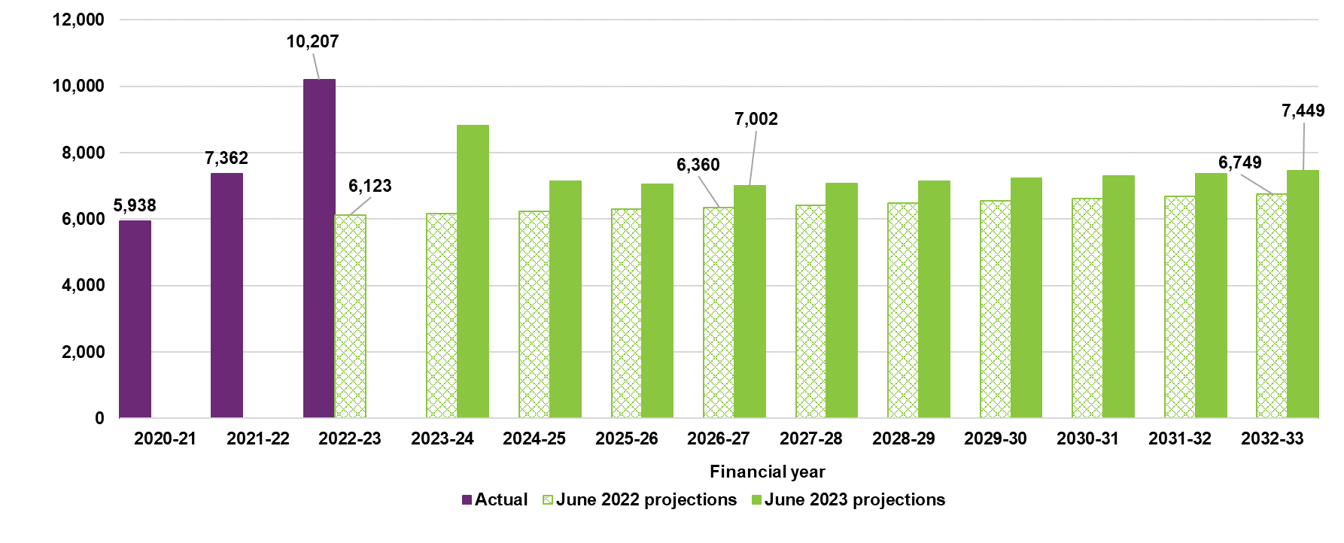

Participants with disabilities other than autism or developmental delay aged 0 to 14
Figures G.7 and G.8 show the actual and projected number of new entrants to the Scheme excluding participants with a primary disability of autism or developmental delay aged 0 to 14 years, for male and female participants, compared to the previous review for each year from 2023-24 onwards.
Male new entrant numbers entering the Scheme in 2022-23 was 2,583, 3.1% higher than the expected number of 2,505 estimated in the June 2022 projections. Female new entrant numbers entering the Scheme for the same period were 1,791, 5.6% lower than the expected number of 1,897 estimated in the June 2022 projections. Actual new entrants numbers in 2022-23, compared to 2021-22, show a decrease of 10.4% for males and 13.2% for females.

Figure G.7 Actual and projected new entrant numbers - participants with disabilities other than autism or development delay aged 0 to 14 years, males
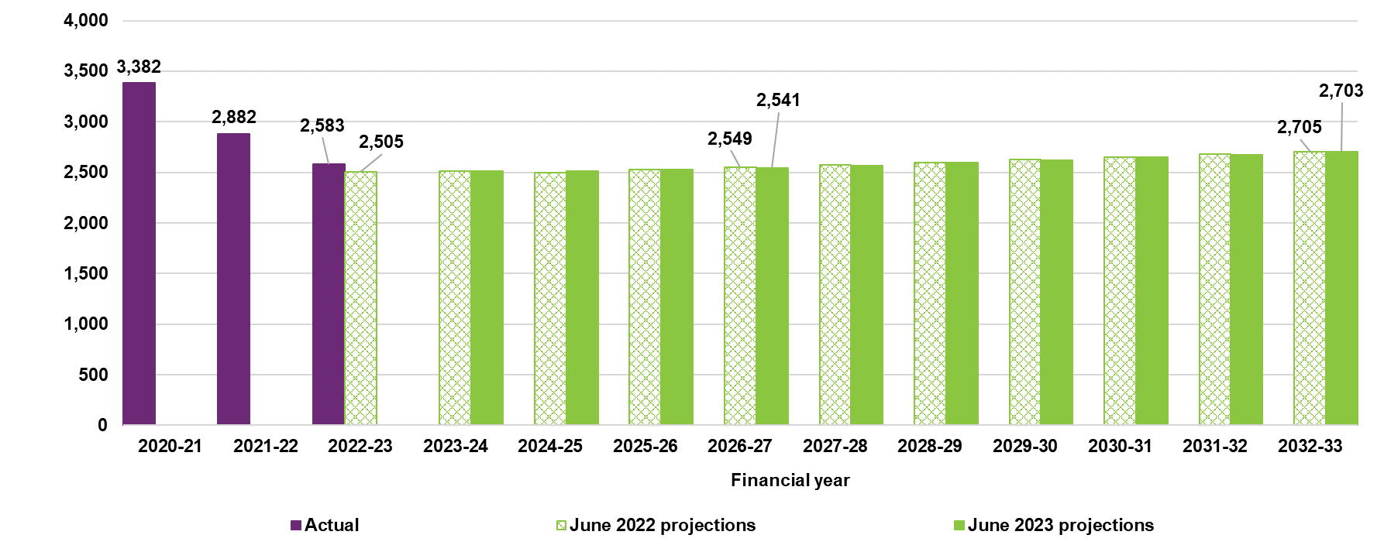

Figure G.8 Actual and projected new entrant numbers - participants with disabilities other than autism and development delay aged 0 to 14 years, females
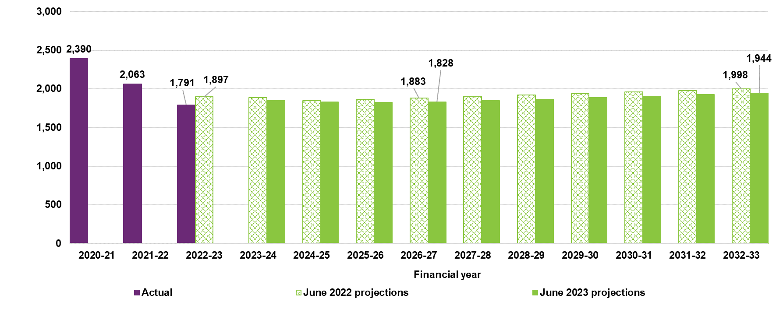

Participants with autism aged 15 years and over
Figures G.9 and G.10 show the actual and projected number of new entrants to the Scheme with a primary disability of autism and aged 15 years and over, for male and female participants, compared to the previous review for each year from 2023-24 onwards.
Male new entrant numbers entering the Scheme in 2022-23 was 4,111, 9.6% higher than the expected number of 3,752 from the June 2022 projections. Female new entrant numbers entering the Scheme for the same period were 3,934, 37.5% higher than the expected number of 2,862 estimated in the June 2022 projections. Actual new entrant numbers in 2022-23, compared to 2021-22, show an increase of 8.1% for males and 32.0% for females.
For both males and females, the estimated new entrant numbers in the June 2023 projections are higher in the short term up to 2025-26, remaining higher in the medium to long term for females, whilst becoming lower for males from 2026-27 onwards, compared to those estimated in the June 2022 projections.

Figure G.9: Actual and projected new entrant numbers - participants with autism aged 15 years and over, males
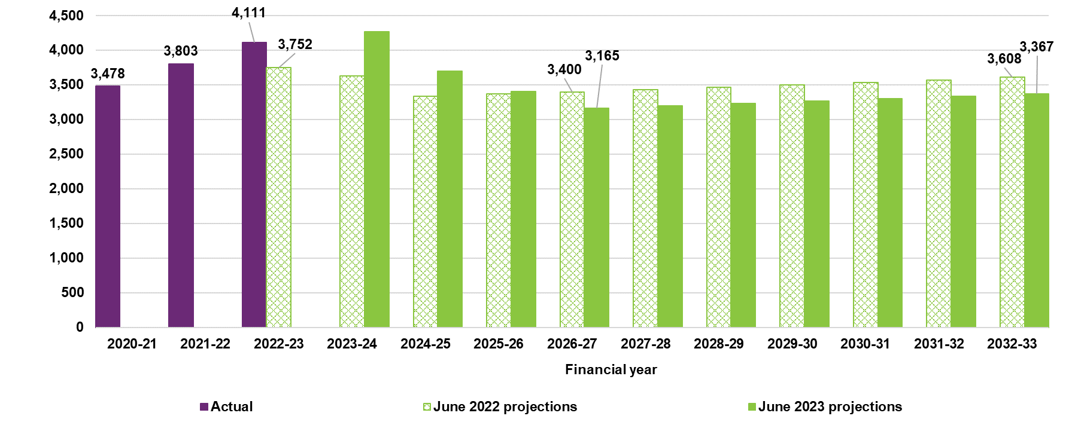

Figure G.10: Actual and projected new entrant numbers - participants with autism aged 15 years and over, females
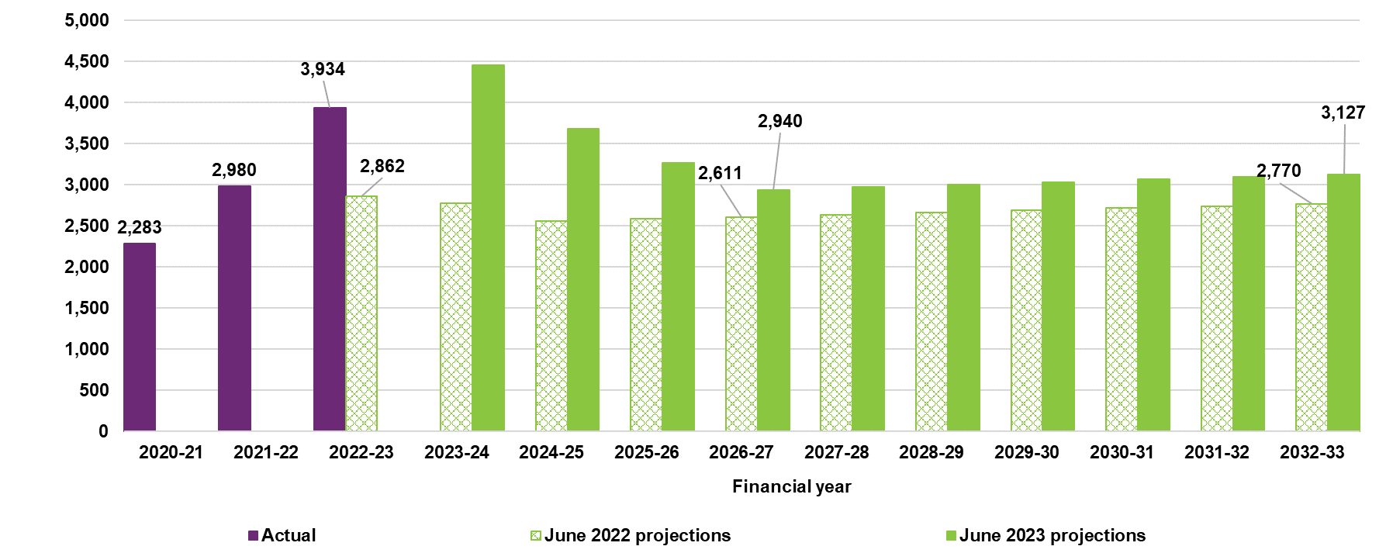

Participants with psychosocial disability aged 15 years and over
Figures G.11 and G.12 show the actual and projected number of new entrants to the Scheme with a primary disability of psychosocial disability and aged 15 years and over, for male and female participants, compared to the previous review for each year from 2023-24 onwards.
Male new entrant numbers entering the Scheme in 2022-23 was 3,554, 18.3% lower than the expected number of 4,352 from the June 2022 projections. Female new entrant numbers entering the Scheme for the same period were 3,162, 21.3% lower than the expected number of 4,016 estimated in the June 2022 projections. Actual new entrant numbers 2022-23, compared to 2021-22, show a decrease of 23.6% for males and 28.4% for females.
The lower projected new entrant numbers, compared to those estimated in the June 2022 projections, for both males and females, is consistent with the recently observed experience of a continuing decline in adult new entrants with psychosocial disabilities.

Figure G.11: Actual and projected new entrant numbers - participants with psychosocial disability aged 15 years and over, males
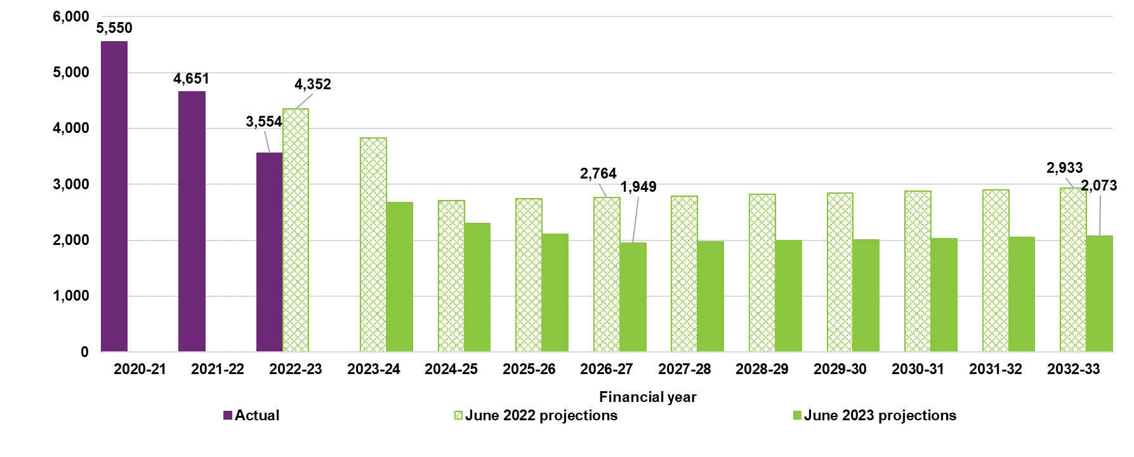

Figure G.12: Actual and projected new entrant numbers - participants with psychosocial disability aged 15 years and over, females
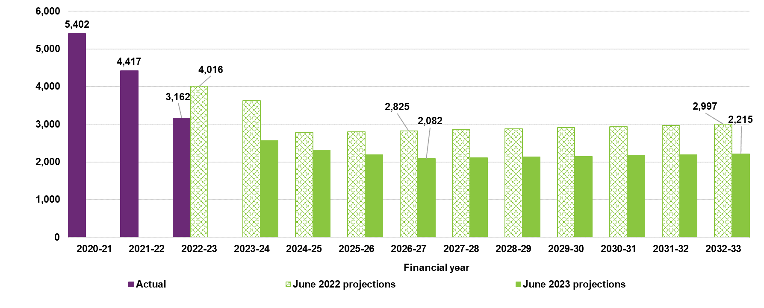

Participants with disabilities other than autism or psychosocial disability aged 15 years and over
Figures G.13 and G.14 show the actual and projected number of new entrants to the Scheme for all disability types excluding autism and psychosocial disability and aged 15 years and over, for male and female participants, compared to the previous review for each year from 2023-24 onwards.
Male new entrant numbers entering the Scheme in 2022-23 year was 8,055, 1.3% lower than the expected number of 8,165 from the June 2022 projections. Female new entrant numbers entering the Scheme for the same period were 6,923, 3.4% lower than the expected number of 7,167 estimated in the June 2022 projections. Actual new entrant numbers in 2022-23, compared to 2021-22, show a decrease of 11.8% for males and 10.9% for females.
The lower projected new entrant numbers, compared to those estimated in the June 2022 projections, for both males and females, is consistent with the recently observed experience of a continuing decline in adult new entrants for all disability types excluding autism and psychosocial disability.

Figure G.13: Actual and projected new entrant numbers - participants with disabilities other than autism or psychosocial disability aged 15 years and over, males
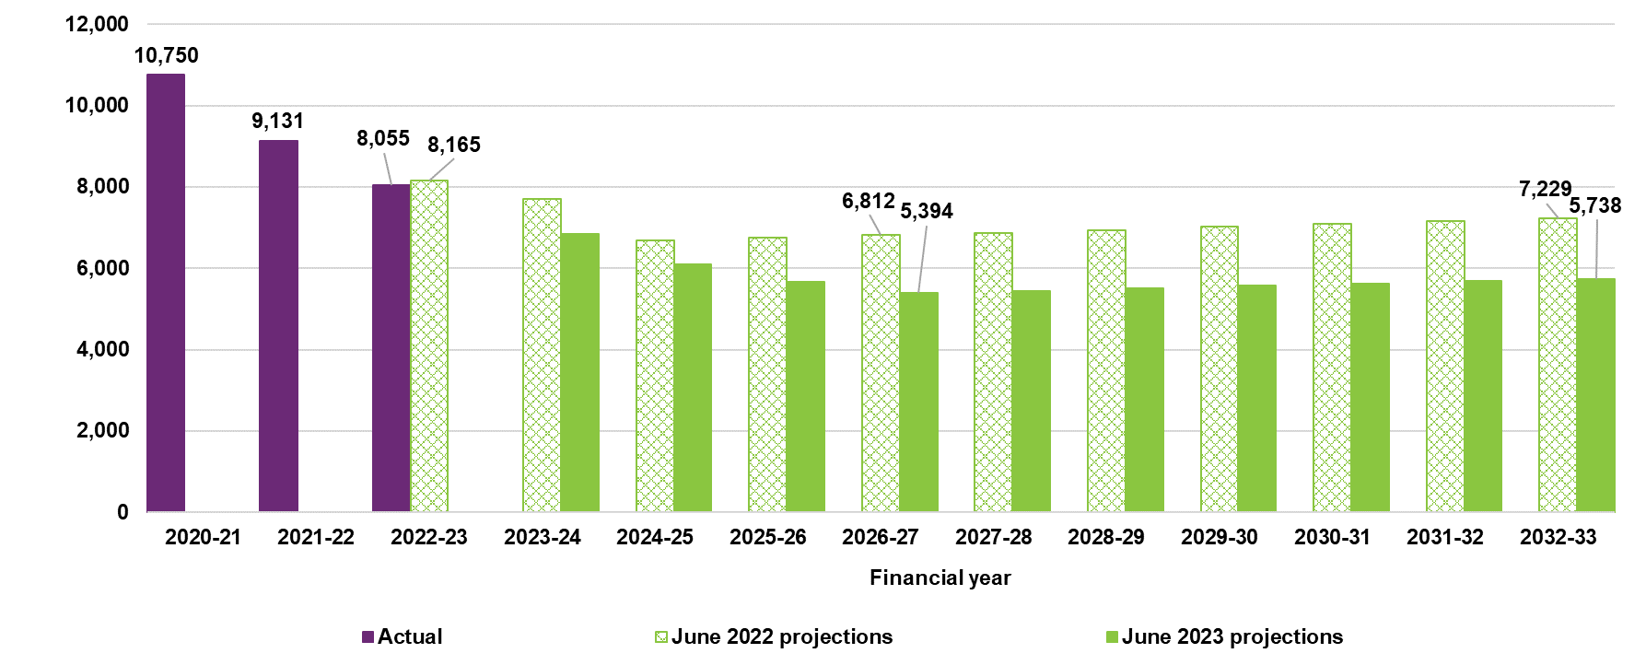

Figure G.14: Actual and projected new entrant numbers - participants with disabilities other than autism or psychosocial disability aged 15 years and over females
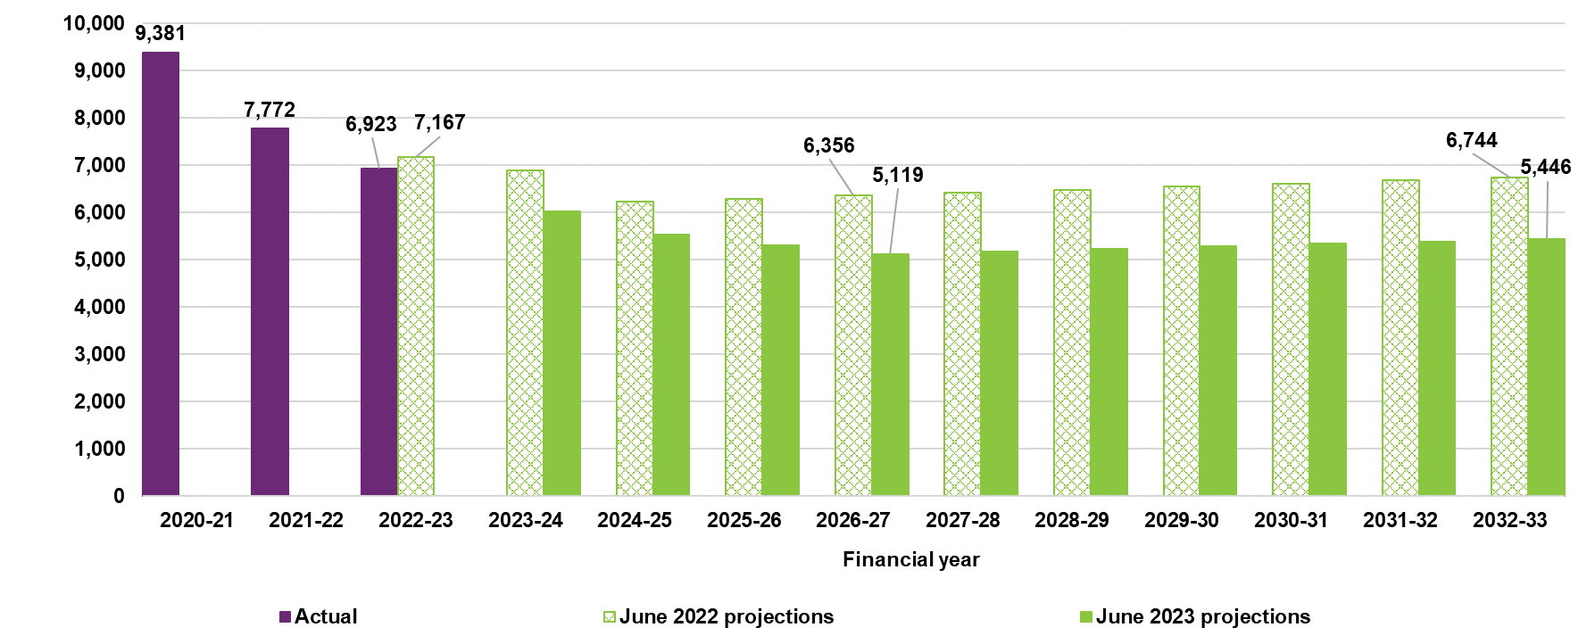

Participation rates projected to increase
Participation rates refer to the proportion of the general population that have a disability and are accessing Scheme supports. Figure G.15 shows the implied participation rates for people aged 0 to 64 years. The chart shows that the participation rate is projected to increase significantly over the next few years, with a 29% increase in the participation rate expected over the 5-year period between 30 June 2023 (2.78% participation rate) and 30 June 2028 (3.58% participation rate). Over the 5-year period between 30 June 2028 and 30 June 2033, the participation rate is expected to increase a further 18% to 4.21%. These participation rates imply that about 1 in 36 people in Australia aged between 0 and 64 years was a participant in the NDIS at 30 June 2023, and by 30 June 2033 this will increase to about 1 in 24 people.

Figure G.15: Implied participation rates for people aged 0 to 64 years
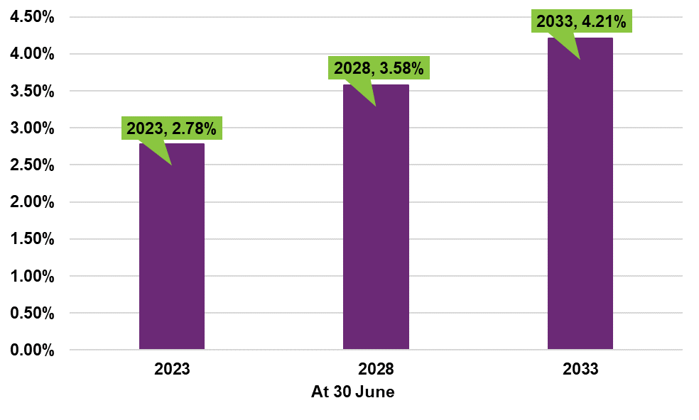
Figure G.16 shows the implied participation rates for major disability groups at this review, for people aged 0 to 64 years. This chart highlights that the main driver of the increase in participation rate is autism, which increases from a participation rate of 0.98% at 30 June 2023 to 1.62% at 30 June 2028 (a 65% increase over this 5-year period), and to a participation rate of 2.14% at 30 June 2033 (a 32% increase over this 5-year period). These participation rates imply that about 1 in 102 people in Australia aged between 0 and 64 years was a participant of the NDIS with a primary disability of autism at 30 June 2023, and by 30 June 2033 this will increase to about 1 in 47 people.

Figure G.16: Implied participation rates for major disability groups for people aged 0 to 64 years
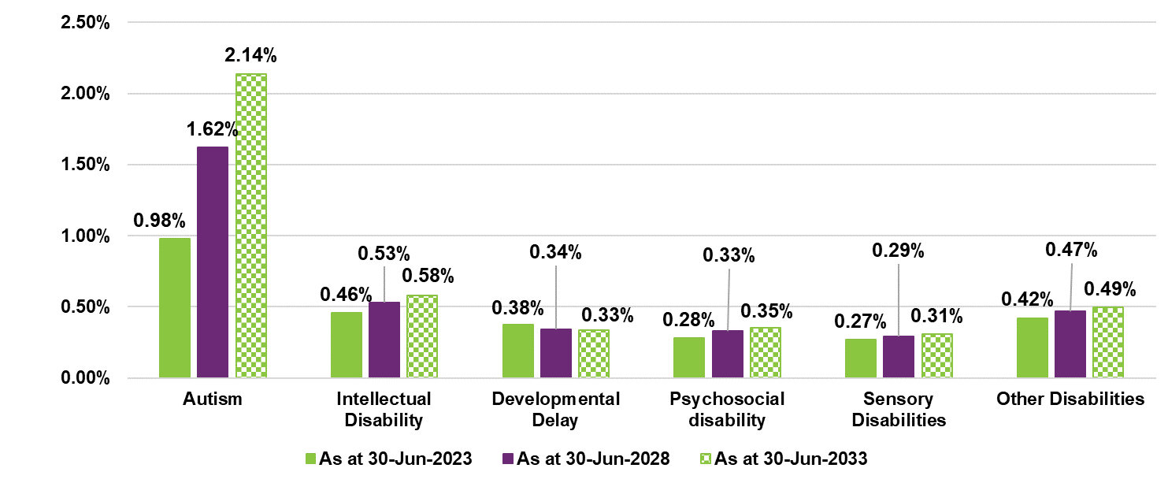

Figure G.17 shows the implied participation rates by age band at this review, for people aged 0 to 64 years. This chart highlights the main driver of the increase in participation rate between 30 June 2023 and 30 June 2033 are participants between the ages of 7 and 24. These participation rates imply 1 in 16 people in Australia aged between 7 and 14 years was a participant of the NDIS at 30 June 2023. By 30 June 2033 this will become approximately 1 in 12 people.

Figure G.17: Implied participation rates for all disability types by age band
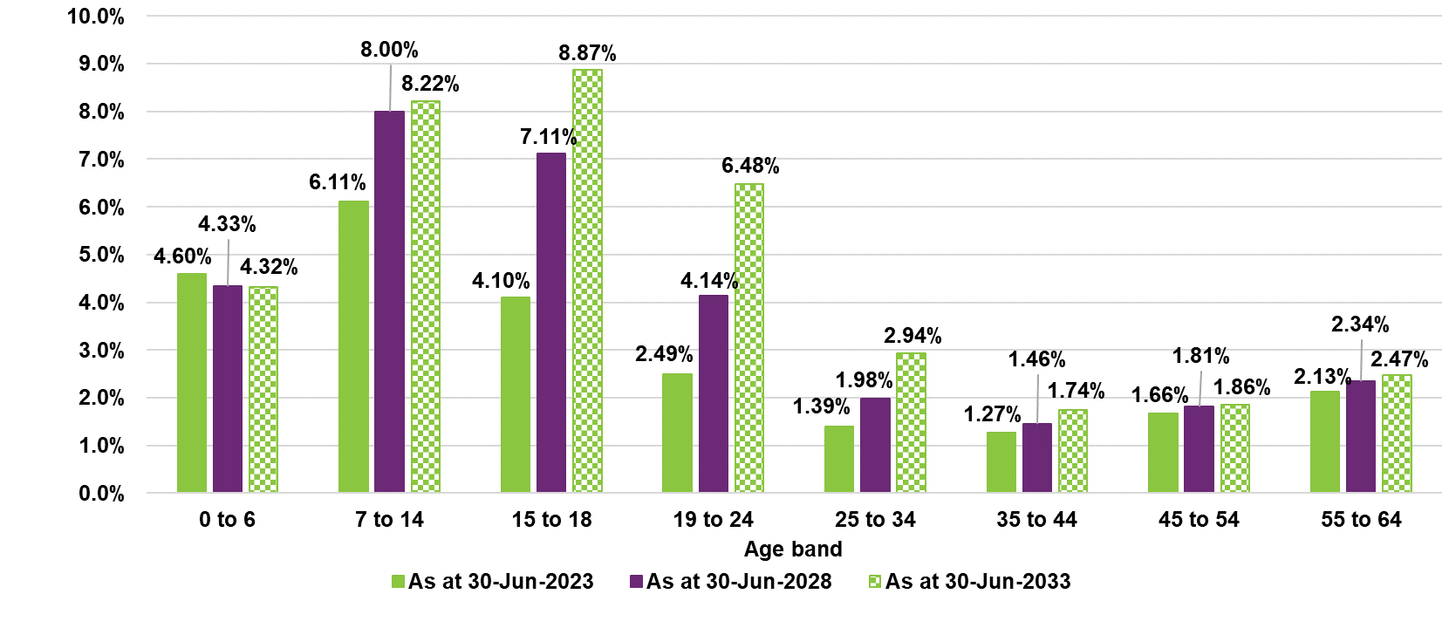

Appendix H Review of Scheme mortality

Background
Scheme mortality rates have been tracking slightly greater than expected across a number of cohorts in recent years. This experience, as well as recommendations by the Australian Government Actuary, prompted a comprehensive review of mortality rates in early 2023 with a view to revise mortality assumptions for the June 2023 projections.
This Appendix sets out the mortality experience observed over the most recent 5 years, the revised assumptions for the June 2023 projections and the impact of updating these assumptions on projected participant numbers and Scheme expense.

Modelling approach
The mortality assumptions for the June 2023 projections were derived using an experience-based model. As in past Scheme projections, separate mortality rate assumptions were derived for each primary disability, gender, level of function and age. The Australian Standard Life Table (ALT 2018-20) was used as a base rate for each age and gender and loadings were applied for primary disability and level of function to determine final mortality assumptions.
Noting that the mortality assumptions for the June 2022 projections were derived using an experience period of 14 months and that a longer experience period was recommended by the Australian Government Actuary in their review of the June 2022 projections, a 5-year period was used to determine the mortality assumptions for the June 2023 projections. This longer period also serves to appropriately allow for the recent increases in mortality due to the pandemic.
The mortality assumptions have been derived allowing for the credibility of experience in each sub-group and have also been adjusted for various other factors to ensure the final mortality assumptions are reasonable.
The analysis presented in this Appendix is shown on a calendar year basis rather than the financial year basis that is seen throughout this AFSR. This is because the data period used for the review of Scheme mortality was January 2018 to February 2023.

Analysis of experience

Scheme mortality experience over time
Figure H.1 shows the annualised mortality rate (and number) of participants leaving the Scheme due to mortality in the calendar years 2017 to 2023 compared to the expected mortality rate based on assumptions from the June 2022 projections and the participant mix in each period. Note that participants were still transitioning into the Scheme up to 30 June 2019 (and 30 June 2020 in Western Australia).
Scheme mortality rates have trended upwards over the last 5 years, with an increase in the 14 months to February 2023. Although the Scheme mortality experience has generally been in line with expectations (using mortality assumptions from the June 2022 projections) up to the end of 2021, the mortality experience over the 14 months was above expected (1.1% actual compared to 0.9% expected). This increase was consistent with the recent general Australian population experience which saw a 15%, increase in the number of deaths in 2022 compared to historical averages.

Figure H.1: Actual vs expected mortality rates and number of participant deaths
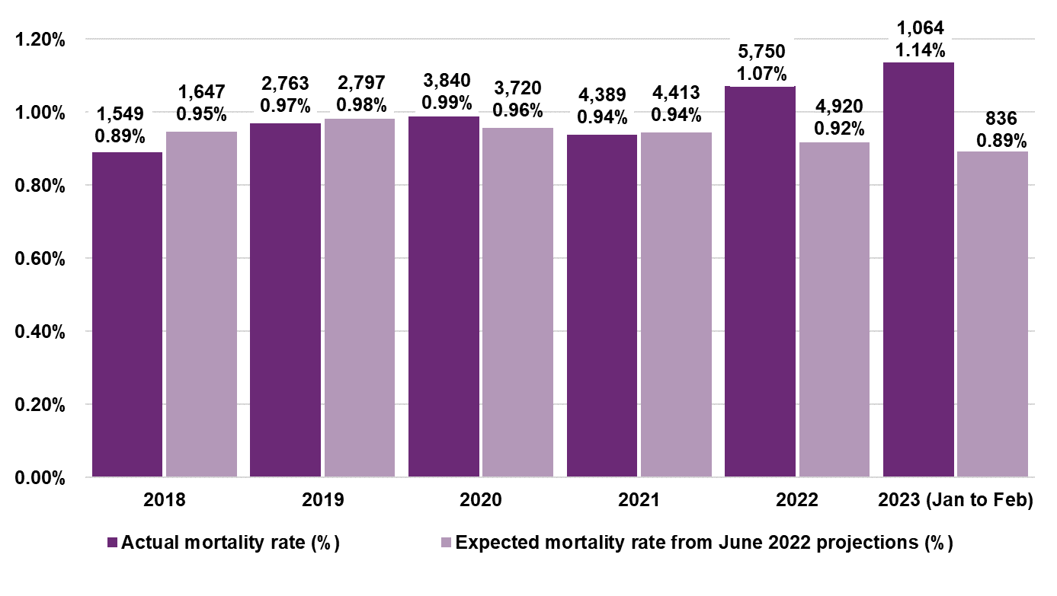
The actual mortality rate in the 14 months to 28 February 2023 of 1.08% was 18.4% higher than expected (0.91%). In total, there were 6,814 deaths, 1,058 more than the 5,756 expected for the period. The main contributors to this difference were:
- Participants aged 35 and over accounting for 93% of the difference.
- Participants with psychosocial, other and acquired brain injury (ABI) disabilities accounting for 70% of the difference.
- Participants with low levels of function accounting for 67% of the difference.

Scheme mortality over time, by disability group
Mortality experience varies widely according to disability, noting that each disability has different participant mixes in terms of ages, gender and levels of function.
Table H.1, Table H.2 and Table H.3 show the actual and expected mortality experience for each primary disability as well as the difference between actual and expected experience. Expected mortality rates are the mortality assumptions from the June 2022 projections.

Table H.1: Actual mortality rates by primary disability
Disability group | 2018 | 2019 | 2020 | 2021 | 2022 | 2023  (Jan to Feb) | Overall (2018 to Feb 2023)
Acquired brain injury | 2.29% | 2.09% | 2.42% | 2.60% | 3.45% | 3.89% | 2.73%
Autism | 0.04% | 0.05% | 0.05% | 0.04% | 0.06% | 0.05% | 0.05%
Cerebral Palsy | 0.62% | 083% | 0.56% | 0.81% | 0.99% | 1.13% | 0.79%
Developmental delay | 0.42% | 0.24% | 0.17% | 0.08% | 0.10% | 0.09% | 0.12%
Hearing Impairment | 0.35% | 0.20% | 0.26% | 0.27% | 0.28% | 0.24% | 0.26%
Intellectual Disability | 0.73% | 0.77% | 0.77% | 0.77% | 0.82% | 0.81% | 0.78%
Multiple Sclerosis | 1.25% | 1.26% | 1.07% | 1.18% | 1.32% | 1.55% | 1.23%
Psychosocial disability | 1.00% | 1.13% | 1.45% | 1.23% | 1.66% | 1.78% | 1.40%
Spinal Cord Injury | 1.54% | 2.14% | 2.00% | 2.12% | 2.82% | 1.83% | 2.20%
Stroke | 2.21% | 3.04% | 3.18% | 3.05% | 3.92% | 4.07% | 3.30%
Visual Impairment | 0.98% | 1.16% | 1.22% | 1.15% | 1.06% | 2.00% | 1.16%
Other Neurological | 4.51% | 5.18% | 5.11% | 4.82% | 5.57% | 6.41% | 5.17%
Other Physical | 3.71% | 3.79% | 4.23% | 3.76% | 3.91% | 4.02% | 3.91%
Other Sensory/Speech | 0.10% | 0.13% | 0.24% | 0.20% | 0.18% | 0.58% | 0.19%
Other | 1.55% | 1.47% | 2.62% | 4.91% | 5.98% | 7.73% | 4.65%
Missing | 0.00% | 0.00% | 0.00% | 0.00% | 0.00% | 0.00% | 0.00%
Total | 0.89% | 0.97% | 0.99% | 0.94% | 1.07% | 1.14% | 0.99%

Table H.2: Expected mortality rates by primary disability
Disability group | 2018 | 2019 | 2020 | 2021 | 2022 | 2023  (Jan to Feb) | Overall (2018 to Feb 2023)
Acquired brain injury | 2.49% | 2.60% | 2.65% | 2.69% | 2.72% | 2.74% | 2.66%
Autism | 0.06% | 0.06% | 0.06% | 0.06% | 0.06% | 0.06% | 0.06%
Cerebral Palsy | 0.78% | 0.79% | 0.78% | 0.77% | 0.77% | 0.78% | 0.78%
Developmental delay | 0.14% | 0.14% | 0.14% | 0.13% | 0.13% | 0.12% | 0.13%
Hearing Impairment | 0.26% | 0.26% | 0.24% | 0.24% | 0.25% | 0.26% | 0.25%
Intellectual Disability | 0.75% | 0.79% | 0.78% | 0.79% | 0.80% | 0.80% | 0.79%
Multiple Sclerosis | 1.42% | 1.45% | 1.48% | 1.50% | 1.52% | 1.54% | 1.49%
Psychosocial disability | 1.04% | 1.07% | 1.10% | 1.12% | 1.13% | 1.14% | 1.11%
Spinal Cord Injury | 1.73% | 1.75% | 1.77% | 1.80% | 1.83% | 1.84% | 1.79%
Stroke | 2.62% | 2.66% | 2.72% | 2.77% | 2.81% | 2.83% | 2.75%
Visual Impairment | 0.95% | 1.03% | 1.08% | 1.14% | 1.21% | 1.25% | 1.11%
Other Neurological | 4.98% | 5.19% | 5.28% | 5.30% | 5.24% | 5.20% | 5.23%
Other Physical | 3.64% | 3.68% | 3.79% | 3.85% | 3.87% | 3.87% | 3.80%
Other Sensory/Speech | 0.03% | 0.04% | 0.04% | 0.05% | 0.06% | 0.06% | 0.04%
Other | 2.54% | 2.59% | 2.78% | 3.20% | 3.44% | 3.52% | 3.15%
Missing | 0.02% | 0.03% | 0.03% | 0.03% | 0.02% | 0.02% | 0.02%
Total | 0.95% | 0.98% | 0.96% | 0.94% | 0.92% | 0.89% | 0.94%

Table H.3: Difference between actual and expected mortality rates by primary disability
Disability group | 2018 | 2019 | 2020 | 2021 | 2022 | 2023  (Jan to Feb) | Overall (2018 to Feb 2023)
Acquired brain injury | -0.20% | -0.51% | -0.23% | -0.09% | +0.73% | +1.15% | +0.07%
Autism | -0.02% | -0.01% | -0.01% | -0.02% | +0.00% | -0.00% | -0.01%
Cerebral Palsy | -0.16% | +0.03% | -0.21% | +0.04% | +0.22% | +0.35% | +0.01%
Developmental delay | +0.28% | +0.11% | +0.03% | -0.05% | -0.03% | -0.04% | -0.01%
Hearing Impairment | +0.09% | -0.06% | +0.02% | +0.03% | +0.02% | -0.02% | +0.02%
Intellectual Disability | -0.02% | -0.02% | -0.01% | -0.02% | +0.02% | +0.00% | -0.01%
Multiple Sclerosis | -0.17% | -0.20% | -0.41% | -0.32% | -0.20% | +0.00% | -0.26%
Psychosocial disability | -0.04% | +0.06% | +0.35% | +0.12% | +0.53% | +0.64% | +0.29%
Spinal Cord Injury | -0.19% | +0.39% | +0.23% | +0.32% | +0.99% | -0.01% | +0.41%
Stroke | -0.42% | +0.38% | +0.47% | +0.28% | +1.11% | +1.23% | +0.55%
Visual Impairment | +0.03% | +0.14% | +0.14% | +0.01% | -0.15% | +0.74% | +0.05%
Other Neurological | -0.47% | -0.01% | -0.16% | -0.48% | +0.33% | +1.21% | -0.06%
Other Physical | +0.07% | +0.11% | +0.44% | -0.09% | +0.04% | +0.15% | +0.11%
Other Sensory/Speech | +0.07% | +0.10% | +0.20% | +0.15% | +0.12% | +0.52% | +0.14%
Other | -0.99% | -1.12% | -0.16% | +1.71% | +2.54% | +4.21% | +1.49%
Missing | -0.02% | -0.03% | -0.03% | -0.03% | -0.02% | -0.02% | -0.02%
Total | -0.06% | -0.01% | +0.03% | -0.01% | +0.15% | +0.24% | +0.05%
Figure H.2 shows that actual mortality rates have increased from 2020 to 2023 in most disability groups. The upward trend in mortality rates is particularly evident amongst participants with acquired brain injury, psychosocial disability, spinal cord injury, stroke, other neurological disability and other disability.
Actual mortality experience against expectations for 2022 was varied.
- Mortality rates amongst participants with autism and intellectual disability were 0.06% and 0.82% respectively and were both broadly in-line with expectations.
- The remaining disability types, other than developmental delay, multiple sclerosis and visual impairment, had higher rates of mortality than expected.

Figure H.2: Actual vs expected mortality rates by calendar year and primary disability

Scheme mortality over time, by age group
As shown in Figure H.3:
- Mortality rates generally increase with age (after the age of 6). In 2022, actual mortality rates were 0.06% for participants aged 7 to 14, increasing to 5.57% for participants over 65.
- For adult participants, mortality rates in the 14 months to 28 February 2023 increased compared to prior years, with larger increases observed for older age bands.
- For participants aged 34 and below, actual mortality experience was reasonably steady between calendar year 2020 and 2022, with a slight increase in 2022.
- Participants aged 35 and over were the primary contributors to the overall increase in mortality in 2022 and 2023. This cohort accounted for 93% of the higher-than-expected deaths in the period.
Actual mortality experience for the 14 months to February 2023 was higher than expected for all age bands, except for the 7 to 14 group, the age band with the greatest number of participants.

Figure H.3: Actual vs expected mortality rates by calendar year and age group

Table H.4: Actual mortality by calendar year and age group
Age group | 2018 | 2019 | 2020 | 2021 | 2022 | 2023  (Jan to Feb) | Overall (2018 to Feb 2023)
0 to 6 | 0.10% | 0.16% | 0.10% | 0.09% | 0.12% | 0.11% | 0.11%
7 to 14 | 0.09% | 0.10% | 0.05% | 0.06% | 0.06% | 0.06% | 0.07%
15 to 18 | 0.20% | 0.17% | 0.18% | 0.14% | 0.15% | 0.14% | 0.16%
19 to 24 | 0.25% | 0.31% | 0.21% | 0.19% | 0.23% | 0.26% | 0.23%
25 to 34 | 0.49% | 0.51% | 0.46% | 0.47% | 0.52% | 0.48% | 0.49%
35 to 44 | 0.94% | 0.92% | 0.94% | 0.87% | 1.06% | 0.97% | 0.95%
45 to 54 | 1.74% | 1.75% | 1.98% | 1.80% | 2.12% | 2.13% | 1.92%
55 to 64 | 3.47% | 3.45% | 3.82% | 3.48% | 3.90% | 4.58% | 3.70%
65+ | 3.67% | 4.92% | 4.45% | 4.90% | 5.57% | 5.85% | 5.05%
Overall | 0.89% | 0.97% | 0.99% | 0.94% | 1.07% | 1.14% | 0.99%

Table H.5: Expected mortality by calendar year and age group
Age group | 2018 | 2019 | 2020 | 2021 | 2022 | 2023  (Jan to Feb) | Overall (2018 to Feb 2023)
0 to 6 | 0.08% | 0.09% | 0.09% | 0.09% | 0.10% | 0.10% | 0.09%
7 to 14 | 0.09% | 0.09% | 0.08% | 0.07% | 0.07% | 0.07% | 0.07%
15 to 18 | 0.20% | 0.19% | 0.16% | 0.15% | 0.13% | 0.12% | 0.15%
19 to 24 | 0.29% | 0.28% | 0.26% | 0.24% | 0.22% | 0.21% | 0.25%
25 to 34 | 0.49% | 0.48% | 0.46% | 0.44% | 0.42% | 0.41% | 0.45%
35 to 44 | 0.92% | 0.91% | 0.90% | 0.88% | 0.84% | 0.82% | 0.88%
45 to 54 | 1.89% | 1.87% | 1.84% | 1.80% | 1.74% | 1.71% | 1.81%
55 to 64 | 3.61% | 3.59% | 3.56% | 3.48% | 3.37% | 3.31% | 3.49%
65+ | 4.78% | 4.85% | 4.86% | 4.88% | 4.87% | 4.86% | 4.86%
Overall | 0.95% | 0.98% | 0.96% | 0.94% | 0.92% | 0.89% | 0.94%

Table H.6: Difference between actual and expected mortality by calendar year and age group
Age  group | 2018 | 2019 | 2020 | 2021 | 2022 | 2023  (Jan to Feb) | Overall (2018 to Feb 2023)
0 to 6 | +0.01% | +0.07% | +0.01% | -0.00% | +0.02% | +0.00% | +0.02%
7 to 14 | -0.01% | +0.01% | -0.02% | -0.01% | -0.01% | -0.00% | -0.01%
15 to 18 | +0.01% | -0.02% | +0.01% | -0.01% | +0.02% | +0.02% | +0.01%
19 to 24 | -0.04% | +0.03% | -0.05% | -0.05% | +0.01% | +0.05% | -0.02%
25 to 34 | -0.00% | +0.03% | +0.00% | +0.03% | +0.10% | +0.07% | +0.04%
35 to 44 | +0.02% | +0.01% | +0.04% | -0.00% | +0.22% | +0.15% | +0.07%
45 to 54 | -0.15% | -0.12% | +0.14% | +0.01% | +0.38% | +0.42% | +0.11%
55 to 64 | -0.14% | -0.14% | +0.26% | -0.00% | +0.53% | +1.27% | +0.22%
65+ | -1.11% | +0.07% | -0.41% | +0.03% | +0.70% | +0.99% | +0.18%
Overall | -0.06% | -0.01% | +0.03% | -0.01% | +0.15% | +0.24% | +0.05%

Scheme mortality over time, by gender
Contrary to experience in the general Australian population, the actual mortality rates of female participants are higher than those of male participants (1.19% compared to 1.00% in 2022). This is driven by a larger proportion of female participants being in participant groups with higher mortality (and often with lower levels of function), e.g., other neurological, intellectual disability, other physical, other, psychosocial disability and multiple sclerosis. Most of the actual male mortality rates in the other participant groups are higher than those of female.
The mortality rate in 2022 was 16% to 17% higher than expected across male and female participants. The actual mortality rate for male participants increased from 0.87% in 2021 to 1.00% in 2022, while the rate for females increased from 1.06% to 1.19%.
Note that the comparison of actual and expected experience also includes participants whose gender is “other”, however this is a relatively small group.

Figure H.4: Actual vs expected mortality rates by calendar year and gender

Table H.7: Actual mortality by calendar year and gender
Gender | 2018 | 2019 | 2020 | 2021 | 2022 | 2023  (Jan to Feb) | Overall (2018 to Feb 2023)
Female | 1.04% | 1.04% | 1.08% | 1.06% | 1.19% | 1.22% | 1.10%
Male | 0.80% | 0.93% | 0.93% | 0.87% | 1.00% | 1.08% | 0.93%
Other | 1.02% | 0.92% | 1.12% | 0.69% | 0.90% | 1.31% | 0.92%
Total | 0.89% | 0.97% | 0.99% | 0.94% | 1.07% | 1.14% | 0.99%

Table H.8: Expected mortality by calendar year and gender
Gender | 2018 | 2019 | 2020 | 2021 | 2022 | 2023  (Jan to Feb) | Overall (2018 to Feb 2023)
Female | 1.05% | 1.08% | 1.06% | 1.04% | 1.01% | 0.99% | 1.04%
Male | 0.89% | 0.92% | 0.90% | 0.89% | 0.86% | 0.84% | 0.88%
Other | 0.74% | 0.77% | 0.81% | 0.81% | 0.76% | 0.73% | 0.78%
Total | 0.95% | 0.98% | 0.96% | 0.94% | 0.92% | 0.89% | 0.94%

Table H.9: Difference between actual and expected mortality by calendar year and gender
Gender | 2018 | 2019 | 2020 | 2021 | 2022 | 2023  (Jan to Feb) | Overall (2018 to Feb 2023)
Female | -0.01% | -0.05% | +0.02% | +0.01% | +0.18% | +0.23% | +0.06%
Male | -0.09% | +0.01% | +0.03% | -0.01% | +0.14% | +0.24% | +0.05%
Other | +0.28% | +0.15% | +0.31% | -0.13% | +0.14% | +0.58% | +0.14%
Total | -0.06% | -0.01% | +0.03% | -0.01% | +0.15% | +0.24% | +0.05%

Revised mortality assumptions
The mortality rates assumed for the June 2023 projections, compared with the previous review, are shown in Tables H.10, Table H.11, Table H.12 and Table H.13. The rates presented in these tables are all based on the mix of participants over the five years to 28 February 2023.
- Exposure refers to the distribution of the underlying participant population over the period of analysis.
- June 2022 projections refers to the mortality rate assumptions in the previous review.
- June 2023 projections refers to the revised mortality rate assumptions in this review.
- Difference is the absolute difference between the mortality rates from the June 2022 projections and June 2023 projections.
Overall, mortality rate assumptions have been increased slightly. The disability groups with the largest increases in mortality assumptions include:
- Other Sensory/Speech (0.05% to 0.11%).
- Other (3.16% to 3.97%).
- Psychosocial disability (1.11% to 1.32%).
- Stroke (2.75% to 3.01%).
- Spinal Cord Injury (1.79% to 1.89%).
The disability group with the largest decrease in mortality rates was for participants with multiple sclerosis (1.49% to 1.38%).

Table H.10: Mortality rate assumptions by primary disability
Disability group | Exposure | June 2022 projections | June 2023 projections | Change
Acquired brain injury | 3% | 2.66% | 2.70% | +0.03%
Autism | 34% | 0.06% | 0.06% | -0.00%
Cerebral Palsy | 4% | 0.78% | 0.79% | +0.02%
Developmental delay | 7% | 0.13% | 0.13% | -0.00%
Hearing Impairment | 4% | 0.25% | 0.25% | +0.00%
Intellectual Disability | 21% | 0.79% | 0.78% | -0.00%
Multiple Sclerosis | 2% | 1.49% | 1.38% | -0.11%
Psychosocial disability | 10% | 1.11% | 1.32% | +0.21%
Spinal Cord Injury | 1% | 1.79% | 1.89% | +0.10%
Stroke | 1% | 2.75% | 3.01% | +0.26%
Visual Impairment | 2% | 1.11% | 1.13% | +0.02%
Other Neurological | 4% | 5.23% | 5.17% | -0.06%
Other Physical | 4% | 3.81% | 3.85% | +0.05%
Other Sensory/Speech | 1% | 0.05% | 0.11% | +0.06%
Other | 1% | 3.16% | 3.97% | +0.81%
Total | 100% | 0.94% | 0.98% | +0.03%
Table H.11 shows the change in mortality assumptions for the five disability groups observed to have the highest number of deaths over the five-year period. The rates for each level of function were adjusted to be more in line with the five-year experience.

Table H.11: Mortality rate assumptions by primary disability and level of function for the top five primary disabilities
Disability group | Exposure | June 2022 projections | June 2023 projections | Change
Other Neurological - level 1 | 1% | 0.96% | 0.97% | +0.01%
Other Neurological - level 2 | 1% | 2.37% | 2.42% | +0.05%
Other Neurological - level 3 | 3% | 7.76% | 7.64% | -0.12%
Intellectual Disability - level 1 | 4% | 0.18% | 0.18% | -0.00%
Intellectual Disability - level 2 | 7% | 0.30% | 0.31% | +0.01%
Intellectual Disability - level 3 | 5% | 0.53% | 0.54% | +0.01%
Intellectual Disability - level 4 | 6% | 1.98% | 1.94% | -0.04%
Other Physical - level 1 | 2% | 1.31% | 1.41% | +0.10%
Other Physical - level 2 | 1% | 3.17% | 3.52% | +0.35%
Other Physical - level 3 | 1% | 7.08% | 6.85% | -0.22%
Psychosocial disability - level 1 | 0% | 0.39% | 0.54% | +0.15%
Psychosocial disability - level 2 | 2% | 0.63% | 0.80% | +0.17%
Psychosocial disability - level 3 | 2% | 0.68% | 0.96% | +0.27%
Psychosocial disability - level 4 | 3% | 0.70% | 1.09% | +0.39%
Psychosocial disability - level 5 | 3% | 2.00% | 2.01% | +0.01%
ABI - level 1 | 0% | 0.48% | 0.51% | +0.03%
ABI - level 2 | 0% | 0.69% | 0.81% | +0.12%
ABI - level 3 | 0% | 1.31% | 1.43% | +0.12%
ABI - level 4 | 0% | 1.38% | 1.61% | +0.23%
ABI - level 5 | 1% | 1.89% | 1.89% | -0.00%
ABI - level 6 | 2% | 3.69% | 3.68% | -0.01%
ABI - level 7 | 0% | 3.26% | 3.42% | +0.16%
Table H.12 and Table H.13 show the result of changing mortality assumptions across age bands and gender.

Table H.12: Mortality rate assumptions by age band
Age group | Exposure | June 2022 projections | June 2023 projections | Change
0 to 6 | 15% | 0.09% | 0.09% | +0.00%
7 to 14 | 25% | 0.07% | 0.08% | +0.00%
15 to 18 | 8% | 0.15% | 0.15% | -0.00%
19 to 24 | 9% | 0.25% | 0.25% | -0.00%
25 to 34 | 9% | 0.45% | 0.46% | +0.01%
35 to 44 | 8% | 0.88% | 0.94% | +0.06%
45 to 54 | 10% | 1.81% | 1.88% | +0.07%
55 to 64 | 12% | 3.49% | 3.59% | +0.11%
65+ | 3% | 4.86% | 5.02% | +0.16%
Total | 100% | 0.94% | 0.98% | +0.03%

Table H.13: Mortality rate assumptions by gender
Gender | Exposure | June 2022 projections | June 2023 projections | Change
Female | 38% | 1.04% | 1.07% | +0.03%
Male | 62% | 0.89% | 0.92% | +0.04%
Total | 100% | 0.94% | 0.98% | +0.03%

Supported Independent Living
Mortality experience for participants with SIL were also considered to determine whether separate mortality assumptions based on SIL status would be appropriate. Ultimately, separate loadings based on SIL status were not applied because:
- The overall mortality experience for participants with and without SIL were not significantly different and adjusting the mortality assumptions to allow for SIL status would not make a material difference to the projected participant numbers and associated Scheme expenses.
- The comparison of actual and expected mortality experience varied according to disability, suggesting that SIL status is not necessarily a determinant of mortality experience.

Impact of changes to assumptions
Table H.14 and Table H.15 set out the impact of changing the mortality rate assumptions on Scheme projections. The slightly higher mortality rate assumptions result in 2,411 (0.23%) fewer participants projected by 30 June 2033 and $0.23 billion lower payments in 2032-33. Over the four-year period to 30 June 2027, 692 fewer participants are projected by 30 June 2027 using the revised assumptions and payments are $0.32 billion (0.02%) lower.

Table H.14: Impact on projected participant numbers of updating mortality assumptions 30 June
Participant numbers | 2024 | 2025 | 2026 | 2027 | 2033
June 2022 projection | 646,012 | 693,889 | 741,077 | 787,820 | 1,062,787
Impact of revised mortality assumptions | -168 | -312 | -487 | -692 | -2,411
% impact on participant numbers | -0.03% | -0.04% | -0.07% | -0.09% | -0.23%

Table H.15: Impact on projected Scheme Expenses (accrual basis) of updating mortality assumptions
Scheme expense ($m) | 2023-24 | 2024-25 | 2025-26 | 2026-27 | 2032-33 | Total 2023-27
June 2022 projection | 38,133 | 44,116 | 50,344 | 55,510 | 96,966 | 188,103
Impact of revised mortality assumptions | 3 | -1 | -10 | -25 | -242 | -33
% impact on Scheme expense | 0.01% | 0.00% | -0.02% | -0.04% | -0.25% | -0.02%

Appendix I Participants with SIL supports

Background
For the June 2022 projections and prior projections, participants with SIL have been projected based on an assumed proportion (percentage) of participants with SIL in the Scheme by primary disability. Given the relative immaturity of the Scheme at the time, with the number of participants with SIL accounting for about 5% of total participants, this approach provided a reasonable estimate of participants with SIL supports.
However, payments for participants with SIL represent around 33% of total Scheme expenses. As the Scheme continues to evolve and, in particular, as the number of participants with SIL has increased significantly over the most recent 12 months, it is necessary to more accurately project participants with SIL supports to better understand the drivers of the future costs of the Scheme.

New approach on modelling participants with SIL
Prior to the June 2023 projections, the number of participants with SIL supports were projected based on an assumed proportion of total participants (inclusive of participants with and without SIL supports). Consequently, it was not possible to capture the projected numbers of participants transitioning into SIL arrangements, or other movements, using this approach. To address this limitation, in the June 2023 projections, future numbers of participants with SIL were projected based on an assumed rates of participants transitioning to SIL.
The overall SIL transition rates were set with two main considerations:
- The profile of participants transitioning into SIL for the first time. The SIL transition rates are calculated based on the exposure of participants without SIL reflecting the recent experience by:
  - Primary disability group – participants with different primary disability have vastly different experience on transition into SIL and is the main differentiator of likelihood of requiring SIL.
  - Level of function – participants with a lower functioning capacity require greater support and more likely to access SIL compared to their higher functioning counterparts.
  - Age group – rates of transition into SIL increase with age up to age 65 reflecting different key life stages. For example, late teen (ages 15-18) transitioning into adulthood and living independently, late adulthood (ages 45-64) when parents/ guardians/ carers may no longer be able to provide informal supports, and age 65 and above where the option of Residential Age Care becomes available.
- The overall projected number of participants expected to access SIL in a given year. This takes into consideration recent Scheme experience, Home and Living eligibility decisions for SIL, operational changes, Budget initiatives related to accessing SIL supports, and consultation with the Home and Living specialists within the Agency.
The new modelling approach assumes that once participants begin accessing SIL, they continue to access SIL until they pass away or transition into aged care at age 65 or above. While experience has shown some participants appear to cease accessing SIL, in most cases, the participants are observed to re-enter SIL and their annual plan budget remains higher than average participants without SIL. The reliability of identifying participants with SIL remains uncertain. This is further discussed as a data limitation in Section 2.1 of the 2022-23 AFSR. Incorporating modelling of participants transitioning out of SIL supports could understate the overall Scheme expenditure.

Transition of participants accessing SIL for the first time
Figure I.1, Figure I.2, Figure I.3 and Figure I.4 show the number and proportion of participants accessing SIL for the first time over the past 2 years by primary disability group and age group.
Participants accessing SIL supports for the first time has been trending upwards for the months up to January 2023, more than doubling over the average 6 months to June 2022. This peaked at around 800 new participants per month in November 2022 and January 2023 and have been reducing over the 5 months to June 2023. This was mainly driven by the changes in the Home and Living application process. While the number of participants varied from month to month, the profile of participants transitioning into SIL by primarily disability has been largely unchanged.

Figure I.1: Monthly participants aged 15 and above that are new to SIL supports by primary disability group
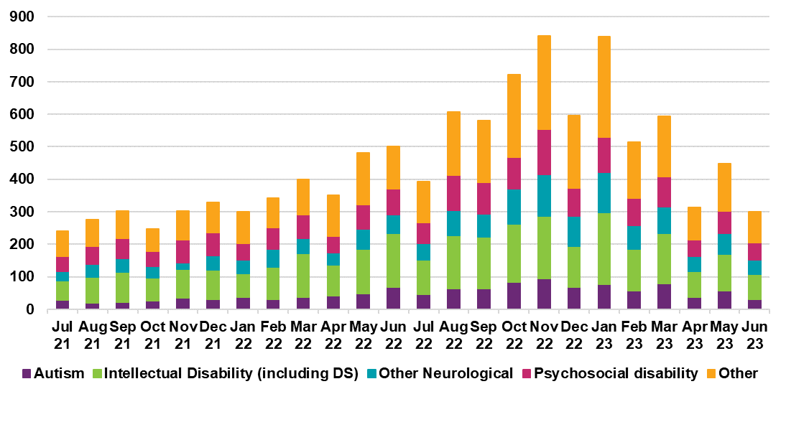

Figure I.2: Monthly proportion of participants that are new to SIL supports by primary disability group
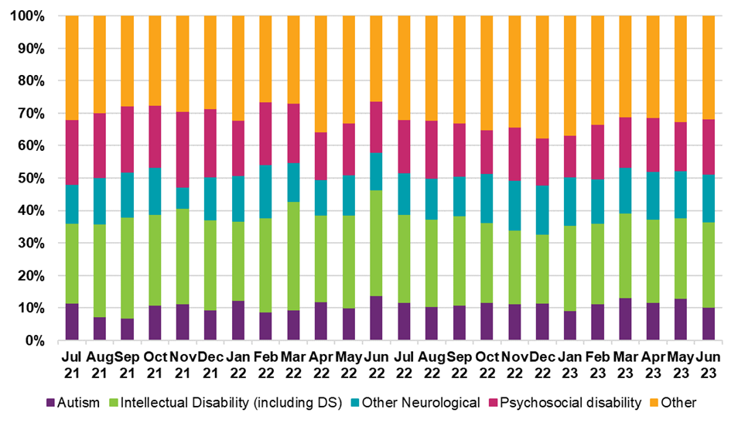

Figure I.3: Monthly participants aged 15 and above that are new to SIL supports by age group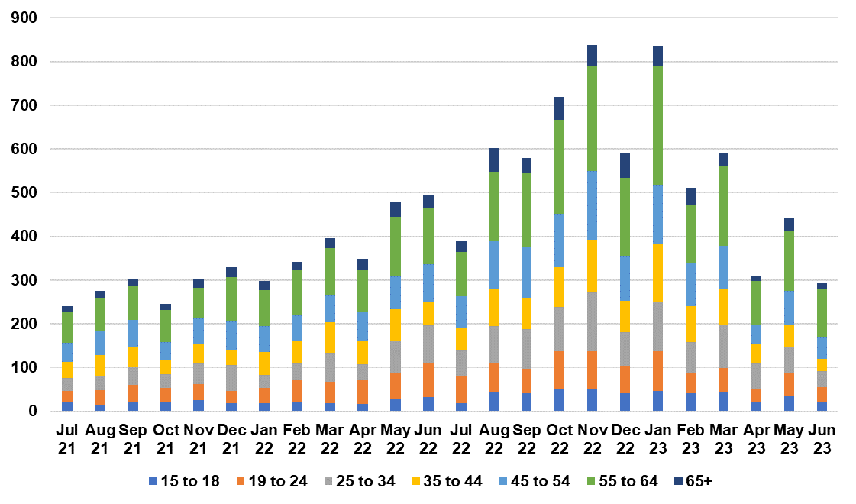

Figure I.4: Monthly proportion of participants that are new to SIL supports by age group

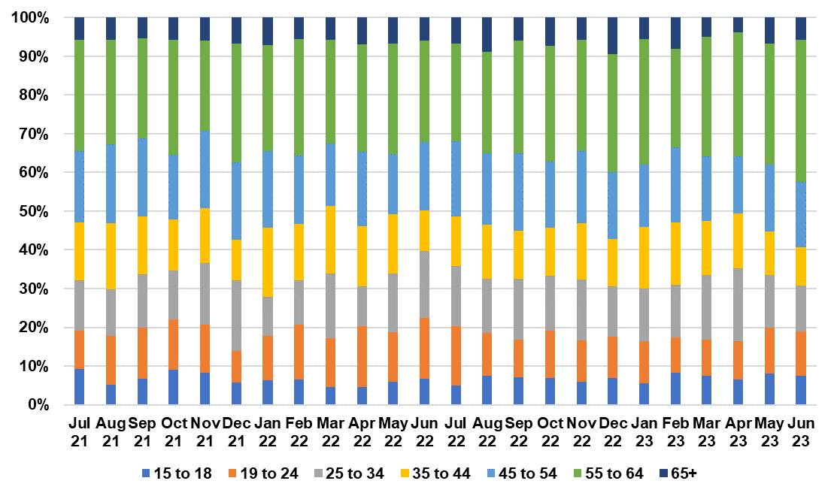Home and Living decisions and participants transitioning to SIL
Home and Living decisions on SIL eligibility are a leading indicator of the number of potential participants transitioning into SIL in the short term. In recent experience, there has been a 6-month lag from when a participant becomes eligible to access SIL supports and when participants are identified as accessing SIL. This reflects the time taken to make appropriate adjustments to the participant’s plan, finding an appropriate SIL provider, delays in SIL providers lodging claims, and the payment made to providers for SIL supports being processed.
Figure I.5, Figure I.6, Figure I.7 and Figure I.8 show the number and proportion of Home and Living decisions on SIL eligibility for participants accessing SIL for the first time by disability group and age group.
The trend of Home and Living decisions on SIL eligibility shows a similar trend to participants accessing SIL for the first time with an approximately 6-month delay.
Prior to July 2022 a Home & Living (H&L) model was implemented that meant any participant could apply for a H&L decision at any time (not just at plan reassessment). This increased the number of applications from participants seeking SIL supports for the first time significantly. However, due to operational processes, there was often a delay of several months between approval of the H&L decision and implementation of a new participant plan which included SIL arrangements.
After July 2022, the SIL process was changed to require that H&L assessments be linked to a plan reassessment. Improvements to operational process were also introduced with more rigour being applied to H&L decision making. This impacted decision rates and outcomes.
Furthermore, the distribution of H&L decisions on SIL eligibility for participants by primary disability and age group has remained relatively stable despite the change in number of decisions, indicating that the profile of participants entering SIL are likely to have a similar profile as the recent experience.

Figure I.5: Monthly Home and Living decisions for SIL eligibility that are new to SIL supports by primary disability group
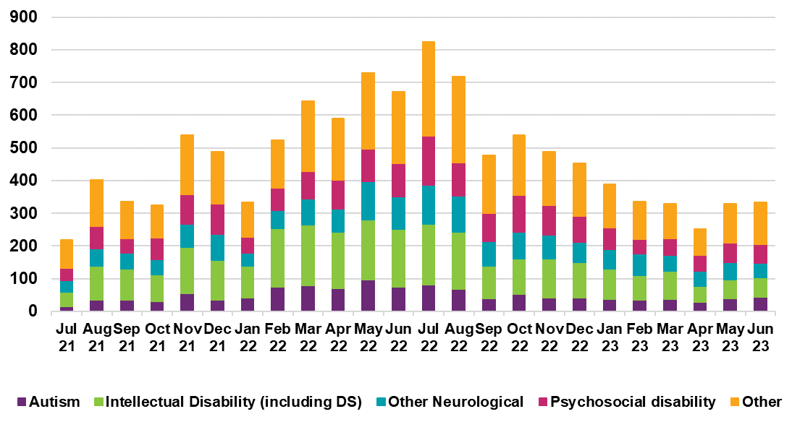

Figure I.6: Monthly proportion of Home and Living decision for SIL eligibility that are new to SIL supports by primary disability group
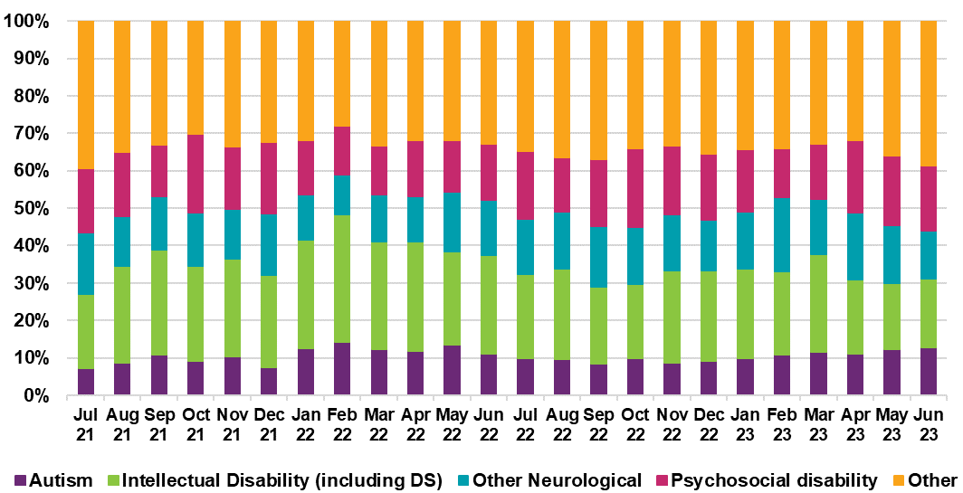

Figure I.7: Monthly Home and Living decision for SIL eligibility that are new to SIL supports by age group
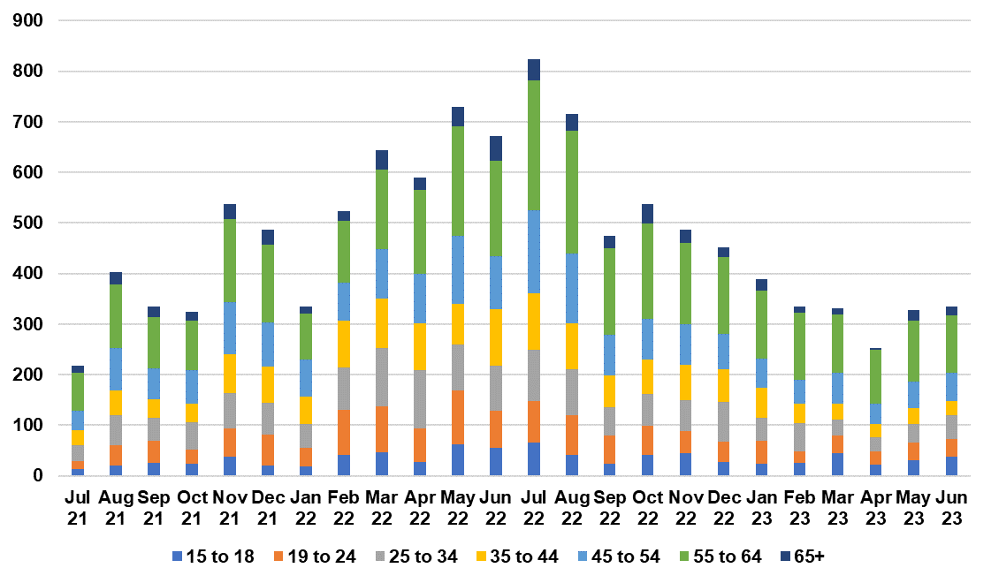

Figure I.8: Monthly proportion Home and Living decision that are new to SIL supports by age group
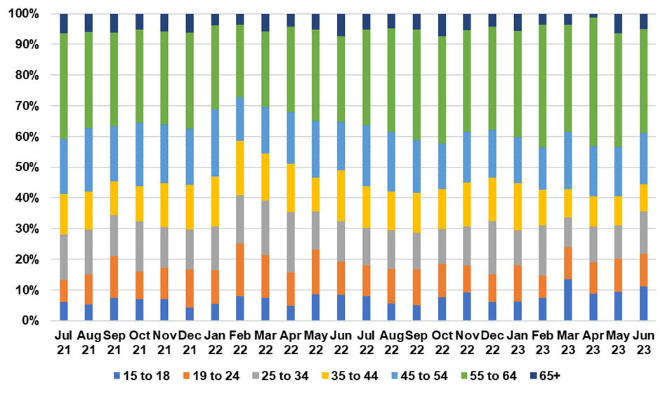

Selected Assumptions
Table I.1 shows the actual SIL transition rates in 2022-23 as well as the assumed SIL transition rates after initiatives by disability group and age group for aged 15 and above. There is no allowance given to participants aged 14 and below.

Table I.1: Actual and assumed SIL transition rates for participants aged 15 and above by primary disability group
Disability Group | 2022-23 | 2023-24 | 2024-25 | 2025-26 | 2026-27 | 2032-33
ABI | 4.8% | 3.0% | 2.0% | 1.7% | 1.3% | 1.2%
Autism | 1.1% | 0.8% | 0.5% | 0.4% | 0.4% | 0.3%
Cerebral Palsy | 3.4% | 2.4% | 1.6% | 1.4% | 1.1% | 0.9%
Hearing Impairment | 0.0% | 0.0% | 0.0% | 0.0% | 0.0% | 0.0%
Intellectual Disability | 2.6% | 1.8% | 1.2% | 1.0% | 0.8% | 0.8%
Multiple Sclerosis | 1.8% | 1.2% | 0.8% | 0.6% | 0.5% | 0.4%
Developmental delay | 0.0% | 0.0% | 0.0% | 0.0% | 0.0% | 0.0%
Other | 5.2% | 3.4% | 2.3% | 2.1% | 1.7% | 1.7%
Other Neurological | 5.2% | 3.0% | 2.0% | 1.7% | 1.3% | 1.0%
Other Physical | 0.9% | 0.6% | 0.4% | 0.4% | 0.3% | 0.3%
Other Sensory/Speech | 0.0% | 0.1% | 0.1% | 0.1% | 0.1% | 0.1%
Psychosocial disability | 1.9% | 1.2% | 0.8% | 0.7% | 0.6% | 0.5%
Spinal Cord Injury | 2.6% | 1.6% | 1.1% | 1.0% | 0.8% | 0.7%
Stroke | 5.2% | 3.2% | 2.2% | 1.9% | 1.5% | 1.4%
Visual Impairment | 0.3% | 0.2% | 0.2% | 0.1% | 0.1% | 0.1%
Overall  (age 15+ only) | 2.2% | 1.4% | 0.9% | 0.8% | 0.6% | 0.5%
The actual SIL transition rates in 2022-23 are vastly different across disability groups. Participants with stroke, other neurological and acquired brain injury have the higher transition rates (5.2%, 5.2%, 4.8% respectively), while participants with autism have a significantly lower SIL transition rate (1.1%).

Table I.2: Actual and assumed SIL transition rates for participants aged 15 and above by age group
Age group | 2022-23 | 2023-24 | 2024-25 | 2025-26 | 2026-27 | 2032-33
0 to 14 | 0.0% | 0.0% | 0.0% | 0.0% | 0.0% | 0.0%
15 to 18 | 1.0% | 0.7% | 0.4% | 0.4% | 0.3% | 0.3%
19 to 24 | 1.7% | 1.1% | 0.7% | 0.6% | 0.5% | 0.4%
25 to 34 | 2.2% | 1.5% | 1.0% | 0.8% | 0.7% | 0.6%
35 to 44 | 2.3% | 1.5% | 1.0% | 0.9% | 0.7% | 0.7%
45 to 54 | 2.3% | 1.7% | 1.1% | 1.0% | 0.8% | 0.7%
55 to 64 | 3.0% | 1.9% | 1.3% | 1.1% | 0.9% | 0.8%
65+ | 1.8% | 1.6% | 1.1% | 0.9% | 0.7% | 0.6%
Overall | 1.2% | 0.8% | 0.5% | 0.4% | 0.4% | 0.3%
Overall  (age 15+ only) | 2.2% | 1.4% | 0.9% | 0.8% | 0.6% | 0.5%
SIL transition rates progressively increase with age starting from age group 15 to 18 up to 55 to 64. Whilst experience shows there are some younger participants (age 0 to 14) accessing SIL, these are regarded as anomalies or data errors and no transitions are assumed for these age groups. For age group 15 to 18, participants could be seeking independence as they enter adulthood and, hence, transition into SIL. The transition rates progressively increase at higher age group as informal supports are no longer available. For example, guardians or family members becomes unable to provide the relevant supports or a change in participants’ condition requires additional supports. At age 65 and over, participants have the option to move into Residential Aged Care (thereby leaving the Scheme) and, hence, have a lower SIL transition rate.

Results
Table I.3 shows the overall comparison of participant numbers with SIL in the June 2022 projections and June 2023 projections.

Table I.3: Change in projected number of participants with SIL 30 June
Participants with SIL | 2023 | 2024 | 2025 | 2026 | 2027 | 2033
June 2023 projections | 31,818 | 35,468 | 37,731 | 39,649 | 41,037 | 50,266
June 2022 projections | 28,311 | 29,745 | 31,034 | 32,381 | 33,778 | 43,673
Difference (#) | 3,507 | 5,724 | 6,697 | 7,269 | 7,259 | 6,593
Difference (%) | 12% | 19% | 22% | 22% | 21% | 15%
More participants with SIL are projected in the Scheme compared to the June 2022 projections, reflecting the higher increase in participants with SIL in 2022-23, and the profile of participants shifting away from younger participants and related disability groups.
Table I.4 and Table I.5 compares the projected participants with SIL from the Jun 2023 projections and June 2022 projections by disability group.
While more participants with SIL is projected in the Scheme compared to the June 2022 projections, the profile of participants has shifted. The new approach allows for different growth in participant numbers with and without SIL, enabling a better reflection of experience. As a result, while more participants with SIL is projected across all disability groups in the short term, fewer participants with SIL with autism and intellectual disability are projected in the long term as the disability profile of participants with SIL shifts towards other neurological and psychosocial disabilities.

Table I.4: Change in projected number of participants with SIL by primary disability group 30 June
Projected participants with SIL | 2023 | 2024 | 2025 | 2026 | 2027 | 2033
June 2023 projections
Autism | 3,716 | 4,327 | 4,821 | 5,329 | 5,805 | 10,267
Intellectual Disability | 14,852 | 15,658 | 16,103 | 16,455 | 16,670 | 17,968
Other Neurological | 1,974 | 2,373 | 2,555 | 2,667 | 2,702 | 2,708
Psychosocial Disability | 3,642 | 4,259 | 4,671 | 5,028 | 5,301 | 6,840
Other Disabilities | 7,634 | 8,852 | 9,581 | 10,170 | 10,559 | 12,483
Total | 31,818 | 35,468 | 37,731 | 39,649 | 41,037 | 50,266
June 2022 projections
Autism | 3,504 | 4,009 | 4,551 | 5,155 | 5,843 | 11,606
Intellectual Disability | 14,161 | 14,597 | 15,015 | 15,439 | 15,842 | 18,266
Other Neurological | 1,333 | 1,340 | 1,330 | 1,323 | 1,320 | 1,345
Psychosocial Disability | 3,093 | 3,353 | 3,518 | 3,682 | 3,843 | 4,738
Other Disabilities | 6,221 | 6,447 | 6,619 | 6,782 | 6,931 | 7,718
Total | 28,311 | 29,745 | 31,034 | 32,381 | 33,778 | 43,673
Difference
Autism | 212 | 318 | 270 | 174 | -38 | -1,339
Intellectual Disability | 691 | 1,061 | 1,088 | 1,016 | 828 | -298
Other Neurological | 641 | 1,034 | 1,224 | 1,344 | 1,382 | 1,363
Psychosocial Disability | 549 | 906 | 1,152 | 1,346 | 1,457 | 2,102
Other Disabilities | 1,413 | 2,405 | 2,962 | 3,388 | 3,628 | 4,765
Total | 3,507 | 5,724 | 6,697 | 7,269 | 7,259 | 6,593
% Difference
Autism | 6% | 8% | 6% | 3% | -1% | -12%
Intellectual Disability | 5% | 7% | 7% | 7% | 5% | -2%
Other Neurological | 48% | 77% | 92% | 102% | 105% | 101%
Psychosocial Disability | 18% | 27% | 33% | 37% | 38% | 44%
Other Disabilities | 23% | 37% | 45% | 50% | 52% | 62%
Total | 12% | 19% | 22% | 22% | 21% | 15%
Similarly, the age profile of participants with SIL has also shifted away from younger cohorts towards older age groups. In particular, no new participants with SIL are projected to join at age 14 or under and more participants with SIL are projected at older age groups. While the Scheme was primarily designed for participants aged 0 to 64, the increase in projected participants with SIL at age 65 and above reflect the continuous challenges participants encounter in transitioning to Residential Aged Care.

Table I.5: Change in projected number of participants with SIL by age group 30 June
Projected participants with SIL | 2023 | 2024 | 2025 | 2026 | 2027 | 2033
June 2023 projections
Children (0 to 14) | 26 | 15 | 12 | 8 | 4 | 1
Young Adults (15 to 24) | 2,806 | 3,240 | 3,371 | 3,450 | 3,405 | 4,282
Adults (25 to 64) | 25,824 | 28,066 | 29,331 | 30,370 | 31,043 | 35,947
Older adults (65+) | 3,162 | 4,147 | 5,016 | 5,822 | 6,585 | 10,036
Total | 31,818 | 35,468 | 37,731 | 39,649 | 41,037 | 50,266
June 2022 projections
Children (0 to 14) | 17 | 18 | 18 | 19 | 19 | 20
Young Adults (15 to 24) | 2,407 | 2,583 | 2,760 | 2,971 | 3,208 | 4,941
Adults (25 to 64) | 23,165 | 23,965 | 24,632 | 25,349 | 26,103 | 32,334
Older adults (65+) | 2,723 | 3,179 | 3,624 | 4,041 | 4,448 | 6,378
Total | 28,311 | 29,745 | 31,034 | 32,381 | 33,778 | 43,673
Difference
Children (0 to 14) | 9 | -3 | -6 | -11 | -15 | -19
Young Adults (15 to 24) | 399 | 657 | 611 | 479 | 197 | -659
Adults (25 to 64) | 2,659 | 4,101 | 4,699 | 5,020 | 4,940 | 3,613
Older adults (65+) | 439 | 968 | 1,393 | 1,781 | 2,137 | 3,658
Total | 3,507 | 5,724 | 6,697 | 7,269 | 7,259 | 6,593
% Difference
Children (0 to 14) | 55% | -15% | -34% | -58% | -79% | -95%
Young Adults (15 to 24) | 17% | 25% | 22% | 16% | 6% | -13%
Adults (25 to 64) | 11% | 17% | 19% | 20% | 19% | 11%
Older adults (65+) | 16% | 30% | 38% | 44% | 48% | 57%
Total | 12% | 19% | 22% | 22% | 21% | 15%

Modelling of future demand for SIL supports
Since the previous review, new investigation and modelling has been undertaken on the future demand for SIL supports in the NDIS. The outputs from this modelling have provided a reasonableness check on assumptions underlying the June 2023 projections and the expected trajectory of the number of participants with SIL. However, it is important to recognise that there remains significant uncertainty about how and when participants may transition into SIL arrangements in the future, and also the extent to which alternative models of H&L supports may be taken up by participants instead of what is currently described as SIL.
The investigation was focused on the volume and types of participants who are not currently in SIL arrangements but might be expected to transition into SIL supports at some point. Participants with similar characteristics and support needs to those who are already in SIL, or those who have been found eligible for SIL based on a H&L decision, were identified. As not all of these participants would be expected to transition into SIL arrangements, assumptions were then developed about the pattern of when future transitions might occur.
The modelling of future demand for SIL consisted of a bottom-up and a top-down approach. For the bottom-up approach, detailed file reviews were conducted on a sample of individual participants across a range of cohorts to form a view of whether they would be likely to have a need for SIL type supports in the next 5 to 10 years. It is important to note that this process was subjective and relied on the judgment of Agency specialists. The results from the sample were then scaled to estimate the level of SIL type need across the Scheme based on the June 2023 participant projection.
The top-down approach (referred to as the characteristic model) used statistical regression modelling to identify characteristics of participants with SIL supports which may predict a SIL type need. It then looked for the presence of those characteristics in the population of participants not current receiving SIL supports. A feature of the characteristic model is that it requires a threshold or level of probability to be chosen, which is subjective, i.e., a requirement that participants exhibit most characteristics identified as predictive markers for SIL will result in a low estimate of SIL type need but is likely to understate the result because many participants with a SIL type need exhibit only some of those characteristics. Conversely, a requirement that participants exhibit fewer characteristics will capture more participants who will emerge to have a SIL type need but is more likely to also identify participants who will not. In order to validate the characteristic model, the results were benchmarked against participants in the Scheme with a level of daily living core supports at a ratio of 1:3 or higher.
Taken together, the models provided two different estimates and hence a plausible range of the number of participants that may require, or request, SIL type supports in the future. However, as noted, both approaches require judgment and the results obtained would fluctuate if the work is repeated going forward.
Under either of the modelling approaches, the timing of when the participants identified as having a future SIL type need will access SIL supports is very uncertain. For participants relying on informal support, such as family carers, the timing of when informal support will cease is not clear but influences the level of participants accessing SIL over time. There are also participants that may never access SIL supports, such as participants with borderline need of SIL as well as those in relatively unique circumstances. To allow for these situations and be comparable to the June 2023 projections, assumed rates of accessing SIL supports were applied to the model results of SIL type need. These rates were based on recent Scheme experience but also with consideration of the Budget initiative in relation to H&L decisions.
Figure I.9 compares the two approaches from the future demand model along with the June 2023 projections. The dotted blue and purple lines denote the estimates of SIL type need from the two approaches from the future demand modelling, including both participants currently in SIL and future demand. The solid blue and purple lines denote the estimates of those who will be accessing SIL supports over time. The June 2023 projection of participants with SIL is shown by the black sold line. This lies within the plausible range described by the results of the characteristics model and the bottom-up model, providing some indication that the June 2023 projections are not unreasonable. However, the modelling of future demand for SIL and SIL type supports will continue to be developed, to gain a better understanding of SIL demand and how it may or may not be realised.

Figure I.9: Estimated number of participants with SIL by 30 June 2028 and 30 June 2033.

Appendix J Average payment assumption setting details
Average payment assumptions have been calculated separately for each of the 15 different support categories, with different types of Scheme expenses treated as follows:
- Payments to participants and providers are treated on a cash basis (when the cash is paid out by the Agency, regardless of when the support was provided).
- Payments relating to in-kind supports are treated on an accrual basis (when the service was provided to the participant).
- Payments relating to Residential Aged Care (RAC) supports have been removed due to the infrequent occurrence of cross-billing payments which may distort the payment experience in each period. Expected payments relating to RAC are explicitly allowed for in the projection through a loading assumption.
The key components considered in setting payment assumptions are discussed in more details below.

The most appropriate averaging period for payment experience
The selection of an averaging period must balance the need to reflect recent experience with minimising volatility of payment patterns by cohort and support category. The assumed averaging period is the three months to 30 April 2023. By modelling the payments based on the three-month period, the projections align more closely to recent payment experience, which continues to increase over time, while still ensuring there is sufficient stability in payment patterns.
The average payment assumptions (i.e., those before allowance for inflation) are set with reference to payments on participants who have been in the Scheme for at least 12 months as of 1 February, 2023. This recognises the time it takes for a new participant to navigate the Scheme.
Payments are annualised based on working days for participants not in Supported Independent Living arrangements (“participants without SIL”); and calendar days for participants with Supported Independent Living arrangements (“participants with SIL”).

Impact of seasonality on the payment experience
Seasonality refers to fluctuations in payment levels over a period of time due to factors such as the number of business days, public holidays and provider claiming behaviour. By utilising a shorter period to inform average payment assumptions, the seasonality impact can result in either understatement or overstatement of payments. Hence, the average annualised payments assumptions are modified to allow for seasonality impacts resulting from the use of the three months to 30 April 2023 as the averaging period.
Table J.1 shows the seasonality factors by support category. The overall assumed adjustment for seasonality is a 2.0% reduction for participants with SIL supports and a 2.8% reduction for participants without SIL supports.

Table J.1: Assumed seasonality factors by support category
Support Category | Participants  Without SIL | Participants  With SIL
Core
Daily Activities | 2.3% | -1.8%
Social Community Civic | -8.3% | -3.2%
Consumables | -3.4% | -1.7%
Transport | 3.5% | 2.5%
Capital
Assistive Technology | 3.3% | -1.0%
Home Modifications | -9.8% | -0.7%
Capacity Building
CB Daily Activities | -6.9% | -4.1%
Support Coordination | -4.3% | -3.4%
CB Employment | -8.8% | -0.3%
CB Choice Control | -5.4% | -2.8%
CB Social Community Civic | -6.4% | 4.3%
CB Relationships | -8.1% | -3.7%
CB Health Wellbeing | 1.6% | 3.0%
CB Home Living | 0.0% | 0.0%
CB Lifelong Learning | 0.0% | 0.0%
Total | -2.8% | -2.0%

First year participants
Participants in their first year in the Scheme are observed to have lower average payments, which is likely to arise from time taken to familiarise themselves with the Scheme and the process of accessing supports. For participants in their first year without SIL supports, average payments assumptions have been discounted by 35% (consistent with the previous review) relative to average payments for participants in the Scheme for at least 12 months, while no reduction (consistent previous review) is assumed for first-year participants with SIL.

New entrant discount
For 2023-24 and beyond, all new participants without SIL supports have a further discount of about 8.4%, relative to existing participants (consistent with the previous review), applied to their average payments’ assumption.
Table J.2 shows the average payment by phasing year. Participants who have entered the scheme within the first 2 years of its availability in their region (D0+) experienced a higher average payment compared to those who have joined at a later stage (D2+). Overall relative difference in average payments was about 8.4% - same as last review.

Table J.2: Average payment triangle by phasing Financial Year
Phasing FY/Delay | 0 | 1 | 2 | 3 | 4 | 5 | 6 | 7 | 8
2013-14 |  |  |  |  |  |  |  | 7,288 | 5,562
2014-15 |  |  |  |  |  |  |  | 5,462
2015-16
2016-17 | 11,562 | 9,797 | 9,234 | 9,130 | 8,694 | 8,503
2017-18 | 10,932 | 9,191 | 8,509 | 8,049 | 7,636
2018-19 | 11,632 | 9,319 | 8,411 | 8,304
2019-20
2020-21

Table J.3: Weighted average payments by cohort
 | 2020-21 | 2021-22 | 2022-23
All | 41,700 | 39,900 | 39,600
Recent Entrants | 34,700 | 33,900 | 34,200

Younger People in Residential Aged Care
Supports for Younger People in Residential Aged Care (YPIRAC) are currently being met through the aged care system. These payments may be irregular. To avoid distortions in our modelling, payments relating to YPIRAC have been excluded from the payment experience and, hence, the resulting base average payment assumptions. However, an explicit and separate allowance is made to reflect YPIRAC payments in our model.

The distribution of Scheme expenses is highly skewed
The Scheme supports participants with a diverse range of needs. Of the payments over the 12 months to 30 June 2023 to mature participants, 52% of payments (similar to the previous review) related to the top 10% of participants when ranked by payment over the period. Conversely, the bottom 40% (similar to the previous review) of participants represent 5% of payments made (Figure J.1).

Figure J.1: Average payment and cumulative percentage of Scheme expenses by ventile (5% band)
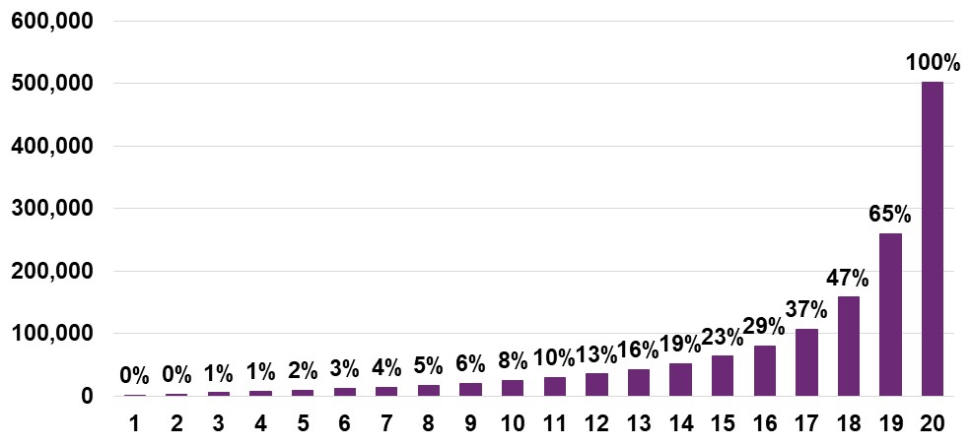

This distribution does not vary greatly even when removing the impact of participants with SIL (who have far higher payments on average). 46% of payments are made in respect of the top 10% of participants without SIL, whilst only 7% are made in respect of the bottom 40% of participants without SIL (Figure J.2).

Figure J.2: Average payment and cumulative percentage of Scheme expenses by ventiles (5% band) – participants without SIL only
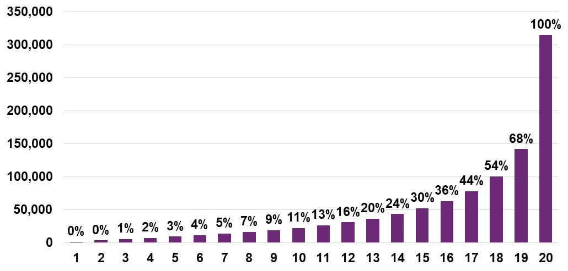
These observations are common in long-tail insurance schemes, and understanding these trends assist with monitoring Scheme sustainability.

Appendix K Projections – Plan budgets
Table K.1 shows that the disability groups with the highest projected total plan budgets are for those with intellectual disability, autism, psychosocial disability, other neurological, and acquired brain injury. These five groups are expected to account for about 70% of total plan budgets in 2023-24, increasing to 75% by 2032-33. By 2026-27, plan budgets for participants with autism is expected to account for the majority of total plan budgets.

Table K.1: Projected total plan budgets ($m) by disability group (2023-24 dollars)
Disability Group ($m) | 2023-24 | 2024-25 | 2025-26 | 2026-27 | 2032-33
Acquired Brain Injury | 3,615 | 4,006 | 4,327 | 4,628 | 6,886
Autism | 11,480 | 13,668 | 15,904 | 18,309 | 40,480
Cerebral Palsy | 3,369 | 3,600 | 3,811 | 4,000 | 5,527
Delay | 1,835 | 1,886 | 1,835 | 1,783 | 2,174
Hearing Impairment | 466 | 503 | 536 | 575 | 891
Intellectual Disability | 13,968 | 15,197 | 16,293 | 17,357 | 25,875
Multiple Sclerosis | 1,415 | 1,549 | 1,663 | 1,770 | 2,548
Other | 1,041 | 1,257 | 1,439 | 1,606 | 2,857
Other Neurological | 4,017 | 4,329 | 4,555 | 4,738 | 6,123
Other Physical | 1,813 | 1,918 | 2,000 | 2,073 | 2,678
Other Sensory Speech | 35 | 32 | 30 | 29 | 30
Psychosocial disability | 6,713 | 7,488 | 8,055 | 8,696 | 13,615
Spinal Cord Injury | 1,193 | 1,317 | 1,429 | 1,533 | 2,346
Stroke | 1,642 | 1,874 | 2,072 | 2,251 | 3,506
Visual Impairment | 580 | 630 | 675 | 718 | 1,051
Total | 53,183 | 59,253 | 64,623 | 70,067 | 116,587
Table K.2 shows the projected plan budgets split by support categories. The distribution of plan budgets remains quite stable over the projection period for most support categories. There is a small increase projected in the Social Community Civic support category and a reduction in the Capacity Building Daily Activities support category.

Table K.2: Projected total plan budgets ($m) by support category (2023-24 dollars)
Support Category ($m) | 2023-24 | 2024-25 | 2025-26 | 2026-27 | 2032-33
Consumables | 1,213 | 1,320 | 1,407 | 1,487 | 2,128
Daily Activities | 26,400 | 29,721 | 32,926 | 35,707 | 59,205
Social Community Civic | 11,459 | 12,928 | 14,485 | 15,936 | 29,179
Transport | 955 | 1,065 | 1,167 | 1,268 | 2,045
Assistive Technology | 957 | 1,026 | 1,081 | 1,131 | 1,507
Home Modifications | 652 | 720 | 769 | 804 | 1,130
CB Choice Control | 561 | 580 | 602 | 653 | 1,057
CB Daily Activities | 7,699 | 8,212 | 8,794 | 9,328 | 13,728
CB Employment | 334 | 397 | 469 | 552 | 1,243
CB Health Wellbeing | 79 | 85 | 90 | 96 | 136
CB Home Living | 3 | 3 | 4 | 4 | 7
CB Lifelong Learning | 0 | 0 | 0 | 0 | 0
CB Relationships | 1,068 | 1,202 | 1,318 | 1,427 | 2,209
CB Social Community Civic | 459 | 543 | 634 | 724 | 1,501
Support Coordination | 1,343 | 1,451 | 879 | 950 | 1,513
Total | 53,183 | 59,253 | 64,623 | 70,067 | 116,587

Appendix L Scenario analysis from previous AFSRs
This section summarises the results of projection scenarios considered in historic Annual Financial Sustainability Report projections since 2016-17. These scenarios assist in understanding the range of plausible projections based on reasonable alternative assumptions.

Note on terminology and term of projection
There have been several changes in terminology in the 2022-23 AFSR compared with previous AFSRs. In this appendix, the original terminology has been used. In particular:
- Scheme expenses were previously referred to as ‘Total participant costs.
- Participants leaving the Scheme were previously referred to as ‘non-mortality exits.
- Supported Independent Living (SIL) was previously referred to as Shared Supported Accommodation (SSA).
- Plan budgets were previously referred to as ‘Committed supports.
- Additional growth was previously referred to as ‘Additional inflation’ or ‘Superimposed inflation’.
It is also important to recognise that the scenarios set out in this appendix include results out to the 2029-30 period. In this AFSR however, results are generally shown out to the 2032-33 period, and therefore are not directly comparable with the scenario results presented here.

Table L.1: 2016-17 AFSR scenarios
Total participant costs ($m) | 2019-20 | 2024-25 | 2029-30
2016-17 Baseline | 21,240 | 30,492 | 41,783
Scenario 1a. Committed supports + utilisation of 85% | 20,436 | 28,943 | 38,863
Scenario 1b. Committed supports + utilisation of 90% | 21,638 | 30,645 | 41,149
Scenario 1c. Committed supports + utilisation of 100% | 24,042 | 34,050 | 45,721
Scenario 2a. 1% p.a. superimposed inflation | 21,756 | 32,762 | 47,095
Scenario 2b. 2% p.a. superimposed inflation | 22,279 | 35,179 | 53,022
Scenario 2c. 10% p.a. superimposed inflation for 2 years | 25,509 | 36,619 | 50,179
Scenario 2d. 5% p.a. superimposed inflation for 5 years | 23,897 | 38,551 | 52,826
Scenario 3a. Increase incidence 0 to 18 by 15% | 22,345 | 32,201 | 44,258
Scenario 3b. Reduce incidence 25+ by 5% | 20,662 | 29,676 | 40,695
Scenario 3c. Combination of 3a. and 3b. | 21,766 | 31,385 | 43,171
Scenario 4a. Halve non-mortality exits ages 0 to 64 | 21,240 | 31,315 | 44,041
Scenario 4b. Double non-mortality exits for ages 65+ | 21,237 | 30,434 | 41,532
Scenario 4c. Increase excess mortality by 50% | 21,168 | 30,017 | 40,583
Scenario 4d. Reduce excess mortality by 50% | 21,252 | 30,899 | 42,984
Scenario 5a. 5% of new incidence to highest LoF | 21,240 | 31,154 | 43,486
Scenario 5b. 5% of starting population to highest LoF | 25,216 | 35,449 | 47,576
Scenario 5c. Combination of 5a. and 5b. | 25,216 | 36,112 | 49,279
Scenario 6a. Increase SSA Numbers by 10% | 20,970 | 29,684 | 39,818
Scenario 6b. Increase SSA average cost by 25% | 21,822 | 30,939 | 41,570
Scenario 6c. Combination of 6a. and 6b. | 22,495 | 31,880 | 42,796
Scenario 7a. Remove age-based loadings for 65+ | 21,176 | 30,068 | 40,729
Scenario 10a. Exclude GI/MM from NIIS | 21,240 | 30,492 | 41,783

Table L.2: 2017-18 AFSR scenarios
Total participant costs ($m) |  | 2019-20 |  |  | 2024-25 | 2029-30
2017-18 Baseline |  |  |  | 15,638 | 31,715 | 44,395
1a | Higher Autism exits |  | 15,453 |  | 30,171 |  | 40,485
1b | Lower Autism exits |  | 15,676 |  | 32,099 |  | 45,579
2 | Intellectual disability new incidence hump 17-22 yrs |  | 15,638 |  | 32,008 |  | 46,518
3a | Higher Proportion of participants in SSA (SIL) |  | 17,636 |  | 35,769 |  | 50,034
3b | Lower Proportion of participants in SSA (SIL) |  | 15,405 |  | 31,197 |  | 43,556
3c | SSA cost innovation |  | 12,489 |  | 29,261 |  | 41,178
4a | Increased Number of adults |  | 16,276 |  | 38,193 |  | 53,883
4b | Decreased number of children |  | 14,213 |  | 30,962 |  | 43,463
4c | Increased new entrants |  | 15,887 |  | 36,377 |  | 50,143
5a | Committed supports and 100% utilisation |  | 18,957 |  | 38,064 |  | 53,473
5b | Committed supports and 75% utilisation |  | 13,839 |  | 28,548 |  | 40,105
7a | AAT and mainstream |  | 18,123 |  | 37,118 |  | 51,450
7b | AAT, mainstream and level of function movement |  | 18,400 |  | 37,686 |  | 52,236
7c | AAT access decisions |  | 16,670 |  | 34,352 |  | 47,592
8a | 3% pa superimposed inflation for 10 years |  | 15,676 |  | 35,882 |  | 55,465
8b | 0% superimposed inflation |  | 14,810 |  | 29,407 |  | 41,164

Table L.3: 2018-19 AFSR scenarios
Total participant costs ($m) |  | 2019-20 | 2024-25 | 2029-30
2018-19 Baseline |  | 16,327 | 30,820 | 43,723
1a | Additional Cost of chronic health (Low range) | 19,333 | 34,760 | 48,886
1b | Additional Cost of chronic health mid-range) | 20,770 | 36,644 | 51,356
1c | Additional Cost of chronic health high range) | 22,404 | 38,785 | 54,162
2 | Lower autism and higher psychosocial disability numbers | 16,347 | 31,077 | 43,893
3 | Intellectual disability new entrants hump for 17-22yrs | 16,327 | 31,209 | 46,322
4a | Higher proportion of participants in SIL over long-term | 16,434 | 32,930 | 48,951
4b | Long-term SIL reached over 20 years | 16,302 | 30,331 | 42,573
4c | SIL cost innovation | 14,874 | 27,978 | 39,510
5 | 85%/100% utilisation rate for non-SIL/SIL respectively | 19,380 | 34,844 | 49,343
6a | Transport policy: Strict tightened eligibility | 16,125 | 30,469 | 43,215
6b | Transport policy: tightened eligibility &increased budget | 16,454 | 31,041 | 44,043
6c | Transport policy: tightened eligibility & bottom-up approach | 18,800 | 35,115 | 49,941
7 | Steady intake date at 30 June 2020 | 16,425 | 28,286 | 41,344
8a | Additional 3% pa superimposed inflation from 2021 | 16,327 | 35,152 | 56,030
8b | Additional 1% pa superimposed inflation from 2021 | 16,327 | 32,264 | 47,825

Table L.4: 2019-20 AFSR scenarios
Total participant costs ($m) | 2019-20 | 2024-25 | 2029-30
2019-20 Baseline |  | 34,109 | 51,304
Scenario 1a. => Continuation of historical superimposed inflation |  | 45,399 | 68,282
Scenario 1b. => Removal of 1% p.a. additional superimposed inflation |  | 32,364 | 48,447
Scenario 1c. => Alternative normal inflation |  | 33,332 | 46,735
Scenario 2a. => Higher proportion of participants in SIL over long-term |  | 37,230 | 60,805
Scenario 2b. => Continuation of increasing SIL cost for 2 years |  | 37,909 | 57,276
Scenario 2c. => SIL cost innovation |  | 31,119 | 46,600
Scenario 3a. => 44,000 additional participants |  | 37,955 | 56,268
Scenario 3b. => 60,000 additional participants |  | 38,430 | 56,879
Scenario 3c. => 99,000 additional participants |  | 39,287 | 57,982
Scenario 5a. => Steady Intake Date at 30 June 2021 |  | 33,207 | 50,180
Scenario 5b. => Higher intake levels sustained for 3 years |  | 36,821 | 54,774

Table L.5: 2020-21 AFSR scenarios
Total participant costs ($m) | 2019-20 | 2024-25 | 2029-30
2020-21 Baseline |  | 41,373 | 59,284
Cost increase scenarios
Two additional years of high inflation |  | 46,613 | 69,464
Higher long term new incidence assumptions |  | 42,625 | 65,556
Lower non-mortality exit rates |  | 41,861 | 61,939
Higher cost of new entrants |  | 42,166 | 61,213
Higher SIL numbers (+500 p.a.) |  | 41,955 | 60,978
Three extra years to reach steady state |  | 42,091 | 60,865
Total of cost increase scenarios |  | 50,448 | 83,596
Plausible high case (variance) |  | 47,843 | 74,156
Cost reduction scenarios |  | 41,373 | 59,284
One year less of high inflation |  | 39,358 | 54,497
Lower long term new incidence assumptions |  | 41,373 | 57,496
Lower general population growth |  | 41,338 | 59,113
Lower SIL numbers (-200 p.a.) |  | 41,140 | 58,607
Lower cost of new entrants |  | 40,579 | 57,355
Total of cost decrease scenarios |  | 38,296 | 49,931
Plausible low case (variance) |  | 38,970 | 53,159

Table L.6: June 2022 projections scenarios
Scheme expense ($m) |  | 2019-20 | 2024-25 | 2029-30
2021-22 Baseline |  |  | 44,116 | 74,058
1a | Higher numbers of participants with SIL (+500 per annum) |  | 44,595 | 75,952
1b | Lower numbers of participants with SIL (-200 per annum) |  | 43,924 | 73,301
2 | Lower rate of participants leaving the Scheme |  | 44,289 | 74,909
3a | Higher assumptions regarding the number of new participants |  | 44,968 | 77,627
3b | Lower assumptions regarding the number of new participants |  | 43,264 | 70,490
3c | Higher assumptions regarding the number of new entrants with autism aged between 15 and 54 |  | 44,201 | 74,473
3d | Three extra years to reach steady state |  | 44,460 | 75,866
4a | Lower payments for new entrants |  | 43,503 | 71,902
4b | Higher payments for new entrants |  | 44,728 | 76,215
5a | Lower additional inflation |  | 42,962 | 69,054
5b | Higher additional inflation |  | 46,689 | 83,836

Appendix M Scenario analysis of participant numbers
The projections presented in Section 5 of this report represent the “baseline” estimate of Scheme population. This appendix shows the impact on participant numbers for the scenarios detailed in Section 6.1.

Scheme projections without the impact of Budget initiatives
This scenario removes all assumptions made in relation to Budget initiatives, i.e., it is the Scheme projection without the impact of Budget initiatives.

Table M.1: Scenario without the impact of Budget initiatives – projected participant numbers and variance to the June 2023 projections
Participant numbers | 30 June 2024 | 30 June 2025 | 30 June 2026 | 30 June 2027 | 30 June 2033
Baseline: June 2023 projections | 668,907 | 714,805 | 754,022 | 792,200 | 1,030,337
Scenario: Without the impact of Budget initiatives
Total Participants | 675,667 | 732,996 | 785,474 | 834,286 | 1,119,997
Variance to baseline | 6,760 | 18,190 | 31,452 | 42,086 | 89,660
% variance to baseline | 1.0% | 2.5% | 4.2% | 5.3% | 8.7%

Number of new entrants to the Scheme
To illustrate the impact of current trajectories related to new entrants continuing, the following scenarios are presented:
- Greater number of new entrants aged 0 to 14 with developmental delay or autism. The new entrant rates for participants aged 0 to 14 with developmental delay or autism are assumed to continue at the current level.
- Greater number of new entrants aged 15 and over with autism: The new entrant rates for male participants aged 15 and over with autism are assumed to continue at the current level, whilst the number of female participants entering the Scheme aged 15 and over is assumed to grow from its current level by 12.3% per annum (the assumed growth rate of 12.3% per annum is in-line with the average growth rate experienced over the 2020-21 and 2021-22 years for this cohort of participants).
- Greater number of new entrants aged 15 and over (excluding those with autism): The new entrant rates for participants aged 15 and over for all disability types excluding those with autism, are increased by 21.8%. This increase in new entrant rates represents the 90th percentile of new entrant outcomes for the 2023-24 year derived from the Stochastic Model (discussed in Section 6.2).
- Lower number of new entrants aged 15 and over (excluding those with autism): The new entrant rates for participants aged 15 and over for all disability types excluding those with autism, are decreased by 21.1%. This decrease in new entrant rates represents the 10th percentile of new entrant outcomes for the 2023-24 year derived from the Stochastic Model.

Table M.2: Scenarios with higher and lower new entrant rates – projected participant numbers and variance to the June 2023 projections
Participant numbers | 30 June 2024 | 30 June 2025 | 30 June 2026 | 30 June 2027 | 30 June 2033
Baseline: June 2023 projections | 668,907 | 714,805 | 754,022 | 792,200 | 1,030,337
Scenario 1: Higher rate of new entrants aged 0 to 14 with developmental delay or autism
Total Participants | 672,433 | 729,145 | 779,826 | 829,172 | 1,117,543
Variance to baseline | 3,526 | 14,339 | 25,804 | 36,972 | 87,206
% variance to baseline | 0.5% | 2.0% | 3.4% | 4.7% | 8.5%
Scenario 2: Higher rate of new entrants aged 15 and over with autism
Total Participants | 669,442 | 717,852 | 760,985 | 804,406 | 1,093,843
Variance to baseline | 535 | 3,047 | 6,963 | 12,206 | 63,506
% variance to baseline | 0.1% | 0.4% | 0.9% | 1.5% | 6.2%
Scenario 3: Higher rate of new entrants aged 15 and over, excluding those with autism
Total Participants | 671,972 | 720,900 | 763,078 | 804,152 | 1,058,313
Variance to baseline | 3,066 | 6,095 | 9,056 | 11,952 | 27,976
% variance to baseline | 0.5% | 0.9% | 1.2% | 1.5% | 2.7%
Scenario 4: Lower rate of new entrants aged 15 and over, excluding those with autism
Total Participants | 665,935 | 708,898 | 745,244 | 780,615 | 1,003,221
Variance to baseline | -2,972 | -5,907 | -8,778 | -11,585 | -27,116
% Variance to baseline | -0.4% | -0.8% | -1.2% | -1.5% | -2.6%

Rate of participants leaving the Scheme
This scenario assumes the impact of Budget initiatives on the rate of participants leaving the Scheme is removed. The result is a higher number of participants for all future years.

Table M.3: Scenario with a lower rate of participants leaving the Scheme – projected participant numbers and variance to the June 2023 projections
Participant numbers | 30 June 2024 | 30 June 2025 | 30 June 2026 | 30 June 2027 | 30 June 2033
Baseline: June 2023 projections | 668,907 | 714,805 | 754,022 | 792,200 | 1,030,337
Scenario: Lower rate of participants leaving the Scheme
Total Participants | 671,632 | 719,832 | 764,190 | 806,352 | 1,063,930
Variance to baseline | 2,726 | 5,027 | 10,169 | 14,153 | 33,593
% variance to baseline | 0.4% | 0.7% | 1.3% | 1.8% | 3.3%
Scenarios with no change to projected participant numbers by comparison to the baseline projections have been excluded from this appendix. These scenarios are as follows:
- Higher growth in the short-term additional growth rates (+1%)
- Higher growth in the short and long term additional growth rates (+1%)
- Lower growth in the short-term additional growth rates (-1%)
- Lower growth in the short and long term additional growth rates (-1%)
- Higher average payments for new entrants
- Lower average payments for new entrants
- Higher number of participants in SIL
- Lower number of participants in SIL

Appendix N Historic average participant payments by SIL type

Table N.1: Previous AFSR projections – average participant payments (participants without SIL) (cash flow basis)
Average participant payments (non-SIL) | 2018-19 | 2019-20 | 2020-21 | 2021-22 | 2022-23 | 2023-24 | 2024-25 | 2025-26 | 2026-27
AFSR
30 June 2023 AFSR projection |  |  |  |  |  | 44,200 | 45,000 | 46,000 | 47,500
31 December 2022 projection |  |  |  |  |  | 42,200 | 43,300 | 44,500 | 45,700
30 June 2022 AFSR projection |  |  |  |  | 43,200 | 44,400 | 47,700 | 51,000 | 52,900
30 June 2021 AFSR projection |  |  |  | 42,200 | 44,900 | 46,800 | 48,000 | 48,700 | 49,600
31 December 2020 projection |  |  |  | 41,200 | 42,600 | 43,800 | 45,100 | 46,300 | 47,600
30 June 2020 AFSR projection |  |  | 34,700 | 36,200 | 37,100 | 38,300 | 39,700 | 41,300 | 42,900
31 December 2019 projection |  |  | 35,400 | 36,200 | 37,100 | 38,100 | 39,300 | 40,700 | 42,200
30 June 2019 AFSR projection |  | 33,400 | 35,100 | 36,100 | 37,000 | 37,700 | 38,200 | 39,300 | 40,500
30 June 2018 AFSR projection | 23,300 | 29,300 | 32,300 | 34,100 | 35,600 | 37,500 | 38,700 | 40,000 | 41,400
Comparison with actuals
Actual average participant payments | 27,100 | 34,100 | 38,600 | 39,500 | 42,700
Actual average participant payments compared with AFSR ($) | 3,800 | 700 | 3,900 | -2,700 | -500
Actual average participant payments compared with AFSR (%)  (Actual - AFSR projection) / Actual | 14.1% | 2.0% | 10.1% | -7.0% | -1.2%

Table N.2: Previous AFSR projections – average participant payments (participants with SIL) (cash flow basis)
Average participant payments (SIL) | 2018-19 | 2019-20 | 2020-21 | 2021-22 | 2022-23 | 2023-24 | 2024-25 | 2025-26 | 2026-27
AFSR
30 June 2023 AFSR projection |  |  |  |  |  | 420,300 | 447,400 | 470,800 | 491,200
31 December 2022 projection |  |  |  |  |  | 396,900 | 424,700 | 449,300 | 467,400
30 June 2022 AFSR projection |  |  |  |  | 374,600 | 391,500 | 426,900 | 461,300 | 483,900
30 June 2021 AFSR projection |  |  |  | 343,000 | 360,800 | 373,800 | 386,700 | 400,100 | 414,200
31 December 2020 projection |  |  |  | 340,000 | 359,400 | 372,600 | 382,500 | 395,800 | 410,800
30 June 2020 AFSR projection |  |  | 319,200 | 338,500 | 354,200 | 370,500 | 389,100 | 407,500 | 425,600
31 December 2019 projection |  |  | 315,700 | 336,600 | 357,100 | 379,400 | 401,400 | 417,900 | 435,200
30 June 2019 AFSR projection |  | 262,600 | 280,100 | 294,600 | 309,700 | 325,500 | 340,600 | 354,400 | 368,800
30 June 2018 AFSR projection | 255,000 | 273,400 | 288,800 | 301,800 | 314,000 | 326,800 | 340,200 | 354,100 | 368,700
Comparison with actuals
Actual average participant payments | 249,600 | 304,400 | 325,500 | 343,900 | 392,800
Actual average participant payments compared with AFSR ($) | -5,400 | 41,800 | 6,300 | 900 | 18,200
Actual average participant payments compared with AFSR (%)  (Actual - AFSR projected) / Actual | -2.1% | 13.7% | 2.0% | 0.2% | 4.6%

NDIS Publications
Annual Financial Sustainability Reports | NDIS
Budget Paper No. 2: Budget Measures: Improving the Effectiveness and Sustainability of the National Disability Insurance Scheme, pgs. 197-8
National Cabinet commits to a sustainable NDIS | Department of Social Services Ministers (dss.gov.au)
2023 Intergenerational Report | Treasury.gov.au
Terms of Reference: Building a strong, effective NDIS | NDIS Review
Scheme expenses relate to the payments made for participant supports and does not include operating expenses. It is based on when the service was provided to the participant recognising some services are paid for after the end of the period.
Projected Scheme expenses for 2031-32 on an accrual basis are projected to be $84.8 billion, in comparison with $89.4 billion reported in the 2021-22 AFSR.
The 2023-24 Budget for 2026-27 is $54,376m, which is $623m lower than the December 2022 projections.
SAP is a software company that makes enterprise software. Also known as Systems, Applications and Products in Data Processing.
Information was provided relating to the Permanent Migration Program 2023-24 and Transitioning Temporary Protection Visa (TPV)/ Safe Haven Enterprise Visa (SHEV) Holders to Permanent Residence.
Allows for changes in immigration policy settings for New Zealand citizens, that fast tracks their eligibility to become Australian citizens.
Participant cohorts are based on age, primary disability type, recorded level of function, gender, whether a participant is in Supported Independent Living arrangements, and duration in the Scheme.
A stochastic model is used to estimate probability distributions of potential outcomes by allowing for random variation in one or more inputs over time. In this case, the inputs which are varied are the assumptions and risks which are most uncertain in the projection of Scheme expenses.
Developmental delay includes both developmental delay (DD) and global developmental delay (GDD); GDD involves a formal diagnosis, whilst DD does not have such a requirement and access to the Scheme may be based on parental observation or identification of delay in a child’s development in an early childhood setting.
For reasons other than mortality
Scheme expenses are before allowance for Agency operating costs.
Average annualised payments have been calculated on a cash basis using the 12 months over each year ending 30 June.
Additional Growth was referred to as ‘Additional Inflation’ and ‘Superimposed Inflation’ at previous reviews.
. Historic inflation rates for prior years have been restated using data as at 30 June 2023. There are some minor changes in these rates die to retrospective changes in the underlying data.
Change in mix refers to the impact on growth in average payments, of changes in the profile of the participant population (i.e., more new entrants in cohorts with a lower-than-average payment per participant would lead to a negative impact) rather than changes in the average payment per participant within specific cohorts. This is excluded from additional growth as it is explicitly modelled in the Scheme projections. In this table, change in mix excludes the growth in average payments impact of change in reported level of function over time. This impact is included in additional growth.
The observed growth in plan budgets per participant in this chart is after adjusting for the impact of the change in mix of participant profile.
Details of the 2022-23 Annual Pricing Review (APR) are available on the NDIS website. Annual pricing review | NDIS
The latest economic forecasts at May 2023, available on the RBA website, have been used in setting assumptions for normal inflation. https://www.rba.gov.au/publications/smp/2023/may/forecasts.html
A stochastic model is used to estimate probability distributions of potential outcomes by allowing for random variation in one or more inputs over time. In this case, the inputs which are varied are the assumptions and risks which are most uncertain in the projection of Scheme expenses.
Additional growth is growth from cost pressures over and above normal inflationary sources (such as general increases in wages and consumer prices). It has been referred to as “additional inflation” or “superimposed inflation” at previous reviews.
Model specification risk is the risk that the inputs and parameters of the model used to project future Scheme expenses is not a true representation of Scheme processes or participant behaviour, and that this leads to biases in the projections.
A confidence interval, here, represents the simulated probability that the Scheme expense will fall between the specified range of outcomes of the stochastic model.
Legislative and/or policy changes could be expected to constrain the range of possible Scheme expense outcomes.
Level of judgement: Low = assumptions influenced by experience and/or data that is known, Medium = assumptions influenced by experience and operational processes, introducing some variability, High = assumptions influenced by experience, operational process, economic conditions etc., with higher variability.
The impact on total Scheme expenses for each level of materiality: Low: ≤1%, Medium: 1-5%, High: >5%.
Corporate Plan | NDIS - The NDIS Corporate Plan 2023-27 has also been released and includes the same Aspiration 1. However, the 2022-26 version is referenced in this report, as it includes targets for 2022-23 on outcomes-based performance metrics against which experience for the 2022-23 year can be measured.
Annual Financial Sustainability Reports | NDIS
Service charter | NDIS
Participant Service Improvement Plan | NDIS
Annual Financial Sustainability Reports | NDIS
Quarterly Reports | NDIS
NDIS outcomes and goals
Budget Paper No. 2: Budget Measures: Improving the Effectiveness and Sustainability of the National Disability Insurance Scheme, pgs. 197-8.
National Cabinet commits to a sustainable NDIS | Department of Social Services Ministers (dss.gov.au)
2023 Intergenerational Report | Treasury.gov.au
Terms of Reference: Building a strong, effective NDIS | NDIS Review
NDIA Data and Insights Website
SAP is a software company that makes enterprise software. Also known as Systems, Applications and Products in Data Processing.
Information was provided relating to the Permanent Migration Program 2023-24 and Transitioning Temporary Protection Visa” (TPV)/ “Safe Haven Enterprise Visa (SHEV) Holders to Permanent Residence.
Allows for changes in immigration policy settings for New Zealand citizens that fast tracks their eligibility to become Australian citizens.
Participant cohorts are based on age, primary disability type, recorded level of function, gender, whether a participant is in Supported Independent Living arrangements, and duration in the Scheme.
A stochastic model is used to estimate probability distributions of potential outcomes by allowing for random variation in one or more inputs over time. In this case, the inputs which are varied are the assumptions and risks which are most uncertain in the projection of Scheme expenses.
Plan budgets represent the dollar amount of support that has been made available to participants in their plan. The proportion of plan budgets which are used is referred to as the ‘utilisation rate’, and the dollar amount of the plan budget used is referred to as ‘payments’. Payments are modelled as this is the actual cost to the Scheme.
The 15 support categories include four core support categories (Transport, Consumables, Daily Activities and Social Community Civic), two capital support categories (Assistive Technology and Home Modifications) and nine capacity building (CB) support categories (Support Coordination, CB Relationships, CB Lifelong Learning, CB Home Living, CB Health and Wellbeing, CB Employment, CB Daily Activities, CB Choice and Control and CB Social Community Civic).
Active and mature participants refer to active participants who have been in the Scheme for at least 12 months.
A deterministic projection model is a projection model which does not allow for uncertainty in its outputs.
In the previous review, a set of model points was used to model cohorts with similar characteristics together, resulting in an approximation to the results of the AFSR model.
This included new entrants to the Scheme, less those whose primary disability changed to autism or intellectual disabilities, left the Scheme or passed away.
It was expected the 263 participants with missing level of function at 30 June 2022 would have correct level of information recorded by 30 June 2023, and thus a net reduction.
For further information, refer to Addendum 1 to NDIA’s Quarterly Report to Disability Ministers at 30 June 2021: https://www.ndis.gov.au/media/3476/download?attachment
The regions that commenced phasing during the Scheme’s trial and early transition period.
Includes participants with global developmental delay.
An additional 309 participants have been included in the net increase in participants with SIL in 2022-23. This is different to the 4,559 participants with SIL reported in the Quarterly Report to Disability Ministers for 2022-23 Q4. Based on their previous SIL access and recent payment experience, these 309 participants are highly likely to be accessing SIL supports and are expected to ‘reemerge’ as accessing SIL during the September 2023 quarter.
An operational change in July 2020 impeded the ability to identify SIL in plans reliably. A temporary solution was implemented, to estimate the number of participants with SIL in their plans in the interim. Since May 2022, a more robust solution has been implemented, leading to a restatement in the number of participants with SIL from July 2020 to April 2022. As a result, the net increase in participants with SIL, and year-on-year trends over the past four years, are not comparable.
This includes the additional 309 participants identified as highly likely to be accessing SIL supports that were not flagged as having SIL supports at 30 June 2023 but are highly likely to be accessing SIL supports.
The number of participants ceasing SIL supports are not included due to data issues around identifying participants ceasing SIL supports and re-entering SIL. The impact is considered immaterial for the purpose of these charts and is a dynamic that continues to be monitored.
Scheme expenses are before allowance for Agency operating expenses.
Time period relates to when the payment was made, rather than when the support was provided.
The June 2022 projections are those reported in the previous review (2021-22 AFSR), with estimates for the 2022-23 financial year referred to as “expected”.
Average annualised payments have been calculated on a cash basis using the 12 months over each year ending 30 June.
Average annualised payments have been calculated on a cash basis using the 12 months over each year ending 30 June.
Average payments per participant have been calculated on a cash basis using the 12 months over each year ending 30 June.
Mix-adjusted average payments per participant show the average payments for each cohort on a comparable basis, i.e., based on the distribution of recent new entrants to the Scheme by age, disability type and level of function. As a result, the mix adjusted average for all participants of $39,600 is lower than the average of $42,700 for participants without SIL shown in Table 4.14. Using mix-adjustment ensure that the variance in average payments between all participants and recent entrants relates purely to lower payments per participant, and not due to any change to the cohort mix.
Referred to as “additional inflation” or “superimposed inflation” at previous reviews.
Historic growth rates for prior years have been restated using data as at 30 June 2023. There are some minor changes to these rates due to retrospective changes in the underlying data.
Change in mix excludes the impact from change in participants’ level of function over time. This is because the model does not explicitly allow participants to change their level of function over time. It is allowed for in the additional growth assumptions. When breaking down the observed growth, the impact of level of function change is removed from change in mix and reflected in the additional growth for this reason.
The plan growth metric measures the change in annualised committed supports for participants who were active at both the start and the end of a month, thereby removing the impact of new entrants and participants leaving the Scheme. The rolling 12-month result is based on compounding the relevant set of monthly results.
The plan growth analysis shows the drivers of change in total plan budgets at the Scheme level, with growth in plan budgets due to participants transitioning into SIL arrangements, and in participants plans during the first 12 months shown separately. In analysing the average payments growth, using participant data, these items are not easily separated and are reflected as the change in mix component. The additional growth component is consistent across both analyses.
The first three components are allowed for through normal inflation assumptions, transitions of participants to SIL supports, and adjustments for the payment levels for participants in their first year respectively.
“Ultimate” rates consider both payments already made and payments for supports already provided but not yet paid. In addition, the “ultimate” utilisation rates are calculated relative to “ultimate” plan budget figures which include an estimate of future changes to plan budgets for past support periods.
For periods prior to 2022-23 there is no material difference between planned budgets recorded at 30 June 2023 and projected ultimate plan budgets. For 2022-23 plan budgets recorded at 30 June 2023 were $44.8b and estimated future changes to planned budgets were $1.1b.
The utilisation rates shown are based on payments to date (i.e., payments already made) and plan budgets to date.
Utilisation for all plans includes both cash and in-kind supports. However, the calculation of utilisation by plan number excludes participants with in-kind supports as it is not possible to accurately separate in-kind payments and plan budgets between plans. Only utilisation of plan budgets between 31 October 2022 and 31 March 2023 is shown, as experience in the most recent quarter is still emerging.
Budget Paper No. 2: Budget Measures: Improving the Effectiveness and Sustainability of the National Disability Insurance Scheme, pgs. 197-8.
Scheme expenses relate to the payments made for participant supports and does not include operating expenses. It is based on when the service was provided to the participant recognising some services are paid for after the end of the period.
Total Scheme expenses shown in today’s dollars is calculated by discounting the nominal total Scheme expenses in each financial year, using the expected nominal GDP growth rate, back to the monetary value at 30 June 2023. The expected nominal GDP growth rate is lower for financial years 2023-24 and 2024-25 year, increasing from 2025-26 onwards to the long-term nominal GDP growth projection of c.5%.
At previous reviews additional growth has been referred to as either “additional inflation” or “superimposed inflation”.
The 2023-24 Budget for 2026-27 is $54,376 million, $623 million lower than the December 2022 projections.
Figures are shown to the nearest hundred dollars. Blanks mean there are no or few participants in that age/disability cohort.
Figures are shown to the nearest hundred dollars. Blanks mean there are no or few participants in that age/disability cohort. Most participants in SIL would be at least 18 years of age.
Note, the utilisation rate for 2022-23 includes estimates of payments for supports provided in the period but were not yet paid for at 30 June 2023. It also includes an estimate of how plan budget amounts for 2022-23 may change retrospectively.
Including participants with global developmental delay.
This is due to higher projected numbers of participants with developmental delay in the June 2023 projections. Children with developmental delay are linked to relatively higher expected rates of leaving the Scheme, compared with participants with other disabilities, therefore increasing the overall assumed rate of participants leaving at the Scheme level.
The increase in Scheme mortality since early 2022 corresponds to trends observed in Australian population mortality, both in terms of “excess mortality” and COVID-19 mortality. However, it is not currently possible to fully identify Scheme mortality due to COVID-19 because “cause of death” information is not currently collected by the Scheme.
Expected mortality rates are based on the mix of participants over the period from January 2018 to February 2023. This was the period of data used to inform the comprehensive mortality review conducted in early 2023 and is the basis of mortality assumptions for the June 2023 projections.
Life tables are produced to show the probabilities of an individual living or dying at a particular age, based on the experience over the period analysed. The Australian Life Table 2018-20 (ALT18-20) is based on mortality experience in Australia over the period 2018 to 2020 and forms the basis of mortality rate assumptions for the 2022-23 AFSR. The latest Australian Life Table ALT2019-21 was released just prior to the mortality review. The changes compared with ALT2018-20 were considered immaterial for the purpose of this AFSR.
Life tables, 2018 - 2020 | Australian Bureau of Statistics (abs.gov.au)
As with other cohorts, assumptions are made about participants with SIL leaving the Scheme due to mortality, moving into aged care at age 65 and above, or leaving the Scheme for other reasons.
Due to operational changes since July 2020, there has been an issue with identifying SIL in plans as they are being completed. A temporary and manual solution was implemented to estimate the number of active participants who should be identified as having SIL in their plans but do not appear as such on the Agency’s system. From May 2022, an automated and more accurate method has been applied in identifying participants in SIL leading to a restatement in the number of participants in SIL from July 2020 to April 2022. Given the basis for identifying participants in SIL has changed since July 2020, the comparison of the number of participants with SIL and the movements from year to year are not entirely on a like for like basis.
Figures are shown to the nearest hundred dollars. Blanks mean there are no or few participants in that age/ disability cohort.
Figures are shown to the nearest hundred dollars. Blanks mean there are no or few participants in that age/disability cohort.
Figures are shown to the nearest hundred dollars. Blanks mean there are no or few participants in that age/disability cohort.
Price changes associated with attendant care predominantly applies to Core Daily Activities, Core Social Community Civic, Capacity Building Lifelong Learning and Capacity Building Home and Living support categories.
Prices for non-quotable items in the Consumables, Transport, Assistive Technology and Home Modifications support categories were proposed to go through a separate pricing process per the APR. Hence inflation for these supports were assumed to align with the forecasts of the Consumer Price Index (3.6%) for the 2023-24 financial year.
RBA CPI/WPI forecast- https://www.rba.gov.au/publications/smp/2023/may/forecasts.html
Figures are shown to the nearest hundred dollars. A dash means there are no or few participants in that age/disability cohort.
There is considerable uncertainty in the calculation of lifetime expense estimates in this section. There is limited longitudinal experience within the Scheme to inform assumptions, with most participants having been in the Scheme for six years or less. These estimates therefore reflect emerging experience, assuming the same average payments and rates of leaving and mortality were to continue over the lifetime of participants.
The adopted long-term discount rate of 5.0% corresponds to the long-term expectation for nominal GDP growth, which is the combination of average long-term productivity growth of 1 per cent per annum, employment growth of 1.5 per cent per annum (noting employment growth is expected to fall over time due to the impact of ageing and slowing population growth on the labour force) and price inflation of 2.5 per cent per annum. This is consistent with the GDP growth assumption in the 2023 Intergenerational Report (IGR).
The point at which the rate of new incidence to disability and entrants to the Scheme reach a stable rate over time.
Allows for $730 million of funding for Budget measures over four years from 2023-24.
Productivity Commission 2017, National Disability Insurance Scheme (NDIS) Costs, Study Report, Canberra (Page 412).
A stochastic model is used to estimate probability distributions of potential outcomes by allowing for random variation in one or more inputs over time. In this case, the inputs which are varied are the assumptions and risks which are most uncertain in the projection of Scheme expenses.
High level analysis indicates that the ongoing Scheme expense in respect of new entrants is approximately 14% lower than of existing participants, after allowing for difference in participant mix. A credibility weighting of 62% is applied to this figure to arrive at the baseline assumption of 8.4%, due to the high level of uncertainty regarding future experience.
Recent experience has shown rising rates of new female participants with autism, possibly linked to a growing recognition of ASD in females, prior underdiagnosis or misdiagnosis and later diagnosis of autism in females compared with males.
In the 2023-27 Corporate Plan, the risk to Scheme sustainability is defined as Scheme scope, growth and/or costs/expenses deviating significantly.
A total of 20,000 simulations were produced using the R programming language.
A confidence interval, here, represents the simulated probability that the Scheme expense will fall between the specified range of outcomes of the stochastic model.
Coefficient of variation (CoV) has been used to measure uncertainty. It is defined as the standard deviation divided by the mean of a distribution. A higher CoV implies a higher level of uncertainty.
The 5th (95th) percentile, here, is the simulated Scheme expense at or below which 5 (95) percent of the simulated Scheme expenses lie.
Since the outcome of the Annual Pricing Review 2022-23 Review is known, there is no variation relating to the normal inflation assumption during the first projection year.
The impact on total Scheme expenses for each level of materiality: Low: ≤1%, Medium: 1-5%, High: >5%.
Level of judgement: Low = assumptions influenced by experience and/or data that is known, Medium = assumptions influenced by experience and operational processes, introducing some variability, High = assumptions influenced by experience, operational process, economic conditions etc., with higher variability.
Projection at Dec 22 informed the 2023-24 Budget Estimates.
The 31 December 2022 projection informed the 2023-24 Budget Estimates.
Released on 3 July 2021
Projections have been adjusted from a cash basis to an accrual basis using accrual factors from the 30 June 2019 AFSR
Projections have been adjusted from a cash basis to an accrual basis using accrual factors from the 30 June 2019 AFSR.
http://www.comlaw.gov.au/Details/C2019C00332/Download
Part 2, section 4, (11).
Further, the National Disability Insurance Scheme forms part of the broader Australia’s Disability Strategy 2021-2031. The strategy is a commitment from all governments to a shared vision of an inclusive Australian society that enables people with disability to fulfil their potential as equal citizens. In particular, the strategy emphasises the need for improved performance of mainstream services in delivering outcomes for people with disability.
“Causal” in the sense that the marginal expenditure is responsible for producing the observed change in outcomes. Establishing a causal link is much more difficult than establishing a correlation and requires (amongst other things) that all potential confounders are properly accounted for.
See, for example, the detailed modelling in Participant Outcomes 30 June 2020 | NDIS and Employment outcomes - participants, their families and carers | NDIS.
Part 2, section 4, (12) and (12A).
Outcomes Framework Pilot Study: Summary Report 2015 | NDIS
Participant and family/carer outcomes: COVID-19 impact | Executive summary, to 30 June 2020
Employment outcomes - participants, their families and carers | NDIS
Corporate Plan | NDIS
More details can be found here: The NDIS Participant Employment Strategy 2019-22
Also available on the same webpage as the NDIS Participant Employment Strategy 2019-22
Figures have been rounded to the nearest whole percentage; differences are calculated from unrounded metrics.
Employment outcomes - participants, their families and carers | NDIS. An updated report on employment outcomes for NDIS participants using date up to 31 December 2022 is due to be published before the end of 2023.
Quarterly Reports | NDIS
Social inclusion and community access - our research | NDIS
Figures have been rounded to the nearest whole percentage; differences are calculated from unrounded metrics.
Figures have been rounded to the nearest whole percentage; differences are calculated from unrounded metrics.
Figures have been rounded to the nearest whole percentage; differences are calculated from unrounded metrics.
Figures have been rounded to the nearest whole percentage; differences are calculated from unrounded metrics.
Figures have been rounded to the nearest whole percentage; differences are calculated from unrounded metrics.
Noting that the education and housing systems have a major role to play in the lifelong learning and home domains.
Figures have been rounded to the nearest whole percentage; differences are calculated from unrounded metrics.
Noting that the education and housing systems have a major role to play in the lifelong learning and home domains.
Family and Carer Outcomes 30 June 2020 | NDIS
See also Volume 1 - Inquiry report - Disability Care and Support (pc.gov.au) pp. 54-55,131
Figures have been rounded to the nearest whole percentage; differences are calculated from unrounded metrics.
Figures have been rounded to the nearest whole percentage; differences are calculated from unrounded metrics.
NDIS Act Section 180B (4)
NDIS Risk Management Rules Part 2 4 (2)
NDIS Rules of the Scheme Actuary Part 3 8
NDIS Rules of the Scheme Actuary Part 2 4 1
NDIS Rules of the Scheme Actuary Part 3 11
NDIS Rules of the Scheme Actuary Part 1 3
NDIA Risk Management Strategy Appendix A
NDIS Insurance Principles and Financial Sustainability Manual Page 18
Home and living demonstration projects | NDIS
https://www.ndis.gov.au/participantsafeguarding
From paragraph 8b of the Rules for the Scheme Actuary. National Disability Insurance Scheme—Rules for the Scheme Actuary 2013 (legislation.gov.au).
Budget Paper No. 2: Budget Measures: Improving the Effectiveness and Sustainability of the National Disability Insurance Scheme, pgs. 197-8.
Terms of Reference: Building a strong, effective NDIS | NDIS Review
Participants with previously unmet needs (PUN) are participants who acquired their disability some years prior and only accessed the Scheme recently (for various reasons).
2023 Intergenerational Report | Treasury.gov.au
These assumptions relate to the proportion of children with developmental delay who are assumed to change to a primary disability of autism or intellectual disability over time. It also includes the impact of changing assumptions related to the proportion of participants transitioning to SIL. The impact of the SIL transition assumption on the overall number of projected participants in the Scheme is very minor as it primarily changes the distribution of participants with and without SIL supports as opposed to changing total participant numbers.
These assumptions relate to the proportion of children with developmental delay who are assumed to change to a primary disability of autism or intellectual disability.
In the last 3 years, about 61% of participants were male.
Figures are shown to the nearest hundred dollars.
Figures are shown to the nearest hundred dollars.
Developmental delay includes both developmental delay (DD) and global development delay (GDD). GDD involves a formal diagnosis, whilst DD does not have such a requirement and access to the Scheme may be based on parental observation or identification of delay in a child’s development in an early childhood setting.
Examples include ensuring the mortality rates are increasing with increasing age and deterioration in participants' level of function.
2023 experience is based on the two months to 28 February 2023.
Provisional Mortality Statistics, Jan - Dec 2022 | Australian Bureau of Statistics (abs.gov.au).
The Actuaries Institute COVID-19 mortality working group estimated excess mortality of 12% for 2022 (COVID-19 Mortality Working Group: Confirmation of 20,000 excess deaths for 2022 in Australia - Actuaries Digital).
The increase in Scheme mortality since early 2022 corresponds to trends observed in Australian population mortality, both in terms of “excess mortality” and COVID-19 mortality. However, it is not currently possible to fully identify Scheme mortality due to COVID-19 because cause-of-death information is not currently collected by the Scheme.
The increase in mortality rates for participants aged over 65 can also be attributed to ageing and a changing mix of disabilities in this group.
Participants who have been accessing SIL prior to July 2020 and through in-kind programs are not included in this analysis for modelling purposes. These participants will be included as part of existing participants with SIL in the Scheme projections.
This approach was taken to remove any timing bias related to payments, given that there is a general lag between when supports are provided and when data is received from States/Territory and Commonwealth governments.
By comparison, the June 2022 projections considered average annualised payments for the three months to 31 May 2022.
Figure includes a credibility allowance of about 50%.
Those participants who had been in the Scheme for at least one year as at 30 June 2022
The top 10% is equivalent to ventiles 19 and 20.
The bottom 40% is equivalent to ventiles 1 to 8.
Recent experience has shown rising rates of new female participants with autism, possibly linked to a growing recognition of ASD in females, prior underdiagnosis or misdiagnosis and later diagnosis of autism in females compared with males.
31 December 2022 projection represents the projection which informed the 2023-24 Budget Estimates.

