



Family and carer outcomes

30 June 2023

Table of Contents

Summary of findings 3

Background 9

This report 9

Outcomes framework 9

Short Form and Long Form 10

Progression towards better outcomes 10

Age group transitions 11

COVID-19 pandemic 12

Number of respondents 13

Longitudinal outcomes by domain 15

Families and carers of NDIS participants 15

Outcomes domains by form 15

Summary of changes 16

Summary of trend by selected indicators (1) 17

Summary of trend by selected indicators (2) 19

Domain 1. Families know their rights and advocate effectively for their family member with a disability. 21

Domain 2. Families feel supported / have the support they need to care 24

Domain 3: Families are able to gain access to desired services, programs, and activities in their community 30

Domain 4: Families promote development/ learning, independence and plan for the future 32

Domain 5: Families enjoy health and wellbeing 36

Domain 6: Families participate in employment % of families or carers who are in a paid job 40

Domain 7: Strengths, abilities and special needs 43

Has the NDIS helped? 44

Families and carers of participants from birth to age 14 44

Families and carers of participants aged 15 to 24 47

Families and carers of participants aged 25 and over 49

Appendix 52

Moving up age groups 52

Age group transitions 53

Longitudinal cohorts 55

Treatment of “Has the NDIS helped?” 56

# Summary of findings

Measuring progress and change

**How have outcomes changed?**

This report summarises the number, extent and nature of changes across key outcome indicators.

In total, 66% of indicators (40 out of 61) showed significant and material change.

* Of these, the birth to 14 participant age group has the largest proportion of family and carer indicators with significant and material changes, at 74%, while 50% of family and carer indicators in the 15 and over participant age group show significant and material changes. Three quarters (75%) of indicators that related to all age groups showed significant and material change.
* Of these indicators with significant and material change, the 15 to 24 participant age group has the highest proportion of indicators showing improvement, at 88%, followed by 75% and 47% for the 25 and over, and the birth to 14 age groups, respectively. Sixty percent of indicators that related to all age groups, and had significant and material change, showed improvement.

In what areas has the NDIS impacted positively?

Overall, there is an increasing trend in the percentage of positive responses with time in Scheme, for all domains and across all cohorts.

* For participants from birth to age 14, for a given number of years in the Scheme, there have been positive changes in perceptions of the Scheme’s role in improving family and carer outcomes across all domains.
* For the 15 and over participant age group, families and carers are most positive about the Scheme’s role in helping them feel supported and assisting them to access services.
* There appears to be a cohort effect (particularly where the participant is aged under 25), with those entering the Scheme later in time responding more positively than those entering the Scheme earlier.
* Higher plan utilisation is strongly associated with a positive response after one year in the Scheme. Improvements are typically largest between utilisation bands 0-20% and 20-40%.

Outcomes that are improving for families and carers[1] (1/2)

Improvements were observed in the areas of employment, feeling supported, access to services, rights and advocacy, and health and wellbeing. More families/carers of younger participants help their child develop and learn, and become more independent. The percentage of families/carers of older participants who have started succession planning is low but increasing.

|  |  |
| --- | --- |
| **Employment** |  |
| Improvements in employment outcomes (having a paid job, working 15 or more hours per week, and being employed in a permanent position) have been observed for families and carers of participants aged 0 to 14, and to a slightly lesser extent, those aged 15 to 24. | * 54.9% in paid employment (9.7 pp increase) * 89.3% working 15 or more hours per week (9.5 pp increase). This compares to a population benchmark of 94.3% * 81.3% are employed in a permanent position (9.5 pp increase) |
| **Families and carers feel supported** |  |
| Respondents have as much contact with other families of people with disability as they would like. | * 61.7% have as much contact with other families of people with disability as they would like (18.3 pp increase) |
| More families and carers are getting the services and supports they need to care for their family member with disability, however the percentage remains low. The percentage is higher than average for the 0 to 14 participant age group. | * 4.9 pp increase to 16.1% * 16.5% for the 0-14 participant age group |
| Families and carers continue to report that they have someone to talk to for emotional support. This is highest for the 0 to 14 age participant age group. | * 56.8% have people they can talk to for emotional support (1.0 pp increase) * 60.9% for the 0-14 participant age group |
| **Access to services** |  |
| Increasingly, families/carers across all participant age groups are reporting that services used are listening to them and are meeting their needs. | * 77.4% report that services used are listening to them (10.1 pp increase) * 34.8% report that services used are meeting their needs (10.7 pp increase) |

****Outcomes that are improving for families and carers****[2] (2/2)

|  |  |
| --- | --- |
| **Rights and advocacy** |  |
| More families/carers of participants aged 0-14 report no boundaries to access or advocacy, and more families/carers of participants aged 15 and over report that they have no difficulties understanding their rights and the rights of their family member with disability. | * 40.9% experience no boundaries (3.5 pp increase) * 93.1% understand their rights (12.5 pp increase over five years) |
| **Health and wellbeing** |  |
| Increasing percentages of families and carers feel that services and supports have helped them to better care for their family member with disability. | * 57.6 pp increase to 84.7% |
| Respondents are more confident about the future of their family member with disability under the NDIS. | * 38.3 pp increase to 81.7% |
| **Supporting learning and development** |  |
| More families and carers of participants aged 0 to 14 report knowing what they can do to support, and what services are needed to promote, their child’s learning and development. | * 45.3% know what they can do to support their child’s learning and development (3.3 pp increase) * 49.3% know what specialist services are needed (5.1 pp increase) |
| **Recognising strengths, abilities and progress** |  |
| Families/carers of participants aged up to 24 increasingly report being able to recognise the strengths and abilities of their family member with disability, and seeing them progressing. | * 90.3% have no difficulties in recognising strengths and abilities (17.6 pp increase) * • 88.2% have no difficulties seeing progress (13.7 pp increase) |
| **Succession planning** |  |
| More families and carers of participants aged 25 and over are seeking assistance with succession planning, and more feel that service providers, professionals and support workers help them to plan for the future. More feel that their family member gets the support they need in general. | * 16.4% have made plans for when they are no longer able to provide care (2.5 pp increase over five years) * 78.0% of these have asked for help from service providers, professionals or support workers (6.3 pp increase over five years) |

Areas of concern/deterioration[3]

|  |  |
| --- | --- |
| **Self-rated health** |  |
| Across all participant age groups, self-rated health of families/ carers has deteriorated over time. | * 14.6 pp decrease to 54.4% |
| **Rights and advocacy** |  |
| Some outcomes related to rights and advocacy for families/carers of participants aged 0 to 14 have deteriorated, particularly in terms of respondents being able to identify the needs of their child/ family and access services to meet those needs. In terms of being able to advocate for their family member with disability, the 15 and over age group showed decreases over time, while the younger age group is fairly stable. | * 63.6% able to identify the needs of their child and family (7.7 pp decrease) * 69.6% able to advocate (6.5 pp decrease) |
| **Families and carers feel supported** |  |
| Some outcomes related to families feeling supported have deteriorated, particularly: having friends they can see as often as they’d like; having people they can ask for practical help as often as they need; and having people they can ask for childcare as often as they need | * 37.0% have friends they can see as often as they’d like (4.4 pp decrease) * 28.0% who have people they can ask for practical help (11.3 pp decrease) * 16.8% have people they can ask for childcare (13.5 pp decrease) |
| **Social and community involvement** |  |
| Families and carers of participants aged 0 to 14 have experienced some deterioration in social and community involvement, with a decline in the percentage of families/ carers who are able to engage in social interactions and community life as much as they want. In addition, there has been an increase (deterioration) in respondents who say that one of the barriers to greater involvement is the situation with their child. | * 9.3 pp decrease to 16.2% in being able to engage socially as much as they want. * 5.2 pp increase to 95.7% in saying the situation with their child is a barrier. |

Benchmarking

Overall, families and carers of NDIS participants generally experience poorer outcomes than the Australian population in the areas of employment and health.

However, the trend is improving on employment for family and carers of younger participants.

The percentage in a paid job has increased for families and carers of participants aged under 25. For this combined group, the percentage in a paid job has increased by 10.3 percentage points over six years.

Longitudinal improvements in the percentage of respondents working 15 hours or more per week mean that this indicator has almost reached the Australian population benchmark (94.3%).

# Background

## This report

This report summarises longitudinal outcomes for families and carers of participants entering the Scheme from 1 July 2016, and who have been in the Scheme for one year or more at 30 June 2023, using data available as at that date.

The purpose of the report is to provide a picture of how the families and carers of participants are progressing, based on information provided by them in interviews conducted using the NDIS outcomes framework questionnaires.

The report summarises the number, extent and nature of changes across key outcome indicators. The results are intended to provide insight into how the Scheme is making a difference for families and carers, and point to any areas where improvements may be required.

The present report builds on the work of previous reports:

<https://data.ndis.gov.au/reports-and-analyses/outcomes-and-goals/family-and-carer-outcomes-report>

## Outcomes framework

A life course approach to measuring participant and family and carer outcomes across main life domains has been used.

Lifespan approach: three cohorts, based on participant age:

The graphical illustration shows the lifespan approach for families and carers with three cohorts based on participant age:
- Birth to 14 years old:
o Domain 1: Rights and advocacy
o Domain 2: Support
o Domain 3: Access to services
o Domain 4: Development
o Domain 5: Health and wellbeing
o Domain 6: Understanding of child’s strengths, abilities and special needs
- 15 to 24 years old:
o Domain 1: Rights and advocacy
o Domain 2: Support
o Domain 3: Access to services
o Domain 4: Independence
o Domain 5: Health and wellbeing
o Domain 6: Understanding of family member’s strengths, abilities and special needs
- 25 years old and over:
o Domain 1: Rights and advocacy
o Domain 2: Support
o Domain 3: Access to services
o Domain 4: Succession plans
o Domain 5: Health and wellbeing


Many of the issues faced by families and carers are similar regardless of participant age (for example, being able to work as much as they want), however there are some differences (for example, families and carers of young children will be focussed on helping their child’s early development and learning, whereas families and carers of young adults will want to help their family member to become as independent as possible).

## Short Form and Long Form

* The Short Form (SF) outcomes questionnaire is completed by all participants, and a family member or carer where available, and contains questions useful for planning as well as key indicators to monitor and benchmark over time.
* The Long Form (LF) outcomes questionnaire is completed for a subset of participants, and a family member or carer where available, and includes some additional questions allowing more detailed investigation of participant and family/carer experience, and additional benchmarking.
* For both the SF and the LF questionnaires, participants and their families and carers are interviewed at baseline (Scheme entry), and approximately annually thereafter. Following the same group longitudinally over time allows within-individual changes in outcomes to be investigated.

**Family / carer baseline outcomes vary by a number of factors, such as:**

* The nature of the participant’s disability and how it affects their life.
* The extent of support received form family and friends.
* How inclusive their community is.
* Their health and other personal traits.

## Progression towards better outcomes

Success should be measured on how far participants and their families and carers have come since entering the Scheme (at “baseline”), acknowledging different starting points.

Whilst some outcomes should improve relatively quickly (for example, access to services, feeling more confident about the future), others may take some years to improve (e.g. employment).

Families and carers of participants – over six years

% who strongly agree or agree that services and supports helped them better care for the participant

The graph shows the percentage of families and carers who strongly agree or agree that services and supports helped them better care for the participant, representing an outcome that improves relatively quickly.
For participants aged 15 and over that have been in the Scheme for 6 years, the percentage responding positively by reassessment time point are:
- 27.1% at baseline
- 74.6% at reassessment 1
- 72.9% at reassessment 2
- 72.4% at reassessment 3
- 83.1% at reassessment 4
- 84.7% at reassessment 5
- 84.7% at reassessment 6


% who feel more confident about the future of their family with disability under the NDIS

% of families or carers who are in a paid job

The graph shows the percentage of families and carers who feel more confident about the future of their family with disability under the NDIS, representing another outcome that improves relatively quickly.
For participants aged 15 and over that have been in the Scheme for 6 years, the percentage responding positively by reassessment time point are:
- 43.3% at baseline
- 78.3% at reassessment 1
- 68.3% at reassessment 2
- 72.9% at reassessment 3
- 71.7% at reassessment 4
- 80.0% at reassessment 5
- 81.7% at reassessment 6


The graph shows the percentage of families and carers who are currently working in a paid job, representing a longer-term outcome where measurable progress may take some years to emerge.
For participants aged 15 and over that have been in the Scheme for 6 years, the percentage responding positively by reassessment time point are:
- 45.1% at baseline
- 48.6% at reassessment 1
- 50.6% at reassessment 2
- 53.5% at reassessment 3
- 56.3% at reassessment 4
- 54.2% at reassessment 5
- 54.9% at reassessment 6


## Age group transitions

Moving to a different survey form

* To allow for participants transitioning into a new age group (for example, from 0-14 to 15-24, or 15-24 to 25 and over) the same approach as for the 30 June 2022 report has been adopted.
* The approach effectively relaxes the strict segregation by participant age group, enabling progress to be viewed across the wider life course and increasing the amount of data included in the analysis.
* In this report, results are presented by family/carer life domain, and by participant age group within domain where appropriate.
* Further details of the approach to dealing with age transitions are provided in the Appendix.

Graphical presentation of results

Results are presented in this report using two key types of graphs:

1. One that is broken down by cohort or years since baseline
2. Another that provides additional detail in the form of an age group breakdown.

For those graphs presented by age group, age transition information is shown in the legend as follows:

|  |  |
| --- | --- |
| **Age group** | **Description** |
| **0-14** | Family/carer has ONLY answered the F0to14 form since the participant entered the Scheme |
| **0-14/15-24** | Family/carer has MOVED UP into the F15to24 form since the participant entered the Scheme |
| **15-24** | Family/carer has ONLY answered the F15to24 form since the participant entered the Scheme |
| **15-24/25+** | Family/carer has MOVED UP into the F25plus form since the participant entered the Scheme |
| **25+** | Family/carer has ONLY answered the F25plus form since the participant entered the Scheme |

## COVID-19 pandemic

As noted in the previous three years’ reports, the global pandemic that took hold from early 2020 is likely to have had an impact on at least some outcomes, such as community participation and employment.

For more information on the potential impact of the COVID-19 pandemic on outcomes to 30 June 2020, see:

<https://data.ndis.gov.au/reports-and-analyses/outcomes-and-goals/covid-19-impact-participant-and-familycarer-outcomes-30-june-2020>

The impact of the COVID-19 pandemic has also been considered as part of the analysis of employment outcomes at 31 December 2020 and 31 December 2022:

<https://data.ndis.gov.au/reports-and-analyses/outcomes-and-goals/employment-outcomes-participants-their-families-and-carers>

## Number of respondents

The table[4] below summarises the number of total respondents by question type and reassessment cohort, for both SF and LF.

|  |  |  |  |  |  |  |  |  |  |  |  |  |  |  |  |
| --- | --- | --- | --- | --- | --- | --- | --- | --- | --- | --- | --- | --- | --- | --- | --- |
| **Forms Covered** | | **Short form (SF)** | | | |  | | |  |  |  | | | | |
| (F0to14*, F15to24*, F25plus*) | **1 year** | | **2 years** | **3 years** | **4 years** | | **5 years** | | | | | | **6 years** | | |
|  | 66398 | | 40997 | 23927 | 11246 | | 4256 | | | | | | 1002 | | |
|  | 0*** | | 0*** | 0*** | 0*** | | 0*** | | | | | | 0*** | | |
|  | 13684 | | 7933 | 4463 | 2130 | | 787 | | | | | | 155 | | |
|  | 26301 | | 14690 | 8961 | 4854 | | 1728 | | | | | | 243 | | |
|  | 13090 | | 6587 | 4037 | 2269 | | 739 | | | | | | 63 | | |
|  | 87620 | | 54618 | 34599 | 19086 | | 8218 | | | | | | 2347 | | |
| **Forms Covered** | | **Long form (LF)** | | | | |  |  | | | |  | |  |  |
| (F0to14*, F15to24*, F25plus*) | **1 year** | | **2 years** | **3 years** | **4 years** | | **5 years** | | | | | | **6 years** | | |
|  | 1914 | | 1035 | 525 | 253 | | 68 | | | | | | <20** | | |
|  | 2236 | | 1233 | 663 | 355 | | 104 | | | | | | 51 | | |
|  | 0**** | | 0**** | 0**** | 0**** | | 0**** | | | | | | 0**** | | |
|  | 931 | | 461 | 211 | 65 | | <20** | | | | | | <20** | | |
|  | 0**** | | 0**** | 0**** | 0**** | | 0**** | | | | | | 0**** | | |
|  | 2718 | | 1442 | 757 | 374 | | 111 | | | | | | 51 | | |

* F0to14=families and carers of participants aged from 0 to 14; F15to24=families and carers of participants aged from 15 to 24; P25plus=families and carers of participants aged 25 and over.

** Exact numbers are not shown for cohorts with less than 20 respondents.

*** There are no questions in the Family/Carer Short Form (SF) that are of this type.

**** There are no questions in the Family/Carer Long Form (LF) that are of these types.

# Longitudinal outcomes by domain

## Families and carers of NDIS participants

## Outcomes domains by form

For families and carers of NDIS participants, the outcomes framework seeks to measure the extent to which families/carers:

|  |  |  |  |  |  |  |  |  |
| --- | --- | --- | --- | --- | --- | --- | --- | --- |
| **Domain** | **Outcomes for families / carers of participants aged** | | | | | | | |
|  | **0 to 14** | | | **15 to 24** | | | | **25 and over** |
| **Domain 1** | Know their rights and advocate effectively for their child/ family member with disability | Know their rights and advocate effectively for their child/ family member with disability | | | Know their rights and advocate effectively for their child/ family member with disability | | | |
| **Domain 2** | Feel supported | | Have the support they need to care | | | Have the support they need to care | | |
| **Domain 3** | Are able to gain access to desired services, programs, and activities in their community | Are able to gain access to desired services, programs, and activities in their community | | | Are able to gain access to desired services, programs, and activities in their community | | | |
| **Domain 4** | Help their children develop and learn | | Help their young person become independent | | | | Have succession plans | |
| **Domain 5** | Enjoy health and wellbeing and participate in social and community activities | Enjoy health and wellbeing and participate in social and community activities | | | Enjoy health and wellbeing and participate in social and community activities | | | |
| **Domain 6** | Participate in employment | Participate in employment | | | Participate in employment | | | |
| **Domain 7** | Understand strengths, abilities and special needs (LF only) | Understand strengths, abilities and special needs (LF only) | | | Understand strengths, abilities and special needs (LF only) | | | |

## Summary of changes

**Number of indicators with significant and material overall change by domain[5]**

Indicators[6] are deemed to show “significant and material overall change” if they meet the following criteria:

McNemar’s test for change from baseline significant at the 5% level

Absolute value of change from baseline greater than 0.02

The above criteria hold for at least three of the cohorts.

Numbers of indicators meeting the above criteria are presented. A total of 61 indicators were considered.

Number of indicators with significant and material overall change by domain for families and carers of participants.
In the domain of rights and advocacy, 3 indicators improved, 1 is context dependent and 3 deteriorated.
In the domain of families feel supported, 3 indicators improved and 3 deteriorated.
In the domain of access to services, 3 indicators improved. 
In the domain of development and learning, 3 indicators improved.
In the domain of succession planning, 1 indicator improved and 1 is context dependent.
In the domain of health and wellbeing, 5 indicators improved, 2 are context dependent and 3 deteriorated.
In the domain of employment, 3 indicators improved and 2 deteriorated.
In the domain of child’s strengths and abilities, 2 indicators improved. 
Overall, 23 indicators improved, 4 are context dependent and 9 deteriorated.


## Summary of trend by selected indicators (1)

| **Domain** | **Participant age group** | **Indicator** | **Change** |
| --- | --- | --- | --- |
|  | 15 and over | % who have no difficulties understanding their rights and the rights of their family member with disability | Improvement |
|  |  | % who have experienced no boundaries to access or advocacy | Improvement |
| **Rights and advocacy** | 0 to 14 | % who are able to identify the needs of their child and family | Deterioration (decrease in positive indicator) |
|  |  | % who are able to access available services and supports to meet the needs of their child and family | Deterioration (decrease in positive indicator) |
|  | All | % who are able to advocate (stand up) for their family member with disability | Deterioration (decrease in positive indicator) |
|  |  | % who have as much contact with other families of people with disability as they would like | Improvement |
|  |  | % who have people they can talk to for emotional support as often as they need | Improvement |
| **Families feel supported** | All | % who get the services and supports they need to care for their family member with disability | Improvement |
|  |  | % who have friends they can see as often as they’d like | Deterioration (decrease in positive indicator) |
|  |  | % who say that they have people they can ask for practical help | Deterioration (decrease in positive indicator) |
| **Families feel supported** | 0 to 14 | % who have people they can ask for childcare as often as they need | Deterioration (decrease in positive indicator) |
| **Access to services** |  | % who say that the services their family member with disability and their family receive meet their needs | Improvement |
|  | 15 and over | % who feel that the services they use for their family member with disability listen to them | Improvement |
|  |  | % who know what specialist services are needed to promote their child’s learning and development | Improvement |
| **Development and**  **learning** | 0 to 14 | % who know what they can do to support their child’s learning and development | Improvement |
|  |  | % who get enough support in parenting their child | Improvement |

## Summary of trend by selected indicators (2)

| **Domain** | **Participant age group** | **Indicator** | **Change** |
| --- | --- | --- | --- |
|  |  | % who have made plans for when they are no longer able to care for their family member with disability | Improvement |
| **Succession planning** | 25 and over | Of those families or carers who have begun making plans, the percentage who have asked for help from service providers, professionals or support workers | Context dependent |
|  | 25 and over | % who feel their family member with disability gets the support they need | Improvement |
|  |  | % who strongly agree or agree that services and supports have helped them to better care for their family member with disability | Improvement |
| **Health and wellbeing** | All | % who strongly agree or agree that they feel more confident about the future of their family with disability under the NDIS | Improvement |
|  |  | % who rate their health as excellent, very good or good | Deterioration (decrease in positive indicator) |
|  | 0 to 14 | % who are able to engage in social interactions and community as much as they want | Deterioration (decrease in positive indicator) |
|  |  | Of those unable to engage in the community as much as they want, % who say the situation with their child is a barrier to engaging more | Deterioration (increase in negative indicator) |
| **Employment** |  | % who are in a paid job | Improvement |
| All | Of those in a paid job, % who work 15 or more hours per week | Improvement |
|  |  | Of those in a paid job, % who are employed in a permanent position | Improvement |
| **Strengths and abilities** | 0 to 24 | % who have no difficulties recognising the strengths and abilities of their family member | Improvement |
|  |  | % who have no difficulties seeing their family member progressing | Improvement |

## Domain 1. Families know their rights and advocate effectively for their family member with a disability.

Understanding rights and accessing advocacy

*For F0to14, analyse by time since first in F15to24, otherwise by time in Scheme*

*Single group (F0to14), by time in Scheme*

The percentage of families or carers of participants aged 15 and over who have no difficulties understanding their rights and the rights of their family member with disability has seen an increasing trend over all cohorts.1 Improvements have been greater the longer participants are in the Scheme. Over five years there has been a 12.5 percentage point increase from 80.6% at baseline to 93.1% at fifth reassessment. For participants who have been in the Scheme for four years, there has been a 12.8 percentage point increase from 75.0% at baseline to 87.8% at fourth reassessment. Participants in the Scheme for three years, two years and one year have seen improvements of 11.9, 5.5 and 2.7 percentage points, respectively, from baseline to latest reassessment.

There has been a small increase in the percentage of families or carers of participants aged 0 to 14 who have experienced no boundaries to access or advocacy between baseline and the latest reassessment period, across all cohorts. For families or carers of participants in the Scheme for six years, the increase between baseline and sixth reassessment was 3.5 percentage points from 37.5% to 40.9%.

Participants entering the Scheme later in time are also more likely to have experienced no boundaries to access or advocacy at baseline. This baseline percentage has increased from 37.5% (cohort 6) to 43.7% (cohort 1).

Improvement

% who have no difficulties understanding their rights and the rights of their family member with disabilityThis table summarises indicators pertaining outcomes for families and carers of participants, presented in the slide deck by outcomes domain, relevant age group as well as whether the change is an improvement, deterioration, or context-dependent, including the numeric direction of these changes. The domains presented in this table are rights and advocacy, families feel supported, access to services as well as development and learning.
"% who have no difficulties understanding their rights and the rights of their family member with disability" belongs to the "Rights and advocacy" domain and is applicable to the participant age group 15 and over. Observations of this outcome longitudinally can be summarised as: Increase in percentages, improvement.
"% who have experienced no boundaries to access or advocacy" belongs to the "Rights and advocacy" domain and is applicable to the participant age group 0 to 14. Observations of this outcome longitudinally can be summarised as: Increase in percentages, improvement.
"% who are able to identify the needs of their child and family" belongs to the "Rights and advocacy" domain and is applicable to the participant age group 0 to 14. Observations of this outcome longitudinally can be summarised as: Decrease in percentages, deterioration.
"% who are able to access available services and supports to meet the needs of their child and family" belongs to the "Rights and advocacy" domain and is applicable to the participant age group 0 to 14. Observations of this outcome longitudinally can be summarised as: Decrease in percentages, deterioration.
"% who are able to advocate (stand up) for their family member with disability" belongs to the "Rights and advocacy" domain and is applicable to the participant age group All. Observations of this outcome longitudinally can be summarised as: Decrease in percentages, deterioration.
"% who have as much contact with other families of people with disability as they would like" belongs to the "Families feel supported" domain and is applicable to the participant age group All. Observations of this outcome longitudinally can be summarised as: Increase in percentages, improvement.
"% who have people they can talk to for emotional support as often as they need" belongs to the "Families feel supported" domain and is applicable to the participant age group All. Observations of this outcome longitudinally can be summarised as: Increase in percentages, improvement.
"% who get the services and supports they need to care for their family member with disability" belongs to the "Families feel supported" domain and is applicable to the participant age group All. Observations of this outcome longitudinally can be summarised as: Increase in percentages, improvement.
"% who have friends they can see as often as they’d like" belongs to the "Families feel supported" domain and is applicable to the participant age group All. Observations of this outcome longitudinally can be summarised as: Decrease in percentages, deterioration.
"% who say that they have people they can ask for practical help" belongs to the "Families feel supported" domain and is applicable to the participant age group All. Observations of this outcome longitudinally can be summarised as: Decrease in percentages, deterioration.
"% who have people they can ask for childcare as often as they need" belongs to the "Families feel supported" domain and is applicable to the participant age group 0 to 14. Observations of this outcome longitudinally can be summarised as: Decrease in percentages, deterioration.
"% who say that the services their family member with disability and their family receive meet their needs" belongs to the "Access to services" domain and is applicable to the participant age group 15 and over. Observations of this outcome longitudinally can be summarised as: Increase in percentages, improvement.
"% who feel that the services they use for their family member with disability listen to them" belongs to the "Access to services" domain and is applicable to the participant age group 15 and over. Observations of this outcome longitudinally can be summarised as: Increase in percentages, improvement.
"% who know what specialist services are needed to promote their child’s learning and development" belongs to the "Development & learning" domain and is applicable to the participant age group 0 to 14. Observations of this outcome longitudinally can be summarised as: Increase in percentages, improvement.
"% who know what they can do to support their child’s learning and development" belongs to the "Development & learning" domain and is applicable to the participant age group 0 to 14. Observations of this outcome longitudinally can be summarised as: Increase in percentages, improvement.
"% who get enough support in parenting their child" belongs to the "Development & learning" domain and is applicable to the participant age group 0 to 14. Observations of this outcome longitudinally can be summarised as: Increase in percentages, improvement.
"% who have made plans for when they are no longer able to care for their family member with disability" belongs to the "Succession planning" domain and is applicable to the participant age group 25 and over. Observations of this outcome longitudinally can be summarised as: Increase in percentages, improvement.
"Of those families or carers who have begun making plans, the percentage who have asked for help from service providers, professionals or support workers" belongs to the "Succession planning" domain and is applicable to the participant age group 25 and over. Observations of this outcome longitudinally can be summarised as: Context dependent.
"% who feel their family member with disability gets the support they need" belongs to the "Health and wellbeing" domain and is applicable to the participant age group 25 and over. Observations of this outcome longitudinally can be summarised as: Increase in percentages, improvement.
"% who strongly agree or agree that services and supports have helped them to better care for their family member with disability" belongs to the "Health and wellbeing" domain and is applicable to the participant age group All. Observations of this outcome longitudinally can be summarised as: Increase in percentages, improvement.
"% who strongly agree or agree that they feel more confident about the future of their family with disability under the NDIS" belongs to the "Health and wellbeing" domain and is applicable to the participant age group All. Observations of this outcome longitudinally can be summarised as: Increase in percentages, improvement.
"% who rate their health as excellent, very good or good" belongs to the "Health and wellbeing" domain and is applicable to the participant age group All. Observations of this outcome longitudinally can be summarised as: Decrease in percentages, deterioration.
"% who are able to engage in social interactions and community as much as they want" belongs to the "Health and wellbeing" domain and is applicable to the participant age group 0 to14. Observations of this outcome longitudinally can be summarised as: Decrease in percentages, deterioration.
"Of those unable to engage in the community as much as they want, % who say the situation with their child is a barrier to engaging more" belongs to the "Health and wellbeing" domain and is applicable to the participant age group 0 to 14. Observations of this outcome longitudinally can be summarised as: Increase in percentages, deterioration.
"% who are in a paid job" belongs to the "Employment" domain and is applicable to the participant age group All. Observations of this outcome longitudinally can be summarised as: Increase in percentages, improvement.
"Of those in a paid job, % who work 15 or more hours per week" belongs to the "Employment" domain and is applicable to the participant age group All. Observations of this outcome longitudinally can be summarised as: Increase in percentages, improvement.
"Of those in a paid job, % who are employed in a permanent position" belongs to the "Employment" domain and is applicable to the participant age group All. Observations of this outcome longitudinally can be summarised as: Increase in percentages, improvement.
"% who have no difficulties recognising the strengths and abilities of their family member" belongs to the "Strengths and abilities" domain and is applicable to the participant age group 0 to 24. Observations of this outcome longitudinally can be summarised as: Increase in percentages, improvement.
"% who have no difficulties seeing their family member progressing" belongs to the "Strengths and abilities" domain and is applicable to the participant age group 0 to 24. Observations of this outcome longitudinally can be summarised as: Increase in percentages, improvement.


Improvement

**% of families or carers**

**who have experienced no boundaries to access or advocacy**This chart plots the percentage of families and carers of participants aged 0 to 14 who have experienced no boundaries to access or advocacy, separately for those who have been in the Scheme approximately one to six years.
The total number of responses for families and carers of participants in the scheme for 6 years is 723, 5 years is 3142, 4 years is 8348, 3 years is 17942, 2 years is 31427, and 1 year is 53065.
This indicator has improved.
For participants in the Scheme for six years, the percentage of families and carers who have experienced no boundaries to access or advocacy was 37.5% at baseline, 39.4% at review 1, 42.1% at review 2, 41.3% at review 3, 46.9% at review 4, 31.8% at review 5, and 40.9% at review 6.


*Note: Cohort 6 in the first indicator has been omitted as participant numbers are too small.*

Identify needs of child and family and access services/ supports to meet needs

*Single group (F0to14), by time in Scheme*

Across most cohorts, in the first year there is a small increase in the percentage of families or carers who are able to identify the needs of their child and family, and who are able to access available services and supports to meet the needs of their child and family. However, following the first year, there is a decreasing trend for these two 0 to 14 age group indicators.

The baseline percentage of families or carers who can identify the needs of their child and family, and have access to services and supports to meet those needs, also decreases with calendar time of Scheme entry.

For families or carers of participants who have been in the Scheme for six years, decreases between baseline and sixth reassessment were:

* 7.7 percentage points for being able to identify the needs of their child and family.
* 10.2 percentage points for being were able to access services and supports to meet the needs of their child and family.

% of families or carers who are able to identify the needs of their child and family

Deterioration (decrease in positive indicator)

This chart plots the percentage of families and carers of participants aged 0 to 14 who are able to identify the needs of their child and family, separately for those who have been in the Scheme approximately one to six years.
The total number of responses for families and carers of participants in the scheme for 6 years is 819, 5 years is 3514, 4 years is 9447, 3 years is 20450, 2 years is 35839, and 1 year is 59930.
This indicator has deteriorated.
For participants in the Scheme for five years, the percentage of families and carers who are able to identify the needs of their child and family was 71.3% at baseline, 72.7% at review 1, 74.2% at review 2, 68.8% at review 3, 67.7% at review 4, 59.6% at review 5, and 63.6% at review 6.

% of families or carers who are able to access available services and supports to meet the needs of their child and family

Deterioration (decrease in positive indicator)

This chart plots the percentage of families and carers of participants aged 0 to 14 who are able to access available services and supports to meet the needs of their child and family, separately for those who have been in the Scheme approximately one to six years.
The total number of responses for families and carers of participants in the scheme for 6 years is 815, 5 years is 3501, 4 years is 9422, 3 years is 20405, 2 years is 35787, and 1 year is 59847.
This indicator has deteriorated.
For participants in the Scheme for five years, the percentage of families and carers who are able to access available services and supports to meet the needs of their child and family was 50.4% at baseline, 49.8% at review 1, 49.7% at review 2, 46.7% at review 3, 47.6% at review 4, 40.0% at review 5, and 40.2% at review 6.


% of families or carers who are able to advocate (stand up) for my family member with disability

*Combined group, by time in Scheme*

For cohorts 3, 4, 5 and 6, there has been a decreasing trend in the percentage of families or carers who are able to advocate (stand up) for their family member with disability. The largest decrease between baseline and latest reassessment was 6.5 percentage points for cohort 6, followed by a decrease of 4.0 percentage points for cohort 5, and smaller decreases of 3.3 and 1.2 percentages points for cohorts 4 and 3, respectively. Percentages for cohorts 1 and 2 experienced minor increases between baseline and latest reassessment.

Considering the age group of the participants:

* The 0-14 group was fairly stable across all cohorts, with an average of 79.0% of respondents reporting they are able to advocate (stand up) for their family member with disability.
* All other age groups showed decreasing trends.
* The largest decrease was associated with the 0-14/15-24 age group of cohort 1, with an 11.2 percentage point difference between baseline (72.2%) and first reassessment (61.1%).

Deterioration (decrease in positive indicator)

For families and carers of participants, the percentage who are able to advocate (stand up) for family members with disability were measured.
There are six graphs, for those in the Scheme for 6 years, 5 years, 4 years, 3 years, 2 years, and 1 year, and the total number of responses is 1748, 6429, 15549, 29033, 47324 and 78933 respectively. Separate lines are shown for All, and age groups 0-14, 0-14/15-24, 15-24, 15-24/25+ and 25+.
This indicator has deteriorated.
The “All” line shows:
For families and carers of participants who have been in the Scheme for 6 Years, the percentage was 76.1% at baseline, 76.9% at review 1, 75.3% at review 2, 73.6% at review 3, 71.4% at review 4, 71.0% at review 5, and 69.6% at review 6.
For families and carers of participants who have been in the Scheme for 5 Years, the percentage was 76.6% at baseline, 77.5% at review 1, 76.9% at review 2, 75.7% at review 3, 74.2% at review 4, and 72.6% at review 5.
For families and carers of participants who have been in the Scheme for 4 Years, the percentage was 76.7% at baseline, 77.5% at review 1, 77.3% at review 2, 76.4% at review 3, and 73.5% at review 4.
For families and carers of participants who have been in the Scheme for 3 Years, the percentage was 75.5% at baseline, 77.4% at review 1, 77.4% at review 2, and 74.3% at review 3.
For families and carers of participants who have been in the Scheme for 2 Years, the percentage was 75.5% at baseline, 77.6% at review 1, and 76.0% at review 2.
For families and carers of participants who have been in the Scheme for 1 Year, the percentage was 75.0% at baseline and 75.3% at review 1.
The 0-14 lines are above the “All” line and the 0-14/15-24, 15-24, 15-24/25+ and 25+ lines are all below the “All” line with the lines for the 0-14/15-24 group decrease more strongly.
Note: the entire cohort 6 for the 15–24/25+ age group, and R2–R5 in cohort 6 for the 25+ age group have been omitted as participant numbers are too small. 




*Note: the entire cohort 6 for the 15-24/25+ age group, and R2-R5 in cohort 6 for the 25+ age group have been omitted as participant numbers are too small.*

## Domain 2. Families feel supported / have the support they need to care

*Combined group, by time in Scheme*

% who have as much contact with other families of people with disability as they would like

There has been an increasing trend in the percentage of families or carers who have as much contact with other families of people with disability as they would like, across all cohorts. Improvements have been greatest for families or carers of participants who have been in the Scheme for six years, with an increase of 18.3 percentage points from baseline (43.3%) to latest reassessment (61.7%). Percentages increased consistently with time in Scheme for all other cohorts.

Improvement

This chart plots the percentage of families and carers of participants of all ages who have as much contact with other families of people with disability as they would like, separately for those who have been in the Scheme approximately one to six years.
The total number of responses for families and carers of participants in the scheme for 6 years is 60, 5 years is 163, 4 years is 498, 3 years is 867, 2 years is 1551, and 1 year is 2882.
This indicator has improved.
For participants in the Scheme for six years, the percentage of families and carers who have as much contact with other families of people with disability as they would like was 43.3% at baseline, 66.7% at review 1, 68.3% at review 2, 64.4% at review 3, 73.3% at review 4, 65.0% at review 5, and 61.7% at review 6.


% of families or carers who have people they can talk to for emotional support as often as they need

*Combined group, by time in Scheme*

Overall, the percentage of families and carers who have people they can talk to for emotional support as often as they need tends to increase slightly with participants’ time in the Scheme. Improvements from baseline to latest reassessment range from 1.0 percentage points (cohort 6) to 2.7 percentage points (cohort 2). For families or carers of participants who have been in the Scheme for six years, at reassessment 6, 56.8% said they had people they can talk to for emotional support.

The 0-14 participant age group had the highest percentage of families or carers who reported having people they could talk to for emotional support as often as they needed, compared to all other age groups. At reassessment 6, 60.9% of families or carers of participants aged 0 to 14 who had been in the Scheme for six years said they had people they could talk to for emotional support.

Improvement

For families and carers of participants, the percentage who have people they can talk to for emotional support as often as they need were measured.
There are six graphs, for those in the Scheme for 6 years, 5 years, 4 years, 3 years, 2 years, and 1 year, and the total number of responses is 1772, 6506, 15736, 29312, 47684 and 79522 respectively. Separate lines are shown for All, and age groups 0-14, 0-14/15-24, 15-24, 15-24/25+ and 25+.
This indicator has improved.
The “All” line shows:
For families and carers of participants who have been in the Scheme for 6 Years, the percentage was 55.9% at baseline, 58.1% at review 1, 59.2% at review 2, 55.0% at review 3, 56.1% at review 4, 56.5% at review 5, and 56.8% at review 6.
For families and carers of participants who have been in the Scheme for 5 Years, the percentage was 56.2% at baseline, 59.3% at review 1, 58.6% at review 2, 57.4% at review 3, 58.3% at review 4, and 57.7% at review 5.
For families and carers of participants who have been in the Scheme for 4 Years, the percentage was 55.8% at baseline, 58.5% at review 1, 58.9% at review 2, 60.4% at review 3, and 57.5% at review 4.
For families and carers of participants who have been in the Scheme for 3 Years, the percentage was 57.4% at baseline, 60.7% at review 1, 61.3% at review 2, and 59.5% at review 3.
For families and carers of participants who have been in the Scheme for 2 Years, the percentage was 58.7% at baseline, 61.4% at review 1, and 61.4% at review 2.
For families and carers of participants who have been in the Scheme for 1 Year, the percentage was 59.1% at baseline and 61.2% at review 1.
The 0-14 lines are above the “All” line and the 0-14/15-24, 15-24, 15-24/25+ and 25+ lines are all below the “All” line at most review time points.
Note: the entire cohort 6 for the 15–24/25+ age group, and R2–R5 in cohort 6 for the 25+ age group have been omitted as participant numbers are too small. 




*Note: the entire cohort 6 for the 15-24/25+ age group, and R2-R5 in cohort 6 for the 25+ age group have been omitted as participant numbers are too small.*

% of families or carers who get the services and supports they need to care for their family member with disability

*Combined group, by time in Scheme*

There is an increasing trend in the percentage of families and carers who get the services and supports they need to care for their family member with disability. Overall, increases between baseline and latest reassessment ranged from 4.8 percentage points (cohort 6) to 8.3 percentage points (cohort 3). The trend was generally increasing for all age groups within each cohort.

The 0-14 age group had the highest percentages of families or carers who reported they get the services and supports they need to care for their family member with disability, across all cohorts, whereas the 15-24 age group tended to have the lowest percentages. For cohorts 1 to 5, around 20% to 23% of the 0 to 14 age group reported getting the services and supports they need at latest reassessment, compared to 12% to 14% for the 15-24 age group.

Although there have been improvements in this indicator, levels remain generally low. The four response options for this question are “Yes”, “I would like more support”, “I would like different support”, or “I would like support at different times” so not answering “Yes” does not mean the family member/carer receives no support. Most respondents say they would like more support.

Improvement For families and carers of participants, the percentage who get the services and supports they need to care for their family member with disability were measured.
There are six graphs, for those in the Scheme for 6 years, 5 years, 4 years, 3 years, 2 years, and 1 year, and the total number of responses is 1737, 6386, 15453, 28789, 46964 and 78286 respectively. Separate lines are shown for All, and age groups 0-14, 0-14/15-24, 15-24, 15-24/25+ and 25+.
This indicator has improved.
The “All” line shows:
For families and carers of participants who have been in the Scheme for 6 Years, the percentage was 11.2% at baseline, 17.5% at review 1, 17.7% at review 2, 16.3% at review 3, 18.5% at review 4, 16.2% at review 5, and 16.1% at review 6.
For families and carers of participants who have been in the Scheme for 5 Years, the percentage was 11.6% at baseline, 17.0% at review 1, 18.1% at review 2, 19.1% at review 3, 19.2% at review 4, and 18.3% at review 5.
For families and carers of participants who have been in the Scheme for 4 Years, the percentage was 12.5% at baseline, 18.4% at review 1, 20.6% at review 2, 21.6% at review 3, and 19.4% at review 4.
For families and carers of participants who have been in the Scheme for 3 Years, the percentage was 12.0% at baseline, 19.2% at review 1, 21.9% at review 2, and 20.3% at review 3.
For families and carers of participants who have been in the Scheme for 2 Years, the percentage was 11.7% at baseline, 19.0% at review 1, and 19.7% at review 2.
For families and carers of participants who have been in the Scheme for 1 Year, the percentage was 11.9% at baseline and 17.6% at review 1.
The 0-14 lines are above the “All” line and the 0-14/15-24, 15-24, 15-24/25+ and 25+ lines are all below the “All” line at most review time points.
Note: the entire cohort 6 for the 15–24/25+ age group, and R2–R5 in cohort 6 for the 25+ age group have been omitted as participant numbers are too small. 





*Note: the entire cohort 6 for the 15-24/25+ age group, and R2-R5 in cohort 6 for the 25+ age group have been omitted as participant numbers are too small.*

% of families or carers who have friends they can see as often as they’d like

*Combined group, by time in Scheme*

There is a slight decreasing trend in the percentage of families or carers who have friends they can see as often as they’d like, between baseline and latest reassessment for cohorts 3, 4, 5 and 6, with cohorts 1 and 2 being more stable. For families or carers of participants who have been in the Scheme for six years, 41.4% said they had friends they could see as often as they’d like at baseline, compared to 37.0% at their sixth reassessment, a 4.4 percentage point decrease.

Deterioration (decrease in positive indicator)

For families and carers of participants, the percentage who have friends they can see as often as they'd like were measured.
There are six graphs, for those in the Scheme for 6 years, 5 years, 4 years, 3 years, 2 years, and 1 year, and the total number of responses is 1772, 6506, 15736, 29312, 47684 and 79522 respectively. Separate lines are shown for All, and age groups 0-14, 0-14/15-24, 15-24, 15-24/25+ and 25+.
This indicator has deteriorated.
The “All” line shows:
For families and carers of participants who have been in the Scheme for 6 Years, the percentage was 41.4% at baseline, 41.6% at review 1, 37.1% at review 2, 35.3% at review 3, 36.1% at review 4, 35.9% at review 5, and 37.0% at review 6.
For families and carers of participants who have been in the Scheme for 5 Years, the percentage was 42.9% at baseline, 41.2% at review 1, 39.4% at review 2, 37.1% at review 3, 37.5% at review 4, and 37.5% at review 5.
For families and carers of participants who have been in the Scheme for 4 Years, the percentage was 43.0% at baseline, 43.0% at review 1, 41.7% at review 2, 39.7% at review 3, and 40.2% at review 4.
For families and carers of participants who have been in the Scheme for 3 Years, the percentage was 44.6% at baseline, 45.0% at review 1, 42.8% at review 2, and 42.2% at review 3.
For families and carers of participants who have been in the Scheme for 2 Years, the percentage was 45.8% at baseline, 45.9% at review 1, and 45.1% at review 2.
For families and carers of participants who have been in the Scheme for 1 Year, the percentage was 47.0% at baseline and 47.1% at review 1.
The 0-14/15-24 lines are below the “All” line at most review time points.
Note: the entire cohort 6 for the 15–24/25+ age group, and R2–R5 in cohort 6 for the 25+ age group have been omitted as participant numbers are too small. 




*Note: the entire cohort 6 for the 15-24/25+ age group, and R2-R5 in cohort 6 for the 25+ age group have been omitted as participant numbers are too small.*

**% of families** or carers who have people they can ask for childcare as often as they need

The percentage of family or carers who say that they have people they can ask for practical help has declined across all cohorts. For participants who have been in the Scheme for six years, there has been a decrease of 11.3 percentage points between baseline (39.4%) and sixth reassessment (28.0%). This includes a slight increase of 2.3 percentage points in the latest two years, from fourth (25.7%) to sixth (28.0%) reassessment.

There is a similar trend for the 0-14 age group, with a larger decrease of 18.0 percentage points over six years between baseline (43.1%) and sixth reassessment (25.1%). In most cohorts, the 0-14 age group had the highest percentages and the 0-14/15-24 age group had the lowest percentages. However, the trend was more favourable for the 0-14/15-24 age group, with small increases in cohorts 1, 2 and 3. The largest increase was 1.9 percentage points for cohort 1, from baseline (28.8%) to first reassessment (30.7%).

Deterioration (decrease in positive indicator)For families and carers of participants, the percentage who have people they can ask for practical help as often as they need were measured.
There are six graphs, for those in the Scheme for 6 years, 5 years, 4 years, 3 years, 2 years, and 1 year, and the total number of responses is 1772, 6506, 15736, 29312, 47684 and 79522 respectively. Separate lines are shown for All, and age groups 0-14, 0-14/15-24, 15-24, 15-24/25+ and 25+.
This indicator has deteriorated.
The “All” line shows:
For families and carers of participants who have been in the Scheme for 6 Years, the percentage was 39.4% at baseline, 38.6% at review 1, 32.8% at review 2, 29.6% at review 3, 25.7% at review 4, 27.7% at review 5, and 28.0% at review 6.
For families and carers of participants who have been in the Scheme for 5 Years, the percentage was 38.4% at baseline, 37.5% at review 1, 34.0% at review 2, 30.8% at review 3, 30.4% at review 4, and 30.2% at review 5.
For families and carers of participants who have been in the Scheme for 4 Years, the percentage was 38.6% at baseline, 37.9% at review 1, 35.7% at review 2, 33.9% at review 3, and 32.7% at review 4.
For families and carers of participants who have been in the Scheme for 3 Years, the percentage was 39.3% at baseline, 39.8% at review 1, 37.5% at review 2, and 35.4% at review 3.
For families and carers of participants who have been in the Scheme for 2 Years, the percentage was 40.6% at baseline, 40.5% at review 1, and 38.7% at review 2.
For families and carers of participants who have been in the Scheme for 1 Year, the percentage was 41.2% at baseline and 40.9% at review 1.
The 0-14/15-24 lines are below the “All” line at most review time points.
Note: the entire cohort 6 for the 15–24/25+ age group, and R2–R5 in cohort 6 for the 25+ age group have been omitted as participant numbers are too small. 




*Note: the entire cohort 6 for the 15-24/25+ age group, and R2-R5 in cohort 6 for the 25+ age group have been omitted as participant numbers are too small.*

% of families or carers who have people they can ask for childcare as often as they need

*Single group (F0to14), by time in Scheme*

There has been a decrease in the percentage of families or carers who have people they can ask for childcare as often as they need between baseline and the latest reassessment period, across all cohorts. For families or carers of participants in the Scheme for six years, the decrease between baseline (30.3%) and sixth reassessment (16.8%) was 13.5 percentage points.

Deterioration (decrease in positive indicator)

*This chart plots the percentage of families and carers of participants aged 0 to 14 who have people they can ask for childcare as often as they need, separately for those who have been in the Scheme approximately one to six years. 
This indicator has deteriorated.
For participants in the Scheme for six years, the percentage of families and carers who have people they can ask for childcare as often as they need was 30.3% at baseline, 27.3% at assessment 1, 23.7% at assessment 2, 19.0% at assessment 3, 17.0% at assessment 4, 10.2% at assessment 5, and 16.8% at assessment 6.
*

## Domain 3: Families are able to gain access to desired services, programs, and activities in their community

% of families or carers who say that the services their family member with disability and their family receive meet their needs

*For F0to14, analyse by time since first in F15to24, otherwise by time in Scheme*

Overall, there is an improving percentage of families or carers who say that the services their family member with disability and their family receive meet their needs. The percentage increases the longer participants are in the Scheme, with improvements of 6.2 percentage points over one year (cohort 1) to 10.7 percentage points over six years (cohort 6), although there is some volatility in the cohort 6 results due to smaller numbers.

Improvements from baseline to latest reassessment were strongest for either the 15-24/25+ age group or the 15-24 age group, depending on cohort. Improvements were particularly strong for the 15-24/25+ age group for cohort 1 (17.6 percentage increase compared to 6.2 percentage points overall) and cohort 2 (18.8 percentage point increase compared to 8.5 percentage points overall).

Positive

For families and carers of participants, the percentage who say that the services their family member with disability and their family receive meet their needs were measured.
There are six graphs, for those in the Scheme for 6 years, 5 years, 4 years, 3 years, 2 years, and 1 year. Separate lines are shown for All, and age groups 0-14, 0-14/15-24, 15-24, 15-24/25+ and 25+.
This indicator has improved.
The “All” line shows:
For families and carers of participants who have been in the Scheme for 6 Years, the percentage was 24.2% at baseline, 26.5% at assessment 1, 36.8% at assessment 2, 28.6% at assessment 3, 34.1% at assessment 4, and 53.6% at assessment 5, and 34.8% at assessment 6.
For families and carers of participants who have been in the Scheme for 5 Years, the percentage was 18.3% at baseline, 28.0% at assessment 1, 30.8% at assessment 2, 27.3% at assessment 3, 23.6% at assessment 4, and 28.4% at assessment 5.
For families and carers of participants who have been in the Scheme for 4 Years, the percentage was 20.8% at baseline, 28.6% at assessment 1, 30.9% at assessment 2, 32.4% at assessment 3, and 31.3% at assessment 4.
For families and carers of participants who have been in the Scheme for 3 Years, the percentage was 20.2% at baseline, 27.3% at assessment 1, 28.3% at assessment 2, and 29.1% at assessment 3.
For families and carers of participants who have been in the Scheme for 2 Years, the percentage was 19.0% at baseline, 26.6% at assessment 1, and 27.5% at assessment 2.
For families and carers of participants who have been in the Scheme for 1 Year, the percentage was 17.8% at baseline and 24.1% at assessment 1.
The 0-14/15-24 and 15-24/25+ lines are above the “All” line at most assessment time points.
Note: the entire cohort 6 for the 0–14/15–24 and15–24/25+ age group and R2–R5 in cohort 6 for the 25+ age group, and R3–R4 in cohort 5 for the 0–14/15–24 age group have been omitted as participant numbers are too small. 




*Note: the entire cohort 6 for the 0-14/15-24 and15-24/25+ age group and R2-R5 in cohort 6 for the 25+ age group, and R3-R4 in cohort 5 for the 0-14/15-24 age group have been omitted as participant numbers are too small.*

% of families or carers who feel that the services they use for their family member with disability listen to them

*For F0to14, analyse by time since first in F15to24, otherwise by time in Scheme*

The percentage of families or carers who feel that the services they use for their family member with disability listen to them has been increasing, and there tends to be more improvement the longer the participants are in the Scheme. There was a 10.1 percentage point increase from baseline to latest reassessment, for cohort 6, compared to a 3.9 percentage point increase from baseline to latest reassessment, for cohort 1.

For cohorts 1, 2 and 3, the 0-14/15-24 age group had the largest percentage of families or carers who feel the services they use listen to them. For example, at the latest reassessment for cohort 3, the percentage was 81.3% for age group 0-14/15-24, compared to 75.3% for all ages.

However, the 15-24/25+ age group showed the largest increases from baseline to latest reassessment for cohorts 1 to 5. The largest increase for this age group was 18.2 percentage points from baseline to latest reassessment in cohort 5.

**Positive**

For families and carers of participants, the percentage who feel that the services they use for their family member with disability listen to them were measured.
There are six graphs, for those in the Scheme for 6 years, 5 years, 4 years, 3 years, 2 years, and 1 year. Separate lines are shown for All, and age groups 0-14, 0-14/15-24, 15-24, 15-24/25+ and 25+.
This indicator has improved.
The “All” line shows:
For families and carers of participants who have been in the Scheme for 6 Years, the percentage was 67.3% at baseline, 68.2% at assessment 1, 67.1% at assessment 2, 60.4% at assessment 3, 70.0% at assessment 4, and 92.6% at assessment 5, and 77.4% at assessment 6.
For families and carers of participants who have been in the Scheme for 5 Years, the percentage was 64.9% at baseline, 70.8% at assessment 1, 71.3% at assessment 2, 73.8% at assessment 3, 69.4% at assessment 4, and 76.4% at assessment 5.
For families and carers of participants who have been in the Scheme for 4 Years, the percentage was 67.6% at baseline, 71.9% at assessment 1, 73.6% at assessment 2, 77.2% at assessment 3, and 77.0% at assessment 4.
For families and carers of participants who have been in the Scheme for 3 Years, the percentage was 67.6% at baseline, 71.6% at assessment 1, 73.1% at assessment 2, and 75.3% at assessment 3.
For families and carers of participants who have been in the Scheme for 2 Years, the percentage was 68.5% at baseline, 71.2% at assessment 1, and 74.6% at assessment 2.
For families and carers of participants who have been in the Scheme for 1 Year, the percentage was 67.8% at baseline and 71.7% at assessment 1.
The 0-14/15-24 lines are above the “All” line at most assessment time points.
Note: the entire cohort 6 for the 0–14/15–24 and15–24/25+ age group and R2–R5 in cohort 6 for the 25+ age group, and R3–R4 in cohort 5 for the 0–14/15–24 age group have been omitted as participant numbers are too small. 


*Note: the entire cohort 6 for the 0-14/15-24 and15-24/25+ age group and R2-R5 in cohort 6 for the 25+ age group, and R3-R4 in cohort 5 for the 0-14/15-24 age group have been omitted as participant numbers are too small.*

## Domain 4: Families promote development/ learning, independence and plan for the future

% of families or carers who know what specialist services are needed to promote their child’s learning and development

All cohorts show improvements compared to baseline in the percentage of families or carers who know what specialist services are needed to promote their child’s learning and development.

However, for families or carers of participants in the Scheme three years or more, strong increases in the first two years (for example, from 44.2% to 57.8% for those in the Scheme for six years) have been followed by declines in subsequent years.

The baseline percentage has been decreasing for more recent entrants, from 44.2% to 38.7% for families or carers of participants who have been in the Scheme for 6 years and 1 year, respectively.

**Positive** This chart plots the percentage of families and carers of participants aged 0 to 14 who know what specialist services are needed to promote their child's learning and development, separately for those who have been in the Scheme one to six years.
This indicator has improved.
For participants in the Scheme for six years, the percentage of families and carers who know what specialist services are needed to promote their child's learning and development was 44.2% at baseline, 52.3% at assessment 1, 57.8% at assessment 2, 56.0% at assessment 3, 56.6% at assessment 4, 48.4% at assessment 5, and 49.3% at assessment 6.


% of families or carers who know what they can do to support their child’s learning and development

*Single group (F0to14), by time in Scheme*

Overall, the percentage of families or carers who know what they can do to support their child’s learning and development has increased since baseline. For families or carers of participants who have been in the Scheme for six years, there was an increase of 3.3 percentage points from 42.0% at baseline to 45.3% at sixth reassessment.

However, for families or carers of participants in the Scheme three years or more, strong increases in the first two years (for example, from 42.0% to 54.7% for those in the Scheme for six years) have been followed by declines in subsequent years.

The baseline percentage has been decreasing for more recent entrants from 42.0% to 38.6% for families or carers of participants who have been in the Scheme for 6 years and 1 year, respectively.

**Positive**

*This chart plots the percentage of families and carers of participants aged 0 to 14 who know what they can do to support their child's learning and development, separately for those who have been in the Scheme one to six years.
This indicator has improved.
For participants in the Scheme for six years, the percentage of families and carers who know what they can do to support their child's learning and development was 42.0% at baseline, 48.5% at assessment 1, 54.7% at assessment 2, 52.6% at assessment 3, 51.3% at assessment 4, 43.9% at assessment 5, and 45.3% at assessment 6.
*

% of families or carers who get enough support in parenting their child

*Single group (F0to14), by time in Scheme*

The percentage of families or carers who get enough support in parenting their child has increased from baseline for cohorts 1 to 4. However, for cohorts 3 and 4, increases in the first two years have been partially offset by subsequent decreases.

For families or carers of participants who have been in the Scheme for five years or more, initial increases have also been followed be declines, so that percentages at latest reassessment are below baseline. For example, for cohort 6, the percentage increased from 46.4% at baseline to 49.4% at second reassessment, then declined to 40.5% at sixth reassessment.

**Positive** This chart plots the percentage of families and carers of participants aged 0 to 14 who get enough support in parenting their child, separately for those who have been in the Scheme one to six years.
This indicator has improved.
For participants in the Scheme for six years, the percentage of families and carers who get enough support in parenting their child was 46.4% at baseline, 48.0% at assessment 1, 49.4% at assessment 2, 45.0% at assessment 3, 45.1% at assessment 4, 43.5% at assessment 5, and 40.5% at assessment 6.


Succession plans

For families or carers who have made plans for when they are no longer able to care for their family member with disability, there was a decrease in the first year, for cohorts five and six. Families or carers of participants who have been in the Scheme for 4 years or less have seen an increasing trend, without any initial decrease.

Of those families or carers who have begun making plans, the percentage who have asked for help from service providers, professionals or support workers increased from baseline to latest reassessment among all cohorts. Families or carers of participants who have been in the Scheme for five years have seen an increase of 6.4 percentage points between baseline (71.7%) and fifth reassessment (78.0%)

*Analyse by time since first in F25plus*

% of families or carers who have made plans for when they are no longer able to care for their family member with disability

Positive

This chart plots the percentage of families and carers of participants aged 25 and over who have made plans for when they are no longer able to care for their family member with disability, separately for those who have been in the Scheme one to six years. For those in the Scheme for six years, only baseline and assessment 1 percentages are shown, since the numbers are too small to show percentages at other assessment time points.
This indicator has improved.
For participants in the Scheme for six years, the percentage of families and carers who have made plans for when they are no longer able to care for their family member with disability was 25.0% at baseline and 13.6% at assessment 1.
Note: Due to small numbers, R2–R5 for C6 are omitted for first indicator.
Of those who made or have begun making plans, % of families or carers who have asked for help from service providers,

professionals or support workers

Context dependent

This chart plots the percentage of families and carers of participants aged 25 and over who have asked for help from service providers, professionals or support workers (of those who made or have begun making plans), separately for those who have been in the Scheme approximately one to five years.
This context dependent indicator has increasing trend. 
For participants in the Scheme for five years, the percentage of families and carers who have asked for help from service providers, professionals or support workers (of those who made or have begun making plans) was 71.7% at baseline, 71.6% at assessment 1, 78.6% at assessment 2, 70.0% at assessment 3, and 78.0% at assessment 5. The numbers are too small to show percentages at assessment 4.
Note: All time points for C6 and R4 for C5 are omitted for second indicator. 



## Domain 5: Families enjoy health and wellbeing

**% of families or carers who feel their family member with disability gets the support they need**

*Analyse by time since first in F25plus*

In most cohorts, there has been an increasing trend in the percentage of families or carers who feel their family member with disability gets the support they need (except for cohort 6, where numbers are small). For cohort 5 there was an 11.2 percentage point increase from 26.2% at baseline to 37.4% at fifth review. For both cohort 5 and 6 there is some volatility due to small numbers.

The percentage of families or carers who feel their family member with disability gets the support they need at baseline has been decreasing for more recent entrants, at 47.2% for cohort 6 compared to 23.7% for cohort 1.

Positive

The line chart illustrates the percentage of families or carers who felt their family member with disability gets the support they needed. For participants who have been in the scheme for 6 years, this indicator deteriorated from 47.2% at baseline to 36.4% at reassessment 1 and improved to 38.9% at reassessment 6. Note that the figures in reassessment 2 to 5 are not shown because there are fewer than 20 participants being reassessed on these reassessment periods.
Note: Due to small numbers, R2–R5 for Cohort 6 are omitted for this indicator.


Support to care, and confidence for the future

*Combined group, by time in Scheme*

The percentages of families or carers who strongly agree or agree that:

* Services and supports have helped them to better care for their family member with disability.
* They feel more confident about the future of their family with disability under the NDIS.

have increased strongly from baseline to latest reassessment. The extent of improvement increases the longer participants are in the Scheme, with improvements of 57.6 percentage points and 38.3 percentage points, respectively, over six years. The increases are most pronounced between baseline and first reassessment for both of these indicators.

**Positive**

% who strongly agree or agree that services and supports have helped them to better care for their family member with disability

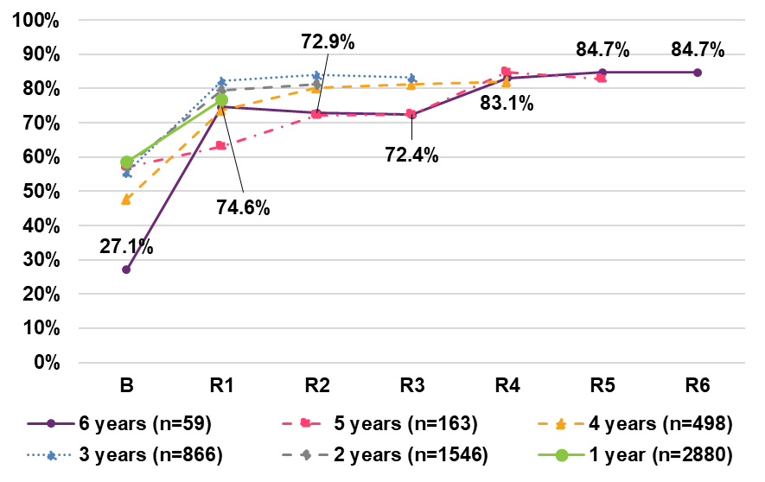

Positive

% who strongly agree or agree that they feel more confident about the future of their family with disability under the NDIS

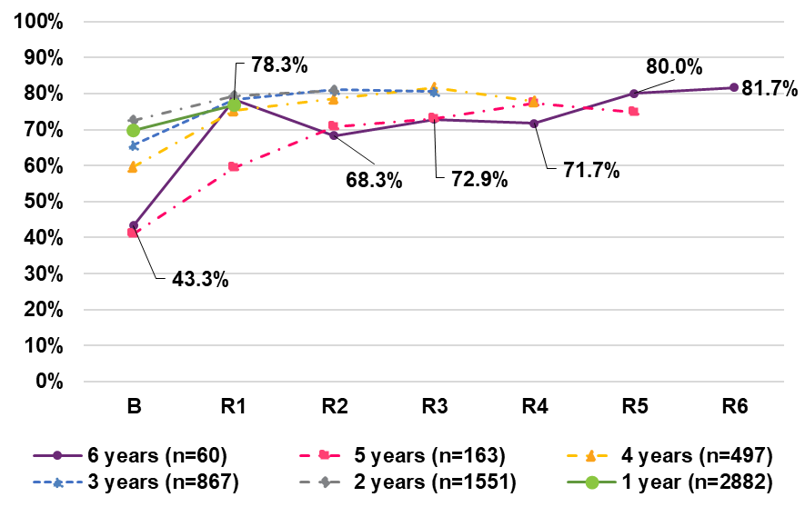

% of families or carers who rate their health as excellent, very good or good

The percentage of families or carers who rate their health as excellent, very good or good has decreased from baseline to latest reassessment, across all cohorts. There was a 14.6 percentage point decrease from baseline (68.9%) to sixth reassessment (54.4%), for families or carers of participants who have been in the Scheme for six years. For cohorts 5, 4, 3, 2 and 1, there were decreases of 14.1, 10.5, 8.5, 5.9 and 3.0 percentage points, respectively.

In general, the 0-14 age group had the highest percentages rating their health as good, very good or excellent across all cohorts. For example, the highest reported percentage was 76.2% at baseline in cohort 1 for the 0-14 age group, compared to 71.7% in cohort 1 for all ages. However, the 0-14 age group showed larger decreases from baseline to latest reassessment, for cohorts 3 to 6 (for example, an 18.1 percentage point decline for cohort 6 compared to a 14.6 percentage point decline for all age groups combined). Percentages tended to be lowest for the 25+ age group.

**Deterioration (decrease in positive indicator)**

There are 6 line charts describing the percentage of families or carers who rate their health as excellent, very good or good. 
The first line chart to the left describes the change in the percentage of families or carers who rate their health as excellent, very good or good for participants who have been in the scheme for 6 years. This indicator deteriorated from 68.9% at baseline to 66.1%, 62.6%, 62.2%, 59.5%, and 50.9% at reassessment 1, 2, 3, 4, and 5 respectively, and finally improved to 54.4% at reassessment 6.
The second line chart to the left describes the change in the percentage of families or carers who rate their health as excellent, very good or good for participants who have been in the scheme for 5 years. This indicator deteriorated from 68.7% at baseline to 65.7%, 61.7%, 60.8%, 56.5%, and 54.6% at reassessment 1, 2, 3, 4, and 5 respectively.
The third line chart to the left describes the change in the percentage of families or carers who rate their health as excellent, very good or good for participants who have been in the scheme for 4 years. This indicator deteriorated from 68.7% at baseline to 66.7%, 63.5%, 62.1%, and 58.2% at reassessment 1, 2, 3, and 4 respectively.
The fourth line chart to the left describes the change in the percentage of families or carers who rate their health as excellent, very good or good for participants who have been in the scheme for 3 years. This indicator deteriorated from 70.2% at baseline to 68.4%, 65.0%, and 61.7% at reassessment 1, 2, and 3 respectively.
The fifth line chart to the left describes the change in the percentage of families or carers who rate their health as excellent, very good or good for participants who have been in the scheme for 2 years. This indicator deteriorated from 71.4% at baseline to 68.9% and 65.5% at reassessment 1 and 2 respectively.
The sixth line chart to the left describes the change in the percentage of families or carers who rate their health as excellent, very good or good for participants who have been in the scheme for 1 year. This indicator deteriorated 71.7% at baseline to 68.7% at reassessment 1.
Note: the entire cohort 6 for the 15–24/25+ age group, and R2–R5 in cohort 6 for the 25+ age group have been omitted as participant numbers are too small. 




*Note: the entire cohort 6 for the 15-24/25+ age group, and R2-R5 in cohort 6 for the 25+ age group have been omitted as participant numbers are too small.*

Comparison to benchmark: self-rated health

% of families or carers who rate their health as excellent, very good or good

*Combined group, by time in Scheme*

Comparing baseline to reassessment 6, the percentage of families and carers who rate their health as good, very good or excellent decreased by 14.6 percentage points, from 68.9% to 54.4%. This indicator is considerably below the benchmark for the Australian population1 (87.0%).

**Deterioration (decrease in positive indicator)**

*Note: Population benchmark figures are from HILDA wave 22 data, standardised for NDIS participant age and gender distribution*

The line chart compares the percentage of families or carers who rate their health as excellent, very good or good against the population benchmark from HILDA wave 22 data. 
This indicator deteriorated from 68.9% at baseline to 66.1%, 62.6%, 62.2%, 59.5%, and 50.9% at reassessment 1, 2, 3, 4, and 5 respectively, and finally improved to 54.4% at reassessment 6. These figures are consistently lower than the population benchmark, which sits around 87.0%.


Life satisfaction

Thinking about what happened last year, and what they expect for the future, % who feel delighted, pleased or mostly satisfied

*Combined group, by time in Scheme*

The percentage of families and carers who felt delighted, pleased, or mostly satisfied about last year and the future increased from baseline to latest reassessment across all cohorts. For families or carers of participants who have been in the Scheme for six years, there was an increase of 5.6 percentage points from 61.1% at baseline to 66.7% at sixth reassessment*.*

**Positive**

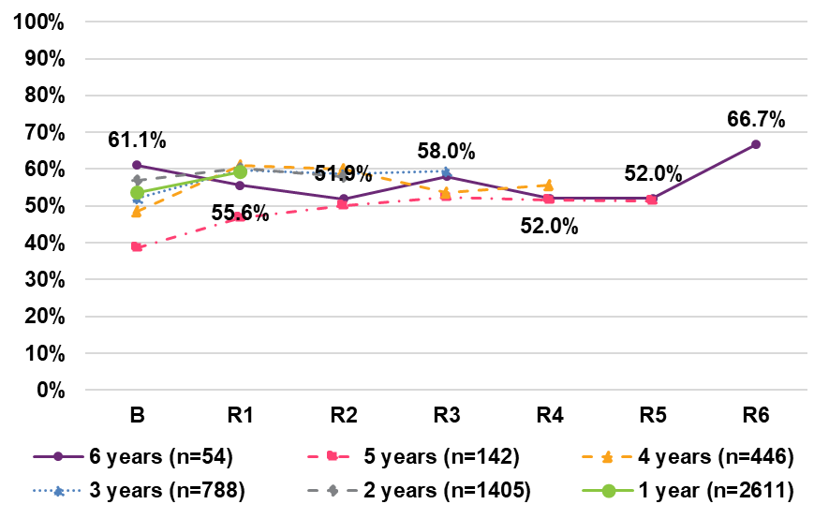

Engaging in social interactions and community life, and barriers

Overall, the percentage of families or carers who are able to engage in social interactions and community as much as they want saw a decreasing trend from baseline to latest reassessment, across all cohorts. For families or carers of participants who have been in the Scheme for six years, there was a decrease of 9.3 percentage points from baseline (25.5%) to sixth reassessment (16.2%). However, there was a 3.6 percentage point increase over the latest year in the Scheme, from 12.6% to 16.2%.

% of families or carers and their partners who are able to engage in social interactions and community life as much as they want

Deterioration (decrease in positive indicator)

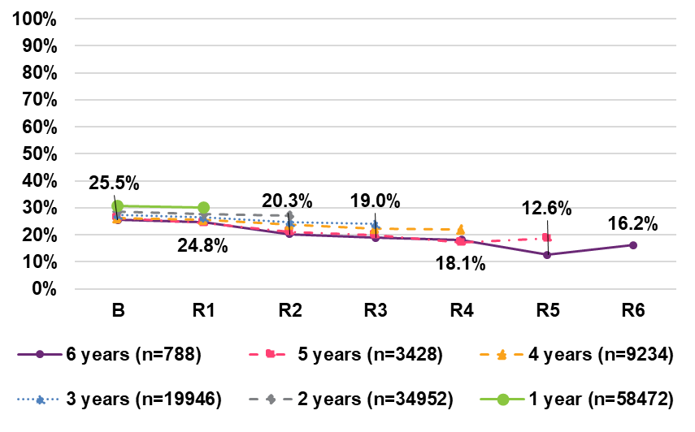

Of those unable to engage in the community as much as they want, there has been an increasing trend in the percentage who say the situation with their child is a barrier to engaging more, across all cohorts. There has been an increase of 5.2 percentage points from baseline to latest reassessment for families or carers of participants who have been in the Scheme for six years, from 90.4% (baseline) to 95.7% (sixth reassessment).

Of those unable to engage in the community as much as they want, % who say the situation with their child is a barrier to engaging in more social interactions within the community.

Deterioration (increase in negative indicator)

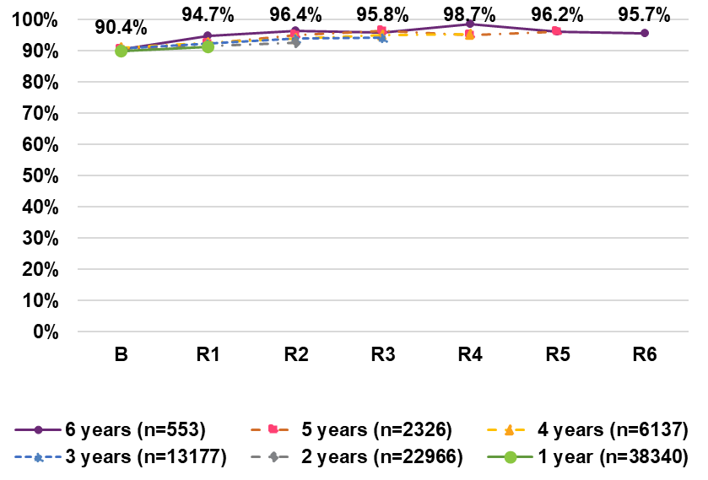

## Domain 6: Families participate in employment **% of families or carers who are in a paid job**

*Combined group, by time in Scheme*

There have been increases from baseline in the percentage of families or carers who are in a paid job, across all cohorts. Improvements are greater the longer participants have been in the Scheme, with a 9.7 percentage point increase for cohort 6, from 45.1% (baseline) to 54.9% (sixth reassessment). Improvements of between 1.9 and 7.4 percentage points were observed for cohorts 1 to 5.

Across all cohorts, the 25+ age group has the lowest percentage in a paid job, and this percentage decreased from baseline to latest reassessment. This decline may be partly due to older average age of these respondents, given that family/ carer age tends to be correlated with participant age. Hence these respondents may be more likely to be starting to retire.

**Positive**

There are 6 line charts describing the percentage of families or carers who are in a paid job. 
The first line chart to the left describes the change in the percentage of families or carers who are in a paid job for 6 years. This indicator improved from 45.1% at baseline to 48.6%, 50.6%, 53.5%, and 56.3% at reassessment 1, 2, 3, and 4 respectively, then deteriorated to 54.2% at reassessment 5, and finally improved to 54.9% at reassessment 6.
The second line chart to the left describes the change in the percentage of families or carers who are in a paid job for 5 years. This indicator improved from 44.9% at baseline to 47.4%, 50.0%, and 52.1 at reassessment 1, 2, and 3 respectively, then deteriorated to 49.7% at reassessment 4, and finally improved to 52.3% at reassessment 5.
The third line chart to the left describes the change in the percentage of families or carers who are in a paid job for 4 years. This indicator improved from 46.5% at baseline to 49.2%, 50.5%, 51.5%, and 51.7% at reassessment 1, 2, 3, and 4 respectively.
The fourth line chart to the left describes the change in the percentage of families or carers who are in a paid job for 3 years. This indicator improved from 45.6% at baseline to 46.3%, 49.1%, and 50.2% at reassessment 1, 2, and 3 respectively.
The fifth line chart to the left describes the change in the percentage of families or carers who are in a paid job for 2 years. This indicator improved from 46.3% at baseline to 48.4% and 49.6% at reassessment 1 and 2 respectively
The sixth line chart to the left describes the change in the percentage of families or carers who are in a paid job for 1 year. This indicator improved from 47.6% at baseline to 49.5% at reassessment 1.
Note: the entire cohort 6 for the 15–24/25+ age group, and R2–R5 in cohort 6 for the 25+ age group have been omitted as participant numbers are too small



*Note: the entire cohort 6 for the 15-24/25+ age group, and R2-R5 in cohort 6 for the 25+ age group have been omitted as participant numbers are too small*.

Hours worked and type of employment

Of those in a paid job, % who work 15 hours or more per week

For those in a paid job, there has been an increasing trend in the percentage of families or carers who work 15 hours or more per week, across all cohorts. For families or carers of participants who have been in the Scheme for six years, there has been an increase of 9.5 percentage points between baseline (79.8%) and latest reassessment (89.3%). For cohorts 1 to 5, improvements ranged from 1.5 to 7.5 percentage points.

**Positive** 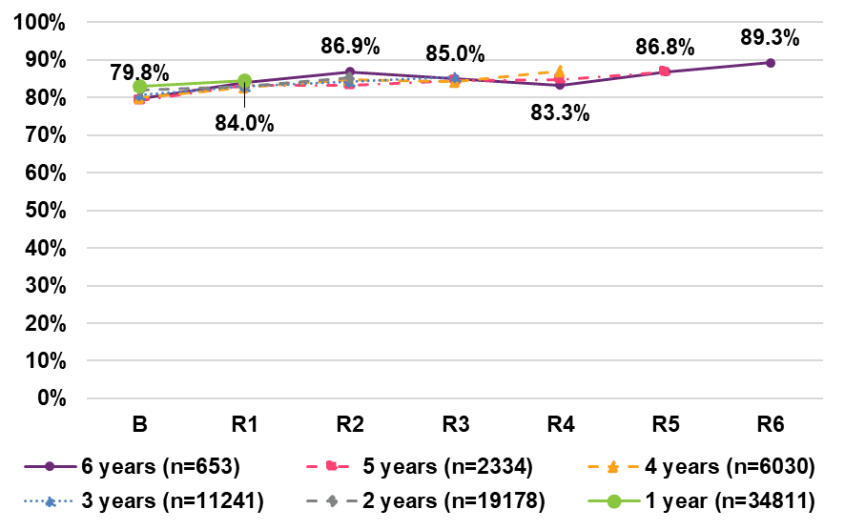

Of those in a paid job, % who are employed in a permanent position

For those in a paid job, there have been improvements in the percentage of families or carers who are in a permanent position across all cohorts. For cohort 6, there was a 9.5 percentage point increase from baseline (71.7%) to sixth reassessment (81.3%). Cohort 5 saw an increase of 7.7 percentage points from baseline (73.2%) to fifth reassessment (80.9%). Cohorts 1, 2, 3 and 4 have been relatively steady, showing maintenance or small improvements.

**Positive**

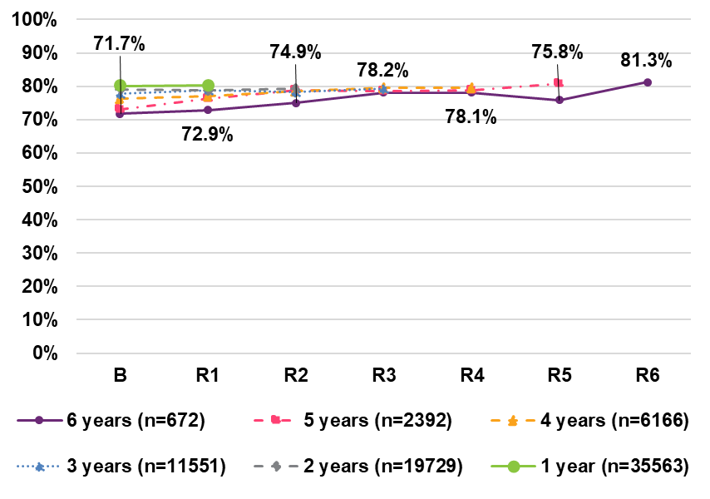

Comparison to benchmark: Employment

*Combined group, by time in Scheme*

Comparing baseline to latest reassessment, the percentage of families and carers:

* in a paid job improved by 9.7 percentage points over six years, however, still remains below the benchmark for the Australian population (76.4%).
* who work 15 hours or more per week improved by 9.5 percentage points and the average (all age groups) at sixth reassessment is 89.3 percentage points which is 5.0 percentage points below the Australian population level (94.3%). However, when the 15-24 age group is considered, the percentage at sixth reassessment (90.6%) is only 3.7 percentage points below the benchmark.

Working in a paid job

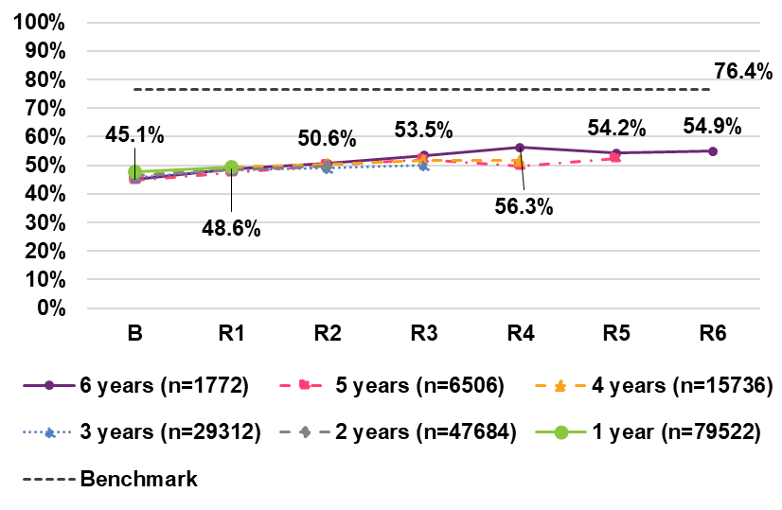

Working 15 hours or more per week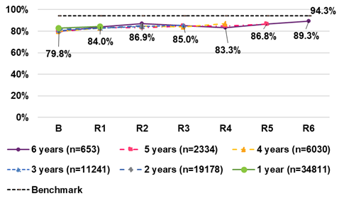

*Population benchmark figures are from:*

* *Working in a paid job: Australian Bureau of Statistics (ABS), Labour Force Status June 2023, standardised for NDIS participant age and gender distribution.*
* *Working 15 hours or more per week: HILDA wave 22, standardised for NDIS participant age and gender distribution.*

## Domain 7: Strengths, abilities and special needs

Recognising strengths, abilities and progress

Overall, the percentages of families or carers of participants aged 0 to 24 who have no difficulties in:

* Recognising the strength and abilities of their family members
* Seeing their family member progressing

have seen improvements from baseline to latest reassessment, for all cohorts. There have been increases of 17.6 percentage points and 13.7 percentage points, respectively, over six years (despite some volatility in the results due to small numbers).

% who have no difficulties in recognising the strength and abilities of their family members

Positive

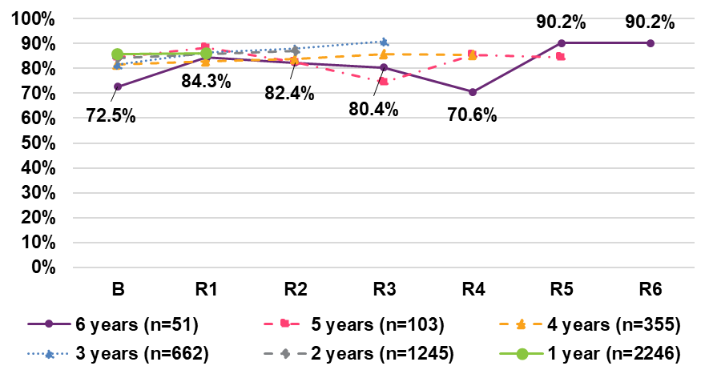

% who have no difficulties in seeing their family member progressing

Positive

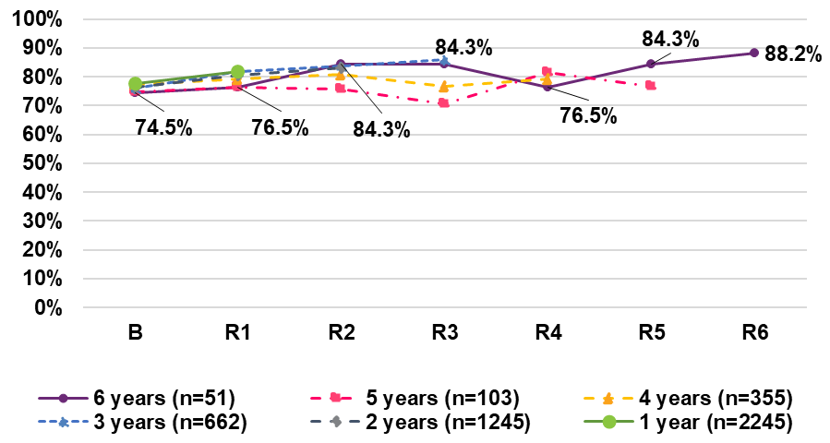

# Has the NDIS helped?

## Families and carers of participants from birth to age 14

Percentage of positive responses (1/2)

Opinions are most positive in relation to improving family/carer capacity to help their child develop and learn, followed by access to services, and families feeling supported. Positive opinions are lower for health and wellbeing.

There is an increasing trend in the percentage of positive responses with time in Scheme, for all domains and across all cohorts. For example, for those in the Scheme for 6 years, improvements over six years ranged from 2.3 percentage points (health and wellbeing) to 16.8 percentage points (rights and advocacy).

There appears to be a cohort effect for all domains, with those entering the Scheme later in time (e.g. those in the Scheme for 1 year) responding more positively than those entering the Scheme earlier (e.g. those in the Scheme for 6 years).

Rights and advocacyThe line chart shows the percentage of families and carers who said the NDIS improved their ability to advocate for their child in the Scheme for 6, 5, 4, 3, 2 and 1 year.
There are 5 lines representing: participants who respond positively and have been in the scheme for 6, 5, 4, 3, 2 and 1 years respectively.
The percentage of participants who responded positively and have been in the Scheme for 5 years are: 48.8% at reassessment 1, 53.8% at reassessment 2, 53.1% at reassessment 3, 59.8% at reassessment 4, 67.2% at reassessment 5, and 65.6% at reassessment 6.


Families feel supported

The line chart shows the percentage of families and carers who said the NDIS improved their level of support for their family by reassessments for participants in the Scheme for 6, 5, 4, 3, 2 and 1 year.
There are 5 lines representing: participants who respond positively and have been in the scheme for 6, 5, 4, 3, 2 and 1 years respectively.
The percentage of participants who responded positively and have been in the Scheme for 5 years are: 56.2% at reassessment 1, 61.6% at reassessment 2, 64.8% at reassessment 3, 68.1% at reassessment 4, 69.7% at reassessment 5, and 68.2% at reassessment 6.


Access to servicesThe line chart shows the percentage of families and carers who said the NDIS improved their access to services, programs and activities in the community by reassessments for participants in the Scheme for 6, 5, 4, 3, 2 and 1 year.
There are 5 lines representing: participants who respond positively and have been in the scheme for 6, 5, 4, 3, 2 and 1 years respectively.
The percentage of participants who responded positively and have been in the Scheme for 5 years are: 62.3% at reassessment 1, 66.4% at reassessment 2, 68.6% at reassessment 3, 71.8% at reassessment 4, 67.4% at reassessment 5, and 70.7% at reassessment 6.


Helping children develop and learn

The line chart shows the percentage of families and carers who said the NDIS improved their ability to help their child develop and learn by reassessments for participants in the Scheme for 6, 5, 4, 3, 2 and 1 year.
There are 5 lines representing: participants who respond positively and have been in the scheme for 6, 5, 4, 3, 2 and 1 years respectively.
The percentage of participants who responded positively and have been in the Scheme for 5 years are: 62.9% at reassessment 1, 69.3% at reassessment 2, 69.9% at reassessment 3, 73.8% at reassessment 4, 75.3% at reassessment 5, and 73.6% at reassessment 6.


Health and wellbeing

The line chart shows the percentage of families and carers who said the NDIS improved their health and wellbeing by reassessments for participants in the Scheme for 6, 5, 4, 3, 2 and 1 year.
There are 5 lines representing: participants who respond positively and have been in the scheme for 6, 5, 4, 3, 2 and 1 years respectively.
The percentage of participants who responded positively and have been in the Scheme for 5 years are: 33.7% at reassessment 1, 34.0% at reassessment 2, 33.9% at reassessment 3, 34.1% at reassessment 4, 38.9% at reassessment 5, and 36.0% at reassessment 6.


Percentage of positive responses (2/2)

Opinions are more positive in relation to families or carers satisfied with the amount of say they had in the development of their child's NDIS plan than in the plan implementation.

There is an increasing trend in the percentage of positive responses with time in Scheme, for all domains and across all cohorts. For example, for those in the Scheme for 6 years, improvements over six years were 8.6 percentage points (plan development) and 12.0 percentage points (plan implementation). Opinions are positive for both domains (around 70% satisfied), with satisfaction being somewhat higher for plan development.

There appears to be a cohort effect for both indicators, with those entering the Scheme later in time (e.g. those in the Scheme for 1 year) responding more positively than those entering the Scheme earlier (e.g. those in the Scheme for 6 years).

Plan developmentThe line chart shows the percentage of families and carers who were satisfied with the amount of say they had in the development of their child’s NDIS plan by reassessments for participants in the Scheme for 6, 5, 4, 3, 2 and 1 year.
There are 5 lines representing: participants who respond positively and have been in the scheme for 6, 5, 4, 3, 2 and 1 years respectively.
The percentage of participants who responded positively and have been in the Scheme for 5 years are: 65.4% at reassessment 1, 68.5% at reassessment 2, 69.1% at reassessment 3, 72.0% at reassessment 4, 73.6% at reassessment 5, and 74.0% at reassessment 6.


Plan implementation

The line chart shows the percentage of families and carers who were satisfied with the amount of say they had in the development of their child’s NDIS plan by reassessments for participants in the Scheme for 6, 5, 4, 3, 2 and 1 year.
There are 5 lines representing: participants who respond positively and have been in the scheme for 6, 5, 4, 3, 2 and 1 years respectively.
The percentage of participants who responded positively and have been in the Scheme for 5 years are: 54.3% at reassessment 1, 56.9% at reassessment 2, 63.2% at reassessment 3, 67.9% at reassessment 4, 67.4% at reassessment 5, and 66.3% at reassessment 6.


By baseline plan utilisation rate, after one year

Higher baseline plan utilisation is strongly associated with a positive response after one year in the Scheme.

The increase is strongest when moving from the 0% to 20% utilisation band to the 20% to 40% utilisation band, although substantial increases are still observed for higher utilisation bands.

For example, in the child development domain, the positive response rate for participants who used 20% to 40% of their funding was 29 percentage points higher than the positive response rate for participants who used 0% to 20%. Comparing the over 80% band with the 20% to 40% band, a further 9 percentage point increase is observed. Hence overall, there is a 38-percentage point increase when comparing the highest and lowest utilisation bands.

The line chart shows the percentage of families and carers of NDIS participants from birth to age 14 who responded positively regarding whether the NDIS improved their rights and advocacy, families feeling supported, access to services, child’s development, and health and wellbeing after one year, by baseline plan utilisation.
There are 5 lines representing: rights and advocacy, family feeling supported, access to services, child’s development and health and wellbeing, respectively.
The percentage of participants who responded positively for:
• Health and wellbeing: 28% for 0% to 20% utilisation, 45% for 20% to 40% utilisation, 49% for 40% to 60% utilisation, 52% for 60% to 80% utilisation, 53% for Over 80% utilisation.
• Child’s development: 49% for 0% to 20% utilisation, 78% for 20% to 40% utilisation, 83% for 40% to 60% utilisation, 86% for 60% to 80% utilisation, 87% for Over 80% utilisation.
• While percentages for other domains are not labelled, they all follow the trend that higher plan utilisation is associated with higher percentages responding positively, with the largest improvements occurring between the 0% to 20% and 20% to 40% utilisation bands.


## Families and carers of participants aged 15 to 24

Percentage of positive responses

Opinions are most positive in relation to families feeling supported, and access to services. Positive opinions are lower for health and wellbeing.

There is an increasing trend in the percentage of positive responses with time in Scheme, for all domains except health and wellbeing and across all cohorts. For example, for those in the Scheme for 6 years, improvements over six years ranged from 12.8 percentage points (access to services) to 17.1 percentage points (rights and advocacy).

There appears to be a cohort effect for all domains except health and wellbeing, with those entering the Scheme later in time (e.g. those in the Scheme for 1 year) responding more positively than those entering the Scheme earlier (e.g. those in the Scheme for 6 years).

Rights and advocacy

The line chart shows the percentage of families and carers who said the NDIS improved their ability to advocate for their child in the Scheme for 6, 5, 4, 3, 2 and 1 year.
There are 5 lines representing: participants who respond positively and have been in the scheme for 6, 5, 4, 3, 2 and 1 years respectively.
The percentage of participants who responded positively and have been in the Scheme for 5 years are: 45.7% at reassessment 1, 51.7% at reassessment 2, 52.3% at reassessment 3, 57.8% at reassessment 4, 63.6% at reassessment 5, and 62.8% at reassessment 6.


Families feel supported

The line chart shows the percentage of families and carers who said the NDIS improved their level of support for their family by reassessments for participants in the Scheme for 6, 5, 4, 3, 2 and 1 year.
There are 5 lines representing: participants who respond positively and have been in the scheme for 6, 5, 4, 3, 2 and 1 years respectively.
The percentage of participants who responded positively and have been in the Scheme for 5 years are: 54.0% at reassessment 1, 57.1% at reassessment 2, 61.2% at reassessment 3, 66.5% at reassessment 4, 68.3% at reassessment 5, and 70.3% at reassessment 6.


Access to services

The line chart shows the percentage of families and carers who said the NDIS improved their access to services, programs and activities in the community by reassessments for participants in the Scheme for 6, 5, 4, 3, 2 and 1 year.
There are 5 lines representing: participants who respond positively and have been in the scheme for 6, 5, 4, 3, 2 and 1 years respectively.
The percentage of participants who responded positively and have been in the Scheme for 5 years are: 53.7% at reassessment 1, 60.2% at reassessment 2, 63.7% at reassessment 3, 67.8% at reassessment 4, 73.0% at reassessment 5, and 66.5% at reassessment 6.


Helping young participants become independent

The line chart shows the percentage of families and carers who said the NDIS improved their ability to help the young participant become independent by reassessments for participants in the Scheme for 6, 5, 4, 3, 2 and 1 year.
There are 5 lines representing: participants who respond positively and have been in the scheme for 6, 5, 4, 3, 2 and 1 years respectively.
The percentage of participants who responded positively and have been in the Scheme for 5 years are: 49.0% at reassessment 1, 51.8% at reassessment 2, 60.3% at reassessment 3, 67.6% at reassessment 4, 60.6% at reassessment 5, and 65.1% at reassessment 6.


Health and wellbeingThe line chart shows the percentage of families and carers who said the NDIS improved their health and wellbeing by reassessments for participants in the Scheme for 6, 5, 4, 3, 2 and 1 year.
There are 5 lines representing: participants who respond positively and have been in the scheme for 6, 5, 4, 3, 2 and 1 years respectively.
The percentage of participants who responded positively and have been in the Scheme for 5 years are: 35.6% at reassessment 1, 33.3% at reassessment 2, 32.3% at reassessment 3, 36.7% at reassessment 4, 34.1% at reassessment 5, and 34.0% at reassessment 6.


By baseline plan utilisation rate, after one year

Higher baseline plan utilisation is strongly associated with a positive response after one year in the Scheme.

The increase is strongest when moving from the 0% to 20% utilisation band to the 20% to 40% utilisation band, although increases are still observed for higher utilisation bands.

For example, in the families feeling supported domain, the positive response rate for participants who used 20% to 40% of their funding was 17 percentage points higher than the positive response rate for participants who used 0% to 20%. Comparing the over 80% band with the 20% to 40% band, a further 5 percentage point increase is observed. Hence overall, there is a 22-percentage point increase when comparing the highest and lowest utilisation bands.

The line chart shows the percentage of families and carers of NDIS participants aged 15 to 24 who responded positively regarding whether the NDIS improved their rights and advocacy, families feeling supported, access to services, young participant’s independence, and health and wellbeing after one year, by baseline plan utilisation.
There are 5 lines representing: rights and advocacy, family feeling supported, access to services, young participant’s independence and health and wellbeing, respectively.
The percentage of participants who responded positively for:
• Health and wellbeing: 24% for 0% to 20% utilisation, 38% for 20% to 40% utilisation, 40% for 40% to 60% utilisation, 42% for 60% to 80% utilisation, 43% for Over 80% utilisation.
• Families feeling supported: 49% for 0% to 20% utilisation, 70% for 20% to 40% utilisation, 75% for 40% to 60% utilisation, 77% for 60% to 80% utilisation, 78% for Over 80% utilisation.
• While percentages for other domains are not labelled, they all follow the trend that higher plan utilisation is associated with higher percentages responding positively, with the largest improvements occurring between the 0% to 20% and 20% to 40% utilisation bands.


## Families and carers of participants aged 25 and over

Percentage of positive responses*

Opinions are most positive in relation to families feeling supported, and access to services. Positive opinions are lower for health and wellbeing, and succession planning.

There are increases in the percentage of positive responses from first to latest reassessment, for all domains and across all cohorts. For example, for C6, improvements over six years ranged from 3.3 percentage points (access to services) to 27.4 percentage points (rights and advocacy).

*\* For cohort 6, numbers are too small to show R3 – R5.*

Rights and advocacy

The line chart shows the percentage of families and carers who said the NDIS improved their ability to advocate for their child in the Scheme for 6, 5, 4, 3, 2 and 1 year.
There are 6 lines representing: participants who respond positively and have been in the scheme for 6. 5, 4, 3, 2 and 1 years respectively.
The percentage of participants who responded positively and have been in the Scheme for 6 years are: 39.3% at reassessment 1, 65.2% at reassessment 2, 66.7% at reassessment 6.
Results for reassessments 3, 4 and 5 in the 6-year cohort is not shown due to small numbers.

Families feel supported

The line chart shows the percentage of families and carers who said the NDIS improved their level of support for their family by reassessments for participants in the Scheme for 5, 4, 3, 2 and 1 year.
There are 5 lines representing: participants who respond positively and have been in the scheme for 5, 4, 3, 2 and 1 years respectively.
The percentage of participants who responded positively and have been in the Scheme for 6 years are: 67.7% at reassessment 1, 75.0% at reassessment 2, 72.8% at reassessment 6.
Results for reassessments 3, 4 and 5 in the 6-year cohort is not shown due to small numbers.

Access to services

The line chart shows the percentage of families and carers who said the NDIS improved their access to services, programs and activities in the community by reassessments for participants in the Scheme for 6, 5, 4, 3, 2 and 1 year.
There are 6 lines representing: participants who respond positively and have been in the scheme for 6, 5, 4, 3, 2 and 1 years respectively.
The percentage of participants who responded positively and have been in the Scheme for 6 years are: 69.0% at reassessment 1, 69.6% at reassessment 2, 72.3% at reassessment 6.
Results for reassessments 3, 4 and 5 in the 6-year cohort is not shown due to small numbers.


Succession planning The line chart shows the percentage of families and carers who said the NDIS improved their ability to help the young participant become independent by reassessments for participants in the Scheme for 6, 5, 4, 3, 2 and 1 year.
There are 6 lines representing: participants who respond positively and have been in the scheme for 6, 5, 4, 3, 2 and 1 years respectively.
The percentage of participants who responded positively and have been in the Scheme for 6 years are: 39.3% at reassessment 1, 38.1% at reassessment 2, 51.2% at reassessment 6.
Results for reassessments 3, 4 and 5 in the 6-year cohort is not shown due to small numbers.


Health and wellbeing The line chart shows the percentage of families and carers who said the NDIS improved their health and wellbeing by reassessments for participants in the Scheme for 6, 5, 4, 3, 2 and 1 year.
There are 6 lines representing: participants who respond positively and have been in the scheme for 6, 5, 4, 3, 2 and 1 years respectively.
The percentage of participants who responded positively and have been in the Scheme for 6 years are: 36.7% at reassessment 1, 39.1% at reassessment 2, 45.0% at reassessment 6.
Results for reassessments 3, 4 and 5 in the 6-year cohort is not shown due to small numbers.


By baseline plan utilisation rate, after one year

Higher baseline plan utilisation is strongly associated with a positive response after one year in the Scheme.

The increase is strongest when moving from the 0% to 20% utilisation band to the 20% to 40% utilisation band, although increases are still observed for higher utilisation bands.

For example, in the families feeling supported domain, the positive response rate for participants who used 20% to 40% of their funding was 17 percentage points higher than the positive response rate for participants who used 0% to 20%. Comparing the over 80% band with the 20% to 40% band, a further 5 percentage point increase is observed. Hence overall, there is a 22-percentage point increase when comparing the highest and lowest utilisation bands.

The line chart shows the percentage of families and carers of NDIS participants aged 25 and over who responded positively regarding whether the NDIS improved their rights and advocacy, families feeling supported, access to services, succession planning, and health and wellbeing after one year, by baseline plan utilisation.
There are 5 lines representing: rights and advocacy, family feeling supported, access to services, succession planning and health and wellbeing, respectively.
The percentage of participants who responded positively for:
• Succession planning: 32% for 0% to 20% utilisation, 41% for 20% to 40% utilisation, 44% for 40% to 60% utilisation, 46% for 60% to 80% utilisation, 47% for Over 80% utilisation.
• Families feeling supported: 57% for 0% to 20% utilisation, 74% for 20% to 40% utilisation, 78% for 40% to 60% utilisation, 78% for 60% to 80% utilisation, 79% for Over 80% utilisation.
• While percentages for other domains are not labelled, they all follow the trend that higher plan utilisation is associated with higher percentages responding positively, with the largest improvements occurring between the 0% to 20% and 20% to 40% utilisation bands.


# Appendix

## Moving up age groups

Questions appearing in both survey forms

If a participant moves up to an older age group, family/carer answers to the same question continue to be tracked across the different survey forms.

For example, the item “I feel that the services my family member with disability and my family use listen to me” is included in two survey forms: families/carers of participants aged 15 to 24 and families/carers of participants aged 25+. Suppose a family member/carer answered twice in the 15 to 24 form and three times in the 25+ form (below):

There are two boxes showing example responses of a family carer of participant who responded:
- “No” and “No” when aged 15 to 24
- “No”, “Yes” and “Yes” when aged 25 and over
Annual reports prior to 30 June 2022 only tracked the person’s answers in the first form (answers in the second form were not analysed, since the participant did not have a baseline in the second age group).
This is a contradiction to this report where answers to the same question continue to be tracked across the different survey forms.


Questions only appearing in older age group

If a participant moves up to an older age group, family/carer answers to questions that are only asked in the older age group start to be tracked in the new survey form.

For example, the item “I know what my family can do to enable my family member with disability to become as independent as possible” is only included for families/carers of participants aged 15 to 24. Suppose a family member/carer answered twice in the 0 to 14 form and three times in the 15 to 24 form:

There are two boxes showing example responses of a family carer of participant who responded:
- Question not asked when the participant was between starting school and age 14
- “No”, “Yes” and “Yes” when aged 15 to 24
Previously, the participant’s answers to this question were not analysed (since the question is not asked in the first age group, and the participant did not have a baseline in the second age group).
This is a contradiction to this report where answers to questions that are only asked in the older age group start to be tracked in the new survey form.


*This report tracks the person’s answers to the question from when they first answer the second form. This is done by “resetting” the baseline at this point, for the purposes of this question. Effectively, this means that the analysis is by “time in age group” rather than “time in Scheme”.*

*The rationale for this approach is that the question was not relevant for family/carers of participants in the younger age group, and so the Scheme was not focussed on improving this particular outcome until they moved to the older age group.*

## Age group transitions

Summary

The table (on the next page) summarises the types of questions and how they are treated in the analysis.

|  |  |  |  |  |  |  |  |  |  |  |  |  |  |
| --- | --- | --- | --- | --- | --- | --- | --- | --- | --- | --- | --- | --- | --- |
| **Example** | **F0to14\*** | **F15to24\*** | | **F25plus\*** | | **Number of age groups** | | **Type of question** | | **Age group transitioning up\*\*** | | | **Treatment in the analysis** |
| I know what specialist services are needed to promote my child's learning and development | 1 | 0 | | 0 | | 1 | | Non-overlapping | | NA | | Single group, by time in Scheme | |
| I recognise the strengths and abilities of my family member | 1 | 1 | | 0 | | 2 | | Overlapping | | NA | | Combined group, by time in Scheme | |
| I know what my family can do to enable my family member with disability to become as independent as possible | 0 | 1 | | 0 | | 1 | | Non-overlapping | | F0to14 | | Analyse by time since first in F15to24 | |
| I feel that the services my family member with disability and my family use listen to me | 0 | 1 | | 1 | | 2 | | Overlapping | | F0to14 | | For F0to14, analyse by time since first in F15to24, otherwise by time in Scheme | |
| Have you made plans for when you are no longer able to care for your family member with disability? | 0 | 0 | | 1 | | 1 | | Non-overlapping | | F15to24 | | Analyse by time since first in F25plus | |
| I have friends and family that I see as often as I like | 1 | | 1 | | 1 | | 3 | | Overlapping | | NA | Combined group, by time in Scheme | |

*\* F0to14=families/carers of participants aged 0 to 14; F15to24=families/carers of participants aged 15 to 24; F25plus=families/carers of participants aged 25 and over.*

*\*\* Note this is the oldest group ageing up. Younger groups may eventually age up also. For example, F0to14 ages up to F15to24, and finally to F25plus*.

## Longitudinal cohorts

For each outcome indicator, longitudinal results are considered separately for six cohorts of families and carers of participants. The cohorts are based on the number of years of experience that the person has contributed to that indicator as at 30 June 2023, in line with the final column of the previous slide. Hence the same person can belong to different cohorts for different indicators. However, for a given indicator, the cohorts are distinct (that is, a person belongs to one cohort only).

The following table shows how cohorts C1-C6 are defined.

|  |  |  |
| --- | --- | --- |
| **Cohort** | **Number of years of experience contributed to indicator** | **Possible total number of years in the Scheme** |
| **C6** | 6 | 6 |
| **C5** | 5 | 5-6 |
| **C4** | 4 | 4-6 |
| **C3** | 3 | 3-6 |
| **C2** | 2 | 2-6 |
| **C1** | 1 | 1-6 |

For example, consider a participant who has been in the Scheme for a total of six years and whose parent responded to the F0to14 questionnaire at baseline and reassessment 1, then to the F15to24 questionnaire at reassessment 2 to 6. For the indicator:

“I know what specialist services are needed to promote my child's learning and development” (only asked in F0to14), the parent would be in cohort C1 (i.e. one reassessment has occurred since baseline where this indicator was asked).

“I recognise the strengths and abilities of my family member” (asked in both F0to14 and F15to24), the parent would be in cohort C6 (i.e. six reassessments for this indicator have occurred since baseline).

“I know what my family can do to enable my family member with disability to become as independent as possible” (only asked in F15to24), the parent would be in cohort C4 (i.e. the parent first responded to this indicator at reassessment 2 (which becomes the reset baseline) and four assessments have occurred since this reset baseline).

The longitudinal analysis is also restricted to instances where the same person responded at each of the time points being considered.

## Treatment of “Has the NDIS helped?”

The final question in each domain asks whether family and carers of participants think that the NDIS has helped with areas related to that domain. In reporting on these questions:

* Only responses at first and subsequent reassessments are included, since the Scheme has not had an opportunity to have an impact at baseline.
* All responses from reassessment 1 onwards contribute to the analysis, and responses are allocated to the age group and duration in Scheme applicable at the time of response. For example, family/carer responses for a participant ageing up at reassessment 3 would be included in the new age group from reassessment 3.
* Hence the analysis is cross-sectional by time in Scheme, i.e. results at reassessment t represent a snapshot of the views of all family/carers when the participant has been in the Scheme for t years. This is in contrast to the longitudinal (by time in Scheme) presentation for the outcome indicators. The rationale for this difference is that the “Has the NDIS helped” questions measure satisfaction with the Scheme, rather than outcomes of family/carers of participants.



**Copyright notice**

© National Disability Insurance Scheme Launch Transition Agency

**Copyright and use of the material in this document**

Copyright in the material in this document, with the exception of third party material, is owned and protected by the National Disability Insurance Scheme Launch Transition Agency (National Disability Insurance Agency).

The material in this document, with the exception of logos, trade marks, third party material and other content as specified is licensed under Creative Commons Attribution Non-Commercial No Derivatives (CC BY NC ND) licence,

version 4.0 International. You may share, copy and redistribute the document in any format. You must acknowledge the National Disability Insurance Agency as the owner of all intellectual property rights in the reproduced.

material by using ‘© National Disability Insurance Scheme Launch Transition Agency’ and you must not use the material for commercial purposes.

Reproduction of any material contained in this document is subject to the CC BY NC ND licence conditions available on the Creative Commons Australia site, as is the full legal code for this material.

The National Disability Insurance Agency expects that you will only use the information in this document to benefit people with disability.

Please see the NDIS website copyright statement for further details about the use of logos and third party material.

1. Unless otherwise stated, changes are over six years. Where numbers are too small to show six year results, changes are for five years, as noted.
2. Unless otherwise stated, changes are over six years. Where numbers are too small to show six year results, changes are for five years, as noted.
3.
4. The table shows the potential number of respondents, however, not all of them responded to each question. The number of missing responses is small and varies by indicator.
5. Unless otherwise stated, changes are over six years. Where numbers are too small to show six year results, changes are for five years, as noted.
6. Unless otherwise stated, changes are over six years. Where numbers are too small to show six year results, changes are for five years, as noted.