

Table of Contents

Section 1: Summary of findings 4
Measuring progress and change 4
Summary of key results 5
Benchmarking to the Australian population 12
Section 2: Background 13
This report 13
Outcomes framework 13
Short Form and Long Form 14
Progression towards better outcomes 14
Age group transitions 15
COVID-19 pandemic 16
Number of respondents 17
Section 3: The early years participants aged 0 to 14 19
Domains and outcomes 19
Summary of changes 20
Summary of trend by selected indicators 20
Daily living: Specialist services 23
Daily living: Development 24
Daily living: Independence 26
Relationships 27
Social, community and civic participation 30
Lifelong learning 33
Section 4: The adult years– participants aged 15 and over 36
Domains and outcomes 36
Summary of changes 36
Summary of trend by selected indicators 37
Lifelong learning 40
Choice and control 43
Relationships 47
Home 50
Social, community and civic participation 51
Employment 58
Health and wellbeing 67
Section 5: PLIDA data linkage 75
Methodology 75
Mental health analysis 76
Accessing Medicare-subsidised mental health services 77
Gross income and taxpayer analysis 86
Age distribution of Scheme participants over time 86
Section 6: Has the NDIS helped? 92
Participants from birth to before starting school 92
Participants from starting school to age 14 94
Participants aged 15 to 24 96
Participants aged 25 and over 99
Section 7: Appendix 103
Age group transitions 103
Treatment of “Has the NDIS helped?” questions 108
Normal age-related development 108

Summary of findings

Measuring progress and change

How have outcomes changed?
This report summarises the number, extent and nature of changes across key outcome indicators. In total, 183 indicators were considered for the older participant age groups (15 and over), and 115 for the younger participant age groups (aged 0 to 14). Of these:
- Overall, 26% of indicators showed significant and material change (26% for the 0 to 14 age group, and 27% for the 15 and over age group).
- Forty-two percent of short-form (SF) indicators showed significant and material change, compared to 12% of long-form (LF). The lower percentage for LF is due to smaller numbers of participants surveyed.
- Amongst indicators with significant and material change, the percentage showing an improvement was 39% for the 0 to 14 age group, and 69% for the 15 and over age group.

In what areas has the NDIS impacted positively?
- Over 90% of parents and carers of participants from birth to starting school said that the NDIS had helped with their child’s development and access to specialist services. Perceptions were increasingly positive the longer participants had been in the Scheme for this age group.
- For the school to 14 participant age group, for a given number of years in the Scheme, the proportion who said that the NDIS has helped increased with time in the Scheme, for all domains. Those entering the Scheme later tended to respond more positively at each reassessment time point.
- Participants aged 15 and over have seen major improvement in the proportion saying the NDIS helped with choice and control, daily living, relationships, health and wellbeing, as well as social, community and civic participation. In general, results are more optimistic for the 25+ age group, compared to those aged 15 to 24.
- In most cases, higher plan utilisation is strongly associated with a positive response after one year in the Scheme. Improvements are typically largest between utilisation bands 0–20% and 20–40% (for most domains).

Summary of key results
Participants aged 0 to 14 (1/2)
Outcomes that are improving for children
Improvements were observed in the areas of daily living, independence, relationships, social and community participation, and lifelong learning.
Specialist services (participants from birth to starting school)
An increasing percentage of parents/carers of young children said that their child used specialist services, and that these services helped their child to gain everyday life skills and helped them to assist their child. | - 95.5% use specialist services (at least 20 pp increase over 1 to 5 years).  - 98.0% say services helped after 5 years.
Daily living
School to 14 - School aged children are becoming more independent.  Birth to 14 - More young participants manage the demands of their world well over time. | - 9.1 pp increase to 49.2%.  - 8.5 pp increase to 54.9% over 5 years.
Relationships (birth to 14)
There is an increasing trend in the percentage of children who make friends with people outside the family, particularly younger children. | - 2.1 pp increase to 62.7% over 4 years for participants aged 0 to 14.  - 17.8 pp increase to 64.0% over 4 years for participants aged 0 to before starting school.
Participants are increasingly likely to fit into family life, particularly those who have recently started school. | - 84.0% overall (14.6 pp increase).  - 85.6% for those who recently started school (25.7 pp increase).

Social, community and civic participation (participants from birth to starting school)
Children in the younger age group who participate in community activities tend to feel welcomed or actively included at these activities. | - 81.2% feel welcomed/included (6.4 pp increase over 4 years).
Note: Unless otherwise stated, changes are over six years. Where numbers are too small to show six year results, changes are for four or five years, as stated.
Participants aged 0 to 14 (2/2)
Areas of concern/deterioration
Survey results highlight concerns about children’s development, social, community and civic participation and school attendance.
Daily living (participants from birth to starting school)
There is an increasing trend in the percentage of parents/carers of children in the birth to starting school age group reporting concerns in six or more areas of daily living – particularly in relation to social interaction, cognitive development, fine motor skills, self-care, and sensory processing. The fact that this coincides with an increasing use of specialist services may reﬂect an increasing awareness of areas of concern and a need to seek assistance. | 82.4% report six or more areas of concern (26.5 pp increase over 5 years).
Social, community and civic participation (participants aged from starting school to 14)
There have been decreases in the percentages of school-age children who spend time after school or on weekends with friends and/or in mainstream programs, as well as those feeling welcome or actively included. Further, parents and carers increasingly want their child to be more involved and see their child’s disability as a barrier to participation. | - 32.7% spend time with friends and/or participate in mainstream programs (no change from baseline).  - 69.7% feel welcomed/actively included (11.5 pp decrease).  - 94.0% say child’s disability is a barrier to greater involvement (7.3 pp increase).
Lifelong learning (participants aged from starting school to 14)
The percentage of children in a mainstream class at school decreased over time, and children who have been in the Scheme for longer as well as older participants are in general less likely to have attended school in a mainstream class. | - Mainstream school attendance – 7.3 pp decrease to 33.2%.  - Involvement in co-curricular activities – 19.7 pp decrease to 24.9%.
Note: Unless otherwise stated, changes are over six years. Where numbers are too small to show six year results, changes are for four or five years, as stated.
Participants aged 15 and over (1/3)
Outcomes that are improving
Survey results are showing that there are significant positive changes for participants aged 15 and over since entering the Scheme (i.e. baseline) in the areas of lifelong learning, choice and control, relationships, home, employment, social/community participation and health and wellbeing. For example:
Lifelong learning
Participants are increasingly getting opportunities to learn new things and completing year 12. In addition, participants are less likely to say there was a course or training they wanted to do in the last 12 months but could not. | - 54.5% get opportunities to learn (4.1 pp increase).  - 48.7% completed year 12 (3.7 pp increase).  - 29.3% couldn’t do a course/training that they wanted (5.6 pp decrease).
Choice and control
An increasing percentage of participants made more decisions than they did two years ago, felt able to have a say with their support services, and chose how to spend their free time | - 8.2 pp increase to 64.9% in making more decisions.  - 45.1% felt able to have a say with support services (2.1 pp increase).  - 76.5% chose how they spend their free time (10.6 pp increase over 5 years).
Relationships
Participants report getting more opportunities to see friends and being more satisfied with their relationship with staﬀ. | - 57.5% see friends without paid staff/family present (12.3 pp increase over four years).  - 93.8% felt happy with their relationship with staff (22.9 pp increase).
Home
A growing percentage of participants chose where they lived, who they lived with, and participated in making decisions about planning for a home. | - 72.0% chose where they lived (14.4 pp increase over 5 years).  - 72.7% chose whom they lived with (12.1 pp increase over 5 years).  - 13.7 pp increase over 4 years in decisions on planning for a home to 21.9%.
Employment
An increasing percentage of participants in the labour force are in a paid job. Participants in a paid job are increasingly receiving support to do their job whilst those interested in a paid job are increasingly being assisted to get one. | - 4.3 pp increase over 5 years in being in a paid job, given in the labour force, to 51.1%.  - 80.3% get support needed to do their job (5.9 pp increase).  - 36.3% are assisted to get a job (15.4 pp increase over 5 years).
Social, community and civic participation
Higher proportions of participants spent their free time doing activities that interest them, were involved in community and had opportunities to try new things and have new experiences. They also felt safer walking alone in their local area after dark, and had a greater say in the community. | - 78.5% participate in activities of interest (8.8 pp increase).  - 13.5 pp increase to 49.1% of participants involved in a community activity.  - 63.8% know people in their community (7.1 pp increase).  - 74.5% had opportunities to try new things (25.5 pp increase).  - 15.7 pp increase to 37.3% in feeling safe walking alone in the local area.
Health and wellbeing
There have been improvements in some health and wellbeing indicators. Participants are more likely to have a doctor they see regularly, less likely to have diﬃculty accessing health services, less likely to have attended hospital in the last 12 months, and more likely to be vaccinated against the ﬂu. In addition, life satisfaction improved over time. | - 93.9% have a regular doctor (8.0 pp increase).  - 74.2% had no difficulty accessing health services (5.2 pp increase).  - 9.3 pp decrease to 30.3% who have been hospitalised in the last 12 months.  - 80.4% received a flu vaccination (27.5 pp increase) in the last 12 months.  - Life satisfaction increased by 18.9 pp to 62.9% over 5 years.
Note: Unless otherwise stated, changes are over six years. Where numbers are too small to show six year results, changes are for four or five years, as stated.
Participants aged 15 and over (3/3)
Areas of concern/deterioration
There are a few areas where there has been a deteriorating trend over time for the older age cohorts – particularly in relation to advocacy, employment and self-rated health:

Choice and control
Participants have become less likely to feel able to advocate for themselves over time in the Scheme. Younger adults are less likely than older adults to feel able to advocate for themselves. Participants continue to express an increasing desire for more choice and control. | - 39.9% feel able to advocate for themselves (5.7 pp decrease).
Employment
Overall, for participants aged 15 and over there has been little change in the percentage in a paid job over time in the Scheme. However, the results vary considerably by age group, with younger participants showing strong improvement in this employment outcome, while older participants show deterioration over time. The percentage of participants in the labour force has declined over time. | - Paid employment decreased by 1.7 pp, with 21.5% in a paid job at the latest reassessment (overall).  - The youngest adult age group experienced a 16.4 pp increase in paid employment, compared to a 5.9 pp decrease for the oldest adult age group.  - The percentage of participants in the labour force increased by 14.6 pp for the youngest adult age group, but decreased by 7.9 pp for the oldest adult age group.
Health and wellbeing
Self-rated health has deteriorated over time, across all age groups and duration cohorts. Older participants are typically less likely to rate their health as “Excellent”, “Very Good” or “Good”. | - 47.8% rated their health positively overall (7.9 pp decrease).  - 67.7% of participants in the youngest adult age group rated their health positively, despite a decrease of 3.1 pp. By contrast, this percentage decreased by 9.4 pp for the 25+ age group to 42.0%.
Relationships
Increasing desire to see friends and family more often. | - 39.9% would like to see family more often and 60.1% would like to see friends more often. An 8.9 and 9.2 percentage point increase over time, respectively.
Note: Unless otherwise stated, changes are over six years. Where numbers are too small to show six year results, changes are for four or five years, as stated.
PLIDA data linkage
PLIDA (Person-Level Integrated Data Asset) has been used to examine how NDIS participants and the broader Australian population interact with Medicare-subsidised mental health services, and their engagement with employment, over recent financial years.
Accessing Medicare-subsidised mental health services
There has been a declining trend in the proportion of NDIS participants accessing mental health services since FY2018/19. By contrast, there has been an increasing trend for the Australian population, except for the latest financial year. This decline aligns with a similar trend observed in the general Australian population, albeit marginal and over a shorter period. Despite these declines, NDIS participants have consistently accessed mental health services at a notably higher proportion compared to the wider Australian population, specifically in the last two financial years.  There has been a significant shift in service provider used among NDIS participants. Since FY2018/19, NDIS participants are more likely to engage Psychiatrist for their mental health needs. However, there’s been a notable decrease in accessing services from Psychologist (or Clinical Psychologist), while GPs have remained stable, and Allied health professional or Paediatrician has declined. | - 18.0% of NDIS participants accessed mental health services in FY2022/23 (7.3 pp decrease since FY2018/19).  - 10.3% of Australian population accessed mental health services in FY2022/23 (0.2 pp decrease since FY2021/22).  - 47.9% of mental health services were accessed through Psychiatrist in FY2022/23 (12.3 pp increase since FY2018/19).  - Mental health services accessed through Psychologist (or Clinical Psychologist) decreased by 11.1 pp to 25.7% from FY2018/19 to FY 2022/23.  - 23.4% of mental health services were accessed through GP in FY2022/23 (0.5 pp increase since FY2018/19).  - Mental health services accessed through Allied health professional or Paediatrician declined by 1.7 pp to 3.0% from FY2018/19 to FY 2022/23.
Earning gross salary and paying tax
An increasing percentage of participants are earning gross salary. With those aged 15 to 24 and 25 to 44 driving the increases.  There is also an increase in the percentage of participants paying tax, which has again been driven by those aged 15 to 24 and 25 to 44. | - Participants earning gross salary increased by 1.3 pp to 25.5%.  - Participants aged 15 to 24, earning a gross salary increased by 5.9 pp to 28.3%.  - 32.3% of participants aged 25 to 44 earned gross salary (1.7 pp increase).  - Participants paying tax increased by 1.9 pp to 10.6%.  - 6.4% of participants aged 15 to 24 paid tax (2.9 pp increase).  - Participants aged 25 to 44 had the highest percentage of taxpayer at 13.0% (3.6 pp increase).

Benchmarking to the Australian population
Overall, participants’ education, employment, community participation and health-related outcomes are generally poorer than for the Australian population. However, the trend is improving on some of these indicators and getting closer to that of the general population (e.g. completing year 12 or above, working 15 or more hours, participating in social and community and activities).
Participants aged 15 and over also have lower percentages than the Australian population in rating their health positively and higher percentages in having attended hospital in the past 12 months, although the trend for the latter indicator is improving. On a positive note, participants are more likely to have a regular doctor than the Australian population.

Background

This report
This report summarises longitudinal outcomes for participants entering the Scheme from 1 July 2016, and who have been in the Scheme for one year or more at 30 June 2023, using data available as at 30 June 2023.
The purpose of the report is to provide a picture of how participants are progressing under the NDIS, based on information provided by them in interviews conducted using the NDIS outcomes framework questionnaires.
The report summarises the number, extent and nature of changes across key outcome indicators. The results are intended to provide insight into how the Scheme is making a difference, and point to any areas where improvements may be required.
The present report builds on the work of previous reports.

Outcomes framework
A life course approach to measuring participants’ goals and outcomes across main life domains has been used.

Lifespan approach: four age-based cohorts
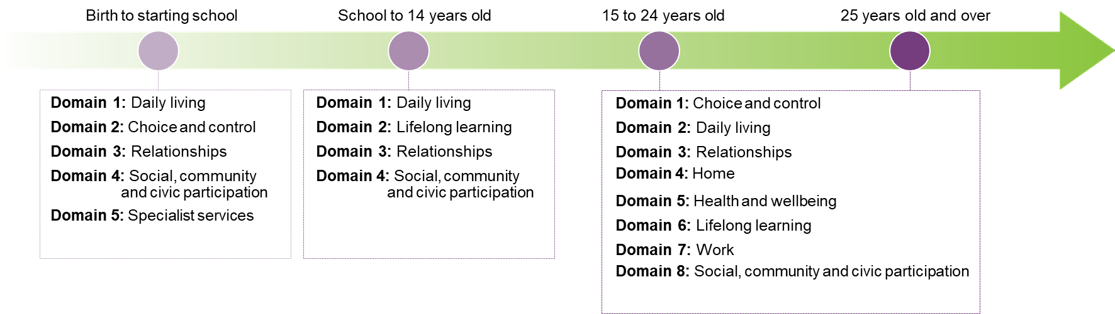
While most domains overlap, goals and outcomes may differ depending on the age group.
This approach facilitates monitoring of participants’ progress over time, as well as benchmarking to Australians without disability and to other OECD countries.

Short Form and Long Form
The Short Form (SF) outcomes questionnaire is completed by all participants, and contains questions useful for planning as well as key indicators to monitor and benchmark over time.
The Long Form (LF) is completed for a subset of participants, and includes some additional questions allowing more detailed investigation of participant experience, and additional benchmarking.
For both the SF and the LF, participants are interviewed at baseline (Scheme entry), and approximately annually thereafter. Following the same group of participants longitudinally over time allows within-individual changes in outcomes to be investigated.

Progression towards better outcomes
Success should be measured on how far participants have come since entering the Scheme (at “baseline”), acknowledging different starting points.
Participants do not enter the Scheme on an equal footing – baseline outcomes vary by a number of factors, such as:
- The nature of the participant’s disability and how it affects their life.
- The extent of support received from family and friends.
- How inclusive their community is.
- Their health and other personal traits.
Whilst some outcomes should improve relatively quickly (such as assistance with daily living), others are much more long-term in nature (for example, employment), and measurable progress may take some years to emerge.
Participants aged 15 and over

% who get support for domestic tasks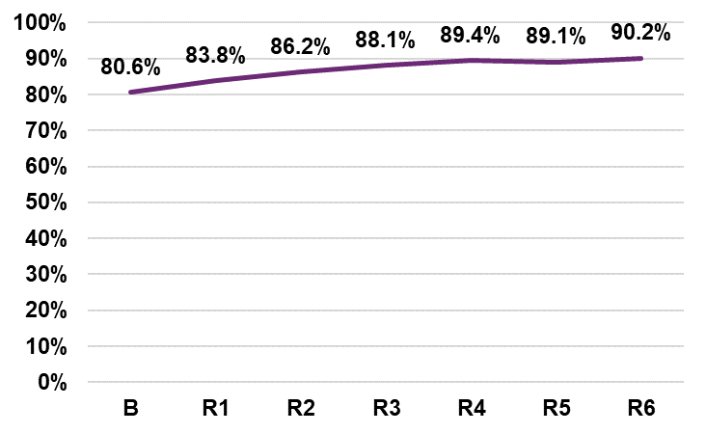

% who spend free time doing activities that interest them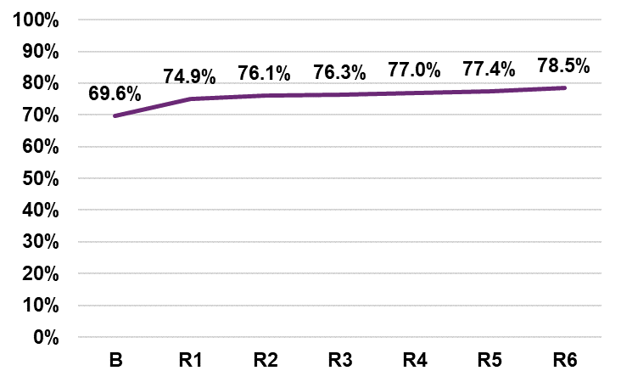

% who are currently working in a paid job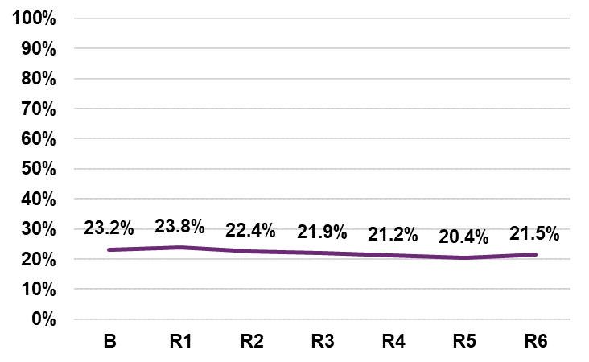

Age group transitions
Moving to a different survey form
To allow for participants transitioning into a new age group (for example, from 15–24 to 25 and over) the same approach as for the 30 June 2022 report has been adopted.
The approach effectively relaxes the strict segregation by participant age group, enabling progress to be viewed across the wider life course and increasing the amount of data included in the analysis.
In this report, results are presented by participant life domain, and by participant age group within domain where appropriate.
Further details of the approach to dealing with age transitions are provided in the Appendix.
Graphical presentation of results
Results are presented in this report using two key types of graphs:
- One that is broken down by cohort or years since baseline (refer to appendix for more information on the longitudinal cohorts).
- Another that provides additional detail in the form of an age group breakdown.
For those graphs presented by age group, age transition information is shown in the legend as follows:

Age group | Description
0–S | Participant has ONLY answered the P0 to SS form since entering the Scheme
0–S/S–14 | Participant has AGED UP into the PS to 14 form since entering the Scheme
S–14 | Participant has ONLY answered the PS to 14 form since entering the Scheme
S–14/15–24 | Participant has AGED UP into the P15 to 24 form since entering the Scheme
15–24 | Participant has ONLY answered the P15 to 24 form since entering the Scheme
15–24/25+ | Participant has AGED UP into the 25+ form since entering the Scheme
25+ | Participant has ONLY answered the P25+ form since entering the Scheme

COVID-19 pandemic
As noted in the previous three years’ reports, the global pandemic that took hold from early 2020 is likely to have had an impact on at least some participant outcomes, such as community participation, and for older age groups, employment.
For more information on the potential impact of the COVID-19 pandemic on outcomes to 30 June 2020, see:
COVID-19 impact on participant and family/carer outcomes 30 June 2020
The impact of the COVID-19 pandemic has also been considered as part of the analysis of employment outcomes, and of health and wellbeing outcomes:
Employment outcomes - participants, their families and carers | NDIS
Health and wellbeing of NDIS participants and their families and carers | NDIS

Number of respondents
The table summarises the number of total respondents by question type in each longitudinal cohort, for both SF and LF.
Forms covered |  |  |  |  | Short form (SF)
PO to SS*, PS to 14*, P15 to 24*, P25 plus*) | 1 year |  | 2 years |  | 3 years |  | 4 years |  | 5 years |  |  |  |  | 6 years
✓✗✗✗ | 31,307 |  | 12,193 |  | 3,546 |  | 687 |  | 69 |  |  |  |  | <20**
✓✓✗✗ | 59,173 |  | 45,572 |  | 31,942 |  | 18,830 |  | 7,774 |  |  |  |  | 1,799
✗✓✗✗ | 45,025 |  | 32,626 |  | 21,186 |  | 11,516 |  | 4,162 |  |  |  |  | 615
✗✓✓✗ | 55,703 |  | 44,063 |  | 32,756 |  | 22,035 |  | 11,006 |  |  |  |  | 3,496
✗✗✓✗ | 18,672 |  | 15,229 |  | 11,468 |  | 6,543 |  | 2,844 |  |  |  |  | 627
✗✗✓✓ | 63,953 |  | 51,211 |  | 42,484 |  | 29,602 |  | 16,063 |  |  |  |  | 5,737
✓✓✓✓ | 115,132 |  | 92,991 |  | 74,528 |  | 52,408 |  | 27,837 |  |  |  |  | 9,790
Forms covered |  |  |  | Long form (LF)
PO to SS*, PS to 14*, P15 to 24*, P25 plus*) | 1 year | 2 years |  | 3 years |  | 4 years |  | 5 years |  |  |  |  | 6 years
✓✗✗✗ | 1,006 | 359 |  | 62 |  | <20** |  | <20** |  |  |  |  | <20**
✓✓✗✗ | 2,081 | 1,153 |  | 593 |  | 289 |  | 82 |  |  |  |  | <20**
✗✓✗✗ | 1,426 | 743 |  | 339 |  | 166 |  | 45 |  |  |  |  | <20**
✗✓✓✗ | 1,878 | 1,000 |  | 509 |  | 310 |  | 86 |  |  |  |  | 59
✗✗✓✗ | 600 | 323 |  | 149 |  | 73 |  | <20** |  |  |  |  | <20**
✗✗✓✓ | 2,142 | 1,194 |  | 641 |  | 382 |  | 132 |  |  |  |  | 51
✓✓✓✓ | NA*** | NA*** |  | NA*** |  | NA*** |  | NA*** |  |  |  |  | NA***
* P0toSS=participants aged from 0 to before starting school; PSto14=participants aged from starting school to 14; P15to24=participants aged from 15 to 24; P25plus=participants aged 25 and over.
** Exact participant numbers are not shown for cohorts with less than 20 participants.
*** There are no questions in the Participant Long Form (LF) that are applicable to all four age groups.

The early years participants aged 0 to 14

Domains and outcomes
For children aged 0 to 14, the outcomes framework seeks to measure the extent to which participants are reaching the following outcomes:
Domain | Outcomes for participants aged
 | 0 to before starting school | School to 14
Daily living – development and independence | Gaining functional, developmental and coping skills appropriate to their ability and circumstances | Growing in independence
 | Showing evidence of autonomy in their everyday lives (choice and control)
Daily living – specialist services | Using specialist services that assist them to be included in families and communities | Not applicable
Relationships | Participating meaningfully in family life | Forming friendships with peers and having positive relationships with family
Social, community and civic participation | Participating meaningfully in community life | Participating in local social and recreational activities
Lifelong learning | Not applicable | Being welcomed and educated in their local school

Summary of changes
Number of indicators with significant and material overall change by domain
Indicators are deemed to show “significant and material overall change” if they meet the following criteria:
- McNemar’s test for unadjusted change from baseline significant at the 5% level.
- Absolute value of change from baseline greater than 0.02, both before and after adjustment for normal age-related development.
- Unadjusted and adjusted changes have the same sign.
- The above criteria hold for at least three of the longitudinal cohorts.
Numbers of indicators meeting the above criteria are presented. A total of 113 indicators were considered.
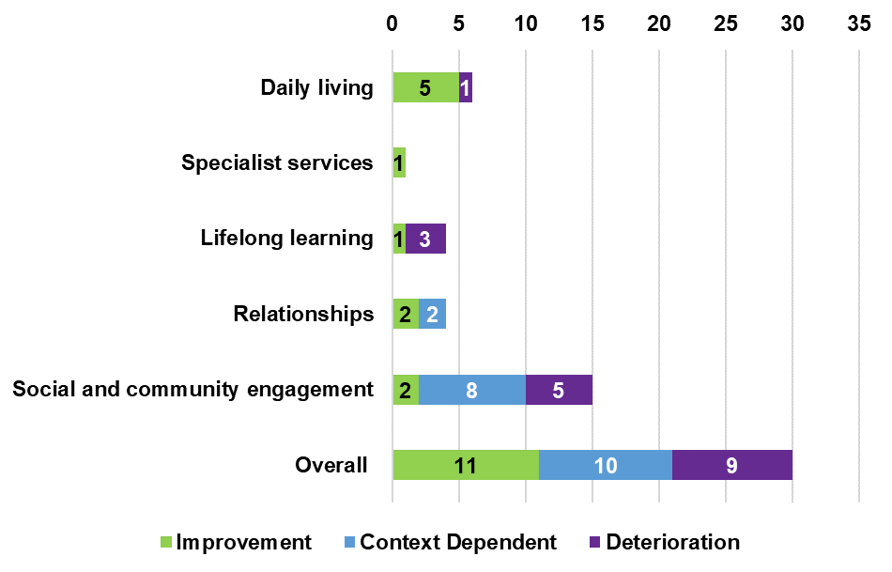

Summary of trend by selected indicators
Domain | Age group | Indicator | Change
 |  | % who use specialist services (e.g. speech pathology, occupational therapy) that assist their learning and development | Improvement
 | 0 to school | % who say services help their child gain the skills she/he needs to participate in everyday life (e.g. go to preschool) | Improvement
Daily Living |  | % who say services support them to assist their child | Improvement
 |  | % with concerns about development in six or more areas | Deterioration increase negative indicator
 | School to 14 | % who say child is becoming more independent | Improvement
 | 0 to 14 | % who say child is able to manage the demands of their world (pretty well or very well) | Improvement
Relationships | 0 to 14 | % who say child can make friends with people outside the family | Improvement
 |  | % who say child fits well into the everyday life of the family | Improvement
 | School to 14 | % of children who spend time after school or on weekends with friends and/or in mainstream programs | *
Social, community and civic participants |  | Of those children who spend time after school and on weekends with friends and/or in mainstream programs, | Deterioration decrease positive indicator
 | 0 to School | Of those who participate, % feeling welcomed or actively included | Improvement
 |  | % who would like their child to be more involved in community activities | Context dependent
 | School to 14 | % who would like their child to have more opportunity to be involved in activities with other children | Context dependent
 |  | % who say that their child’s disability is a barrier to greater involvement in activities with other children | Deterioration increase negative indicator
Lifelong learning | School to 24 | % children/young adults who attend or attended school in a mainstream class | Deterioration decrease positive indicator
 |  | % of children who were actively included in co-curricular activities when at school | Deterioration decrease positive indicator
* This indicator is not significant but highly relevant to the next indicator “Of those children who spend time after school and on weekends with friends and/or in mainstream programs, % feeling welcomed or actively included”.

Daily living: Specialist services

My child uses specialist services (e.g. speech pathology, occupational therapy) that assist their learning and development

The percentage increases strongly over the first year in the Scheme (by 12 to 23 percentage points), with smaller but still substantial increases (up to 11 percentage points) in the second year.
After four or five years in the Scheme, around 95% of respondents say that their child uses specialist services that assist their learning and development.
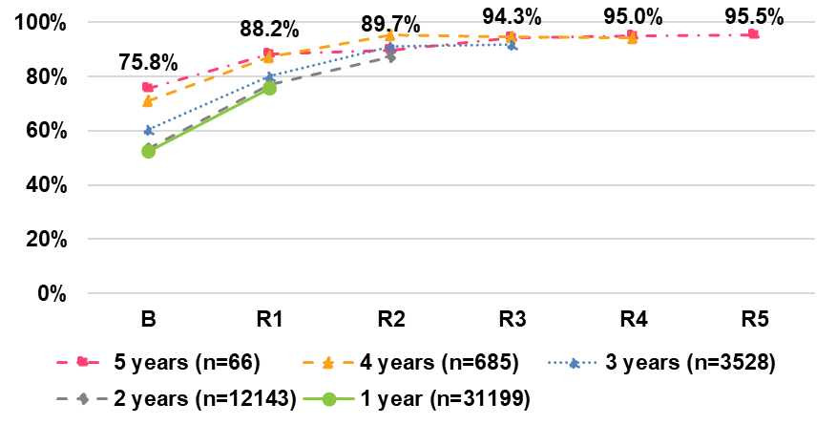

Daily living: Specialist services Gaining skills and assisting child
Overall, there is a slight increasing trend in the percentage of parents/carers who report that the specialist services help their child to gain key skills and support them in assisting their child. However, the largest percentage point increase is consistently seen in the first year across all cohorts – between 3.5 and 8.1 percentage points.
After five years in the Scheme, 97.9% of respondents felt that the services their child receives helps their child to gain key skills and the same percentage believed that the services support them in assisting their child, both featuring a 4.2 percentage point increase since baseline, respectively. Children in the Scheme for three years experienced the largest increases since baseline on both indicators – 11.2 and 8.7 percentage points, respectively.

These services help my child gain the skills she/he needs to participate in everyday life (e.g. go to preschool).
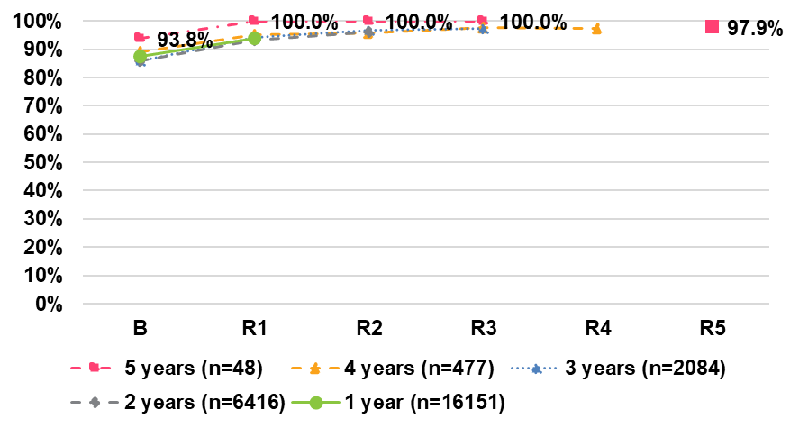
These services support me to assist my child
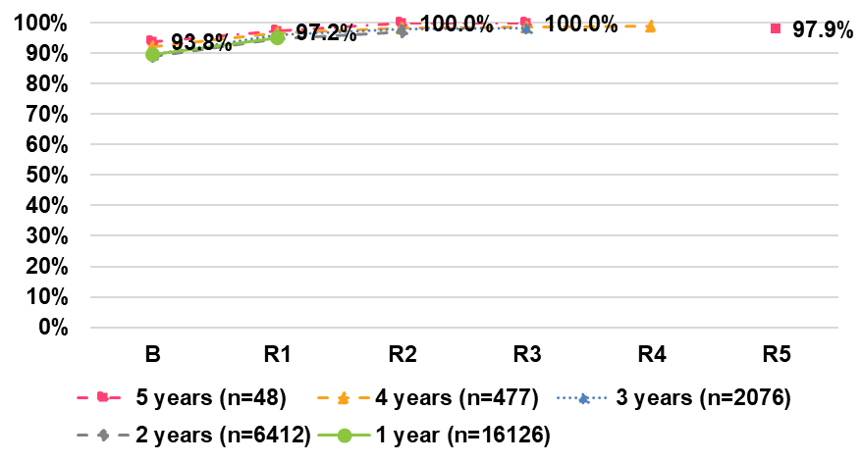

Daily living: Development

Concerns about development in six or more areas

There has been an increase in the percentage of respondents reporting concerns about development in six or more areas between baseline and latest reassessment period across all cohorts.
For participants in the Scheme for five years, the increase between baseline and third reassessment was 33.3 percentage points from 55.9% to 89.2%2. This percentage decreased to 76.2% in the fourth year but increased again to 82.4% in the fifth year. Note that due to relatively small numbers (68 participants), results can be somewhat volatile.
For participants in the Scheme for four years, the increase between baseline and fourth reassessment was 20.4 percentage-points from 56.7% to 77.1%. For participants in the Scheme for three years, the increase between baseline and third reassessment was 13.9 percentage points from 62.8% to 76.7%, including a 3.0 percentage point increase in the latest year. For participants in the Scheme for two years, the increase between baseline and third reassessment was 10.5 percentage- points from 67.1% to 77.6%, including a 3.8 percentage-point increase in the latest year. While for participants who have been in the Scheme for one year, there was an increase of 6.5 percentage points from 68.8% to 75.2%.

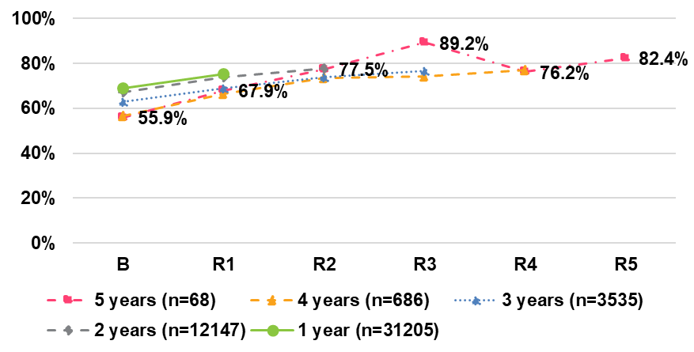

Concerns by individual area of development

Language/communication was the area with the highest percentage of concerns at fourth reassessment (95.6%), followed by social interaction (89.1%) and self-care (88.2%). Eating/feeding was by far the area with the lowest percentage of concerns (62.5%).
Compared to baseline, the percentage of parents/carers expressing concern about their child’s development after four years in the Scheme has:
increased by 14 or more percentage points in five areas – social interaction (25.4 percentage points), cognitive development (21.6 percentage points), self-care (19.2 percentage points), fine motor skills (14.4 percentage points) and sensory processing (17.8 percentage points). increased slightly for gross motor skills and language/communication by 2.5 and 6.7 percentage points, respectively. decreased by 1.6 percentage points for eating/feeding.
Over the latest year there were small increases across most areas (between +0.2 and +3.2 percentage points) in each area of concern.
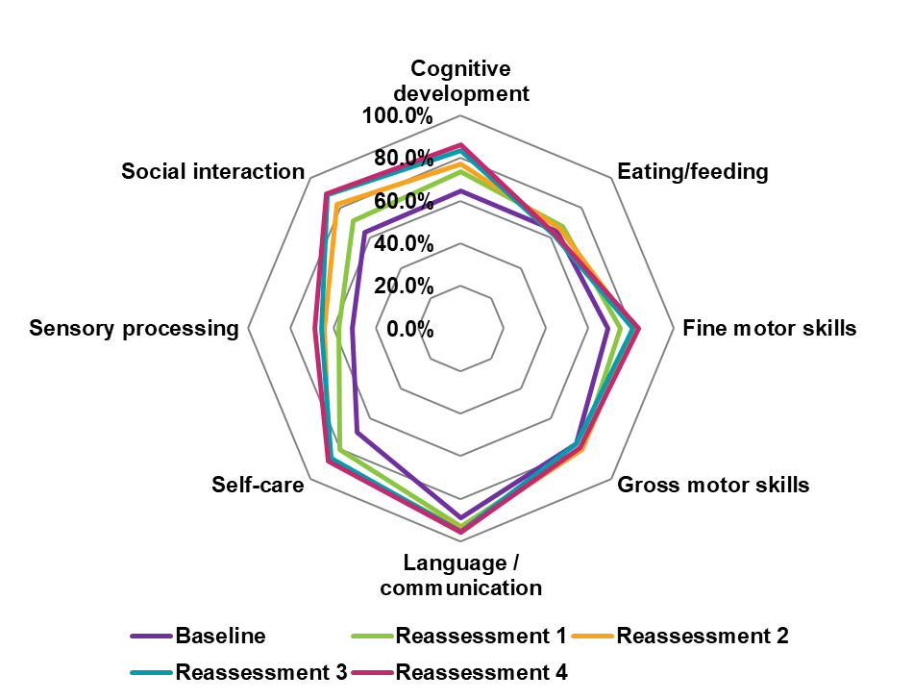

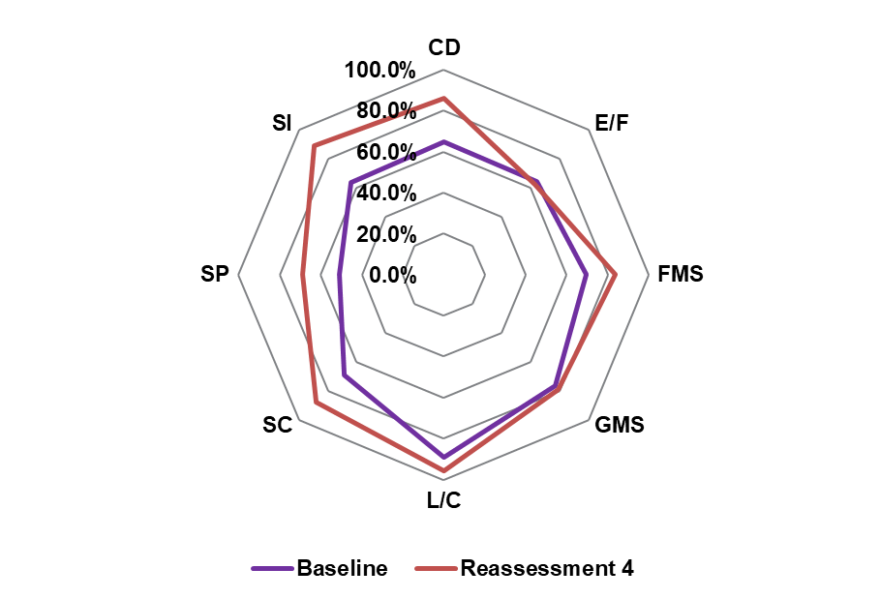

Daily living: Independence
My child is becoming more independent
For participants who have been in the Scheme for three to six years, the percentage increased by between 9 and 10 percentage points between baseline and latest reassessments. For the 1 year and 2 years cohorts, there were increases of 5.9, and
8.3 percentage points, respectively, from baseline. Across most cohorts (except 6 years cohort), the largest improvement was between baseline and first reassessment.
In the 1-to-4-year cohorts, a higher percentage of respondents in the 0–S/S–141 group reported that their child is becoming more independent, compared to the S–14 group (at baseline and all reassessment points). For example, 55.2% and 52.1% of 4 years cohort respondents said that their child is becoming more independent at reassessment 4 for the 0–S/S–14 and S–14 groups, respectively.
However, improvements over time are substantially smaller in the 0–S/S–14 group, compared to children in the School to 14 age group (S–14). For example, for cohort four, there was an increase of 1.3 percentage points for the 0–S/S–14, compared to 11.5 percentage points for the S–14 group.
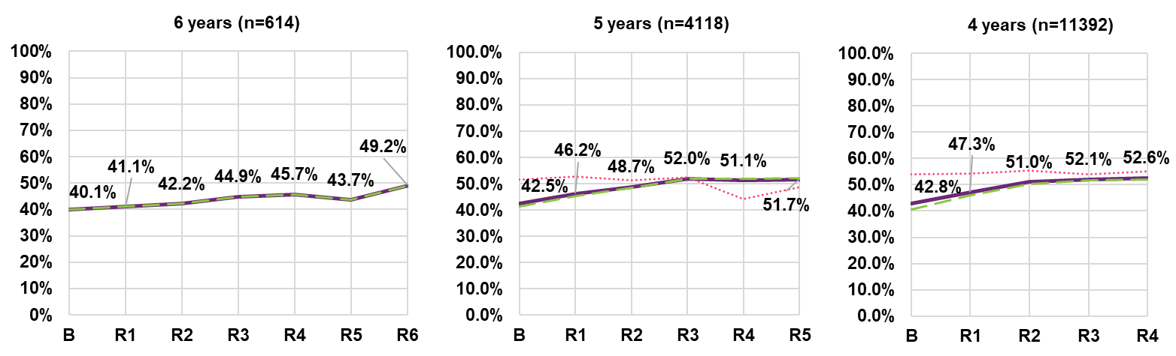
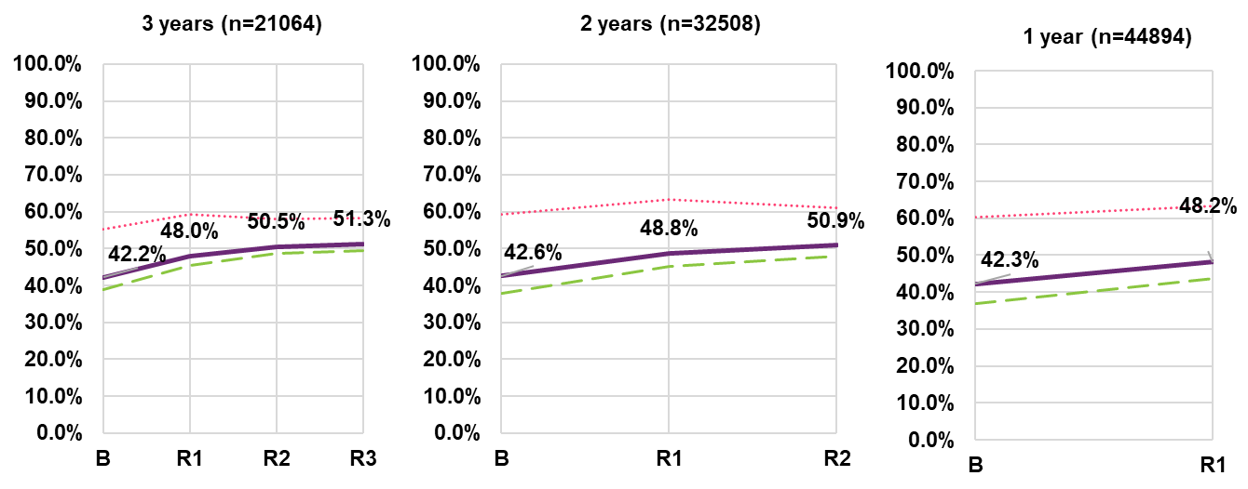

% of children who manage the demands of their world (pretty well or very well)1
For children aged 0 to 14 who have been in the Scheme for one to five years, there is an overall increase of between 4.3 and 12.6 percentage points from baseline to the latest reassessment. However, the percentage of children who manage the demands of their world very well or pretty well has declined slightly over the latest year in the Scheme for cohorts C3 and C4 – by 0.7 and 1.7

percentage points, respectively. 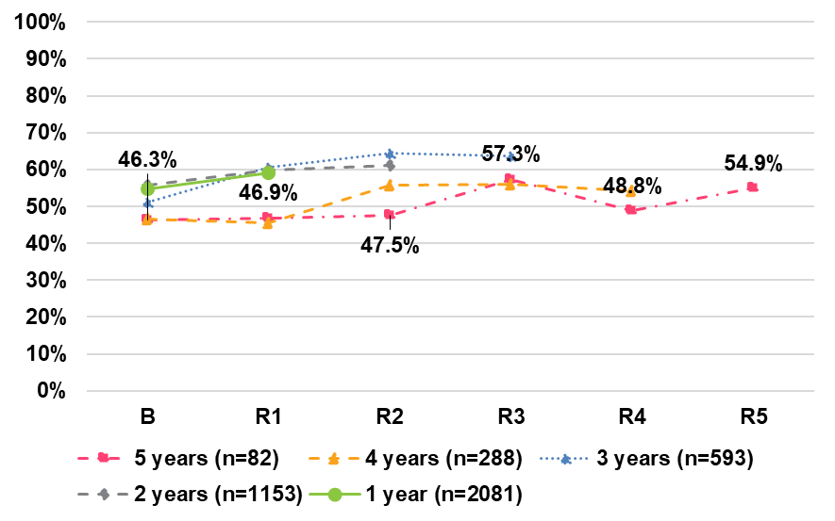

Relationships

My child can make friends with people outside the family
There is an increasing trend in the percentage of children who make friends with people outside the family for cohorts 1, 2 and 3, with the largest increase at first reassessment (between 2.4 and 3.4 percentage points).
There are some differences by age group for all cohorts:
- The 0–S/S–14 age group (for most cohorts and reassessment periods) has the highest percentage of children who can make friends with people outside the family – 75.8% at reassessment 1 (cohort 1). For those in the Scheme for 2 to 4 years, there was an increase of more than 5 percentage points from baseline to latest reassessment; larger increases are also seen at first reassessment for these cohorts.
- The largest improvement over time is associated with the 0–S age group, with increases of over 15 percentage points for those in the Scheme for 3 to 5 years. The increase is 11.0 percentage point for the 2-year cohort and 5.4 percentage points for the 1-year cohort.

The S–14 age group has a slight declining trend in cohorts 3 to 6
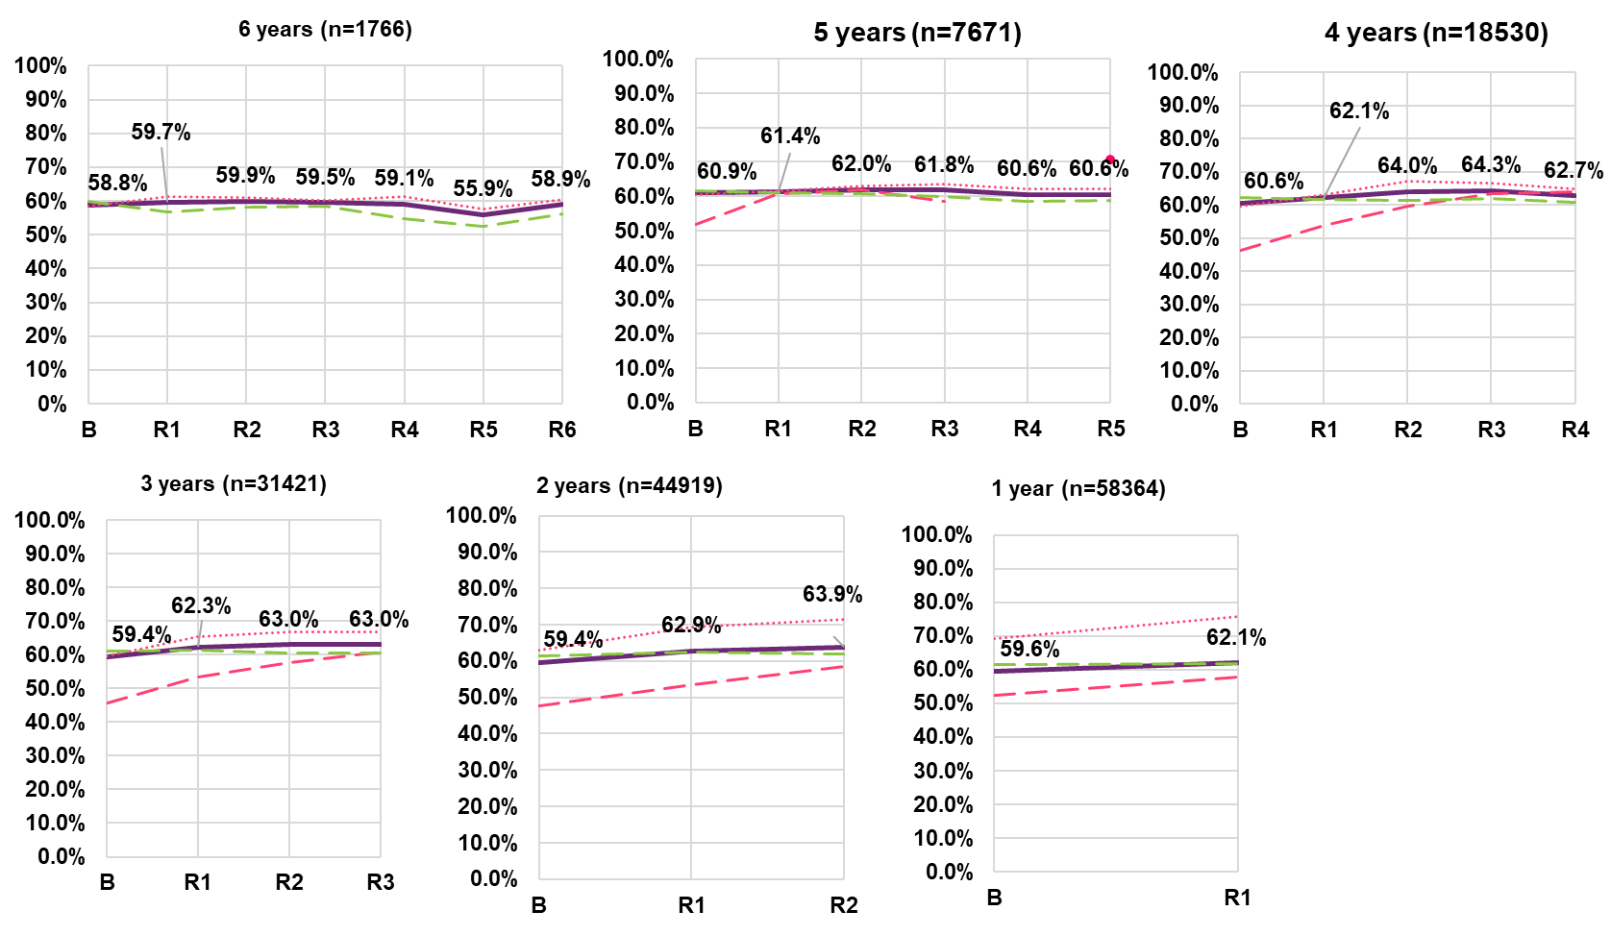
Note: Data labels displayed in the graph relate to the “All” series.
Note: The entire cohort 6 and R4 in cohort 5 for the 0–S age group have been omitted as participant numbers are too small.

My child fits well into the everyday life of the family
There is an increasing trend in the percentage of parents/carers reporting that their child fits in with the everyday life of the family, with positive changes for all cohorts between baseline and latest reassessment. The largest improvement occurs at first reassessment, for all cohorts. For cohort 6, there is a 11.6 percentage point increase between baseline (69.4%) and fifth reassessment (81.0%), although there was a 4.4 percentage point decrease between reassessment 4 and 5.
Considering age group, the S–14 group is fairly stable across cohorts 1 to 5 and has an average of about 87% of respondents reporting that the child fits well into family life across these cohorts.
The largest increases over time are evident for the 0–S/S–14 age group, with increases of between 24 and 31 percentage points, of which the most profound change occurs at first reassessment. For example, for children in this age group who have been in the Scheme for six years, there is an increase of 25.7 percentage points from baseline (59.9%) to sixth reassessment (85.6%).
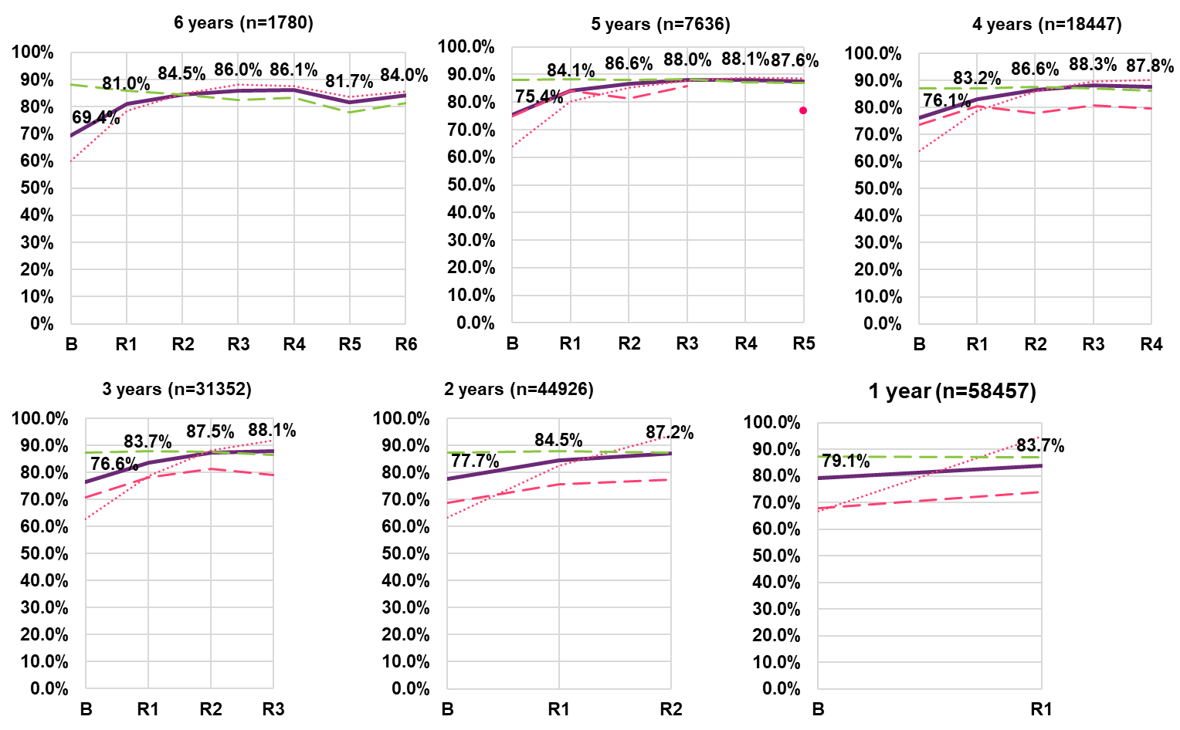

Of those who participate, % who feel welcomed or actively included

Respondents report that children in the birth to starting school age group who participate in community activities generally feel welcomed or actively included (81.2% after four years in the Scheme). This is an increase of 6.4 percentage points over the four years since baseline. Similar trends can be seen for the other cohorts, notwithstanding a decrease of 2.2 percentage points in the latest year for cohort 3. Larger increases are generally seen in earlier years across all cohorts. 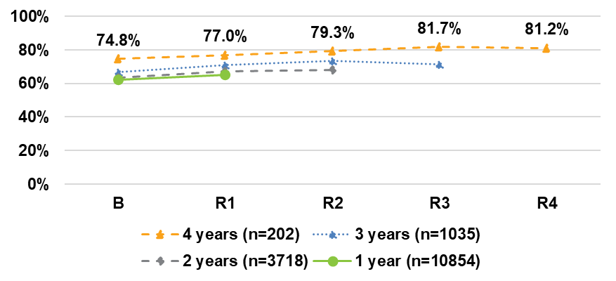

Social, community and civic participation
Spend time with friends and/or in mainstream programs
There has been a slight decreasing trend in the percentage of children who spend time after school or on weekends with friends and/or in mainstream programs for cohort 2–5. However, For children who have been in the Scheme for six years, 32.7% participated in activities at both their six-year reassessment and baseline.
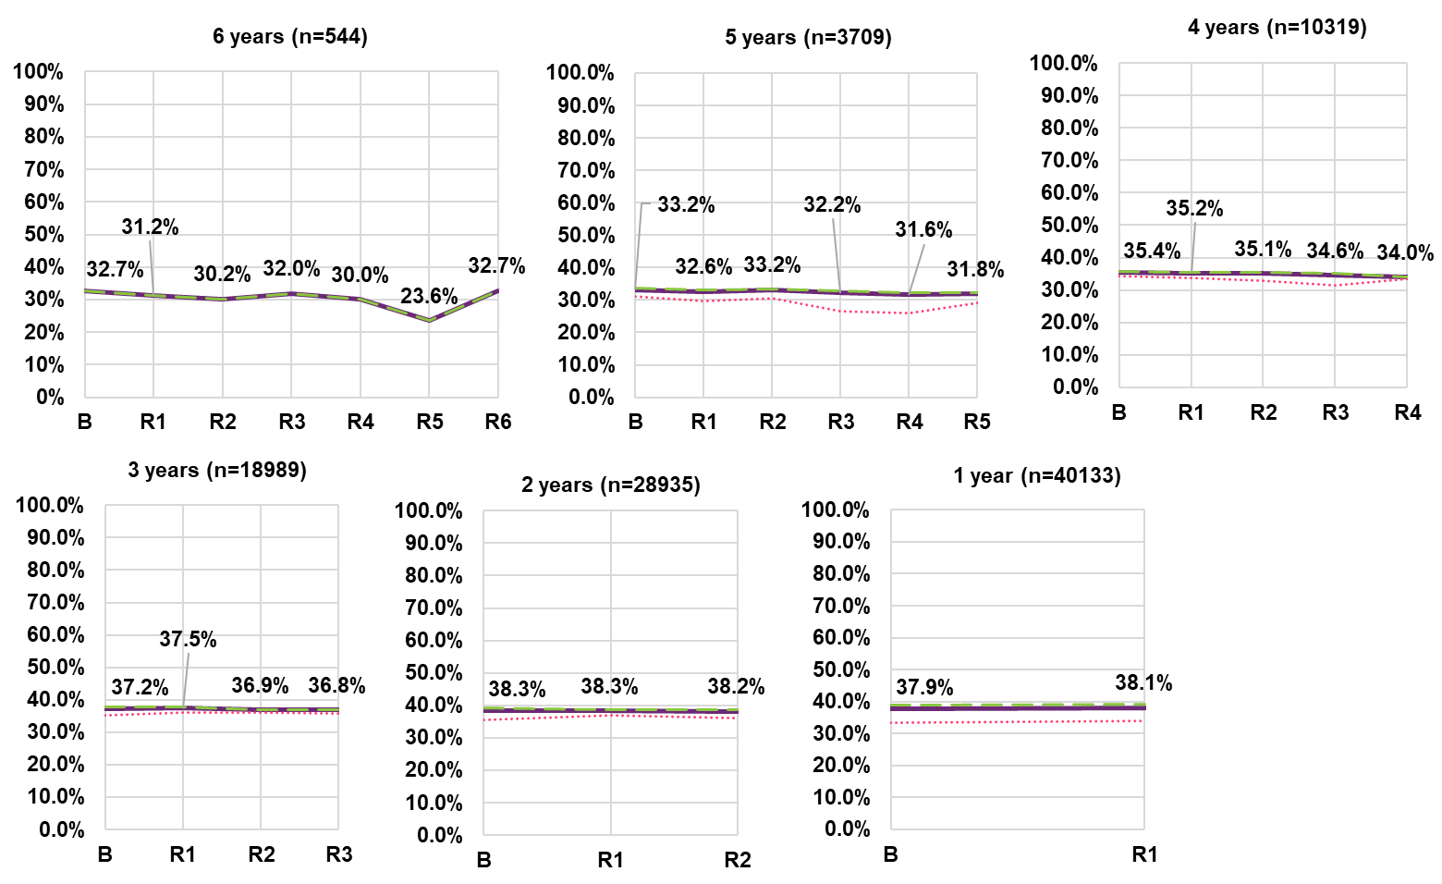

Feeling welcome or actively included with friends and/or in mainstream programs
Of those children who spend time after school and on weekends with friends and/ or in mainstream programs, the percentage feeling welcomed or actively included is declining over time – by 18.7 percentage points for cohort 6 between baseline (81.2%) and fifth reassessment (62.5%) (followed by an increase to 69.7% in the sixth year); and by 6.7 percentage points for cohort 5 between baseline (76.8%) and fifth reassessment (70.1%). Those who transitioned up from the 0 to School age group (0–S/S–14) had higher percentages feeling welcomed or actively included for cohorts 1 to 3. For cohort 4, there was an overall deterioration of 4.4 percentage points; however, this was more pronounced (6.1 percentage point drop) in those who transitioned up from the 0 to School age group (0–S/S–14).
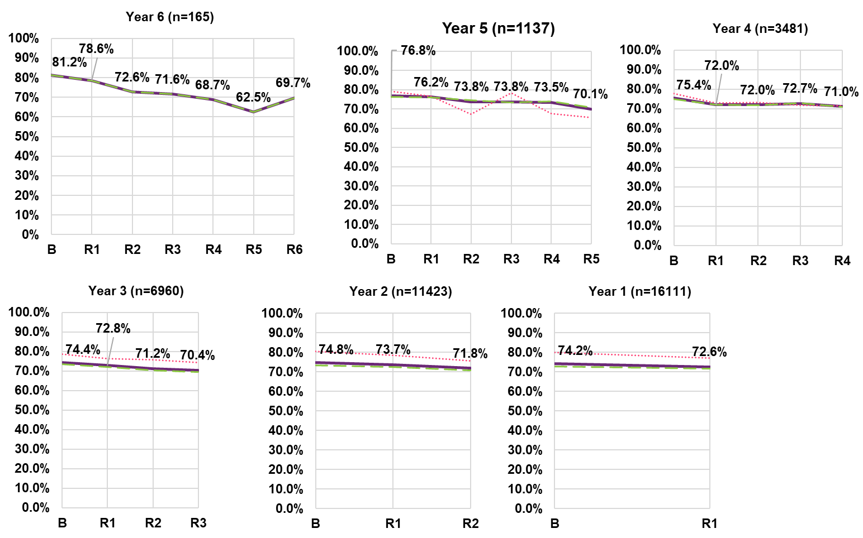

Involvement in community activities
% of parents/carers who would like their child to be more involved in community activities

There is an increasing trend in the percentage of parents/carers who would like their child to be more involved in community activities2 across all cohorts, with the extent of change increasing by years in the Scheme for the 0 to School age group (e.g. 6.7 percentage points for cohort 1 up to 27.2 percentage points for cohort 5).
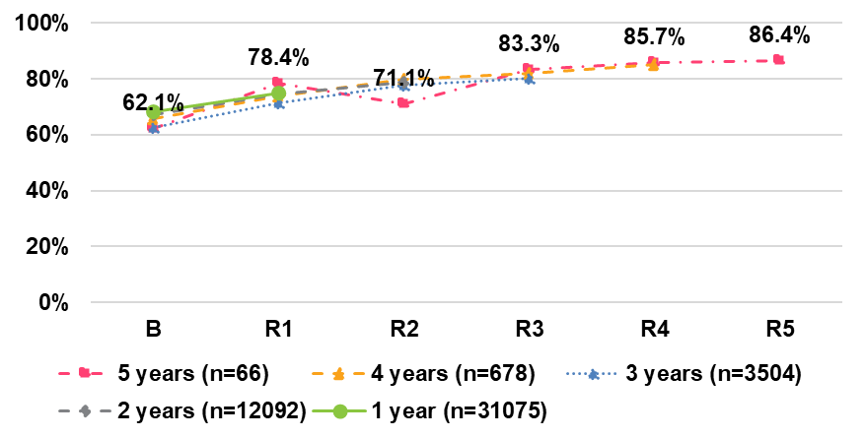

% who say they would like their child to have more opportunity to be involved with other children

For school aged children (School to 14), the percentage of respondents who want their child to have more opportunity to be involved in activities with other children has increased for all six cohorts since baseline. However, the increases are most pronounced in the first two years of responding to this item. For example, for children in the Scheme for six years, there was a change of 8.2 percentage points in the first year, while there are small declines of 0.8

percentage points in the last two years.
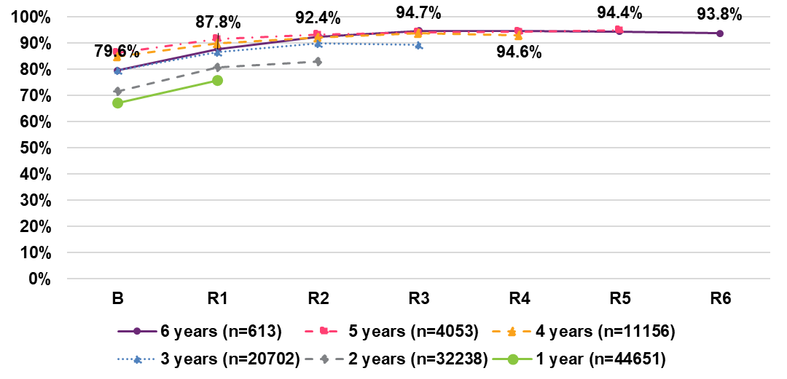

Child’s disability as a barrier to their involvement in community activities
The percentage who say that their child’s disability is a barrier to greater involvement in activities with other children has increased for all five cohorts since baseline, with greater increases for children who have been in the Scheme longer. For the 1 year to 6 years cohorts, there have been increases of 3.1, 4.3, 5.0, 6.3, 7.7 and7.3 percentage points, respectively.
Nevertheless, the strongest increases are generally in the first two years. Further, there has been a stabilisation over the latest year for those in the Scheme 4 or 5 years. For those in the Scheme for 6 years, the latest year saw a decrease of 2.7 percentage points.
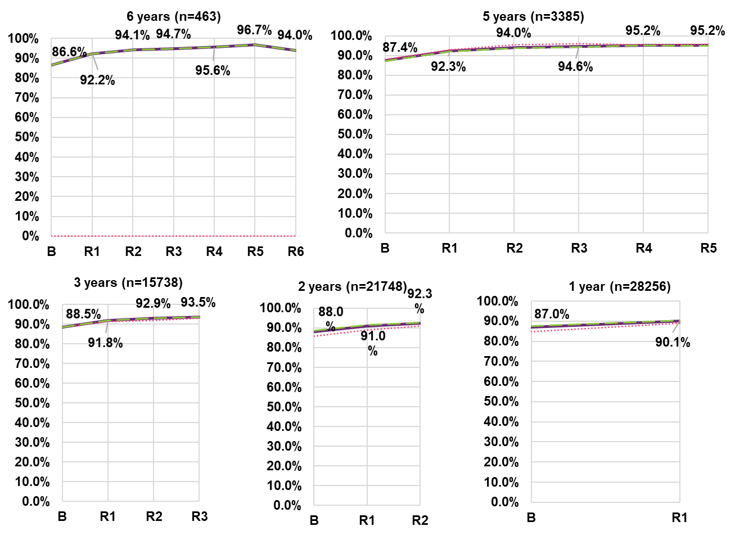

Lifelong learning

Children/young adults who attend or attended school in a mainstream class
There has been a deterioration across all cohorts in the percentage who attend (or have attended) school in a mainstream class. For the 5 years cohort, the percentage attending school in a mainstream class decreased by 7.6 percentage points between baseline and fifth reassessment, from 46.8% to 39.1%. For the 6 years cohort, the percentage decreased by 5.3 percentage points in the first four years from 40.5% to 35.2%, followed by a sharp 7.3 percentage point one-year drop partially offset by an The 15–24 age group has by far the lowest percentage of participants who attend or have attended school in a mainstream class (5 to 27 percentage points lower than the combined group), and the S–14 group has the highest percentage (8 to 15 percentage points higher). The transitioning groups are intermediate: the S–14/15–24 group being lower than average and the 0–S/S–14 group being higher than average.
There appears to be an entry cohort effect for this indicator, with higher levels observed for shorter duration cohorts (participants who entered the Scheme later). This is evidenced by the purple lines shifting upwards moving from left to right.
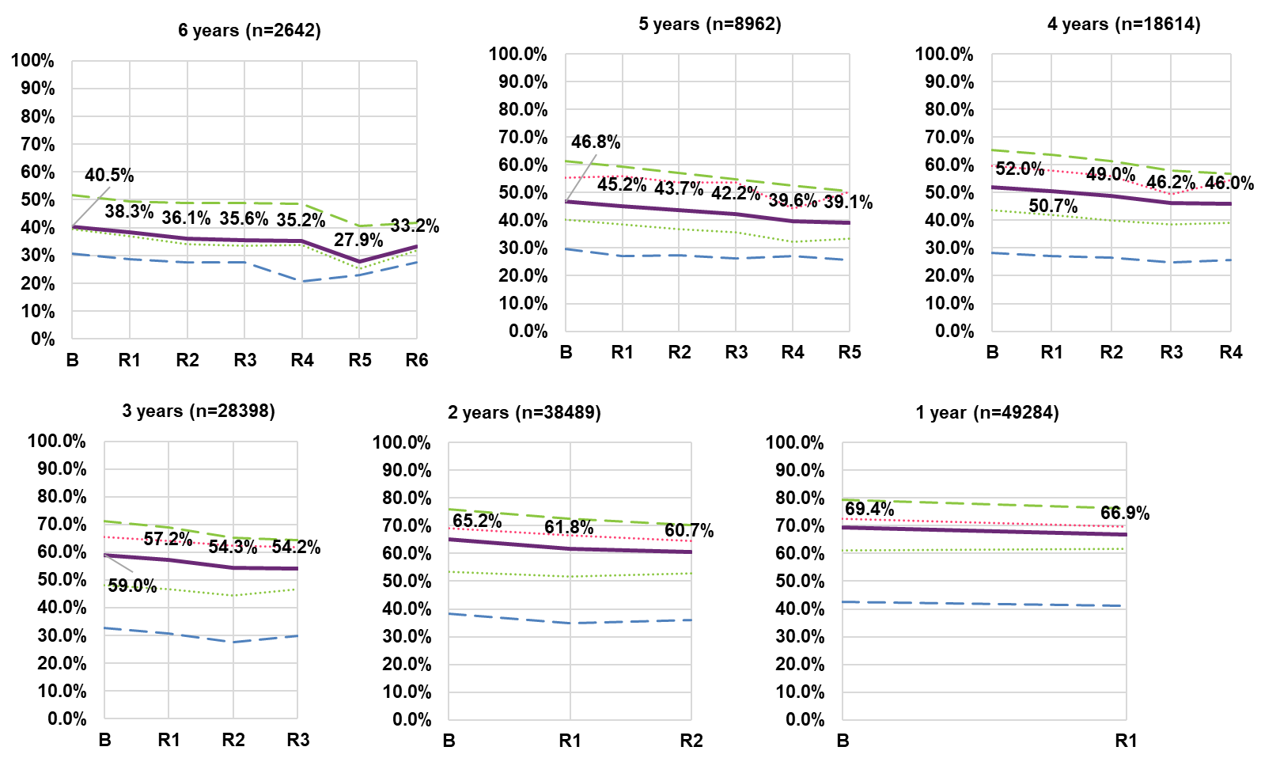

% of children who were actively included in co-curricular activities when at school
There is a decreasing trend in the percentage of children who were actively included in co-curricular activities when at school for cohort 4–6. For those in the Scheme for 6 years, there was a 19.7 percentage point decrease between baseline and sixth reassessment from 44.6% to 24.9%.
Participants in the Scheme for three years, two years and one year have seen improvements of 1.4, 2.6 and 2.5 percentage points, respectively, from baseline to latest reassessment.
The 15–24 age group has the highest percentage of participants who were actively included in co-curricular activities when at school and the 0–S/S–14 and S–14 age group have lower percentages.
Participants entering the Scheme later in time are also less likely to be actively included in co-curricular activities when at school at baseline. This baseline percentage has decreased from 44.6% to 25.4% for participants who have been in the Scheme for 6 years and 1 year, respectively.
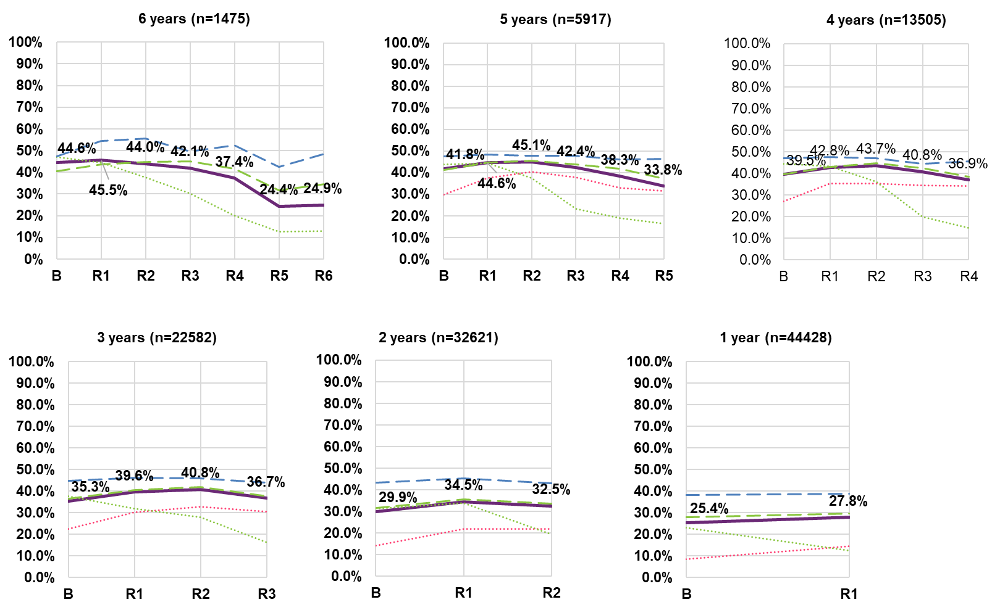Note: Data labels displayed in the graph relate to the “All” series.
Note: The entire cohort 6 for 0–S/S–14 age group is not shown due to insufficient numbers for this indicator.

The adult years– participants aged 15 and over

Domains and outcomes
The participant group aged 15 years and over comprises the following:
Age group | Participant Characteristic
15 to 24 | Young adults characterised by increasing levels of independence and participation in community, with some individuals moving out of the family home, and transitioning from school to employment or further study.
25 and over | Older adults, where employment is an important area. The older members of this cohort are also starting to transition to retirement. For both young and older adults, choice and control is a normal part of everyday life.
The eight outcome domains for participants aged 15 years and over are:
- Choice and control
- Daily living
- Relationships
- Home
- Health and wellbeing
- Lifelong learning
- Work
- Social, community and civic participation

Summary of changes

Number of indicators with significant and material overall change by domain
Indicators are deemed to show “significant and material overall change” if they meet the following criteria:
- McNemar’s test for change from baseline significant at the 5% level
- Absolute value of change from baseline greater than 0.021
- The above criteria hold for at least three of the longitudinal cohorts.
Numbers of indicators meeting the above criteria are presented. A total of 183 indicators were considered.

Summary of trend by selected indicators

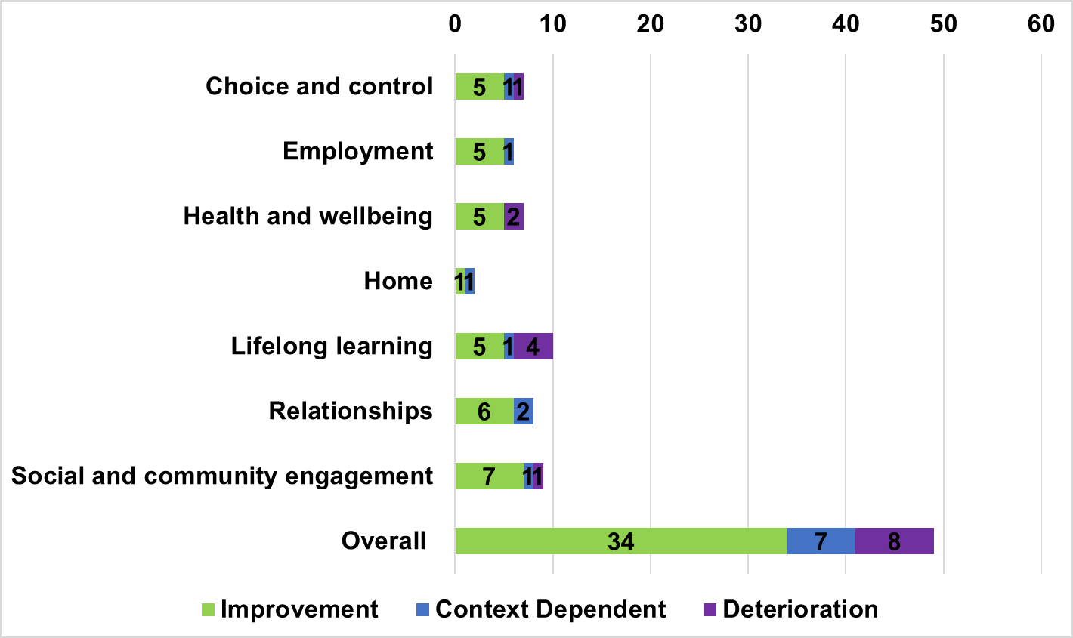

Domain | Age Group | Indicator | Change
 | 15 and over | % who get opportunities to learn new things | Improvement positive indicator
Lifelong learning |  | % who wanted to do a course or training in the last 12 months but could not | Decrease improvement negative indicator
 | 15 and over | % who have completed year 12 or above | Improvement positive indicator
 |  | % currently participating in education, training or skill development | Deterioration creased positive indicator
 |  | % who do not have more independence/control over their life than they did 2 years ago because of factors unrelated to their disability | Decrease improvement negative indicator
 | 15 to 24 | % who make more decisions in their life than they did 2 years ago | Improvement positive indicator
Choice and control |  | % who want more choice and control in their life | Context dependent
 |  | % who feel able to have a say with their support services (most or all of the time) | Improvement positive indicator
 | 15 and over | % who say they choose how they spend their free time | Improvement positive indicator
 |  | % who say they feel able to advocate (stand up) for themselves | Deterioration creased positive indicator
 | 15 to 24 | % who get to see their friends without paid staﬀ or family present | Improvement positive indicator
 |  | % who feel happy with their relationship with staﬀ | Improvement positive indicator
Relationships | 15 and over | % who would like to see their family more often | Context dependent
 |  | % who would like to see their friends more often | Context dependent
 | 15 to 24 | % who make decisions in planning for a home of their own with or without the help of others | Improvement positive indicator
Home | 15 and over | % say they choose where they lived | Improvement positive indicator
 |  | % say they choose whom they lived with | Improvement positive indicator
 |  | % who spend their free time doing activities that interest them | Improvement positive indicator
 |  | % who have been actively involved in a community activity in the last 12 months | Improvement positive indicator
 |  | % who know people in their community | Improvement positive indicator
Social community and civic participation |  | % who feel safe getting out and about in their community | Deterioration creased positive indicator
 | 15 and over | % who have opportunity to try new things and have new experiences | Improvement positive indicator
 |  | % who feel safe walking alone in their local area after dark | Improvement positive indicator
 |  | % who have a say within the general community | Improvement positive indicator
 |  | % who said there was something they wanted to do in the last 12 months, but could not | Deterioration increase negative indicator

Lifelong learning

Do you get opportunities to learn new things?
Overall, there is an increasing trend in the percentage of participants who reported getting opportunities to learn new things. The percentage increased (compared to baseline) by between 4.0 and 4.1 percentage points for the C4, C5 and C6 cohorts. However, the trend for this indicator differs by age group:
- A much higher percentage of participants in the S–14/15–24 reported positively on this indicator (i.e. above 68%) compared to other age groups. However, there was no longitudinal change except for cohort 4 and 5, where there was a deterioration between baseline and the latest reassessment on both cohorts.
- The 15–24 age group had the next highest percentage of participants reporting positively on this indicator – 67% at sixth reassessment (cohort 6), with a modest 1.5 to 2.6 percentage point increase between baseline and latest reassessment (across all cohorts).
- Starting from a lower baseline level – 53% at sixth reassessment (cohort 6), the 15–24/25+ age group had a strong increasing trend, with gains of between 5.9 and 13.9 percentage points for cohorts 1 through 5.
- The 25+ age group also showed an increasing trend – between 2.2 and 4.4 percentage points. However, the group had a lower percentage of participants responding positively on the indictor, when compared to the other age groups.
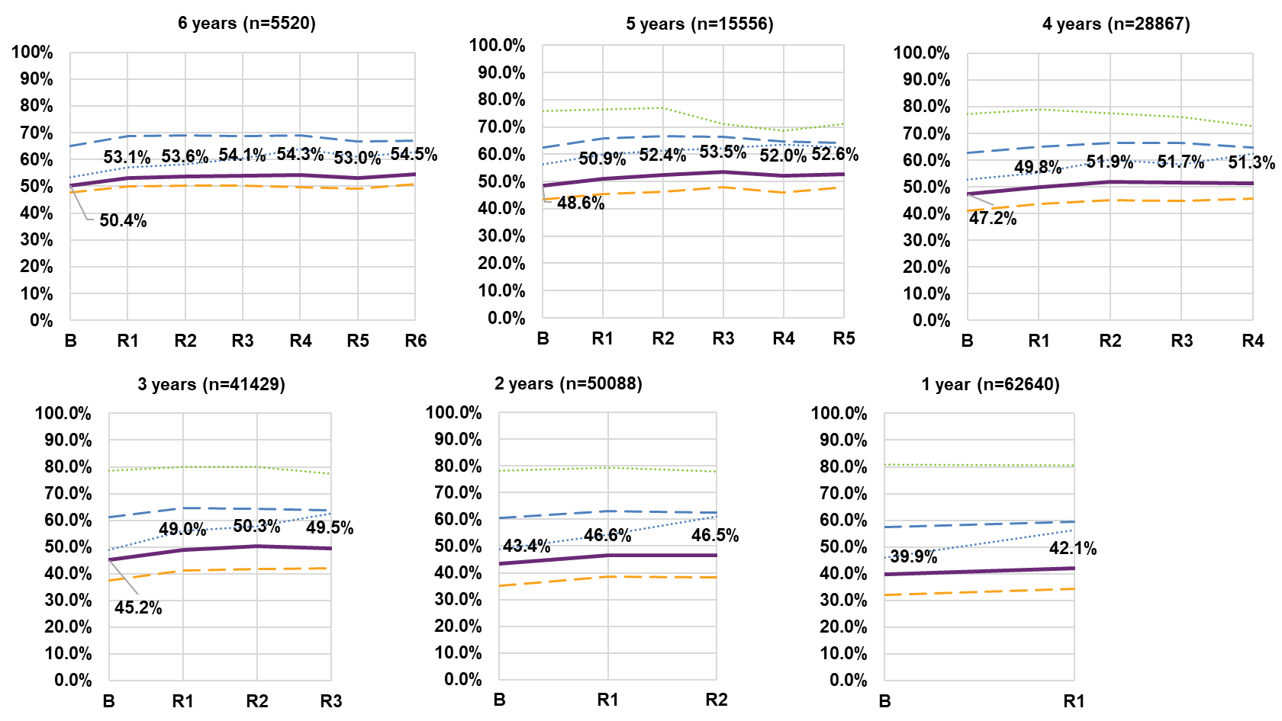
Note: Data labels displayed in the graph relate to the “All” series.
Note: The entire cohort 6 for the S–14/15–25 age group have been omitted as participant numbers are too small.

% who wanted to do a course or training in the last 12 months but could not
There is a decreasing trend (improvement) in the percentage of participants who wanted to do a course or training in the last 12 months but could not. For C6, the percentage decreased from 34.8% at baseline to 29.3% at sixth reassessment (5.6 percentage points). Similar improvement (6.2 percentage points) was observed for C5, with smaller improvements (0.8 to 4.1 percentage points) for C1 to C4.
There was some variation by age group:
- The youngest S–14/15–24 group reported lower (more favourable) percentages but an increasing (deteriorating) trend.
- The 15–24/25+ group showed substantial improvement between baseline and latest reassessment (e.g. 14 and 15 percentage point reductions for 5 years and 6 years cohorts respectively).
- The 15–24 age group was fairly stable across all cohorts.
- The 25+ age group showed similar improvements to overall.
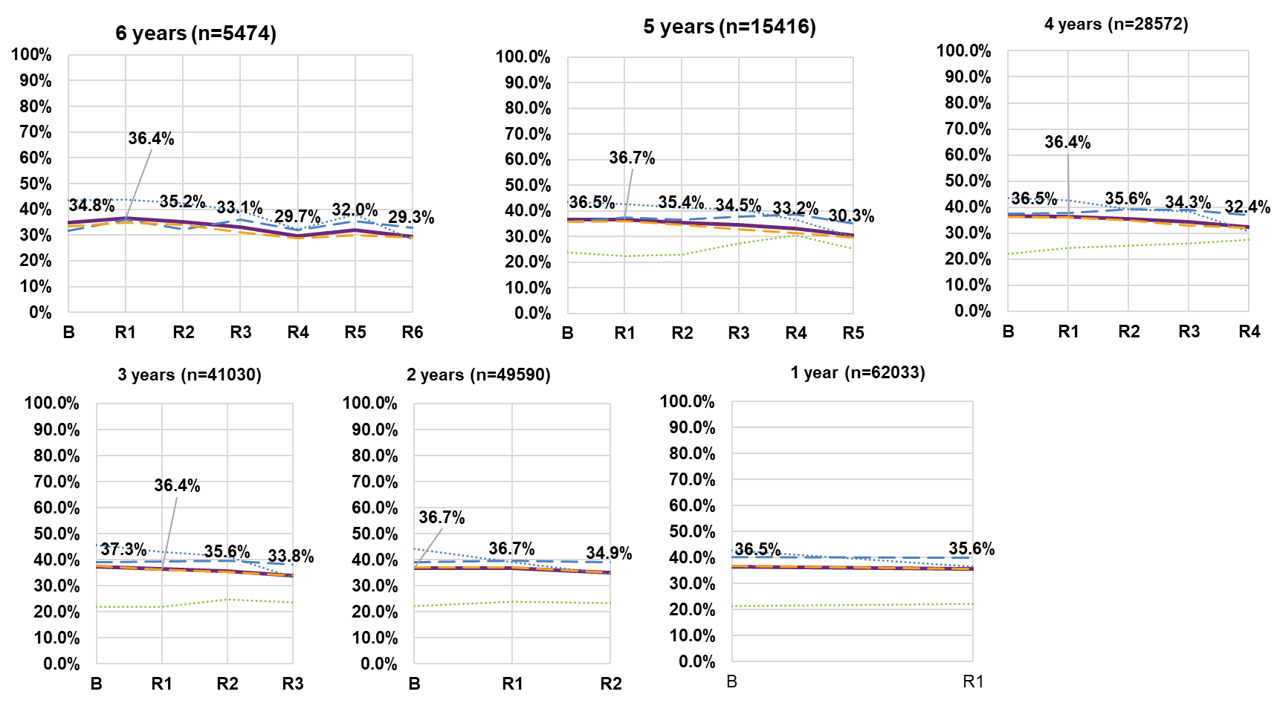
Note: Data labels displayed in the graph relate to the “All” series.
Note: The entire cohort 6 for the S–14/15–25 age group have been omitted as participant numbers are too small.

Completed year 12 or above (Benchmark)

Compared to the general Australian population (76.7%), a substantially lower percentage of NDIS participants aged 15 and over have completed year 12 or above (across all cohorts). Notwithstanding, there is an increasing trend for cohorts 1 through 4. Cohort 5 and 6 display increasing trend to reassessment three, with declines between third and latest reassessment.
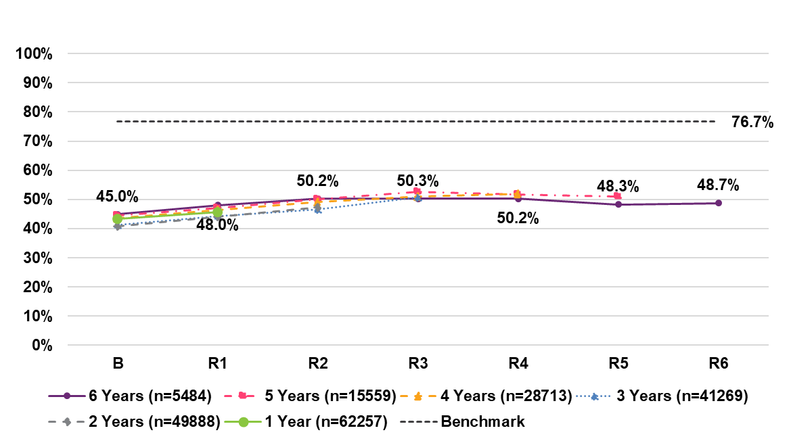

% currently participating in education, training or skill development
After an initial increase in the first year, participation in education/training has shown a decreasing trend overall. For cohort 6, there was an overall decrease of
6.5 percentage points between baseline (21.5%) and sixth reassessment (15.0%), despite a 1.2 percentage point increase at first reassessment (22.7%).
The 25+ age group had the lowest percentages participating. For example, for cohort 5, about 14% of participants aged 25+ did some sort of education or training and this remained fairly stable across reassessment periods. This is consistent across cohorts, although cohorts 1 and 2 had slightly lower percentages.
The S–14/15–24 group had by far the highest percentages participating, possibly due to still attending school. However, there was a decline of 31.5 percentage points over five years for cohort 5, from 68.2% to 36.8%.
The 15–24 group also experienced a decline of 23.1 percentage points over five years for cohort 5, from 53.8% to 30.8%.
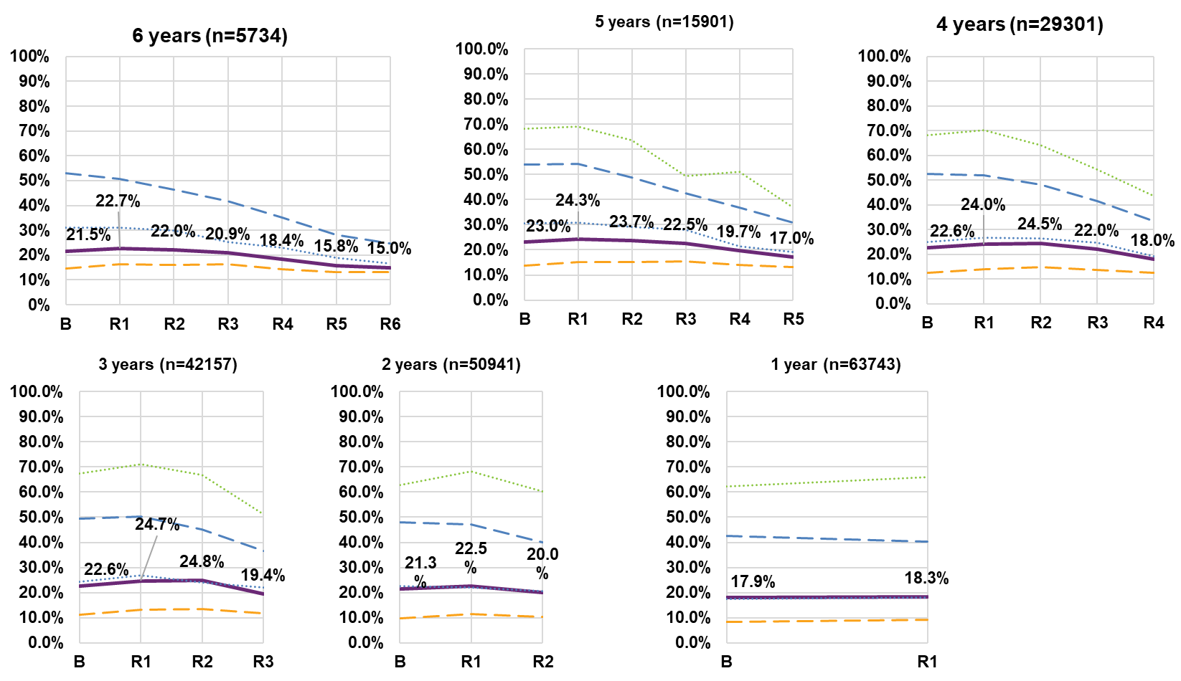
Note: Data labels displayed in the graph relate to the “All” series.
Note: The entire cohort 6 for the S–14/15–25 age group have been omitted as participant numbers are too small.

Choice and control

Independence, making decisions and wanting more choice and control

For PSto14, analyse by time since first in P15to24, otherwise by time in Scheme
There are positive changes over time in choice and control outcomes for participants aged 15 to 24 across all cohorts.
Participants are increasingly likely to make more decisions in their life than they did 2 years ago (an 8.2 percentage point increase over six years). Gains are largest at first and second reassessment, with smaller gains at later reassessments. This is consistent across all cohorts. However, there is a 1.3 percentage point decrease at fourth reassessment for cohort 6.
Time since first in P15to24
The percentage of participants who do not have more independence/control over their life than they did 2 years ago due to factors unrelated to their disability is declining (i.e. improving). For cohort 6 there was a 4.4 percentage point decrease between baseline (10.7%) and sixth reassessment (6.3%). The largest decrease was at second reassessment.
There is an increasing trend in the percentage of participants who want more choice and control in their life (a 17.1 percentage-point increase over six years). This may suggest that participants are becoming more empowered and want more agency over their choices, or it may be flagging challenges to exerting choice and control.

% who do not have more independence/control over their life than they did 2 years ago because of factors unrelated to their disability
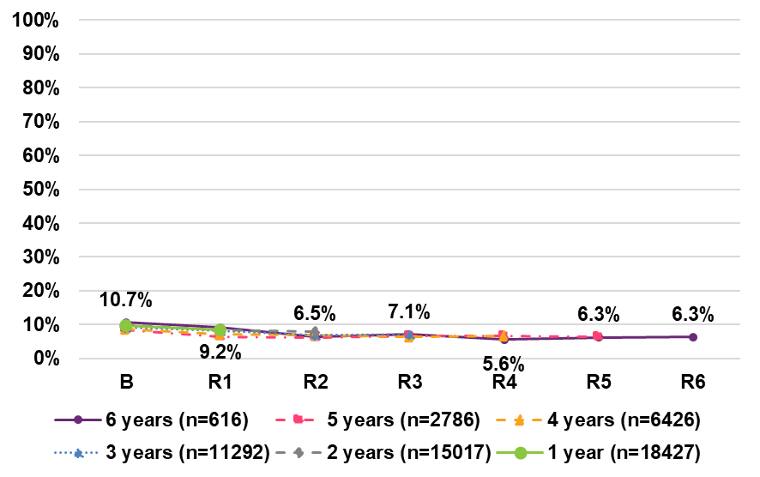

% who make more decisions in their life than they did 2 years ago
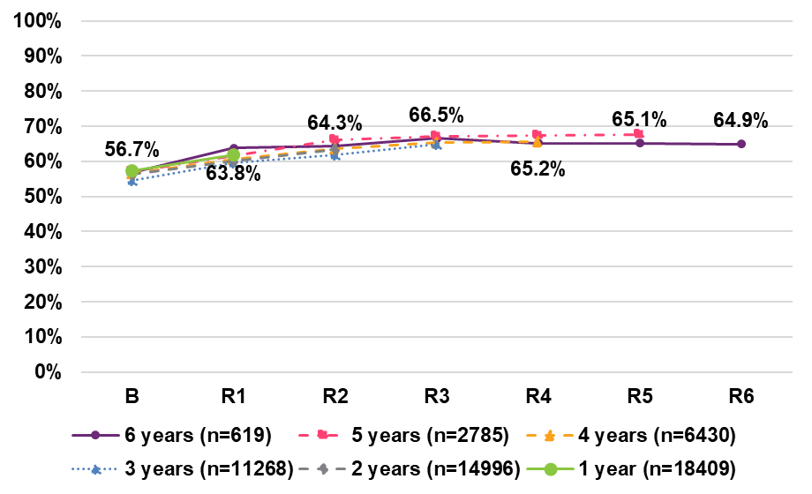
% who want more choice and control in their life
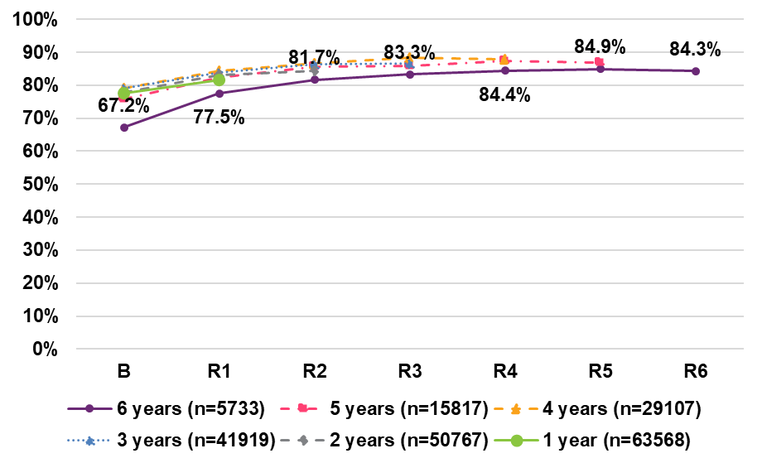

% who feel able to have a say with their support services (most or all of the time)
For PSto14, analyse by time since first in P15to24, otherwise by time in Scheme
There is slight increasing trend in the overall percentage of participants who are able to have a say with their support services (most or all of the time). For Cohort 6 there was a 2.0 percentage point increase from 43.0% at baseline to 45.1% at sixth reassessment (purple line). In terms of age group variation:
- A higher percentage of participants in the 25+ age group felt able to have a say with their support services, compared with other age groups. For example, 47.5% of participants aged 25+ felt able to have a say at sixth reassessment, while 34.7% of participants aged 15–24 felt able to have a say. This is consistent across cohorts.
- The S–14/15–24 age group had the lowest percentage of participants who felt able to have a say – e.g. for cohort 5 fifth reassessment it was 27.2% (a 3.9 percentage point increase), compared to 36.2%, 45.6% and 49.4% for age groups 15–24, 15–24/25+, and 25+, respectively.
- The 15–24/25+ age group displays the largest increases across all cohorts, with 45.6% of participants feeling able to have a say at fifth reassessment – a 9.3 percentage point increase from baseline (36.3%).
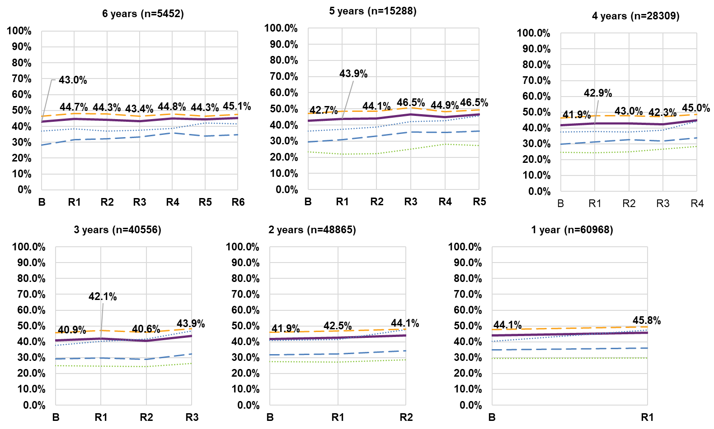
Note: Data labels displayed in the graph relate to the “All” series.
Note: The entire cohort 6 for the S–14/15–25 age group have been omitted as participant numbers are too small.

% who say they choose how they spend their free time

Generally, there are positive changes over time in the percentage of participants who say they choose how they spend their free time except for cohort 6 due to smaller numbers. For participants in cohort five, the percentage increased by 10.6 percentage points, from 59.1% at baseline to 69.7% at fifth reassessment. Cohorts one, two, three and four also show increases over time – 1.7, 5.0, 8.3, and 7.6 percentage points between baseline and latest reassessment.
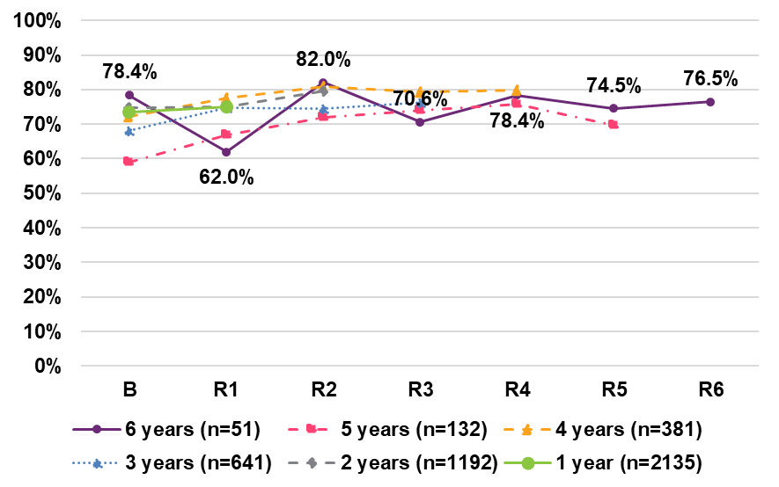

% who feel able to advocate (stand up) for themselves
For PSto14, analyse by time since first in P15to24, otherwise by time in Scheme
Participants aged 15 and over are less likely to feel able to advocate (stand up) for themselves over time. Over a six-year period, there was a 5.7 percentage point.
decrease between baseline (45.6%) and fifth reassessment (39.9%). This declining trend is also evident for cohorts 3, 4 and 5, while there has been no real change for cohorts 1 and 2.
There is a declining trend across all age groups, except participants in the S–14/15–24 age group where there are slight improvements at later reassessment periods except for cohort 5. However, this age group has the lowest percentage of participants reporting positively – 19.6% at fifth reassessment for cohort 5. The 25+ age group had the highest percentage of participants reporting that they feel able to advocate for themselves (44.9% at fifth reassessment for cohort 5). 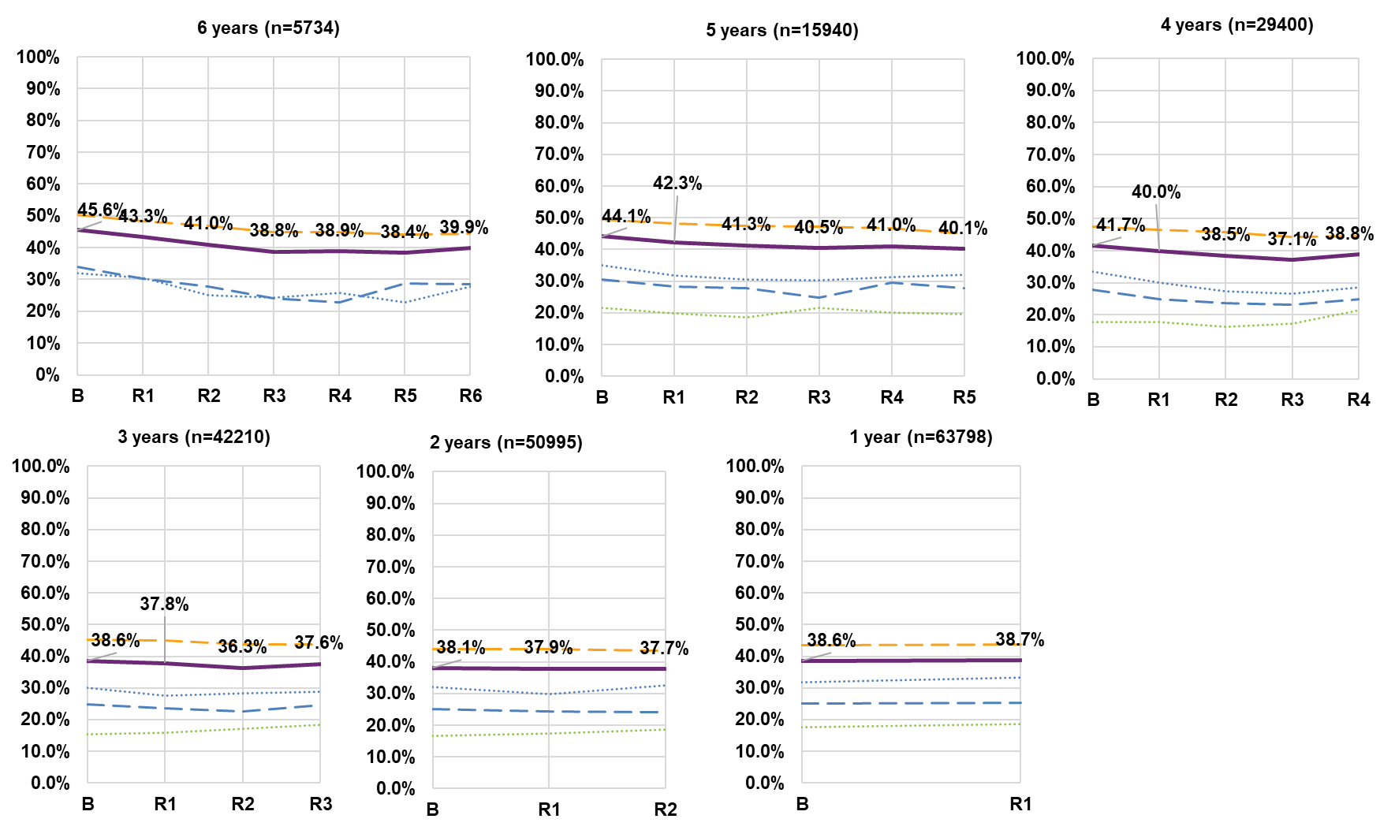

Relationships

Relationships with friends and staff
Time since first in P15to24
Long Form survey results show improvements over time for relationships with friends and staff.
% who get to see their friends without paid staff or family present1

For participants aged 15 to 24 in cohort 4, results suggest that participants are increasingly getting to see their friends without paid staff or family present1 – 57.5% at fourth reassessment compared to 45.2% at baseline, an increase of
12.3 percentage points over four years. Cohorts 1 to 3 show improvements on this indicator of 6.2 to 12.1 percentage points.
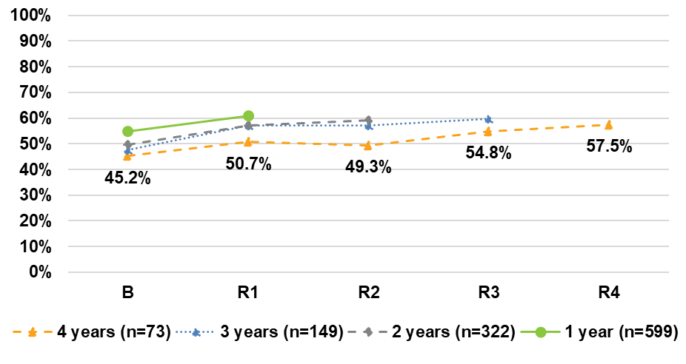

For PSto14, analyse by time since first in P15to24, otherwise by time in Scheme
% who feel happy with their relationship with staff

A higher percentage of participants aged 15 and over are reporting feeling happy with their relationship with staff – 93.8% at sixth reassessment compared to 70.8% at baseline. There have been increases of between 9.8 and 21.7 percentage points for participants in the Scheme for three or more years. Smaller increases are evident for those in cohort 1 and 2 – 5.0 and 5.8 percentage points, respectively.
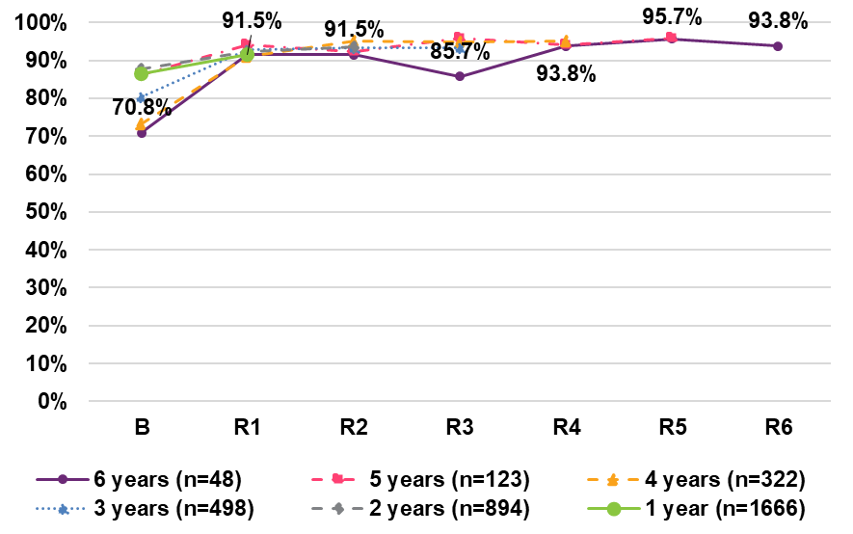
Note that due to small numbers, this LF indicator is not available for participants in the Scheme for five and six years.

% who would like to see their family more often
For PSto14, analyse by time since first in P15to24, otherwise by time in Scheme
Participants expressed an increasing desire to see family more often. For example, for those in cohort 6, the percentage wanting to see their family more often increased by 8.9 percentage points from 31.0% at baseline to 39.9% at sixth reassessment.
A higher percentage of older participants (25+ age group) indicated that they would like to see their family more often, and this group showed a larger increase over time. For those in the Scheme six years, there was a 9.9 percentage point increase between baseline (35.1%) and sixth reassessment (45.0%).
The younger age groups (15–24 and 15–24/25+) had smaller increases over time,6.9 and 5.6 percentage points, respectively.
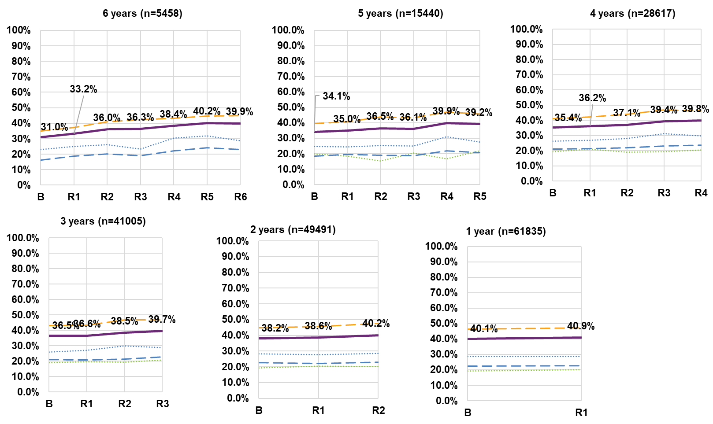
Note: Data labels displayed in the graph relate to the “All” series.
Note: The entire cohort 6 for the S–14/15–25 age group have been omitted as participant numbers are too small.

% who would like to see their friends more often
For PSto14, analyse by time since first in P15to24, otherwise by time in Scheme
Over time, participants aged 15 and over are increasingly wanting to see their friends more often. For example, for participants in cohort 6 there was a 9.2 percentage point increase in the percentage wanting to see their friends more often (between baseline and sixth reassessment). However, there was a 1.4 percentage point decrease between the latest 2 years.
The trend appears to be consistent across the age groups, although there is a higher percentage of participants in the younger age groups (i.e. S–14/15–24 and 15–24) who would like to see their friends more often compared to the 25+ group. For example, at fifth reassessment (Cohort 5), 71.2% of participants in the S–14/15–24 age group reported wanting to see their friends more often, compared to 60.0% of participants in the 25+ age group.
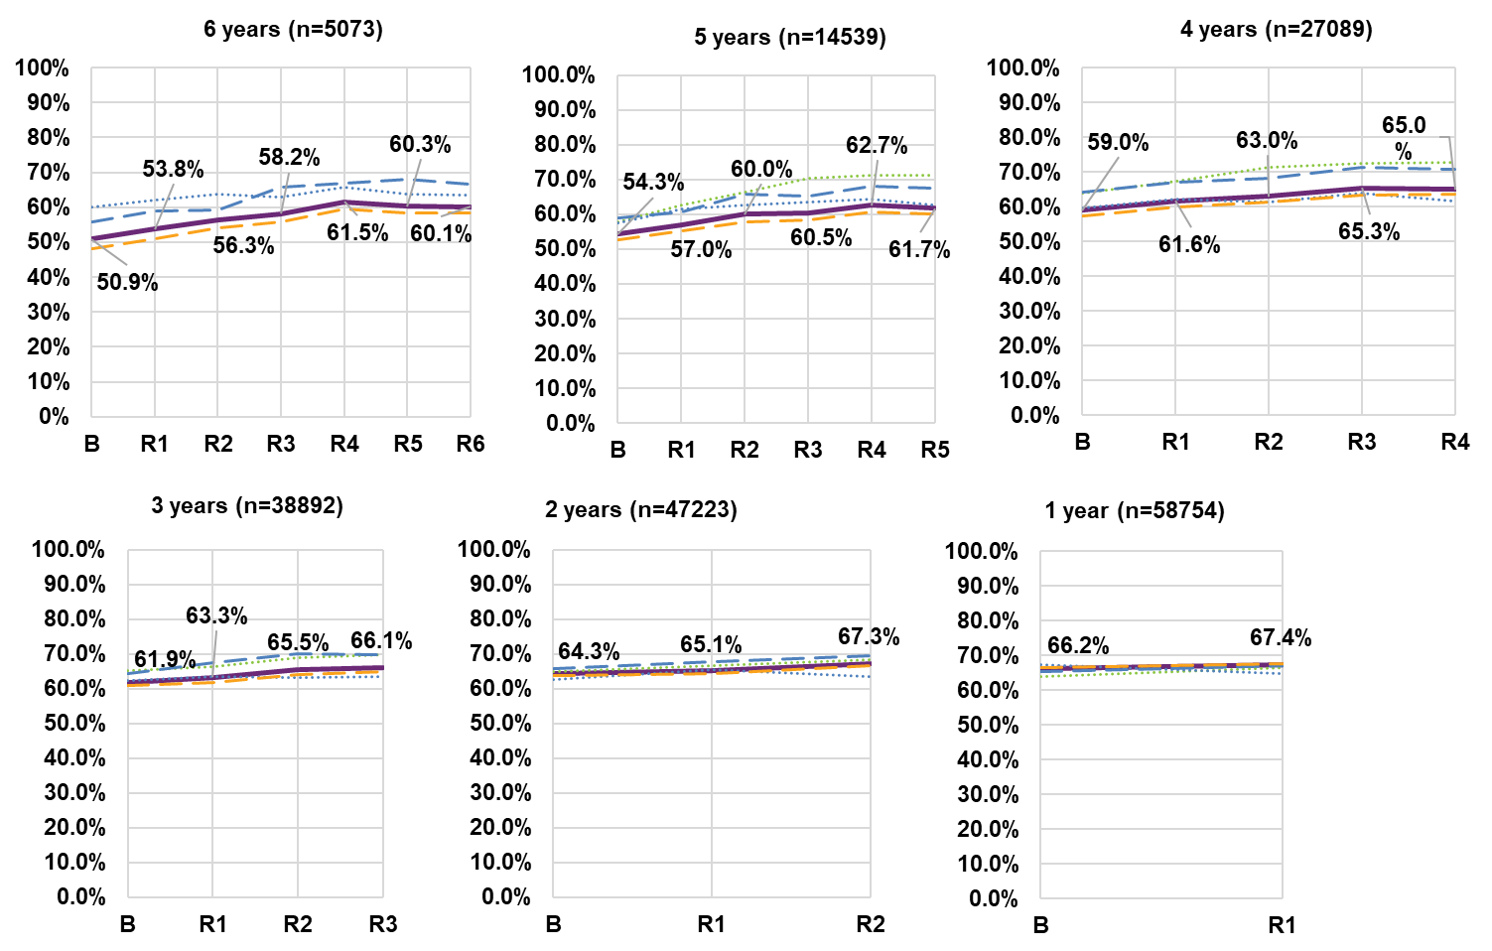
Note: Data labels displayed in the graph relate to the “All” series.
Note: The entire cohort 6 for the S–14/15–25 age group have been omitted as participant numbers are too small.

Home

Home-related decisions
Time since first in P15to24

Participants aged 15 to 24 are showing longitudinal improvements in their home related decisions and choices. While there is still a very low percentage of participants reporting that they make decisions in planning for a home of their own1 (21.9% at fourth reassessment), this is a 13.7 percentage point increase from baseline (8.2%). For the 3-years cohort, there has been a 13.4 percentage point increase from baseline, to 26.8% at third reassessment.
For PSto14, analyse by time since first in P15to24, otherwise by time in Scheme
Similarly, participants aged 15 and over are increasingly reporting choice in where and with whom they live. Over six years:
- 72.0% of participants say they chose where they lived at fifth reassessment for 5-years cohort, compared to 57.6% at baseline (a 14.4 percentage point increase), including a large increase at latest reassessment. However, there is a lower percentage of participants reporting on this metric at the sixth reassessment compared to baseline, which could possibly be attributed to the small sample size of the data.
- 72.5% of participants say they chose whom they lived with (sixth reassessment), compared to 66.7% at baseline (a 5.8 percentage point increase). Increases across other cohorts were between 2.6 and 12.1 percentage points.
% who make decisions in planning for a home of their own with or without the help of others
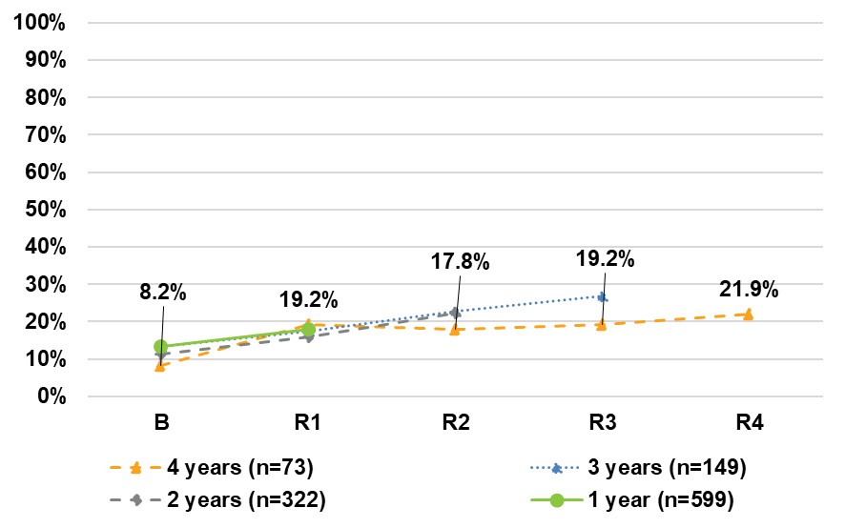.

% who say they chose where they lived % who say the chose whom they
lived with
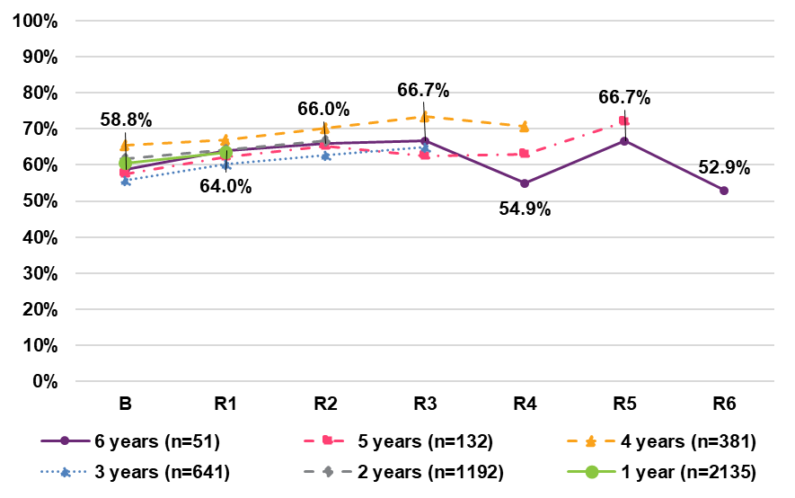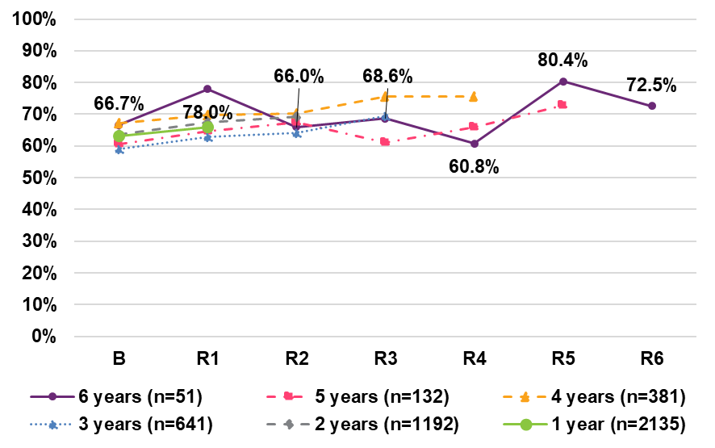
.

Social, community and civic participation

% who spend their free time doing activities that interest them
For all cohorts, improvements over time have been observed for the percentage who spend their free time doing activities that interest them – for example,
8.8 percentage points between baseline (69.6%) and sixth reassessment (78.5%) for cohort 6.
While fairly consistent across age groups, a higher percentage of the younger age group that has transitioned up into the 15–24 group (S–14/15–24) report spending their free time doing activities that interest them. For example, 81.4% of the S–14/15–24 spend their free time doing activities that interest them at fifth reassessment (Cohort 5), compared to 75.7% of participants in the 25+ age group.
Note that there is a cohort effect for the 25+ age group, where lower percentages are observed from participants who entered the Scheme more recently. For example, the baseline percentage for this age group increases steadily from 51.8% for cohort 1 to 68.8% for cohort 6.
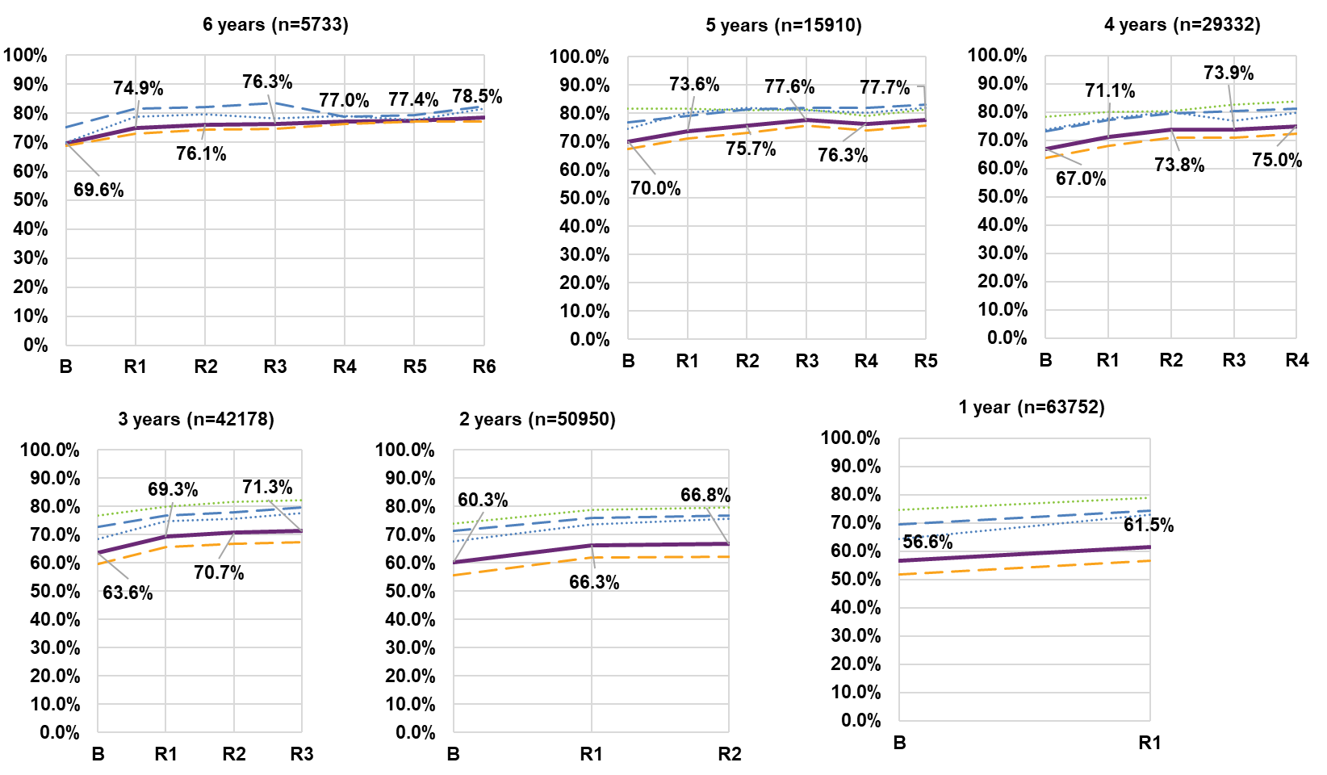

Actively involved in a community activity in the last 12 months
For PSto14, analyse by time since first in P15to24, otherwise by time in Scheme
The percentage of participants actively involved in a community, cultural or religious group in the last 12 months has improved across all six cohorts.
For cohort 6, there has been an increase of 13.5 percentage points between baseline (35.6%) and sixth reassessment (49.1%), including a 1.4 percentage point decrease in the latest year. For Cohort 5, the percentage increased by 11.6 percentage points, from 35.3% at baseline to 46.9% at fifth reassessment.
Cohorts 1, 2, 3 and 4, there have experienced increases of 2.6, 4.5, 6.3 and 7.7 percentage points, respectively. There is a fairly consistent trend across all age groups.

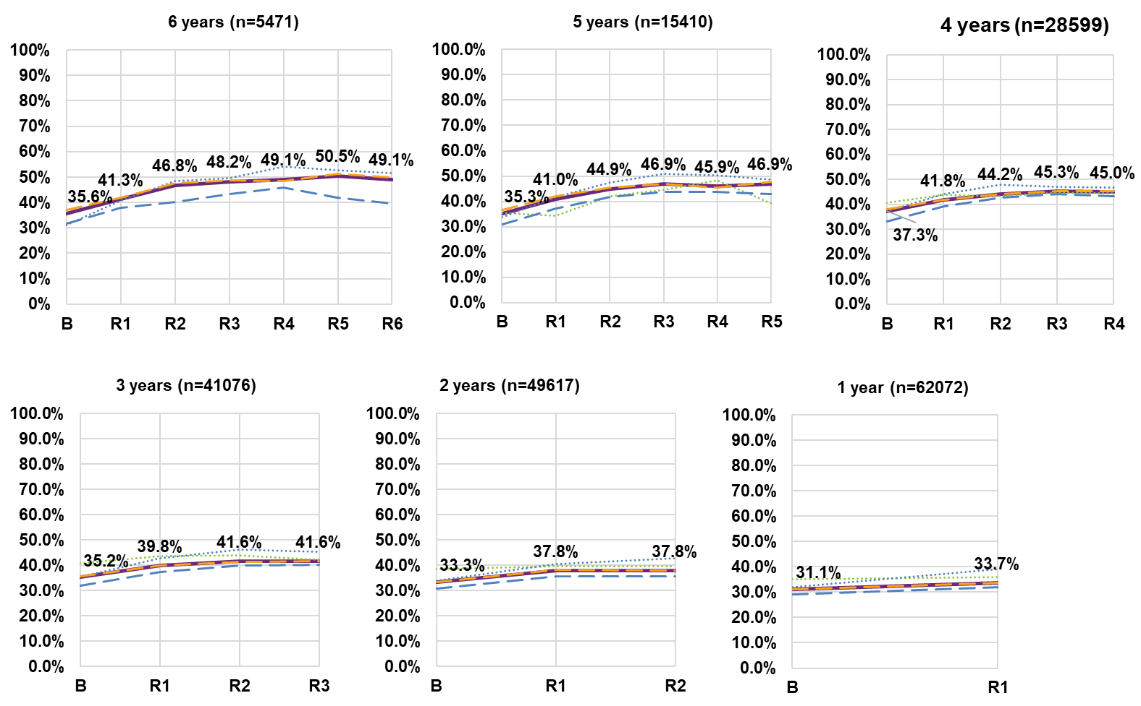
Note: Data labels displayed in the graph relate to the “All” series.
Note: The entire cohort 6 for the S–14/15–25 age group have been omitted as participant numbers are too small.

Actively involved in a community activity in the last 12 months (benchmark)
For PSto14, analyse by time since first in P15to24, otherwise by time in Scheme

Compared to the general Australian population1, a substantially lower percentage of NDIS participants aged 15 and over have been actively involved in a community, cultural or religious group in the last 12 months (across all cohorts). After 6 years, 49.1% of participants report active involvement in a community activity in the last 12 months, which is a 13.5 percentage point increase; however, still well below the population benchmark of 73.7%.
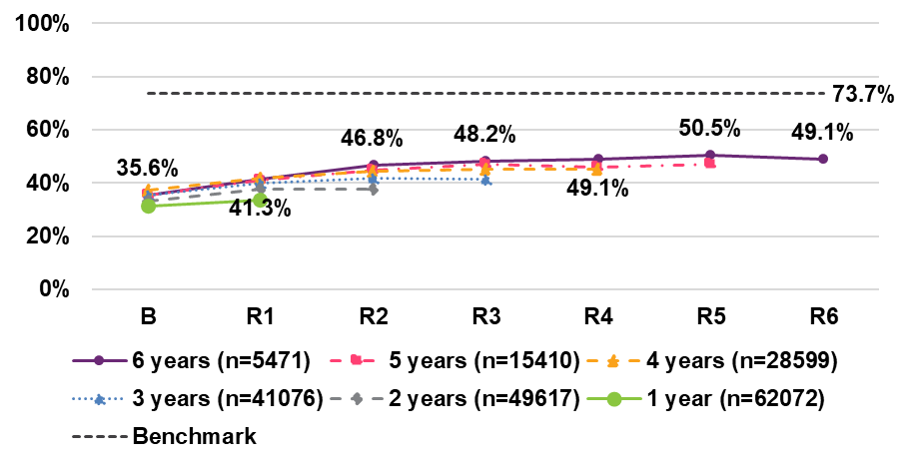

Do you know people in your community?
For PSto14, analyse by time since first in P15to24, otherwise by time in Scheme
The percentage of participants who know people in their community has increased between baseline and latest year for all cohorts. An increase of 7.1 percentage points is evident in cohort 6, while increases of 3.3, 4.2, 4.8, 4.2 and 4.4 percentage points can be seen for cohorts 1, 2, 3, 4 and 5. Some age group differences are:
- There is a slight decrease for the S–14/15–24 age group in cohort 5 – 5.1 percentage points.
- Participants in the 15–24/25+ age group show a slight declining trend for cohorts 4 and 5 – 1.6 and 1.2 percentage points, respectively.
- A higher percentage of participants in the 25+ age group know people in their community – 67.0% at sixth reassessment, compared to 58.8% at baseline. By comparison, 60.4% of the 15–24 age group and 52.0% of the 15–24/25+ age group know people in their community at sixth reassessment.
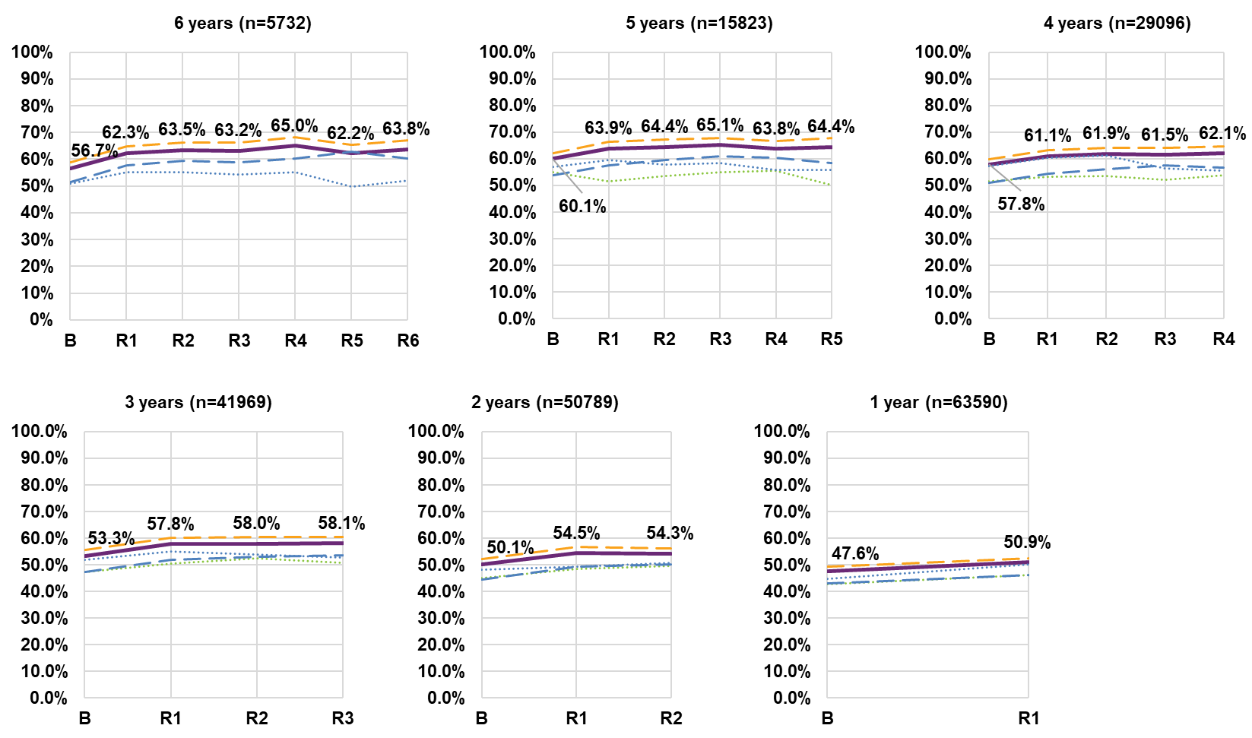
Note: Data labels displayed in the graph relate to the “All” series.
Note: The entire cohort 6 for the S–14/15–25 age group have been omitted as participant numbers are too small

Feel safe getting out and trying new things

For PSto14, analyse by time since first in P15to24, otherwise by time in Scheme
The percentage of participants who feel safe getting out and about in their community has declined slightly over time with a 5.8 percentage point drop between baseline (48.2%) and sixth reassessment (42.4%), for those in cohort 6.
A higher percentage of participants are indicating that they have opportunities to try new things and have new experiences. While there is a large increase for cohort six (49.0% to 74.5%), this is mainly due to sharp increases in the first two years (29.0 percentage points) and a stabilisation between third and sixth reassessment. The general increasing trend appears to be flatter, with improvements across cohorts 1 to 5 of 3.0, 4.1, 4.8, 10.0, 3.8 percentage points, respectively.
% who feel safe getting out and about in their community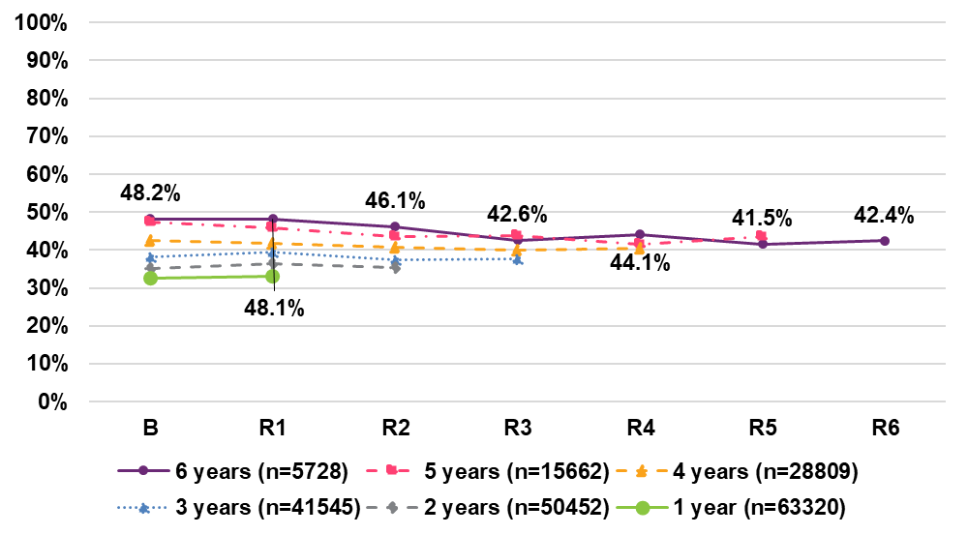
% who have opportunity to try new things and have new experiences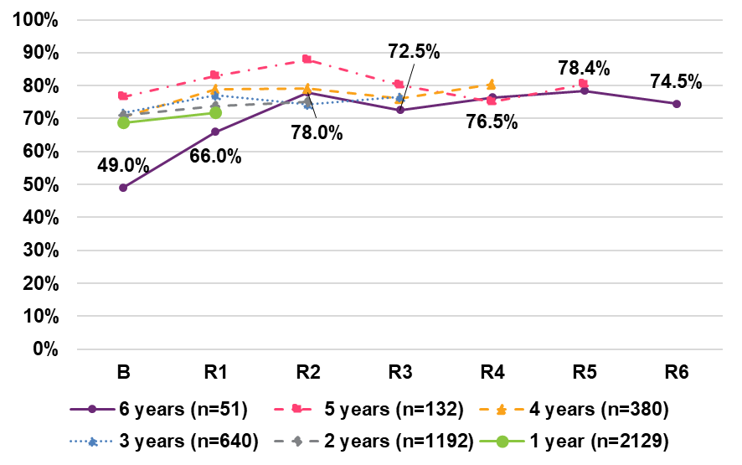

Safety and having a say (benchmarks)

Key long form survey indicators relating to feeling safe walking alone in their local area after dark, and having a say within the general community on issues that are important to them, are improving over time within the Scheme for participants aged 15 and over.
Over six years, there was a 15.7 percentage point increase in feelings of safety, with 37.3% responding positively at sixth reassessment compared to 21.6% at baseline, which includes a 11.8 percentage point increase in the latest two years. While improving, performance against this indicator is below that of the general Australian population (49.9%).
Compared to the general Australian population (58.4%), a substantially lower percentage of NDIS participants aged 15 and over feel that they are able to have a say within the general community on matters that are important to them. Over six years, the percentage reporting positively has increased by 13.7 percentage points to 39.2%, although there is some volatility for intermediate time points due to small numbers.
Cohorts 1 to 5 showed increases of 1.1, 4.2, 6.3, 6.6 and 2.3 percentage points, respectively.

Feel safe walking alone in their local area after dark

Have a say within the general community

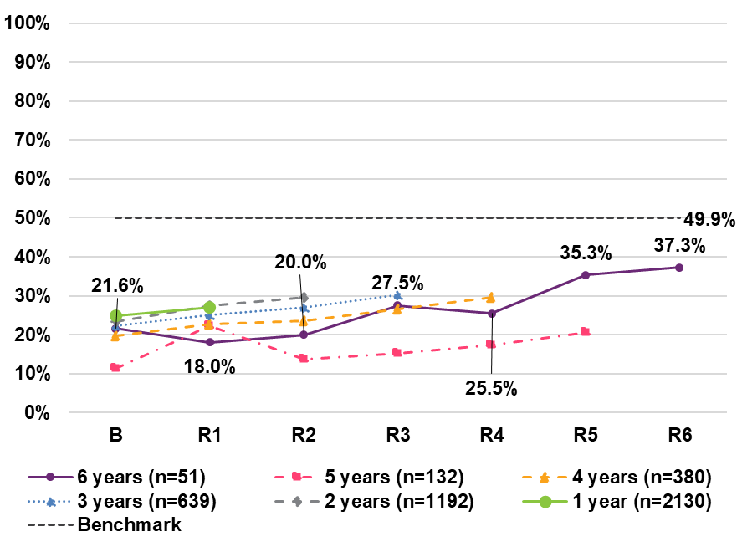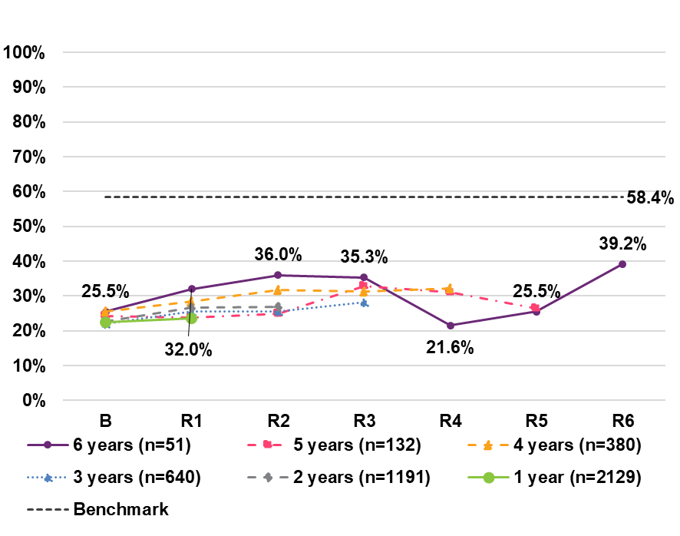
Population benchmark figures are from: Feel safe walking alone in their local area after dark: Australian Bureau of Statistics (ABS), Personal Safety 2021–22, standardised for NDIS participant gender distribution. Have a say within the general community: ABS, General Social Survey (GSS) 2020, standardised for NDIS participant age and gender distribution

% who said there was something they wanted to do in the last 12 months, but could not

For PSto14, analyse by time since first in P15to24, otherwise by time in Scheme
Overall, there has been an increase in the percentage of participants (deterioration in outcome) who say there was something they wanted to do in the past 12 months but could not (across all cohorts). For participants in Cohort 6, there was a 9.7 percentage point increase (deterioration in outcome) from 59.1% at baseline to 68.8% at sixth reassessment.
While still increasing (outcomes deteriorating) over time, a lower percentage of participants in the S–14/15–24 age group reported that there was something they wanted to do in the last 12 but could not (at earlier reassessment periods) – e.g. 64.5% at reassessment 2 (cohort 5), compared with 73.2% for the 25+ age group.
Unlike the other age groups, the 15–24/25+ age group shows a decreasing trend for this indicator (improvement in outcomes) across all cohorts of between 4.0 and 8.2 percentage points. For cohorts 4, 5 and 6, there was an increase at first reassessment followed be a decline for subsequent reassessments. The largest change for this age group was at latest reassessment.

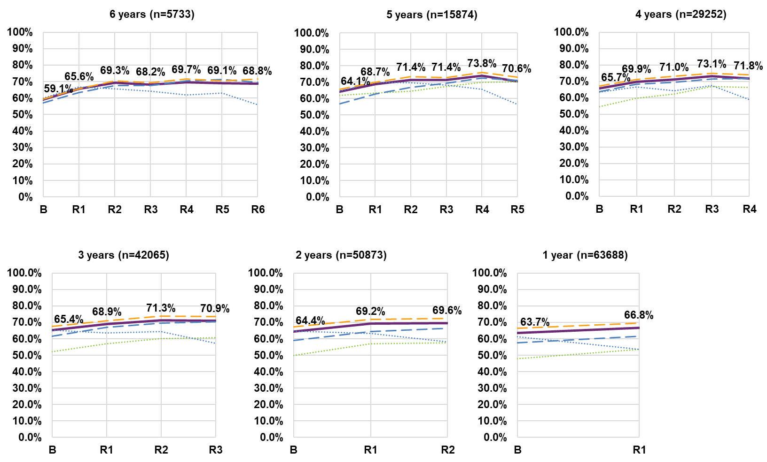

Note: Data labels displayed in the graph relate to the “All” series.
Note: The entire cohort 6 for the S–14/15–25 age group have been omitted as participant numbers are too small.

Employment

% who are currently working in a paid job
For PSto14, analyse by time since first in P15to24, otherwise by time in Scheme
Overall, there has been a slight increase in the percentage of participants aged
15 and over who are in a paid job across all cohorts. However, this result is primarily driven by the 25 and over age groups (15–24/25+ and 25+).
The 15–24 and S–14/15–24 age groups are showing positive changes over time (notwithstanding a much lower baseline percentage) with large increases since baseline for most cohorts. For example, for the 15–24 age group, there was a 16.4 percentage point increase between baseline (9.6%) and sixth reassessment (26.0%).
However, the 25+ age group showed a consistent decline in the percentage of participants working in a paid job of between 1.0 and 5.9 percentage points for cohorts 2 to 6.
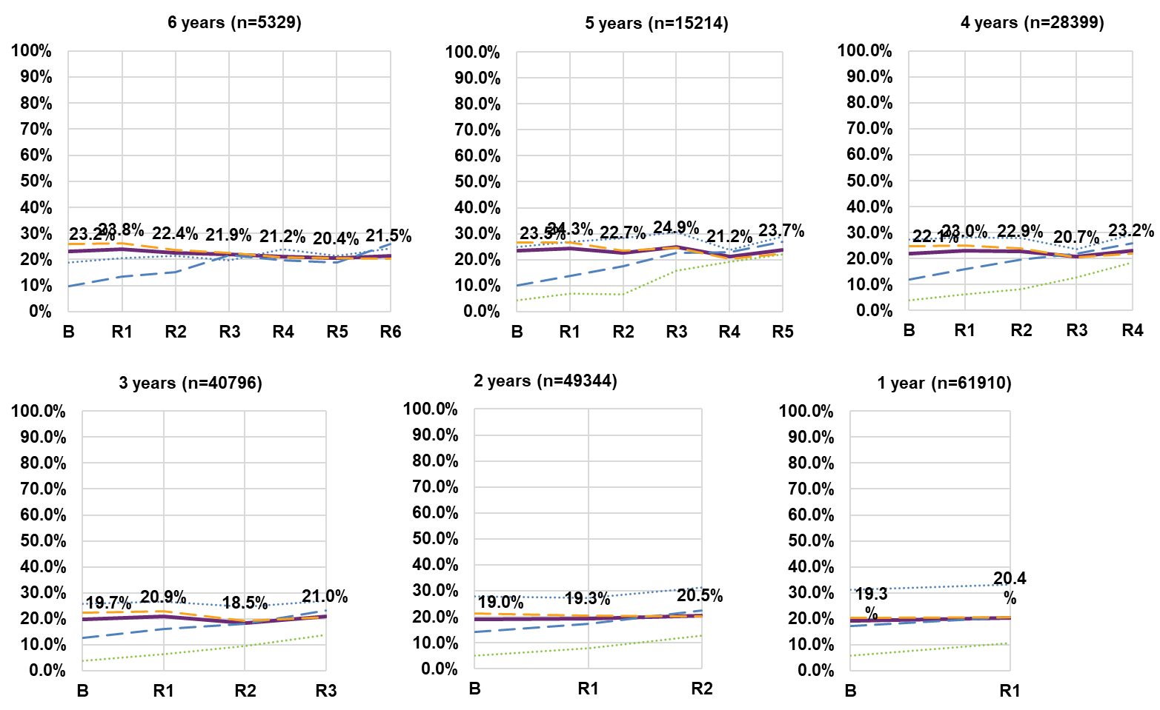

% who are currently working in a paid job, given that they are part of the labour force
For PSto14, analyse by time since first in P15to24, otherwise by time in Scheme
Overall, there has been a slight increase in the percentage of participants aged 15 and over who are currently working in a paid job, given that they are part of the labour force, across all cohorts. For those in cohort 6, the percentage increased by 2.6 percentage points from 47.6% at baseline to 50.2% at sixth reassessment.
All age groups except aged 25+ are showing positive changes over time (notwithstanding a much lower baseline percentage) with large increases since baseline for all cohorts. For example, for the 15–24 age group, there was a 22.6 percentage point increase between baseline (16.8%) and sixth reassessment (39.4%).
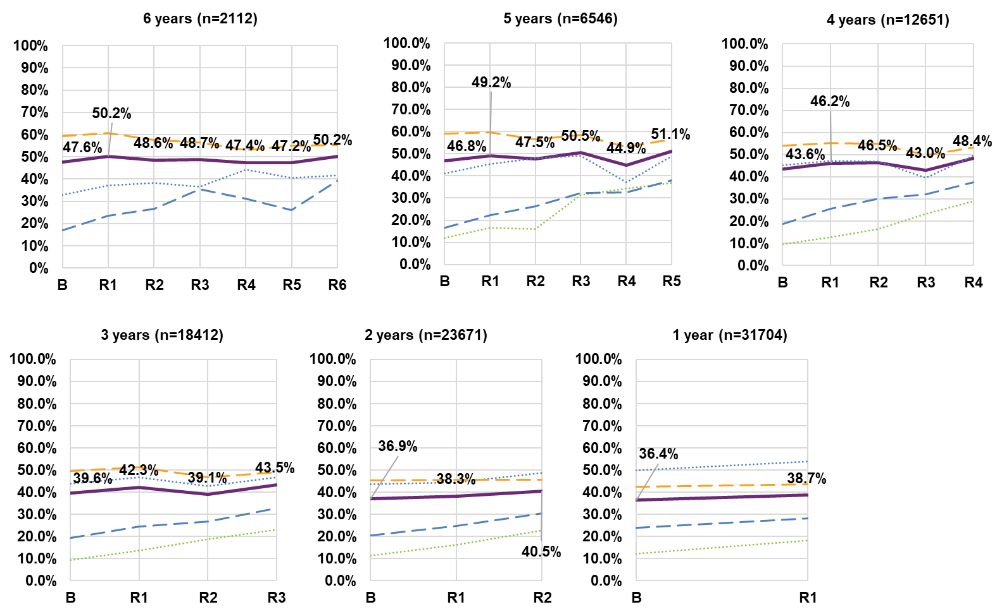
Note: Data labels displayed in the graph relate to the “All” series.
Note: The entire cohort 6 for the S–14/15–25 age group have been omitted as participant numbers are too small.

% who are in the labour force (working or job seeking)
For PSto14, analyse by time since first in P15to24, otherwise by time in Scheme
Overall, there has been a slight decrease in the percentage of participants aged 15 and over who are in the labour force (working or job seeking) for cohort 5 and
6. For those in cohort 6, the percentage decreased by 4.8 percentage points from 52.4% at baseline to 47.6% at sixth reassessment.
The S–14/15–24 and 15–24 age groups are showing positive changes over time with large increases since baseline for all cohorts. For example, for the 15–24 age group, there was a 14.6 percentage point increase between baseline (58.8%) and sixth reassessment (73.4%).
However, the 15–24/25+ and 25+ age group showed a generally declining trend over time, with the former age group declining between 0.9 and 7.9 percentage points and the latter age group declining between 1.7 and 4.1 percentage points. One possible contributor to this deterioration is that participants who struggled to find a job after school may tend to lose motivation and leave the labour force.
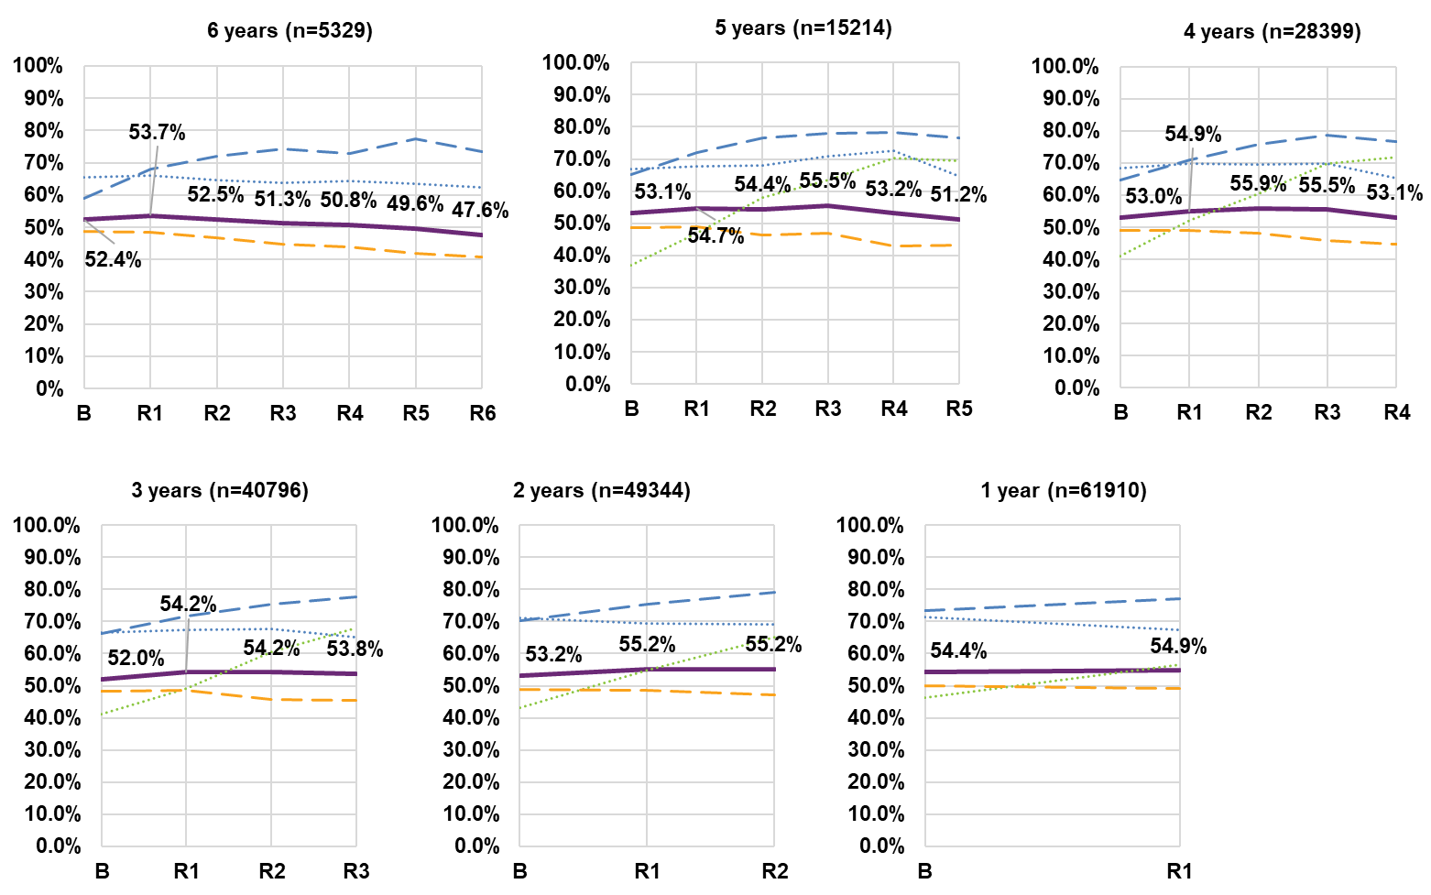
Note: Data labels displayed in the graph relate to the “All” series.
Note: The entire cohort 6 for the S–14/15–25 age group have been omitted as participant numbers are too small.

Of those in a paid job, % working 15 hours or more per week
The percentage working 15 or more hours per week (for those with a paid job) shows an increasing trend. For example, for cohort 6, the percentage increased from 66.5% at baseline to 70.6% at sixth reassessment.
While most age groups improved on this indicator over time, the 15–24 age group had the largest change, with increases of between 6.5 and 40.8 percentage points depending on cohort, likely reflecting the transition from school to work. For participants in the Scheme six years, there was an increase from 18.4% at baseline to 59.2% at sixth reassessment.
The 25+ age group reports the highest percentages of participants working 15 hours or more per week and these remain fairly stable overtime. For those in the Scheme six years, the percentage working 15 hours or more per week at sixth reassessment was 73.2%, compared to 73.0% at baseline.
The S–14/15–24 also had large increases for cohorts 2, 3 and 4 – 19.9, 29.5 and 35.8 percentage points, respectively. However, the overall percentage of participants in this age group working 15 hours or more per week was low (45.3% at fourth reassessment, C4). Many of these participants will still be at school.
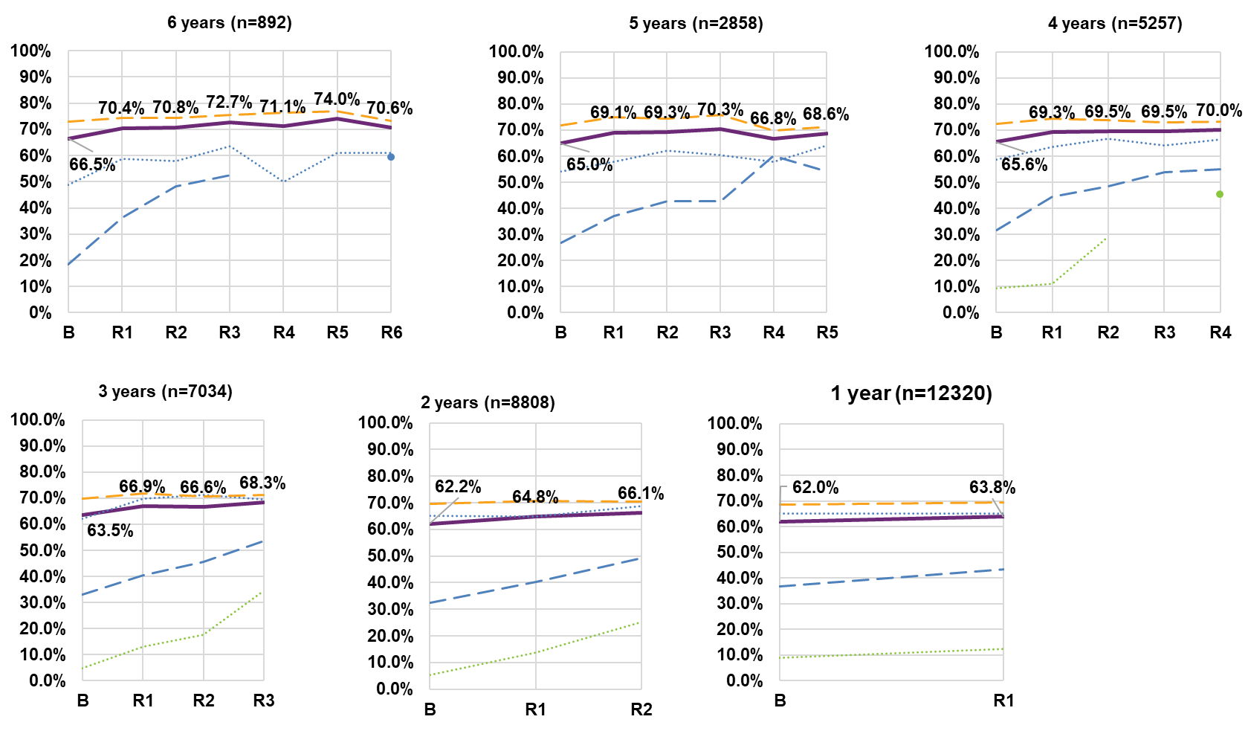
Note: Data labels displayed in the graph relate to the “All” series.
Note: The entire cohort 6 for the S–14/15–25 age group have been omitted as participant numbers are too small.

% who are not working and not looking for work
There is a slight decrease in the percentage of participants aged 15 and over who are not working and not looking for work – for cohorts 1 through 5 (purple line).
In the younger age groups – i.e. S–14/15–24 and 15–24, there is a declining (improvement) trend in the percentage of participants who are not working and not looking for work. For participants in the 15–24 age group and in the Scheme for six years, there has been a decrease of 14.8 percentage points between baseline (62.5%) and sixth reassessment (47.7%). This is consistent for other cohorts.
Larger improvements can be seen for the S–14/15–24, particularly for cohorts 5 and 4, with decreases of 29.0 and 29.5 percentage points, respectively. These trends likely reflect the transition from school to work.
However, there is a small increasing (negative) trend in the 25+ age group (between 0.3 and 6.2 percentage points), whereby a higher percentage of participants report not working and not looking for work between baseline and latest reassessment. Older participants in this group may be retiring from the workforce.
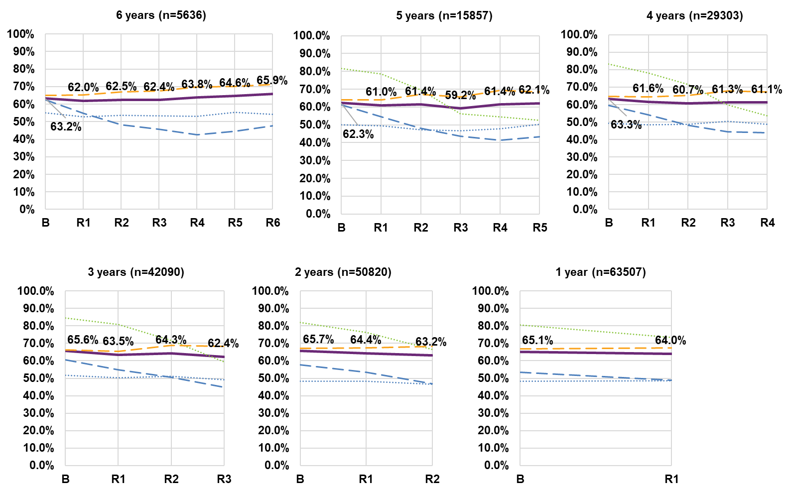
Note: Data labels displayed in the graph relate to the “All” series.
Note: The entire cohort 6 for the S–14/15–25 age group have been omitted as participant numbers are too small.

% who are assisted to get a job
The percentage who are assisted to get a job shows an increasing trend across all cohorts. For example, for cohort 6, the percentage increased from 21.4% at baseline to 33.6% at sixth reassessment.
While most age groups improved on this indicator over time, the 15–24 age group had the largest change, with increases of between 7.8 and 28.2 percentage points depending on cohort. For participants who have been in the Scheme for six years, there was an increase from 12.9% at baseline to 41.2% at sixth reassessment.
The S–14/15–24 also had large increases for cohorts 2, 3, 4 and 5 – 7.9, 13.1, 24.2 and 25.9 percentage points, respectively. Conversely, the 25+ age group had large decreases for cohorts 2, 3, and 4 of 8.9, 7.1, and 1.8 percentage points between the baseline and latest reassessment.
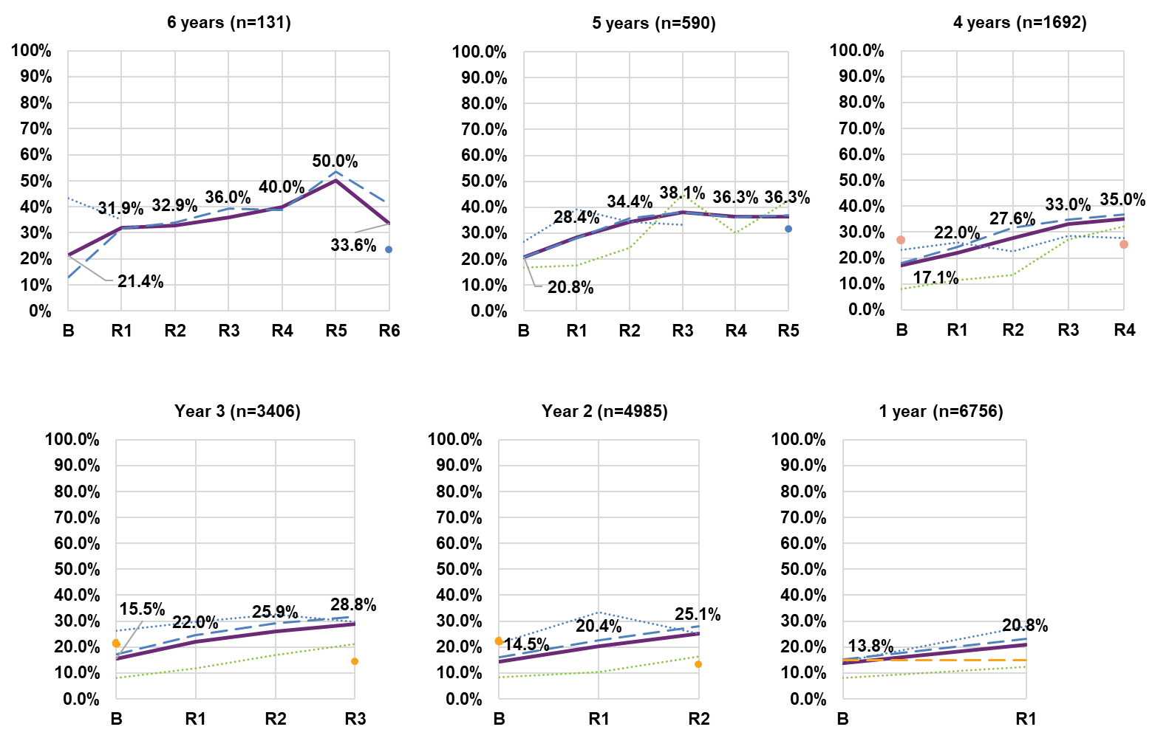Note: Data labels displayed in the graph relate to the “All” series.
Note: The entire cohort 6 for the S–14/15–24 age group, R2 to R5 in cohort 6 and R4 in cohort 5 for the 15–24/25+ age group, the entire cohort 5 and 6 and R1–R3 in cohort 4 and R1–R2 in cohort 3 and R1 in cohort 2 for the 25+ age group have been omitted as participant numbers are too small.

% who get the support they need to do the job
The percentage who get the support they need to do the job shows an increasing trend across all cohorts. For example, for cohort 6, the percentage increased from 74.4% at baseline to 80.3% at sixth reassessment.
While most age groups improved on this indicator over time, the 15–24 age group had the largest change, with increases of between – 2.0 and 11.1 percentage points depending on cohort. For participants in the Scheme six years, there was an increase from 50.0% at baseline to 61.1% at sixth reassessment.
The 25+ age group also had large increases between 3.9 and 6.8 percentage points for cohorts 1 to 6.
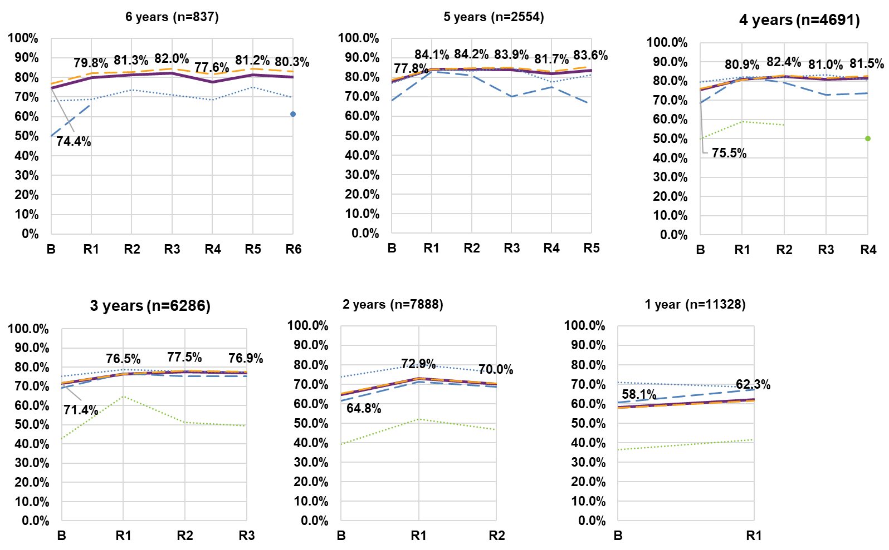
Note: Data labels displayed in the graph relate to the “All” series.
Note: The entire cohort 5 and 6 and R3 in cohort 4 for the S–14/15–24 age group, R2 to R5 in cohort 6 for the 15–24 age group have been omitted as participant numbers are too small.

Benchmarks
Participants’ employment outcomes are generally poorer than for the Australian population. There has been a slight increase in the percentage of participants working in a paid job between baseline and latest reassessment for cohorts 1 through 5. For participants in cohort 6, this has remained at around 22% over the six-year period, which is well below the benchmark employment rate for the general Australian population (72.5%).1 However, as seen previously, participant trends differ by age group, with younger participants showing improved employment outcomes.
Likewise, a lower percentage of participants aged 15 and over work 15 hours or more per week, compared with the general population (93.0%).1 However, there is a slight increasing trend on this indicator.

About 63% of NDIS participants aged 15 and over are neither working nor looking for work, compared to 24.8% of the overall Australian population.

Working in a paid job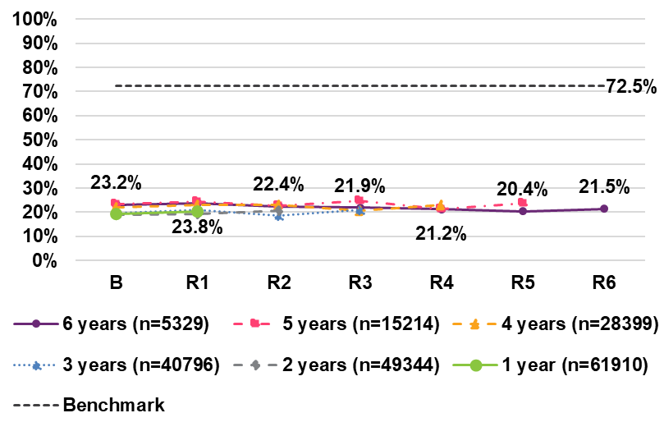
Working 15 or more hours per week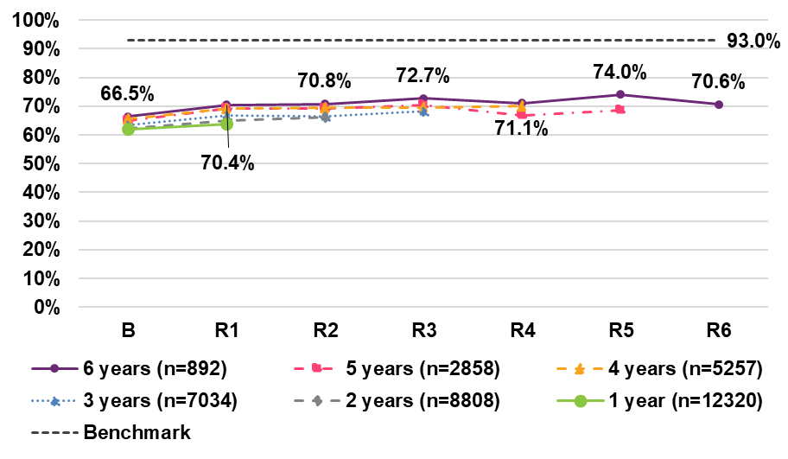

Not working and not looking for work
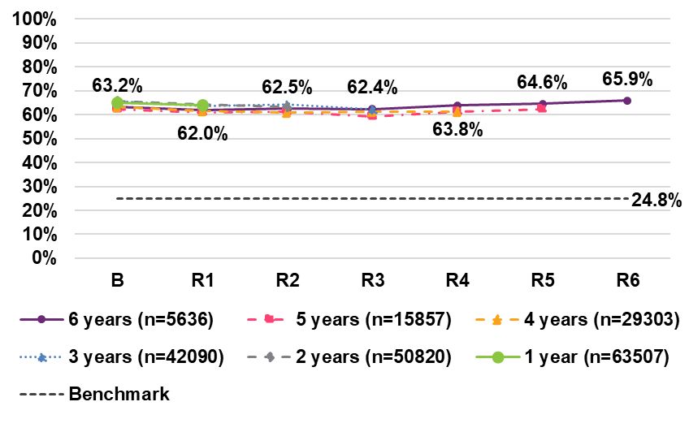

Health and wellbeing
% who have a doctor they see on a regular basis
Across all cohorts, an increasing percentage of participants say they have a regular doctor:
- 8.0 percentage point increase for Cohort 6 from 85.9% at baseline to 93.9% at sixth reassessment
- 6.6 percentage point increase for Cohort 5 from 87.5% (baseline) to 94.1% (fifth reassessment)
- 5.8 percentage point increase for Cohort 4 from 87.7% (baseline) to 93.5% (fourth reassessment)
- 5.4 percentage point increase for Cohort 3 from 86.9% (baseline) to 92.2% (third reassessment)
- 4.4 percentage point increase for Cohort 2 from 85.9% (baseline) to 90.3 % (second reassessment)
- 3.3 percentage point increase for Cohort 1 from 85.3% (baseline) to 88.7% (first reassessment). Overall, most age groups are quite consistent and follow a similar trend.

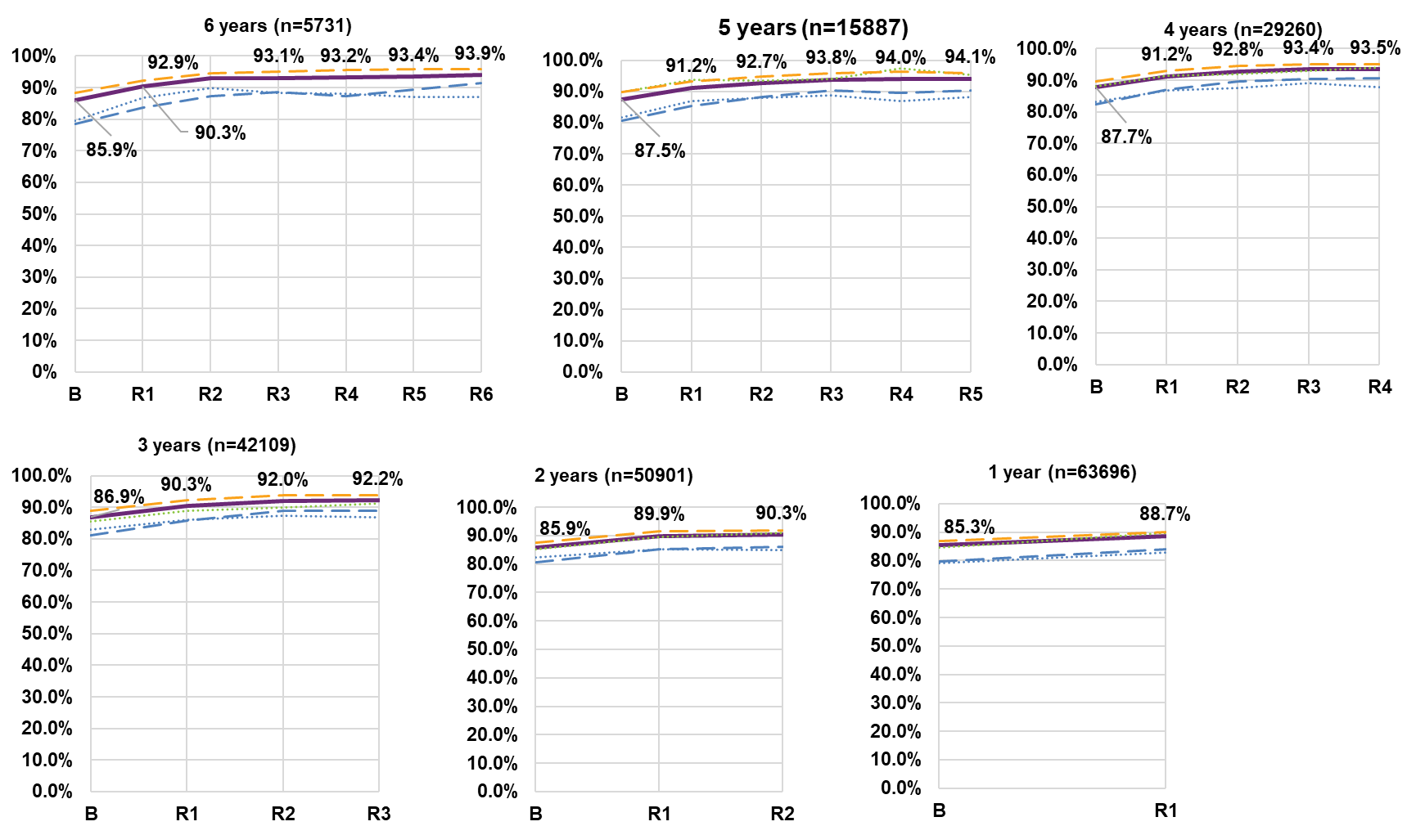
Note: Data labels displayed in the graph relate to the “All” series.
Note: The entire cohort 6 for the S–14/15–25 age group have been omitted as participant numbers are too small.

% who did not have any difficulties accessing health services
Seventy-four percent of participants in cohort 6 reported that they did not have any difficulties accessing services after six years in the Scheme – a 5.2 percentage point increase from baseline (69.0%). This trend is consistent across cohorts, with a smaller change for cohorts 1 and 2.
When age group is considered, a higher percentage of participants in the S–14/15–24 age group report having no difficulties with accessing services across all cohorts (except cohort 5), compared to other age groups. This age group has remained fairly stable over time at around 73% to 81%.

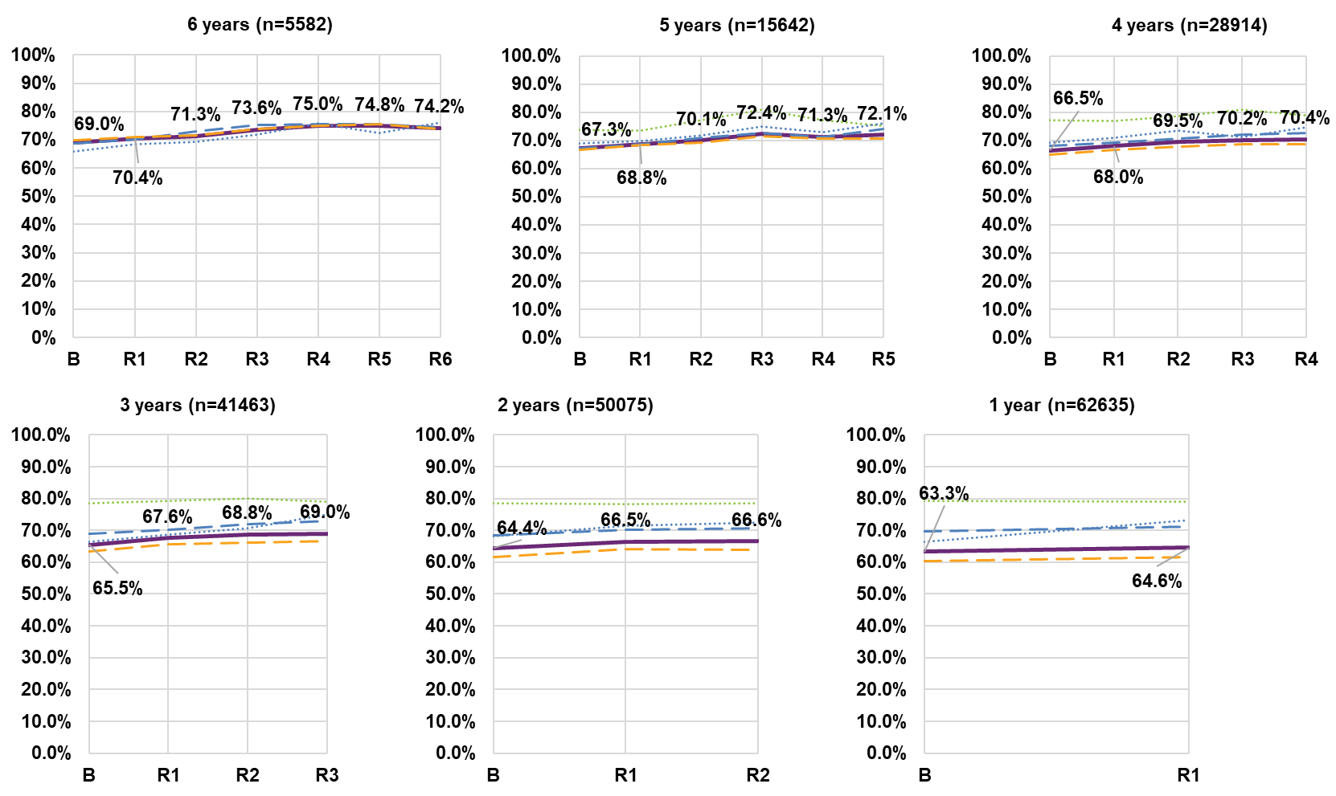
Note: Data labels displayed in the graph relate to the “All” series.
Note: The entire cohort 6 for the S–14/15–25 age group have been omitted as participant numbers are too small.

% who have been to hospital in the last 12 months
Longitudinal data for hospitalisations of participants aged 15 years and over in the last 12 months for Cohort 6 shows a 9.2 percentage point decrease from 39.5% at baseline to 30.3% at sixth reassessment. A similar declining (improving) trend is observed across other cohorts.
The older participant age group (25+) has a higher percentage (across the board)
of respondents who have been to hospital in the last 12 months – for example 34.5% of participants at sixth reassessment (6-years cohort) in the 25+ age group reported going to hospital, compared with 20.4% of the 15–24 age group. Nonetheless, there is still a declining trend for this age group.
The 15–24 and 15–24/25+ age group had the lowest percentage of participants who have been to hospital in the last 12 months – 20.4% (15–24) and 17.4% (15–24/25+) at sixth reassessment (6-year cohort), compared to 34.5% for the 25+ age group.

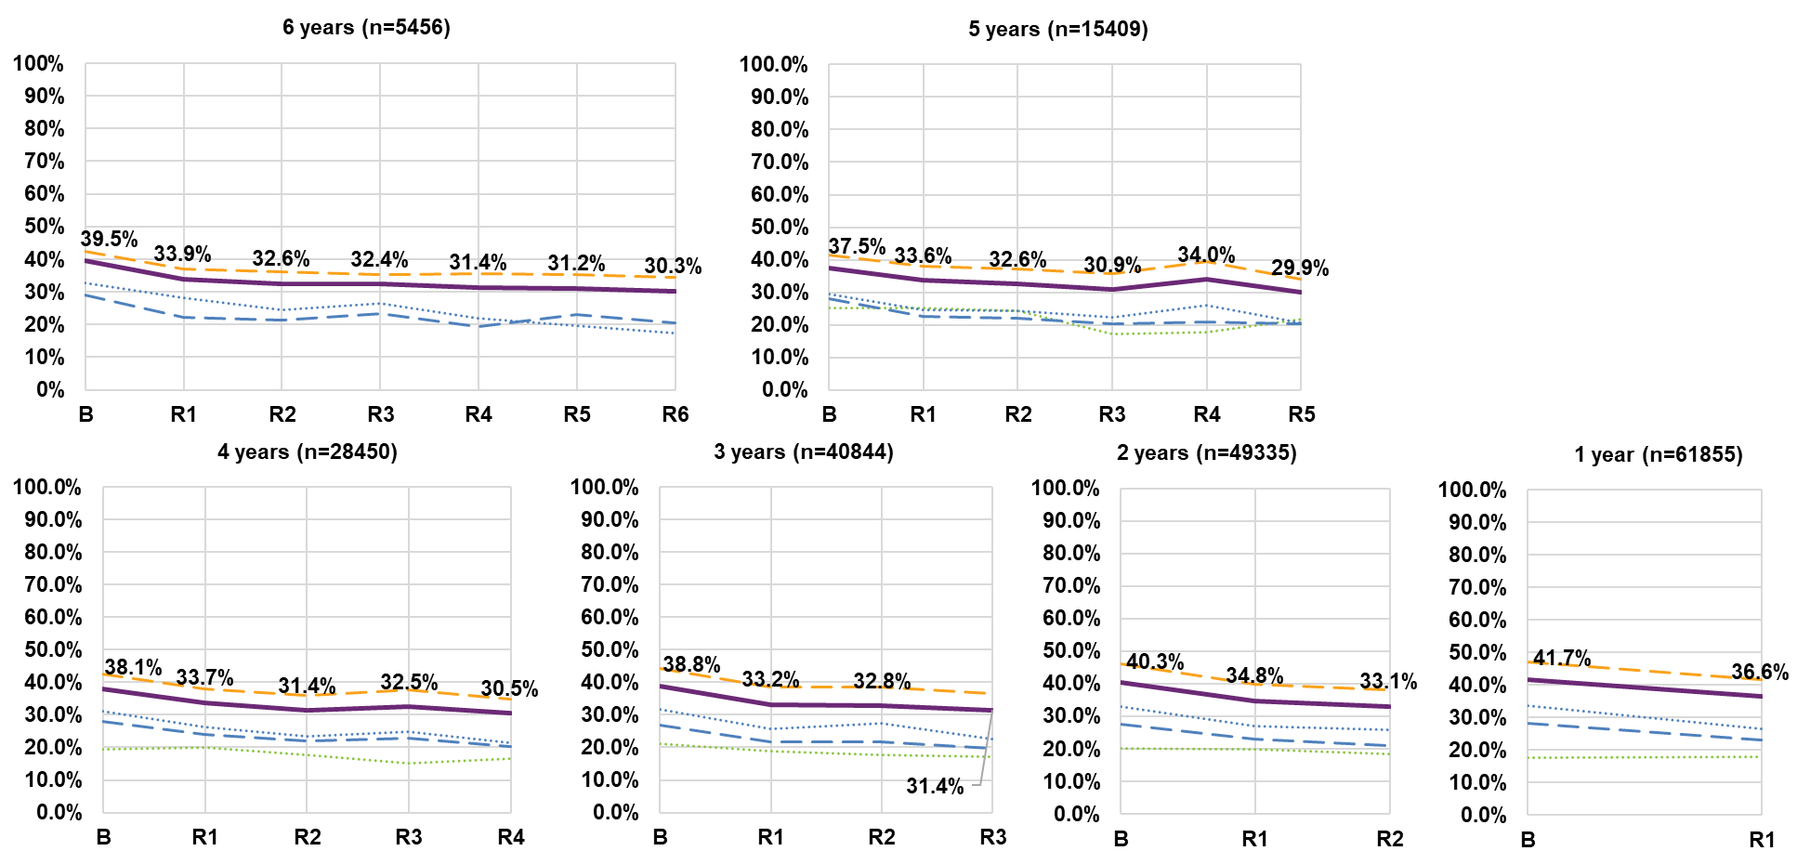
Note: Data labels displayed in the graph relate to the “All” series.
Note: The entire cohort 6 for the S–14/15–25 age group have been omitted as participant numbers are too small.

% who rate their health as excellent, very good or good
The percentage of participants rating their health as excellent, very good, or good has declined slightly over time with a 7.9 percentage point drop between baseline (55.7%) and sixth reassessment (47.8%), for those in cohort 6. However, for this cohort, there has been an increase in the latest year of 1.9 percentage points.
The 25+ age group follows the same trend but has a much lower percentage of participants who rate their health as good or better – e.g. 42.0% at sixth reassessment for cohort 6, compared with 61%–68% for the younger age groups.
Whilst the younger age groups typically report higher percentages of participants who rate their health as good or better, they still experience a declining trend. Earlier cohorts and reassessment periods are generally associated with smaller decreases and in particular, cohort 1 for the 15–24/25+ age group shows a 5.9 percentage point increase at first reassessment.

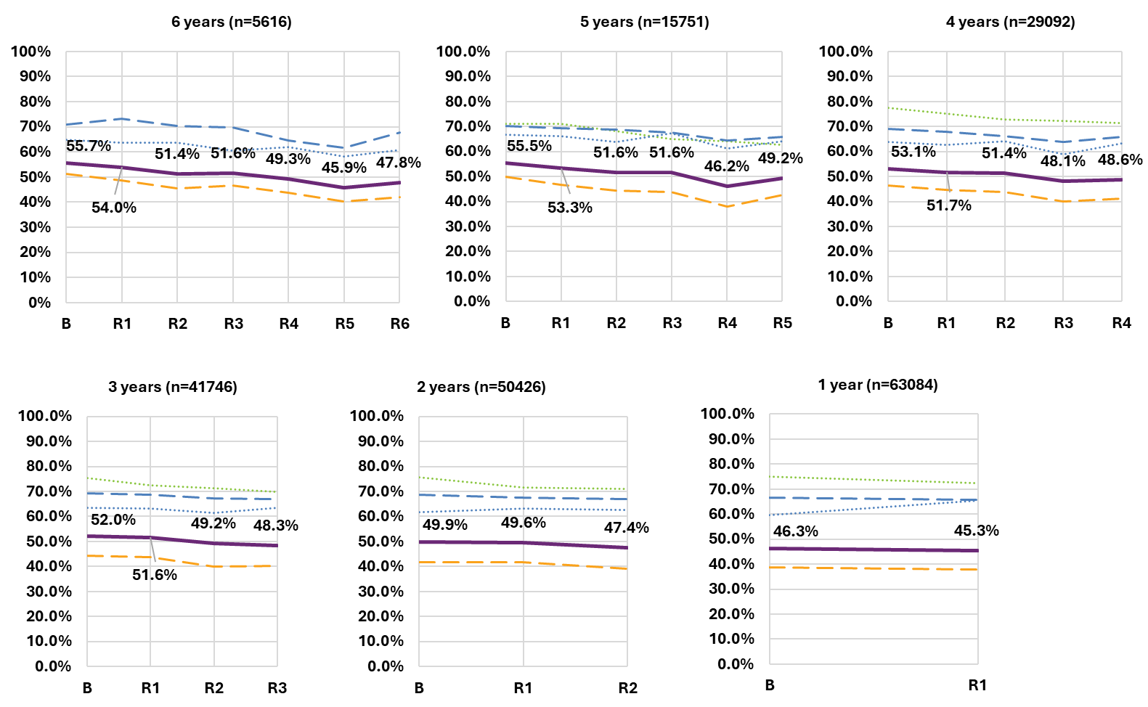
Note: Data labels displayed in the graph relate to the “All” series.
Note: The entire cohort 6 for the S–14/15–25 age group have been omitted as participant numbers are too small.

Self-rated health, regular doctor and hospital visits

Despite improvements in some indicators, participants’ health and wellbeing is generally poorer than for the Australian population, across a number of key
indicators. Participant self-rated health has been deteriorating, both longitudinally (i.e. for a given cohort over time) and cross-sectionally (i.e. later entrants appear to have worse outcomes). Longitudinally, the percentage rating their health as “Excellent”, “Very Good” or “Good” decreased by 7.9 percentage points over six years to 47.8%, compared to 84.6% for the Australian population overall.
However, participants are more likely than the general population to have a regular doctor. There has been a gradual increase in the percentage with a regular doctor, from 85.9% to 93.9% over six years, which is substantially higher than the Australian population average of 68.4%.
The percentage of participants who have attended hospital in the past 12 months decreased over six years from 39.5% to 30.3%. Despite this improvement, the percentage remains higher than for the general Australian population, at 10.3%.

Self-rated health
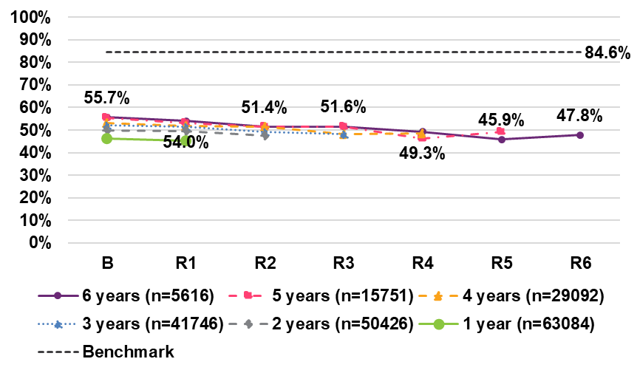
Having a regular doctor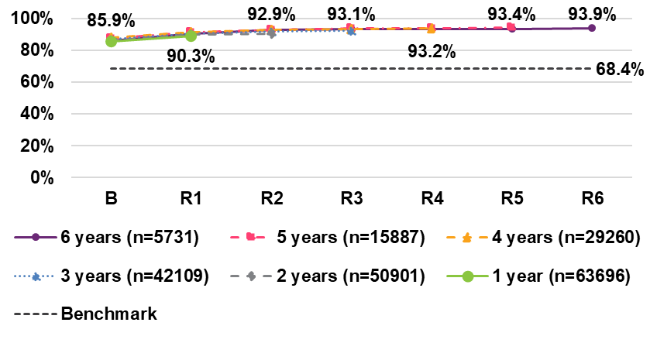
Attended hospital in the last 12 months
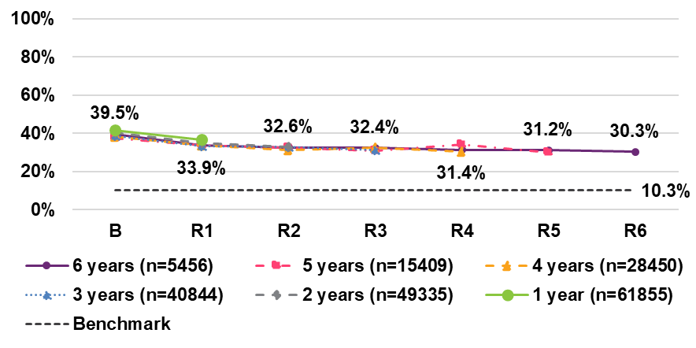

% who felt delighted, pleased or mostly satisfied about their life in general now and in the future
Participant life satisfaction has tended to improve, with an increase of 9.8 percentage points from baseline to sixth reassessment (Cohort 6) in the percentage of participants feeling delighted, pleased or mostly satisfied about their life in general, now and in the future (despite some volatility due to small numbers).
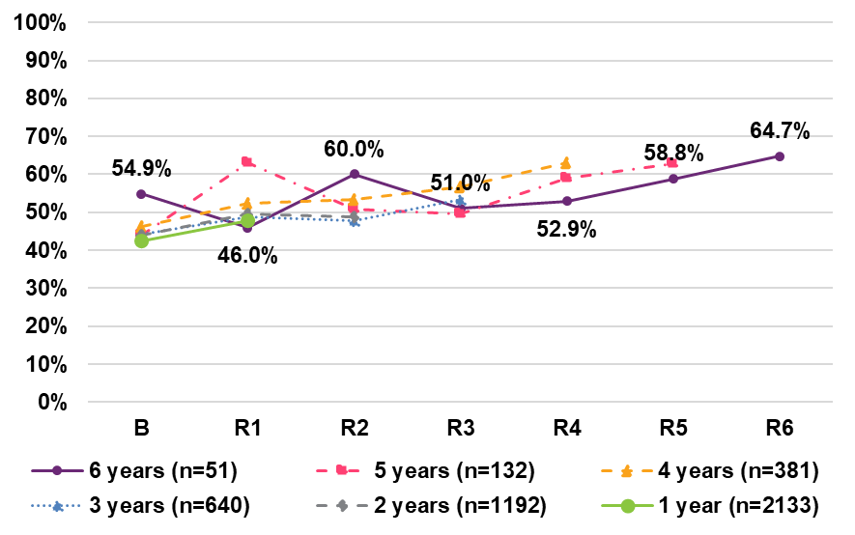

% who have had a flu vaccination in the last 12 months (benchmark)

The percentage of participants receiving a flu vaccination in the past 12 months has increased for all cohorts. For those in cohort 6, the percentage increased from 52.9% at baseline to 80.4% at sixth reassessment, which is more than double the Australian population average of 37.6%.
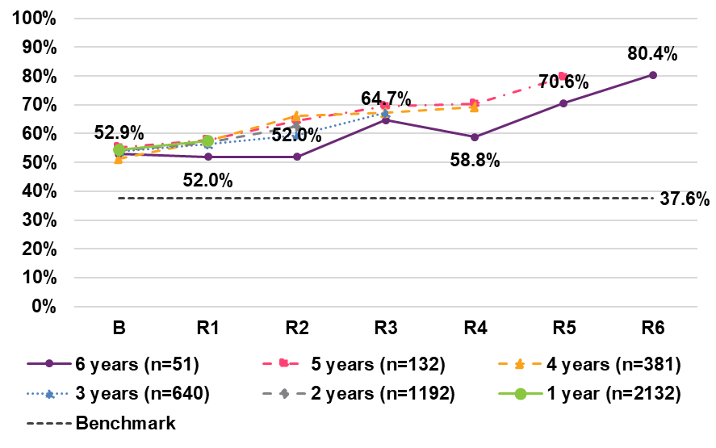

PLIDA data linkage

Methodology
The NDIS participant cohort comprises all distinct participants (linked) who: | The Australian population cohort comprises of all distinct individuals who:
- were part of the scheme during the financial year.  - had age band information reported.  - had disability type information reported.  - had gender information reported. | - were recorded on the Census 2021.  - were not an overseas visitor.  - had age band information reported.

Mental health analysis:
- Focuses on NDIS participants over the past five financial years from FY2018/19, providing a comprehensive view of the trends within this cohort.
- The wider Australian population is limited to two financial years (FY2021/22 and FY2022/23) due to the available Census data. We are relying on Census 2021 data to extrapolate population figures for the Australian population, and assuming consistency in the population numbers for each intervening financial year. This approach does not account for births, immigration, deaths, or emigration during the intervening financial years.
- Therefore, a comparison between NDIS participants and the broader population should be interpreted with consideration for this assumption and potential limitation.
Income analysis:
- Examines the working age population, those aged 15 and over in the NDIS participant and Australian population cohorts.
- Insights are provided for four financial years from FY2018/19 because Australian Taxation Office datasets are only available till FY2021/22.

Mental health analysis

Scheme participants trends
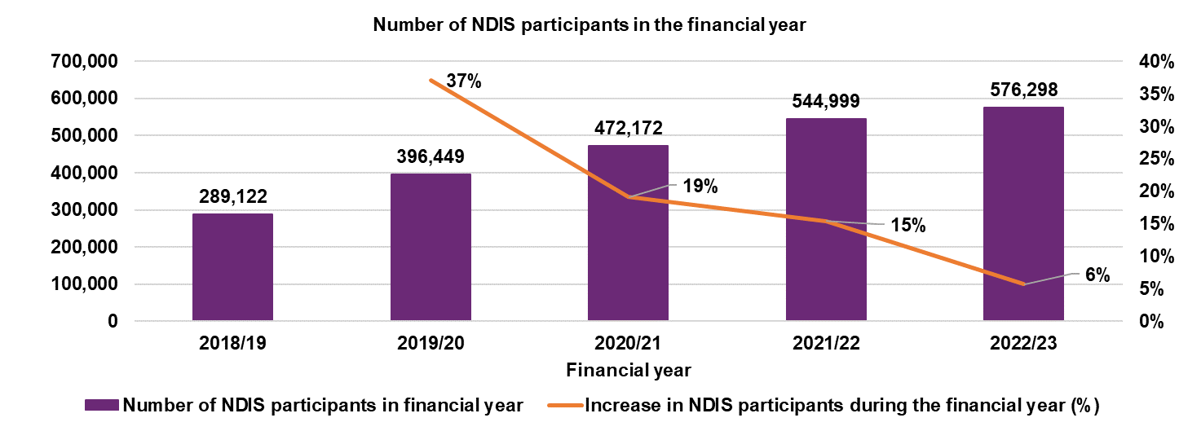
Since FY2018/19, transition to full Scheme has seen:
- the number of active participants almost double
- the relative increase in the number of participants drop each financial year – from a high of 37% in FY2019/20 to 6% in FY2022/23.

Defining Medicare-subsidised mental health services including provider types’
- Medicare-subsidised Mental health-specific services are delivered by psychiatrists, general practitioners (GPs), psychologists, clinical psychologists, other allied health professionals and paediatricians. These services are delivered in a range of settings – for example, hospitals, consulting rooms, home visits, and telehealth – as defined in the MBS.
- Note that Mental health services includes service items that are part of the larger GP services and Allied health services.
- Medicare-subsidised psychiatrist services are provided by psychiatrists on a fee- for-service basis and are partially or fully funded by the Australian Government’s
- Medicare program. These services include patient consultations in various settings, group psychotherapy, telepsychiatry, case conferences, and electroconvulsive therapy.
- Medicare-subsidised GP services are offered by medical practitioners meeting specific qualifications, including vocationally registered practitioners or fellows of recognized medical colleges. GP mental health services encompass consultations by medical professionals, excluding psychiatrists.
- Medicare-subsidised psychologist services are provided by psychologists and are reimbursed by Medicare, covering psychological therapy, focused psychological strategies, and enhanced primary care items.
- Medicare-subsidised allied mental health services are provided by allied mental health professionals like occupational therapists, social workers, and mental health nurses. These services include focused psychological strategies and enhanced primary care, with mental health workers encompassing various professionals, including psychologists. Some psychologist services are included because they cannot be readily separated from the other mental health workers.

Accessing Medicare-subsidised mental health services

Comparison between NDIS participants and Australian population

Since FY2018/19, the proportion of NDIS participants accessing Medicare-subsidised mental health services has been trending downwards from over a quarter of participants in FY2018/19 to 18% in FY2022/23. This decline may be partly due to the increasing proportion of child participants, who are less likely to access mental health services.
By contrast, there has been an increasing trend in the proportion of the Australian population accessing Medicare-subsidised mental health services between FY2011/12 and FY2021/22, from 7% to 11%. The Australian population also experienced a decline in the proportion of individuals engaging with mental health services in FY2022/23 though it was marginal – going from 10.5% in FY2021/22 to 10.3% in FY2022/23.
Over the last two financial years, the proportion of NDIS participants accessing these services has been 1.7 to 1.9 times the proportion for the wider Australian population.
The number of mental health services accessed by NDIS participants increased marginally each financial year from FY2018/19 to FY2020/21, followed by a decline over the next two financial years, reaching its lowest point in the most recent financial year. Similarly, the Australian population also experienced a marginal decline in average number of services accessed over FY2022/23.
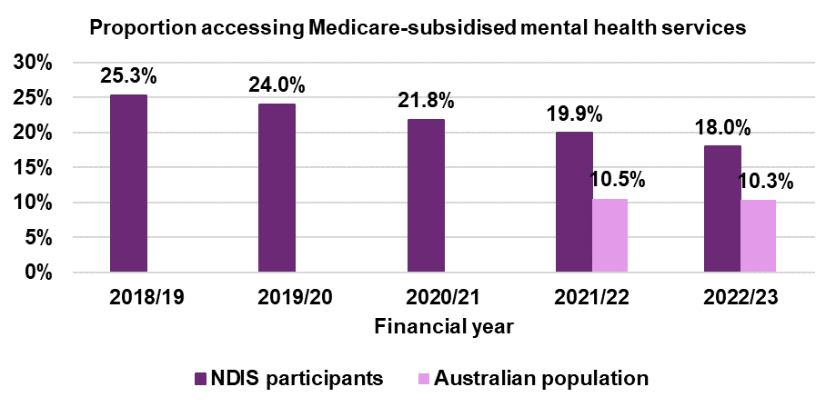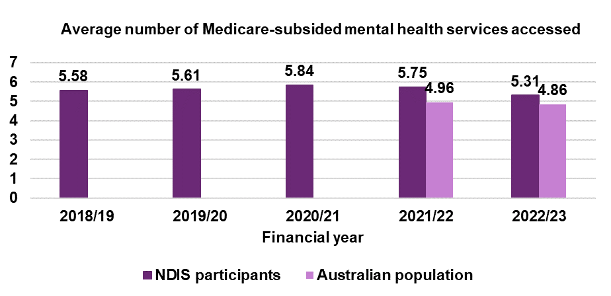

Accessing Medicare-subsidised mental health services (1/2)

NDIS participants
By provider type
Overall, the number of mental health services accessed by NDIS participants has generally been increasing for each provider type over the initial financial years FY2019/20 to FY2021/22 (apart from minor decline in accessing services delivered by Allied Health professionals and Paediatricians). However, declines have occurred in the most recent financial year.
Note that during FY2019/20 through to FY2021/22, restrictions brought on by COVID-19 pandemic led to the introduction of a wide range of additional services to support individuals needing mental health care, such as the expansion of telehealth services and an increase in the number of services that could accessed. These initiatives are likely to have impacted the mental health care landscape.
The distribution of mental health services accessed by provider type has shifted significantly over the last five financial years with the following results:
- The proportion of services delivered by a Psychiatrist has increased considerably, and now comprises nearly 48% of all services accessed, up from 36% in FY2018/19.
- In contrast, the proportion of services delivered by a Psychologist (and/or Clinical Psychologist) has declined from 37% in FY2018/19 to just over a quarter in FY2022/23.
- Participants’ access to services provided by GPs has generally remained steady at 22% to 23%, likely reflecting the pivotal role they play as the initial point of contact for many individuals seeking mental health care.
- There has been a declining trend in the proportion of services delivered by a Allied Health professional or Paediatrician –from 4.7% in FY2018/19 to 3.0% in FY2022/23.

Accessing Medicare-subsidised mental health services (2/2)
NDIS participants
By provider type
Proportion of mental health services accessed by provider type
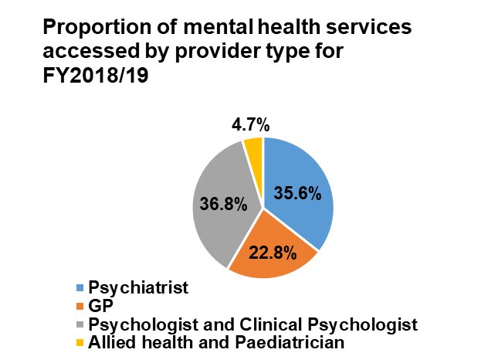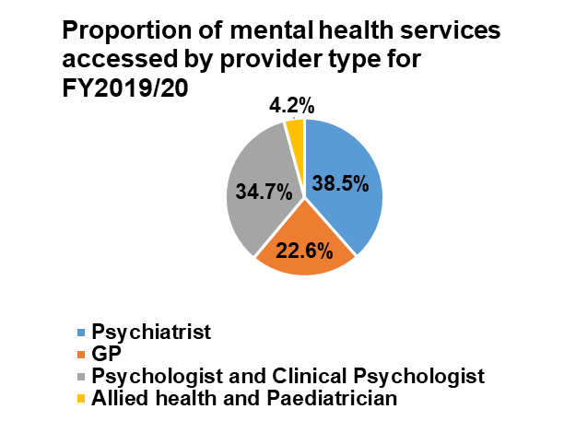

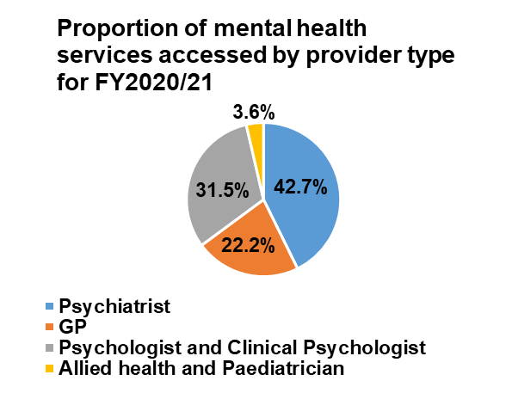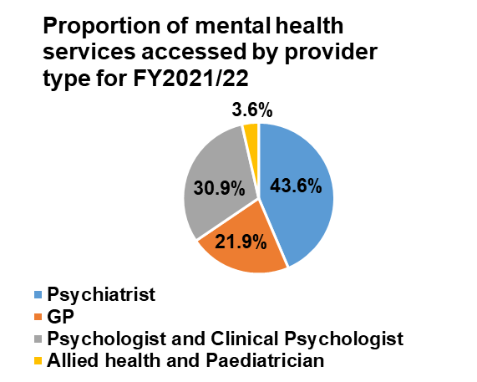

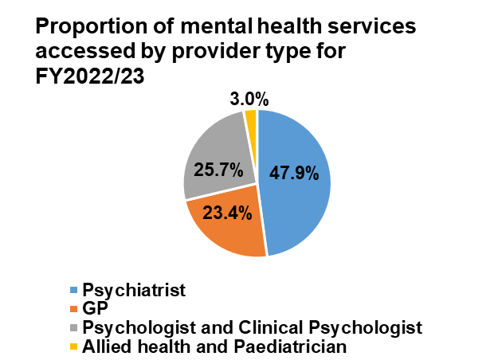
Change in accessing mental health services by provider type
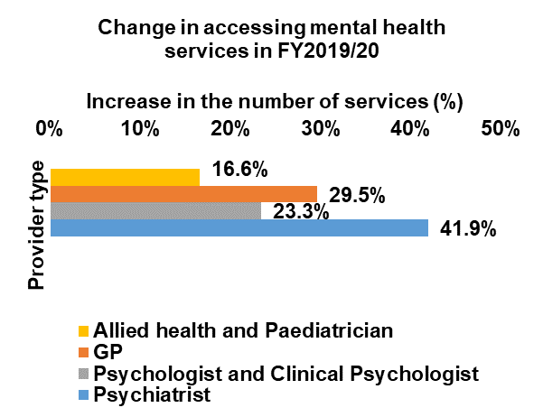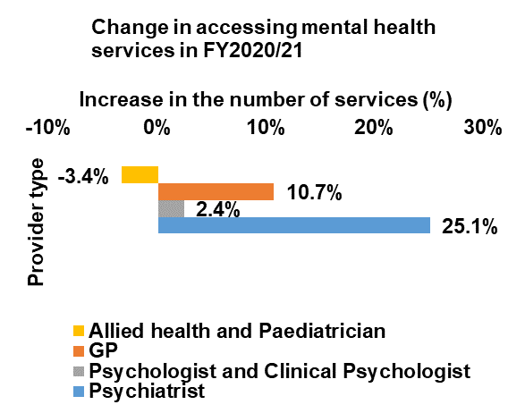

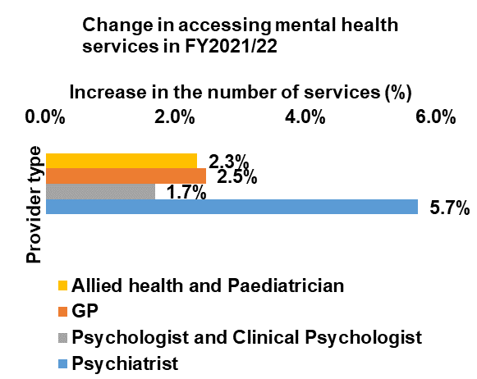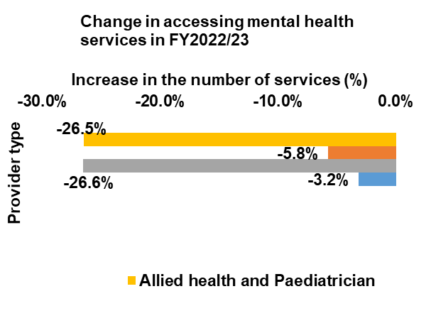

Accessing Medicare-subsidised mental health services
Australian population
By provider type
During FY2022/23, the number of mental health services accessed by the Australian population declined for each provider type. All provider types experienced a decline of over 4.5 percentage points except those services which were provided by a Psychiatrist (fell by 0.4 percentage points).
The distribution by provider type was similar in the two financial years. The proportion of services provided by a Psychiatrist increased by 0.8 percentage points in FY2022/23, while the proportions provided by all other provider types experienced marginal decreases (0.1 to 0.5 percentage points) over the financial year.
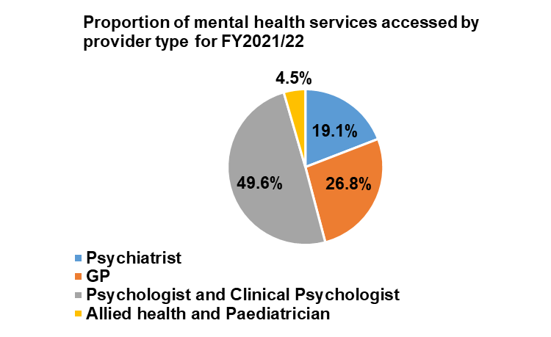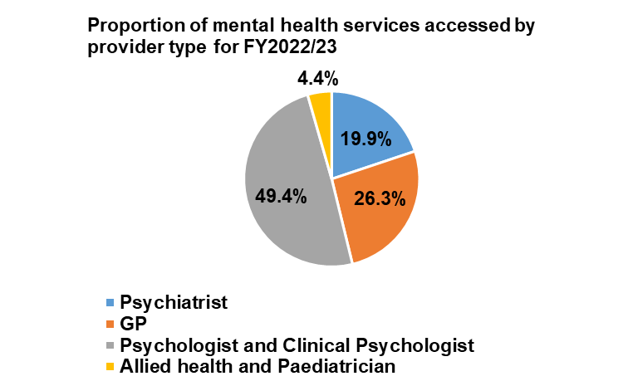

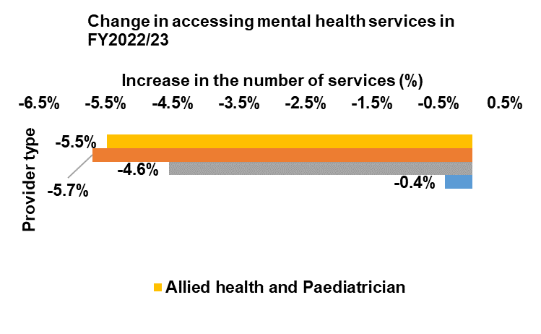
Comparison between NDIS participants and Australian population
Using a Psychiatrist
The proportion of NDIS participants accessing Psychiatrist-provided mental health services has remained at around 8.5% from FY2018/19 to FY2020/21, with a drop in the last two financial years to 7.6% in FY2022/23. These proportions are much higher than for the Australian population. From FY2014/15 to FY2021/22, the proportion
of the Australian population accessing Psychiatrist-provided mental health services remained steady at around 2%. The data for the Australian population for the last two financial years show that the proportion continues to remain at around 2.0%.
The average number of services accessed through Psychiatrist by NDIS participants showed marginal increases over FY2019/20 and FY2020/21, followed by declines in the last two financial years. Similarly, the average number of consultations
decreased slightly in the last financial year for the Australian population. The decline in recent financial years may be partially attributed to the easing of restrictions and reduction in government support.
Across the last two financial years, NDIS participants’ tendency to consult Psychiatrist was almost four-fold compared to the Australian population. Moreover, NDIS participants, on average, attend an extra session with Psychiatrist compared to the Australian population.

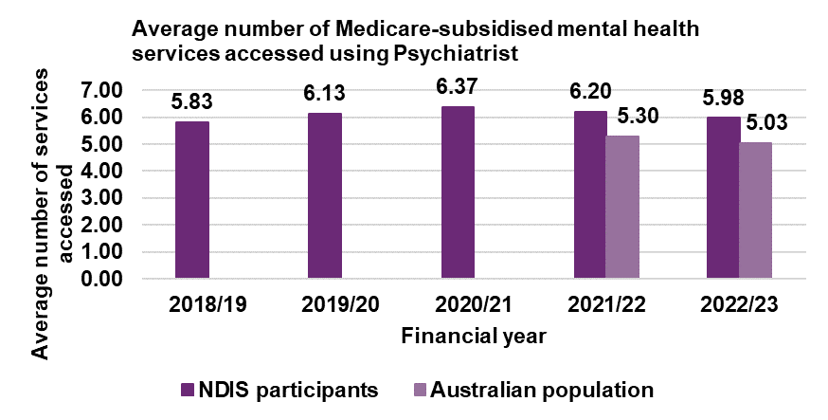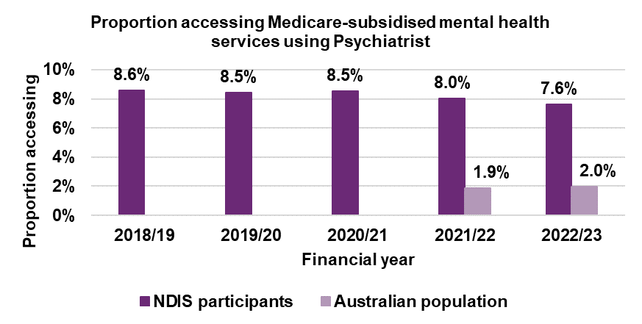

Comparison between NDIS participants and Australian population
Using a GP
The proportion of NDIS participants consulting a GP for their mental health services decreased by over 5 percentage points over the past five financial years. The decline among NDIS participants could be partly due to participants seeking support directly from mental health professional rather than their GP. In contrast, Australian population access to GP-provided mental health services increased from 6% in FY2011/12 to around 9% in FY2018/19, after which it remained steady to FY2021/22. The Australian population experienced a marginal decline in the proportion of individuals engaging GP services during the last financial year.
In the past three financial years, the average number of GP mental health services used by NDIS participants has been steady at approximately 2 sessions, after rising slightly in FY2019/20 and FY2020/21. However, a marginal decrease has been observed for the Australian population in the latest financial year, with the average number of GP mental health services declining from 1.65 to 1.61 sessions. It is likely that both NDIS participants and the broader Australian population tend to rely on GP referrals to access Medicare benefits for subsequent consultations with mental health specialists.
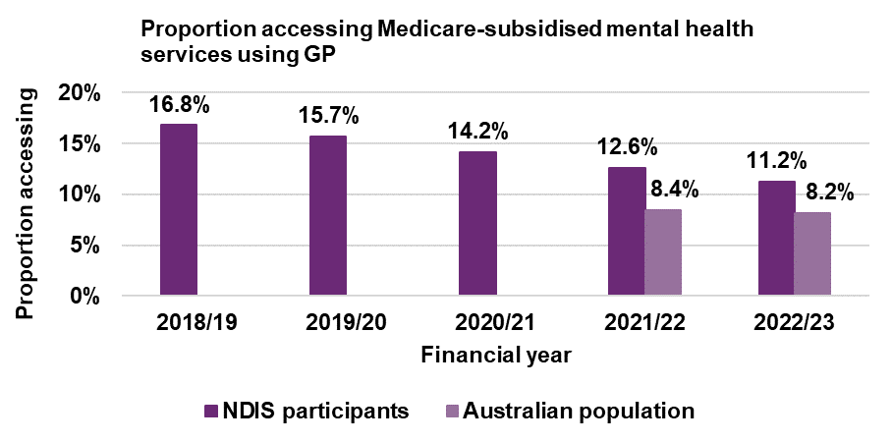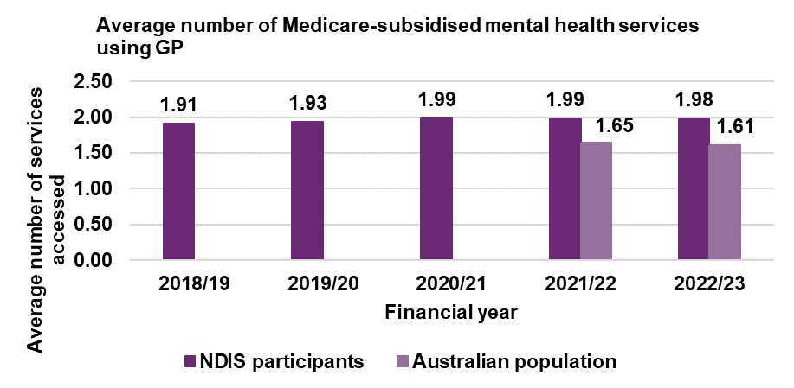

Comparison between NDIS participants and Australian population
Using a Psychologist
Over the past five financial years, the proportion of NDIS participants consulting a Psychologist (including Clinical Psychologist) has seen a notable decline, falling from 11.0% in FY2018/19 to 4.7% in FY2022/23. This downward trend among NDIS participants could be due to a changing mix of severities and types of disabilities, difficulties accessing Psychologist services, switching to other types of services such as Psychiatrist, or other factors.
Meanwhile, the proportion of the broader Australian population consulting a Psychologist decreased very slightly in the last financial year, from 4.8% to 4.7%. Consequently, the proportion consulting Psychologist (including Clinical Psychologist) was the same for NDIS participants and the Australian population in FY2022/23, at 4.7%. Again, the wider Australian population results are generally in line with AIHW Medicare-subsidised mental health-specific services report which showed that population access to Psychologist-provided mental health services remained steady at around 5% from FY2015/16 to FY2021/22.
The average number of Psychologist (including Clinical Psychologist) mental health services accessed by NDIS participants increased from FY2019/20 to FY2021/22, followed by a modest decline. For the Australian population, the average number of Psychologist (including Clinical Psychologist) consultations decreased slightly in the latest financial year. Nonetheless, over the past two financial years, the average numbers of consultations for NDIS participants and the Australian population have been consistent.

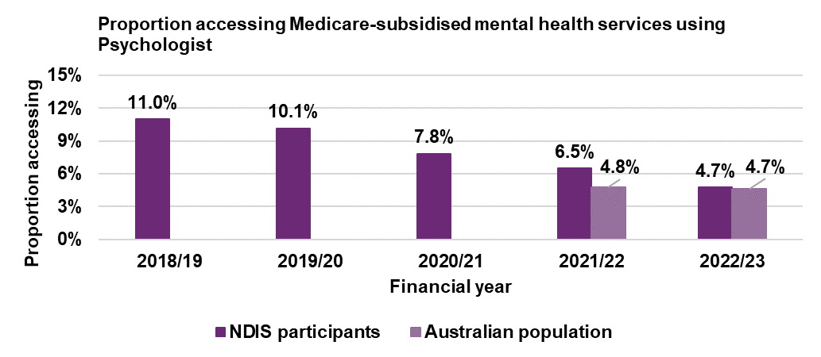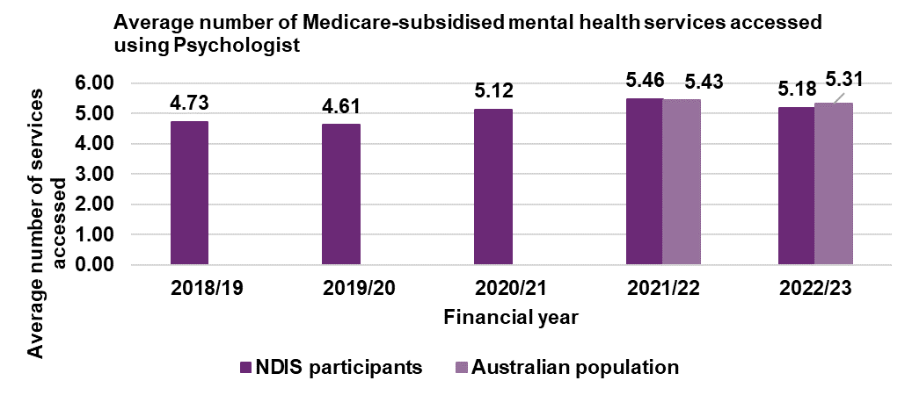

Comparison between NDIS participants and Australian population
Using an Allied health professional or Paediatrician
Allied health professional or Paediatrician has decreased to 0.6% over the past five financial years. Meanwhile, the proportion of the Australian population seeking mental health care from Allied health professionals or Paediatrician during the last financial year remained steady. Notably, in FY2022/23, the proportion of individuals accessing Allied health professionals or Paediatricians for mental health care needs was nearly identical between NDIS participants and the Australian population.
NDIS participants progressively increased their visits to Allied health professional or Paediatrician each financial year until FY2021/22, after which there was a slight decline. Similarly, the average number of Allied health professional or Paediatrician consultations decreased slightly for the Australian population in the most recent financial year. However, over the past two financial years, the average number of consultations between NDIS participants and the Australian population has been consistent, indicating a comparable level of Allied health professional or Paediatrician support required for both cohorts.

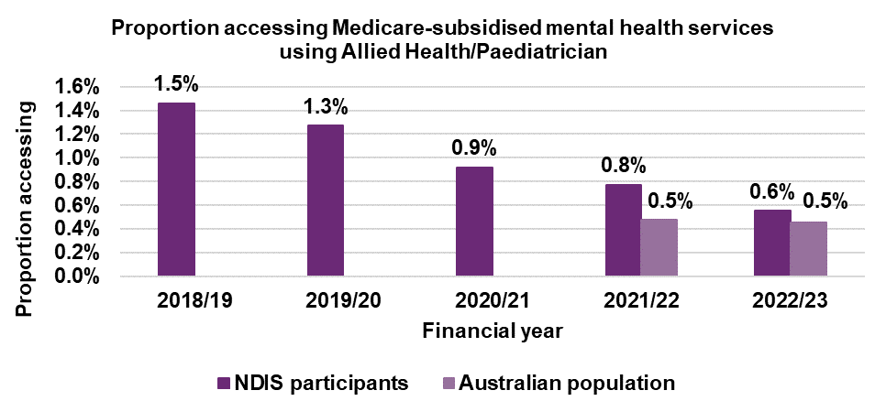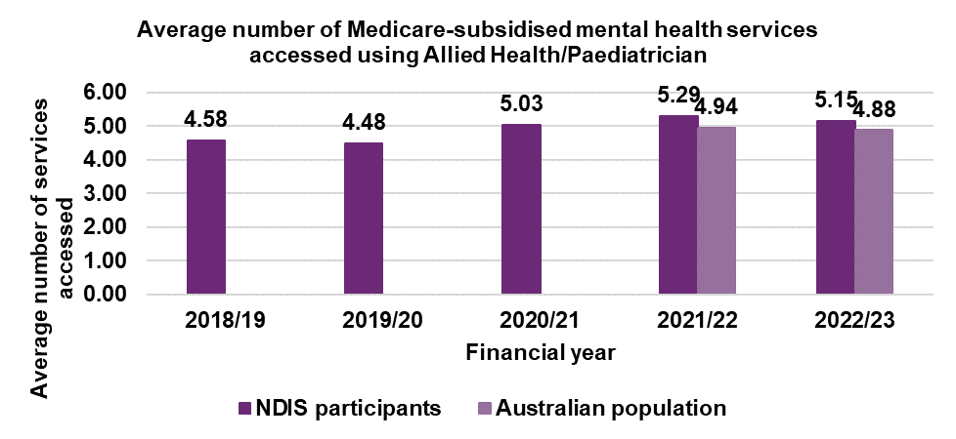

Gross income and taxpayer analysis

Age distribution of Scheme participants over time
For the subset of participants aged 15 and over:

- The proportion of participants aged 45 to 64, which comprises the largest proportion of the working-age group in the scheme, has experienced the largest decrease among all age bands over the four financial years, declining by nearly
- 3 percentage points. This decline is likely due to a combination of factors, including a diminishing rate of new entrants joining the Scheme within this age band
- over time (net increases range from a high of 30.1% in FY2019/20 to 9.5% in FY2021/22) and many participants transitioning into the 65 and over age group.
- Due to the age eligibility rules, the proportion aged 65 and over is lower but has been increasing at a faster rate than for other age groups, as participants age in the Scheme. In FY2021/22, this age group accounted for over 7% of the NDIS participant population.
- The change in proportion of NDIS participants within age bands 15 to 24 and 25 to 44 was minimal over the four financial years with the 15 to 24 age band increasing by just 1 percentage point and the 25 to 44 age band decreasing by just over 1 percentage point.
- Potential for significant growth exists in the proportion of participants aged 15 to 24 in subsequent financial years. With the below 15 age cohort currently accounting for over 40% of all participants in the scheme, a substantial transition into the older cohort is anticipated in the future.
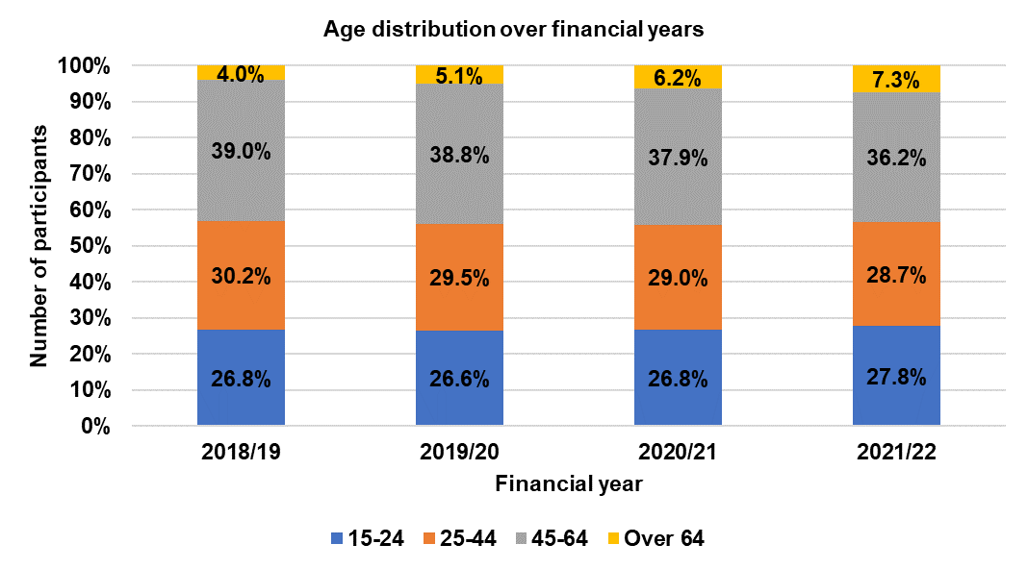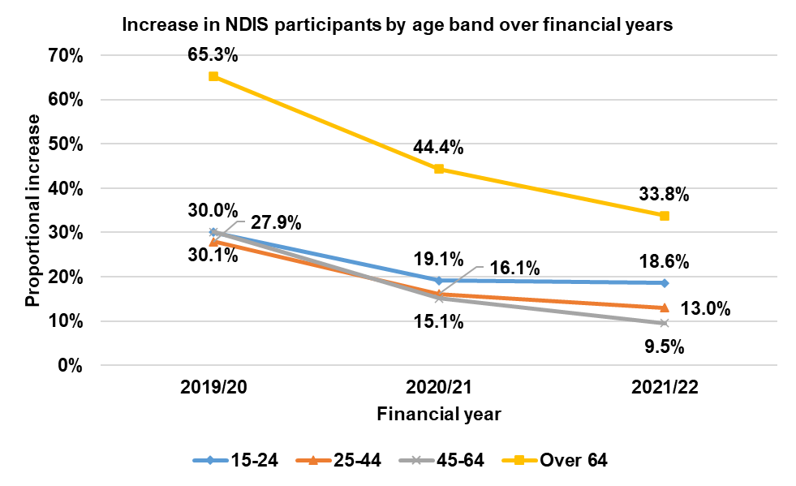

Defining ‘gross salary’ and ‘taxable income’
Gross salary is the total amount of earnings received by an individual, including all forms of remuneration, such as wages, salaries, bonuses, allowances, overtime pay, and any other payments received for services rendered. However, it excludes other sources of income such as investment income, business profits, rental income, and any other earnings not directly related to employment.
In the analysis, the gross salary amount is determined through two datasets: Australian Taxation Office’s Personal Income Tax (PIT) and Payment Summary datasets. In cases where a gross salary amount is provided in the PIT dataset, that value is utilised. If the gross salary amount is null in the PIT dataset, we then refer to the Payment Summary dataset, provided a value is present. It is important to note that a gross salary amount with a value of zero or null indicates that the individual did not receive any gross salary during the financial year.

Net tax amount refers to the total amount of tax owed by an individual or entity after deductions, offsets, and tax credits have been applied to their taxable income. It represents the final tax liability that must be paid to the Australian government.
Taxable income includes various types of income, such as wages, salaries, bonuses, allowances, tips, business income, rental income, investment income, and any other earnings received during the financial year. Additionally, taxable income may also include certain government payments, such as pensions and allowances, and some superannuation benefits. Deductions may include work-related expenses, self-education expenses, charitable donations, and other allowable deductions.
In the analysis, the net tax amount is determined through Australian Taxation Office’s Withheld Debt dataset. If a net tax amount is provided i.e., not null then it is utilised. A null net tax amount indicates that the individual has not paid any tax during the financial year.

Comparison between NDIS participants and Australian population
Percentage of gross salary earners over time
By financial year
The proportion of NDIS participants aged 15 years and above, who earned a gross salary amount through the financial year, remained relatively stable around 24% from FY2018/19 to FY2020/21. The 2021/22 financial year saw an increase to just over 25%.
The NDIS population result for FY2021/22 is still much lower than the Australian population result which showed over 62% of the wider Australian population aged 15 years and above earned a gross salary amount during FY2021/22.
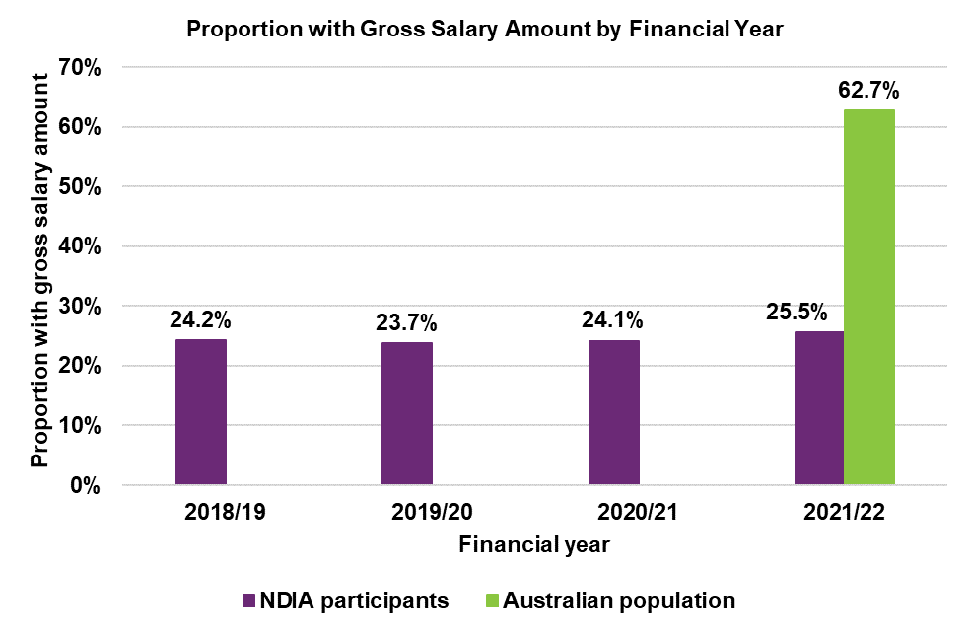

NDIS participants

Percentage of gross salary earners over time
By financial year and age group
Over the four financial years, the proportion of NDIS participants aged 15 to 24 earning gross salary has risen from 22% in FY2018/19 to over 28% by FY2021/22. This suggests that younger participants are increasingly engaging in some level of employment activity.

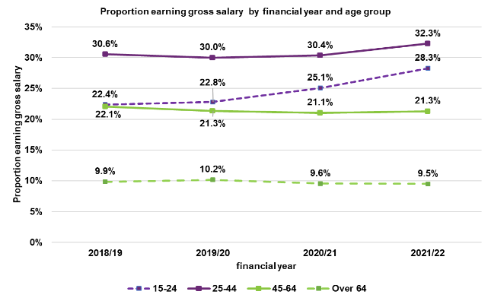
The highest proportion of NDIS participants earning gross salary during each of the financial years is for those aged 25 to 44. The proportion was steady at around 30% from FY2018/19 to FY2020/21 before rising to over 32% in FY2021/22. The proportions of NDIS participants aged 45 to 64, and over 64,

who earned gross salary have remained relatively stable over the past four financial years. For those aged 45 to 64 the percentage is around 21%, while for those aged 64 it is around 10%.

Comparison between NDIS participants and Australian population
Percentage paying tax over time
By financial year

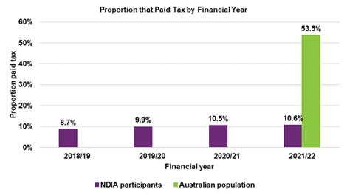
The proportion of NDIS participants The aged 15 years and above, who paid tax during the financial year steadily increased from 8.7% in FY2018/19 to 10.6% in FY2021/22.
In comparison, a considerably higher proportion (over 53%) of the Australian population aged 15 years and above paid tax during FY2021/22.

NDIS participants

Percentage paying tax over time
By financial year and age group
The proportion of NDIS participants aged 15 to 24 paying tax in the financial year has almost doubled – from 3.5% in FY2018/19 to 6.4% by FY2021/22. The amount of taxable income earned by this age bracket has been trending upwards.
In FY2021/22, the highest proportion of NDIS participants paying tax was for those aged 25 to 44. The proportion for this age group has been rising steadily from below 10% in FY2018/19 to 13% in FY2021/22.

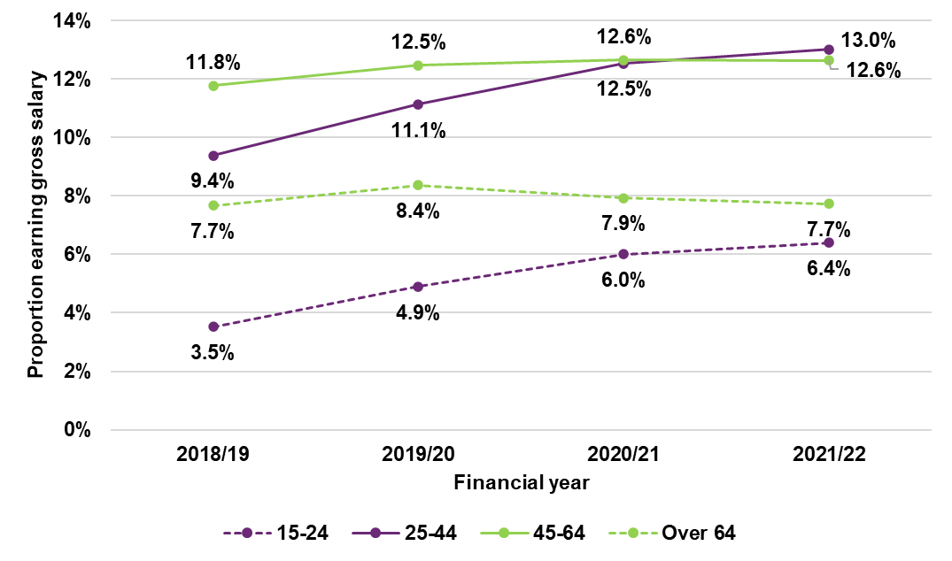
In comparison, the proportion of NDIS participants aged 45 to 64 and of those over 64 paying tax has generally been stable over the past four financial years. The percentage for the 45 to 64 age group has consistently been around 12%, with the percentage for the over 64 age group remaining around 8%.

Has the NDIS helped?

Participants from birth to before starting school

Percentage of positive responses by cohort and reassessment (1/2)
Opinions are most positive in relation to child development, followed by access to specialist services, and ability to communicate. Positive opinions are lower for fitting into community life.
The percentage of positive responses increased between R1 and R2, and between R1 and latest reassessment, for cohorts 1 to 5 across all domains. For example, for those in the Scheme for 5 years, improvements from R1 to R5 ranged from
3.5 percentage points (access to specialist services) to 14.5 percentage points (fit into community life).
Opinions are less positive for the 6-year cohort in comparison to other cohorts (noting, however, that the numbers in this cohort are smaller).

Percentage of positive responses by cohort and reassessment (2/2)
Child development Access to specialist services
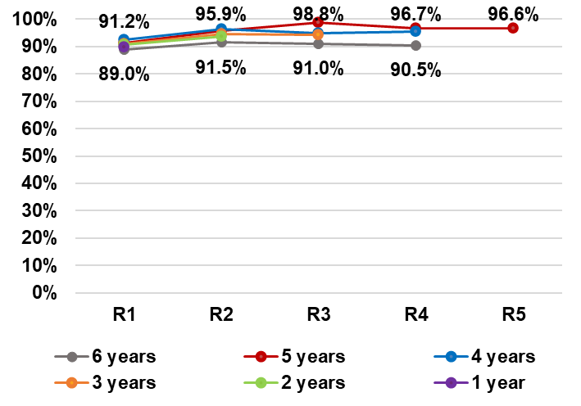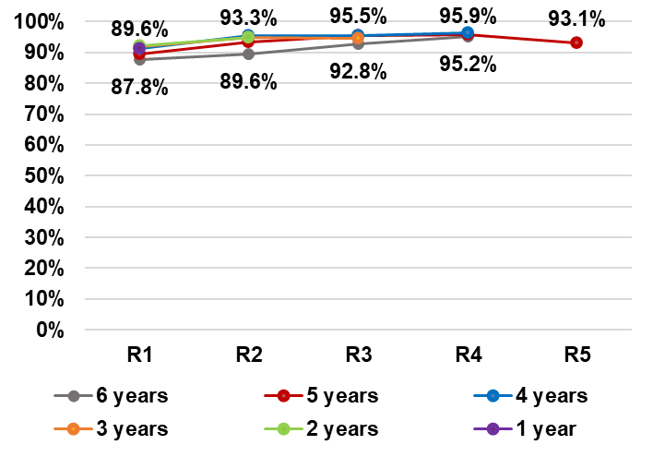

Ability to communicate Fit into family life
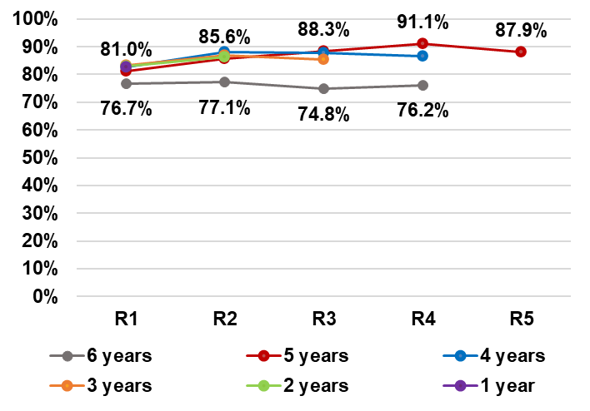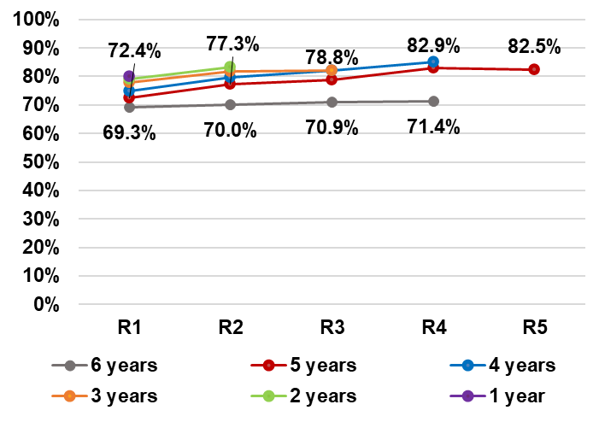
Fit into community life
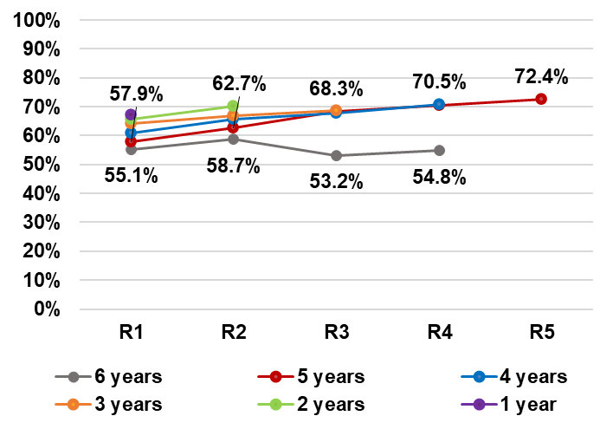
Note: In all graphs, the top row of data labels is for cohort 5

Percentage of positive responses by reassessment

Opinions on whether the NDIS has helped tend to be positive, particularly in relation to the child’s development (90.6% after one year in the Scheme, increasing to 97.1% after five years) and access to specialist services (91.5% after one year in the Scheme, increasing to 94.1% after five years).
Generally increasing trends with time in Scheme are observed for all domains, although there is some variability and most of the increase tends to occur between R1 and R2.

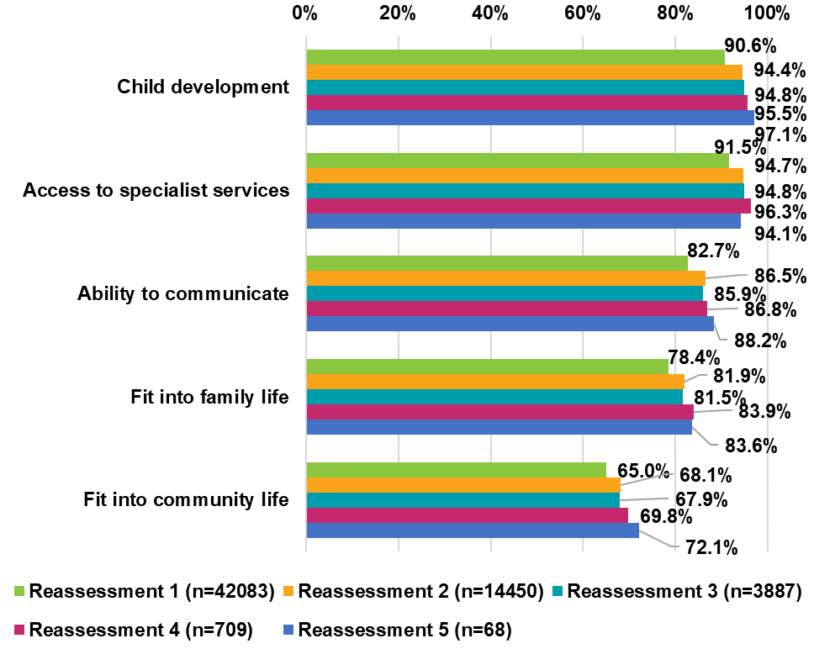

By baseline plan utilisation, outcomes after one year

Higher plan utilisation is strongly associated with a positive response after one year in the Scheme, across all five domains. The largest improvement is between utilisation bands 0–20% and 20–40%, an increase of around 20–31 percentage points, depending on the domain.
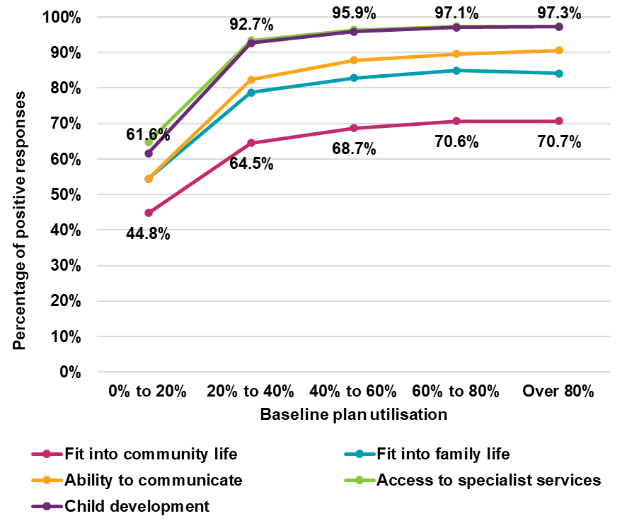

Participants from starting school to age 14

Percentage of positive responses by cohort and reassessment
Opinions are most positive in relation to child’s independence, followed by family and friends. Positive opinions are lower for access to education.
There is an increasing trend in the percentage of positive responses with time in Scheme, for all domains and across all cohorts. For example, for those in the Scheme for 6 years, improvements over six years ranged from 9.1 percentage points (social and recreational life) to 18.4 percentage points (child’s independence).
There appears to be a cohort effect for all domains, with those entering the Scheme later in time (e.g. those in the Scheme for 1 year) responding more positively than those entering the Scheme earlier (e.g. those in the Scheme for 6 years).
Child’s independence Family friends
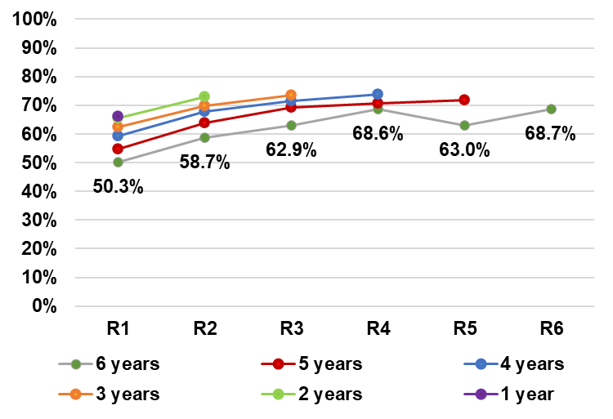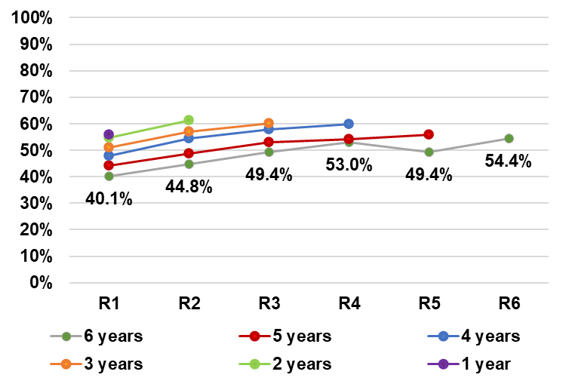
Access to education Social and recreational life
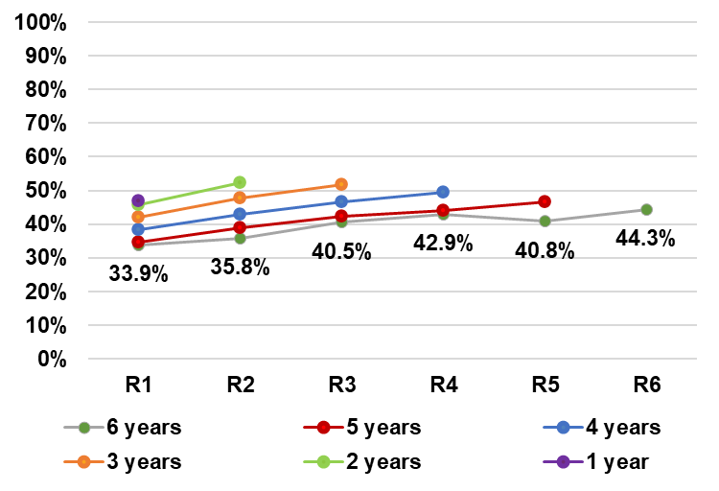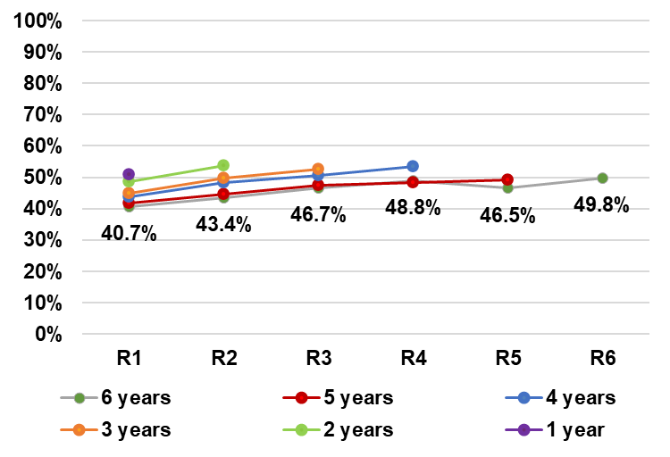
Note: Data labels in all graphs are for cohort 6.

Percentage of positive responses by reassessment

Opinions on whether the NDIS has helped vary by domain for the starting school to 14 cohort. The percentage responding positively was highest for independence (63.0% after one year in the Scheme, increasing to 68.7% after six years) and lowest for access to education. For education, the mainstream education system has a much bigger role in ensuring successful outcomes than the NDIS.
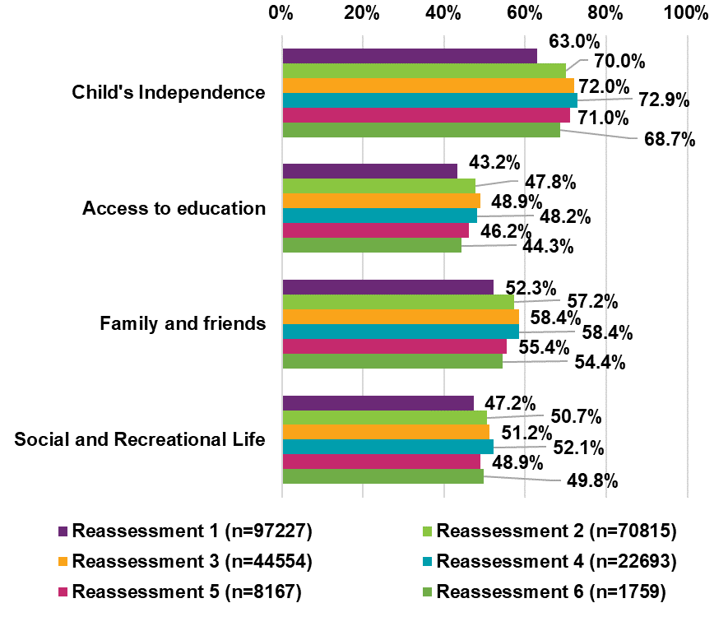

When aggregated across all cohorts, the percentages of positive responses increased from reassessment 1 to reassessment 3 or 4, but decreased at reassessment 5 and 6. However, these apparent decreases at later reassessments are confounded by the cohort effect noted on the previous slide. For example, the R6 result comes entirely from the year 6 cohort, which responds less positively than the other cohorts. When results are split by cohort, as on the previous slide, there is an increasing trend for all cohorts.

By baseline plan utilisation, outcomes after one year
Higher plan utilisation is strongly associated with a positive response after one year in the Scheme. The improvement is especially large between utilisation bands 0–20% and 20–40%.
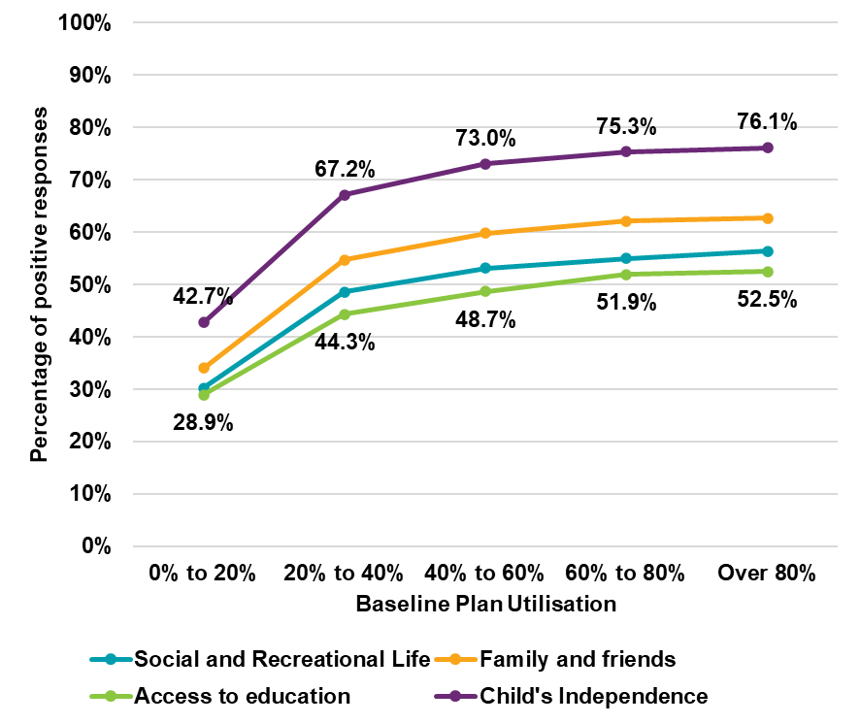

Participants aged 15 to 24

Percentage of positive responses by cohort and reassessment (1/2)
Across all eight domains (shown on this slide and the next), opinions are most positive in relation to daily living, followed by choice and control. Positive opinions are lower for work (see next slide) and home.
For three of the four domains shown on this slide (choice and control, daily living and relationships) there is an increasing trend in the percentage of positive responses with time in Scheme across all cohorts. For example, for those in the Scheme for 6 years, improvements over six years ranged from 14.0 percentage points (choice and control/ relationship) to 17.6 percentage points (daily living).
For choice and control and relationships, opinions are less positive for the 6-year cohort compared to other cohorts.

Choice and control Daily living
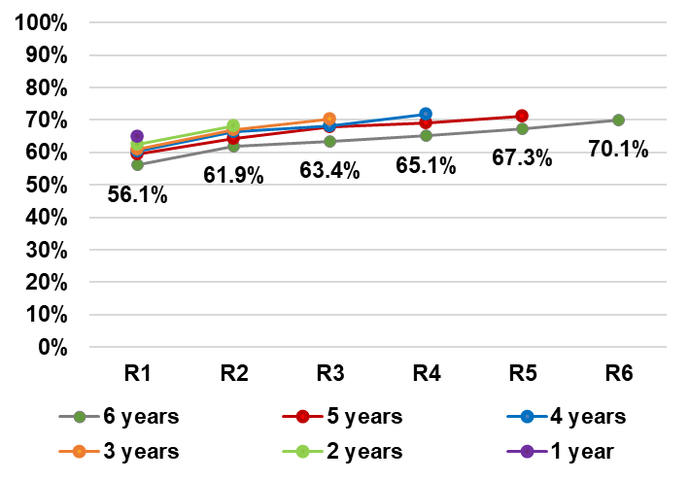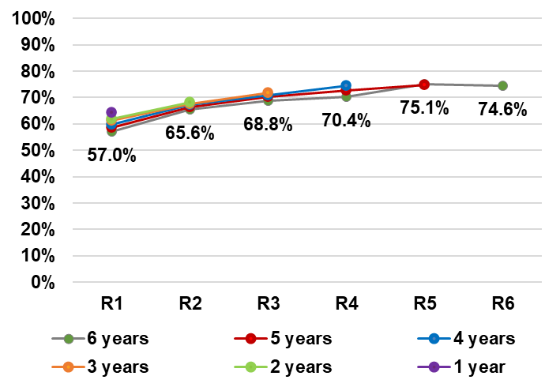
Relationships Home
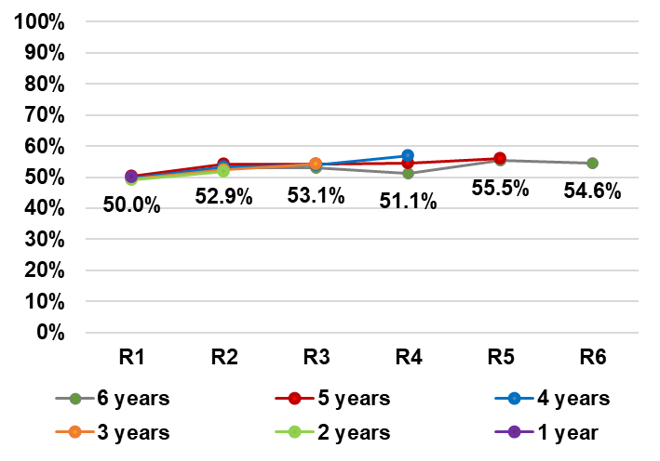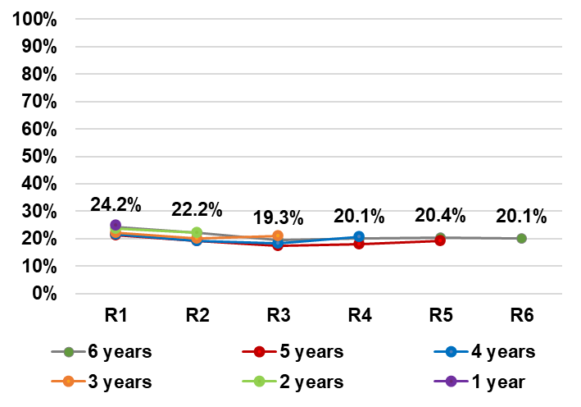
Note: Data labels in all graphs are for cohort

Percentage of positive responses by cohort and reassessment (2/2)
There is an increasing trend in the percentage of positive responses with time in Scheme for two of the domains on this slide (health and wellbeing, and social, community and civic participation).
For those in the Scheme for 6 years, improvements over six years were 10.5 percentage points for health and wellbeing, and 9.3 percentage points for social, community and civic participation.
Health and wellbeing Lifelong learning
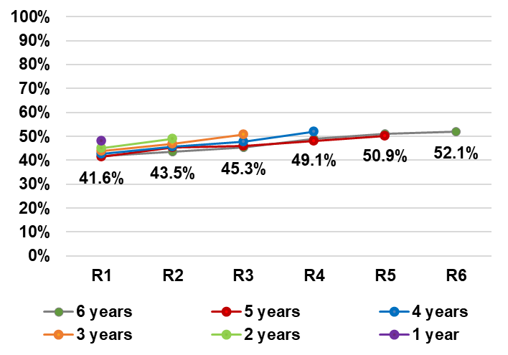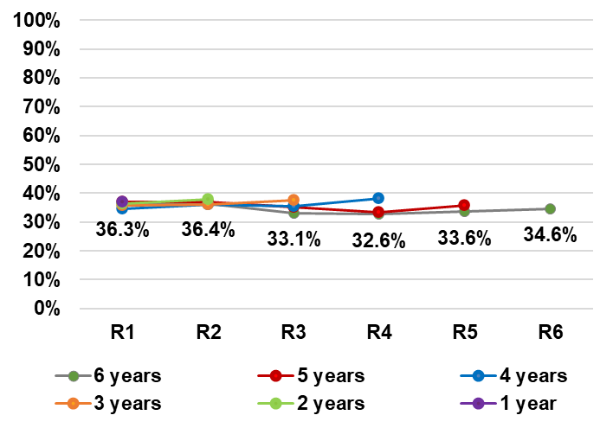
Work Social, community and civic participation
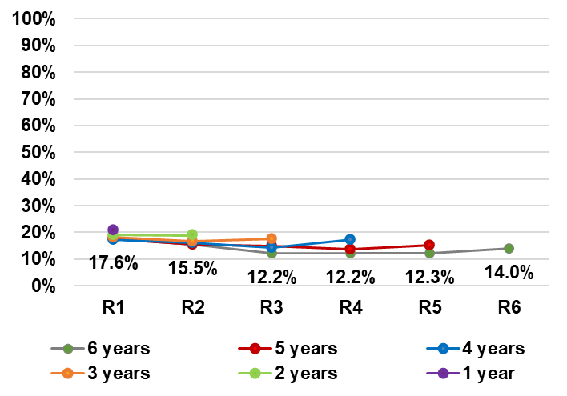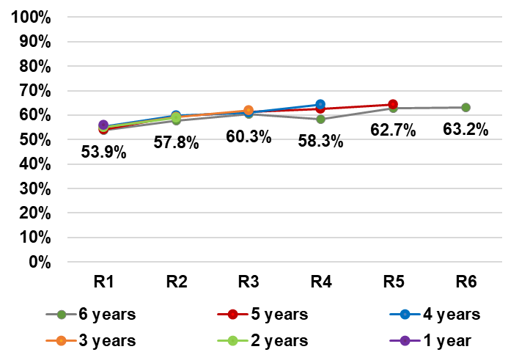

Percentage of positive responses by reassessment

Opinions on whether the NDIS has helped vary considerably by domain for the young adult cohort. The percentage who say the NDIS has helped is lowest for work (18.9% after one year in the Scheme, decreasing to 14.0% after six years), and highest for daily living (61.7% after one year, increasing to 74.6% after six years).
The percentage who think that the NDIS has helped increased between first and sixth reassessment across all domains except home, lifelong learning, and work. Improvements are the greatest between reassessment 1 and reassessment 2 for all five domains that saw improvement over six reassessments, namely choice and control (4.7 percentage point improvement), daily living (+5.9 percentage points), relationships (+2.9 percentage points), health and wellbeing (+2.2 percentage points) and social, community and civic participation (+3.9 percentage points).
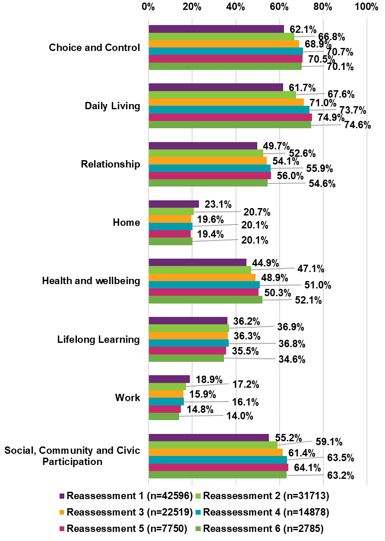

By baseline plan utilisation, outcomes after one year

Higher plan utilisation is strongly associated with a positive response across most domains, after one year in the Scheme.
In all domains except work, the percentage saying the NDIS helped increases consistently for higher baseline plan utilisation categories. In all domains, the greatest increase is seen between utilisation bands 0–20% and 20–40%.
For the work domain, the percentage saying the NDIS helped them find the
right job increased between utilisation bands 0–20% and 60–80%. However, this percentage decreased slightly for those utilising over 80% of their plans at baseline.
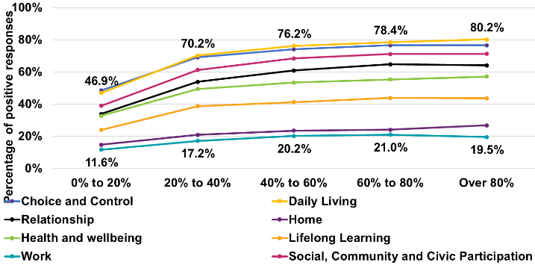

Participants aged 25 and over

Percentage of positive responses by cohort and reassessment (1/2)
Across all eight domains (shown on this slide and the next), opinions are most positive in relation to daily living, followed by choice and control. Positive opinions are lower for work, lifelong learning, and home.
For all four domains shown on this slide, there is an increasing trend in the percentage of positive responses with time in Scheme across all cohorts. For example, for those in the Scheme for 6 years, improvements over six years ranged from 8.9 percentage points (home) to 17.1 percentage points (daily living).
Choice and control Daily living

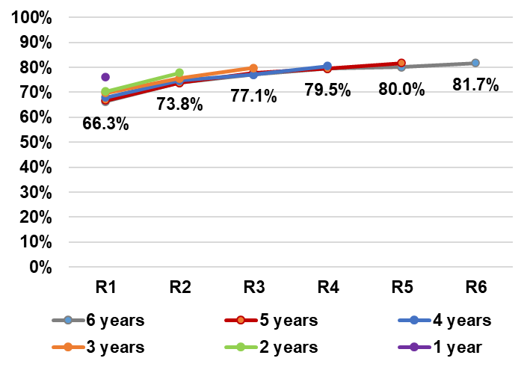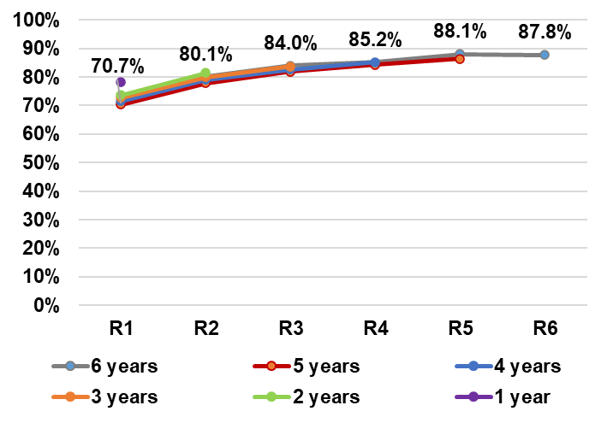

Relationships Home
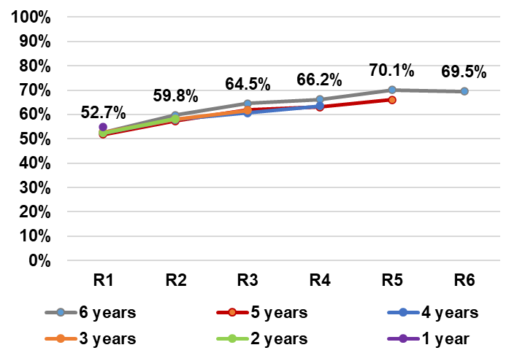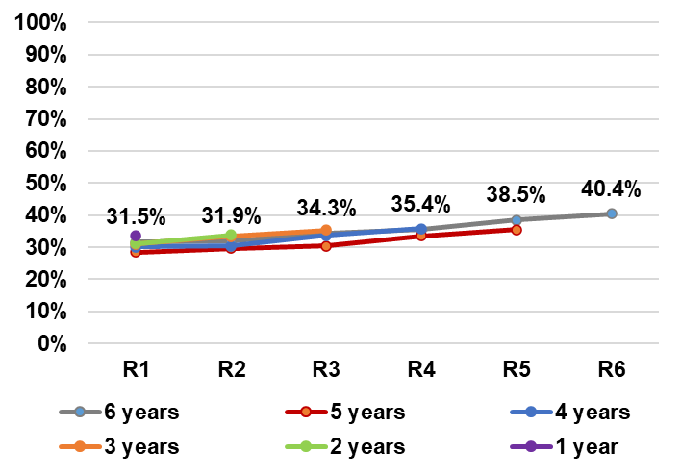
Note: Data labels in all graphs are for cohort

Percentage of positive responses by cohort and reassessment (2/2)
There is an increasing trend in the percentage of positive responses with time in Scheme for three of the four domains shown on this slide.
For example, for those in the Scheme for 6 years, improvements over six years ranged from 3.3 percentage points (lifelong learning) to 17.1 percentage points (social, community and civic participation).
Health and wellbeing Lifelong learning
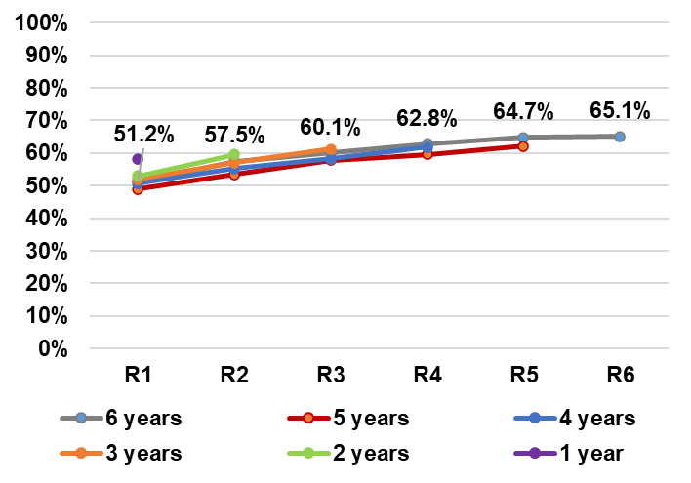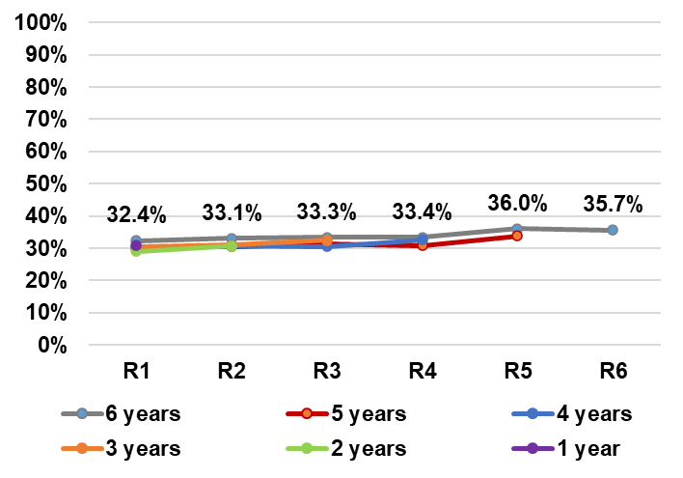

Work Social, community and civic participation
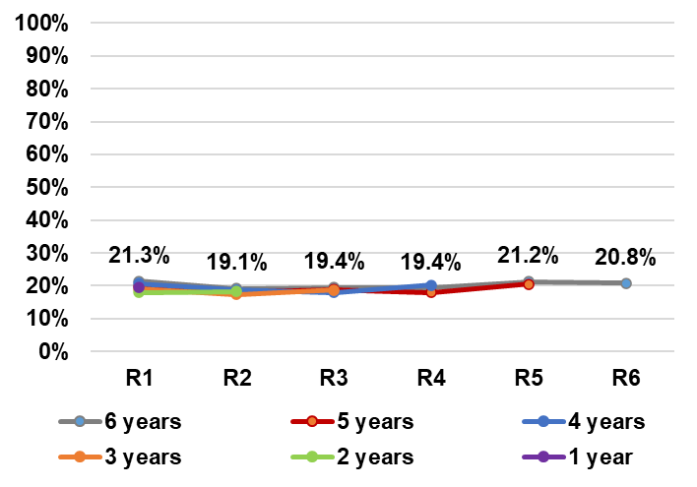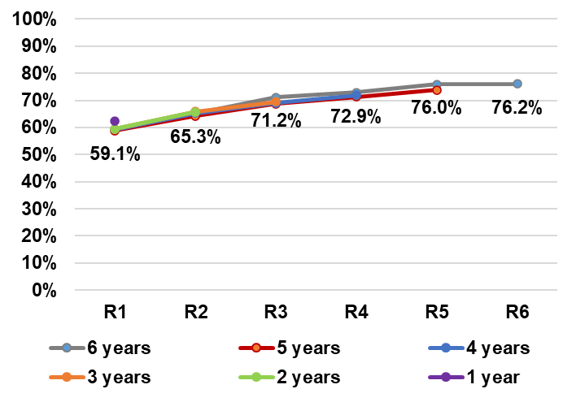
Note: Data labels in all graphs are for cohort

Percentage of positive responses by reassessment

The percentage who think the NDIS has helped is highest for daily living (74.6% after one year in the Scheme, increasing to 87.8% after six years in the Scheme). This is followed by choice and control, which had a 10.0 percentage- point increase between first and six reviews (71.7% after one year in the Scheme, increasing to 81.7% after six years in the Scheme).
Percentages are lowest for lifelong learning (30.3% after one year, increasing to 35.7% after six years) and work (19.3% after one year, and 20.8% after six years).
Nevertheless, all domains have shown overall positive increases between first
and sixth reassessment.

. 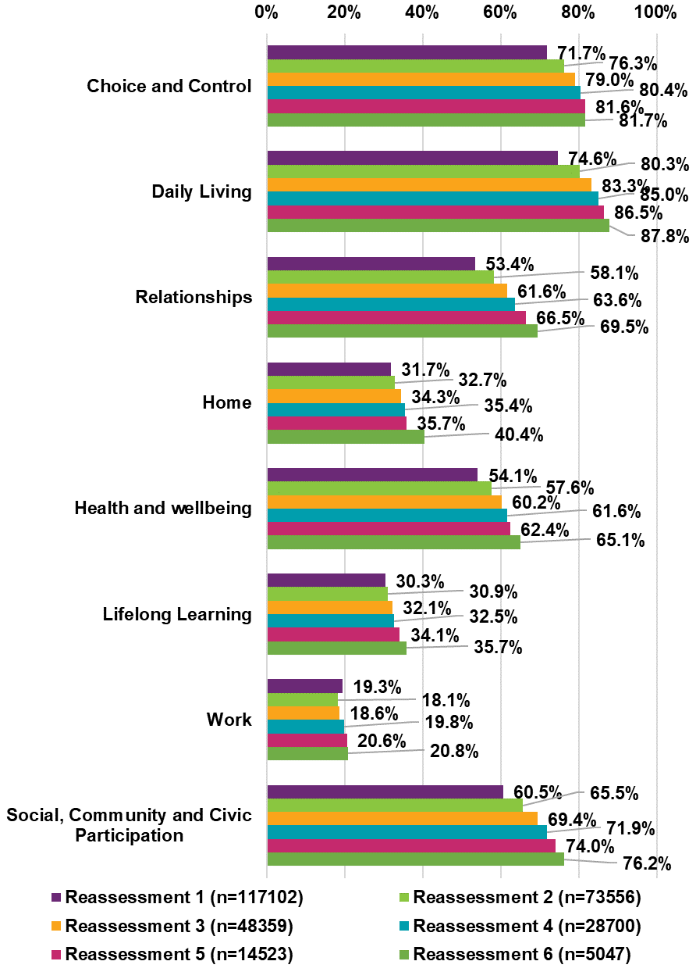

By baseline plan utilisation, outcomes after one year

Higher plan utilisation is strongly associated with a positive response across all eight domains, after one year in the Scheme.
In most domains except work, the percentage saying the NDIS helped has increased consistently for higher baseline plan utilisation categories. Across all domains except home, the increase is the greatest between utilisation bands 0–20% and 20–40%.
The percentage saying the NDIS helped them find the right home increased by
6.4 percentage points between utilisation bands 60–80% and 80%+.
In the work domain, there is a slight decrease (0.9 percentage points) in the percentage saying the NDIS helped between utilisation bands 60–80% and 80%+.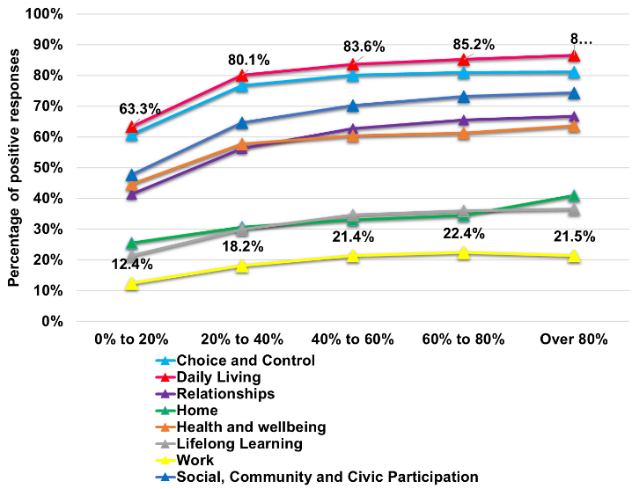

Appendix

Age group transitions

Moving up age groups
Questions appearing in both survey forms
If a participant moves up to an older age group, answers to the same question continue to be tracked across the different survey forms.
For example, the question “Are you currently working in a paid job?” is asked in two survey forms: age 15 to 24 and age 25+. Suppose a participant answered twice in the 15 to 24 form and three times in the 25+ form (below):
15 to 24  No No | 25+  No Yes Yes
Annual reports prior to 30 June 2022 only tracked the participant’s answers in the first form (answers in the second form were not analysed, since the participant did not have a baseline in the second age group).
This report tracks the participant’s answers to the same question across both forms. Analysis is by ‘time in Scheme’.
Questions only appearing in older age group
If a participant moves up to an older age group, answers to questions that are only asked in the older age group start to be tracked in the new survey form.
For example, the question “Do you make more decisions in your life than you did two years ago?” is only asked in the age 15 to 24 survey form. Suppose a participant answered twice in the starting school to 14 form and three times in the 15 to 24 form (below):
Starting school to 14  (Question not asked) | 15 to 24  No Yes Yes
Previously, the participant’s answers to this question were not analysed (since the question is not asked in the first age group, and the participant did not have a baseline in the second age group).
This report tracks the participant’s answers to the question from when they first answer the second form. This is done by ‘resetting’ the baseline at this point, for the purposes of this question. Effectively, this means that the analysis is by ‘time in age group’ rather than ‘time in Scheme’.
The rationale for this approach is that the question was not relevant for participants in the younger age group, and so the Scheme was not focussed on improving this particular outcome until they moved to the older age group.

Summary by question type
Example of questions | POtoSS | PSto14 | P15to24 | P25Plus | Number of groups | Type of question | Age group transitioning up | Treatment of analysis
My child is able to tell me what he/she wants | 1 | 0 | 0 | 0 | 1 | Non- overlapping | Not applicable | Single group, by time in Scheme
My child can make friends with people outside the family | 1 | 1 | 0 | 0 | 2 | Overlapping | Not applicable | Combined group, by time in Scheme
My child is becoming more independent | 0 | 1 | 0 | 0 | 1 | Non- overlapping | P0toSS | Analyse by time since first in PSto14
At school, are you/were you actively included in the following co-curricular activities? | 0 | 1 | 1 | 0 | 2 | Overlapping | P0toSS | For P0to SS, analyse by time since first in PSto14, otherwise by time in Scheme
What is the usual number of hours worked per week? | 0 | 1 | 1 | 1 | 3 | Overlapping | P0toSS | For P0to SS, analyse by time since first in PSto14, otherwise by time in Scheme
Do you make more decisions in your life than you did 2 years ago? | 0 | 0 | 1 | 0 | 1 | Non- overlapping | PSto14 | Analyse by time since first in P15to24
Are you currently working in a paid job? | 0 | 0 | 1 | 1 | 2 | Overlapping | PSto14 | For PSto14, analyse by time since first in P15to24, otherwise by time in Scheme
Living/housing arrangements, household income, who responded | 1 | 1 | 1 | 1 | 4 | Overlapping | Not applicable | Combined group, by time in Scheme

Longitudinal cohorts
For each outcome indicator, longitudinal results are considered separately for six cohorts of participants. The cohorts are based on the number of complete years of experience that the participant has contributed to that indicator as at 30 June 2023, in line with the final column of the previous slide. Hence the same participant can belong to different cohorts for different indicators. However, for a given indicator, the cohorts are distinct (that is, a participant belongs to one cohort only).
The following table shows how cohorts C1–C6 are defined.
Cohort | Number of years of experience contributed to indicator | Possible total number of years in the Scheme
C6 | 6 | 6
C5 | 5 | 5–6
C4 | 4 | 4–6
C3 | 3 | 3–6
C2 | 2 | 2–6
C1 | 1 | 1–6
For example, consider a participant who has been in the Scheme for a total of six years and who responded to the P0toSS questionnaire at baseline and reassessment 1, then to the PSto14 questionnaire at reassessments 2 to 6. For the indicator:
- “My child is able to tell me what he/she wants” (only asked in P0toSS), the participant would be in cohort C1 (i.e. one reassessment has occurred since baseline where this indicator was asked).
- “My child can make friends with people outside the family” (asked in both P0toSS and PSto14), the participant would be in cohort C6 (i.e. six reassessments for this indicator have occurred since baseline).
- “My child is becoming more independent” (only asked in PSto14), the participant would be in cohort C4 (i.e. the participant first responded to this indicator at reassessment 2 (which becomes the reset baseline) and four reassessments have occurred since this reset baseline).

Treatment of “Has the NDIS helped?” questions
The final question in each domain asks whether the participant thinks that the NDIS has helped with areas related to that domain. In reporting on these questions:
- Only responses at first and subsequent reassessments are included, since the Scheme has not had an opportunity to have an impact at baseline.
- All responses from reassessment 1 onwards contribute to the analysis, and responses are allocated to the age group and duration in Scheme applicable at the time of response. For example, a participant ageing up at reassessment 3 would be included in the new age group from reassessment 3.
- Hence the analysis is cross-sectional by time in Scheme, i.e. results at reassessment t represent a snapshot of all participants’ views as at t years in the Scheme. This is in contrast to the longitudinal (by time in Scheme) presentation for the outcome indicators. The rationale for this difference is that the “Has the NDIS helped” questions measure satisfaction with the Scheme, rather than outcomes of participants.

Normal age-related development
Adjustments for effects independent of the Scheme
For participants aged 0 to 24, longitudinal change in outcomes may be partly due to normal age-related development, rather than fully attributable to participation in the NDIS.
For example, the percentage of parents and carers saying their child is able to tell them what they want increased by between 11.8 and 40.3 percentage points,
depending on years in the Scheme. Recognising that children’s growth in age naturally increases their cognitive and linguistic abilities, these improvements cannot be fully attributed to participation in the NDIS.
To assess possible impacts of the Scheme, an “adjusted” version of longitudinal change which removes the estimated component due to age-related development has been used. For example, in comparing latest reassessment with baseline,
the baseline percentages are adjusted as if all participants were at their latest- reassessment age, effectively holding age constant in the comparison.
In this report, adjustments for normal age-related development apply to all questions unique to the 0 to 24 age groups. The adjusted longitudinal change forms part of the criteria for selecting indicators with a significant and material change, as described on the “summary of changes” slides. However, for clarity, the results summarising aggregate change contained in the report only show the unadjusted changes.
ndis.gov.au
Copyright and use of the material in this document
Copyright in the material in this document, with the exception of third party material, is owned and protected by the National Disability Insurance Agency.
The material in this document, with the exception of logos, trademarks, third party material and other content as specified is licensed under Creative Commons Attribution Non-Commercial No Derivatives (CC BY NC ND) licence, version 4.0 International. You may share, copy and redistribute the document in any format.
You must acknowledge the National Disability Insurance Agency as the owner of all intellectual property rights in the reproduced material by using ‘© National Disability Insurance Agency’ and you must not use the material for commercial purposes.
Reproduction of any material contained in this document is subject to the CC BY NC ND licence conditions available on the Creative Commons Australia site, as is the full legal code for this material.
The National Disability Insurance Agency expects that you will only use the information in this document to benefit people with disability.
National Disability Insurance Agency
Telephone 1800 800 110
Webchat ndis.gov.au
Follow us on our social channels
For people who need help with English
TIS: 131 450
For people who are deaf or hard of hearing
TTY: 1800 555 677
Speak and Listen: 1800 555 727
National Relay Service: relayservice.gov.au

This is a notably lower percentage, compared to the June 2022 report where 57% of significant and material indicators for the 0 to 14 age group improved. This is because some context-dependent indicators were added to consideration this time, and many of which were significant and material. Please see slide 23 for more details.
1 All percentages quoted in this box are for FY2021/22; all changes referenced are over 4 years, from FY2018/19 to FY2021/22.
https://dataresearch.ndis.gov.au/reports-and-analyses/outcomes-and-goals/previous-participant-outcomes-reports
https://dataresearch.ndis.gov.au/reports-and-analyses/outcomes-and-goals/covid-19-impact-participant-and-familycarer-outcomes-30-june-2020
https://dataresearch.ndis.gov.au/reports-and-analyses/outcomes-and-goals/employment-outcomes-participants-their-families-and-carers
https://dataresearch.ndis.gov.au/reports-and-analyses/outcomes-and-goals/health-and-wellbeing-ndis-participants-and-their-families-and-carers
The table shows the potential number of respondents, however, not all of them responded to each question. The number of missing responses is small relative to total response numbers and varies by indicator.
Cohort 6 (6 years cohort) has been omitted as participant numbers are too small
Cohort 6, as well as reassessment 4 (R4) in cohort 5 have been omitted as participant numbers are too small
Parents/carers are asked whether they have concerns about their child’s development in eight areas (shown on the next slide). This slide shows the percentage who say they have concerns in six or more of these eight areas. Note that an increase in the percentage indicates deterioration.
Cohort 6 has been omitted as participant numbers are too small.
Results for cohorts 5 and 6 (C5 and C6) are not shown due to insufficient numbers for this indicator
Percentage of children who spend time after school and on weekends with friends and/or in mainstream programs.
This indicator is not significant but highly relevant to the next indicator “Of those children who spend time after school and on weekends with friends and/or in mainstream programs, % feeling welcomed or actively included
Results are not shown for those in the Scheme for six years since the numbers are too small to show percentages at other reassessment time points
Note that this indicator includes responses from the School to 14 and 15 to 24 age group forms, so relates to children from school age to 24. The entire cohort 6 for 0–S/S–14 age group is not shown due to insufficient numbers for this indicator
See the Appendix for discussion of age-related development and adjustment methodology, which was used for the 0–14 and15–24 only indicators
Population benchmark data is from the Australian Bureau of Statistics (ABS), Education and Work May 2022, standardised for NDIS participant age and gender distribution
Note that due to small numbers, this LF indicator is not available for participants in the Scheme for five and six years.
Population benchmark figures are from the Australian Bureau of Statistics (ABS), General Social Survey (GSS) 2020, standardised for NDIS participant age and gender distribution. GSS item “Has been involved in groups in the last 12 months” including social groups, community support groups, civic and political groups.
For more information on employment outcomes, see https://data.ndis.gov.au/reports-and-analyses/outcomes-and-goals/employment-outcomes-participants-their-families-and-carers
Conditioning on the participant currently being not in a paid job, but would like one.
Conditioning on the participant currently being in a paid job
Population benchmark figures are from: • Working in a paid job: Australian Bureau of Statistics (ABS), Labour Force Status June 2023, standardised for NDIS participant age and gender distribution. • Working 15 hours or more per week: HILDA wave 22, standardised for NDIS participant age and gender distribution. • Not working and not looking for work: ABS, Labour Force Status June 2023, standardised for NDIS participant age and gender distribution.
For more information on employment outcomes, see https://data.ndis.gov.au/reports-and-analyses/outcomes-and-goals/employment-outcomes-participants-their-families-and-
For more information on employment outcomes, see https://data.ndis.gov.au/reports-and-analyses/outcomes-and-goals/employment-outcomes-participants-their-families-and-carers
Population benchmark figures are from: - Self-rated health: HILDA wave 22 data, standardised for NDIS participant age and gender distribution. - Hospital visits: HILDA wave 21 data, standardised for NDIS participant age distribution. - Regular doctor: HILDA wave 21 data, standardised for NDIS participant age distribution.
Population benchmark figures are from: • Flu vaccination: NCIRS (National Centre for Immunisation Research and Surveillance) 2022 data , standardised for NDIS participant age distribution.
Person Level Integrated Data Asset (PLIDA), from 2018/19 to 2022/23, Medicare Benefits Schedule, ABS DataLab. Findings based on use of PLIDA data.
Medicare-subsidised services - mental health (2023) Australian Institute of Health and Welfare. Available at: https://www.aihw.gov.au/mental-health/topic-areas/medicare-subsidised-services (Accessed: 27 July 2023).
Person Level Integrated Data Asset (PLIDA), from 2018/19 to 2022/23, Medicare Benefits Schedule, ABS DataLab. Findings based on use of PLIDA data.
Medicare-subsidised services - mental health (2023) Australian Institute of Health and Welfare. Available at: https://www.aihw.gov.au/mental-health/topic-areas/medicare-subsidised-services (Accessed: 27 July 2023).
Person Level Integrated Data Asset (PLIDA), from 2018/19 to 2022/23, Medicare Benefits Schedule, ABS DataLab. Findings based on use of PLIDA data
Person Level Integrated Data Asset (PLIDA), from 2018/19 to 2022/23, Medicare Benefits Schedule, ABS DataLab. Findings based on use of PLIDA data
Person Level Integrated Data Asset (PLIDA), from 2018/19 to 2022/23, Medicare Benefits Schedule, ABS DataLab. Findings based on use of PLIDA data.
Medicare-subsidised services - mental health (2023) Australian Institute of Health and Welfare. Available at: https://www.aihw.gov.au/mental-health/topic-areas/medicare-subsidised-services (Accessed: 27 July 2023).
Medicare-subsidised services - mental health (2023) Australian Institute of Health and Welfare. Available at: https://www.aihw.gov.au/mental-health/topic-areas/medicare-subsidised-services (Accessed: 27 July 2023).
Medicare-subsidised services - mental health (2023) Australian Institute of Health and Welfare. Available at: https://www.aihw.gov.au/mental-health/topic-areas/medicare-subsidised-services (Accessed: 27 July 2023).
Person Level Integrated Data Asset (PLIDA), from 2018/19 to 2021/22, NDIS – participant information, ABS DataLab. Findings based on use of PLIDA data.
Person Level Integrated Data Asset (PLIDA), from 2018/19 to 2021/22, Personal Income Tax/Payment Summary, ABS DataLab. Findings based on use of PLIDA data
R5 and R6 not shown for 6 years cohort due to insufficient data.

