National Disability Insurance Scheme


Annual Financial Sustainability Report

2021-22

Sarah Johnson BCom FIAA David Gifford BEc MBA FIAA
Scheme Actuary Deputy Scheme Actuary

Table of Contents
Executive Summary 4
Section 1: Introduction 26
1.1 Background 26
1.2 Financial sustainability of the NDIS 27
1.3 Reliance and limitations 28
Section 2: Information and data integrity 29
Section 3: Modelling approach 31
Section 4: Scheme experience 36
4.1 Participant numbers 36
4.2 Actual versus expected participant numbers 36
4.3 Total Scheme expense 47
4.4 Average payments per participant 52
4.5 Scheme payment inflation experience 56
4.6 Plan budgets 59
4.7 Utilisation 66
Section 5: Projections 69
5.1 Total Scheme expense projections 69
5.2 Comparison with previous AFSR 71
5.3 Projection of plan budgets and utilisation 72
5.4 Participant projections 76
5.5 Average payment assumptions 89
5.6 Inflation assumptions 93
5.7 Average payment per participant assumptions after inflation 98
5.8 Operating expenses 103
5.9 Lifetime expense for care and support 104
Section 6: Uncertainty and comparisons to previous projections 107
6.1 Scenario analysis 107
6.2 Stochastic modelling 119
6.3 Historic AFSR projections 122
Section 7: Outcomes 127
7.1 Outcomes and financial sustainability 127
7.2 The outcomes framework questionnaires 128
7.3 Participant outcomes – results 132
7.4 Family and carer outcomes – results 143
Section 8: Information systems and risk management approach 147
8.1 Information systems 147
8.2 Risk Management 149
Section 9: Recommendations 152
9.1 Progress on previous recommendations 152
9.2 New recommendations 157
Appendix A: Average payment assumption setting details 162
Appendix B: Comparison to previous review – detailed tables 167
Appendix C: Reconciliation to previous review 175
Appendix D: State and Territory breakdown 177
Appendix E: Historic average participant payments by SIL type 178
Appendix F: Scenario analysis from previous AFSRs 179
Appendix G: Scenario analysis of participant numbers 183
Appendix H: Analysis of Scheme new entrant rates 187
Appendix I: Analysis of experience of participants leaving the Scheme 203
Appendix J: Analysis of Scheme mortality experience 216
Appendix K: Investment Effectiveness Program 234

Executive Summary
An annual financial sustainability report (AFSR) is required under section 180B of the NDIS Act and provides an assessment of the financial sustainability of the National Disability Insurance Scheme (“the Scheme”, or NDIS). The AFSR is produced using data at 30 June each year and a summary of each year’s AFSR has been included in the NDIA annual report. This report uses data to 30 June 2022 to project the future expenses of the Scheme.
The previous report was the AFSR released on 8 October 2021 (the “2020-21 AFSR”). It was based on data to 30 June 2021, with commentary about experience to 30 June 2021 (the “previous review”). References to the “previous review” throughout this report refer to results contained within that report.
Financial sustainability
The NDIS Insurance Principles and Financial Sustainability Manual outlines the NDIS’ insurance model in detail and defines financial sustainability as the state where:
- The Scheme is successful on the balance of objective measures and projections of economic and social participation and independence, and on participants’ views that they are getting enough money to buy enough goods and services to allow them reasonable access to life opportunities - that is, reasonable and necessary support.
- Contributors think that the cost is and will continue to be affordable, under control, represents value for money and, therefore, remain willing to contribute.
2021-22 financial projection of Scheme expenses
Projected total Scheme expenses on an accrual basis are $34.0 billion in 2022-23, increasing to $89.4 billion in 2031-32. Projected Scheme expenses on an accrual basis, for the four years to June 2026, have been estimated to be $166.6 billion.

Table 1: Baseline projection of Scheme expenses
Scheme Expenses ($m) | 2022-23 | 2023-24 | 2024-25 | 2025-26 | 2031-32 | 2022-26
Scheme Expenses (cash basis)
Scheme Expenses (0-64) | 30,931 | 34,357 | 39,364 | 44,519 | 76,700 | 149,171
Scheme Expenses (65+) | 2,544 | 3,211 | 4,099 | 5,081 | 11,389 | 14,934
Total Scheme Expenses (cash basis) | 33,475 | 37,568 | 43,463 | 49,599 | 88,089 | 164,105
Scheme Expenses (accrual basis)
Scheme Expenses (0-64) | 31,394 | 34,874 | 39,955 | 45,187 | 77,843 | 151,411
Scheme Expenses (65+) | 2,582 | 3,259 | 4,160 | 5,157 | 11,559 | 15,158
Total Scheme Expenses (accrual basis) | 33,976 | 38,133 | 44,116 | 50,344 | 89,403 | 166,569
Total Scheme Expenses (% of GDP) | 1.48% | 1.61% | 1.77% | 1.93% | 2.55% | 1.70%
It is important to recognise that the projected Scheme expenses are shown in nominal terms, i.e. that future dollars of estimated Scheme expenses include the effects of inflation over time. This impact of inflation increases over the longer term and so is particularly significant for the result in 2031-32. Expressing Scheme expenses as a proportion of GDP is a way of removing the impacts of economic inflation. Scheme expenses are estimated to be 1.48% of GDP in 2022-23, increasing to 2.55% in 2031-32. In considering longer-term projections it is recommended that users refer to expenses as a % of GDP rather than nominal dollar figures as these provide a more meaningful measure of Scheme expenses.
The level of uncertainty associated with the Scheme projections also increases over the longer term. In particular, there is a wide range of plausible outcomes for the 2031-32 year as shown in Table 2. The 5th percentile and 95th percentile results form a 90% confidence interval for the range of expected outcomes for projected Scheme expenses. The 90% confidence interval is $31.8 billion to $37.4 billion or 1.38% to 1.63% of GDP for 2022-23. This increases to $72.7 billion to $115.0 billion or 2.07% to 3.28% of GDP for 2031-32. Further explanation of the uncertainty in Scheme projections and the stochastic model used to produce these results is included later in this Executive Summary and in Section 6.2.

Table 2: Range of plausible outcomes of Scheme expenses
2021-22 AFSR | 2022-23 | 2023-24 | 2024-25 | 2025-26 | 2031-32 | 2022-26
Scheme Expenses ($m)
Baseline Projection | 33,976 | 38,133 | 44,116 | 50,344 | 89,403 | 166,569
5th Percentile Projection | 31,844 | 35,224 | 40,069 | 45,108 | 72,700 | 152,246
95th Percentile Projection | 37,439 | 43,844 | 51,853 | 59,926 | 114,973 | 193,061
% of GDP
Baseline Projection | 1.48% | 1.61% | 1.77% | 1.93% | 2.55% | 1.70%
5th Percentile Projection | 1.38% | 1.49% | 1.61% | 1.73% | 2.07% | 1.56%
95th Percentile Projection | 1.63% | 1.85% | 2.08% | 2.29% | 3.28% | 1.97%
The projected Scheme expenses are approximately $8.8 billion higher than the previous review in the four years to June 2026, and about $21.4 billion higher in 2031-32 (Table 3).
Table 3: Comparison of 2021-22 AFSR with 2020-21 AFSR
Projected Scheme Expenses ($m) | 2022-23 | 2023-24 | 2024-25 | 2025-26 | 2031-32 | 2022-26
2021-22 AFSR (a) | 33,976 | 38,133 | 44,116 | 50,344 | 89,403 | 166,569
2020-21 AFSR (b) | 33,886 | 37,973 | 41,373 | 44,551 | 68,049 | 157,782
Difference ($) (a – b) | 90 | 160 | 2,743 | 5,793 | 21,354 | 8,786
Difference (%) (a/b – 1) | 0.3% | 0.4% | 6.6% | 13.0% | 31.4% | 5.6%
The sources of variance between this projection and the previous review are shown in Table 4.
Table 4: Movements in Scheme expenses since previous review due to experience and updated assumptions
Projected Scheme Expenses ($m) | 2022-23 | 2023-24 | 2024-25 | 2025-26 | 2031-32 | 2022-26
2020-21 AFSR | 33,886 | 37,973 | 41,373 | 44,551 | 68,049 | 157,782
Update for participant population | 894 | 969 | 999 | 1,026 | 1,321 | 3,887
Update average payment assumptions | -1,686 | -1,921 | -2,116 | -2,253 | -3,765 | -7,977
Update for 2021-22 Annual Pricing Review | 1,242 | 835 | 915 | 993 | 1,608 | 3,984
Subtotal: updates for experience and Annual Pricing Review | 450 | -118 | -203 | -234 | -836 | -105
Update for all changes to participant population assumptions | 82 | 409 | 876 | 1,304 | 4,825 | 2,671
Update for normal inflation | 0 | 327 | 518 | 735 | 1,200 | 1,579
Update for additional inflation | -442 | -458 | 1,553 | 3,988 | 16,164 | 4,642
Total Updates for all changes | 90 | 160 | 2,743 | 5,793 | 21,354 | 8,786

Past experience and the Annual Pricing Review have resulted in a projection which is essentially unchanged (a $0.1bn reduction) for the four years (2022-26), comprising:
  - a $3.9 billion increase due to higher than expected numbers of participants and a different mix of participants compared with expected. Participant projections are shown in Section 5.4;
  - an $8.0 billion reduction due to lower than expected average payments per participant in 2021-22, and hence a lower starting point for the projection. This is driven by several factors including prolonged lockdowns due to COVID-19 pandemic and workforce shortages materialising in the second half of 2021-22, impacting availability of support workers; and
  - a $4.0 billion increase due to the 2021-22 Annual Pricing Review (APR). The update to prices in the APR reflects the Fair Work Commission increase to the national minimum wage for disability support workers as well as additional inflationary pressures related to attendant care in the current COVID-19 impacted environment.
Future assumptions result in an increase of $8.9bn for the four years (2022-26), comprising:
  - a $2.7 billion increase due to higher new entrant assumptions and assumptions of fewer participants leaving the Scheme to better reflect recent experience;
  - a $1.6 billion increase due to higher expectations regarding normal inflation after 2022-23. Normal inflation refers to the increases in the prices paid for supports and reflects both average increases to wage inflation and the Consumer Price Index (CPI); and
  - a $4.6 billion increase due to changes in additional inflation assumptions. Additional inflation (in addition to normal inflation) may arise from a variety of sources including future price increases in excess of normal inflation, increased volumes of service being utilised by participants, reductions in levels of informal support received by participants and increases in the scope of supports provided by the Scheme.

Information and data used for analysis
The actuarial analysis underpinning this report relies upon the Agency’s case management system, finance system and data warehouse, as well as external sources (such as various industry benchmarks and population surveys). The analysis in this report is based on data at 30 June 2022, unless stated otherwise. The sources of data are summarised in Table 5.
Table 5: Summary of data utilised for actuarial analysis
Data | Description
Access requests to the NDIS | - Demographic information (age, gender, disability, geographic location, living arrangements and other participant profile information)  - Contact details  - Access request date  - Outcome of request (for example: eligible, ineligible)
Payments to service providers | - Service provider submitting the claim for payment  - Participant for whom the support was provided  - The support item and cost of support provided  - Dates of when the support was provided  - Method of plan management used
Payments to participants | - Participant submitting the claim for payment  - The support category provided  - Total amount spend on support category  - Period of reimbursement
NDIS participant plans | - Plan approval date  - Length of plan  - All plan budgets included in the plan  - Level of function
In-kind supports data | - Unit record in-kind support details from State/Territory programs including details on support type, level and duration of coverage.
Data on outcomes | - For participants entering the Scheme from 1 July 2016, data on outcomes has been collected from 99% of all participants, with the intention to collect information from all participants.
Financial information | - Data from the SAP CRM system were reconciled with financial information in SAP.
ABS Survey of Disability, Ageing and Carers | - Prevalence of disability in Australia, including demographic and socioeconomic profile of people with disabilities.
Economic information | - Government economic forecasts for GDP  - Inflation indicators
Demographic information | - Australian Life Tables 2018-2020 – published in November 2021  - Population forecasts – estimated for the 2021 Intergenerational Report  - Budget 2022-23: population projections, Australia, 2021-22 to 2032-33 from the Centre for Population Projections

Projection model
An experience-based projection model continues to be used to project Scheme participant numbers, average payments per participant, and total Scheme expenses reported in the AFSR. As with previous AFSRs, the 2021-22 AFSR is based on projecting average payments made for supports for 2,052 participant cohorts. The average payments for each cohort are then multiplied by projected participant numbers and summed across all cohorts to arrive at the total projected Scheme expenses.
To enable a closer alignment to the Agency’s plan budget setting process, the projection model has been enhanced to include a projection of future plan budgets. This complements the total projection of Scheme expenses and allows future utilisation rates to be estimated.
Plan budget projections are included in Section 5.3 of the report, along with the projected utilisation rate which is calculated as the ratio of the Scheme expenses to these projected plan budgets.
Assumptions have been set considering factors both internal and external to the Scheme. External factors include broader macroeconomic factors, insofar as they impact the Scheme. Internal factors include trends in past numbers of participants and average payments per participant.
As with any projection, there is uncertainty in the results. As the Scheme continues to mature, the expected trajectory of Scheme experience and projected expenses can change materially, resulting from the decisions and actions of the Government and Agency and the Australian and global economic climate. Two approaches have been used to illustrate the drivers of uncertainty and the estimated impacts those have on the projection results:
- Testing the sensitivity of projected Scheme expenses to changes in specific key assumptions in Section 6.1; and
- Projecting Scheme expenses using a stochastic model which provides a more holistic view of the interaction between material risks facing the Scheme and the variability in these risk factors. The approach and results of this model are included in Section 6.2.
Number of participants
The number of actual participants in the Scheme each year, and the projected number of future participants at this review compared to those from the previous review, are presented in Figure 1. At 30 June 2026 it is estimated that there will be 741,077 participants in the Scheme, and by 30 June 2032 it is estimated that the number of participants will increase to 1,017,522. The current projections indicate a higher rate of growth in projected participant numbers, compared to the previous review.
Figure 1: Comparison of participant numbers to previous review
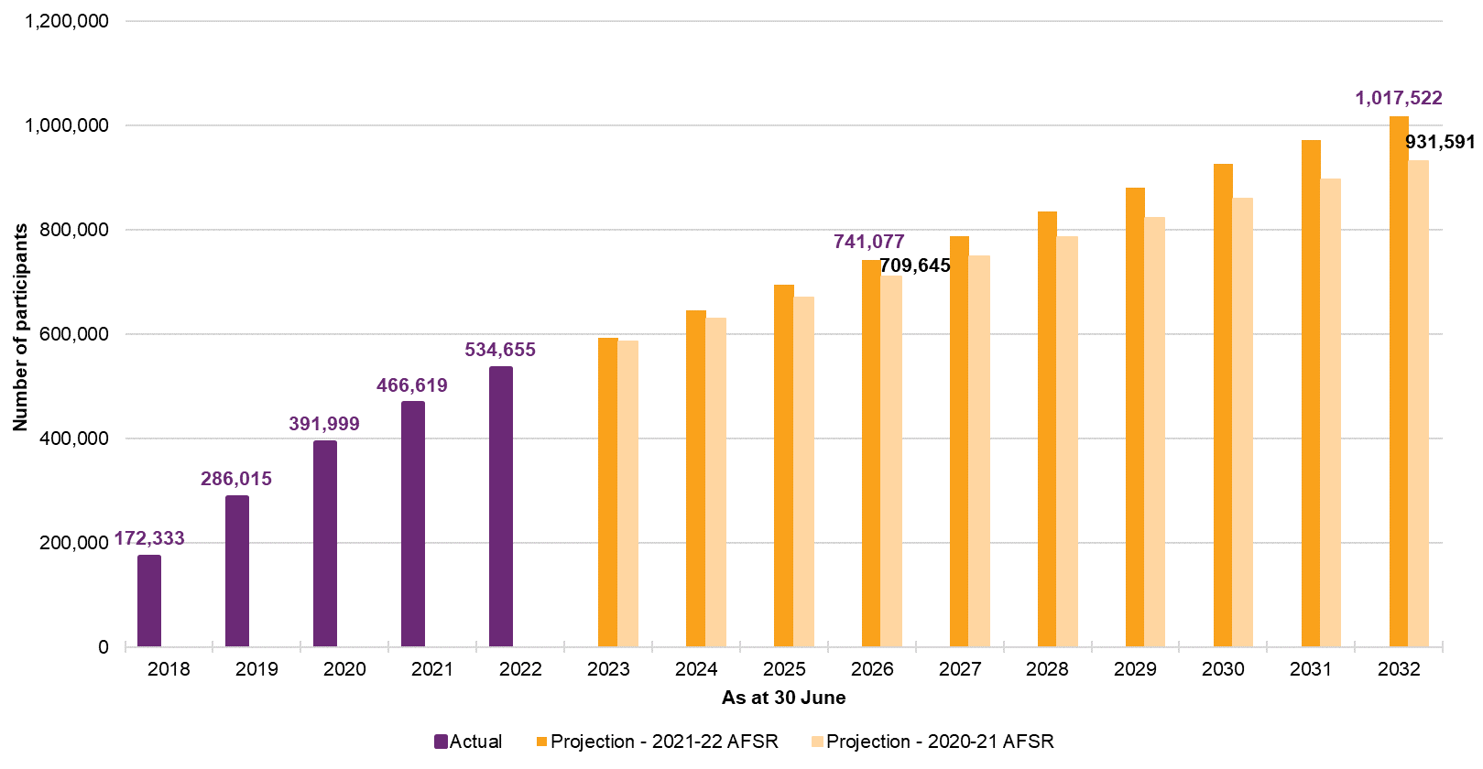
The drivers in the growth in the number of participants are the rate of new entrants to the Scheme and the rate at which participants leave the Scheme.
It is also important to note that the mix of participants in the Scheme is changing over time. A high proportion of recent new entrants to the Scheme are children and/ or have a high reported level of function compared with existing participants. Both children and those with a high level of function tend to have lower support needs than other participants. As a result, the average payment per new entrant to the Scheme is lower than that of existing participants, and so the increase in participant numbers does not necessarily lead to an increase in Scheme expenses of the same magnitude.
New entrants
The rate of new entry to the Scheme continues to be high, including in the geographical areas where the Scheme has been operating for several years. As an example, the rate of new entrants in geographical areas that commenced in 2014 was 380 participants per 100,000 population aged between 0 and 64 over the year ended 31 March 2022. This is approximately 40% higher than the 2020-21 AFSR assumed rate of 272 participants per 100,000 population aged between 0 and 64, and about 23% higher than the rate assumed at this review of 308 per 100,000 population aged between 0 and 64.
Figure 2: Expected new entrant rate together with observed experience for the year ended 31 March 2022 by financial phasing year
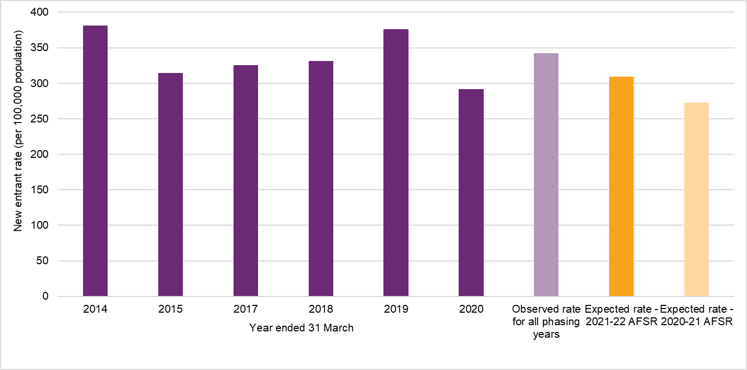
The new entrant assumption adopted at this review (308 participants per 100,000 population aged between 0 and 64), is 14% higher than the rate assumed in the previous review. The approach to modelling new entrants has evolved over time in response to the emerging experience and available data. More recently, the observed experience of new participants entering the Scheme has stabilised such that the new entrant rates adopted at this review have been estimated solely based on a method which relies on currently observed experience, whilst noting that the assumed number of new participants in the medium to long term is below the number recently observed. The details of the approach used, and the resulting new entrant assumptions are set out in Section 5.4.
Participants leaving the Scheme
A proportion of participants leaving the Scheme was always expected within the original Scheme design, as one of the Scheme’s objectives is that early investment and intervention should lead to capacity building and greater social and economic participation where support from the NDIS is no longer required.
The experience of participants leaving the Scheme has changed materially since the last full review which was completed in 2019 (using 2018 experience). The refinement to the eligibility reassessment process during 2019 and ongoing operational improvements since then have had a significant impact on the underlying experience, whilst the COVID-19 lockdown restrictions have had a significant though transitory impact on the experience since 2020.
The actual overall rates of participants leaving the Scheme from 2019 to 2021 were much lower than the long-term rate of 1.67% per annum adopted in the 2020-21 AFSR. As a result, overall rates of participants leaving the Scheme have been revised downwards from 1.67% to 1.19% (based on the participant mix at 30 June 2021).
Participants with Supported Independent Living
Since the previous review, analysis has been undertaken to understand the composition of the participants new to Supported Independent Living (SIL) arrangements between those participants transitioning from existing schemes and those who were new to disability supports.
Figure 3 shows that the revised projection is slightly higher than at the previous review. This reflects a higher number of participants having moved into SIL arrangements due to the clearing of backlogs of home and living decisions. While this initiative is well progressed, at this review a higher number of participants has been assumed to move into SIL in the future compared with the 2020-21 AFSR (with an increase of approximately 300 to 400 additional SIL participants per year).
Figure 3: Experience to date and projections of participants new to SIL
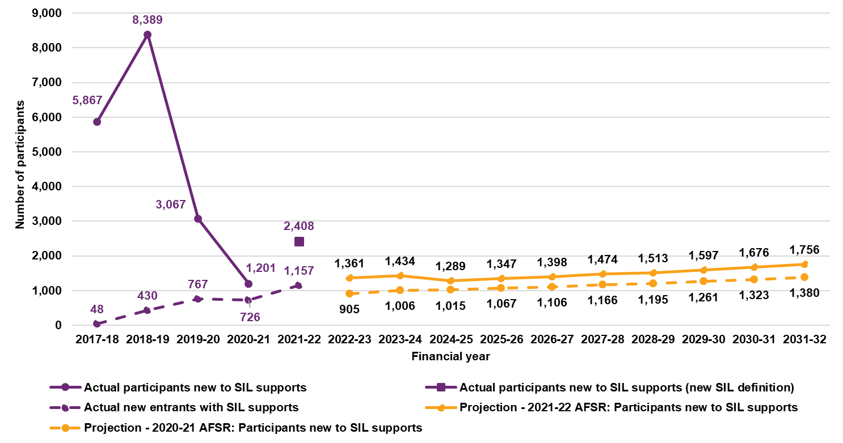
Payments experience 2021-2022
From 1 July 2021 to 30 June 2022, $27.6 billion in payments for supports were made on a cash basis across all participants. This was $1.2 billion or 4.2% less than the 2020-21 AFSR estimate of $28.8 billion. Total payments on an accrual basis were $28.6 billion, 2.0% lower than the 2020-21 AFSR estimate of $29.2 billion.
A significant component of the variance is estimated to be related to systemic impacts from COVID-19 on the supply of and demand for disability support services. Supply-side impacts that are likely to have driven lower payment experience include disability workforce shortages, mobility restrictions and workforce absenteeism from COVID illness and isolation requirements. Demand-side impacts include participant or family wariness of accessing supports due to COVID exposure and participant COVID infection and illness.

The impacts of the primary drivers of the variance in the Scheme expenses for 2021-22 are summarised in Table 6.
Table 6: Estimated drivers of variation in Scheme expenses in 2021-22
Drivers of variation | Estimated  Impact ($m) | Estimated Impact (%)
Participant numbers | +15 | -1%
Participant mix | -126 | 10%
Systematic supply and demand impacts | -440 | 37%
Provider compliance | -65 | 5%
Residential Aged Care variance | -175 | 15%
Total explained | -792 | 66%
Unexplained variation | -413 | 34%
Total variation (Actual less expected on cash basis) | -1,204 | 100%
In summary, the variance in Scheme expenses for 2021-22 compared with expected is explained by:
- Systematic disruptions to demand for and supply of services (estimated to be $440m or 37% of total variation)
- A lower than expected expense for participants in Residential Aged Care (estimated to be $175m or 15% of total variation)
- The mix of new entrants which have a relatively low per participant expense, (partially offset by higher than expected participant numbers overall) – estimated to be $111m or 9%
- Activities to address provider compliance; and
- Other items which are not explained as they are not able to be quantified.
Average payments per participant
Despite the lower than expected Scheme expenses in 2021-22, the average payment increased between 2020-21 and 2021-22 by 1.6% to about $55,200 per participant. This is lower than the increases observed in previous periods. Average payments have increased by 9.2% per annum over the last three years (Figure 4).
Figure 4: Average annualised payments over time ($)
Over the past four years, the mix of participants in the Scheme has changed. That is, as the Scheme has rolled out across the country, the proportion of participants by different characteristics has changed. In particular, the proportion of children in the Scheme at June 2022 is much higher compared to the proportion at June 2019, and the proportion of participants with SIL in the Scheme at June 2022 is lower compared to the proportion at June 2019.
In 2021-22, average payments increased by 5.1% for participants with SIL and 3.6% for participants without SIL compared to 1.6% overall. Over the last three years, the average annualised payment has increased for participants with SIL by 11.9%, and the average annualised payment has increased for participants without SIL by 14.4% as shown in Figure 5.
Figure 5: Average annualised payments over time by SIL status ($)
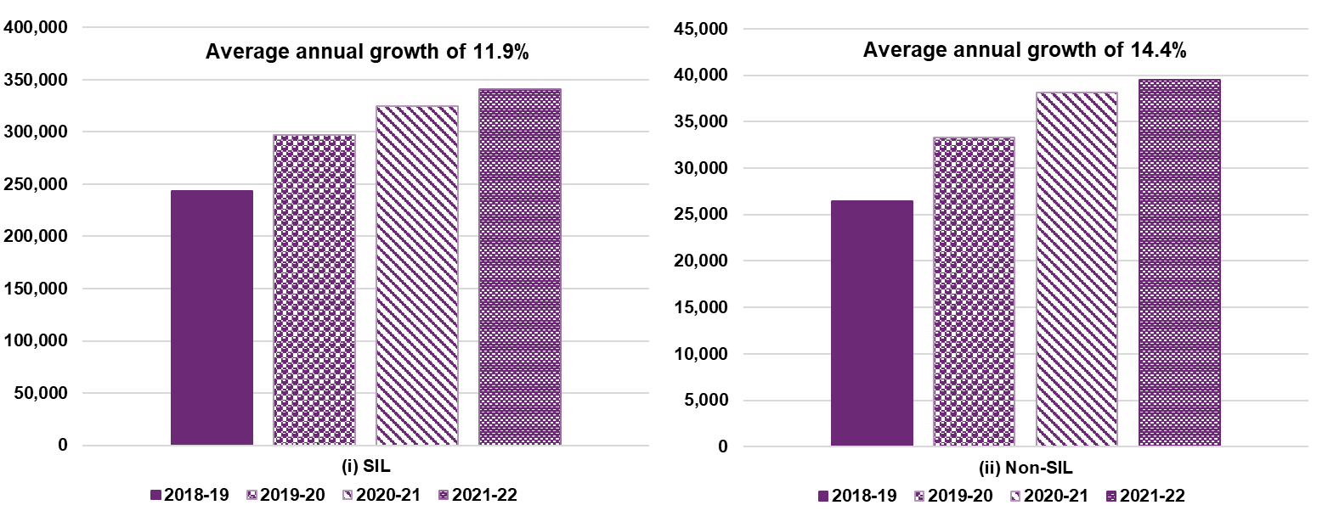
Figure 6 shows the change in average payment over time by age band for participants without SIL. The average annual increase over the last three years for participants aged 0 to 14 was 10% per annum, the average increase for participants aged 15 to 24 years was 9% per annum, the average increase for participants aged 25 to 64 was 19% per annum, and the average increase for participants aged over 65 was 20% per annum. For participants without SIL, average payments have increased at a faster rate for adults (those aged over 25). This reflects a material increase in the hours of attendant care support these participants are receiving over time.
Figure 6: Average annualised payments over time for participants without SIL by age band ($)
For age groups other than 25-64 years, the average annualised payment was very similar in 2021-22 compared with 2020-21, while the age group 25-64 saw an increase of 6% in average payment.

Inflation
An analysis has been undertaken to quantify the components driving historic inflation. Table 7 sets out the high-level results of the experience analysis where inflation is measured as the yearly change in average payments.
Table 7: Breakdown of past observed inflation in payments
Item of inflation | 2018-19 | 2019-20 | 2020-21 | 2021-22 | Average  2018-22 | Average 2019-22
Observed inflation | 9.2% | 19.7% | 6.9% | 1.6% | 9.2% | 9.2%
less normal inflation and price reviews | 6.4% | 12.0% | 2.1% | 2.4% | 5.6% | 5.4%
less change in mix | 1.5% | -6.6% | -9.2% | -6.2% | -5.2% | -7.4%
Additional inflation | 1.4% | 14.3% | 14.0% | 5.4% | 8.6% | 11.2%
Figure 7 sets out the quarterly rate of annualised plan inflation over the three years to June 2022, as well as the rolling 12-month average plan inflation rate. Total plan inflation is divided into inflation which occurs at plan review (interplan inflation) and inflation which occurs within a plan between reviews (intraplan inflation). At June 2022, total plan inflation for the previous 12 month period was 8.9% per annum, of which intraplan inflation made up 6.4% per annum. The rate has increased over the past six months, having been 5.6% for the twelve months to 31 December 2021.

Figure 7: Plan inflation for active participants
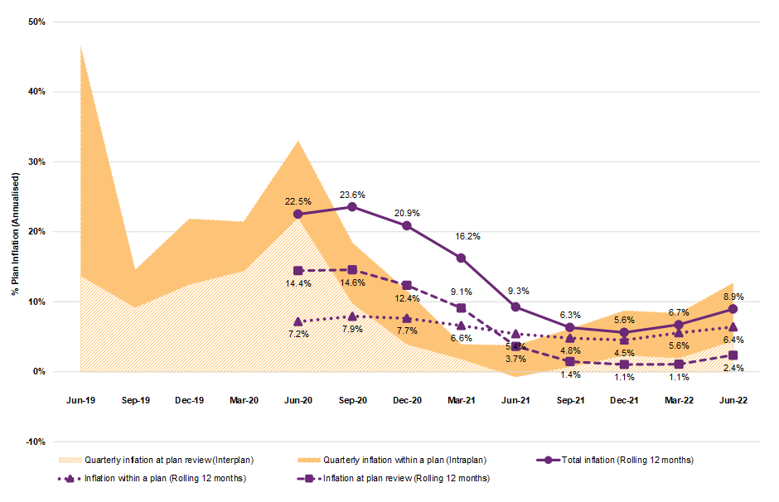
Plan inflation was also high over the preceding two years, averaging 22.5% in 2019-20 and 9.3% in 2020-21. This has been observed in other social insurance schemes in Australia and New Zealand, in the absence of substantial legislative or policy change.
Inflation assumptions
Normal inflation assumptions have been selected based on the increases in price limits from the 2021-22 Annual Price Review (APR) and on recent economic forecasts and inflationary expectations.
Additional inflation assumptions have been selected which are higher than those in the 2020-21 AFSR, with the exception of the first two years of the projection. However, they are still well below the average historical experience of the Scheme.
In 2022-23 and 2023-24, it is expected that additional inflation will continue to be constrained by supply side impacts of workforce shortages and also potentially by COVID-19 related effects. These constraints are expected to subside by 2024-25 and a higher rate of additional inflation is assumed, albeit lower than the rates observed in 2019-20 and 2020-21. This level of inflation is then expected to decrease marginally in 2025-26 before reducing to a long-term rate of 2% per annum. The long-term rate of additional inflation reflects that under the current parameters of the Scheme, inflationary pressures in excess of the general economic environment are likely to reduce as the Scheme continues to mature but will remain present.
Normal inflation has been combined with additional inflation rates to calculate total inflation. Table 8 details the underlying normal and additional inflation assumptions adopted for each projection year, with a comparison made to historic inflation experience. The adopted inflation assumptions compared with those from the previous review are shown in Figure 8.
Table 8: Comparison of historic inflation experience and adopted total inflation
Inflation on payments | Actual | Projection Year
Inflation on payments | Average  2019-22 | 2022-23 | 2023-24 | 2024-25 |  | 2025-26 | 2031-32
June 2021-22 AFSR
Normal inflation (incl. APR) | 5.4% | 7.2% | 2.6% | 3.6% |  | 3.6% | 3.3%
Additional inflation | 11.2% | 3.4% | 3.0% | 6.0% |  | 5.0% | 2.0%
Total inflation (excl. change in mix) | 16.6% | 10.6% | 5.6% | 9.6% |  | 8.6% | 5.3%
Change in Mix | -7.4% | -2.7% | -3.3% | -2.5% |  | -1.9% | -0.4%
Total Inflation (incl. change in mix) | 9.2% | 7.7% | 2.1% | 6.9% |  | 6.6% | 4.8%

Figure 8: Comparison of adopted total inflation with previous review
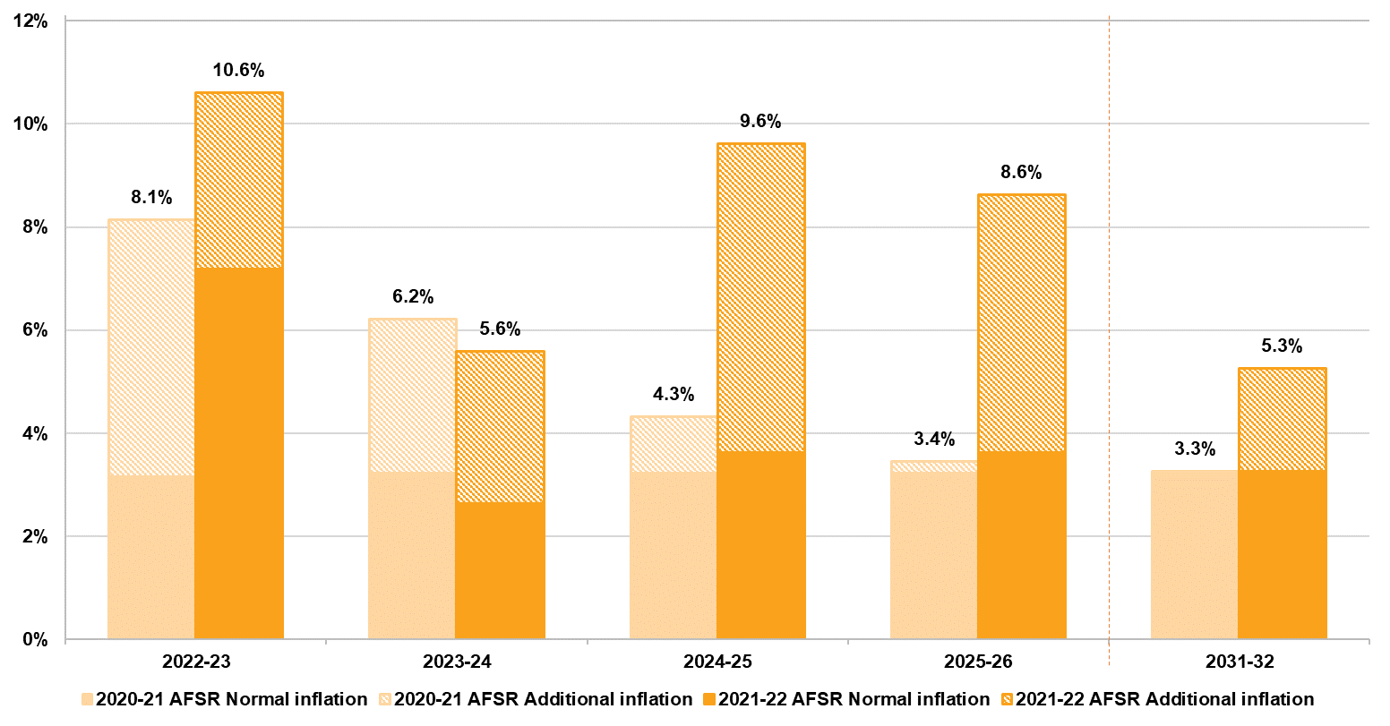
Overall higher normal inflation is adopted reflective of the 2021-22 APR and higher forecasts in relation to future inflation. Higher additional inflation assumptions (in addition to normal inflation) have been set taking into consideration:
- A deeper analysis of additional inflation has been undertaken, identifying various sources. This indicates that additional inflation has been driven by changes in participant level of function, a broadening in the types of supports utilised by participants, and an increase in the volumes of supports utilised, particularly in relation to attendant care. This analysis shows more detail regarding the forces driving the additional inflation and provides a stronger justification for the higher additional inflation assumed.
- In their Review of NDIA actuarial forecast model and drivers of Scheme costs, Taylor Fry concluded that a projection of Scheme expenses which is higher than the 2020-21 AFSR model would not be unreasonable. Taylor Fry noted that the allowance for additional inflation in the 2020-21 AFSR was likely to be on the low side given the significant upside risk related to inflation facing the Scheme.
- Observed additional inflation in payments over 2021-22 was 5.4%, and there is reasonable evidence that growth in payments would have been higher had it not been for both demand-side and supply-side effects arising from COVID-19. These effects have been estimated to have reduced payments by approximately, 2-3%, meaning the underlying additional inflation for 2021-22 was approximately 7-8%, considerably higher than future assumptions at the previous review.
- Current plan decision making resulted in increases in plans of approximately 9% over 2021-22, with an annualised rate of 12% over the quarter to June 2022. These figures included price increases of approximately 2%, meaning that real growth in plan values were approximately 7% over the 2021-22 year and 10% in the quarter to June 2022, rates which are also considerably higher than future inflation assumptions at the previous review.
- Any reduction in inflation from current levels will necessarily require fewer plan increases and/or more plan reductions relative to current, and there remains considerable uncertainty about the likelihood of this in the short to medium term as there are few substantive legislative, policy or operational responses currently planned to mitigate these plan increases. Exploratory initiatives in identifying and assessing fraud and compliance matters impacting the Scheme have commenced, however as these initiatives are in their preliminary stages of implementation, their impact on inflation levels was unclear at the time of assumption selections. These initiatives will continue to be closely monitored and will be appropriately factored in at future reviews as greater clarity on the estimated impact is better understood.
There is considerable uncertainty regarding these future levels of additional inflation, and the impact of different scenarios is quantified in Section 6.1.
Operating Expenses
The Agency maintains a detailed activity-based costing of its operations. The operating expenses adopted in this AFSR are based on this internal model. In 2021-22 actual operating expenses (at $1,590 million) were lower than budgeted in the Portfolio Budget Statements (PBS) by $83 million, or 4.9% (Table 9). In 2021-22 operating expenses represented 5.6% of Scheme expenses for participant supports, which is lower than the 2020-21 result of 6.3% of Scheme expenses.
Table 9: Actual operating expenses compared to expectations for 2021-22
Operating expenses - full year to 30 June 2022 | $m
Actual | 1,590
Budget (from 2022-23 PBS) | 1,672
Difference (Actual - Budget) | -83
Operating expenses, as a percentage of Scheme expenses, are projected to reduce over time, as the relative expense of bringing new participants into the Scheme is expected to reduce, and because the average payment per participant is expected to increase at a faster rate than the inflation rate assumed to underpin the Scheme’s operating expenses. Operating expenses are projected to be 5.2% of Scheme expenses for participant supports in 2022-23, reducing to 4.2% in 2025-26, and 3.4% in 2029-30.
The projected operating expenses of $1,780 million in 2022-23 are approximately $190 million (or 12%) higher than actual operating expenses in 2021-22 (and $107 million higher than the amount allowed for in 2021-22 in the 2022-23 PBS). However, this variance is regarded as relatively small in the context of the sustainability risks relating to Scheme expenses which are identified in this report, and the recommended operating expense range in the 2017 Productivity Commission study report, of 7 to 10% of Scheme expenses. In adopting an estimate which is considerably higher than both the actual and budgeted expenses in 2021-22, it is noted that significant investments are required, to develop stronger noncompliance payment controls and fraud mitigation measures, as well as to achieve a continued focus on improvement in participant experience (as prescribed by the Participant Service Guarantee (PSG) which was legislated in 2022). This investment needs to take the form of frontline capability and capacity, as well as strategic investments in broader organisation capabilities
Scenario analysis and uncertainty
The projections presented in Section 5 of this report represent the “baseline” estimate of Scheme population and expenses. There is considerable uncertainty in relation to these projections, and the actual expense may vary from the baseline projections, possibly significantly.
In the 2020-21 AFSR, a set of combined scenarios were used to illustrate a plausible range of projected Scheme expenses. Since the previous review, a stochastic model of the AFSR projections has been developed which provides a more rigorous approach to measuring the level of uncertainty in the projected Scheme expenses. Section 6 details the projected outcomes of varying key assumptions and an overview of the stochastic model. The stochastic simulation results in the projected Scheme expenses are shown in Figure 9.
Figure 9: Projected total annualised Scheme expenses with uncertainty bands
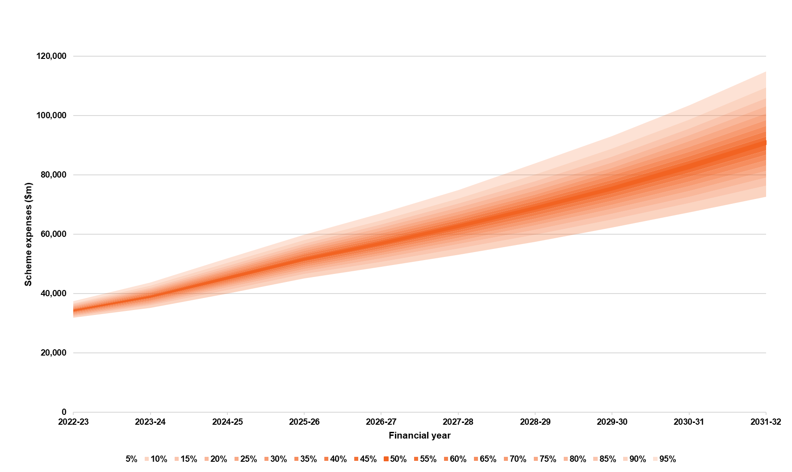
The 90% confidence interval for the range of expected outcomes for projected Scheme expense is:
- $31.8 billion to $37.4 billion for the year ending 30 June 2023, a range of $5.6 billion (16% of the baseline estimate).
- $153.4 billion to $191.6 billion for the four years to 30 June 2026, a range of $38.2 billion (23% of the baseline estimate).
- $72.7 billion to $115.0 billion for the year ending 30 June 2032, a range of $42.3 billion (47% of the baseline estimate).
For any given level of confidence, the range of expected outcomes widens with the duration of the projection, reflecting the increased uncertainty of assumptions and future experience in the longer term.
The key risks determined as part of the risk analysis were additional inflation, model specification risk, normal inflation, the numbers of new entrants to the Scheme and projected plan utilisation.
Outcomes
A holistic assessment of Scheme financial sustainability requires consideration of both the costs of participant funding and the associated benefit the funding provides for participants in enabling them to achieve the desired goals and outcomes.
In the NDIS Corporate Plan 2021-25, Aspiration 1 is “a quality experience and improved outcomes for participants”. Aligned to Aspiration 1 are specific performance metrics, such as the proportion of participants in work and the proportion of participants involved in community and social activities. The NDIA had a target of 24 per cent of working-age participants in paid employment by June 2022, with the achieved result of 23 per cent slightly below this target. For participants aged 15 and over, the percentage of participants actively involved in the community was 43% compared to the 2021-22 target of 48%.
The NDIS Outcomes Framework also measures outcomes for the families and carers of participants, recognising that the outcomes for people with a disability and the people who support them are likely to be closely linked. The percentage of parents/carers of participants in a paid job is 50% compared to the 2021-22 target of 49%.
On the whole, perceptions of the Scheme have been positive, with participants and their families/carers more likely to report that the Scheme had helped them in various areas of their lives the longer the participant was in the Scheme. Participant outcomes and family and carer outcomes are further discussed in Section 7.

Introduction
An annual financial sustainability report (AFSR) is required under section 180B of the NDIS Act and provides an assessment of the financial sustainability of the National Disability Insurance Scheme (“the Scheme”, or NDIS). This report includes analyses and discussion on recent Scheme experience, best estimate projections of future participant numbers and expenses (based on emerging experience and future expectations), and strategies to address risks to sustainability.
On 18 October 2022, the Minister for the National Disability Insurance Scheme (NDIS) announced the Independent Review into the NDIS to improve the wellbeing of Australians with disability and ensure the Scheme’s sustainability so that future generations receive the benefit of the NDIS.
It is expected that the Review will lead to changes in the NDIA’s work plan. Initiatives and activities described in this report, which commenced prior to the announcement of the Review, should be viewed in that context.

Background
The purpose of the NDIS is to provide reasonable and necessary funding to people with a permanent and significant disability so that they have choice and control over the supports and services they need to pursue an ordinary life. A key cornerstone underlying the operation of the Scheme is strong insurance principles, where evidence-based decisions on access and planning are made by drawing on objective information on individuals and the longitudinal data that is collected on participants in the Scheme. Experience is closely and regularly monitored to allow emerging risks and issues to be identified and where required, remediation strategies to be implemented.
The Scheme has a lifetime, person-centric approach to its model of support for people with disability, where early investment in core, capacity building and capital supports are anticipated to drive better outcomes for participants and their family/carers over their lifetime.
The NDIS Insurance Principles and Financial Sustainability Manual outlines the insurance model in detail and defines financial sustainability as the state where:
- the Scheme is successful on the balance of objective measures and projections of economic and social participation and independence, and on participants’ views that they are getting enough money to buy enough goods and services to allow them reasonable access to life opportunities - that is, reasonable and necessary support.
- contributors think that the cost is and will continue to be affordable, under control, represents value for money and, therefore, remain willing to contribute.
The current government expectation of Scheme expenses is included in the annual Portfolio Budget Statements (PBS), noting it is not only the financial cost of the Scheme that is important within the context of financial sustainability, but also the outcomes for participants achieved by the Scheme.
Outcomes for participants and their families/carers are reported regularly in the NDIA’s Quarterly Reports to Disability Ministers, and more detailed analysis and data is available on the NDIA Data and Insights website. Section 7 of this report contains key information relating to outcomes measurement and recent results of the outcomes being achieved by Scheme participants, their families and carers.

Financial sustainability of the NDIS
The NDIS has been in operation since 1 July 2013. The first three years of the Scheme were a trial period, and this was followed by the transition period which commenced on 1 July 2016, with the Scheme progressively rolled out across the country within four years.
Since inception, the National Disability Insurance Agency (“the Agency”, or NDIA) has had an increasing focus on improving participant experience. The Participant Service Charter sets out what participants can expect from the NDIA. It is being actioned under the Participant Service Improvement Plan 2022-23 which sets out how the Agency is working towards increased consistency and transparency of decision making with better operational procedures, guidelines and controls. The Agency is also designing and building a new Information and Communication Technology (ICT) system which will provide an enhanced Customer Relationship Management system and improve the end-to-end participant pathway.
However, significant pressures on the financial sustainability of the Scheme remain and have become more significant. This is reflected in the upward revision of projected Scheme expenses in past AFSR and PBS estimates over time.
There are few substantive legislative, policy or operational responses currently planned to mitigate upward cost pressures. While improvements to Agency processes are underway, as well as initiatives to address fraud and compliance, many of these are at an early stage. To the extent that any such initiatives are already implemented they will be reflected in the experience used to set the assumptions at this review, but no additional future savings have been allowed for explicitly.

Reliance and limitations
It is the responsibility of the Agency and other parties to ensure that recipients of copies of, or extracts from, this document understand the reliances on which any conclusions in this document are based.
Given the long-term nature of the Scheme, experience continues to be relatively immature, and many aspects remain difficult to interpret. Specifically, estimation of future expenditure based on experience is inherently challenging given the relative size, complexity, and immaturity of the Scheme, meaning there is significant uncertainty in the projection. In addition, within emerging experience to date, issues have been identified with the current resource allocation process, and in particular the lack of a mechanism for robust assessments of support need. As the Scheme continues to mature, and staff, operational and governance capabilities improve, there is an expectation that the Scheme experience will change, perhaps materially, and this would affect the eventual trajectory of Scheme Expense.
Future events, which cannot currently be predicted, may also occur and would have an unexpected impact on Scheme experience and thus the projections in this report. For example, the COVID-19 pandemic was an unforeseen event that posed some initial uncertainty to participant experience, outcomes and cost trajectory of the Scheme in 2020. The impacts of COVID-19, and related issues such as workforce shortages in the disability sector, remain significant and there is a high level of uncertainty regarding how long this will continue to be the case.
Lastly, more data on Scheme experience is available in NDIA quarterly reports and on the NDIA Data and Insights website.

Information and data integrity
An integral part of an insurance model is the collection of accurate data in a timely manner. This is because quality data drives the ability of the Agency to monitor emerging experience, perform meaningful analyses, project the financial position of the Scheme and, hence make consistent evidence-based decisions to support Scheme objectives. The success of the Scheme is dependent on the availability and quality of the data and information collected.
The data collected by the Agency is varied and broad-reaching and covers information across each step of the participant pathway, from Scheme access and eligibility to participant plan approval, plan implementation and plan review. Payments for disability supports and the outcomes for participants and their family/carers are also collected regularly to track progress of participants and the Scheme. The information being collected enables the Agency to continually build one of the most comprehensive, longitudinal data sources on disability in the world.
Information and data used for analysis
The actuarial analysis underpinning this report relies upon the Agency’s case management system, finance system and data warehouse, as well as external sources (such as various industry benchmarks and population surveys). While there is a substantial amount of data in the current Client Relationship Management (CRM) system, this section focuses on the data utilised for the analysis presented in this report.
The analysis in this report is based on data at 30 June 2022, unless stated otherwise. The sources of data are summarised in Table 2.1

Table 2.1: Summary of data utilised for actuarial analysis
Data | Description
Access requests to the NDIS | - Demographic information (age, gender, disability, geographic location, living arrangements and other participant profile information)  - Contact details  - Access request date  - Outcome of request (for example: eligible, ineligible)
Payments to service providers | - Service provider submitting the claim for payment  - Participant for whom the support was provided  - The support item and cost of support provided  - Dates of when the support was provided  - Method of plan management used
Payments to participants | - Participant submitting the claim for payment  - The support category provided  - Total amount spend on support category  - Period of reimbursement
NDIS participant plans | - Plan approval date  - Length of plan  - All plan budgets included in the plan  - Level of function  - Reference package and typical support package
In-kind supports data | - Unit record in-kind support details from State/Territory programs including details on support type, level and duration of coverage.
Data on outcomes | - For participants entering the Scheme from 1 July 2016, data on outcomes has been collected from 99% of all participants, with the intention to collect information from all participants.
Financial information | - Data from the SAP CRM system were reconciled with financial information in SAP.
ABS Survey of Disability, Ageing and Carers | - Prevalence of disability in Australia, including demographic and socioeconomic profile of people with disabilities.
Economic information | - Government economic forecasts for GDP  - Inflation indicators
Demographic information | - Australian Life Tables 2018-2020 – published in November 2021  - Population forecasts – estimated for the 2021 Intergenerational Report  - Budget 2022-23: population projections, Australia, 2021-22 to 2032-33 from the Centre for Population Projections

Modelling approach
An experience-based projection model continues to be used to project Scheme participant numbers and Scheme expenses. To reflect the ongoing maturing of the Scheme, the latest developments in Scheme experience, and refinements to operational processes, several enhancements to modelling techniques have been undertaken since the previous AFSR.
As with previous AFSRs, the 2021-22 AFSR is based on projecting average payments made for supports for 2,052 participant cohorts. The average payments for each cohort are then multiplied by projected participant numbers and summed across all cohorts to arrive at the total Scheme expenses.
To enable a closer alignment to the Agency’s plan budget setting process, the projection model has been enhanced to include projection of future plan budgets. This complements the total payment projections and allows future utilisation rates to be estimated.
Plan budget projections are included in Section 5.3 of the report, along with the projected utilisation rate which is calculated as the ratio of the Scheme expense to these projected plan budgets.
Assumptions have been set considering factors both internal and external to the Scheme. External factors include broader macroeconomic factors, to the extent they impact the Scheme. Internal factors include trends in past numbers of participants and payments per participant.
As with any projection, there is uncertainty in the results. This is particularly relevant given the heightened systemic risk due to the factors mentioned above. As the Scheme continues to mature, the expected trajectory of Scheme experience and projected expenses can change materially, resulting from the decisions and actions of the Government and Agency and the Australian and global economic climate. Two approaches have been used to illustrate the drivers of uncertainty and the estimated impacts those have on the projection results:
- Testing the sensitivity of projected Scheme expenses to changes in specific key assumptions in Section 6.1, and
- Projecting Scheme expenses using a stochastic model which provides a more holistic view of the interaction between material risks facing the Scheme and the variability in these risk factors. The approach and results of this model are included in Section 6.2.
Figure 3.1 summarises the modelling approach in graphical format, with the main components of the modelling approach noted below.
Participant numbers
- Annual population projections are calculated by exact age and cohort by adding participant intake to the starting population as at 30 June 2022, subtracting reduction due to mortality and participants leaving the Scheme, and ageing the remaining participants by one year.
- Each cohort is differentiated by age band (summarised into nine groups), primary disability and level of function (57 groups), gender (two groups) and whether a participant is accessing SIL supports (two groups). This leads to 2,052 unique cohorts.
- The number and profile of participants expected to enter the Scheme in each projection year is based on the historic profile of new entrants, split between:
  - New incidence to disability; and
  - Previously unmet need for disability supports.
- Prior to the Steady Intake Date of 30 June 2024, some allowance is made for participants with previous unmet need. Beyond the Steady Intake Date, the projected number of new entrants is based on the assumed new incidence to disability rate.
- There is also a transition model to explicitly allow for participants who enter the Scheme with developmental delay but are later determined to have autism or an intellectual disability. Some participants with a developmental delay will transition to another disability once a diagnosis has been made. These transfers typically happen between the ages of 5 to 8, although this can also occur outside of these ages.
- The number of participants in SIL arrangements is modelled based on an assumed proportion of each cohort, with the increase in the total number of participants with SIL being based on recently observed experience. Participants with SIL are modelled explicitly despite only comprising 5% of all participants, as they contribute significantly to Scheme expenses (32% over 2021-22).
Scheme Expenses relating to participant supports
- Payments per participant are estimated by cohort using annualised payment levels for the three months to 31 May 2022 for “active and mature” participants, i.e., participants who were had an approved plan at both 28 February 2022 and 31 May 2022, and had their first plan approved on or prior to 28 February 2021. Allowance is made for monthly seasonality typically observed and payments in June 2022 are checked to ensure that they do not vary substantially from those assumed.
- Explicit allowance is made for variance in average payment per participant for future new entrants, relative to the broader Scheme population.
- Expenses are projected on a cash flow basis, representing the estimated rate of outflows from the Scheme (noting in-kind supports are expected to be used evenly throughout a participant’s plan). Scheme expenses are split between 15 different support categories.
- Inflation of expenses is added in future years from both normal inflationary sources and sources of additional inflation.
- Accrual factors are derived for each of the 15 different support categories to convert the Scheme expenses from a cash basis to an accrual basis.
Total Scheme expenses
- Operating expenses are added to Scheme expenses related to participant supports to calculate total Scheme expenses.
- The sensitivity of results is tested by varying key assumptions and recalculating the estimated total Scheme expenses. A stochastic AFSR projection model based on a condensed set of model points is also used to reflect uncertainty within the projections.
Projected plan budgets
- Projected plan budgets are estimated by cohort using annualised plan budget levels for the month of 31 May 2022 for “mature participants”. An allowance is made for monthly seasonality typically observed and plan budgets in June 2022 are checked to ensure that they do not vary substantially from those assumed.
- Explicit allowance is made for variance in average plan budgets for future new entrants, relative to the broader Scheme population.
- Projected plan budgets are split between 15 different support categories.
- Inflation of plan budgets is added in future years from both normal inflationary sources and sources of additional inflation.
Stochastic Model
In addition to the deterministic projections in this report, a stochastic projection model was developed to analyse the uncertainty of future Scheme expense outcomes (‘Stochastic Model’).
Stochastic simulation has been used to determine 5,000 simulated outcomes. Each simulation randomly selected plausible outcomes for key assumptions. The plausible variation in assumptions were based on an analysis of historic data, appropriate external benchmarks, previous scenario analysis and actuarial judgement. This gave cash-flow ranges for each projection year.
A scan of internal NDIA reporting and external publications has been used to identify the key risks that are most likely to impact on the uncertainty of future cash flows of the Scheme. These key risks have been consolidated, where appropriate, and then analysed for materiality in their contribution to future projection uncertainty.
The methodology underlying the Stochastic Model can be described as:
- The number of model points has been determined based on the ability of the model to vary assumptions related to the key risks that are expected to influence future Scheme expense projection outcomes.
- Future participant numbers for each cohort have been determined as the number of participants at the start of each financial year, plus new entrants, less mortality and participants leaving the Scheme, less those ageing into the next age band grouping, plus those ageing up from the previous age band grouping, plus/minus transitions of functional capacity for those in developmental delay, plus/minus transition of participants into Supported Independent Living (“SIL”).
- Future cash flows have been calculated using average payments for each cohort, updated for inflation in future periods, multiplied by the average number of participants in the cohort for each financial year multiplied by an incurred cost development factor.
- Stochastic elements have been introduced to the assumption setting related to the key risks. These assumptions have been allowed to vary stochastically based on their expected future variation. This approach captures the compounding of risks over time.
- In instances where relationships between key risks are assumed, the correlations are generated by the creation of two unit normal random variables using a Cholesky decomposition of contemporaneous covariance matrix.

Figure 3.1: Schematic of modelling approach using the average payment-based model

Scheme experience
This section includes trends in Scheme experience to 30 June 2022. Comparisons of actual experience are made to projections from the previous review relating to key drivers of Scheme expenses including participant numbers, average payment per participant, plan budgets, inflation experience and historic utilisation rates.

Participant numbers
The Scheme population continues to grow at a rapid rate, considerably more than population growth, with an increase of 14.6% in active participants compared to the Scheme population at 30 June 2021. The increase reflects the net effect of new entrants and participants leaving the Scheme over the past 12 months as shown in Figure 4.1.
Figure 4.1: Active participants in the Scheme by quarter over the past 3 years

Actual versus expected participant numbers
The net increase in Scheme participants was higher than expected
The Scheme population of 534,655 active participants at 30 June 2022 was 0.8% (or 4,198) higher than that expected from the previous review. The net increase in participants over the 12 months to 30 June 2022 was 68,036, or 6.6% higher than expected.
Table 4.1: Actual versus expected total participant numbers and net increase at 30 June 2022
At 30 June 2022 | Actual | Expected | Difference | %Difference
Participant Numbers | 534,655 | 530,457 | 4,198 | 0.8%
Net Increase over past 12 months | 68,036 | 63,838 | 4,198 | 6.6%
The comparison of actual net increase in participants to that expected from the previous review is shown in Table 4.2, Table 4.3, Table 4.4, and Table 4.5 by key participant characteristics (participants with SIL and without SIL, age group, primary disability group and reported level of function respectively).
Table 4.2 illustrates that the net increase in participants with SIL (including those who were already in the Scheme but transferred to receiving SIL during the year) was more (1,295 or 116.3%) than expected. This reflects a higher number of participants moving into SIL arrangements due to the clearing of backlogs of home and living decisions.
Due to operational changes since July 2020, there has been a known issue with identifying participants with SIL. From May 2022 onwards, an automated and more accurate method has been applied in identifying participants with SIL, leading to restatement of both the actual and expected number of participants with SIL from July 2020 to April 2022. This issue is now resolved, therefore no further restatement is expected going forward.
Table 4.2: Actual versus expected net increase in number of participants with SIL at 30 June 2022
SIL Status | Actual | Expected | Difference | %Difference
SIL | 2,408 | 1,113 | 1,295 | 116.3%
Non-SIL | 65,628 | 62,725 | 2,903 | 4.6%
Total | 68,036 | 63,838 | 4,198 | 6.6%
Table 4.3 illustrates a higher than expected net increase in participants across each age group above age 14. The biggest differences were in the cohort aged 15 to 18, where the net increase was 1,141 more than expected (16.3% higher), followed by participants aged 25 to 34 and those aged 35 to 44 where the net increases were 1,005 more than expected (21.9% higher) and 918 more than expected (24.6% higher) respectively.
Despite large percentage increases above age 14, these cohorts accounted for only slightly more than half of the total participants. The net increase in participants aged 0 to 6 and aged 7 to14 were slightly less than expected, and hence overall participant numbers were only 6.6% higher than expected.
Table 4.3: Actual versus expected net increase in participants in 2021-22 by age group
Age Group | Actual | Expected | Difference | %Difference
0 to 6 | 10,605 | 10,640 | -35 | -0.3%
7 to 14 | 18,475 | 18,764 | -289 | -1.5%
15 to 18 | 8,122 | 6,981 | 1,141 | 16.3%
19 to 24 | 5,614 | 5,073 | 541 | 10.7%
25 to 34 | 5,601 | 4,596 | 1,005 | 21.9%
35 to 44 | 4,648 | 3,730 | 918 | 24.6%
45 to 54 | 4,114 | 3,712 | 402 | 10.8%
55 to 64 | 5,442 | 5,441 | 1 | 0.0%
65+ | 5,415 | 4,902 | 513 | 10.5%
Total | 68,036 | 63,838 | 4,198 | 6.6%
Table 4.4 illustrates that the net increase in participants across most primary disability groups differed significantly from that expected at the previous review. The largest deviation arose from participants with autism, where there was a net increase of 7,237 more than expected (30.4% higher), with over 75% of this variation arising from age 0 to 18. This includes those who entered the Scheme as well as those who were already in the Scheme but whose primary disability changed to autism less those who left the Scheme or passed away. This was partly offset by fewer than expected participants with a primary disability of developmental delay (1,778 or 13.4% lower), intellectual disability (1,645 or 24.2% lower) and other physical disability (1,147 or 60.4% lower).
Table 4.4: Actual versus expected net increase in participants in 2021-22 by primary disability
Primary Disability | Actual | Expected | Difference | %Difference
Acquired Brain Injury | 1,755 | 1,174 | 581 | 49.5%
Autism | 31,061 | 23,824 | 7,237 | 30.4%
Cerebral Palsy | 634 | 672 | -38 | -5.7%
Developmental Delay | 11,485 | 13,263 | -1,778 | -13.4%
Hearing Impairment | 2,252 | 2,951 | -699 | -23.7%
Intellectual Disability | 5,158 | 6,803 | -1,645 | -24.2%
Multiple Sclerosis | 1,000 | 768 | 232 | 30.3%
Other | 2,596 | 1,454 | 1,142 | 78.5%
Other Neurological | 1,596 | 1,812 | -216 | -11.9%
Other Physical | 751 | 1,898 | -1,147 | -60.4%
Other Sensory/Speech | -515 | 209 | -724 | -346.1%
Psychosocial Disability | 8,099 | 7,135 | 964 | 13.5%
Spinal Cord Injury | 429 | 305 | 124 | 40.4%
Stroke | 1,159 | 957 | 202 | 21.1%
Visual Impairment | 576 | 611 | -35 | -5.8%
Total | 68,036 | 63,838 | 4,198 | 6.6%
Table 4.5 illustrates that the net increase in participants with a reported high level of function was lower than expected, while that of medium and low levels of functions was higher than expected.
Table 4.5: Actual versus expected net increase in participants in 2021-22 by reported level of function
Reported Level of Function | Actual | Expected | Difference | %Difference
High | 21,474 | 25,425 | -3,951 | -15.5%
Medium | 34,311 | 30,532 | 3,779 | 12.4%
Low | 12,309 | 7,880 | 4,429 | 56.2%
Missing | -58 |  | -58
Total | 68,036 | 63,838 | 4,198 | 6.6%
Reported Levels of function continue to reduce
A persistent deterioration in reported levels of function is observed within the participant population. This can be seen in Figure 4.2 which shows the reported functional distribution for participants who entered the Scheme prior to 30 June 2017. It indicates that over time the proportion with a high level of function has decreased, and the proportions with low levels of function have increased. The shift in distribution was most significant in the initial years after participants entered the Scheme, although there remains a noticeable change in the fifth and sixth years.
Similar trends are consistently observed for participants who entered in later years (post 2017) and for individual cohorts of participants. The deterioration of level of function is present in all disability groups, and in most age groups (children or adults), whether the actual participant number is higher or lower than expected. Despite this, the pace and extent of deterioration varies across disabilities.
It is likely that the shift reflects inconsistent assessments over time, and it has been associated with increasing Scheme expenses (as participants with lower function on average have higher support packages and hence higher average payments).
Figure 4.2: Change in reported functional distribution from 30 June 2017 to 30 June 2022
The increase in participants with SIL was higher than expected
The number of Scheme participants with SIL has increased due to existing participants moving into SIL arrangements, and, to a lesser extent, new entrants requiring SIL supports. The increase in 2021-22 was higher than in 2020-21, as shown in Figure 4.3.
Figure 4.3: Increase in participants with SIL over the past 3 years
At 30 June 2022, the number of participants with SIL was 5% higher than expected at 26,950. The net increase in participants with SIL during 2021-22 was 116% higher than expected (Table 4.6). This reflects a higher number of participants moving into SIL arrangements due to the clearing of backlogs of home and living decisions.
Table 4.6: Actual versus expected total participant numbers and net increase in SIL (expected adjusted for SIL restatement)
At 30 June 2022 | Actual | Expected | Difference | %Difference
Numbers of Participants with SIL | 26,950 | 25,655 | 1,295 | 5.0%
Net Increase in SIL | 2,408 | 1,113 | 1,295 | 116.3%
The higher than expected net increase in participants with SIL was primarily due to those aged 45 years and over (Table 4.7).
Table 4.7: Actual versus expected net increase in participants with SIL by age group at 30 June 2022
Age Group | Actual | Expected | Difference | %Difference
0 to 18 | 20 | 15 | 5 | 32.1%
19 to 24 | 186 | 136 | 50 | 36.4%
25 to 34 | 276 | 248 | 28 | 11.5%
35 to 44 | 312 | 179 | 133 | 74.8%
45 to 54 | 249 | -1 | 250 | -27685.0%
55 to 64 | 699 | 148 | 551 | 373.2%
65+ | 666 | 389 | 277 | 71.4%
Total | 2,408 | 1,113 | 1,295 | 116.3%
The largest net increases by primary disability were for intellectual disability, psychosocial disability and other neurological. The net increase was higher than expected for all disability types except for autism (Table 4.8).
Table 4.8: Actual versus expected net increase in participants with SIL by primary disability at 30 June 2022
Primary Disability | Actual | Expected | Difference | %Difference
Autism | 316 | 375 | -59 | -15.6%
Intellectual Disability | 538 | 292 | 246 | 84.2%
Psychosocial Disability | 489 | 258 | 231 | 89.8%
Sensory Disabilities | 8 | 5 | 3 | 62.4%
Other Disabilities | 1,057 | 184 | 873 | 475.0%
Total | 2,408 | 1,113 | 1,295 | 116.3%
Overall, at 30 June 2022 approximately 5.0% of Scheme participants are currently in SIL arrangements, slightly lower than the proportion of 5.3% 12 months ago (Figure 4.4). This is a continuation of a downward trend which can be observed over the last three years, as a result of the changing mix of participants in the Scheme. Many new entrants are children or young adults with lower support needs than existing participants and the transition of participants with SIL from State/Territory and Commonwealth programs into the Scheme has tapered off. This reducing proportion of participants with SIL leads to a reduction in the overall (Scheme level) average payment per participant as the new participants have lower levels of support need, on average, than existing participants.
Figure 4.4: Active participants in the Scheme over the past 3 years, split by SIL status
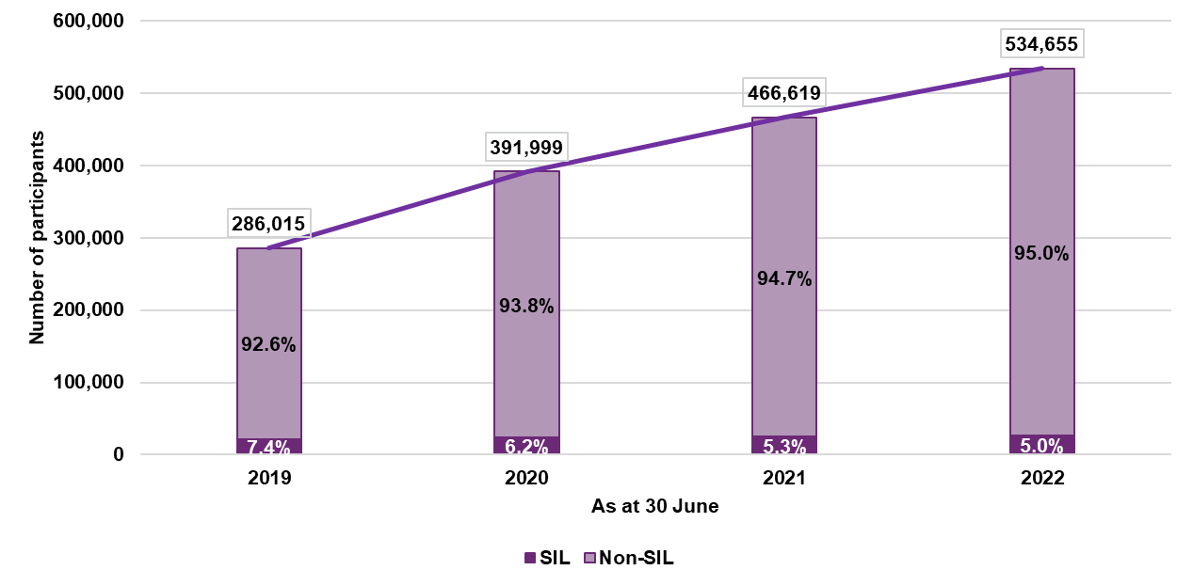
Scheme participants as a proportion of the general population continue to increase
Participation rate refers to the proportion of the Australian population who are NDIS participants. The rate varies by age and gender, reflecting the prevalence of different disability groups.
Figure 4.5: Participation rates by age and gender at 30 June 2022
The rate of net increase in participant numbers declined in 2021-22 as transition from the State/Territory disability programs has tapered off and almost all new entrants are individuals who are new to disability supports. The net increase in participant numbers in the 12 months to June 2022 was 68,036, lower than the net increase of 74,620 in the 12 months to June 2021.
However, the participation rates for mature regions continue to exceed benchmark levels assumed in the original Scheme design. Figure 4.6 displays the participation rate for each phasing cohort by the number of quarters since phasing into the Scheme commenced. The development curves show the proportion of active participants aged from 0 to 64 (compared to the general population) in the Scheme at specific development points in time. Increases over time reflect participants entering the Scheme while reductions reflect participants leaving the Scheme, passed away or turning age 65.
It was expected that these participation curves would “flatten out” over time. However, the Scheme population in these regions continues to increase above general population growth, and participation rates for ages 0 to 64 have continued to rise even in more “mature” geographical areas, with little sign of slowing. As an example, the unbroken dark purple line represents the participation rate of the regions that phased into the Scheme in the September 2013 quarter (e.g., Barwon in Victoria and Hunter in NSW). It is evident that even after 35 quarters (more than nine years), there remains an upward trend in the number of participants entering the Scheme.
Figure 4.6: Participants as a proportion of Australian population since phase-in date – aged 0 to 64
Figure 4.7 displays the participation rate for participants with autism by phase-in quarter. It shows the same trends as Figure 4.6 (i.e., the participation rate curves do not flatten out over time). These curves are steeper than those in Figure 4.6, indicating that the participation rate for autism is increasing faster than that of the Scheme as a whole.

Figure 4.7: Participants with Autism as a proportion of Australian population since phase-in date – aged 0 to 64
The number of new entrants to the Scheme is not reducing
The two drivers in the growth in the number of participants are the rate of new entrants to the Scheme, and the rate at which participants are leaving the Scheme or passing away. The rate of new entrants to the Scheme continues to be high. This can be seen in Figure 4.8 which shows the actual number of new entrants by year, together with the projected number of new entrants in the 2021-22 year from the 2020-21 AFSR. This chart shows that the actual number of new entrants in the year ended 30 June 2022 (79,321) only declined marginally compared to the actual number of new entrants in the year ended 30 June 2021 (80,453) and was significantly higher than those projected in the 2020-21 AFSR (72,741).
Figure 4.8: Number of new entrants to the Scheme aged 0 to 64 by financial year
Rates of participants leaving the Scheme have increased due to backlog clearances
Within the context of financial sustainability, it is important to understand the emerging experience of participants leaving the Scheme. Participants may leave the Scheme for various reasons and are analysed in two categories for projection purposes:
- Mortality: participants who have passed away.
- Participants leaving the Scheme: participants who no longer meet the Scheme’s eligibility criteria, have chosen to leave the Scheme of their own accord, or have chosen to move into residential aged care if over the age of 65. A proportion of participants leaving the Scheme was always expected within the original Scheme design, as one of the Scheme’s objectives is that early investment and intervention should lead to capacity building and greater social and economic participation where support from the NDIS is no longer required.
Figure 4.9 shows the experience of mortality and participants leaving the Scheme in the calendar years of 2019, 2020, 2021 and first half of 2022, compared to long-term expectations from the previous review. Experience of participants leaving the Scheme was well below expected from 2019 to 2021, due to low number of eligibility reassessments and COVID-19 related restrictions. Resumption of reassessment activities was slow until the first half of 2022, when additional resources were deployed to clear a backlog which had arisen. As a result, the rate of participants leaving the Scheme observed during 2022 has been higher and much closer to the long-term assumption adopted in the previous review. However, this is not expected to continue as the backlog has now been cleared.
Recent mortality rates were slightly higher than expected in the 2020-21 AFSR at 1.10% per annum in the six months to 30 June 2022 compared to 0.94% per annum expected for the calendar year of 2021 (CY2021).
Figure 4.9: Actual versus expected – rate of mortality and participants leaving the Scheme
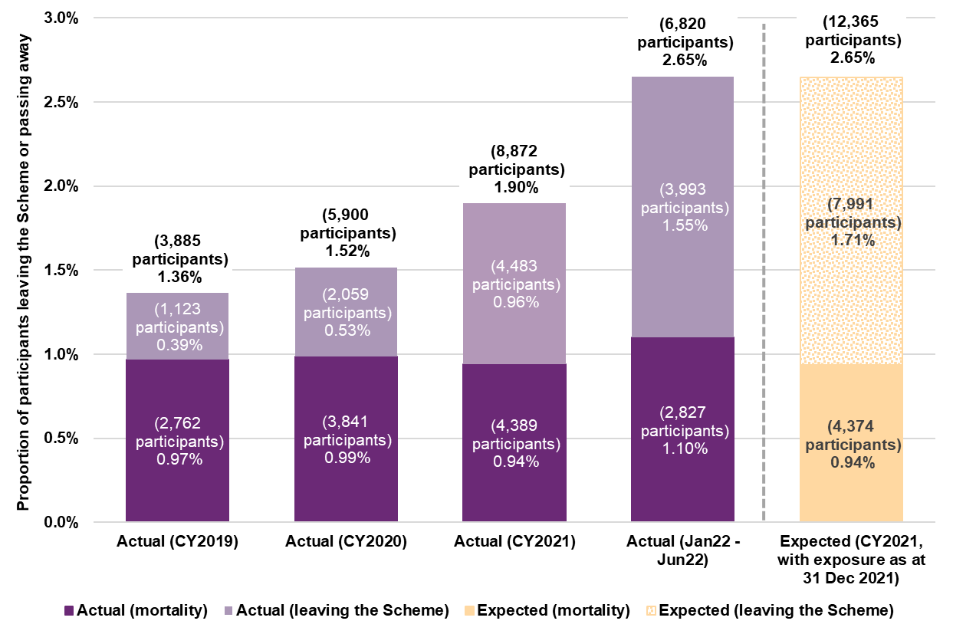

Total Scheme expense
Scheme expenses (before operating expenses) for the year were lower than expected, due primarily to COVID-19
From 1 July 2021 to 30 June 2022, $27.6 billion in Scheme expenses (before operating expenses) were incurred on a cash basis across all participants. This was $1.2 billion or 4.2% less than the 2020-21 AFSR estimate of $28.8 billion. Scheme expenses (before operating expenses) on an accrual basis were $28.6 billion, 2.0% lower than the 2020-21 AFSR estimate of $29.2 billion.
The differences between actual and expected Scheme expenses on a cash basis for 2021-22 by disability group and age are shown in the tables below. Participants with intellectual disability, autism and cerebral palsy had lower than expected payments, while participants with stroke and other neurological disabilities had higher than expected payments. Participants aged 0 to 14 and 15 to 24 had larger variance in payments than those in older age groups.
Table 4.9: Actual vs Expected Payments by primary disability
Primary Disability ($m) | Actual  (i) | Expected  (ii) | Difference ($)  iii = (i)-(ii) | Difference (%)  iv = (i) / (ii) - 1 | Scheme Impact v = iv x share
Intellectual Disability | 8,279 | 8,878 | -599 | -6.7% | -2.1%
Autism | 5,272 | 5,856 | -584 | -10.0% | -2.0%
Cerebral Palsy | 2,116 | 2,274 | -159 | -7.0% | -0.6%
Other Neurological | 2,132 | 2,060 | 72 | 3.5% | 0.2%
Stroke | 777 | 713 | 64 | 9.0% | 0.2%
Others | 9,051 | 9,050 | 1 | 0.0% | 0.0%
Total | 27,627 | 28,831 | -1,204 | -4.2% | -4.2%

Table 4.10: Actual vs Expected Payments by age group
Age Group ($m) | Actual  (i) | Expected  (ii) | Difference ($)  (i)-(ii) | Difference  (%)  iv =(i) / (ii) - 1 | Scheme  Impact  v = iv x share
0 to 14 | 3,889 | 4,318 | -429 | -9.9% | -1.4%
15 to 24 | 4,234 | 4,715 | -481 | -10.2% | -1.6%
25 to 64 | 17,619 | 17,962 | -343 | -1.9% | -1.0%
65+ | 1,778 | 1,837 | -59 | -3.2% | -0.2%
Missing | 107 | 0 | 107 | NA | NA
Total | 27,627 | 28,831 | -1,204 | -4.2% | -4.2%

The potential drivers of lower than expected payment experience are outlined in subsequent paragraphs. In summary, variances over the 2021-22 year were driven by systematic disruptions to demand for and supply of services and, to a lesser extent, lower payment mix for new entrants and lower number of younger participants in Residential Aged Care.
Drivers of payment variation in 2021-22
Table 4.11 breaks down the $1.2 billion variance in actual to expected payments (on a cash basis) into the following categories:
- Variance in the number of active participants in the Scheme
- Variance in the average annualised payment rates due to:
  - Changes in participant mix
  - Systemic supply and demand impact for disability support services
  - Provider compliance activities
  - Cross-billing for participants in Residential Aged Care (RAC)
- Remaining amounts which do not fall into any of the above categories.
Table 4.11: Drivers of variation in Scheme expense in 2021-22
Drivers of variation | Estimated  Impact ($m) | Estimated  Impact (%)
Participant numbers | +15 | -1%
Participant mix | -126 | 10%
Systematic supply and demand impacts | -440 | 37%
Provider compliance | -65 | 5%
Residential Aged Care variance | -193 | 15%
Total explained | -792 | 66%
Unexplained variation | -413 | 34%
Total variation (Actual less expected on cash basis) | -1,204 | 100%

Participant numbers
At 30 June 2022, active participants in the Scheme were 0.8% above expected as described in Section 4.1. The higher than expected participant numbers resulted in payments being $15 million higher than expected.
Participant mix
Expected average annualised payment rates in the 2020-21 AFSR projections differ by various participant characteristics. Therefore, some of the variance in actual to expected payments can be explained by differences in the observed participant profile compared to expected.
The overall mix-adjusted average annualised payments were 3.8% below expected, whereas the average payment variance was larger at 4.7% below expected on an unadjusted basis. This suggests that actual payment mix of participants are lower on average, compared to the expected payment mix. A substantial part of this difference will be driven by:
- Higher than expected new entries (and transitions) into autism; a lower-payment primary disability group; and
- Lower than expected new entries and transitions into higher payment primary disability groups like intellectual disability and psychosocial disability.
Table 4.12 shows that the number of participants with autism (lower average payment primary disability) were 4.1% above expected, while intellectual disability (higher average payment primary disability) was 1.7% below expected.
Table 4.12: Participants compared with expected at 30 June 2022 and Expected Average Payment for 2021-22
Primary Disability | Actual vs Expected:  Participants | Expected  Average  Payment
Autism | 4.1% | 35,900
Intellectual Disability | -1.7% | 93,770
Psychosocial Disability | 1.7% | 59,460
Sensory Disabilities | -4.5% | 29,050
All Other Disabilities | 0.2% | 70,870
It is estimated that differences in actual and expected participant mix resulted in payments being $126 million lower than expected.
Systematic supply and demand impacts
The impacts of COVID-19 on the supply and demand for disability support services has contributed to lower than expected payments in the last financial year. Supply-side impacts that are likely to drive lower payment experience include disability workforce shortages, mobility restrictions and workforce absenteeism from COVID illness and isolation requirements. Demand-side impacts include participant or family wariness of accessing supports due to COVID exposure and participant COVID infection and illness.
Two approaches have been used to estimate the impact of COVID on payment experience in FY2021-22:
- A top-down regression analysis of payment data against COVID indicators to determine contribution of COVID to trends in average payments. COVID indicators include a workforce shortage indicator for disability support services, COVID case numbers, mobility data, and public health restriction intensity.
- A bottom-up approach measuring spend lost due to COVID illness and isolation requirements for participants and workers. This was based on estimated COVID infections and close contacts for participants and workers, allowing for conversion of some services to telehealth and an estimated rate of worker replacement.
The results of this analysis indicate that the impact on the Scheme expenses in 2021-22 is an estimated reduction of $440 million.
Provider compliance activities
Over the last year, a program of interventions was undertaken to monitor and address potential noncompliance in claiming behaviour from providers. Interventions included sending self-assessment letters to promote behaviour change, and targeted various behaviours, including:
- Claiming of weekend rates on a weekday
- Inappropriate volumes of supports claimed e.g., more than 24 hours in a single day or more than 72 hours across three days
- Double claiming supports with short-term accommodation (STA) that are covered by STA e.g., assistance with self-care activities etc.
- Overcharging plan management set-up and monthly fees
- Extreme overcharging of low skilled services e.g., assistance with personal domestic activities, house and/or yard maintenance etc.
The impact of these interventions was not allowed for in the 2020-21 AFSR projections, therefore any reduction in payments because of the program would result in actual payments being lower than expected. To quantify this impact, an ARIMA model was employed to measure the change in provider claiming behaviour post-intervention. After accounting for random variation in provider claiming patterns and averaging across the 50th and 80th prediction intervals, the savings for the provider compliance program in 2020-21 was estimated to be $65 million.
RAC cross-billing
Cross-billing payments for participants in Residential Aged Care (RAC) were $175 million lower than expected. This was due to the actual number of participants in RAC being lower than expected in the 2020-21 AFSR projection as well as the payment per participant in RAC being lower than expected.
Invoices related to RAC raised by end of 2021-22 were $355 million; down by about 31% from $511 million invoices raised in 2020-21.

Average payments per participant
Average payments have grown at a slower rate in 2021-22 compared with previous years
Participant numbers were slightly higher than expected over 2021-22, and hence the variance in Scheme expense (before operating expense) is primarily a result of lower growth than expected in the average payment per participant. Average annualised payments were 4.7% less than expected over the 12 months to 30 June 2022 for all participants. Participants without SIL had average annualised payments 6.7% below expected, compared to participants with SIL who had average annualised payments 0.1% above expected. Therefore, the lower than expected average annualised payment experience over 2021-22 was driven by non-SIL participants.
Over the past three years, average annualised payments per participant increased at a rate significantly higher than general inflation (9.2% over the last three years). However, between 2020-21 and 2021-22, annual average payment increased by only 1.6% to $55,200. (Figure 4.10).
Figure 4.10: Average annualised payments over time ($)
Over the past three years, the mix of participants (i.e., the proportions of participants with various characteristics) in the Scheme has changed. In particular, the proportion of children in the Scheme as at 30 June 2022 is higher compared to the proportion as at 30 June 2019, and the proportion of SIL participants in the Scheme as at 30 June 2022 is lower compared to the proportion as at 30 June 2019. All else being equal, these shifts would be expected to reduce the average payments of Scheme participants, as the shift in mix is towards lower payments (i.e. younger and non-SIL participants).
In 2021-22, average payments increased by 5.1% for participants with SIL and 3.6% for participants without SIL, compared to 1.6% overall. These averages are higher than the overall average, as the proportion of participants with SIL decreased in 2021-22. Over the last three years, the average annualised payment has increased for participants with SIL by 11.9%, and the average annualised payment has increased for participants without SIL by 14.4% as shown in Figure 11.
Figure 4.11: Average annualised payments over time by SIL status ($)
Figure 4.12 shows the change in average payment over time by age band for participants without SIL. The average annual increase over the last three years for participants aged 0 to 14 is 10% per annum, the average increase for participants aged 15 to 24 is 9% per annum, the average increase for participants aged 25 to 64 is 19% per annum, and the average increase for participants aged over 65 is 20% per annum. For participants without SIL, average payments have increased at a faster rate for adults (those aged over 25) and reflects a material increase in the hours of attendant care support these participants are receiving over time.
Figure 4.12: Average annualised payments over time for non-SIL participants by age band ($)
Between 2020-21 and 2021-22, growth in the average annualised payment for age groups other than those aged 25-64 was approximately 1%, while those aged 25-64 experienced an increase of 6% in their average payment. Over the same period the proportion of participants aged 25 to 64 years has reduced, as shown in Figure 4.13. The lower growth in average payments for participant cohorts which are growing as a proportion of the Scheme has contributed to the overall lower average payment growth experienced in 2021-22.
Figure 4.13: Average distribution of participants without SIL by age band
The average annualised payment per participant is lower for new entrants (on a mix-adjusted basis)
In 2021-22, the average annualised payment for recent non-SIL new entrants is approximately 15% lower than the average payment for all participants, on a mix-adjusted basis (Figure 4.14). Given that age and primary disability are objective, it is reasonable to infer that this variance results from the average payment for new entrants, with a given level of function, varying from that of the population more broadly.
Figure 4.14: Mix-adjusted average payment for participants without SIL

Scheme payment inflation experience
An analysis has been undertaken to quantify the components of historic inflation in payments for participants by the underlying driver of the increase. Table 4.13 sets out the results of the experience analysis where inflation is measured as the annual change in average payments.

Table 4.13: Breakdown of past observed inflation
Item of inflation | 2018-19 | 2019-20 | 2020-21 | 2021-22 | Average  2018-22 | Average 2019-22
Observed inflation | 9.2% | 19.7% | 6.9% | 1.6% | 9.2% | 9.2%
less pricing impacts | 6.4% | 12.0% | 2.1% | 2.4% | 5.6% | 5.4%
less change in mix | 1.5% | -6.6% | -9.2% | -6.2% | -5.2% | -7.4%
Additional inflation | 1.4% | 14.3% | 14.0% | 5.4% | 8.6% | 11.2%
Explained by:
1. LoF (Level of Function) Change | 0.9% | 1.9% | 2.6% | 1.7% | 1.8% | 2.1%
2. Volume of supports | 3.7% | 2.4% | 2.3% | 0.5% | 2.2% | 1.7%
3. Increased use of attendant care | -3.4% | 6.3% | 6.3% | 1.1% | 2.5% | 4.5%
4. Increased use of therapy supports | 0.1% | 1.6% | 2.0% | 0.0% | 0.9% | 1.2%
5. Increased use of other supports | 0.1% | 2.0% | 0.9% | 2.1% | 1.3% | 1.7%

Inflation rate for grouped support categories | 2018-19 | 2019-20 | 2020-21 | 2021-22 | Average  2018-22 | Average 2019-22
Attendant care | -4.5% | 8.3% | 8.6% | 1.5% | 3.5% | 6.1%
Therapy | 1.1% | 16.9% | 19.0% | -0.1% | 9.2% | 11.9%
Other supports | 0.8% | 12.9% | 5.7% | 14.8% | 8.6% | 11.2%
The observed rate of Scheme inflation has averaged 9.2% per annum over the latest four years. The key contributors to this observed rate are:
    - Pricing impacts of 5.6% per annum. This includes the impact of normal economic inflation and changes to NDIS price limits. The 2022-23 Annual Price Review increased prices by 7% in aggregate or 4% above normal inflationary expectations (which is not included in the historic experience shown).
- A reduction due to change in participant mix of 5.2% per annum, noting that this is anticipated as the AFSR model allows for this attribute and hence does not form a part of the modelled additional inflation.
- Level of function change: This refers to the change in average payments observed when participants level of function changes, and has averaged 1.8% per annum. This is likely to continue, albeit at a reducing rate over time, if the current functional assessment processes remain in place, and as long as the indirect link between functional assessment and funding levels remain.
- Volume of supports: This refers to the increase in supports from the addition of additional support categories to a participant’s total plan budget, contributing 2.2% per annum. Plan management and support coordination have had high rates of inflation due to increasing proportions of participants using those supports over time, although in absolute terms, daily activities, social and community participant and therapies have also contributed to escalation in payments. This impact has been steadily reducing over time and is expected to continue to reduce.
- Increased use of attendant care supports: This refers to participants receiving more hours of care from disability support workers or a greater proportion of hours of higher intensity supports over time unrelated to the change in level of function. This has averaged 2.5% per annum, however has varied substantially. The observed rate of 1.1% in 2021-22 is lower than the rate of 6.3% observed in each of the two preceding years, which is consistent with recent evidence of workforce and supply side constraints for disability support workers and COVID-related demand effects.
- Increased use of therapy supports: This has averaged 0.9% per annum and has arisen from participants receiving more hours of therapy supports or more expensive supports over time.
- Increased use of other supports: The remaining 1.3% per annum of additional inflation is due to increased use of other supports including consumables and capital items.

Plan budgets
At the point when the Scheme is mature, plan budgets should provide a robust indicator of the reasonable and necessary supports required for each participant if there were no supply constraints and barriers for participants to utilise their plan budget, such as ease of access and lack of understanding of their supports. Plan budgets can thus be used to determine a reasonable upper bound on potential longer-term Scheme expense within the Scheme.
Annualised plan budgets at 30 June 2022 were $36.8 billion, about 14% higher than annualised plan budgets at 30 June 2021. The overall growth in plan budgets has reduced over time as the proportional increase in participant numbers has slowed and the distribution of participants has shifted towards younger ages and lower support needs. During this time, operational and planning processes in determining plan budgets have been refined and the Scheme has continued to mature.
Figure 4.15: Total annualised plan budgets at end of each financial year
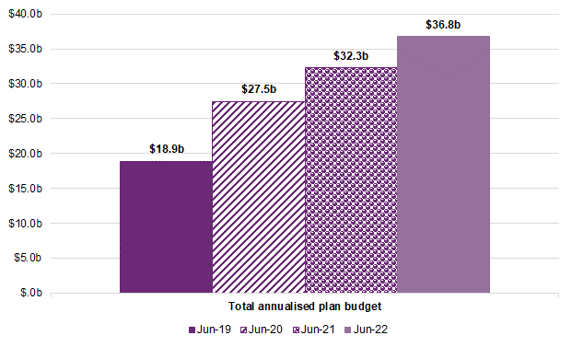
While the Scheme is expanding, the increasing plan budget are largely driven by existing participants. In the 12 months to the end of June 2022, total plan inflation for continuing participants was 8.9% per annum and was also high over the preceding two years, averaging 22.5% in 2019-20 and 9.3% in 2020-21. Figure 4.16 sets out the quarterly rate of annualised plan inflation over the three years to June 2022, as well as the rolling 12 month average plan inflation rate.
Figure 4.16: Plan inflation for active participants
Of the 8.9% per annum total plan inflation for the 12 month period to June, intraplan inflation made up 6.4% per annum. The total rate has increased over the past six months, having been 5.6% for the twelve months to 31 December 2021.
Plan reviews result in plan budgets varying from plan to plan for a variety of reasons – for example, one-off capital items in one plan and not the next. Another example is investment in capacity building (such as behavioural supports) resulting in less need for core support over time. The NDIA has published an Operational Guideline on ‘Changing Your Plan’ which details the reasons why a new plan could be different to a current plan.
These reasons can also occur before a plan is due to be renewed, and often the plan may be reviewed early, and a new plan put in place, both of which contribute to increases in plan budgets. Increases in plan budgets by time in Scheme are shown in Figure 4.17.
Figure 4.17: Average annualised plan budgets for participants over time
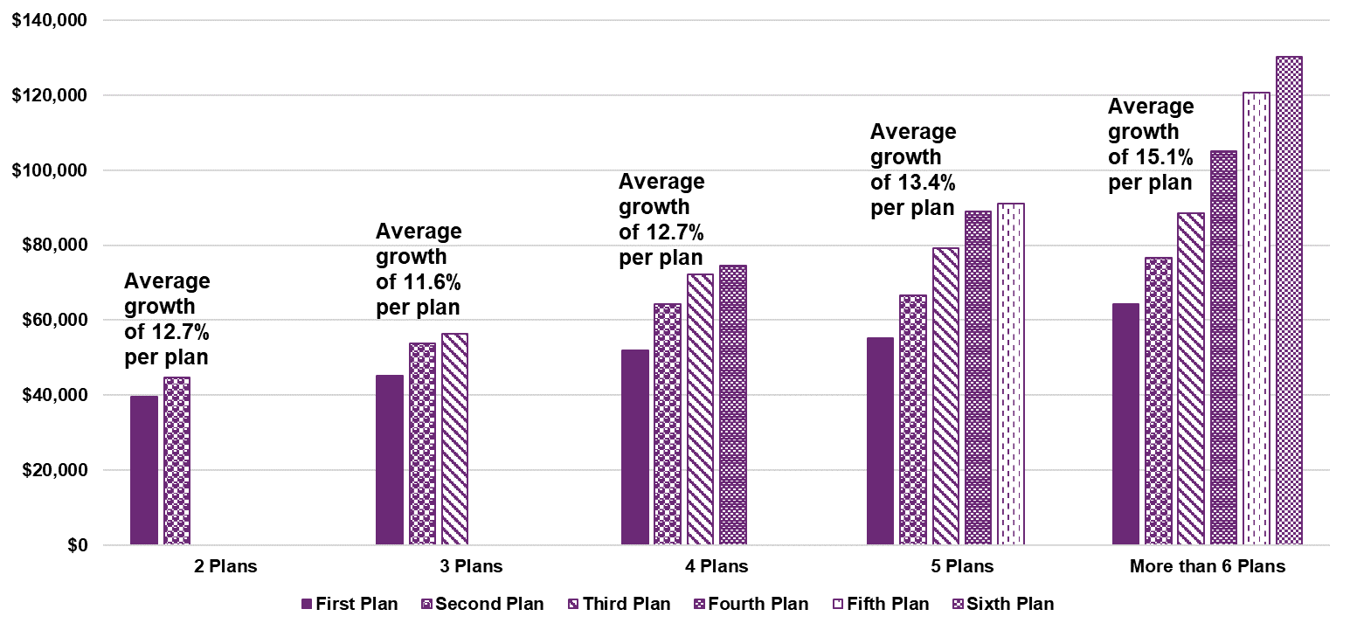
While this level of plan inflation persists and without changes to the assessment process for participants accessing the Scheme, it is reasonable to assume that additional inflation in Scheme expenses will continue in the medium to long term. This has been observed in other social insurance schemes in Australia and New Zealand, in the absence of substantial legislative or policy change.
In contrast, plan budgets for new participants have been decreasing over time and have the effect of lowering the average across the Scheme overall. In aggregate, the average annualised plan budgets at the end of the financial year have been relatively stable for the most recent three years, as highlighted in Figure 4.18.
Figure 4.18: Average annualised plan budget as at 30 June over time
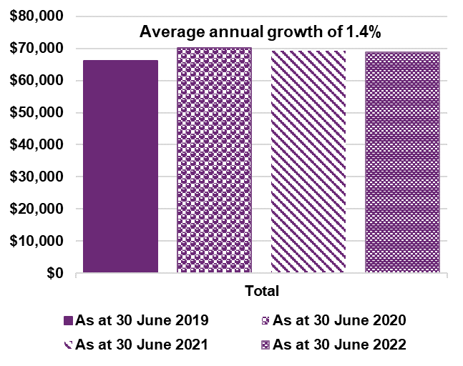
The overall average annualised plan budget has increased by 1.4% per annum on average, over the past three years. However, there has been a reduction of 1.2% and 0.6% in 2020-21 and 2021-22 respectively.
This results from a continuing shift in the mix of participants, despite the Scheme having been available to all Australians since the 2019-20 year. The recent reduction in overall growth rate of plan budgets can be attributed to:
- A high proportion of new entrants aged below 18 entering the Scheme. As children and young adults have lower plan budgets on average than adults, this contributes to a reduction in average plan budgets across the Scheme.
- New entrants have been observed to have a higher level of function than existing participants, reflecting participants with higher support needs having previously transitioned into the Scheme. This results in new entrants having lower support needs and hence lower plan budgets, on average.
- Fewer new participants with SIL as those requiring SIL supports tend to require intensive support and care and generally transitioned from Commonwealth or State/ Territory programs into the Scheme in earlier years.

Figure 4.19: Average annualised plan budgets over time by SIL status
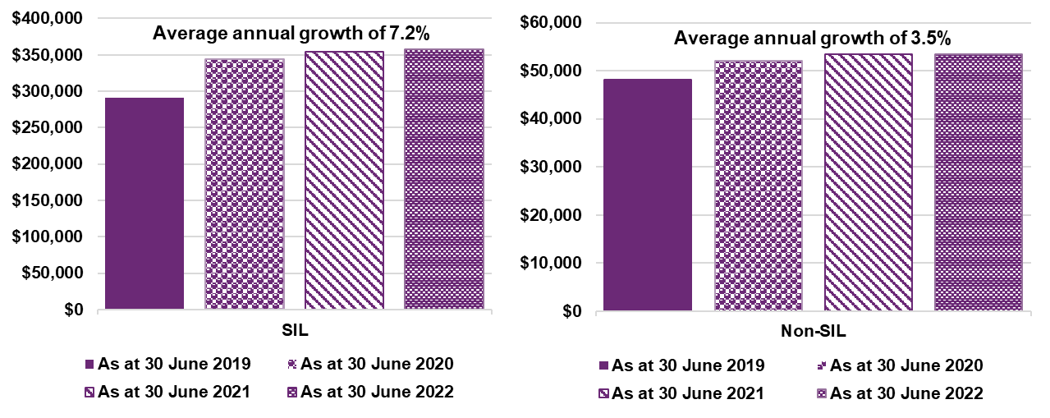
Average plan budgets over time continue to increase for both participants with and without SIL but have been relatively stable in the two most recent years. Average plan budgets for participants with SIL and without SIL have increased by 7.2% and 3.5% per annum respectively. The average annualised plan budget has increased by 2.9% per annum over 2020-21 and 1.1% 2021-22 for participants with SIL, and for participants without SIL, 2.5% per annum in 2020-21 and 0.1% per annum in 2021-22.
The lower increase for participants without SIL compared to participants with SIL was expected as most of the new entrants are without SIL and have higher levels of function.
Figure 4.20: Average annualised plan budgets over time by age band
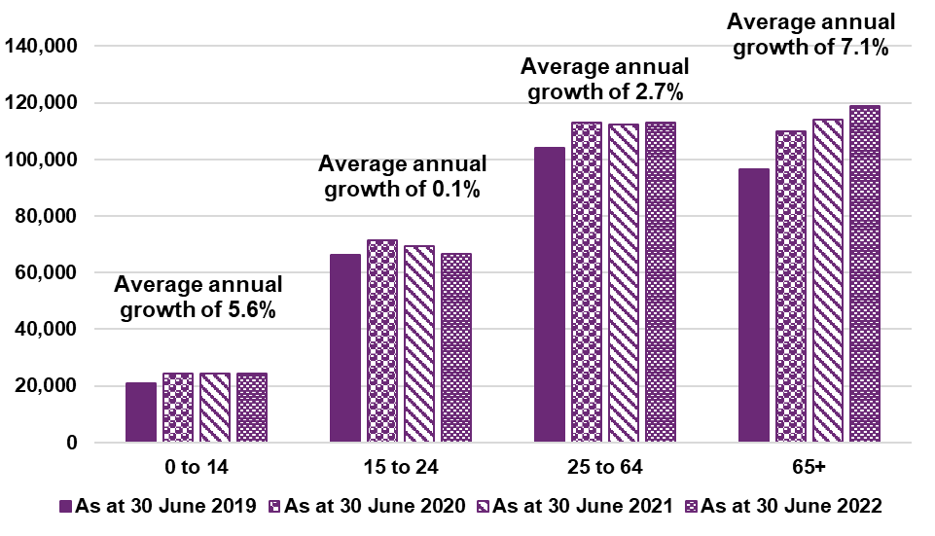
Average annualised plan budgets have increased across most age groups other than participants aged 15 to 24. While overall average plan budgets for those aged 15 to 24 have remained broadly unchanged, increasing at 0.1% per annum, average plan budgets have decreased by 2.6% and 4.0% in 2020-21 and 2021-22, respectively. Average plan budgets for those aged 0 to 14 and 25 to 64 increased by 5.6% per annum and 2.7% per annum, however, average plan budgets for both age groups have been broadly unchanged for 2020-21 and 2021-22. The relatively lower inflation in recent years for the younger age groups was mainly driven by the shift of the profile of participants due to new entrants and is expected to continue. Age 65 and over continue to show an increase in average plan budget at 7.1% per annum.
Figure 4.20 shows the change in average annualised plan budget over time by age band for participants without SIL. Similarly, those aged 65 and over observed the highest inflation over time at 7.5% per annum compared with other age group. The average increase for participants aged 0 to 14 was 5.6% per annum, the average increase for those aged 15 to 24 was 1.3% per annum, the average increase for those aged 25 to 64 was 4.8% per annum, and the average increase for participants aged over 65 was 7.5% per annum.
Figure 4.21: Average annualised plan budget over time for participants without SIL by age band
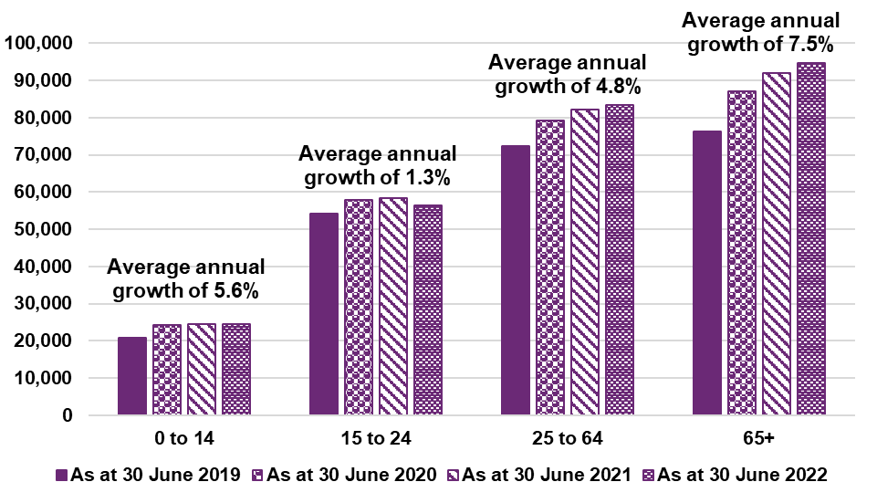
Table 4.14 highlights the average annualised plan budgets by disability group, for the last four financial years.
Table 4.14: Average annualised plan budget by disability group ($)
Disability group | Jun-19 | Jun-20 | Jun-21 | Jun-22
ABI | 122,100 | 141,600 | 145,300 | 148,200
Autism | 36,100 | 39,800 | 39,700 | 39,100
Cerebral Palsy | 124,500 | 141,700 | 145,800 | 148,100
Developmental delay | 14,800 | 18,500 | 19,200 | 20,000
Hearing Impairment | 15,700 | 16,000 | 15,200 | 15,000
Intellectual Disability | 94,100 | 102,000 | 101,600 | 102,700
Multiple Sclerosis | 94,000 | 103,800 | 106,300 | 108,000
Other | 79,200 | 94,600 | 86,100 | 90,200
Other Neurological | 103,900 | 123,000 | 129,700 | 136,100
Other Physical | 65,700 | 75,100 | 74,900 | 77,600
Other Sensory/Speech | 12,900 | 14,000 | 14,600 | 16,200
Psychosocial disability | 62,900 | 74,000 | 77,400 | 80,600
Spinal Cord Injury | 134,600 | 158,200 | 161,600 | 162,700
Stroke | 98,100 | 118,500 | 126,600 | 134,800
Visual Impairment | 35,300 | 39,800 | 41,400 | 43,600
Disability groups that predominantly include older participants and greater proportion of lower functioning participants such as ABI, other neurological and psychosocial disability have experienced more pronounced increases in plan budgets over time. Disability groups consisting of younger participants, such as autism, developmental delay and intellectual disability have experienced lower growth in plan budgets.
Table 4.15: Average annualised plan budget by age group ($)
Age Group | Jun-19 | Jun-20 | Jun-21 | Jun-22
0 to 6 | 19,000 | 24,100 | 24,400 | 24,800
7 to 14 | 21,800 | 24,600 | 24,500 | 24,300
15 to 18 | 47,800 | 52,900 | 49,700 | 45,700
19 to 24 | 81,600 | 87,500 | 87,800 | 87,600
25 to 34 | 103,200 | 110,300 | 108,200 | 106,800
35 to 44 | 104,300 | 112,800 | 111,100 | 110,800
45 to 54 | 106,300 | 114,900 | 113,600 | 114,100
55 to 64 | 102,600 | 112,800 | 114,900 | 118,000
65+ | 96,600 | 109,700 | 113,900 | 118,800
In the most recent two years, there has been a reduction in average annualised plan budgets across participants aged between 7 and 44, in particular those aged 15 to 18 with an 8% reduction in average annualised plan budget.

Utilisation
Plan budgets represent the dollar amount of support that has been made available to participants in their plan. There has historically been a gap between plan budgets and supports which are utilised. The proportion of plan budgets which are used is referred to as the ‘utilisation rate’.
Utilisation rates were relatively stable until 2019-20. A marginal increase in utilisation rate to 73% was observed in 2020-21, followed by a notable increase in utilisation rate to 77% in 2021-22.
Table 4.16 provides an overview of utilisation rates by support year at 30 June 2022.
Table 4.16: Estimated utilisation rate by support year at 30 June 2022
Utilisation component | 2017-18 and prior | 2018-19 | 2019-20 | 2020-21 | 2021-22 | Total
Plan budgets to date ($m) | 12,591 | 14,576 | 24,418 | 32,345 | 36,030 | 119,959
Estimated future changes to plan budgets ($m) | 0 | 1 | 16 | 45 | 681 | 742
Projected ultimate plan budgets ($m) | 12,591 | 14,577 | 24,433 | 32,390 | 36,710 | 120,702
Payments to date ($m) | 8,790 | 10,376 | 17,313 | 23,471 | 26,322 | 86,273
Estimated future payments ($m) | 0 | 3 | 12 | 52 | 1,884 | 1,951
Projected ultimate payments ($m) | 8,791 | 10,378 | 17,325 | 23,523 | 28,206 | 88,224
Utilisation to date (%) | 69.8% | 71.2% | 70.9% | 72.6% | 73.1% | 71.9%
Projected ultimate utilisation (%) | 69.8% | 71.2% | 70.9% | 72.6% | 76.8% | 73.1%
The utilisation rates shown in the last row of Table 4.16 are projected “ultimate” rates, considering both payments already made and payments for supports already provided but not yet paid. This is to allow for the impact of payment delays when calculating ultimate utilisation for a given support year. In addition, the “ultimate” utilisation rates are calculated relative to “ultimate” plan budget figures which include an estimate of future changes to plan budgets for past support periods.
Figure 4.22 illustrates that utilisation rates are consistently higher for participants with SIL compared to those without SIL.
For non-SIL participants, there has been a notable increase in the three-month rolling utilisation rate since February 2022. This increase has been observed across almost all support categories, with Capacity Building Daily Activities and Social & Community Participation, driving the increase in utilisation rates since February 2022.
There has also been an increase observed over this period, for participants with SIL, albeit to a lesser extent, driven by Core Daily Activities.
Figure 4.22: Three month rolling utilisation rates by SIL status from July 2020 to June 2022
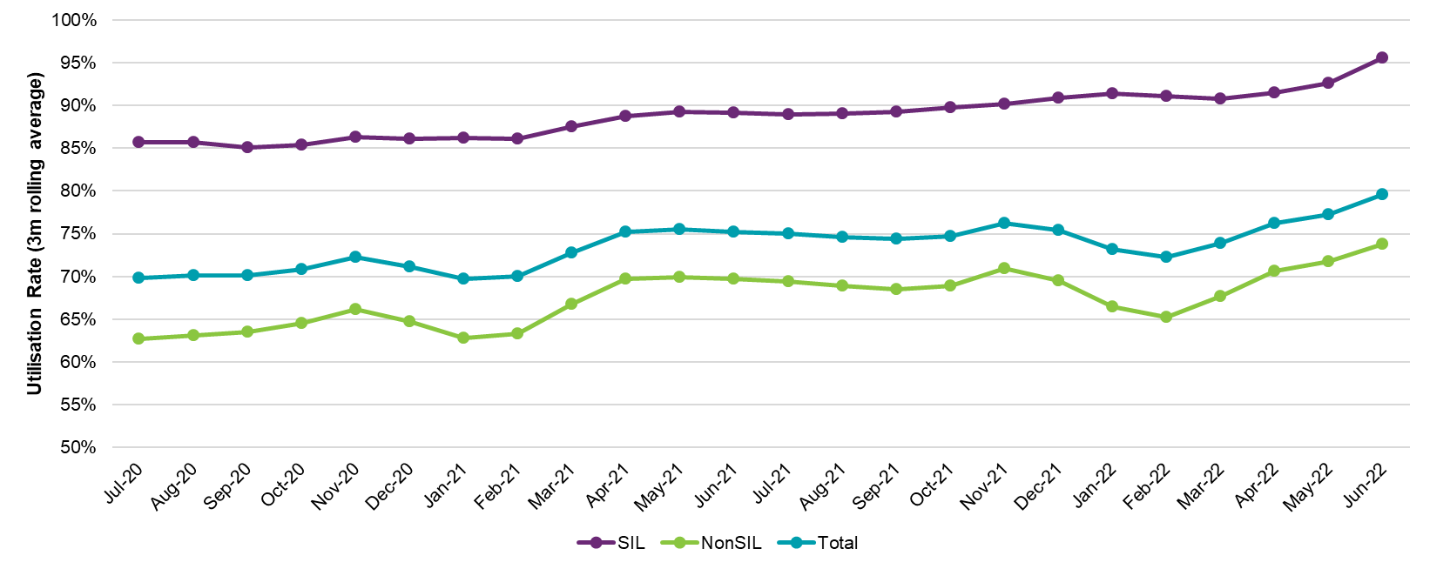
Also noteworthy is that utilisation has consistently been observed to increase, the longer participants have been in the Scheme. This is shown in Figure 4.23 which shows the breakdown of utilisation rates by plan number. Utilisation of plan budgets for participants on their first plan is 55%, compared to 80% for participants on their fifth (or greater) plan. This increase in plan utilisation, with increased duration in the Scheme, is implicitly reflected in the allowance for additional inflation when projecting future payments directly.
The utilisation rate of 75% across all plans shown in Figure 4.23 relates to Scheme experience between 1 October 2021 and 31 March 2022 (based on data to 30 June 2022). This is an increase from the equivalent figure a year prior of 71%. Roughly half of this increase can be attributed to changes in the participant mix, with the remainder of the increase coming from an overall increase in utilisation within each cohort.
Figure 4.23: Utilisation of plan budgets by plan number from 1 October 2021 to 31 March 2022 based on data to 30 June 2022

Projections
This section includes the projection of Scheme expense from 2022-23 to 2031-32, using data at 30 June 2022. The methodology for the projection is included in section 3. As outlined in section 4 of this report, actual participant expense experience in 2021-22 was lower than the projections undertaken at the previous review. This was driven by lower average payments per participant. The projections consider this experience and adopt a forward-looking view regarding future Scheme inflation.

Total Scheme expense projections
Combining participant number projections with average payment assumptions result in total Scheme experience projections for each financial year on a cash basis. An allowance for support provided prior to 30 June 2022 but not yet paid takes the projected expenses from a cash basis to an accrual basis.
Participant number projections
Table 5.1 shows that the Scheme is projected to have a Steady Intake Date population at 30 June 2024 of over 646,000 participants, of whom 613,000 are expected to be aged 0 to 64. This is equivalent to a participation rate of 2.81% of the Australian general population aged 0 to 64.
Table 5.1: Baseline projection of participant numbers
Number of participants as at June 30 | 2022 | 2023 | 2024 | 2025 | 2026 | 2032
0-64 years | 512,659 | 565,204 | 613,461 | 655,902 | 697,469 | 942,226
65+ years | 21,996 | 27,090 | 32,551 | 37,987 | 43,607 | 75,296
Total | 534,655 | 592,294 | 646,012 | 693,889 | 741,077 | 1,017,522
Participation rate (0-64) | 2.39% | 2.62% | 2.81% | 2.98% | 3.14% | 3.99%
Table 5.2 and Table 5.3 show the split in the projection between existing participants and future participants (i.e. new entrants post 30 June 2022). 42% of projected participants in 2031-32 are estimated to be current Scheme participants, with 58% being new entrants to the Scheme.

Table 5.2: Split of participant numbers between existing and future participants
Number of Participants as at 30 June | 2023 | 2024 | 2025 | 2026 | 2032
Existing Scheme participants | 521,547 | 507,074 | 493,631 | 481,543 | 427,039
Future participant intake | 70,747 | 138,938 | 200,258 | 259,533 | 590,483
Total Number of Participants | 592,294 | 646,012 | 693,889 | 741,077 | 1,017,522
Table 5.3: Proportional split of participants between existing and future participants
Number of Participants as at 30 June (%) | 2023 | 2024 | 2025 | 2026 | 2032
Existing Scheme participants | 88.1% | 78.5% | 71.1% | 65.0% | 42.0%
Future participant intake | 11.9% | 21.5% | 28.9% | 35.0% | 58.0%
Total Number of Participants | 100.0% | 100.0% | 100.0% | 100.0% | 100.0%
Scheme expense projection
Projected Scheme expenses on an accrual basis are $34.0 billion in 2022-23, increasing to $89.4 billion in 2031-32. Estimated Scheme expenses for the four years to June 2026 are $166.6 billion on an accrual basis.
Table 5.4: Baseline projection of Scheme expenses
Scheme Expenses ($m) | 2022-23 | 2023-24 | 2024-25 | 2025-26 | 2031-32 | 2022-26
Scheme Expenses (cash basis)
Scheme Expenses (0-64) | 30,931 | 34,357 | 39,364 | 44,519 | 76,700 | 149,171
Scheme Expenses (65+) | 2,544 | 3,211 | 4,099 | 5,081 | 11,389 | 14,934
Total Scheme Expenses (cash basis) | 33,475 | 37,568 | 43,463 | 49,599 | 88,089 | 164,105
Scheme Expenses (accrual basis)
Scheme Expenses (0-64) | 31,394 | 34,874 | 39,955 | 45,187 | 77,843 | 151,411
Scheme Expenses (65+) | 2,582 | 3,259 | 4,160 | 5,157 | 11,559 | 15,158
Total Scheme Expenses (accrual basis) | 33,976 | 38,133 | 44,116 | 50,344 | 89,403 | 166,569
Total Scheme Expenses (% of GDP) | 1.48% | 1.61% | 1.77% | 1.93% | 2.55% | 1.70%
It is important to recognise that the projected Scheme expenses are shown in nominal terms, i.e. that future dollars of estimated Scheme expenses include the effects of inflation over time, as shown in Table 5.4. This impact of inflation increases over the longer term and so is particularly significant for the result in 2031-32. Expressing Scheme expenses as a proportion of GDP is a way of removing the impacts of economic inflation. Scheme expenses are estimated to be 1.48% of GDP in 2022-23, increasing to 2.55% in 2031-32. In considering longer-term projections it is recommended that users refer to expenses as a % of GDP rather than nominal dollar figures as these provide a more meaningful measure of Scheme expenses.
Table 5.5 shows the Scheme expenses projections on an accrual basis, split between existing Scheme participants and future participant intake (post 30 June 2022). In 2031-32, 60.8% of projected expenses relate to current Scheme participants, with 39.2% relating to new entrants.
Table 5.5: Breakdown of Scheme expenses between existing and new participants
Scheme Expenses ($m) - accrual basis | 2022-23 | 2023-24 | 2024-25 | 2025-26 | 2031-32
Existing Scheme participants | 32,967 | 34,700 | 37,662 | 40,621 | 54,370
Future participant intake | 1,009 | 3,432 | 6,454 | 9,723 | 35,033
Total Scheme Expense | 33,976 | 38,133 | 44,116 | 50,344 | 89,403

Scheme Expenses (%) - accrual basis | 2022-23 | 2023-24 | 2024-25 | 2025-26 | 2031-32
Existing Scheme participants | 97.0% | 91.0% | 85.4% | 80.7% | 60.8%
Future participant intake | 3.0% | 9.0% | 14.6% | 19.3% | 39.2%
Total Scheme Expense | 100.0% | 100.0% | 100.0% | 100.00% | 100.0%

Comparison with previous AFSR
This section compares the 2021-22 AFSR Scheme expense projections with those from the previous review. The projected Scheme expenses are approximately $8.8 billion higher than the previous review in the four years to June 2026, and about $21.4 billion higher in 2031-32 (Table 5.6).
More detailed comparisons with the previous review are shown in Appendix C.
Table 5.6: Comparison of 2021-22 AFSR with 2020-21 AFSR
Projected Scheme Expenses ($m) | 2022-23 | 2023-24 | 2024-25 | 2025-26 | 2031-32 | 2022-26
2021-22 AFSR (a) | 33,976 | 38,133 | 44,116 | 50,344 | 89,403 | 166,569
2020-21 AFSR (b) | 33,886 | 37,973 | 41,373 | 44,551 | 68,049 | 157,782
Difference ($) (b – a) | 90 | 160 | 2,743 | 5,793 | 21,354 | 8,786
Difference (%) (a/b – 1) | 0.3% | 0.4% | 6.6% | 13.0% | 31.4% | 5.6%
The sources of variance between this projection and the previous review are shown in Table 5.7.
- Participant and payment experience and the impact of the 2021-22 Annual Pricing Review have resulted in a projection which is essentially unchanged (a $0.1bn reduction) for the four years (2022-26), comprising:
  - a $3.9bn increase due to higher than expected participants and a different mix of participants compared with expected. Participant projections are shown in Section 5.4
  - an $8.0bn reduction due to lower than expected average payments in 2021-22, and hence a lower starting point for the projection. This is driven by several factors including prolonged lockdowns due to the COVID-19 pandemic and workforce shortages materialising in the second half of 2021-22, impacting availability of support workers
  - a $4.0bn increase due to the 2021-22 Annual Pricing Review (APR). The update to prices in the 2021-22 APR includes the increase in the national minimum wage for disability support workers awarded by the Fair Work Commission as well as additional cost pressures related to attendant care in the current COVID-19 impacted environment.
- Future assumptions result in an increase of $8.9bn for the four years (2022-26), comprising:
  - a $2.7bn increase due to higher new entrant assumptions and lower rates of participants leaving the Scheme assumptions to better reflect recent experience
  - a $1.6bn increase due to higher expectations regarding normal inflation after 2022-23. This reflects recent economic forecasts as well as the potential for wages in the disability sector to increase faster than the long-term average due to potential ongoing supply shortages.
  - a $4.6bn increase due to changes in additional inflation assumptions.
Table 5.7: Scheme Expense projection movements since previous review due to experience and updated assumptions
Scheme Expense - Accrual basis ($m) | 2022-23 | 2023-24 | 2024-25 | 2025-26 | 2031-32 | 2022-26
2020-21 AFSR model | 33,886 | 37,973 | 41,373 | 44,551 | 68,049 | 157,782
Update for participant experience | 894 | 969 | 999 | 1,026 | 1,321 | 3,887
Update average payment assumptions | -1,686 | -1,921 | -2,116 | -2,253 | -3,765 | -7,977
Update for 2021-22 Annual Pricing Review | 1,242 | 835 | 915 | 993 | 1,608 | 3,984
Subtotal: updates for experience and Annual Pricing Review | 450 | -118 | -203 | -234 | -836 | -105
Update for all changes to participant population assumptions | 82 | 409 | 876 | 1,304 | 4,825 | 2,671
Update for normal inflation | 0 | 327 | 518 | 735 | 1,200 | 1,579
Update for additional inflation | -442 | -458 | 1,553 | 3,988 | 16,164 | 4,642
Total updates for all changes | 90 | 160 | 2,743 | 5,793 | 21,354 | 8,786

Projection of plan budgets and utilisation
To enable a closer alignment to the Agency’s plan budget setting process, the AFSR model has been enhanced to include a projection of future plan budgets. This can also be used to project the expected utilisation rate for future years. The utilisation rate is the proportion of a participant’s plan which is used for payment of supports.
Projected Plan Budgets
Average plan budget amounts have been selected for each participant cohort and support category based on recent experience. This process is similar to the assumption setting for average payment amounts. As for the projection of average payments and Scheme expenses, inflation of plan budgets consists of normal inflation and additional inflation components. The change in mix of participants over time also impacts the rate at which average plan budgets and total plan budgets grow over time.
Table 5.8 summarises the results for projected plan budgets.
Table 5.8: Total and Average Plan Budgets
 | 2021-22 | 2022-23 | 2023-24 | 2024-25 | 2025-26 | 2031-32
Plan Budgets ($b) | 36,710 | 44,666 | 50,564 | 57,628 | 65,019 | 116,529
Implied Growth (%) |  | 21.7% | 13.2% | 14.0% | 12.8% | 10.2%
Proportion with SIL | 26.2% | 25.9% | 25.3% | 25.2% | 25.1% | 24.2%
Proportion without SIL | 73.8% | 74.1% | 74.7% | 74.8% | 74.9% | 75.8%
Average Plan Budgets ($) | 73,330 | 79,270 | 81,670 | 86,020 | 90,620 | 117,140
Implied Growth (%) |  | 8.1% | 3.0% | 5.3% | 5.3% | 4.4%
Assumed Inflation (%) |  | 10.7% | 6.4% | 8.0% | 7.3% | 5.3%

Table 5.8 shows the total and projected plan budgets (broken down into proportions for participants in Supported Independent Living and those not); and the expected growth in average plan budgets over the projection period. Scheme-level plan budgets are expected to grow by 21.7% from $36.7 billion in 2021-22 to $44.7 billion by 2022-23 (of which 25.9% relates to participants with Supported Independent Living and 74.1% for those without). By 2025-26, total annual plan budgets are expected to be about $65 billion (25.1% for participants with Supported Independent Living and 74.9% for those without).
The projected average annualised plan budget for 2022-23 is expected to increase by 8.1% to $79,270. Approximately 7% of this increase is due to the changes to price limits in the 2021-22 Annual Pricing review, noting that the unspent portions of all in-force plans were indexed to reflect the new price limits on 9 July 2022. By 2025-26, average plan budget per participant is expected to be $90,620. Projected average annual plan budgets are expected to further grow by 3.0% in 2023-24, and 5.3% for each of 2024-25 and 2025-26. The growth in projected average budgets is lower than the inflation rate applied due to changes in the projected mix of participants. That is, to the extent that the proportion of participants in the Scheme who are children or who have a high level of function grows, the average plan budget will be lower. As an example, the percentage of participants who are children (and who have lower budgets) is expected to increase (through new entrants/transitions) in 2023-24.
Table 5.9 details the resulting average annualised plan budgets for 2022-23 by age and disability groups after inflation has been applied to the base average payment assumptions.
Table 5.9: Average annualised plan budgets ($) by age band and disability group in 2022-23 (2022-23 dollars)
Disability Group | 0 to 6 | 7 to 14 | 15 to 18 | 19 to 24 | 25 to 34
Autism | 31,900 | 28,400 | 47,500 | 85,800 | 113,900
Intellectual Disability | 47,200 | 41,800 | 72,200 | 111,900 | 137,100
Psychosocial Disability | 36,900 | 44,700 | 66,200 | 114,500 | 90,700
Developmental Delay | 21,900 | 19,200
Sensory | 19,000 | 14,200 | 17,000 | 20,000 | 25,600
Other | 52,000 | 61,700 | 98,500 | 150,800 | 171,600
Total | 26,500 | 30,700 | 55,000 | 98,200 | 121,500

Disability Group | 35 to 44 | 45 to 54 | 55 to 64 | 65+ | Total
Autism | 130,800 | 140,200 | 162,000 | 186,600 | 47,500
Intellectual Disability | 155,300 | 186,700 | 201,700 | 222,600 | 122,700
Psychosocial Disability | 91,200 | 88,400 | 92,800 | 103,300 | 92,000
Developmental Delay |  |  |  |  | 21,500
Sensory | 35,100 | 36,500 | 34,900 | 36,300 | 25,600
Other | 158,900 | 156,000 | 151,100 | 149,900 | 142,000
Total | 126,200 | 130,500 | 133,900 | 140,000 | 79,300
Table 5.9 displays the projected average annualised plan budgets (in 2022-23 dollars) by grouped disability and age band for the 2022-23 financial year.
- Plan budgets are expected to generally increase with age. At Scheme level, plan budgets are expected to be about $26,500 for participants aged 0 to 6 years, about $121,500 for participants aged 25 to 34 years; and about $140,000 for participants over 65 years of age.
- Children have lower average annualised plan budgets than adults, reflecting a higher proportion of early intervention participants, lower usage of SIL arrangements and more informal supports, primarily provided by parents.
- Participants with intellectual disability and other disabilities have the largest average plan budgets.
- Participants with sensory disabilities and developmental delay have the lowest average plan budgets.
Projected Utilisation
Figure 5.1 shows Scheme expenses as a proportion of total plan budgets historically and for the first four years of the projection period, as well as the Scheme utilisation rate for each year.
Figure 5.1: Utilisation rate over time
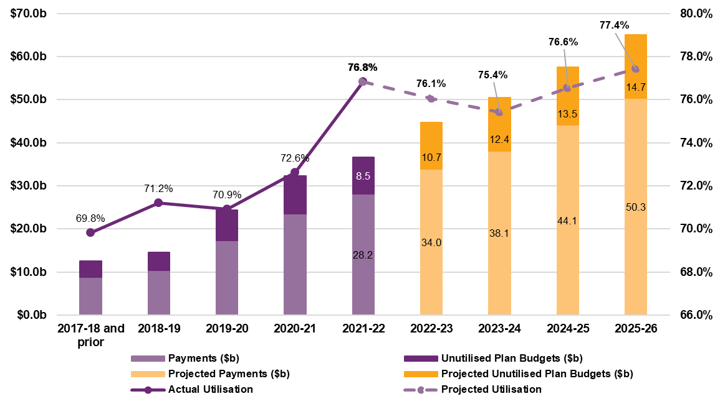
The overall utilisation rate was close to 70% until 2019-20, although experience varied significantly across different participant cohorts. In 2020-21 the utilisation rate increased to 72.6%.
Utilisation was higher again in 2021-22 at 76.8%. One contributor to this was plans not having been indexed in July 2021 when the changes to price limits from the 2020-21 Annual Pricing Review came into effect. This led to an estimated increase in utilisation of approximately 1% - 1.5%.
Projected utilisation for 2022-23 and 2023-24 is expected to reduce slightly, due to ongoing workforce shortages in the disability sector, meaning it is unlikely that participants will be able to utilise more of the supports in their plans than has recently been observed.
In 2024-25 and 2025-26, when workforce shortages and other COVID-19 related impacts are expected to subside, participants are expected to utilise more of their plans, leading to a projected utilisation rate of 76.6% in 2024-25 and of 77.4% in 2025-26.

Participant projections
The current projections indicate a higher rate of growth in projected participant numbers, compared to the previous review (Figure 5.2). This is primarily driven by higher new incidence assumptions and overall lower rate of assumptions for participant leaving the Scheme.
Figure 5.2: Projected participant numbers (all ages)
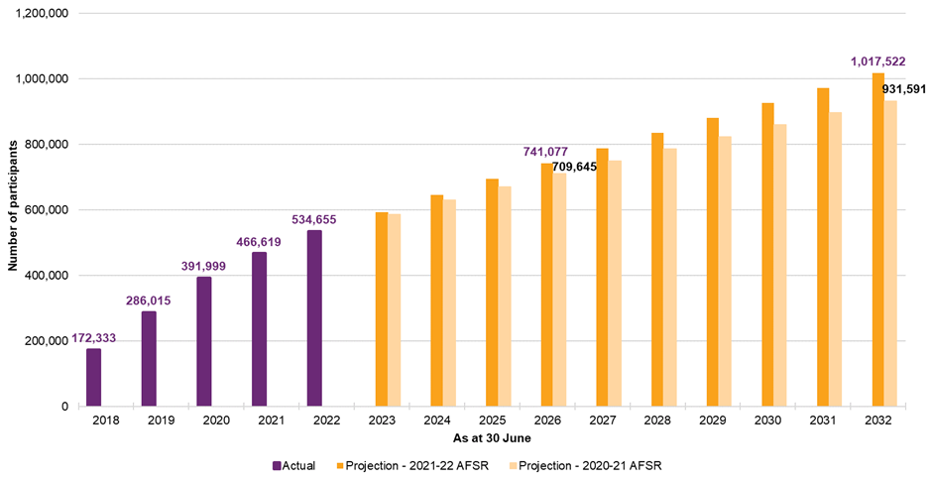
New entrants
The approach to modelling new entrants has evolved over time in response to the emerging experience and available data. At this review new entrant rates have been determined based on the direct method, which relies on the observed new entrant experience to estimate the new entrant rates. This requires relatively stable new entrant experience to inform assumptions about the future entrants to the Scheme.
The new entrant rate assumptions adopted at the 2020-21 AFSR were estimated by equally weighting the results from the direct and indirect methods with new entrant rate assumptions at earlier reviews being based exclusively on the indirect method due to the relative immaturity of the available experience.
In setting future assumptions relating to new entrants using the direct method which relies on currently observed experience, it is however necessary to estimate, the proportional split within the observed experience between:
- New incidence to disability – i.e., new entrants who acquired their disability relatively recently, or who have only recently met the necessary criteria for access to the Scheme. These participants are indicative of longer-term levels of new entrants; and
- Previously unmet need (PUN) – i.e., participants who acquired their disability some years prior who only accessed the Scheme recently (for various reasons). These participants would not therefore be indicative of longer-term levels of new entrants.
To assist in determining this proportional split, a deep dive investigation was performed by the Agency’s Performance Management and Quality (PMQ) Branch, the details of which are provided below. A sample of 1,001 recent new entrants from the geographic areas that phased into the Scheme at 31 December 2018 and prior, was analysed. Key findings were:
- 78% of the sample are regarded as likely to be new incidence to disability. This figure comprises participants who:
  - acquired their disability in the past 12 months; or
  - acquired a disability more than 12 months previously but where there was a recent event or change in circumstances giving rise to their gaining access to the Scheme.
- 22% of the sample are regarded as likely to be previously unmet need. This figure comprises participants who generally took more than 12 months to apply to the Scheme since acquiring their disability because they:
  - were unaware of the NDIS and the supports available; or
  - because they did not have the capacity to apply or follow up on their application and did not receive the appropriate support to do so.
From the New Entrants Deep Dive investigation, lower PUN proportions were observed at younger ages and a higher proportion of PUN participants was observed for psychological disability (especially for males) compared to all other disability groups.
To reflect these findings, separate PUN proportion curves were fitted for males and females with psychological disability by age, with a further set of PUN proportion curves then fitted for males and females by age, for all disability groups excluding psychological disability. The selected PUN proportions by age group, disability type and gender are summarised in Table 5.10.
Table 5.10: Selected previously unmet need proportions by age group, disability type and gender
 | Selected previously unmet need proportion
Age | Psychosocial disability |  | All disabilities excluding psychosocial disability
group | Female | Male | Female | Male
0-6 | 0% | 0% | 0% | 0%
7-18 | 1% | 1% | 10% | 5%
19-24 | 23% | 28% | 17% | 22%
25-34 | 38% | 46% | 17% | 24%
35-44 | 38% | 46% | 17% | 24%
45-54 | 38% | 46% | 17% | 24%
55-64 | 38% | 46% | 17% | 24%
Figure 5.3 shows the number of new entrants to the Scheme for years ended 31 March. The key points to note are:
- The overall number of new entrants peaked in 2019.
- The number of new entrants to the Scheme who transferred from an existing disability program has been declining since peaking in 2019. In 2022, the participants who transferred from an existing disability program (about 4,350 participants) represented only 6% of the total number of new entrants (compared to the 2019 year where participants transferring from an existing disability program represented 62% of the total number of new entrants); and
- Most importantly, the number of participants entering the Scheme who are new to disability supports was broadly similar in 2021 and 2022 and is expected to continue declining until the Steady Intake Date, which is assumed to occur around 30 June 2024.
Figure 5.3: New entrants to the Scheme
Applying the adopted PUN assumptions to the observed new entrant experience for the 12 months ended 31 March 2022, results in an updated new entrant rate assumption of 308.4 participants per 100,000 population aged between 0 and 64. This is 14% higher than the new entrant rate assumed at the 2020-21 AFSR of 271.6 participants per 100,000 population aged between 0 and 64. Figure 5.4 shows the new entrant rate assumption adopted for the 2020-21 AFSR, the new entrant rate assumption adopted at this review, together with the observed new entrant rate for the year ended 31 March 2022 by financial phasing year.

Figure 5.4: New entrant rate assumptions together with observed experience for the year ended 31 March 2022 by financial phasing year
The new entrant rates by disability group within the 2020-21 AFSR and the 2021-22 AFSR are shown in Table 5.11.
Table 5.11: Adopted new entrant rates (per 100,000 population) by disability group, at the 2020-21 AFSR and 2021-22 AFSR
Disability group | 2020-21 AFSR new entrant rate (1) | 2021-22 AFSR new entrant rate (2) | Change  (2) - (1)  # %
Acquired Brain Injury | 6.0 | 7.2 | 1.2 | 19%
Autism | 55.1 | 94.1 | 39.0 | 71%
Cerebral Palsy | 3.1 | 2.2 | -0.9 | -28%
Developmental Delay | 112.4 | 110.5 | -1.9 | -2%
Hearing Impairment | 12.3 | 11.2 | -1.1 | -9%
Intellectual Disability | 17.0 | 21.0 | 4.0 | 23%
Multiple Sclerosis | 2.9 | 4.0 | 1.1 | 36%
Other | 4.3 | 7.9 | 3.6 | 86%
Other Neurological | 11.6 | 9.9 | -1.7 | -15%
Other Physical | 11.4 | 6.7 | -4.6 | -41%
Other Sensory/Speech | 1.9 | 0.4 | -1.5 | -79%
Psychosocial Disability | 24.2 | 24.4 | 0.1 | 1%
Spinal Cord Injury | 1.8 | 1.7 | -0.1 | -7%
Stroke | 4.6 | 4.7 | 0.1 | 2%
Visual Impairment | 3.0 | 2.6 | -0.3 | -12%
Total All Disabilities | 271.6 | 308.4 | 36.8 | 14%
This table shows that the increase in new entrant rate for autism is large and is driven by the emerging experience of higher levels of intake than expected for participants with autism. To better understand the age cohorts driving the higher new entrant experience for participants with autism, Figure 5.5 and Figure 5.6 show the new entrant experience for participants with a primary disability of autism for years ended 31 March, for ages 0 to 14 at Scheme entry and ages 15+ at Scheme entry, respectively. The results are split between new entrants who are new to disability supports and new entrants transferring from an existing disability program. From the perspective of estimating the new entrant rates using the direct method, participants new to disability supports:
- appear to have peaked in 2020 for participants aged 0 to 14 (Figure 5.5) and are expected to continue to enter at rates that are similar to currently observed experience. (The reduction since 2020 may be due to children entering the Scheme with developmental delay due to possible delays in receiving an autism diagnosis, noting that the rate of young participants transitioning from a primary disability type of delay to that of autism has increased in 2022); and
- are continuing to increase for ages 15 and over (but noting that the higher numbers are predominantly driven by the 15 to 24 age group) (Figure 5.6), which is consistent with increased prevalence rates of autism that have been observed in recent times both in Australia and internationally.
This continuing upward trend indicates that the future rate of new entrants with a primary disability of autism and aged 15 and older may be higher than recent experience and/or the Steady Intake Date may be later than 30 June 2024. Changes to these assumptions would result in a higher projected number of participants as well as a higher projected expense for this cohort.
Figure 5.5: New entrants with autism aged 0 to 14 years at Scheme entry
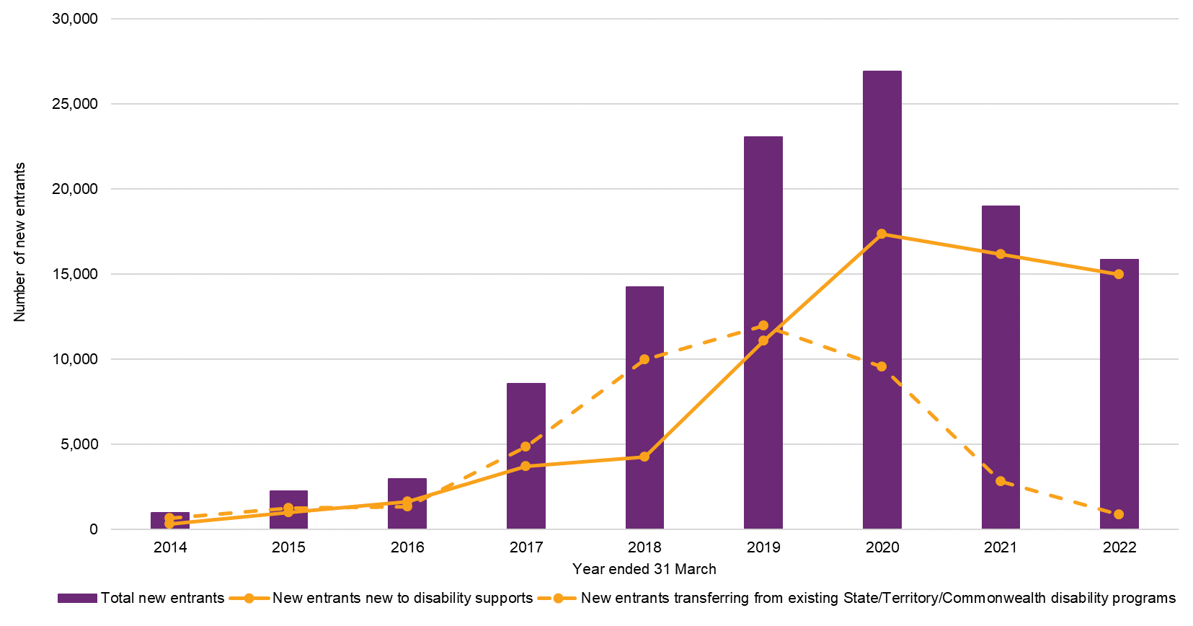
Figure 5.6: New entrants with autism aged 15 years and older at Scheme entry
Table 5.12 shows the estimated annual number of new entrants by gender and age group using Australian population data for people aged 0 to 64 years at 30 June 2021 for the 2020-21 and 2021-22 AFSRs.

Table 5.12: Estimated annual number of new entrants by gender and age group using (1) 2020-21 AFSR new entrant rate assumptions; and (2) 2021-22 AFSR new entrant rate assumptions
Gender and age group | Estimated annual number of new entrants using Australian population data at 30 June 2021 and: |  | Change (2) - (1)
 | 2020-21 AFSR new entrant rate assumptions (1) | 2021-22 AFSR new entrant rate assumptions (2) | # | %
Male / 0 to 6 years old | 22,495 | 21,209 | -1,287 | -6%
Male / 7 to 18 years old | 6,955 | 10,309 | 3,354 | 48%
Male / 19 to 64 years old | 9,007 | 10,101 | 1,093 | 12%
Total Male | 38,457 | 41,618 | 3,161 | 8%
Female / 0 to 6 years old | 9,022 | 8,798 | -224 | -2%
Female / 7 to 18 years old | 3,626 | 6,089 | 2,463 | 68%
Female / 19 to 64 years old | 7,883 | 9,570 | 1,687 | 21%
Total Female | 20,532 | 24,457 | 3,926 | 19%
All Persons / 0 to 6 years old | 31,518 | 30,007 | -1,511 | -5%
All Persons / 7 to 18 years old | 10,581 | 16,398 | 5,817 | 55%
All Persons / 19 to 64 years old | 16,891 | 19,671 | 2,780 | 16%
Total All Persons | 58,989 | 66,075 | 7,086 | 12%
The impact of the updated new entrant rate assumptions can be seen in Figure 5.7, which shows the actual number of new entrants together with those projected in the 2020-21 AFSR and 2021-22 AFSR. This chart shows that the actual number of new entrants in the year ended 30 June 2022 (79,321) only declined marginally relative to 2020-21 (80,453) and was significantly higher than those projected in the 2020-21 AFSR (72,741). The higher number of new entrants projected in the 2021-22 AFSR compared to the 2020-21 AFSR reflects the higher adopted new entrant rate assumptions.
Figure 5.7: Comparison of new entrant numbers to previous review
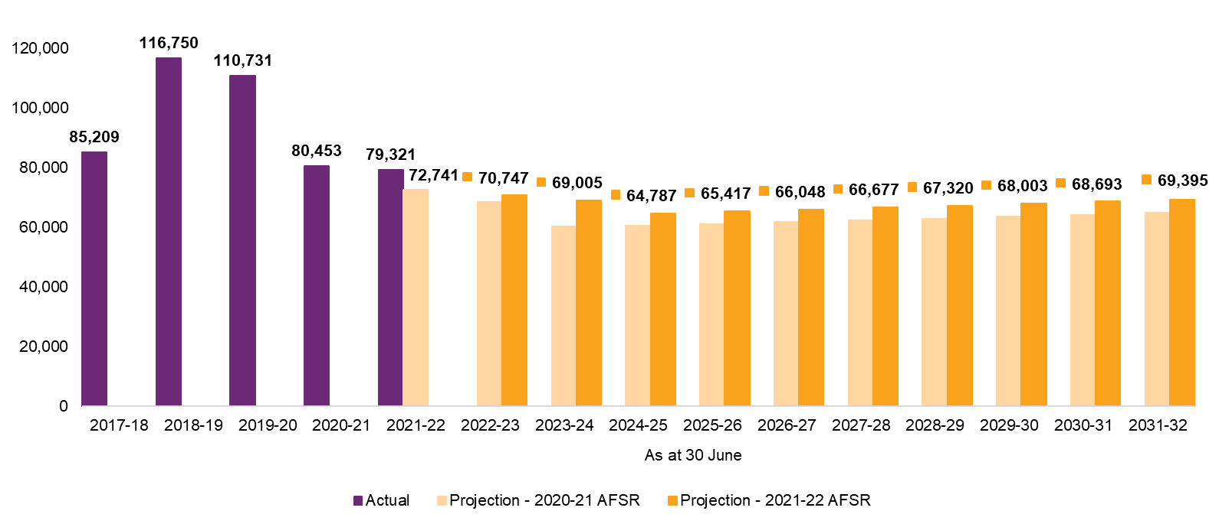
Mortality and participants leaving the Scheme
Both assumptions for mortality and participants leaving the Scheme were revised since the previous review.
Overall experience for participants leaving the Scheme changed materially since the last full review which was completed in 2019 (using 2018 experience). The pause of the Eligibility Reassessment process during 2019, its recommencement in 2020 and the ongoing operational improvements in this area of the Agency since then had a large impact on the underlying trend, whilst COVID-19 lockdown restrictions had also a significant though transitory impact on the experience since 2020. As shown in Figure 5.8, the observed rate of participants leaving the Scheme up to the end of 2021 was much lower than the long-term rate of 1.67% adopted in the 2020-21 AFSR.
As a result, the overall rate of participants leaving the Scheme was revised downwards from 1.67% to 1.19% (based on the participant mix at 30 June 2021) in the current review. This single set of assumptions is reflective of the long-term trend and is also consistent with the recent experience at the time of the analysis.
The rate of participants leaving the Scheme increased in early 2022, over and above the revised assumptions. This increase in experience was due to additional resources deployed to clear backlogs, seasonal factors and a greater focus on eligibility reassessments given the lower number of access requests in early 2022. The higher rate of participants leaving the Scheme is not expected to be maintained beyond June 2022 and so was not used as a basis for setting the assumptions in this review.
Figure 5.8: Actual vs Expected rates of participants leaving the Scheme by calendar quarter
Overall mortality experience was slightly higher than expected over 2021 and early 2022. As shown in Table 5.13, the actual overall mortality rate was 0.95%, marginally higher than the expected rate of 0.93% (although it is noted that the relativity of actual mortality rates to expected can vary according to the underlying mix of participants).
The assumed mortality rates are constructed by applying disability specific loadings to standard population mortality rates from the Australian Life Tables. For this review, to reflect the slightly higher than expected mortality experience, a recalibration of the loadings was undertaken, leading to a marginally higher rate of 0.94% per annum.
However, new Australian Life Tables (ALT 2018-20) were released since the last review. Mortality rates from the new ALT 2018-20 tables were slightly lower than the previous ones, driven by gradual mortality improvement in the general population because of better public health and advancement in medical science.
Finally, adjustments were also made to ensure the adopted mortality rates increase smoothly with age. These impacts offset the marginal increase in loadings, leading to an overall mortality rate of 0.93% per annum, similar to that at the previous review, based on the participant mix at February 2022.
Experience compared with expected was more varied by age and gender, as shown in Table 5.13.

Table 5.13: Actual and Expected Mortality rates by age group
 |  | Mortality Rates
Age | Average number of participants | Actual | Expected (2020-21 AFSR) | 2021-22 AFSR
0 to 6 | 79,324 | 0.09% | 0.11% | 0.10%
7 to 14 | 132,586 | 0.06% | 0.07% | 0.07%
15 to 18 | 39,732 | 0.14% | 0.14% | 0.14%
19 to 24 | 42,139 | 0.20% | 0.24% | 0.24%
25 to 34 | 45,540 | 0.49% | 0.45% | 0.44%
35 to 44 | 42,221 | 0.86% | 0.88% | 0.86%
45 to 54 | 51,451 | 1.84% | 1.78% | 1.77%
55 to 64 | 60,504 | 3.54% | 3.37% | 3.41%
65+ | 18,761 | 4.90% | 4.74% | 4.82%
Total | 512,258 | 0.95% | 0.93% | 0.93%
Past and projected numbers of participants leaving the Scheme across all reasons including mortality are shown in Figure 5.9. Compared with the previous review, there is a material decrease, from more than 20,000 to less than 18,000 in 2024-25, and almost 29,000 to less than 24,000 in 2031-32, driven by the reduction in long-term rates of participants leaving the Scheme. The exception is 2022-23, where there is a small increase in projected participants leaving, reflecting the adoption of the long-term rates from the current review instead of the lower short-term rates from the last review.
The total numbers of participants projected to leave the Scheme in 2022-23 is only marginally higher than the actual 2021-22 result, despite the expected future growth in participant numbers. This is because of the clearing of eligibility reassessment backlogs during 2021-22 which led to a higher rate of participants leaving than is expected going forward.
Figure 5.9: Past and projected numbers of deaths in the Scheme and participants leaving the Scheme
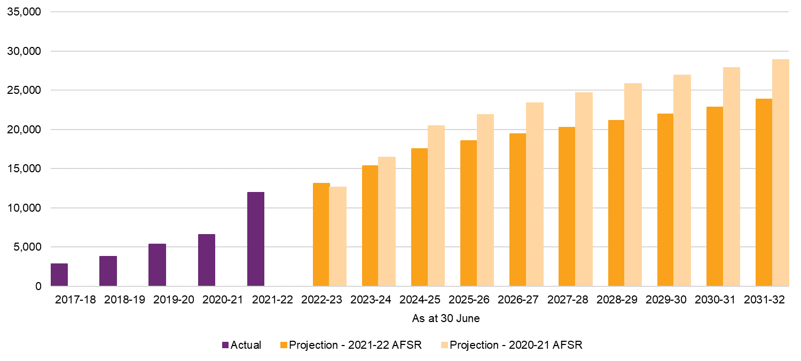
Scheme population projection
The expected number of participants at the end of each year is calculated as the starting participant population, adding expected participant intake and subtracting participants leaving the Scheme or passing away over the year. The resulting participant projection by age group is shown in Table 5.14.
Table 5.14: Projected participant numbers by age group
 | At 30 June
Number of participants | 2022 | 2023 | 2024 | 2025 | 2026 | 2032
Children (0 to 14) | 221,950 | 242,436 | 258,986 | 272,507 | 283,595 | 316,728
Young adults (15 to 24) | 87,949 | 102,029 | 117,670 | 133,935 | 152,005 | 268,255
Adults (25 to 64) | 202,760 | 220,739 | 236,805 | 249,459 | 261,869 | 357,243
Older adults (65+) | 21,996 | 27,090 | 32,551 | 37,987 | 43,607 | 75,296
Total | 534,655 | 592,294 | 646,012 | 693,889 | 741,077 | 1,017,522

 | At 30 June
Number of participants | 2022 | 2023 | 2024 | 2025 | 2026 | 2032
Children (0 to 14) | 41.5% | 40.9% | 40.1% | 39.3% | 38.3% | 31.1%
Young adults (15 to 24) | 16.4% | 17.2% | 18.2% | 19.3% | 20.5% | 26.4%
Adults (25 to 64) | 37.9% | 37.3% | 36.7% | 36.0% | 35.3% | 35.1%
Older adults (65+) | 4.1% | 4.6% | 5.0% | 5.5% | 5.9% | 7.4%
Total | 100.0% | 100.0% | 100.0% | 100.0% | 100.0% | 100.0%
Young adults represent a growing proportion of the Scheme’s participant numbers as the children entering the Scheme in earlier projection years transition into older age bands. Table 5.15 illustrates the projections split by disability group.
Table 5.15: Projected participant numbers by disability group
 | At 30 June
Number of participants | 2022 | 2023 | 2024 | 2025 | 2026 | 2032
Autism | 182,494 | 211,814 | 241,591 | 270,920 | 300,488 | 479,090
Intellectual Disability | 96,469 | 102,027 | 107,598 | 112,930 | 118,315 | 150,335
Psychosocial Disability | 56,559 | 63,974 | 70,306 | 74,520 | 78,659 | 102,026
Developmental Delay | 58,718 | 64,158 | 67,276 | 69,122 | 70,252 | 74,728
Sensory | 36,511 | 39,012 | 41,407 | 43,540 | 45,664 | 58,095
Other | 103,904 | 111,310 | 117,834 | 122,856 | 127,698 | 153,249
Total | 534,655 | 592,294 | 646,012 | 693,889 | 741,077 | 1,017,522

 | At 30 June
Number of participants | 2022 | 2023 | 2024 | 2025 | 2026 | 2032
Autism | 34.1% | 35.8% | 37.4% | 39.0% | 40.5% | 47.1%
Intellectual Disability | 18.0% | 17.2% | 16.7% | 16.3% | 16.0% | 14.8%
Psychosocial Disability | 10.6% | 10.8% | 10.9% | 10.7% | 10.6% | 10.0%
Developmental Delay | 11.0% | 10.8% | 10.4% | 10.0% | 9.5% | 7.3%
Sensory | 6.8% | 6.6% | 6.4% | 6.3% | 6.2% | 5.7%
Other | 19.4% | 18.8% | 18.2% | 17.7% | 17.2% | 15.1%
Total | 100.0% | 100.0% | 100.0% | 100.0% | 100.0% | 100.0%
The increase in projected participant numbers from 2022 to 2032 is broadly consistent with the previous review. Autism and intellectual disability continue to be the largest drivers of new entrants for future projections. Over time the proportion of participants with autism in the Scheme is expected to continue to increase and the proportion of participants with developmental delay is expected to reduce, as participants with developmental delay are subsequently diagnosed with either autism or intellectual disability.
SIL population projection
Table 5.16 presents the split of projected participants with SIL and without SIL.
Table 5.16: Projected participant numbers with SIL and without SIL
 | At 30 June
Number of participants | 2022 | 2023 | 2024 | 2025 | 2026 | 2032
Non-SIL | 507,705 | 563,983 | 616,267 | 662,855 | 708,696 | 975,728
SIL | 26,950 | 28,311 | 29,745 | 31,034 | 32,381 | 41,795
Total | 534,655 | 592,294 | 646,012 | 693,889 | 741,077 | 1,017,522
SIL as a % of Total Scheme Population
Projection | 5.0% | 4.8% | 4.6% | 4.5% | 4.4% | 4.1%
Similar to the last review, the number of participants in SIL arrangements is projected to increase over time to reflect existing participants moving into SIL arrangements, as well as a small number of new entrants to the Scheme accessing SIL.
Participants who were previously in State/Territory or Commonwealth disability programs make up the bulk of the current participants with SIL. However, as discussed in Section 4.1, transitions of participants with SIL from previous government programs have tapered off. Since the proportions of existing participants moving into SIL arrangements and that of new entrants accessing SIL are relatively small, the growth of participants with SIL is unlikely to match the rate of growth of the Scheme population, and therefore the proportion of participants with SIL will decrease over time.
Figure 5.10 shows the revised projection of participants moving into SIL arrangements in the current review compared with the previous review. In 2021-22, a higher number of participants moved into SIL arrangements due to the clearing of backlogs of home and living decisions. While this initiative is well progressed, improvements have been made to help streamline the process for making home and living decisions. Whilst the number of new SIL participants has been increased relative to the previous review, it remains below the number observed over the 2021-22 year.
Figure 5.10: Intake experience to date and trajectory for participants with SIL
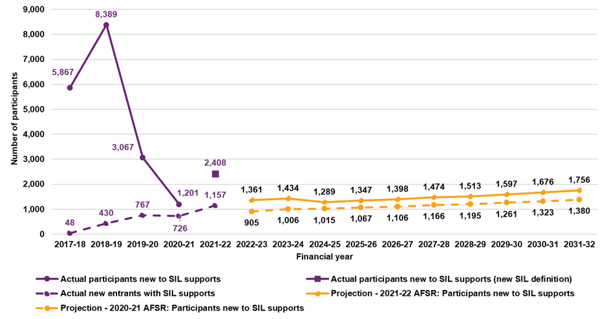

Average payment assumptions
Scheme experience over the past twelve months has seen lower average payments per participant than expected when compared to assumptions from the 2020-21 AFSR. These lower levels are reflected in the base average payment assumptions, which were derived from actual payments data in the three months to 31 May 2022 and adjusted to reflect expected seasonality (as high payment levels have been observed historically in the months of March to May relative to other months).
Base average payment assumptions (i.e., those before allowance for inflation) are set with reference to payments for participants who have been in the Scheme for at least 12 months (with a separate allowance being made for lower expected payments for participants in their first year). Compared to expected payments from the 2021-22 AFSR, these assumptions are lower by about 3.7% (about 5% for non-SIL and 1.3% for SIL). Assumptions within most of the support categories from the primary disabilities in Table 5.17 have reduced relative to expectation.
Table 5.17: Changes in average payment assumptions (by major support categories)
Primary Disability/ Support Category | Core Daily Activities | Social Community Civic | CB Daily Activities | CB Social Community Civic | Transport | Support Coordination | Other | Total
Autism | -11.2% | -11.5% | -8.5% | -11.1% | -8.0% | -5.9% | -6.2% | -10.0%
Cerebral Palsy | -7.0% | -4.7% | -2.2% | -1.8% | -9.1% | -6.5% | 3.3% | -5.2%
Intellectual Disability | -4.2% | 1.0% | 0.1% | -12.2% | -9.9% | -1.6% | 6.3% | -2.2%
Other Neurological | -3.6% | -2.1% | 0.5% | -13.1% | -12.0% | -2.1% | 8.2% | -2.0%
Other | 1.4% | -1.6% | 2.5% | -20.9% | -11.1% | 0.2% | 7.4% | -1.5%
Total | -5.1% | -2.3% | -3.5% | -12.0% | -9.9% | -1.9% | 3.9% | -3.7%
Average payments have reduced by about 10% for autism, 5% for cerebral palsy and 2% for each of intellectual disability and other neurological disabilities. Other disability groups also reduced by about 1.5%. Payments for the largest support categories have experienced lower levels of growth relative to expectation; with Daily Activities (the largest support category) being between 4% to 11% lower than expected in the 2020-21 AFSR. However, average payment assumptions have increased for other support categories (3.9% in total).
For participants in their first year and with Supported Independent Living, average payment assumptions have been reduced by 10% relative to ‘mature’ participants; while a reduction of 20% is assumed for first-year non-SIL participants.
Table 5.18 shows the projected average annual payments by grouped disability and age band for the 2022-23 financial year. The following is noted:
- The average annualised payment amount for all Scheme participants in 2022-23 is $53,700. This is about $4,000 (7%) lower than the assumed average payment for 2022-23 in the previous AFSR;
- Children have lower average annualised payments than adults, reflecting a higher proportion of early intervention participants, less usage of SIL arrangements and more informal supports, primarily provided by parents;
- Participants with intellectual disability and other disabilities have the largest average payments; and
- Participants with sensory disabilities and developmental delay have the lowest average payments.

Table 5.18: Average annual payments ($) by age band and disability group in 2022-23
Disability Group | 0 to 6 | 7 to 14 | 15 to 18 | 19 to 24 | 25 to 34
Autism | 20,700 | 18,600 | 28,800 | 56,000 | 78,700
Intellectual Disability | 30,800 | 28,700 | 48,700 | 77,600 | 98,000
Psychosocial Disability |  | 20,900 | 39,200 | 73,800 | 56,900
Developmental Delay | 12,200 | 10,000
Sensory | 9,000 | 7,300 | 7,300 | 10,200 | 14,900
Other | 35,500 | 42,100 | 66,400 | 106,000 | 123,900
Total | 15,800 | 20,100 | 34,700 | 66,100 | 84,800

Disability Group | 35 to 44 | 45 to 54 | 55 to 64 | 65+ | Total
Autism | 94,900 | 104,900 | 119,900 | 140,200 | 31,400
Intellectual Disability | 114,400 | 137,900 | 150,300 | 164,900 | 88,400
Psychosocial Disability | 58,100 | 56,300 | 60,700 | 64,600 | 58,800
Developmental Delay |  |  |  |  | 11,800
Sensory | 21,700 | 23,000 | 22,300 | 23,300 | 14,900
Other | 113,300 | 107,700 | 101,000 | 97,000 | 97,000
Total | 88,800 | 90,600 | 91,600 | 93,000 | 53,700
The projected average annual payment assumptions, by support category, disability and age band, for the 2022-23 financial year are shown in Table 5.19.
Table 5.19: Average annual payments ($) by age band and support category in 2022-23 (2022-23 dollars)
Support Category | 0 to 6 | 7 to 14 | 15 to 18 | 19 to 24 | 25 to 34
Consumables | 600 | 600 | 700 | 800 | 1,100
Daily Activities | 2,000 | 5,900 | 15,300 | 35,200 | 49,500
Social Community Civic | 200 | 1,600 | 5,800 | 17,400 | 21,500
Transport | 500 | 1,800 | 2,800 | 1,700 | 1,700
Assistive Technology | 600 | 400 | 600 | 700 | 1,100
Home Modifications |  | 100 | 100 | 300 | 700
Capacity Building Daily Activities | 11,000 | 7,700 | 5,700 | 4,600 | 4,600
Employment |  |  | 500 | 1,500 | 100
Support Coordination | 200 | 500 | 1,200 | 1,600 | 2,100
Remaining Capacity Building | 700 | 1,500 | 2,100 | 2,300 | 2,400
Total | 15,800 | 20,100 | 34,700 | 66,100 | 84,800

Support Category | 35 to 44 | 45 to 54 | 55 to 64 | 65+ | Total
Consumables | 1,300 | 1,500 | 1,800 | 2,000 | 1,000
Daily Activities | 54,000 | 56,800 | 58,200 | 58,600 | 29,300
Social Community Civic | 19,800 | 17,600 | 16,100 | 15,900 | 10,100
Transport | 1,600 | 1,500 | 1,500 | 1,600 | 1,600
Assistive Technology | 1,400 | 1,800 | 2,500 | 3,000 | 1,100
Home Modifications | 900 | 1,200 | 1,400 | 1,600 | 500
Capacity Building Daily Activities | 4,900 | 5,200 | 5,400 | 5,800 | 6,700
Employment | 100 | 100 |  |  | 200
Support Coordination | 2,600 | 2,800 | 2,700 | 2,700 | 1,500
Remaining Capacity Building | 2,200 | 2,100 | 1,900 | 1,900 | 1,800
Total | 88,800 | 90,600 | 91,600 | 93,000 | 53,700
Table 5.19 shows higher average payment assumptions for Core Daily Activities and Social Community & Civic, the two largest support categories. Assumptions are also higher for participants aged 15 years and over. The highest average payment for participants aged 0 to 14 is Capacity Building Daily Activities (which includes therapies).

Inflation assumptions
Scheme expenses are assumed to increase over time with inflation, both from normal inflationary sources (such as general increases in wages and consumer prices) and from additional cost pressures, referred to as additional inflation in this report. Additional inflation may arise from a variety of sources including price increases in excess of normal inflation, increased volumes of service being utilised by participants, reductions in levels of informal support received by participants, and increases in scope of supports provided by the Scheme. These increases may be reflected in increased plan values, increased plan utilisation, or a combination of both.
Observed increases in average payment per participant (at an aggregate level) are also influenced by ongoing changes in the mix of participants. Specifically, new entrants to the Scheme have higher functional capacity on average and hence lower average expenses than existing participants. Taken in isolation, this change will lead to a reduction in average payment per participant (which will be observed as offsetting other sources of inflation which increase the average payment per participant). Changes in average payment resulting from participant mix are not explicitly modelled; rather they arise as a function of assumptions relating to new incidence, and mortality and participants leaving the Scheme by cohort.
Normal inflation and Annual Pricing Review
The changes to NDIS price limits as part of the 2021-22 Annual Pricing Review (APR) came into effect on 1 July 2022, and so have been used to set inflation assumptions for the initial year of the 2021-22 AFSR projection. (No separate rate of normal inflation is assumed for 2022-23.) This includes:
- 9.05% per annum increase for attendant care rates. This includes a 4.6% per annum increase in the Fair Work Commission’s minimum wage for disability support workers, a 0.5% increase due to change in the superannuation guarantee contribution and a further increase of 3.7% (2.0% of which is a temporary COVID-related loading assumed to apply for the 2022-23 year only).
- no change for Therapy supports
- 5.1% for other core and capital supports (predominantly assistive technology, home modifications, transport and consumables).
The normal inflation rates adopted for the 2023-24 year onward reflect the most recent economic forecasts, ranging from 3.1% to 4.0% per annum, and then continuing at 3.3% per annum in the longer term. This comprises:
- For attendant care, a rate of 2.3% per annum in 2023-24 followed by 4% until 2025-26 and 3.5% thereafter. This is based on the most recent forecasts of the Wage Price Index (WPI) and includes the gradual increase of the Superannuation Guarantee rate as an additional 0.5% per annum until 2025-26. The rate assumed for 2023-24 is 2.0% lower than that based on the forecast WPI due to the reversal of the temporary loading applied as part of the 2021-22 APR (see above). From 2026-27, a 3.5% per annum increase is assumed, reflective of the long-term expected wage inflation.
- Rates of 3.5% and 2.5% per annum for remaining supports in 2023-24 and after. This reflects the most recent Consumer Price Index forecast released by the Reserve Bank of Australia. A 3.5% per annum increase is adopted for 2023-24 and 2.5% thereafter.
These rates have generally increased compared with the normal inflation assumption of 3.2% per annum at the previous review. The increase is due to both the price limit changes in the 2021-22 APR and recent inflationary pressures which have led to a short-term outlook of higher inflation in the Australian economy (before returning to lower target levels in the longer term).
Table 5.20: Selected normal inflation rates including the 2021-22 Annual Pricing Review
 | 2022-23 | 2023-24 | 2024-25 | 2025-26 | 2031-32
Attendant care | 9.1% | 2.3% | 4.0% | 4.0% | 3.5%
Therapy and other Capacity Building supports | 0.0% | 3.5% | 2.5% | 2.5% | 2.5%
Other supports | 5.1% | 3.5% | 2.5% | 2.5% | 2.5%
Overall | 7.2% | 2.6% | 3.6% | 3.6% | 3.3%
Additional inflation
Additional inflation is defined as the increase in average payments above normal inflation (after allowing for the change in mix of participants). Sustained high levels of additional inflation remains one of the most critical sustainability pressures for the Scheme given their material impact on projected Scheme expenses.
In the early years of the Scheme, this inflation reflected the dynamic and rapidly changing environment of a newly established Scheme. However, these high levels of additional inflation have persisted each year, despite the increasing maturity of the Scheme, although lower inflation was observed in 2021-22 compared with previous years. This is evidenced in the observed inflation rate of 9.2% per annum over the past three years for Scheme participants (or 16.6% per annum when the effect of the change in population mix is removed).
Noting the high uncertainty that exists in relation to additional inflation, a number of considerations have been made in setting additional inflation assumptions:
- A deeper analysis of additional inflation has been undertaken, identifying various sources (as shown in Section 4). This indicates that additional inflation has been driven by changes in participant level of function, a broadening in the types of supports utilised by participants, and an increase in the volumes of supports utilised, particularly in relation to attendant care. This analysis shows more detail regarding the forces driving the additional inflation and provides a stronger justification for the higher additional inflation assumed;
- In the Review of NDIA actuarial forecast model and drivers of Scheme costs, Taylor Fry concluded that a projection of Scheme expenses which is higher than the 2020-21 AFSR model would not be unreasonable. Taylor Fry noted in particular that the allowance for the additional inflation in the 2020-21 AFSR was likely to be on the low side given the significant upside risk related to inflation facing the Scheme;
- The observed additional inflation in payments over 2021-22 was 5.4%, and there is reasonable evidence that growth in payments would have been higher had it not been for both demand-side and supply-side effects arising from COVID-19. It is hard to precisely quantify these effects, but a modest impact of 2-3% on payments would mean an underlying additional inflation for 2021-22 of approximately 7-8%, considerably higher than future assumptions adopted at the previous review;
- Current plan decision making resulted in increases in plans of approximately 9% over 2021-22, with an annualised rate of 12% over the quarter to June 2022. These figures included price increases of approximately 2%, meaning that real growth in plan values were approximately 7% over the 2021-22 year and 10% in the quarter to June 2022, rates which are also considerably higher than future inflation assumptions at the previous review;
- Any reduction in inflation from current levels will necessarily require fewer plan increases and/or more plan reductions relative to current, and there remains considerable uncertainty about the likelihood of this in the short to medium term as there are few substantive legislative, policy or operational responses currently planned to mitigate these plan increases, over and above current operational discipline. Planning is underway in relation to various initiatives addressing fraud and compliance, however until these initiatives are fully scoped, and benefits estimated it is not possible to explicitly factor them into future projections.
Table 5.21 sets out the additional inflation assumptions adopted at this review. The components of additional inflation associated with change in level of function and increased volume of supports over time are applied across all support categories, with the level of function component having separate assumptions for participants with SIL. In addition, a further component of additional inflation has been applied at support category level, with separate rates selected for attendant care, therapy and other supports.
Table 5.21: Adopted additional inflation assumptions
 | Actual |  |  |  |  |  | Assumed
Item of inflation | Average 2019-22 | 2021-22 | 2022-23 | 2023-24 |  | 2024-25 |  | 2025-26 |  | 2031-32
Applied to all support categories:
Level of Function change – non-SIL | 2.6% | 1.8% | 1.8% | 1.5% |  | 1.5% |  | 1.5% |  | 1.0%
Level of Function change - SIL | 1.1% | 0.4% | 0.4% | 0.4% |  | 0.4% |  | 0.4% |  | 0.4%
Volume of supports | 1.7% | 0.5% | 0.5% | 0.5% |  | 0.5% |  | 0.5% |  | 0.5%
Applied to specific support categories:
Attendant care | 6.1% | 1.5% | 1.5% | 1.5% |  | 4.4% |  | 3.3% |  | 0.7%
Therapy | 11.9% | -0.1% | 0.0% | 0.0% |  | 4.4% |  | 3.3% |  | 0.7%
Other supports | 11.2% | 14.8% | 4.0% | 2.0% |  | 4.4% |  | 3.3% |  | 0.7%
The assumptions made about future sources of additional inflation can also be expressed in terms of the contribution of each component to the overall inflation rate. This is shown in Table 5.22.
Table 5.22: Contribution to total additional inflation assumptions
 | Actual |  |  |  |  | Assumed
Item of inflation | Average  2019-22 | 2021-22 | 2022-23 | 2023-24 |  | 2024-25 | 2025-26 |  | 2031-32
Level of Function change | 2.1% | 1.7% | 1.3% |  | 1.2% | 1.2% |  | 1.2% | 0.8%
Volume of supports | 1.7% | 0.5% | 0.6% |  | 0.6% | 0.6% |  | 0.5% | 0.5%
Increased use of:
Attendant care | 4.6% | 1.1% | 0.9% |  | 0.9% | 3.1% |  | 2.5% | 0.5%
Therapy | 1.2% | 0.0% | 0.0% |  | 0.0% | 0.5% |  | 0.4% | 0.1%
Other supports | 1.7% | 2.1% | 0.5% |  | 0.3% | 0.6% |  | 0.5% | 0.1%
Total additional inflation | 11.2% | 5.4% | 3.4% |  | 3.0% | 6.0% |  | 5.0% | 2.0%
Overall, the inflation rates assumed in 2022-23 and 2023-24 are well below the average observed over recent years and are in line with experience observed in 2021-22. This reflects that the impacts of workforce shortages are expected to continue in the short term and hence lead to constraints on the inflation of attendant care and therapy expenses. However, the workforce shortages are expected to subside, and higher rates of additional inflation are assumed in 2024-25 and 2025-26 before reducing to the longer-term rate of 2% per annum. In relation to the other components of the additional inflation future assumptions:
- Inflation associated with the change in recorded level of function of participants over time is assumed to reduce over time for participants without SIL. Inflation from this source is assumed to remain low and stable for participants with SIL, given the low average level of function and higher level of homogeneity across the cohort.
- Inflation associated with increased volume of supports, or participants receiving new types of supports over time is assumed to be stable at 0.5% per annum.
- Inflation due to increased use of “Other supports”, including capital supports, consumables and transport is volatile and is not expected to be impacted by workforce shortages and COVID-19 related constraints in the same ways as attendant care or therapy supports. The assumptions of 4.0% per annum adopted for 2022-23 and 2.0% per annum for 2023-24 are lower than recent experience but higher than other categories of support.
Total inflation
Normal inflation has been combined with additional inflation rates to calculate total inflation. Table 5.23 details the underlying normal and additional inflation assumptions adopted for each projection year, with a comparison made to historic inflation experience. The comparison to historic experience is shown both including and excluding changes in population mix. Additionally, Figure 5.11 compares the total adopted inflation with the previous review.
Table 5.23: Comparison of historic inflation experience and adopted total inflation
Inflation on payments | Actual | Projection Year
Inflation on payments | Average  2019-22 | 2022-23 | 2023-24 | 2024-25 |  | 2025-26 | 2031-32
June 2021-22 AFSR
Normal inflation (including APR) | 3.2% | 7.2% | 2.6% | 3.6% |  | 3.6% | 3.3%
Additional inflation | 11.2% | 3.4% | 3.0% | 6.0% |  | 5.0% | 2.0%
Total inflation (excluding change in mix) | 16.6% | 10.6% | 5.6% | 9.6% |  | 8.6% | 5.3%
Change in mix | -7.4% | -2.7% | -3.3% | -2.5% |  | -1.9% | -0.4%
Total Inflation (including change in mix) | 9.2% | 7.7% | 2.1% | 6.9% |  | 6.6% | 4.8%
Overall higher inflation is projected for the next four years, compared with the 2020-21 AFSR, apart from in 2023-24 as shown in Figure 5.11.
Figure 5.11: Comparison of adopted total inflation with previous review
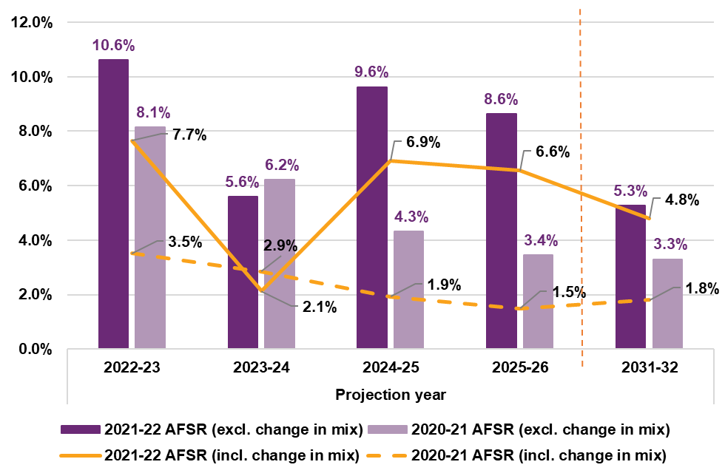

Average payment per participant assumptions after inflation
Table 5.24 shows the projected average payment by SIL status and the growth in average payment by year, as well as the components of this growth, split between normal inflation, additional inflation, and change in mix.
The projected growth in average payments per participant is expected to be driven by inflation (both normal and additional), offset by changes in the participant mix, particularly for participants without SIL. Normal inflation includes the impact of the price increases introduced from July 2022 as announced in the 2022-23 Annual Pricing Review, before dropping to long-term levels in subsequent projection years. Further scenarios based on alternative inflation assumptions are included in Section 6.1.

Table 5.24: Average annual payments ($) by SIL status and inflation components
Average Payments Per Participant ($) |  | Projection Year
Average Payments Per Participant ($) | 2021-22 | 2022-23 | 2023-24 | 2024-25 | 2025-26 | 2031-32
2021-22 AFSR Projection
Non-SIL | 39,500 | 43,200 | 44,400 | 47,700 | 51,000 | 65,800
SIL | 340,900 | 374,600 | 391,500 | 426,900 | 461,300 | 618,600
Total | 55,200 | 59,400 | 60,700 | 64,900 | 69,100 | 88,600

Average Payments Per Participant ($) |  | Projection Year
Average Payments Per Participant ($) | 2021-22 | 2022-23 | 2023-24 | 2024-25 | 2025-26 | 2031-32
Total Inflation
Non-SIL |  | 9.3% | 2.9% | 7.4% | 7.0% | 4.8%
SIL |  | 9.9% | 4.5% | 9.0% | 8.1% | 5.1%
Total |  | 7.7% | 2.1% | 6.9% | 6.6% | 4.8%
Change in Mix
Non-SIL |  | -1.0% | -2.9% | -2.3% | -1.7% | -0.5%
SIL |  | -1.1% | -0.3% | -0.1% | 0.0% | 0.1%
Total |  | -2.7% | -3.3% | -2.5% | -1.9% | -0.4%
Normal inflation
Non-SIL |  | 6.6% | 2.7% | 3.5% | 3.5% | 3.2%
SIL |  | 8.5% | 2.4% | 3.9% | 3.9% | 3.4%
Total |  | 7.2% | 2.6% | 3.6% | 3.6% | 3.3%
Additional inflation
Non-SIL |  | 3.8% | 3.2% | 6.3% | 5.3% | 2.2%
SIL |  | 2.6% | 2.4% | 5.2% | 4.2% | 1.6%
Total |  | 3.4% | 3.0% | 6.0% | 5.0% | 2.0%
Table 5.25 details the resulting average annual payments by age group in each projection year after total inflation has been applied to the base average payments assumptions.

Table 5.25: Average annual payments ($) by age group and projection year
Age group | Projection year
Age group | 2022-23 | 2023-24 | 2024-25 | 2025-26 | 2031-32
Children (0 to 14) | 19,890 | 20,600 | 22,100 | 23,600 | 29,100
Young adults (15 to 24) | 55,700 | 55,400 | 57,700 | 60,100 | 72,100
Adults (25 to 64) | 99,300 | 101,000 | 107,900 | 114,900 | 140,600
Older adults (65+) | 103,700 | 107,700 | 116,200 | 124,500 | 156,300
Total | 59,400 | 60,700 | 64,900 | 69,100 | 88,600
Average annual payments increase each year across all age groups. Table 5.26 illustrates the percentage change in average annual payments by age group and projection year. The average annual payments, and therefore year-on-year percentage changes, are impacted by changes in the mix of participants.
Table 5.26: Change in average annual payments ($) by age group and projection year
Age group | 2022-23 |  | 2023-24 | 2024-25 | 2025-26 | 2031-32
Children (0 to 14) |  |  | 3.5% | 7.4% | 6.7% | 3.7%
Young adults (15 to 24) |  |  | -0.5% | 4.2% | 4.1% | 4.5%
Adults (25 to 64) |  |  | 1.7% | 6.8% | 6.5% | 3.5%
Older adults (65+) |  |  | 3.9% | 7.9% | 7.2% | 4.1%
Total |  |  | 2.1% | 6.9% | 6.6% | 4.8%
Projected average annual payments are expected to grow by 2.1%, 6.9% and 6.6% for 2023-24, 2024-25 and 2025-26 respectively. A combination of a shifting mix of participants into lower average payments and relatively low inflation assumptions, particularly for intellectual disability, resulted in low projected growth of 2.1% in 2023-24. The percentage of participants with a primary disability of autism is expected to increase (through new entrants/transitions) by about 1.1% between 2022-23 and 2023-24. Compared to other main disability groups, participants with autism have lower average payments.
Table 5.26 displays the projected average annual payments (in 2025-26 dollars) by grouped disability and age band for the 2025-26 financial year. Consistent with current average payment, the table shows that:
- The average annualised payment amount for all Scheme participants in 2025-26 is $69,100.
- Children have lower average annualised payments than adults, reflecting a higher proportion of early intervention participants, lesser usage of SIL arrangements and more informal supports, primarily provided by parents.
- Participants with intellectual disability and other disabilities have the largest average payments.
- Participants with sensory disabilities and developmental delay have the lowest average payments.

Table 5.27: Average annual payments ($) by age band and disability group in 2025-26 (2025-26 dollars)
Disability Group | 0 to 6 | 7 to 14 | 15 to 18 | 19 to 24 | 25 to 34
Autism | 24,500 | 24,600 | 36,700 | 69,400 | 99,700
Intellectual Disability | 48,000 | 35,200 | 60,500 | 102,800 | 128,800
Psychosocial Disability | 8,900 | 38,500 | 51,400 | 97,500 | 78,600
Developmental Delay | 14,400 | 13,100
Sensory | 11,600 | 9,300 | 9,700 | 13,700 | 19,400
Other | 51,100 | 53,000 | 82,200 | 130,100 | 163,000
Total | 19,300 | 25,600 | 42,000 | 80,200 | 109,800

Disability Group | 35 to 44 | 45 to 54 | 55 to 64 | 65+ | Total
Autism | 121,300 | 124,500 | 142,500 | 187,500 | 42,900
Intellectual Disability | 152,800 | 179,400 | 194,100 | 226,700 | 115,900
Psychosocial Disability | 79,700 | 75,800 | 80,800 | 87,700 | 79,800
Developmental Delay |  |  |  |  | 14,100
Sensory | 28,200 | 31,200 | 29,800 | 31,400 | 20,000
Other | 150,500 | 140,400 | 128,600 | 131,400 | 127,400
Total | 117,800 | 116,200 | 116,000 | 124,500 | 69,100
Similarly, the projected average annual payments (in 2025-26 dollars), by support category and age band, for the 2025-26 financial year are shown in Table 5.28. The averages presented in the tables below are a weighted combination of the assumptions by cohort for each support category.

Table 5.28: Average annual payments ($) by age band and support category in 2025-26 (2025-26 dollars)
Support Category | 0 to 6 | 7 to 14 | 15 to 18 | 19 to 24 | 25 to 34
Consumables | 800 | 800 | 800 | 900 | 1,300
Daily Activities | 2,800 | 7,600 | 18,000 | 41,500 | 63,400
Social Community Civic | 300 | 2,100 | 7,200 | 21,800 | 29,000
Transport | 600 | 2,400 | 3,500 | 2,300 | 2,300
Assistive Technology | 700 | 400 | 600 | 700 | 1,300
Home Modifications | 0 | 100 | 100 | 300 | 900
Capacity Building Daily Activities | 12,800 | 9,500 | 6,800 | 5,500 | 5,600
Employment | 0 | 0 | 700 | 2,100 | 200
Support Coordination | 300 | 600 | 1,400 | 1,900 | 2,500
Remaining Capacity Building | 900 | 2,100 | 2,800 | 3,000 | 3,300
Total | 19,300 | 25,600 | 42,000 | 80,200 | 109,800

Support Category | 35 to 44 | 45 to 54 | 55 to 64 | 65+ | Total
Consumables | 1,700 | 1,900 | 2,200 | 2,600 | 1,300
Daily Activities | 71,300 | 72,000 | 72,600 | 77,900 | 37,500
Social Community Civic | 27,100 | 23,700 | 21,600 | 22,200 | 13,600
Transport | 2,200 | 2,100 | 2,000 | 2,200 | 2,200
Assistive Technology | 1,800 | 2,300 | 3,100 | 4,000 | 1,300
Home Modifications | 1,300 | 1,500 | 1,800 | 2,100 | 700
Capacity Building Daily Activities | 5,900 | 6,200 | 6,400 | 7,200 | 7,900
Employment | 100 | 100 | 100 | 0 | 300
Support Coordination | 3,400 | 3,600 | 3,500 | 3,600 | 1,900
Remaining Capacity Building | 3,100 | 2,900 | 2,600 | 2,700 | 2,500
Total | 117,800 | 116,200 | 116,000 | 124,500 | 69,100
Consistent with current payment experience, Table 5.28 shows that:
- At Scheme level, average payments per participant for Core Daily Activities and Social Community & Civic are the largest by support category at about $37,500 and $13,600, respectively.
- These two support categories have high averages as they are expected to comprise over 70% of total payments by 2025-26 and are utilised by participants across most disability groups, especially at ages over 18.
- However, for participants aged 0 to 14 years, Capacity Building Daily Activities is the largest support category by average payment.

Operating expenses
The Agency maintains a detailed activity-based costing model representing its operations. The operating expenses adopted in this AFSR are based on this internal model. In 2021-22 actual operating expenses (at $1,590 million) were lower than budgeted in the PBS by $83 million, or 4.9% (Table 5.29). In 2021-22 operating expenses represented 5.6% of Scheme expense, which is lower than the 2020-21 result of 6.3% of Scheme expense.
Table 5.29: Actual operating expenses compared to expectations for 2021-22
Operating expenses - full year to 30 June 2022 | $m
Actual | 1,590
Budget (from 2022-23 PBS) | 1,672
Difference (Actual - Budget) | -83
Operating expenses, as a percentage of Scheme expense, are projected to reduce over time, as the relative expense of bringing new participants into the Scheme is expected to reduce, and also because the average payment per participant is expected to increase at a faster rate than the inflation rate which is assumed to underpin the Scheme’s operating expenses (Table 5.30). Operating expenses are projected to be 5.2% of participant expenses in 2022-23, reducing to 4.2% in 2025-26, and 3.4% in 2029-30.
Table 5.30: Operating expenses as a proportion of Scheme expenses
Operating and Scheme Expense ($m) | 2022-23 | 2023-24 | 2024-25 | 2025-26 | 2026-27 | 2027-28 | 2028-29 | 2029-30
2021-22 AFSR
Scheme Expense (accrual basis) | 33,976 | 38,133 | 44,116 | 50,344 | 55,510 | 61,160 | 67,333 | 74,058
Operating Expenses | 1,780 | 1,825 | 1,986 | 2,120 | 2,196 | 2,310 | 2,424 | 2,533
As a % of Scheme Expense | 5.2% | 4.8% | 4.5% | 4.2% | 4.0% | 3.8% | 3.6% | 3.4%
The projected operating expenses of $1,780 million in 2022-23 are approximately $190 million (or 12%) higher than actual operating expenses in 2021-22 (and $107 million higher than the budgeted amount allowed for in 2021-22 in the 2022-23 PBS). In adopting an estimate which is considerably higher than both the actual and budgeted expenses in 2021-22, it is noted that:
- Development of stronger noncompliance payment controls and fraud mitigation measures, together with continued focus on sustainability initiatives and the continued improvement in participant experience (as prescribed by the Participant Service Guarantee (PSG) which was legislated in 2022), and associated outcomes requires significant investment. This investment needs to take the form of frontline capability and capacity, as well as strategic investments in broader organisation capabilities. For example, in order to meet the PSG targets, the Agency recruited additional planning staff over the second half of the 2021-22 year. Without adequate operational funding for the Agency, risks associated with Scheme expense increase. These are quantified in Section 6.1;
- The adopted level of operating expenses essentially assumes a consistent level of resources per participant supported. Any reduction in operating expenses below this level is consistent with reductions in resources, increased workloads and less capacity to support participants and manage risk, including fraud and integrity.
- The budgeted expenses in the 2022-23 PBS did not consider growth in participant volumes, instead providing continuation of budget from 2021-22 at the same values (with a minor adjustment for an increase in indexation). The full cost to service participant growth in 2022-23 is not able to be absorbed by the Agency; and
- In the 2017 PC study report, a target operating expense range of 7 to 10% was recommended, and the adopted level of expenses is therefore well below the recommended range. The adopted expense rate is also at the lower end of, or below the range of expense rates seen in comparable injury support schemes around Australia, even allowing for the greater scale of the Scheme.

Lifetime expense for care and support
In addition to annual projections, the AFSR is required to include estimates of the lifetime expense for care and support (lifetime expense) for participants. These are estimated Scheme expenses for care and support provided over the participant’s entire lifetime. They provide a useful benchmark to monitor the financial sustainability of the Scheme, as better outcomes for participants should generally result in lower long-term costs of disability support in the future. Therefore, as more experience emerges, the lifetime expense estimates for participants may be expected to reduce, on average.
Average participant lifetime expenses have been projected based on the assumptions underlying the baseline projections, excluding operating expenses, and then discounted to a present value at 30 June 2022 assuming a long-term discount rate of 5.0% per annum for all future years.

The lifetime expense is projected separately for both:
- the expected cohort of new entrants to the Scheme during 2022-23; and
- existing participants at 30 June 2022.
The lifetime cost projection for new entrants does not include participants who are expected to join the Scheme in 2022-23 due to a Previously Unmet Need (PUN). It is intended to reflect the underlying profile, and associated cost, of new incidence to disability each year going forward once the Scheme reaches a steady intake state.
Table 5.31 shows the lifetime expenses for the estimated annual population of new entrants in 2022-23.
The average lifetime expenses are calculated by disability group, and then applied to the estimated annual population of new entrants in 2022-23 to get the total lifetime expenses.
Table 5.31: Average Payments & Total Lifetime Expenses for New Entrants in 2022-23
Disability group | New entrant population (2022-23) | Average Lifetime  Expense  ($m) | Total Lifetime Expenses  ($m) | Total Lifetime Expenses  (%)
ABI | 1,121 | 2.30 | 2,581 | 3%
Autism | 19,702 | 1.91 | 37,725 | 39%
Cerebral Palsy | 467 | 2.18 | 1,020 | 1%
Hearing Impairment | 2,357 | 0.22 | 510 | 1%
Intellectual Disability | 4,503 | 2.83 | 12,727 | 13%
Multiple Sclerosis | 903 | 1.25 | 1,126 | 1%
Developmental Delay | 21,530 | 1.18 | 25,363 | 26%
Other | 1,766 | 0.96 | 1,697 | 2%
Other Neurological | 2,263 | 1.25 | 2,836 | 3%
Other Physical | 1,514 | 0.86 | 1,307 | 1%
Other Sensory Speech | 83 | 0.06 | 5 | 0%
Psychosocial disability | 5,405 | 1.43 | 7,750 | 8%
Spinal Cord Injury | 264 | 3.04 | 802 | 1%
Stroke | 1,078 | 1.63 | 1,760 | 2%
Visual Impairment | 585 | 0.76 | 443 | 0%
Total | 63,539 | 1.54 | 97,651 | 100%
 |  | Projected GDP (2022-23) | 2,302,760
 |  | % Of GDP | 4.24%
The total lifetime expenses for the estimated annual population of new entrants in 2022-23 is projected to be $97.7 billion based on the current long-term assumptions, representing 4.24% of projected GDP for 2022-23.
Table 5.31 also shows that about 78% of the total lifetime expenses are for participants with autism, developmental delay and intellectual disability.

Current Participants
The total lifetime expenses for the 534,655 current participants in the Scheme are estimated to be $1.43 trillion, representing 61.92% of the projected GDP for 2022-23.
The estimated average lifetime expense of these participants is $2.7 million which is significantly higher than the average of $1.5 million for new entrants due to the different disability and age distributions of the two populations. In particular, the profile of current participants is skewed towards those with lower functional levels compared with new entrants. The new entrants cohort has a greater number of higher functioning children, many of whom enter the Scheme through the early intervention requirement (Section 25 of the Act), and who are expected to leave the Scheme and hence have a lower average lifetime expense.

Uncertainty and comparisons to previous projections
This section includes scenario analysis where individual assumptions are varied compared with the baseline projection to show the sensitivity of results to changes in future expectations.
It also contains the results of a stochastic AFSR projection model. This model allows for the uncertainty of the most significant key risks to the estimation of Scheme expenses and the results provide a confidence interval for the range of expected projection outcomes.
Finally, a comparison of the 2021-22 AFSR projection results with historical AFSR results and Productivity Commission estimates is shown, to illustrate how expectations of Scheme expenses have changed over time.

Scenario analysis
The projections presented in Section 5 of this report represent the baseline estimate of Scheme population and expenses. As highlighted throughout this report, there is considerable uncertainty in relation to these projections, and actual Scheme expenses may vary from the baseline projections, possibly significantly.
To quantify the inherent uncertainty within the baseline projection, an alternative set of projections have been calculated for several scenarios. These consider a range of plausible outcomes in relation to the uncertainties above.
As there are differing relative impacts of the scenarios on existing participants (participants with an approved plan as at 30 June 2022), and new participants (participants who receive an approved plan from 1 July 2022), scenarios are shown separately for existing and new participants. Scenarios are also presented combining both existing and new participants (“all projected participants”). The total Scheme projection, split between existing participants and new participants is shown in Table 6.1.
Table 6.1: Split of Scheme expenses between existing and new participants
Scheme Expense ($m) - accrual basis | 2022-23 | 2023-24 | 2024-25 | 2025-26 | 2031-32
Existing participants | 32,967 | 34,700 | 37,662 | 40,621 | 54,370
New participants | 1,009 | 3,432 | 6,454 | 9,723 | 35,033
All projected participants | 33,976 | 38,133 | 44,116 | 50,344 | 89,403

Scenarios relating to number of participants transitioning into Supported Independent Living (SIL)
There are only two years of experience of participants transitioning into Supported Independent Living following all geographic regions gaining access to the Scheme. Furthermore, operational processes to assess the suitability of SIL or other alternative living arrangements for participants have changed significantly over that period and continue to be developed. Hence, there is limited experience and continuing uncertainty over the longer-term numbers of participants with SIL in the Scheme. To quantify the inherent uncertainty with assumptions relating to participants transitioning into SIL, the following scenarios were considered.
Scenario: Higher numbers of participants with SIL
This scenario considers a higher number of participants with SIL (approximately 500 more per annum compared with the baseline projection). This adds $0.7 billion in 2025-26 and $2.7 billion in 2031-32 to total Scheme expenses.
Table 6.2: Scenario results - Higher numbers of participants with SIL (+500 per annum)
 | Projection Year |  |  |  |  | Total
 | 2022-23 | 2023-24 | 2024-25 | 2025-26 | 2031-32 | 2022-26
Existing participants
Scheme Expenses ($m) | 33,130 | 34,940 | 38,071 | 41,206 | 55,983 | 147,346
Variance to baseline ($m) | 162 | 239 | 409 | 585 | 1,613 | 1,432
% variance to baseline | 0.5% | 0.7% | 1.1% | 1.4% | 3.0% | 1.0%
New participants
Scheme Expenses ($m) | 1,014 | 3,456 | 6,524 | 9,863 | 36,072 | 20,857
Variance to baseline ($m) | 5 | 24 | 70 | 140 | 1,039 | 202
% variance to baseline | 0.5% | 0.7% | 1.1% | 1.4% | 3.0% | 1.0%
All projected participants
Scheme Expenses ($m) | 34,144 | 38,396 | 44,595 | 51,069 | 92,054 | 168,203
Variance to baseline ($m) | 167 | 263 | 479 | 725 | 2,652 | 1,634
% variance to baseline | 0.5% | 0.7% | 1.1% | 1.4% | 3.0% | 1.0%

Scenario: Lower numbers of participants with SIL
This scenario considers a lower number of participants with SIL (approximately 200 less per annum compared with the baseline projection). This reduces total Scheme expenses by $0.3 billion in 2025-26 and $1.1 billion in 2031-32.
Table 6.3: Scenario results - Lower numbers of participants with SIL (-200 per annum)
 | Projection Year |  |  |  |  | Total
 | 2022-23 | 2023-24 | 2024-25 | 2025-26 | 2031-32 | 2022-26
Existing participants
Scheme Expenses ($m) | 32,902 | 34,605 | 37,498 | 40,387 | 53,725 | 145,392
Variance to baseline ($m) | -65 | -96 | -163 | -234 | -645 | -573
% variance to baseline | -0.2% | -0.3% | -0.4% | -0.6% | -1.2% | -0.4%
New participants
Scheme Expenses ($m) | 1,007 | 3,423 | 6,426 | 9,667 | 34,617 | 20,523
Variance to baseline ($m) | -2 | -9 | -28 | -56 | -416 | -81
% variance to baseline | -0.2% | -0.3% | -0.4% | -0.6% | -1.2% | -0.4%
All projected participants
Scheme Expenses ($m) | 33,909 | 38,028 | 43,924 | 50,054 | 88,342 | 165,915
Variance to baseline ($m) | -67 | -105 | -192 | -290 | -1,061 | -654
% variance to baseline | -0.2% | -0.3% | -0.4% | -0.6% | -1.2% | -0.4%
Scenario relating to the rates of participants leaving the Scheme
The observed rates of participants leaving the Scheme are lower than projected in previous reports, although the level in 2021-22 has increased in line with the higher number of eligibility reassessments being undertaken. Although the backlog in eligibility reassessments has been cleared at 30 June 2022, the level of participants leaving the Scheme in the future remains uncertain. To quantify the inherent uncertainty with participants leaving the Scheme, the following scenario was considered.

Scenario: Lower rate of participants leaving the Scheme
In this scenario the rate at which participants leave the Scheme is assumed to be 25% lower than the assumption in the baseline projection. This adds $0.3 billion in 2025-26 and $1.3 billion in 2031-32 to total Scheme expenses.
Table 6.4: Scenario results - Lower rate of participants leaving the Scheme
 | Projection Year |  |  |  |  | Total
 | 2022-23 | 2023-24 | 2024-25 | 2025-26 | 2031-32 | 2022-26
Existing participants
Scheme Expenses ($m) | 32,994 | 34,789 | 37,826 | 40,867 | 55,180 | 146,476
Variance to baseline ($m) | 27 | 88 | 164 | 246 | 810 | 526
% variance to baseline | 0.1% | 0.3% | 0.4% | 0.6% | 1.5% | 0.4%
New participants
Scheme Expenses ($m) | 1,009 | 3,433 | 6,463 | 9,754 | 35,511 | 20,659
Variance to baseline ($m) | 0 | 1 | 9 | 31 | 478 | 40
% variance to baseline | 0.0% | 0.0% | 0.1% | 0.3% | 1.4% | 0.2%
All projected participants
Scheme Expenses ($m) | 34,003 | 38,222 | 44,289 | 50,621 | 90,691 | 167,135
Variance to baseline ($m) | 27 | 89 | 173 | 277 | 1,288 | 566
% variance to baseline | 0.1% | 0.2% | 0.4% | 0.6% | 1.4% | 0.3%
Scenarios relating to numbers of new entrants to the Scheme
The observed numbers of new participants, whilst slightly lower than the previous review are higher than those projected in earlier reports, including in mature regions which phased into the Scheme several years ago. Whilst the number of new entrants per annum is reducing, it is unclear when they will stabilise and at what level. To quantify the inherent uncertainty with assumptions relating to the number of new entrants to the Scheme, the following scenarios were considered.

Scenario: Higher assumptions regarding the number of new participants
The assumption relating to new entrant rates is 15% higher than those assumed in the baseline projections, whilst the projected number of previously unmet need participants remains unchanged from the baseline projections. The variation of 15% above and below the baseline assumption represents a 95% confidence interval around the new entrant assumptions adopted in the 2021-22 AFSR. The increase of 15% adds $1.3 billion in 2025-26 and $5.0 billion in 2031-32 to the total Scheme expenses.
Table 6.5: Scenario results - Higher assumptions regarding the number of new participants
 | Projection Year |  |  |  |  | Total
 | 2022-23 | 2023-24 | 2024-25 | 2025-26 | 2031-32 | 2022-26
Existing participants
Scheme Expenses ($m) | 32,967 | 34,700 | 37,662 | 40,621 | 54,370 | 145,950
Variance to baseline ($m) | 0 | 0 | 0 | 0 | 0 | 0
% variance to baseline | 0.0% | 0.0% | 0.0% | 0.0% | 0.0% | 0.0%
New participants
Scheme Expenses ($m) | 1,136 | 3,872 | 7,306 | 11,049 | 40,080 | 23,363
Variance to baseline ($m) | 128 | 439 | 852 | 1,326 | 5,048 | 2,745
% variance to baseline | 12.6% | 12.8% | 13.2% | 13.6% | 14.4% | 13.3%
All projected participants
Scheme Expenses ($m) | 34,104 | 38,572 | 44,968 | 51,670 | 94,451 | 169,314
Variance to baseline ($m) | 128 | 439 | 852 | 1,326 | 5,048 | 2,745
% variance to baseline | 0.4% | 1.2% | 1.9% | 2.6% | 5.6% | 1.6%

Scenario: Lower assumptions regarding the number of new participants
In this scenario the assumptions relating to new entrants is 15% lower than those assumed in the baseline projections. This reduces the Scheme expenses by $1.3 billion in 2025-26 and $5.0 billion in 2031-32.
Table 6.6: Scenario results - Lower assumptions regarding the number of new participants
 | Projection Year |  |  |  |  | Total
 | 2022-23 | 2023-24 | 2024-25 | 2025-26 | 2031-32 | 2022-26
Existing participants
Scheme Expenses ($m) | 32,967 | 34,700 | 37,662 | 40,621 | 54,370 | 145,950
Variance to baseline ($m) | 0 | 0 | 0 | 0 | 0 | 0
% variance to baseline | 0.0% | 0.0% | 0.0% | 0.0% | 0.0% | 0.0%
New participants
Scheme Expenses ($m) | 881 | 2,993 | 5,602 | 8,397 | 29,985 | 17,873
Variance to baseline ($m) | -128 | -439 | -852 | -1,326 | -5,048 | -2,745
% variance to baseline | -12.6% | -12.8% | -13.2% | -13.6% | -14.4% | -13.3%
All projected participants
Scheme Expenses ($m) | 33,849 | 37,694 | 43,264 | 49,018 | 84,355 | 163,824
Variance to baseline ($m) | -128 | -439 | -852 | -1,326 | -5,048 | -2,745
% variance to baseline | -0.4% | -1.2% | -1.9% | -2.6% | -5.6% | -1.6%

Scenario: Higher assumptions regarding the number of new entrants with autism aged between 15 and 54
In this scenario the assumptions regarding the number of new entrants with autism aged between 15 and 54 is 15% higher than the assumptions used for baseline projections for this cohort. This adds $0.1 billion in 2025-26 and $0.6 billion in 2031-32 to the total Scheme expenses.
Table 6.7: Scenario results - Higher assumptions regarding the number of new entrants with autism aged between 15 and 54
 | Projection Year |  |  |  |  | Total
 | 2022-23 | 2023-24 | 2024-25 | 2025-26 | 2031-32 | 2022-26
Existing participants
Scheme Expenses ($m) | 32,967 | 34,700 | 37,662 | 40,621 | 54,370 | 145,950
Variance to baseline ($m) | 0 | 0 | 0 | 0 | 0 | 0
% variance to baseline | 0.0% | 0.0% | 0.0% | 0.0% | 0.0% | 0.0%
New participants
Scheme Expenses ($m) | 1,021 | 3,475 | 6,539 | 9,860 | 35,641 | 20,895
Variance to baseline ($m) | 12 | 43 | 85 | 137 | 608 | 276
% variance to baseline | 1.2% | 1.2% | 1.3% | 1.4% | 1.7% | 1.3%
All projected participants
Scheme Expenses ($m) | 33,988 | 38,175 | 44,201 | 50,481 | 90,011 | 166,845
Variance to baseline ($m) | 12 | 43 | 85 | 137 | 608 | 276
% variance to baseline | 0.0% | 0.1% | 0.2% | 0.3% | 0.7% | 0.2%

Scenario: Three extra years to reach steady state
This scenario assumes the Scheme will take three extra years to reach steady state (a slower transition to the Steady Intake Date), such that it occurs on 30 June 2027 instead of the current assumption of 30 June 2024. This adds $0.9 billion in 2025-26 and $1.9 billion in 2031-32.
Table 6.8: Scenario results - Three extra years to reach steady state
 | Projection Year |  |  |  |  | Total
 | 2022-23 | 2023-24 | 2024-25 | 2025-26 | 2031-32 | 2022-26
Existing participants
Scheme Expenses ($m) | 32,967 | 34,700 | 37,662 | 40,621 | 54,370 | 145,950
Variance to baseline ($m) | 0 | 0 | 0 | 0 | 0 | 0
% variance to baseline | 0.0% | 0.0% | 0.0% | 0.0% | 0.0% | 0.0%
New participants
Scheme Expenses ($m) | 1,009 | 3,492 | 6,798 | 10,593 | 36,935 | 21,891
Variance to baseline ($m) | 0 | 59 | 344 | 870 | 1,903 | 1,273
% variance to baseline | 0.0% | 1.7% | 5.3% | 8.9% | 5.4% | 6.2%
All projected participants
Scheme Expenses ($m) | 33,976 | 38,192 | 44,460 | 51,213 | 91,305 | 167,841
Variance to baseline ($m) | 0 | 59 | 344 | 870 | 1,903 | 1,273
% variance to baseline | 0.0% | 0.2% | 0.8% | 1.7% | 2.1% | 0.8%
Scenario relating to the average payment for new entrants to the Scheme
There are still relatively few years of experience from which to determine the average payment for new entrants, compared to existing participants. As more new entrants enter the Scheme the average payments for new entrants may vary substantially from that previously observed. To quantify the inherent uncertainty with the average payment for new entrants to the Scheme, the following scenarios were considered.

Scenario: Lower payments for new entrants
In this scenario the average payments for future new entrants are assumed to be 17% lower than those for existing participants, compared with 8.4% lower in the baseline projections. This reduces Scheme expenses by $0.9 billion in 2025-26 and $3.0 billion in 2031-32.
Table 6.9: Scenario results - Lower payments for new entrants
 | Projection Year |  |  |  |  | Total
 | 2022-23 | 2023-24 | 2024-25 | 2025-26 | 2031-32 | 2022-26
Existing participants
Scheme Expenses ($m) | 32,967 | 34,700 | 37,662 | 40,621 | 54,370 | 145,950
Variance to baseline ($m) | 0 | 0 | 0 | 0 | 0 | 0
% variance to baseline | 0.0% | 0.0% | 0.0% | 0.0% | 0.0% | 0.0%
New participants
Scheme Expenses ($m) | 894 | 3,079 | 5,841 | 8,834 | 32,057 | 18,649
Variance to baseline ($m) | -114 | -353 | -613 | -889 | -2,976 | -1,969
% variance to baseline | -11.3% | -10.3% | -9.5% | -9.1% | -8.5% | -9.6%
All projected participants
Scheme Expenses ($m) | 33,862 | 37,780 | 43,503 | 49,455 | 86,427 | 164,599
Variance to baseline ($m) | -114 | -353 | -613 | -889 | -2,976 | -1,969
% variance to baseline | -0.3% | -0.9% | -1.4% | -1.8% | -3.3% | -1.2%

Scenario: Higher payments for new entrants
The average payments for future new entrants are assumed to be the same as those for the corresponding cohorts of existing participants. This adds $0.9 billion in 2025-26 and $3.0 billion in 2031-32 to the total Scheme expenses.
Table 6.10: Scenario results - Higher payments for new entrants
 | Projection Year |  |  |  |  | Total
 | 2022-23 | 2023-24 | 2024-25 | 2025-26 | 2031-32 | 2022-26
Existing participants
Scheme Expenses ($m) | 32,967 | 34,700 | 37,662 | 40,621 | 54,370 | 145,950
Variance to baseline ($m) | 0 | 0 | 0 | 0 | 0 | 0
% variance to baseline | 0.0% | 0.0% | 0.0% | 0.0% | 0.0% | 0.0%
New participants
Scheme Expenses ($m) | 1,123 | 3,785 | 7,067 | 10,612 | 38,008 | 22,588
Variance to baseline ($m) | 114 | 353 | 613 | 889 | 2,976 | 1,969
% variance to baseline | 11.3% | 10.3% | 9.5% | 9.1% | 8.5% | 9.6%
All projected participants
Scheme Expenses ($m) | 34,091 | 38,486 | 44,728 | 51,233 | 92,378 | 168,538
Variance to baseline ($m) | 114 | 353 | 613 | 889 | 2,976 | 1,969
% variance to baseline | 0.3% | 0.9% | 1.4% | 1.8% | 3.3% | 1.2%
Scenarios relating to inflation
The average payments per participant have grown at rates substantially exceeding normal inflation for several years, and there is uncertainty as to whether the drivers of lower inflation in 2021-22 will continue in 2022-23 and beyond. Additional inflation of average participant payments can be attributed to plan budget inflation or increased utilisation. Plan budget inflation remains above normal inflation, although there has been a shift from ‘interplan’ (plan to plan) inflation to ‘intraplan’ inflation in recent periods. Utilisation of participant plans has increased in 2021-22 compared with previous years, but any further increases are likely to be constrained to the extent that workforce shortages continue beyond 2021-22. The factors impacting additional inflation are varied and whilst some of the pressures giving rise to past increases would not be expected to continue indefinitely, others have become more prominent recently. Hence past rates of inflation do not provide definitive guidance regarding likely future rates of inflation.
In relation to normal inflation, during 2021-22 a higher inflationary environment has emerged in Australia and globally. Economic forecasts of CPI and wage inflation have been revised upwards for the short to medium term. However, the degree to which inflationary pressures will remain is uncertain, as is the extent to which policy initiatives by the Australian government and the Reserve Bank of Australia will be effective at controlling future inflation.
To quantify the inherent uncertainty with future inflation the following scenarios were considered.
Scenario: Lower additional inflation
The following scenario assumes a reduction of assumed additional inflation of 2-3% per annum in 2024-25 and 2025-26, and a reduction of the long-term rate from 2% to 1% per annum. This reduces Scheme expenses by $2.4 billion in 2025-26 and $6.9 billion in 2031-32.
Table 6.11: Scenario results – Lower additional inflation
 | Projection Year |  |  |  |  | Total
 | 2022-23 | 2023-24 | 2024-25 | 2025-26 | 2031-32 | 2022-26
Existing participants
Scheme Expenses ($m) | 32,967 | 34,700 | 36,677 | 38,687 | 50,164 | 143,031
Variance to baseline ($m) | 0 | 0 | -985 | -1,934 | -4,206 | -2,919
% variance to baseline | 0.0% | 0.0% | -2.6% | -4.8% | -7.7% | -2.0%
New participants
Scheme Expenses ($m) | 1,009 | 3,432 | 6,285 | 9,260 | 32,323 | 19,987
Variance to baseline ($m) | 0 | 0 | -169 | -463 | -2,710 | -632
% variance to baseline | 0.0% | 0.0% | -2.6% | -4.8% | -7.7% | -3.1%
All projected participants
Scheme Expenses ($m) | 33,976 | 38,133 | 42,962 | 47,947 | 82,487 | 163,018
Variance to baseline ($m) | 0 | 0 | -1,154 | -2,397 | -6,916 | -3,551
% variance to baseline | 0.0% | 0.0% | -2.6% | -4.8% | -7.7% | -2.1%

Scenario: Higher additional inflation
The following scenario assumes an increase in assumed additional inflation from 2023-24 to be more in line with observed experience in the past 3 years (approximately 3% per annum higher then assumed in the baseline projection for 2023-26), and an increase in the long-term rate from 2% to 3% per annum. This adds $4.4 billion in 2025-26 and $13.8 billion in 2031-32. This scenario can also be used to gauge the impact of higher normal inflation assumptions compared with the baseline projection, whilst noting that the inflation assumption for 2022-23 has not been changed.

Table 6.12: Scenario results – Higher additional inflation
 | Projection Year |  |  |  |  | Total
 | 2022-23 | 2023-24 | 2024-25 | 2025-26 | 2031-32 | 2022-26
Existing participants
Scheme Expenses ($m) | 32,967 | 35,714 | 39,859 | 44,204 | 62,775 | 152,743
Variance to baseline ($m) | 0 | 1,013 | 2,197 | 3,583 | 8,405 | 6,793
% variance to baseline | 0.0% | 2.9% | 5.8% | 8.8% | 15.5% | 4.7%
New participants
Scheme Expenses ($m) | 1,009 | 3,533 | 6,830 | 10,581 | 40,449 | 21,953
Variance to baseline ($m) | 0 | 100 | 376 | 858 | 5,416 | 1,334
% variance to baseline | 0.0% | 2.9% | 5.8% | 8.8% | 15.5% | 6.5%
All projected participants
Scheme Expenses ($m) | 33,976 | 39,246 | 46,689 | 54,784 | 103,224 | 174,696
Variance to baseline ($m) | 0 | 1,114 | 2,573 | 4,441 | 13,821 | 8,127
% variance to baseline | 0.0% | 2.9% | 5.8% | 8.8% | 15.5% | 4.9%
It is important to note that the assumptions used for the ‘higher additional inflation’ scenario are an alternative view of future expectations based on actual experience and hence the results should not be regarded as an upper bound or extreme. Further discussion on the range of projection results based on a quantitative view of key risks and uncertainty is included in Section 6.2.
Overall comments on scenarios
These results indicate that the projected Scheme expenses are most sensitive to the assumptions for additional inflation. In the longer term, the results are also sensitive to the assumptions regarding numbers of new entrants to the Scheme.
In the 2020-21 AFSR, a set of combined scenarios relating to both existing and new participants were included. These scenarios were used to illustrate a plausible range of projected Scheme expenses. At that time, it was noted that the range adopted included considerably more risk that the estimates were an under-estimate rather than an over-estimate. This resulted from considerably greater upside risk relating to additional inflation, new entrants and the rate of participants leaving the Scheme.
Since the previous review, a stochastic model of the AFSR projections has been developed and this provides a more rigorous approach to measuring the level of uncertainty in projected Scheme expenses. This model is described in Section 6.2 along with the results produced by the model in respect of the 2021-22 AFSR projections.

Stochastic modelling
Approach
In addition to the deterministic analysis in this report, a stochastic projection model was developed to analyse the uncertainty of future Scheme expense outcomes (“Stochastic Model”). The assumptions in the model have been selected to align with the key risks of the Scheme.
Risk variability, and associated correlations, were determined using analysis of historic data, external benchmarks, scenario analysis and actuarial judgement. Assumptions of the Stochastic Model were randomly varied, based on the risk analysis, to determine a distribution of expected future Scheme expense outcomes, using 5,000 simulations.
Identification of key risks for stochastic modelling
The review of NDIA documents identified a wide number of risks related to the AFSR Scheme expense projections. These risks were grouped into broader categories, reflective of the key assumptions within the Stochastic Model.
The key risks determined as part of the risk analysis were:
- Additional inflation: An analysis of the latest four years of escalation in average payments identified high variation in payments above normal inflation. The key components included internal pricing reviews (which often recommended above-normal inflation price limit increases), increasing volumes and types of supports being provided to participants, and deteriorating participant functional assessments (leading to higher average plan budgets).
- Model specification risk: The dynamically changing nature of the NDIS means that the deterministic projection model is an imperfect representation of the future payment process, leading to potential bias in the projections. This risk is high at this review, given the NDIS payment processes are still evolving, meaning a limited history for assumption setting, as well as some limitations in the data available for analysis.
- Normal inflation: The Stochastic Model has allowed for heightened uncertainty above recent historic levels. The higher uncertainty reflects escalating Australian inflation rates, similar experience overseas, increased geopolitical uncertainties, significant supply chain issues and the residual impacts of previous monetary policy initiatives.
New entrants: The Scheme continues to experience higher new entrants than anticipated, particularly for people with autism. Some also relates to previously unmet need from former disability systems. The steady state level of new entrants is unknown and will partly depend on how future eligibility assessments are processed.

- Plan utilisation: The projected utilisation of plan budgets is uncertain, although likely to rise as participants better navigate the NDIS system, provider markets continue to develop and as the plan assessment process better reflects a participants reasonable and necessary needs.
An analysis of correlations between model assumptions identified two main relationships. The first was a link between additional inflation in participants with and without SIL. The second was a negative correlation between the rate of change of average plan budgets and plan budget utilisation. The Scheme experience is insufficiently developed to allow identification and quantification of other correlations.
Key uncertainty results
Table 6.13 shows the results of the Stochastic Model by projection year, expressed as the difference between the projected Scheme expense at key percentiles and the base projection. The standard deviation and coefficient of variation (“CoV”) from the Stochastic Model for each projection year are also shown.
Table 6.13: Scheme expense percentiles ($m) and CoV by projection year
Percentiles | Scheme expense for percentile less baseline projection ($m)
Percentiles | 2022-23 | 2023-24 | 2024-25 | 2025-26 | 2031-32 | 2022-26
5.0% | -2,132 | -2,908 | -4,048 | -5,233 | -16,701 | -13,185
25.0% | -731 | -692 | -944 | -1,334 | -6,218 | -3,041
75.0% | 1,714 | 2,905 | 3,938 | 4,838 | 11,404 | 12,597
95.0% | 3,462 | 5,712 | 7,736 | 9,584 | 25,571 | 25,052
Standard deviation | 1,696 | 2,616 | 3,558 | 4,529 | 13,029 | 11,413
Coefficient of Variation | 4.9% | 6.7% | 7.8% | 8.7% | 14.1% | 6.6%
The percentile results above are shown in Table 6.14 expressed as a percentage of the baseline projection of Scheme expenses.
Table 6.14: Difference in Scheme expense percentiles as a proportion of baseline projection
Percentiles | Difference in Scheme expense result to baseline projection (%)
Percentiles | 2022-23 | 2023-24 | 2024-25 | 2025-26 | 2031-32 | 2022-26
5.0% | -6.3% | -7.6% | -9.2% | -10.4% | -18.7% | -7.9%
25.0% | -2.2% | -1.8% | -2.1% | -2.7% | -7.0% | -1.8%
75.0% | 5.0% | 7.6% | 8.9% | 9.6% | 12.8% | 7.6%
95.0% | 10.2% | 15.0% | 17.5% | 19.0% | 28.6% | 15.0%
The 90% confidence interval (defined as the range between the 5th and 95th percentile) for the range of expected outcomes for the year ending 30 June 2023 is from $2.1 billion below to $3.5 billion above the baseline projection, a range of $5.6 billion, or 16%.
The 90% confidence interval for the range of expected outcomes for the four years to 30 June 2026 is from $13.1 billion below to $25.1 billion above the baseline projection, a range of $38.2 billion, or 23%.
The 90% confidence interval for the range of expected outcomes for the year ending 30 June 2032 is from $16.7 billion below to $25.6 billion above the baseline projection, a range of $42.3 billion, or 47%.
Table 6.14 also illustrates that level of uncertainty associated with the Scheme projections increases over the longer term. In particular, there is a wide range of plausible outcomes for the 2031-32 year as shown in Table 6.15. The 90% confidence interval for the range of outcomes for Scheme expenses is $31.8 billion to $37.4 billion or 1.38% to 1.63% of GDP for 2022-23. This increases to $72.7 billion to $115.0 billion or 2.07% to 3.28% of GDP for 2031-32.
Table 6.15: Range of plausible outcomes of Scheme expenses
2021-22 AFSR | 2022-23 | 2023-24 | 2024-25 | 2025-26 | 2031-32 | 2022-26
Scheme Expenses ($m)
Baseline Projection | 33,976 | 38,133 | 44,116 | 50,344 | 89,403 | 166,569
5th Percentile Projection | 31,844 | 35,224 | 40,069 | 45,108 | 72,700 | 152,246
95th Percentile Projection | 37,439 | 43,844 | 51,853 | 59,926 | 114,973 | 193,061
% of GDP
Baseline Projection | 1.48% | 1.61% | 1.77% | 1.93% | 2.55% | 1.70%
5th Percentile Projection | 1.38% | 1.49% | 1.61% | 1.73% | 2.07% | 1.56%
95th Percentile Projection | 1.63% | 1.85% | 2.08% | 2.29% | 3.28% | 1.97%
Quantification of key risks
Table 6.16 shows the CoV uncertainty associated with each risk if it were modelled separately and independently of the other key risks.
Table 6.16: CoV assessment of each individual component of risk
Risk Type | Payments Coefficient of Variation for financial year
Risk Type | 2022-23 | 2023-24 | 2024-25 | 2025-26 | 2031-32 | 2022-26
Additional inflation | 3.8% | 5.0% | 5.7% | 6.1% | 8.3% | 4.9%
Model specification risk | 2.0% | 2.9% | 3.7% | 4.3% | 7.7% | 3.0%
Normal Inflation | 1.4% | 1.9% | 2.1% | 2.2% | 2.8% | 1.8%
New entrants | 0.4% | 1.0% | 1.6% | 2.2% | 6.6% | 1.4%
Utilisation | 0.6% | 0.8% | 1.0% | 1.1% | 1.4% | 0.8%
The largest contributors to risk in the shorter term are additional inflation risk, model specification risk, and normal inflation risk. In the longer term, new entrants risk becomes increasingly more significant.
Table 6.17 shows the build-up of CoV by key risk type, beginning with additional inflation and then adding, piece wise, each additional key risk after the benefits of diversification have been considered. The order of the build-up of risks is important in this context, and the largest contributors to risk have been included first.
Table 6.17: Build-up of CoV risk after allowing for diversification between key risks
Risk Type | Payments Coefficient of Variation for financial year
Risk Type | 2022-23 | 2023-24 | 2024-25 | 2025-26 | 2031-32 | 2022-26
Cumulative Effect
Additional inflation | 3.8% | 5.0% | 5.7% | 6.1% | 8.3% | 4.9%
Model specification risk | 5.0% | 6.7% | 7.8% | 8.6% | 12.6% | 6.6%
Normal Inflation | 5.1% | 7.0% | 8.2% | 8.9% | 13.1% | 6.9%
New entrants | 5.2% | 7.1% | 8.3% | 9.2% | 14.6% | 7.1%
Utilisation | 4.9% | 6.7% | 7.8% | 8.7% | 14.1% | 6.6%
Incremental Effect
Additional inflation | 3.8% | 5.0% | 5.7% | 6.1% | 8.3% | 4.9%
Model specification risk | 1.2% | 1.7% | 2.1% | 2.4% | 4.3% | 1.7%
Normal Inflation | 0.1% | 0.3% | 0.4% | 0.4% | 0.5% | 0.3%
New entrants | 0.1% | 0.1% | 0.1% | 0.2% | 1.5% | 0.1%
Utilisation | -0.3% | -0.4% | -0.5% | -0.5% | -0.5% | -0.4%
The total risk is not the sum of the individual risks, because most of the key risks are assumed to be independent of each other. The analysis in this report suggests some negative correlation between additional inflation and utilisation risk, explaining the negative incremental effect of the addition of utilisation to the above table. These results highlight that over 90% of the aggregate risk can be captured by the largest three risks in each projection year.

Historic AFSR projections
Uncertainty will always be a feature of the AFSR projections. With each update of the AFSR, projection assumptions balance both the emerging experience (considering the significance and duration of the trends), and future expectations which continue to change over time. As a result, future projections can look quite different to historic experience. Updates to assumptions consider both the significant growth in the Scheme over the past six years and the relative immaturity of the Scheme. As more and more data becomes available and as the Scheme continues to evolve, so too does the projection of Scheme expenses.
Consequently, the projection has changed over time reflecting the emerging Scheme experience. The changes in estimates of Scheme expenses as well as participant numbers and average payments per participants are set out below. The Scheme expense estimates by the Productivity Commission in 2017 (PC estimates) are also included for comparison.

Table 6.18: Scheme Expense – AFSR projections and 2017 PC estimates
Scheme Expense ($b) | 2017-18 | 2018-19 | 2019-20 | 2020-21 | 2021-22 | 2022-23 | 2023-24 | 2024-25 | 2025-26
PC estimates
2017 Productivity Commission Estimates | 7.7 | 14.7 | 20.8 | 22.2 | 23.7 | 25.2 | 26.8 | 28.5 | 30.3
2017 Productivity Commission Estimates (including unanticipated expenses) |  |  | 21.9 | 23.8 | 25.5 | 27.2 | 29.0 | 30.8 | 32.7
AFSR
30 June 2022 AFSR projection |  |  |  |  |  | 34.0 | 38.1 | 44.1 | 50.3
30 June 2021 AFSR projection |  |  |  |  | 29.2 | 33.9 | 38.0 | 41.4 | 44.6
31 December 2020 AFSR projection |  |  |  |  | 28.1 | 32.9 | 36.9 | 40.7 | 44.1
30 June 2020 AFSR projection |  |  |  | 22.3 | 26.1 | 28.9 | 31.4 | 34.3 | 37.4
31 December 2019 AFSR projection |  |  |  | 21.8 | 25.4 | 28.5 | 31.4 | 34.2 | 37.1
30 June 2019 AFSR projection |  |  | 16.7 | 21.1 | 24.2 | 26.9 | 28.9 | 30.8 | 33.3
30 June 2018 AFSR projection |  | 9.5 | 16.0 | 20.3 | 23.6 | 26.6 | 29.5 | 31.7 | 34.0
Comparison with actuals
Actual Scheme expense (accrual) | 5.4 | 10.5 | 17.6 | 23.3 | 28.6
Actual Scheme expense compared with June AFSR ($) |  | 0.9 | 0.8 | 1.0 | -0.6
Actual Scheme expense compared with June AFSR (%)  (Actual – AFSR projection) / Actual |  | 8.9% | 4.8% | 4.5% | -2.1%
Total participant Scheme expense projections have been revised upwards for each successive AFSR projection. Actual Scheme expenses (on an accrual basis) for the three financial years 2018-19, 2019-20 and 2020-21 have exceeded the estimate from the most recent AFSR by amounts between $0.8 billion and $1.0 billion. However, actual Scheme expenses for the most recent financial year were $0.6 billion lower than the 30 June 2021 AFSR projection. These deviations highlight the challenge of achieving accurate projections of Scheme expenses even in the short term.
While a component of the increases in the AFSR projection over time is from a greater intake of participants than previously expected, the main driver is the average payment per participant which has continued to significantly increase. This is discussed in further detail below.

Table 6.19: Participant numbers - AFSR projections and 2017 PC estimates
Total participant numbers | 2017-18 | 2018-19 | 2019-20 | 2020-21 | 2021-22 | 2022-23 | 2023-24 | 2024-25 | 2025-26
PC estimates
2017 Productivity Commission Estimates | 264,100 | 447,300 | 473,700 | 485,900 | 497,700 | 509,300 | 520,800 | 532,000 | 542,900
AFSR
30 June 2022 AFSR projection |  |  |  |  |  | 592,300 | 646,000 | 693,900 | 741,100
30 June 2021 AFSR projection |  |  |  |  | 530,500 | 586,400 | 630,300 | 670,400 | 709,600
31 December 2020 AFSR projection |  |  |  |  | 537,900 | 596,600 | 643,200 | 682,800 | 721,600
30 June 2020 AFSR projection |  |  |  | 456,300 | 500,200 | 532,300 | 558,100 | 583,500 | 608,500
31 December 2019 AFSR projection |  |  |  | 443,200 | 485,200 | 518,400 | 544,000 | 568,500 | 592,500
30 June 2019 AFSR projection |  |  | 369,100 | 423,900 | 470,600 | 501,500 | 523,700 | 544,600 | 564,300
30 June 2018 AFSR projection |  | 306,200 | 380,500 | 426,600 | 465,100 | 499,300 | 521,000 | 541,700 | 561,700
Comparison with actuals
Actual participant numbers | 172,300 | 286,000 | 392,000 | 466,600 | 534,700
Actual participant numbers compared with June AFSR (#) |  | -20,200 | 22,900 | 10,300 | 4,200
Actual participant numbers compared with June AFSR (%)  (Actual – AFSR projection) / Actual |  | -7.1% | 5.8% | 2.2% | 0.8%
Participants entered the Scheme more slowly than initially anticipated in the bilateral agreements between the Commonwealth and State/Territory governments. The PC estimates also assumed that participants would initially enter the Scheme more rapidly. Participant projections for each successive AFSR projection have been revised to reflect the pace at which participants have entered the Scheme, with increases in assumptions at each AFSR except the 30 June 2021 AFSR.
For the 30 June 2022 AFSR projection, participant intake assumptions have been revised upwards slightly to reflect the emerging experience of higher than expected participant intake into the Scheme relative to expectations at the preceding AFSR. This has meant that future projections remain well above all earlier estimates as well as the PC estimates.

Table 6.20: Average participant payments - AFSR projections and 2017 PC estimates
Average participant payments ($ Cash basis) | 2017-18 | 2018-19 | 2019-20 | 2020-21 | 2021-22 | 2022-23 | 2023-24 | 2024-25 | 2025-26
PC estimates
2017 Productivity Commission Estimates | 39,900 | 41,300 | 45,100 | 46,400 | 48,200 | 50,100 | 52,100 | 54,100 | 56,400
2017 Productivity Commission Estimates (including unanticipated expenses) |  |  | 47,500 | 49,500 | 51,900 | 54,100 | 56,300 | 58,500 | 60,900
AFSR
30 June 2022 AFSR projection |  |  |  |  |  | 59,400 | 60,700 | 64,900 | 69,100
30 June 2021 AFSR projection |  |  |  |  | 57,800 | 59,900 | 61,600 | 62,800 | 63,700
31 December 2020 AFSR projection |  |  |  |  | 55,000 | 57,200 | 59,100 | 60,900 | 62,400
30 June 2020 AFSR projection |  |  |  | 51,800 | 53,800 | 55,300 | 57,200 | 59,800 | 62,400
31 December 2019 AFSR projection |  |  |  | 51,800 | 53,900 | 56,200 | 58,700 | 61,100 | 63,500
30 June 2019 AFSR projection |  |  | 49,800 | 52,000 | 53,400 | 54,800 | 56,200 | 57,700 | 59,700
30 June 2018 AFSR projection |  | 38,800 | 45,500 | 49,500 | 52,400 | 55,100 | 57,900 | 59,700 | 61,600
Comparison with actuals
Actual average participant payments | 38,900 | 42,500 | 50,800 | 54,300 | 55,200
Actual average participant payments compared with AFSR ($) |  | 3,700 | 1,000 | 2,500 | -2,600
Actual average participant payments compared with AFSR (%)  (Actual – AFSR projection) / Actual |  | 8.5% | 1.9% | 4.7% | -4.8%
Assumptions for average participant payments have generally been revised upwards at successive AFSR projections. This reflects the emerging experience of sustained significant growth in actual average participant payments over an extended period. Despite these substantial increases, the AFSR projections have typically under-projected average payments in each following year. Projections have assumed operational initiatives would lead to reduced inflation in average payments over time.
Average payments per participant in 2021-22 were lower than projected from the 30 June 2021 AFSR as explained in Section 4.3. This experience has been considered in the reductions made during this review to starting average payment assumptions as discussed in Section 5.5.
Actual inflation and assumed inflation assumptions are included in Table 6.21. Higher inflation is assumed at this review, higher normal inflation in the next 12 months and higher additional inflation from 2024-25 onwards. Refer to Section 5.6 for further information regarding the inflation assumptions that have been adopted at this review.

Table 6.21: Actual and assumed rates of growth in average payments per participant
Total growth rate | 2018-19 | 2019-20 | 2020-21 | 2021-22 | 2022-23 | 2023-24 | 2024-25 | 2025-26
30 June 2022 AFSR projection |  |  |  |  | 7.7% | 2.1% | 6.9% | 6.6%
30 June 2021 AFSR projection |  |  |  | 6.5% | 3.5% | 2.9% | 1.9% | 1.5%
31 December 2020 AFSR projection |  |  |  | 1.3% | 3.9% | 3.3% | 3.1% | 2.5%
30 June 2020 AFSR projection |  |  | 1.9% | 3.8% | 2.9% | 3.6% | 4.4% | 4.4%
31 December 2019 AFSR projection |  |  | 2.0% | 3.9% | 4.4% | 4.5% | 4.0% | 3.8%
30 June 2019 AFSR projection |  | 17.4% | 4.2% | 2.8% | 2.5% | 2.7% | 2.6% | 3.5%
30 June 2018 AFSR projection | -0.1% | 17.3% | 8.8% | 5.8% | 5.2% | 5.0% | 3.1% | 3.2%
Actual experience at 30 June | 9.2% | 19.7% | 6.9% | 1.6%
As noted above, the AFSR projection is not an extrapolation of past trends. Instead, assumptions have been set using a forward-looking approach. Hence, there is significant upside risk in the projection.

Outcomes

Outcomes and financial sustainability
Any assessment of Scheme financial sustainability needs to consider not only the costs of participant funding but also the extent to which this funding enables participants to achieve their goals and outcomes.
Underscoring the insurance-based principles upon which the Scheme rests, the National Disability Insurance Scheme Act 2013 (the NDIS Act) specifies that reasonable and necessary supports for people with disability should:
- support people with disability to pursue their goals and maximise their independence;
- support people with disability to live independently and to be included in the community as fully participating citizens; and
- develop and support the capacity of people with disability to undertake activities that enable them to participate in the community and in employment.
Hence, the NDIA has a responsibility to measure how participant funding impacts the achievement of outcomes related to maximising independence and inclusion in the community, including employment. This includes consideration of both amount and type of funding, for example, the types of supports that lead to good outcomes for participants.
In turn, analysis of how funded supports change in response to outcomes contributes to effective monitoring of Scheme financial sustainability.
As Scheme expenses increase, it becomes increasingly important for the Agency to demonstrate how the Scheme is successfully building the capacity of participants to increase their independence and economic and social participation. Further, the Australian public, who contribute through taxation, will expect value for money from the investment. A positive benefit-cost analysis, where there is evidence of marginal gains being achieved with the funding, will help to demonstrate the success of, and engender trust in, the Scheme.
Ideally, this benefit-cost analysis should have wider scope than just the NDIS. The NDIS is expected to benefit the broader Australian economy, for example through increased participation in work for people with disability and their families and carers (with consequent reduction in government income support), reduced hospitalisations through improved support in the community, and reduced involvement with the justice system through improved community connections and health and wellbeing outcomes.
Hence, measurement of outcomes and costs, both to the NDIS and other mainstream service systems, is critical in understanding the success of the NDIS and is a legislative requirement.
Outcomes and the Investment Effectiveness Program
As discussed in Section 9.2 and Appendix K of this report, the Investment Effectiveness Program (IEP) will formally examine the relationship between expenditure and outcomes. It will build on previous work undertaken to link outcomes and funding, and provide a framework for examining the benefit-cost questions outlined above. The longitudinal data collected on outcomes will be a key input to the IEP.
Families and carers
Families and carers play an important role in supporting NDIS participants. Improved outcomes for participants under the NDIS can be expected to facilitate this role, leading to improved outcomes for families and carers also, such as increased employment.
The NDIS Act also acknowledges the role of families and carers in participants’ lives:
- The role of families, carers and other significant persons in the lives of people with disability is to be acknowledged and respected.
- The relationship between people with disability and their families and carers is to be recognised and respected.

The outcomes framework questionnaires
The outcomes framework questionnaires collect information on how participants and their families and carers are progressing in different areas (domains) of their lives.
The questionnaires were developed to monitor individual and Scheme progress over time, and to benchmark (for example, to Australians without disability, and to other OECD countries). Longitudinal modelling of the data collected has also been used to investigate the link between outcomes and risk factors, including socio-demographic factors, as well as the supports received by participants. As described in Section 9.2 and in Appendix K, the IEP will build on this modelling work in an attempt to explain the causal link between supports (including individual, community and mainstream) and the achievement of outcomes.
Development
Development of the questionnaires involved:
- A review of existing national and international frameworks
- A review of available population data against which to benchmark performance, including Australian Bureau of Statistics (ABS) surveys as well as other sources
- Consultation with a wide range of stakeholders, including the NDIA Independent Advisory Council (IAC), key stakeholder groups, disability researchers, participants and families/carers
- A pilot of the questionnaires.
Questionnaires by life stage
Leveraging research conducted by the IAC, the outcomes framework takes a lifespan approach to the measurement of outcomes, recognising that different milestones are important for different age groups. Hence different versions of the questionnaires are used, for both participants and families/carers, depending on the age of the participant.
The four versions of the participant questionnaires are for participants aged:
- From birth to before starting school
- From starting school to 14
- 15 to 24
- 25 and over
The three versions of the family/carer questionnaires are for families and carers of participants aged:
- From birth to 14
- 15 to 24
- 25 and over
Participant domains
Participant domains vary for children and adults. While most domains overlap, goals and outcomes may differ depending on the age group.
Figure 7.1: Participant domains by age group
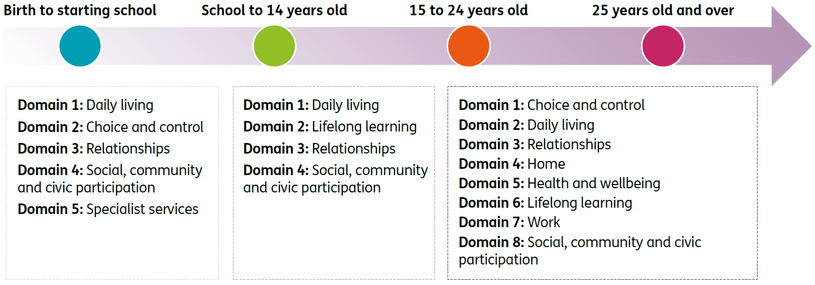
Family/carer domains
Overall, families and carers share many similar goals and challenges, regardless of participant age. As such, several the domains do indeed overlap.
Figure 7.2: Family/carer domains by participant age group
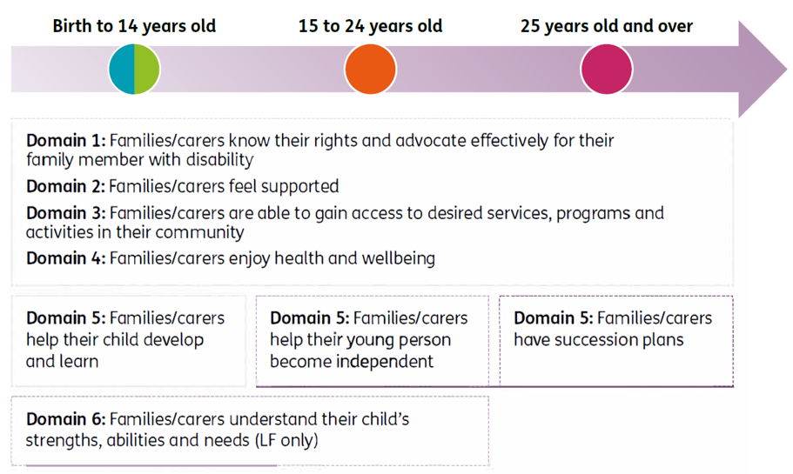
Short Form (SF) versus Long Form (LF)
The pilot was used to refine the questionnaires, including removing redundant questions and revising wording for clarity. It also led to the development of two versions of the questionnaires, a long form (LF), similar to the versions piloted, and a short form (SF).
The SF is completed by all participants and a family member or carer where possible and contains questions useful for planning as well as key indicators to monitor and benchmark over time.
The LF is completed for a subset of participants and includes all the SF questions plus some additional questions allowing more detailed investigation of participant and family/carer experience, and additional benchmarking.
Baseline versus longitudinal
Participants and their families and carers are interviewed at baseline (Scheme entry), and approximately annually thereafter.
It is important to recognise that, with respect to how they are going in different areas of their lives, participants do not enter the Scheme on an equal footing. A range of individual and external factors will impact on the experiences of participants at baseline, including the extent to which their disability affects their life, where they live, and the extent of support they receive from family and friends.
Consequently, the success of the Scheme should be judged not on baseline outcomes, but on how far participants have come since they entered the Scheme, acknowledging their different starting points.
The longitudinal history built up from responses to the outcomes framework questionnaires is used to analyse progress at an individual and Scheme level, to provide insight into how the Scheme is making a difference and point to areas where improvements may be required.
Reporting on outcomes
Information collected from the questionnaires is used to contribute to a range of publicly available reports, including:
- Quarterly reports to disability ministers (Quarterly Reports | NDIS)
- Annual outcomes reports (Participant outcomes report | NDIS, Family and carer outcomes report | NDIS)
- Deep dives focussing on specific outcome areas, such as employment (Employment outcomes - participants, their families and carers | NDIS) and the impact of the COVID-19 pandemic on participant and family/carer outcomes (COVID-19 impact on participant and family/carer outcomes 30 June 2020 | NDIS).

Participant outcomes – results
Economic and social participation
This section “Economic and social participation” and the next section “Has the NDIS helped?” show analyses of participant outcomes at 30 June 2022, for participants entering the Scheme from 1 July 2016. It is worth bearing in mind that the global COVID-19 pandemic that took hold from early 2020 has had an impact on at least some participant and family/carer outcomes, such as employment and community participation. The initial impact (to 30 June 2020) on outcomes was considered in a publicly available report. The impact on employment outcomes to 31 December 2020 was further considered in the latest report on employment outcomes.
Analysing changes in participants’ economic and social participation is important for understanding whether the reasonable and necessary supports funded by the Scheme are resulting in better participant outcomes. In the NDIS Corporate Plan 2022-26, Aspiration 1 is “a quality experience and improved outcomes for participants”, and there are specific performance metrics and targets outlined, such as the proportion of participants in work and the proportion of participants involved in community and social activities. Changes in outcomes have been measured for participants who have been in the Scheme for at least two years, to allow sufficient time for the reasonable and necessary supports provided by the Scheme to have an influence on participant outcomes.
Employment
The NDIA recognises the critical role of employment in boosting the well-being, economic security and social inclusion of people with disability. From a sustainability perspective, when an NDIS participant works they contribute to the economy, use less support for other activities to fill their days, and family members and carers can also return to work and contribute to the economy. The NDIA had a target of 24 per cent of working-age participants in paid employment by June 2022, with the achieved result of 23 per cent slightly below this target.
The NDIS Participant Employment Strategy 2019-22 (the Strategy) which was released on 30 September 2019 and sets out the NDIA’s vision, commitment and plan for supporting participants to find and keep meaningful employment.
The current low unemployment rate in Australia offers increased opportunities for employment of people with disability, including NDIS participants, although the interruptions to employment preparation caused by COVID lockdowns are yet to be fully overcome in some areas. The Employment Action Plan 2021-22 adapted the Strategy action plans to the current environment and contains 12 targeted actions that sit under six priority areas.
Overall, the strategy aims to improve employment outcomes for participants and people with disability more broadly, and to guide the Agency in becoming a leader and advocate of disability employment.
Results – percentage in a paid job
The corporate plan employment metric for participants aged 15 and over is based on the SF question “Are you currently working in a paid job?” with response options “Yes”, “No, but I would like one” and “No and I don’t want one”. The indicator “percentage in a paid job” is the number answering “Yes” as a percentage of the total number answering the question, and hence the denominator includes people who are not interested in employment. From a benchmarking perspective, this is similar to the “employment to population ratio” reported in the ABS Labour Force statistics.
The percentage in a paid job for those in the Scheme for at least two years continues to be relatively stable overall. However, results differ by age group. While employment has increased for those in the 15-24 year age group, it has remained stable or declined for all other age bands. Specifically, comparing responses at the most recent plan review (between two and five years after entry) with responses at Scheme entry, there has been a:
- ten percentage point increase from 11% to 21% for participants aged 15-24 years
- less than 0.5 percentage point increase from 28% to 29% for participants aged 25-34 years
- one percentage point decrease from 29% to 28% for participants aged 35-44 years
- two percentage point decrease from 25% to 23% for participants aged 45-54 years
- three percentage point decrease from 19% to 16% for participants aged 55-64 years
- four percentage point decrease from 13% to 9% for participants aged 65 years and older.
Overall, for participants of working age (15-64 years) there has been a one percentage point increase, from 22% to 23%. This compares to a 2021-22 target of 24%.
Figure 7.3 provides more detail on these results, showing trends over time in the Scheme by age band for different duration cohorts (participants who have been in the Scheme for approximately five, four, three or two years at 30 June 2022).
Figure 7.3: Percentage of participants in a paid job – longitudinal trends for participants in the Scheme for two to five years
Figure 7.3 shows a strong increasing trend in the percentage with a paid job for the 15 to 24 age group for all duration cohorts, in part reflecting the transition from school to work. For participants in the Scheme for four or five years, those aged 25 to 54 are the most likely to have a paid job, and the level of employment and trend over time is similar for the three age groups within this range. For participants in the Scheme for two or three years, those aged 25 to 44 are more likely than those aged 45 to 54 to have a paid job. For all duration cohorts, the level of employment is lower for participants aged 55 to 64, and lowest for those aged 65 and over, and both age groups show a decreasing trend. Part of this decreasing trend is likely to be due to participants retiring from the workforce.
Further details about the employment outcomes for NDIS participants can be found in the publicly available report titled “Employment outcomes for NDIS participants at 31 December 2020”.
Social and community participation
Participation in the community has many benefits for participants, including fostering a sense of belonging and connection, developing social networks and reducing isolation, and increasing confidence and feelings of safety. It can also be a way to increase opportunities for employment or study. Participation in the community can lead to increased independence and reduced reliance on Scheme supports.
Results – percentage actively involved in the community
The corporate plan social and community engagement metric for participants aged 15 and over is based on the SF question “Have you been actively involved in a community, cultural or religious group in the last 12 months?” with response options “Yes, a general community group”, “Yes, a group for people with disability”, “No, but I would like to be” and “No and I don’t want to be”. The indicator for social and community engagement is the number answering “Yes” (regardless of setting) as a percentage of the total number answering the question.
Despite COVID-19, participation in community and social activities has continued to increase. Results tend to be more similar by age group than for employment. Specifically, the percentage actively involved in a community, cultural or religious group in the last 12 months showed a:
- seven percentage point increase from 34% to 41% for participants aged 15–24 years
- ten percentage point increase from 36% to 47% for participants aged 25-34 years
- eight percentage point increase from 37% to 45% for participants aged 35-44 years
- seven percentage point increase from 36% to 43% for participants aged 45-54 years
- six percentage point increase from 36% to 41% for participants aged 55-64 years
- six percentage point increase from 36% to 42% for participants aged 65 years and older.
Overall, for participants aged 15 and over, there has been a seven percentage point increase, from 36% to 43%. This compares to a 2021-22 target of 48%.
Figure 7.4 provides more detail on these results, showing trends over time in the Scheme by age band for different duration cohorts (participants who have been in the Scheme for approximately five, four, three or two years at 30 June 2022). Due to improvements persisting over time, the change from baseline is greater the longer participants have been in the Scheme, for all age groups.

Figure 7.4: Percentage of participants actively involved in the community – longitudinal trends for participants in the Scheme for two to five years
Figure 7.4 shows that increases in social and community participation generally tend to level off slightly after approximately three years in the Scheme. Whilst differences by age are smaller than for employment, participants aged 25 to 34 tend to be slightly above other age groups whereas participants aged 15 to 24 tend to be slightly below. The extent of improvement is slightly lower for the oldest two age groups.
“Has the NDIS helped?”
Participants who have entered the Scheme since 1 July 2016 have been asked whether the NDIS has helped with areas related to each domain. Participants are asked at each plan review, allowing the Agency to gain valuable longitudinal insights. Results for selected domains are shown in this section, and compare responses provided at the first plan review with those from later reviews, for participants who have been in the Scheme for at least two years.
On the whole, perceptions of the Scheme have been positive, with participants and their families/carers more likely to report that the Scheme had helped them in various areas of their lives the longer the participant was in the Scheme. These results suggest a growing level of support for the Scheme by its participants and the family members and carers of participants. These positive perceptions are another indication of Scheme effectiveness and in the long term assist in strengthening the ongoing financial sustainability of the Scheme.
Results –choice and control metric
The choice and control metric for participants aged 15 and over is based on the SF question “Has the NDIS helped you have more choices and more control over your life?”
Positive perceptions of whether the NDIS has helped with choice and control have increased for the latest review compared to the first review across all age bands. Older participants tend to have higher levels of satisfaction. Specifically, the percentage who think that the NDIS has helped them have more choices and more control over their life showed a:
- nine percentage point increase from 61% to 70% for participants aged 15-24 years
- eleven percentage point increase from 66% to 77% for participants aged 25-34 years
- ten percentage point increase from 68% to 78% for participants aged 35-44 years
- ten percentage point increase from 68% to 79% for participants aged 45-54 years
- ten percentage point increase from 70% to 81% for participants aged 55-64 years
- twelve percentage point increase from 70% to 81% for participants aged 65 years and older.
Overall, for participants aged 15 and over, there has been a ten percentage point increase, from 66% to 76%. This compares to a 2021-22 target of 75%.
Figure 7.5 provides more detail on these results, showing trends over time in the Scheme by age band for different duration cohorts (participants who have been in the Scheme for approximately five, four, three or two years at 30 June 2022).

Figure 7.5: Percentage who think the NDIS has helped them have more choices and more control over their life – longitudinal trends for participants in the Scheme for two to five years, participants aged 15 and over
Figure 7.5 shows the generally lower levels of satisfaction for participants aged 15 to 24 compared to the older age groups.
Other results – “Has the NDIS helped?”
For children aged from birth to before starting school, results have improved across all domains.
Table 7.1 shows the percentages responding positively at first review and at latest review, as well as the change between the two time points.

Table 7.1: “Has the NDIS helped?” – participants aged from birth to before starting school
Domain | First review % |  | Latest Review % | Percentage point change
Daily living: child’s development |  | 91 | 95 | +3
Daily living: access to specialist services |  | 91 | 95 | +4
Choice and control (child’s ability to communicate what they want) |  | 83 | 87 | +4
Relationships (fitting into family life) |  | 77 | 83 | +6
Social, community and civic participation (fitting into community life) |  | 64 | 70 | +6
Improvements were slightly stronger for fitting into family and community life (although results for these domains started off at a lower level and hence had more scope to improve).
Figure 7.6 provides more detail for two areas (development and access to specialist services), showing trends over time in the Scheme for different duration cohorts (participants who have been in the Scheme for approximately five, four, three or two years at 30 June 2022).
Figure 7.6: Percentage who think the NDIS has helped – longitudinal trends for participants in the Scheme for two to five years, age 0 to before starting school
Figure 7.6 shows very high initial levels of satisfaction for these two areas. Nevertheless, an improving trend over time in the Scheme has been observed. Results for the different duration cohorts are generally similar.
For children aged from starting school to age 14, results are generally less positive than for the younger age group but show stronger improvement over time.
Table 7.2 shows the percentages responding positively at first review and at latest review, as well as the change between the two time points.
Table 7.2: “Has the NDIS helped?” – participants from starting school to age 14
Domain | First review % |  | Latest Review % | Percentage point change
Daily living (independence) |  | 61 | 73 | +12
Lifelong learning (access to education) |  | 41 | 50 | +9
Relationships (with family and friends) |  | 50 | 60 | +10
Social, community and civic participation (social and recreational life) |  | 45 | 53 | +7
Figure 7.7 provides more detail for two domains (gaining independence and relationships with family and friends), showing trends over time in the Scheme for different duration cohorts (participants who have been in the Scheme for approximately five, four, three or two years at 30 June 2022).
Figure 7.7: Percentage who think the NDIS has helped – longitudinal trends for participants in the Scheme for two to five years, age starting school to 14
Figure 7.7 shows a consistent increasing trend for these two indicators over time in the Scheme. Participants entering more recently show higher levels of satisfaction than those entering earlier.
For young adults aged 15 to 24 years, Table 7.3 shows the percentages responding positively at first review and at latest review, as well as the change between the two time points.

Table 7.3: “Has the NDIS helped?” – participants aged 15 to 24
Domain | First review % | Latest Review % | Percentage point change
Choice and control | 61 | 70 | +9
Daily living | 60 | 72 | +12
Relationships | 50 | 55 | +5
Home | 22 | 20 | -2
Health and wellbeing | 43 | 50 | +7
Lifelong learning | 36 | 37 | +1
Work | 18 | 17 | -1
Social, community and civic participation | 55 | 62 | +7
From Table 7.3, the largest improvement over time in the Scheme has been observed for the daily living domain (+12 percentage points). Strong improvements have also been observed for choice and control (+9 percentage points), relationships (+5), health and wellbeing (+7) and social, community and civic participation (+7). Lifelong learning showed a marginal increase (+1), and there were slight declines for home and work.
Figure 7.8 provides more detail for two domains (daily living and health and wellbeing), showing trends over time in the Scheme for different duration cohorts (participants who have been in the Scheme for approximately five, four, three or two years at 30 June 2022).
Figure 7.8: Percentage who think the NDIS has helped – longitudinal trends for participants in the Scheme for two to five years, age 15 to 24
Figure 7.8 shows that improvements continue to occur for these two domains, even after five years in the Scheme.
For participants aged 25 years and over, perceptions tend to be more positive than for those aged 15 to 24, and the older adult group also shows a stronger improvement over time. Table 7.4 shows the percentages responding positively at first review and at latest review, as well as the change between the two time points.
Table 7.4: “Has the NDIS helped?” – participants aged 25 and over
Domain | First review % | Latest Review % | Percentage point change
Choice and control | 68 | 79 | +11
Daily living | 72 | 83 | +11
Relationships | 52 | 61 | +9
Home | 30 | 34 | +4
Health and wellbeing | 51 | 60 | +9
Lifelong learning | 30 | 32 | +2
Work | 19 | 19 | 0
Social, community and civic participation | 59 | 69 | +10
From Table 7.4, the largest improvements over time in the Scheme have been observed for daily living and choice and control (+11 percentage points). Strong improvements have also been observed for relationships (+9), health and wellbeing (+9) and social, community and civic participation (+10). By contrast with the younger adult group, there was an improvement for the home domain (+4 percentage points). Similar to the younger adult group, lifelong learning showed a marginal increase (+2), and there was no material change for work.
Figure 7.9 provides more detail for two domains (daily living and health and wellbeing), showing trends over time in the Scheme for different duration cohorts (participants who have been in the Scheme for approximately five, four, three or two years at 30 June 2022).

Figure 7.9: Percentage who think the NDIS has helped – longitudinal trends for participants in the Scheme for two to five years, age 25 and over
Figure 7.9 shows that as for young adults, improvements continue to occur for these two domains, even after five years in the Scheme.

Family and carer outcomes – results
The NDIS Outcomes Framework measures outcomes for the families and carers of participants as well as participants, recognising that the outcomes for people with a disability and the people who support them are likely to be closely linked. Families and carers of participants who are well supported under the Scheme and who are achieving greater independence and social and economic participation, are likely to find the caring role easier and to experience increased wellbeing and greater opportunities for social and economic participation themselves. This improved situation for families and carers should in turn translate into further improved outcomes for participants,.
Results – percentage of parents/carers in a paid job
The NDIA’s corporate plan metric for parent and carer employment is based on the SF question “Are you currently working in a paid job?” with response options “Yes” and “No”.
As for participants, it should be noted that the global COVID-19 pandemic that took hold from early 2020 has had an impact on family/carer employment (and other indicators).
The percentage of parents/carers in a paid job for participants who have been in the Scheme for at least two years has improved over time. Specifically, comparing responses at the most recent plan review (between two and five years after entry) with responses at Scheme entry, there has been a:
- five percentage point increase from 46% to 51% for parents/carers of participants aged 0-14 years
- one percentage point increase from 46% to 48% for participants aged 15 years and over.
Overall, for parents/carers of participants across all ages combined, there has been a four percentage point increase, from 46% to 50%. This compares to a 2021-22 target of 49%.
Figure 7.10 provides more detail on these results, showing trends over time in the Scheme for different duration cohorts (families/carers of participants who have been in the Scheme for approximately five, four, three or two years at 30 June 2022).
Figure 7.10: Percentage of parents/carers of participants in a paid job – longitudinal trends for participants in the Scheme for two to five years
Figure 7.10 shows that for participants in the Scheme five years (and to a lesser extent, four years), families and carers of those aged 0 to 14 tend to have lower employment outcomes than families and carers of older participants. However, this difference is not apparent for families and carers of participants in the Scheme for shorter durations. For families and carers of participants aged 15 and over, improvements seem to have levelled off over the latest year.
Results – “Has the NDIS helped?”
Table 7.5 shows the percentages of families and carers responding positively at first review and at latest review, as well as the change between the two time points. Results are shown separately for participants aged 0 to 14 and those aged 15 and over.
Table 7.5: “Has the NDIS helped?” – families and carers
 | Participant aged 0 to 14 |  |  |  | Participant aged 15 and over
Domain | First review % |  | Latest review % | Percentage point change | First review % | Latest review % | Percentage point change
Rights and advocacy |  | 62 | 70 | +8 | 50 | 62 | +12
Families feel supported |  | 68 | 76 | +8 | 62 | 74 | +12
Access to services, programs and activities |  | 70 | 77 | +7 | 59 | 70 | +10
Health and wellbeing |  | 43 | 48 | +4 | 35 | 40 | +5
Child’s development |  | 75 | 81 | +6 | - | - | -
From Table 7.5, perceptions tend to be more positive for families/carers of participants aged 0 to 14 than for those of older participants. The largest improvements over time in the Scheme have been observed for “rights and advocacy” and “families feel supported” (+8 percentage points for families/carers of participants aged 0 to 14, and +12 percentage points for families/carers of participants aged 15 and over). Strong improvements have also been observed for access to services (+7 and +10 for families/carers of participants aged 0 to14 and those aged 15 and over, respectively), and to a lesser extent health and wellbeing (+4 and +5, respectively).
Figure 7.11 provides more detail for the question “Has the NDIS improved the level of support for your family?”, showing trends over time in the Scheme for different duration cohorts (participants who have been in the Scheme for approximately five, four, three or two years at 30 June 2022).

Figure 7.11: Percentage of families/carers who think that the NDIS has improved the level of support for their family – longitudinal trends for participants in the Scheme for two to five years, age 0 to 14 and 15 and over
Figure 7.11 shows that families and carers increasingly feel that the NDIS has improved the level of support for their family, the longer the participant has been in the Scheme. Families and carers of participants entering more recently tend to have higher levels of satisfaction.

Information systems and risk management approach
The agency’s Information systems (comprising case management, finance and data warehouse) and risk management approach are important infrastructure in ongoing financial sustainability.

Information systems
Case management systems
The Agency currently uses SAP Customer Relationship Management (CRM) as its case management system. The CRM system was deployed as a Minimum Viable Product on 1 July 2016 and is hosted and maintained by Services Australia. The primary objective of this delivery was to enable critical operational activities, such as plan approvals and payments. This approach did not meet the needs of the Agency, and as a consequence, has meant the implementation of necessary enhancements to the CRM has not been straightforward. The existing system has a number of limitations, in particular an over-reliance on manual and off-system business processes, and limited capability to prioritise and direct work to the appropriate staff member to complete a task. This is mitigated somewhat by PANDA reporting which provides a single view of work for planning staff (work in progress) and leadership through individual and team dashboards. Business Intelligence (BI) tools consolidate and prioritise CRM work according to Service Level Agreements. Business Data Owners approve definitions with the oversight of the Data Management Committee.
The Agency is building PACE, a business system based on Salesforce CRM that will replace the existing SAP CRM over time. PACE will save time, reduce workarounds and off system processes and give staff more time for quality interactions with participants. It will deliver:
- A high-quality business system.
- Built-in quality and integrity controls.
- More flexibility and capability to put co-design and consultation outcomes in place.
- Simpler internal processes to help the NDIA support participants and meet timeframes in our Participant Service Guarantee.
- Platforms and systems that help our planner and partner work.
- Full implementation of the 2022 amendments to the NDIS Act.
PACE will manage workflow for key activities similar to the current Work Load Manager (WLM). It will support effective management of check-ins, variations, reassessments, technical advice, enquiries, complaints, referrals, information requests and quality control checks.
User Acceptance Testing (UAT) of PACE started in June 2022 and key processes and PACE features will be tested in Tasmania before the end of the year. Testing in real time is part of the continuous improvement process. The NDIA is also building an evaluation model to capture, assess and report back on the feedback from real time testing. Improvements will be made to PACE based on the experience of Tasmanian participants, their families and carers, providers, NDIA and Partners in The Community staff before a national roll-out is considered.
As of 30 June 2022, more than 12,100 people in Tasmania are benefiting from the NDIS, with 7,696 people receiving support for the first time and 343 first plans recently approved. Tasmania was chosen for its diversity in participants and geography. It also contains a smaller number of cross border service providers.
Finance systems
SAP Finance is the Agency’s finance system and was introduced on 1 July 2016. All payments to and from the Agency are made using SAP Finance. In line with Services Australia’s practice, the Agency uses the SAP Public Sector Collection and Disbursement (SAP PSCD) system as an intermediary between the SAP CRM and SAP Finance (operated by Services Australia as a shared service). Work is being undertaken to design and implement additions to the Agency’s claims and payment functionalities to include e-invoicing and real-time payments capabilities.
Data warehouse
The strategic Enterprise Data Warehouse (EDW) has matured and stabilised over the past year with the Integrated Data Store 2.0 (IDS2) Data Architecture now fully deployed. The collection of disparate data sources and assembly into a single integrated data model, ensures integrity and consistency across legislated, business and operational reporting, as well as bespoke analytic deep dives and ad hoc reporting requests.
The main areas of focus for the EDW team over 2022-23 are:
- Maintain consistent, comprehensive and integrated data and reporting through the 3P transition of Scheme participants and plans to the new PACE platform.
- Uplift the IDS2 core data modelling standards, and deliver more customised, user-friendly data assets which will help analyst communities work more efficiently and to consistent standards.
- Improve data governance systems and processes by promoting standardised data definition across all platform users. Assist Business Data Owners to maintain the business glossary to improve context of data.
- Add new tools and services to EDW that provider greater choice to users, simplify data ingestion and transformation processes and allow better user access and data security management.
- Embed a new quality assurance framework into all development and enhancement projects, ensuring the highest quality service is maintained.
- Support the uplift of business data quality management, with continuous monitoring and alerts for source data exceptions and anomalies and data quality threshold breaches

Risk Management
Risk Management Arrangements
The Agency’s approach to risk management is to embed an understanding of risks, controls, and mitigations in every aspect of the organisation, including business planning, reporting, decision making, operations, and strategic initiatives. The proactive use of risk management enables the Agency to effectively manage its operational and strategic risks within the bounds of appetite set by the Board.
The Risk Management Strategy describes the Agency’s strategic approach to managing risks and is underpinned by risk management processes and procedural materials that guide all levels of the organisation to identify and manage risks and implement applicable strategies to minimise negative impacts and maximise opportunities. Implementation of a positive risk culture within the Agency is supported through executive advocacy, risk training, and awareness activities.
The Agency has a structured approach to identifying, managing, escalating, and communicating key risks. Together the Board, Chief Risk Officer, and Executive Leadership Team oversee the efficacy of risk management performance of the NDIA. The responsibilities of the Board to ensure effective implementation of a contemporary risk management framework is enabled through the Risk Committee and Audit Committee.
The Chief Risk Officer has responsibility to ensure:
- NDIA systems, reporting and processes have risk management embedded.
- Risk owners are supported by dedicated risk officers.
- Appropriate controls are in place to mitigate fraud and promote compliance, and manage risk associated with safeguarding public funds while concurrently supporting participant choice and control.

Strategic risks
On an annual basis, the Board determines the strategic risks for the Agency, which are directly aligned to the Corporate Plan. The Board determined nine strategic risks for 2022-23 in the areas of:
- Participant Experience
- Participant Outcomes
- Partner Performance
- Provider Market Quality
- Financial Sustainability
- Scheme Integrity
- People Capability and Capacity
- ICT Delivery and Support
- Stakeholder Relationship and Trust.
The Agency’s strategic risks are monitored against key performance indicators and reported to the Executive Leadership Team and Risk Committee on a quarterly basis. The strategic risks are complemented by operational risks and controls which are owned and managed at group or initiative level.
Business continuity and Risk management system
The Agency is committed to ensuring that participant supports, provider services, and other critical business functions are maintained or quickly restored in the event of a significant outage, incident or crisis event. The Agency has established business continuity management plans, maintained through regular review and scenario analysis, to ensure the rapid resumption of participant and provider services and critical business activities in emergency situations.
The Agency’s integrated risk management system provides a single platform for managing operational, strategic, fraud, project and regulatory risks, audit recommendations, incidents, and business continuity plans. The system gives accountable executives extended visibility to the risks and controls within their business and the broader Agency and provides for a connected risk environment through which inter-dependencies can be identified and managed.

Ongoing Risk Management
While the Agency’s tools, processes and procedures are commensurate with an entity of this size and level of maturity, they will continue to evolve with the Scheme. Future advancement in risk maturity will focus on further embedding positive risk behaviours and culture within the Agency, continuing to improve the integration and digitisation of its risk ecosystem to enhance risk-based decision making and consistency (particularly around access and plan budgets), better governance and implementation of policy changes, and proactive management of financial sustainability risks.
Managing strategic and operational risks to remain at an acceptable level is fundamental to the success and longevity of the Scheme. While strategies to mitigate these risks are articulated in current risk reporting, it will be important to monitor the effectiveness of these strategies in real time to ensure that they are having the desired impact and to make the necessary adjustments to ensure they remain within acceptable tolerances.

Recommendations
The AFSR is required to include “a discussion of the key risks and issues identified and, where these have an adverse impact on financial sustainability, recommendations designed to manage the risks or address the issues”.
It is important to recognise that measures to address financial sustainability risks do not just consider current and estimated future amounts of Scheme expenses or participant plan budgets. Many of the recommendations presented in this section are instead focused on reducing the level of uncertainty associated with future support needs and therefore payments made for supports, or on improving participant outcomes through the provision of supports funded by the Scheme. Reducing uncertainty and achieving positive outcomes from funded supports are both core components of financial sustainability.
Section 9.1 sets out the recommendations included in the 2020-21 AFSR and the progress which has been made in these areas during 2021-22. Section 9.2 includes new recommendations arising from the analysis undertaken in the development of this report, that are intended to manage identified risks and achieve greater certainty in relation to the long-term financial sustainability of the Scheme.
On 18 October 2022, the Minister for the National Disability Insurance Scheme (NDIS) announced the Independent Review into the NDIS to improve the wellbeing of Australians with disability and ensure the Scheme’s sustainability so that future generations receive the benefit of the NDIS.
It is expected that the Review will lead to changes in the NDIA’s work plan. Initiatives and activities described in this section, which commenced prior to the announcement of the Review, should be viewed in that context.

Progress on previous recommendations
During 2021-22, the Agency has progressed various pieces of work, and has commenced or continued many activities relating to recommendations from the 2020-21 AFSR.
The previous recommendations covered a number of key themes relating to the Scheme’s purpose and the Agency’s operations:
- Embedding insurance principles in NDIS culture and communications.
- Focussing on participant outcomes, including monitoring of initiatives to improve outcomes, supporting participants to make informed decisions, reviewing the evidence base for early intervention supports and innovations in the market.
- Consistent and equitable Agency decision-making, including establishing a co-design approach to measuring functional capacity and to guidance materials for decision-making, stronger controls on evidence used in decision-making, and understanding the drivers of higher than expected new entrants to the Scheme.
- Scheme and scope coverage, including facilitating access for participants to supports from other service systems and learning from themes emerging in the Administrative Appeals Tribunal (AAT).
- Improving operational processes, including utilising the findings of quality assurance reviews, embedding improvements made to the future CRM system and strengthening the Agency’s requirements for information recorded on payments to non-registered providers.
The progress made in these areas is summarised below.
Embed insurance principles in NDIS culture and communications
The NDIS insurance principles are documented in the ‘Insurance Principles and Financial Sustainability Manual’ which is available on the NDIS public website. It outlines the principles which cover actuarial estimation of the Scheme funding requirement, as well as the focus on lifetime value for Scheme participants, investment in research and innovation to support long-term objectives of the Scheme, and the development of community capability to support participants’ social and economic participation and independence.
The publication of this AFSR and associated discussions with key stakeholders in the disability sector form an important communication of the actuarial estimates of projected funding requirements as conducted by the Scheme Actuary, as well as the reviews of the experience of NDIS participants in the setting of assumptions as required.
The NDIA has also developed an Engagement Framework with disability sector representatives to guide engagement including strategic communications going forward. This has enabled the commencement of a co-design approach to key projects, as discussed under ‘Consistent and equitable decision-making’ below. A co-design approach will help to ensure that the NDIA can most effectively focus on the long-term value of participant supports where the measures of value are agreed across the sector. Co-design includes communication of and discussion to better understand the research and innovation being undertaken for new supports, and the development of community capability to support NDIS participants and other Australians with disability.
Focussing on participant outcomes
The NDIA continues to monitor and report on participant outcomes to understand how the Scheme is making a difference while highlighting areas where improvements may be needed. The NDIA is also undertaking the Investment Effectiveness Program (IEP) to measure the impact of different types of support more comprehensively on a broader range of outcomes. This is included as a new recommendation in Section 9.2.
A policy and implementation plan is being developed to guide how the Agency supports NDIS participants to make decisions, enables opportunities to make decisions and builds the knowledge and skills of people with disability (and people who support them) to make decisions.
This work builds on an extensive public consultation undertaken in 2021 to develop a new Support for Decision Making policy. To help create this policy, since March 2022 the NDIA has:
- developed an engagement approach with support from the Steering Committee to co-design the policy with people with disability and other key stakeholders; and
- commenced a partnership with Inclusion Australia to work with people with disability who most benefit from supported decision making to co-design the policy and make sure the voices of people with an intellectual disability are central to how the work is progressed.
The NDIA continues to build on the existing national early childhood approach to ensure the delivery of a model that provides evidence-based, high quality and timely supports to young children and families that are embedded in an integrated and collaborative early childhood ecosystem.
Progress has been made on implementing the Early Childhood Early Intervention (ECEI) reset recommendations. Achievements to date include publishing new guidance and an updated early childhood provider report form that helps providers write reports about a child’s progress and outcomes in a consistent way.
The NDIA also continues to support the developing NDIS market such as developing Home and Living options and partnering with the sector to improve quality and outcomes of support coordination. An example is the Home and Living demonstration projects initiative to trial and evaluate alternative models of contemporary home and living supports. The demonstration projects are one mechanism to strengthen the capacity of the market to generate the future state of home and living supports and further demonstration project rounds are anticipated.
Consistent and equitable agency decision-making
The NDIA Engagement Framework has been developed with disability sector representatives to guide, support and strengthen our engagement with the disability community now and into the future. A number of co-design projects are now underway. In many cases, these are supported by Steering Committees who are advising the NDIA on the co-design approach:
- Information Gathering for Access and Planning (IGAP)
- Home and Living
- Support for Decision Making
- Participant Safety
- Cultural and Linguistic Diversity (CALD) Strategy, and
- First Nations Strategy.
In particular, the IGAP project is responsible for delivering a new person-centred model of information gathering that delivers consistency and equity in access and planning outcomes. In the first half of 2022, the NDIA has commenced engaging with the disability community to understand people’s access and planning experiences through focus groups, and an online survey.
The NDIA is committed to making the NDIS more transparent and easier to understand. As part of this, the NDIA continues to update and review guidelines to make the language clearer and easier to understand. The new guidelines include more information about how decisions are made.
For example, 'Would we fund it' includes examples of commonly requested items that are found to cause most confusion. For each item, reasonable and necessary decisions are explained and an overview provided of whether or not it is typically funded. This guide is intended to be read alongside the ‘Our Guideline - Reasonable and necessary supports’, and new items will be added to this resource as they are developed.
To improve consistency in access and planning decisions, the NDIA is providing further guidance on the type and quality of evidence required. These process changes aim to ensure eligible participants receive timely support aligned with the Participant Service Guarantee (PSG) commitments.
Specifically, the NDIA has recently implemented the ‘Supporting Evidence Form – Home and Living’, which replaces the ‘Home and Living Support Request’ form. These changes aim to simplify and speed up the process to deliver home and living supports more efficiently and accurately. The NDIA is looking to produce similar evidence templates across other areas in response to participant and provider feedback for greater clarity.
The NDIA has taken steps to improve communications with participants who entered the Scheme through early intervention regarding reassessment of eligibility. For instance, the NDIA has published clear guidelines to explain that participants entering the Scheme for developmental delay are usually no longer eligible after they turn seven and will need to have an impairment that is likely to be permanent and meet either the disability requirements or the early intervention requirements. Early childhood partners are guided to talk to families or carers before a child turns 6, and explain what information is needed to decide if the child is still eligible.
In terms of better understanding the Scheme’s higher than expected new entrants, the NDIA’s Performance Management and Quality (PMQ) Branch carried out a deep dive investigation into new entrants in the last quarter of 2021. This investigation focussed on understanding of the observed experience of recent new entrants from the geographic areas that phased into the Scheme the earliest, the proportional split between new entrants that are new incidence of disability versus those that are previously unmet need. Detailed analysis has shown that although the new entrant rates for many disability types appears to be reducing and stabilising in-line with the assumption of a 30 June 2024 Steady Intake Date, there remains considerable uncertainty around the long-term assumed new entrant rate for participants with a primary disability of autism aged between 15 and 54 years. This is discussed further in Section 9.2.
Scheme scope and coverage
While taking into consideration that each decision made in the AAT is merit-based (i.e. specific to the individual facts and circumstances of the particular case leading to a decision before the Tribunal), and thus not a legal precedent, the NDIA is constantly monitoring the issues emerging from its AAT decisions to further develop its policies in supporting a consistent and equitable approach to its funding packages, under s34 of the Act ‘Reasonable and necessary supports’.
Improving operational processes
The NDIA has implemented a continuous improvement process that identifies areas of improvement in reasonable and necessary decision-making through quality assurance reviews. This information is used in the development of on-system coaching modules for delegates and subsequent monitoring to track the changes in these areas.
As set out in Section 8.1, the Agency is building PACE, a business system based on Salesforce CRM that will replace the existing SAP CRM over time. PACE will save time, reduce workarounds and off system processes and give more time for quality interactions with participants. It will deliver:
- a high-quality business system.
- built-in quality and integrity controls.
- more flexibility and capability to put co-design and consultation outcomes in place.
- simpler internal processes to help the NDIA support participants and meet timeframes in our Participant Service Guarantee.
- platforms and systems that help planner and partner work.
- better capability for the NDIA to fully implement the 2022 amendments to the NDIS Act.
The NDIA continues undertake a range of strategies to detect fraud as well as other types of noncompliance. However, activities including data analytics and monitoring of behaviours is reliant on the quality and the scope of data collected and managed by the Agency.
In mid-2022, a requirement for all plan managers to capture the provider ABN for all plan-managed payment requests, including participant reimbursements, was put in place. This has led to the continuation of improvement in the data captured on non-registered providers.
The data captured on non-registered providers of self-managed supports is still very limited. The pilot of a new ‘my NDIS participant portal’ has been conducted in 2022 and further development of a new portal provides opportunity to improve the scope and quality of the data collected.
In September 2022, the Agency implemented a new operational plan to reduce the time taken for participants to be discharged from hospital. The plan includes increasing the staff dedicated to supporting participants who are awaiting discharge and streamlining processes to facilitate quicker decision-making.

New recommendations
Continue to develop understanding of causal links between NDIS funding and participant outcomes through the Investment Effectiveness Program
The NDIA should continue to pursue a better understanding of the impact that Scheme funding has on participants’ attainment of outcomes. In the long run, the lack of such understanding has the potential to result in suboptimal funding allocations and impact the overall effectiveness of the Scheme. Understanding these links can better inform participants on how their decisions regarding potential supports impact their individual needs and help their ongoing choices under the Scheme.
The Investment Effectiveness Program (IEP) commenced in early 2022 to better understand and establish links between funding and participant outcomes. This is a multi-year project and is being undertaken in consultation with participants, academics and stakeholders from the disability sector, as well as the Department of Social Services.
Further detail about the IEP is set out in Appendix K.
Recommendation 1: The NDIA should continue work on measuring the impact of funding on participant outcomes through the IEP, to better support the Agency’s and other stakeholders’ understanding of the link between funding and participant outcomes, and its impact on the long-term effectiveness of the Scheme.
Improve understanding of the increased use of supports by participants over time
Analysis of payments inflation has shown that a significant proportion of the increase in payments per participant can be attributed to the increased use of supports over time. In particular, participants are using more hours of attendant care and/ or more high intensity care as their duration in the Scheme increases. The 2021-22 AFSR projections include an assumption that this increased use of supports over time will continue in the medium to long term, although the extent to which this drives future inflation is uncertain.
Also, plan inflation remains high and investigations in the last 12 months have shown that significant levels of inflation are occurring within a plan between reviews (intraplan inflation). Intraplan inflation tends to occur when a participant’s needs and situation change before a plan is due to be reassessed. The most common categories of support where plan inflation occurs are core daily activities as well as social and community participation, which mainly reflect the costs of attendant care.
Recommendation 2: Further work should be done to understand the change in support needs of participants over time, in particular the need for more attendant care. This in turn will help to determine whether this is likely to continue to be a driver of inflation, and whether changes to the Scheme design may have an impact on the use of supports and may help to reduce the level of uncertainty regarding growth in longer-term participant expenses.
Deepen understanding of participants entering the Scheme with autism or transitioning from developmental delay to autism
The numbers of NDIS participants with autism is significantly higher than estimated in the original Scheme design, and recent experience continues to show high numbers of new entrants to the Scheme with a primary disability of autism. This reflects increased prevalence rates of autism that have been observed in recent times both in Australia and internationally.
In particular, the rate of new entrants with autism at young adult ages continues to increase steadily and there is a high level of uncertainty as to whether further increases will occur. In addition, many young children who enter the Scheme due to developmental delay go on to receive an autism diagnosis.
The higher than anticipated numbers of participants with autism entering the Scheme has contributed to upward revisions of projected Scheme expenses over time. The continued uncertainty about future experience means that it is difficult to make improvements to the Scheme design and processes to better support individuals with autism. Such improvements may enable more consistent decision making about Scheme eligibility, better support for participants with autism and also better focus on evidence based early interventions for children with developmental delay who can then transition to mainstream supports where appropriate.
Recommendation 3: The Agency should seek to better understand the drivers of the increasing prevalence of autism, and specifically the higher than expected numbers of participants entering the Scheme with autism or with developmental delay who are then diagnosed with autism. This work would also help clarify to what extent the high rates of new entrants with autism may persist going forward.
Improve understanding of participants and potential participants with psychosocial disability
As at 30 June 2022, there were 56,559 active participants with a primary psychosocial disability, representing 10.6% of all Scheme participants. However, the participation rate of participants with psychosocial disability is lower than original expectations when the Scheme was designed. For example, the participation rate of participants with a psychosocial disability aged 25-44 is 2.8 per 1,000 in the general population compared with 4.7 per 1,000 in the original Productivity Commission estimates.
Investigation into new entrants has shown that a higher proportion of participants entering the Scheme with a psychosocial disability have a previously unmet need (PUN) compared with other disability types, indicating that it is more likely that participants with a psychosocial disability may have required reasonable and necessary supports but had not approached the Scheme.
There is a high level of uncertainty about the future experience of participants with a psychosocial disability including the numbers of new entrants going forward as well as the extent to which delayed entry to the Scheme may lead to higher levels of reasonable and necessary supports in cases where a condition has deteriorated.
Recommendation 4: The Agency should seek to better understand the reasons why individuals with a psychosocial disability may not approach the Scheme, or may not meet the eligibility criteria when applying for access to the Scheme. This will also inform estimates of longer-term rates of new entrants with a psychosocial disability to the Scheme.
Investigate potential long-term Scheme participation rates and Scheme expenses beyond the 10 year term of the results reported in this AFSR
This AFSR sets out the results of Scheme projections for a period of 10 years from 30 June 2022 to 30 June 2032. During that period the number of participants in the Scheme will grow from 534,655 to an estimated 1,017,522, and Scheme expenses as a proportion of GDP are projected to increase from 1.48% in 2022-23 to 2.55% in 2031-32. By applying the assumptions underlying the AFSR projection beyond 10 years, the rate of growth in participant numbers and expenses slows but does not stabilise in the foreseeable future. Several factors contribute to this, including the longer-term impacts of higher than expected number of children entering the Scheme with autism or developmental delay, as well as the ageing impacts of the population and that the proportion of participants in the Scheme aged over 65 will continue to grow for many years.
Given the relative immaturity of the NDIS, it is important to develop more robust longer-term projections and to explore the implications of potential future Scheme participation and expenses in the context of Australia’s social policy. For example, Treasury’s Intergenerational Report is based on projections over a 40 year period.
The lifetime expense estimates for participants already in the Scheme, and for an annual cohort of new entrants to the Scheme are included in Section 5.9 of this report. However, further work is needed to produce a robust long-term projection of the Scheme, and to address issues such as:
- the point at which the number of Scheme participants stabilises as a proportion of the Australian population
- the proportion of the general population the Scheme is ultimately expected to support
- the point at which Scheme expenses will stabilise as a proportion of GDP, and
- the level of Scheme expense as proportion of GDP which is financially sustainable.
This is in line with observations made by the Australian Government Actuary in their review of the AFSR and Scheme projections.
Recommendation 5: The Agency should undertake investigations into the Scheme participation rates implied by the AFSR model and develop a better understanding of the long-term trajectory of the proportions of the Australian population who are supported by the NDIS. The scope of the investigation should also include Scheme expenses as a proportion of national GDP, the level at which the proportion stabilises and also the point in time when it stabilises, depending on the assumptions underlying longer-term projections of the Scheme.
Home and living policy development
The Agency is committed to developing a policy to inform the way the Scheme supports participants to pursue their home and living goals. The aim is to give participants more choice and control over where they live, who they live with and how they are supported. This will enable the NDIS too systematically and over time reduce reliance on outdated, legacy models of group home support in favour of contemporary best practice models of support that better enable participant outcomes of independence and social and economic participation. In early 2022, an engagement approach was developed to co-design the policy with people with disability and key stakeholders. During the first quarter of 2022-23, co-design activities with a ‘Design Group’ of participants, providers and Disability and Carer Representative Organisations (DCROs) have been completed, and the design outputs have been tested with a larger number of participant, provider and DCRO representatives.
Recommendation 6: The Agency should continue to engage in co-design activities to develop a Home and Living policy which supports participants with their living arrangements.
Increased focus on compliance
Initiatives in identifying and assessing compliance matters impacting the Scheme have increased since the establishment of the Agency’s Compliance Response Team in July 2021. The NDIA continues to proactively monitor and respond to incorrect or unusual claims made by registered providers. A key element of the NDIA’s compliance approach is to work with providers to raise awareness of their responsibilities and educate on how to be compliant when claiming. Data modelling has shown that this activity has had a positive impact on claiming behaviour.
However, due to these initiatives being in their preliminary stages of implementation, their impact on inflation levels was unclear at the time of assumption selections at this review.
Recommendation 7: The initiatives of the Compliance Response Team should continue to be closely monitored including the extent to which changes in the behaviour of providers after an intervention are ongoing rather than temporary. This will enable better targeting of effective compliance measures and further reduction in the cost of noncompliant behaviour over time. Robust monitoring will also lead to a better understanding of the estimated impact of such measures on Scheme expenses.
Further investment in data improvements
The strategic Enterprise Data Warehouse (EDW) has matured and stabilised over the past year with the IDS2 Data Architecture now fully deployed. This has improved the integrity and consistency across legislated, business and operational reporting, as well as bespoke analytic deep dives and ad hoc reporting requests. Also, specific improvements have been made to better identify and monitor key indicators across the Scheme such as participants with SIL and the end-to-end process duration for Home and Living applications.
The introduction of the PACE platform over the next year is expected to lead to more consistent and integrated data as well as better data quality for reporting, although a period of significant change in systems and processes must be navigated and managed.
Recommendation 8: Further investments should be made in the Agency’s data assets and the quality of data collected including longer-term development of the EDW post implementation of the new PACE platform. This will enable more effective tracking of operational processes, monitoring of Scheme experience and consistency of decision making about participants and their plans.

Appendix A: Average payment assumption setting details
Average payment assumptions have been calculated separately for each of the 15 different support categories, with different types of Scheme expenses treated as follows:
- Payments to participants and providers are treated on a cash basis (when the cash is paid out by the Agency, regardless of when the support was provided).
- Payments relating to in-kind supports are treated on an accrual basis (when the service was actually provided to the participant).
- Payments relating to Residential Aged Care (RAC) supports have been removed due to the infrequent occurrence of cross-billing payments which distort the payment experience in a given period. Payments relating to RAC are separately allowed for in the projection.
The key components considered in setting payment assumptions are discussed below.
The most appropriate averaging period for payment experience
The selection of an averaging period must balance the need to reflect recent experience with minimising volatility of payment patterns by cohort and support category. The adopted averaging period is the three months to 31 May 2022. By modelling the payments based on the three-month period, the projections align more closely to recent payment experience, which continues to increase over time, while still ensuring there is sufficient stability in payment patterns.
Annual average payment assumptions have been calculated for mature participants in each cohort based on the average annualised payments experience of this three-month period.
Impact of seasonality on the payment experience
Seasonality refers to fluctuations in payment levels over a period of time due to factors such as the number of business days, public holidays and provider claiming behaviour. By utilising a shorter period to inform average payment assumptions, the seasonality impact can result in understatement or overstatement of expenses. Hence, the average annualised payments assumptions need to be modified to allow for the seasonality impacts resulting from the use of the three months to 31 May 2022 as the averaging period. The two key drivers of seasonality appear to be the number of business days in the period, and participant and provider behaviour. The impact of seasonality differs at support category level.
Analysis of previous payments experience between 2018 and 2022 indicated that the overall payments average for the year after removing inflationary impacts was 3% lower than the three-month payment period to 31 May 2022.
Table A.1 shows that seasonality factors have been adopted at the support category level, mostly driven by observed payment relativity and to a lesser extent, the number of business days relative to the rest of the year. Overall, payment assumptions have been decreased by about 3% to allow for the seasonality impact.
Table A.1: Adopted seasonality factors by support category
Support Category |  | Adopted Seasonality Factor
Core
Daily Activities
SIL supports |  | -2%
Non-SIL supports |  | -2%
Social Community Civic |  | -9%
Consumables |  | 0%
Transport |  | 9%
Capital
Assistive Technology |  | 0%
Home Modifications |  | 0%
Capacity Building
CB Daily Activities |  | -8%
Support Coordination |  | -4%
CB Employment |  | 0%
Other CB supports |  | -6%
Total |  | -3%
Average monthly payments for Transport are mainly driven by the number of fortnightly payments made in a given month. This is due to the fortnightly periodic cash payments made directly to the majority of participants, specific to Transport, which comprise 46% of payments within this support category.
Allowance for time in Scheme
Participants in their first year in the Scheme are observed to have lower average payments, which is likely to arise from time taken to familiarise themselves with the Scheme and the process of accessing supports. Average payment assumptions are therefore set based on “mature participants”, defined as those who were active at both 28 February 2022 and 31 May 2022, and had their first plan approved on or prior to 28 February 2021 (i.e. those who had been active for at least 12 months as at 28 February 2021).
A reduction in average payments is adopted for participants in their first year to account for the lower rate of payment. The adopted assumption is 80% (of the average payment for mature participants) for participants without SIL and 90% for participants with SIL.
Residential Aged Care
Supports for young participants in Residential Aged Care (RAC) are currently being met through the aged care system. These payments are recorded in the CRM, but are irregular, distorting the payment experience in a given period. As a result, these payments have been excluded from the payment experience and the resulting base average payment assumptions, and instead allowed for separately in the model. The impact of this adjustment is an increase of 1.1% to the Scheme expenses projections spread over the next five years. The allowance is expected to decrease over time as younger participants in RAC move into alternative SIL or Independent Living Option (ILO) arrangements, and as a result payments to these participants are captured on-system and become more regular in nature.
Adjustment for “SIL indicator” issue
Prior to this review, there were operational limitations in the way SIL supports were entered into the plan in the CRM (support category level, rather than at the support line-item level). Since 1 July 2020 the ability to accurately identify participants with SIL has been limited, as the support category is not detailed enough to distinguish between SIL supports and other activities of daily living. Since participants with SIL have higher average payments than participants without SIL, not adjusting for this misclassification would overstate the average payment assumptions for participants without SIL.
For this review, the Agency has developed and adopted a more robust business rule which is now codified into the Agency’s data warehouses. As of April 2022, an additional 517 participants have now been categorised as participants with SIL.
Payments for participants aged 65 years and over
Payments for participants aged over 65 years are assumed to increase at the rate of 1.0% per annum above the normal wage inflation rate for participants whose primary disability is acquired brain injury, spinal cord injury, autism, intellectual disability or cerebral palsy, up to a maximum loading of 25.0%. These primary disabilities are expected to have average payment assumptions that increase with age, although there is limited experience to support this to date. The average age for the 65 years and over age group will increase gradually over time as the Scheme matures. Hence, average payments for this cohort should increase above normal inflation until a more mature state is reached. The estimated impact is a $13.6 million (or 0.04%) increase in projected Scheme expenses over 2023-24, increasing to around $395.3 million (or 0.44% higher) by 2031-32.
The distribution of Scheme expenses is highly skewed
The Scheme supports participants with a diverse range of needs. Of the payments over the 12 months to 30 June 2022 to mature participants, 52% related to the top 10% of participants when ranked by payment over the period. Conversely, the bottom 40% of participants represent 5% of payments made (Figure A.1).
Figure A.1: Average payment and cumulative percentage of Scheme expenses by ventile (5% band)

This distribution does not vary greatly even when removing the impact of participants with SIL (who have far higher payments on average). 46% of payments are made in respect of the top 10% of participants without SIL, whilst only 7% are made in respect of the bottom 40% of participants without SIL (Figure A.2).
Figure A.2: Average payment and cumulative percentage of Scheme expenses by ventile (5% band) – participants without SIL only
These observations are common in long-tail insurance schemes, and understanding these trends assist with monitoring Scheme sustainability.

Appendix B: Comparison to previous review – detailed tables
Scheme expenses
Table B.1: Baseline projection of Scheme expenses (cash basis) – compared to the previous review
Projected Scheme expenses ($m) | 2022-23 | 2023-24 | 2024-25 | 2025-26 | 2031-32
2021-22 AFSR
Scheme expenses (cash basis)
0-64 years | 30,931 | 34,357 | 39,364 | 44,519 | 76,700
65+ years | 2,544 | 3,211 | 4,099 | 5,081 | 11,389
Total Scheme expenses (cash basis) | 33,475 | 37,568 | 43,463 | 49,599 | 88,089
2020-21 AFSR
Scheme expenses (cash basis)
0-64 years | 30,965 | 34,345 | 37,067 | 39,583 | 58,751
65+ years | 2,464 | 3,114 | 3,748 | 4,367 | 8,378
Total Scheme expenses (cash basis) | 33,429 | 37,459 | 40,814 | 43,950 | 67,129
Difference
Scheme expenses (cash basis)
0-64 years | -34 | 12 | 2,297 | 4,936 | 17,950
65+ years | 80 | 96 | 351 | 713 | 3,011
Total Scheme expenses (cash basis) | 46 | 109 | 2,648 | 5,649 | 20,960
% Difference
Scheme expenses (cash basis)
0-64 years | 0% | 0% | 6% | 12% | 31%
65+ years | 3% | 3% | 9% | 16% | 36%
Total Scheme expenses (cash basis) | 0% | 0% | 6% | 13% | 31%

Table B.2: Baseline projection of Scheme expenses (accrual basis) – compared to the previous review
Projected Scheme expenses ($m) | 2022-23 | 2023-24 | 2024-25 | 2025-26 | 2031-32
2021-22 AFSR
Scheme expenses (accrual basis)
0-64 years | 31,394 | 34,874 | 39,955 | 45,187 | 77,843
65+ years | 2,582 | 3,259 | 4,160 | 5,157 | 11,559
Total scheme expenses (accrual basis) | 33,976 | 38,133 | 44,116 | 50,344 | 89,403
2020-21 AFSR
Scheme expenses (accrual basis)

0-64 years | 31,386 | 34,812 | 37,569 | 40,119 | 59,548
65+ years | 2,501 | 3,161 | 3,803 | 4,432 | 8,501
Total scheme expenses (accrual basis) | 33,886 | 37,973 | 41,373 | 44,551 | 68,049
Difference
Scheme expenses (accrual basis)
0-64 years | 9 | 62 | 2,386 | 5,068 | 18,295
65+ years | 81 | 98 | 357 | 725 | 3,058
Total scheme expenses (accrual basis) | 90 | 160 | 2,743 | 5,793 | 21,354
% Difference
Scheme expenses (accrual basis)
0-64 years | 0% | 0% | 6% | 13% | 31%
65+ years | 3% | 3% | 9% | 16% | 36%
Total scheme expenses (accrual basis) | 0% | 0% | 7% | 13% | 31%
Scheme expenses by participants with SIL and without SIL
Table B.3 shows the impact of the changes in emerging experience and assumptions compared with the previous review on projected Scheme expenses, split between participants with SIL and those without SIL. Projected Scheme expenses for participants with SIL have significantly increased (8% in 2022-23 and 24% in 2025-26). For participants without SIL, projected Scheme expenses have decreased by 3% in 2022-23, and have increased by 9% in 2025-26 and 28% by 2031-32.

Table B.3: Change in projected Scheme expenses by SIL status (cash basis)
Scheme expenses | Projection Year
($m, cash basis) | 2022-23 | 2023-24 | 2024-25 | 2025-26 | 2031-32
2021-22 AFSR
SIL | 10,352 | 11,363 | 12,972 | 14,627 | 25,312
Non-SIL | 23,124 | 26,205 | 30,491 | 34,972 | 62,777
Total | 33,475 | 37,568 | 43,463 | 49,599 | 88,089
2020-21 AFSR
SIL | 9,570 | 10,268 | 11,007 | 11,799 | 18,074
Non-SIL | 23,860 | 27,192 | 29,807 | 32,151 | 49,055
Total | 33,429 | 37,459 | 40,814 | 43,950 | 67,129
Difference
SIL | 782 | 1,096 | 1,965 | 2,828 | 7,239
Non-SIL | -736 | -987 | 684 | 2,821 | 13,722
Total | 46 | 109 | 2,648 | 5,649 | 20,960
% Difference
SIL | 8% | 11% | 18% | 24% | 40%
Non-SIL | -3% | -4% | 2% | 9% | 28%
Total | 0% | 0% | 6% | 13% | 31%

Scheme expenses by Age Band
Table B.4: Change in projected Scheme expenses by age band (cash basis)
Scheme expenses | Projection Year
($m, cash basis) | 2022-23 | 2023-24 | 2024-25 | 2025-26 | 2031-32
2021-22 AFSR
Children (0 to 14) | 4,619 | 5,161 | 5,875 | 6,557 | 9,178
Young adults (15 to 24) | 5,288 | 6,085 | 7,261 | 8,591 | 18,713
Adults (25 to 64) | 21,025 | 23,111 | 26,228 | 29,371 | 48,809
Older adults (65+) | 2,544 | 3,211 | 4,099 | 5,081 | 11,389
Total | 33,475 | 37,568 | 43,463 | 49,599 | 88,089
2020-21 AFSR
Children (0 to 14) | 5,143 | 5,850 | 6,373 | 6,785 | 8,874
Young adults (15 to 24) | 5,610 | 6,427 | 7,165 | 7,914 | 14,054
Adults (25 to 64) | 20,213 | 22,068 | 23,529 | 24,884 | 35,823
Older adults (65+) | 2,464 | 3,114 | 3,748 | 4,367 | 8,378
Total | 33,429 | 37,459 | 40,814 | 43,950 | 67,129
Difference
Children (0 to 14) | -524 | -689 | -498 | -228 | 304
Young adults (15 to 24) | -322 | -341 | 96 | 677 | 4,659
Adults (25 to 64) | 812 | 1,043 | 2,699 | 4,487 | 12,986
Older adults (65+) | 80 | 96 | 351 | 713 | 3,011
Total | 46 | 109 | 2,648 | 5,649 | 20,960
% Difference
Children (0 to 14) | -10% | -12% | -8% | -3% | 3%
Young adults (15 to 24) | -6% | -5% | 1% | 9% | 33%
Adults (25 to 64) | 4% | 5% | 11% | 18% | 36%
Older adults (65+) | 3% | 3% | 9% | 16% | 36%
Total | 0% | 0% | 6% | 13% | 31%

Scheme expenses by Disability Group
Table B.5: Change in projected Scheme expenses by disability group (cash basis)
Scheme expenses | Projection Year
($m, cash basis) | 2022-23 | 2023-24 | 2024-25 | 2025-26 | 2031-32
2021-22 AFSR
Autism | 6,777 | 8,166 | 10,091 | 12,255 | 29,483
Intellectual Disability | 9,754 | 10,599 | 11,975 | 13,401 | 21,291
Psychosocial Disability | 3,940 | 4,557 | 5,346 | 6,111 | 10,474
Developmental Delay | 760 | 835 | 917 | 983 | 1,197
Sensory | 621 | 692 | 792 | 894 | 1,466
Other | 11,624 | 12,719 | 14,342 | 15,955 | 24,177
Total | 33,475 | 37,568 | 43,463 | 49,599 | 88,089
2020-21 AFSR
Autism | 7,216 | 8,545 | 9,797 | 11,072 | 21,794
Intellectual Disability | 9,838 | 10,670 | 11,376 | 12,044 | 16,748
Psychosocial Disability | 3,744 | 4,290 | 4,716 | 5,104 | 7,775
Developmental Delay | 857 | 1,013 | 1,113 | 1,171 | 1,303
Sensory | 648 | 731 | 796 | 852 | 1,221
Other | 11,126 | 12,211 | 13,017 | 13,708 | 18,287
Total | 33,429 | 37,459 | 40,814 | 43,950 | 67,129
Difference
Autism | -439 | -379 | 294 | 1,183 | 7,689
Intellectual Disability | -84 | -70 | 599 | 1,357 | 4,544
Psychosocial Disability | 196 | 267 | 629 | 1,008 | 2,699
Developmental Delay | -98 | -178 | -196 | -188 | -106
Sensory | -27 | -39 | -4 | 42 | 245
Other | 498 | 508 | 1,325 | 2,247 | 5,890
Total | 46 | 109 | 2,648 | 5,649 | 20,960
% Difference
Autism | -6% | -4% | 3% | 11% | 35%
Intellectual Disability | -1% | -1% | 5% | 11% | 27%
Psychosocial Disability | 5% | 6% | 13% | 20% | 35%
Developmental Delay | -11% | -18% | -18% | -16% | -8%
Sensory | -4% | -5% | 0% | 5% | 20%
Other | 4% | 4% | 10% | 16% | 32%
Total | 0% | 0% | 6% | 13% | 31%

Scheme expenses by Support Categories
Table B.6 shows projections by support categories have shifted substantially compared to the previous review.
Table B.6: Change in projected Scheme expenses by support category (cash basis)
Scheme expenses | Projection Year
($m, cash basis) | 2022-23 | 2023-24 | 2024-25 | 2025-26 | 2031-32
2021-22 AFSR
Core
Daily Activities | 18,524 | 20,527 | 23,625 | 26,885 | 47,332
Social Community Civic | 6,357 | 7,192 | 8,433 | 9,779 | 18,995
Transport | 1,000 | 1,166 | 1,365 | 1,569 | 2,803
Consumables | 631 | 714 | 811 | 907 | 1,428
Capital
Assistive Technology | 686 | 770 | 867 | 959 | 1,434
Home Modifications | 353 | 401 | 449 | 496 | 745
Capacity Building
CB Daily Activities | 3,858 | 4,360 | 5,023 | 5,676 | 9,238
Support Coordination | 874 | 1,016 | 1,183 | 1,349 | 2,374
CB Employment | 117 | 144 | 179 | 219 | 552
CB Choice and Control | 465 | 566 | 689 | 788 | 1,371
Other CB supports | 610 | 711 | 839 | 971 | 1,817
Total | 33,475 | 37,568 | 43,463 | 49,599 | 88,089

Scheme expenses | Projection Year
($m, cash basis) | 2022-23 | 2023-24 | 2024-25 | 2025-26 | 2031-32
2020-21 AFSR
Core
Daily Activities | 17,947 | 19,800 | 21,407 | 22,949 | 34,944
Social Community Civic | 6,184 | 6,994 | 7,684 | 8,354 | 13,705
Transport | 1,059 | 1,209 | 1,336 | 1,450 | 2,226
Consumables | 616 | 689 | 747 | 795 | 1,096
Capital
Assistive Technology | 634 | 705 | 758 | 801 | 1,061
Home Modifications | 372 | 419 | 446 | 471 | 640
Capacity Building
CB Daily Activities | 4,191 | 4,796 | 5,279 | 5,682 | 7,915
Support Coordination | 947 | 1,111 | 1,218 | 1,315 | 1,973
CB Employment | 469 | 569 | 648 | 729 | 1,395
CB Choice and Control | 456 | 535 | 592 | 643 | 971
Other CB supports | 554 | 632 | 699 | 762 | 1,201
Total | 33,429 | 37,459 | 40,814 | 43,950 | 67,129
Difference
Core
Daily Activities | 577 | 728 | 2,218 | 3,936 | 12,388
Social Community Civic | 173 | 197 | 749 | 1,426 | 5,290
Transport | -59 | -43 | 30 | 119 | 577
Consumables | 15 | 24 | 64 | 111 | 332
Capital
Assistive Technology | 52 | 65 | 109 | 158 | 372
Home Modifications | -19 | -17 | 4 | 25 | 105
Capacity Building
CB Daily Activities | -333 | -436 | -256 | -6 | 1,323
Support Coordination | -73 | -95 | -36 | 35 | 401
CB Employment | -352 | -424 | -469 | -510 | -843
CB Choice and Control | 9 | 31 | 97 | 145 | 400
Other CB supports | 57 | 79 | 139 | 210 | 616
Total | 46 | 109 | 2,648 | 5,649 | 20,960

Scheme expenses | Projection Year
($m, cash basis) | 2022-23 | 2023-24 | 2024-25 | 2025-26 | 2031-32
% Difference
Core
Daily Activities | 3% | 4% | 10% | 17% | 35%
Social Community Civic | 3% | 3% | 10% | 17% | 39%
Transport | -6% | -4% | 2% | 8% | 26%
Consumables | 2% | 4% | 9% | 14% | 30%
Capital
Assistive Technology | 8% | 9% | 14% | 20% | 35%
Home Modifications | -5% | -4% | 1% | 5% | 16%
Capacity Building
CB Daily Activities | -8% | -9% | -5% | 0% | 17%
Support Coordination | -8% | -9% | -3% | 3% | 20%
CB Employment | -75% | -75% | -72% | -70% | -60%
CB Choice and Control | 2% | 6% | 16% | 23% | 41%
Other CB supports | 10% | 13% | 20% | 28% | 51%
Total | 0% | 0% | 6% | 13% | 31%

Scheme expenses as proportion of Gross Domestic Product (GDP)
Total Scheme expenses (accrual basis) are estimated to represent 1.48% of GDP in 2022-23, increasing to 1.93% in 2025-26 and 2.55% in 2031-32. For ages 0 to 64, this is 1.36% of GDP in 2022-23, 1.73% of GDP in 2025-26 and 2.22% of GDP in 2031-32. Scheme expenses as a proportion of GDP are projected to be higher than the previous review after 2023-24 (Figure B.1 and B.2).
Figure B.1: Comparison of Scheme expenses (accrual basis) as a proportion of GDP – all ages
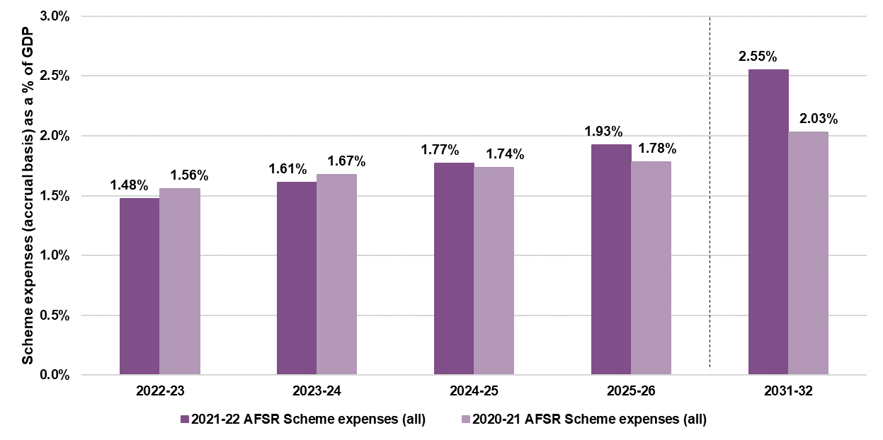

Figure B.2: Comparison of Scheme expenses (accrual basis) as a proportion of GDP – ages 0 to 64

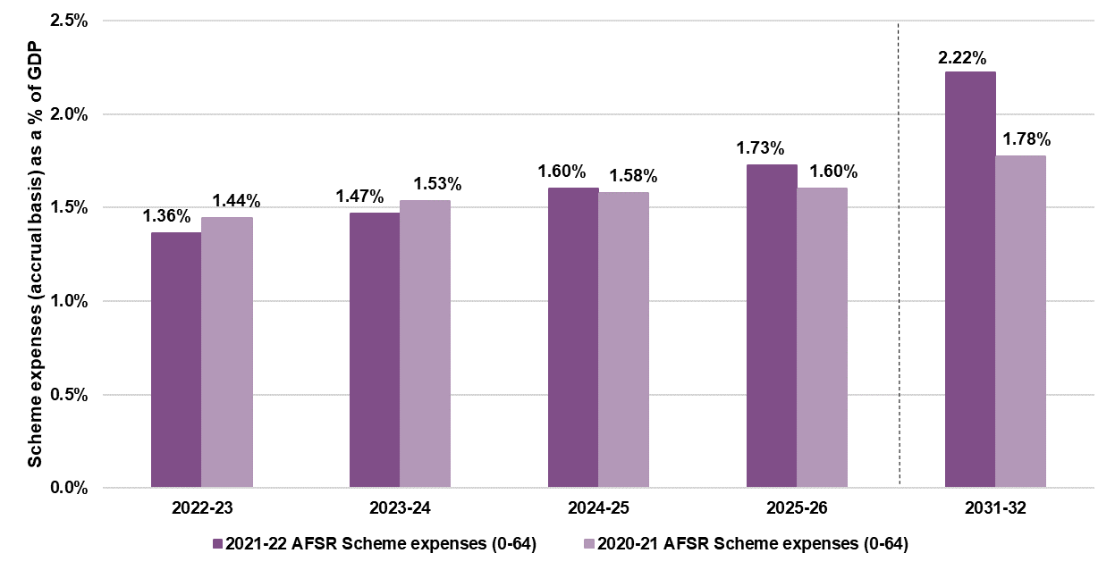

Appendix C: Reconciliation to previous review
Table C.1 shows the main drivers of movements in participant numbers as well as the total movement from the previous review.
Table C.1: Change in projected participant numbers from previous review (30 June 2021)
Change in projected participant numbers | Projection Year
Change in projected participant numbers | 2022-23 | 2023-24 | 2024-25 | 2025-26 | 2031-32
2020-21 AFSR  AFSR model as at 30 June 2021 | 586,433 | 630,327 | 670,400 | 709,645 | 931,591
a) 2020-21 AFSR, with a year of experience  2020-21 AFSR model with 1 July 2021 to 30 June 2022 experience | +4,504 | +4,126 | +4,070 | +4,243 | +5,011
b) General population growth | - | +25 | +44 | +58 | +183
c) Updated Australian life table assumptions | +156 | +320 | +487 | +657 | -1,733
d) Change in mortality rate assumptions reflecting changes in mix | -267 | -553 | -848 | -1,150 | +2,997
e) Revised assumptions reflecting lower long-term rates of participants leaving the Scheme | -631 | +1,064 | +5,197 | +9,095 | +33,634
f) Increases in new entrants assumptions | +4,126 | +8,236 | +12,017 | +15,879 | +44,863
g) Revised assumption of level of previously unmet needs | -2,027 | +2,436 | +2,355 | +2,237 | +1,530
h) Change in transition assumption | - | +32 | +167 | +412 | +1,973
2021-22 AFSR model  Projections based on assumptions in this report | 592,294 | 646,012 | 693,889 | 741,077 | 1,017,522
Total movement from 2020-21 AFSR to 2021-22 AFSR model | +5,861  (+1.0%) | +15,685  (+2.5%) | +23,488  (+3.5%) | +31,432  (+4.4%) | +85,931  (+9.2%)
The projected number of participants at 30 June 2022 is approximately 5,900 higher than the previous review, mainly driven by the increase rate of new entrants to the Scheme and a decrease in the rate at which participants leave the Scheme.

Table C.2 shows the main drivers of movements in Scheme expenses as well as the total movement from the previous review.
Table C.2: Change in projected Scheme expenses (cash basis) from previous review (30 June 2021)
Change in projected scheme expenses (cash basis) | Projection Year
Change in projected scheme expenses (cash basis) | 2022-23 | 2023-24 | 2024-25 | 2025-26 | 2031-32
2020-21 AFSR  AFSR model as at 30 June 2021 | $33.4b | $37.5b | $40.8b | $44.0b | $67.1b
a) 2021-22 AFSR, with a year of experience  2021-22 AFSR model with 1 July 2021 to 30 June 2022 experience | +$0.9b | +$1.0b | +$1.0b | +$1.0b | +$1.3b
b) Revised average payment assumptions | -$1.7b | -$1.9b | -$2.1b | -$2.3b | -$3.8b
c) 2022-23 Annual Pricing Review | +$1.2b | +$0.8b | +$0.9b | +$1.0b | +$1.6b
d) General population growth | $0.0b | +$0.0b | +$0.0b | +$0.0b | +$0.0b
e) Updated Australian life table assumptions | +$0.0b | +$0.0b | +$0.1b | +$0.1b | +$0.3b
f) Change in mortality rate assumptions reflecting changes in mix | -$0.0b | -$0.1b | -$0.1b | -$0.1b | -$0.5b
g) Revised assumptions reflecting lower long-term rates of participants leaving the Scheme | -$0.0b | +$0.0b | +$0.1b | +$0.3b | +$1.5b
h) Increases in new entrant assumptions | +$0.1b | +$0.3b | +$0.6b | +$0.9b | +$3.7b
i) Change in level of previously unmet needs | -$0.0b | +$0.0b | +$0.2b | +$0.2b | +$0.1b
j) Change in transition assumption | -$0.0b | -$0.0b | -$0.0b | -$0.1b | -$0.3b
k) Change to SIL assumptions | +$0.0b | +$0.1b | +$0.1b | +$0.1b | -$0.1b
l) Full impact of updated normal inflation | $0.0b | +$0.3b | +$0.5b | +$0.7b | +$1.2b
m) Additional inflation changes (excl. RAC) | -$0.4b | -$0.5b | +$1.5b | +$3.9b | +$15.9b
2021-22 AFSR model  Projections based on assumptions in this report | $33.5b | $37.6b | $43.5b | $49.6b | $88.1b
Total movement from 2020-21 AFSR to 2021-22 AFSR model | +$0.0b  (+0.1%) | +$0.1b  (+0.3%) | +$2.6b  (+6.5%) | +$5.6b  (+12.9%) | +$21.0b  (+31.2%)
For 2021-22, the Scheme expense is projected to be about 0.1% higher than the previous review. This is mainly attributable to an increase in base inflation assumptions by support category and offset by a decrease in base payment assumptions by support category, which reflect the lower than expected average payments experience over the past 12 months.
Scheme expenses are projected to materially exceed the previous review from 2024-25 onwards and, in 2031-32, the projected Scheme expense is higher than the previous review by 31.2% ($21.0b). The increase is mainly driven by higher additional inflation assumptions.

Appendix D: State and Territory breakdown
The projection model sets assumptions and projects participant numbers and expenses at a national level. A separate model has been developed to allocate projected participant numbers and expenses by State and Territory. The resulting participant numbers and expenses by jurisdiction are shown in Table D.1 and Table D.2.
Table D.1: Projected participant numbers by jurisdiction
 | At 30 June
Participant numbers | 2023 | 2024 | 2025 | 2026 | 2032
NSW | 175,448 | 187,084 | 196,365 | 204,926 | 275,703
VIC | 156,116 | 169,003 | 180,150 | 190,845 | 258,114
QLD | 128,707 | 146,004 | 162,776 | 179,939 | 251,963
SA | 50,978 | 55,028 | 58,536 | 61,979 | 86,239
WA | 52,295 | 57,982 | 63,285 | 68,742 | 97,590
TAS | 13,249 | 14,313 | 15,239 | 16,177 | 22,683
ACT | 9,774 | 10,089 | 10,239 | 10,322 | 13,837
NT | 5,726 | 6,511 | 7,298 | 8,147 | 11,393
Total | 592,294 | 646,012 | 693,889 | 741,077 | 1,017,522
Table D.2: Projected Scheme expenses by jurisdiction
 | Year ended 30 June
Scheme expenses ($m) | 2023 | 2024 | 2025 | 2026 | 2032
NSW | 10,599 | 11,668 | 13,283 | 14,939 | 26,074
VIC | 8,396 | 9,672 | 11,442 | 13,317 | 24,323
QLD | 7,359 | 8,285 | 9,593 | 10,945 | 19,193
SA | 2,917 | 3,308 | 3,866 | 4,457 | 8,073
WA | 2,832 | 3,196 | 3,713 | 4,248 | 7,582
TAS | 903 | 1,014 | 1,182 | 1,357 | 2,429
ACT | 505 | 516 | 537 | 540 | 834
NT | 465 | 473 | 499 | 541 | 895
Total | 33,976 | 38,133 | 44,116 | 50,344 | 89,403

Appendix E: Historic average participant payments by SIL type
Table E.1: Previous AFSR projections – average participant payments (participants without SIL) (cash flow basis)
Average participant payments (non-SIL) | 2018-19 | 2019-20 | 2020-21 | 2021-22 | 2022-23 | 2023-24 | 2024-25 | 2025-26
AFSR
30 June 2022 AFSR projection |  |  |  |  | 43,200 | 44,400 | 47,700 | 51,000
30 June 2021 AFSR projection |  |  |  | 42,200 | 44,900 | 46,800 | 48,000 | 48,700
31 December 2020 AFSR projection |  |  |  | 41,200 | 42,600 | 43,800 | 45,100 | 46,300
30 June 2020 AFSR projection |  |  | 34,700 | 36,200 | 37,100 | 38,300 | 39,700 | 41,300
31 December 2019 AFSR projection |  |  | 35,400 | 36,200 | 37,100 | 38,100 | 39,300 | 40,700
30 June 2019 AFSR projection |  | 33,400 | 35,100 | 36,100 | 37,000 | 37,700 | 38,200 | 39,300
30 June 2018 AFSR projection | 23,300 | 29,300 | 32,300 | 34,100 | 35,600 | 37,500 | 38,700 | 40,000
Comparison with actuals
Actual average participant payments | 27,100 | 34,100 | 38,600 | 39,500
Actual average participant payments compared with AFSR ($) | 3,800 | 700 | 3,900 | -2,700
Actual average participant payments compared with AFSR (%)  (Actual – AFSR projection) / Actual | 14.1% | 2.0% | 10.1% | -7.0%

Table E.2: Previous AFSR projections – average participant payments (participants with SIL) (cash flow basis)
Average participant payments (SIL) | 2018-19 | 2019-20 | 2020-21 | 2021-22 | 2022-23 | 2023-24 | 2024-25 | 2025-26
AFSR
30 June 2022 AFSR projection |  |  |  |  | 374,600 | 391,500 | 426,900 | 461,300
30 June 2021 AFSR projection |  |  |  | 343,000 | 360,800 | 373,800 | 386,700 | 400,100
31 December 2020 AFSR projection |  |  |  | 340,000 | 359,400 | 372,600 | 382,500 | 395,800
30 June 2020 AFSR projection |  |  | 319,200 | 338,500 | 354,200 | 370,500 | 389,100 | 407,500
31 December 2019 AFSR projection |  |  | 315,700 | 336,600 | 357,100 | 379,400 | 401,400 | 417,900
30 June 2019 AFSR projection |  | 262,600 | 280,100 | 294,600 | 309,700 | 325,500 | 340,600 | 354,400
30 June 2018 AFSR projection | 255,000 | 273,400 | 288,800 | 301,800 | 314,000 | 326,800 | 340,200 | 354,100
Comparison with actuals
Actual average participant payments | 249,600 | 304,400 | 325,500 | 343,900
Actual average participant payments compared with AFSR ($) | -5,400 | 41,800 | 6,300 | 900
Actual average participant payments compared with AFSR (%)  (Actual – AFSR projection) / Actual | -2.1% | 13.7% | 2.0% | 0.2%

Appendix F: Scenario analysis from previous AFSRs
This section summarises the results of projection scenarios considered in historic Annual Financial Sustainability Report projections since 2016-17. These scenarios assist in understanding the range of plausible projections based on reasonable alternative assumptions.
Note on terminology and term of projection
There have been several changes in terminology in the 2021-22 AFSR compared with previous AFSRs. In this appendix, the original terminology has been used. In particular:
- Scheme expenses were previously referred to as ‘Total participant costs’;
- Participants leaving the Scheme were previously referred to as ‘non-mortality exits’;
- Supported Independent Living (SIL) was previously referred to as Shared Supported Accommodation (SSA);
- Plan budgets were previously referred to as ‘Committed supports’;
- Additional inflation was previously referred to as ‘Superimposed inflation’.
It is also important to recognise that the scenarios set out in this appendix include results out to the 2029-30 period. In this AFSR however, results are generally shown out to the 2031-32 period, and therefore are not directly comparable with the scenario results presented here.

2016-17 Scenarios
Total participant costs ($m) | 2019-20 | 2024-25 | 2029-30
2016-17 Baseline | 21,240 | 30,492 | 41,783
Scenario 1a. Committed supports + utilisation of 85% | 20,436 | 28,943 | 38,863
Scenario 1b. Committed supports + utilisation of 90% | 21,638 | 30,645 | 41,149
Scenario 1c. Committed supports + utilisation of 100% | 24,042 | 34,050 | 45,721
Scenario 2a. 1% p.a. superimposed inflation | 21,756 | 32,762 | 47,095
Scenario 2b. 2% p.a. superimposed inflation | 22,279 | 35,179 | 53,022
Scenario 2c. 10% p.a. superimposed inflation for 2 years | 25,509 | 36,619 | 50,179
Scenario 2d. 5% p.a. superimposed inflation for 5 years | 23,897 | 38,551 | 52,826
Scenario 3a. Increase incidence 0 to 18 by 15% | 22,345 | 32,201 | 44,258
Scenario 3b. Reduce incidence 25+ by 5% | 20,662 | 29,676 | 40,695
Scenario 3c. Combination of 3a. and 3b. | 21,766 | 31,385 | 43,171
Scenario 4a. Halve non-mortality exits ages 0 to 64 | 21,240 | 31,315 | 44,041
Scenario 4b. Double non-mortality exits for ages 65+ | 21,237 | 30,434 | 41,532
Scenario 4c. Increase excess mortality by 50% | 21,168 | 30,017 | 40,583
Scenario 4d. Reduce excess mortality by 50% | 21,252 | 30,899 | 42,984
Scenario 5a. 5% of new incidence to highest LoF | 21,240 | 31,154 | 43,486
Scenario 5b. 5% of starting population to highest LoF | 25,216 | 35,449 | 47,576
Scenario 5c. Combination of 5a. and 5b. | 25,216 | 36,112 | 49,279
Scenario 6a. Increase SSA Numbers by 10% | 20,970 | 29,684 | 39,818
Scenario 6b. Increase SSA average cost by 25% | 21,822 | 30,939 | 41,570
Scenario 6c. Combination of 6a. and 6b. | 22,495 | 31,880 | 42,796
Scenario 7a. Remove age based loadings for 65+ | 21,176 | 30,068 | 40,729
Scenario 10a. Exclude GI/MM from NIIS | 21,240 | 30,492 | 41,783
2017-18 Scenarios
Total participant costs ($m) |  | 2019-20 | 2024-25 | 2029-30
 | 2017-18 Baseline | 15,638 | 31,715 | 44,395
1a | Higher Autism exits | 15,453 | 30,171 | 40,485
1b | Lower Autism exits | 15,676 | 32,099 | 45,579
2 | Intellectual disability new incidence hump 17-22 yrs | 15,638 | 32,008 | 46,518
3a | Higher Proportion of participants in SSA (SIL) | 17,636 | 35,769 | 50,034
3b | Lower Proportion of participants in SSA (SIL) | 15,405 | 31,197 | 43,556
3c | SSA cost innovation | 12,489 | 29,261 | 41,178
4a | Increased Number of adults | 16,276 | 38,193 | 53,883
4b | Decreased number of children | 14,213 | 30,962 | 43,463
4c | Increased new entrants | 15,887 | 36,377 | 50,143
5a | Committed supports and 100% utilisation | 18,957 | 38,064 | 53,473
5b | Committed supports and 75% utilisation | 13,839 | 28,548 | 40,105
7a | AAT and mainstream | 18,123 | 37,118 | 51,450
7b | AAT, mainstream and level of function movement | 18,400 | 37,686 | 52,236
7c | AAT access decisions | 16,670 | 34,352 | 47,592
8a | 3% pa superimposed inflation for 10 years | 15,676 | 35,882 | 55,465
8b | 0% superimposed inflation | 14,810 | 29,407 | 41,164
2018-19 Scenarios
Total participant costs ($m) |  | 2019-20 | 2024-25 | 2029-30
 | 2018-19 Baseline | 16,327 | 30,820 | 43,723
1a | Additional Cost of chronic health (Low range) | 19,333 | 34,760 | 48,886
1b | Additional Cost of chronic health mid-range) | 20,770 | 36,644 | 51,356
1c | Additional Cost of chronic health high range) | 22,404 | 38,785 | 54,162
2 | Lower autism and higher psychosocial disability numbers | 16,347 | 31,077 | 43,893
3 | Intellectual disability new entrants hump for 17-22yrs | 16,327 | 31,209 | 46,322
4a | Higher proportion of participants in SIL over long-term | 16,434 | 32,930 | 48,951
4b | Long-term SIL reached over 20 years | 16,302 | 30,331 | 42,573
4c | SIL cost innovation | 14,874 | 27,978 | 39,510
5 | 85%/100% utilisation rate for non-SIL/SIL respectively | 19,380 | 34,844 | 49,343
6a | Transport policy: Strict tightened eligibility | 16,125 | 30,469 | 43,215
6b | Transport policy: tightened eligibility &increased budget | 16,454 | 31,041 | 44,043
6c | Transport policy: tightened eligibility & bottom up approach | 18,800 | 35,115 | 49,941
7 | Steady intake date at 30 June 2020 | 16,425 | 28,286 | 41,344
8a | Additional 3% pa superimposed inflation from 2021 | 16,327 | 35,152 | 56,030
8b | Additional 1% pa superimposed inflation from 2021 | 16,327 | 32,264 | 47,825
2019-20 Scenarios
Total participant costs | 2019-20 | 2024-25 | 2029-30
2019-20 Baseline |  | 34,109 | 51,304
Scenario 1a. => Continuation of historical superimposed inflation |  | 45,399 | 68,282
Scenario 1b. => Removal of 1% p.a. additional superimposed inflation |  | 32,364 | 48,447
Scenario 1c. => Alternative normal inflation |  | 33,332 | 46,735
Scenario 2a. => Higher proportion of participants in SIL over long-term |  | 37,230 | 60,805
Scenario 2b. => Continuation of increasing SIL cost for 2 years |  | 37,909 | 57,276
Scenario 2c. => SIL cost innovation |  | 31,119 | 46,600
Scenario 3a. => 44,000 additional participants |  | 37,955 | 56,268
Scenario 3b. => 60,000 additional participants |  | 38,430 | 56,879
Scenario 3c. => 99,000 additional participants |  | 39,287 | 57,982
Scenario 5a. => Steady Intake Date at 30 June 2021 |  | 33,207 | 50,180
Scenario 5b. => Higher intake levels sustained for 3 years |  | 36,821 | 54,774

2020-21 Scenarios
Total participant costs ($m) | 2019-20 | 2024-25 | 2029-30
2020-21 Baseline |  | 41,373 | 59,284
Cost increase scenarios
Two additional years of high inflation |  | 46,613 | 69,464
Higher long term new incidence assumptions |  | 42,625 | 65,556
Lower non-mortality exit rates |  | 41,861 | 61,939
Higher cost of new entrants |  | 42,166 | 61,213
Higher SIL numbers (+500 p.a.) |  | 41,955 | 60,978
Three extra years to reach steady state |  | 42,091 | 60,865
Total of cost increase scenarios |  | 50,448 | 83,596
Plausible high case (variance) |  | 47,843 | 74,156
Cost reduction scenarios |  | 41,373 | 59,284
One year less of high inflation |  | 39,358 | 54,497
Lower long term new incidence assumptions |  | 41,373 | 57,496
Lower general population growth |  | 41,338 | 59,113
Lower SIL numbers (-200 p.a.) |  | 41,140 | 58,607
Lower cost of new entrants |  | 40,579 | 57,355
Total of cost decrease scenarios |  | 38,296 | 49,931
Plausible low case (variance) |  | 38,970 | 53,159

Appendix G: Scenario analysis of participant numbers
The projections presented in Section 5 of this report represent the “baseline” estimate of Scheme population. The appendix shows the impact on participant numbers for the scenarios detailed in Section 6.1 of the report. The participant projections corresponding to each scenario have been split by existing participants and new participants, and in total. The total Scheme projection of participants is split between existing participants and new entrants (from 1 July 2022 onwards) is shown in Table G.1.
Table G.1: Split of participant numbers between existing and new participants
Participant Numbers | Jun-22 | Jun-23 | Jun-24 | Jun-25 | Jun-26 | Jun-32
Existing participants | 534,655 | 521,547 | 507,074 | 493,631 | 481,543 | 427,039
New Participants | 0 | 70,747 | 138,938 | 200,258 | 259,533 | 590,483
All projected participants | 534,655 | 592,294 | 646,012 | 693,889 | 741,077 | 1,017,522
Scenario relating to the rates of participants leaving the Scheme
Scenario: Lower rate of participants leaving the Scheme
In this scenario the rate at which participants leave the scheme is assumed to be 25% lower than the assumption in the baseline projection.
Table G.2: Lower rate of participants leaving the Scheme
 | Projection Year
 | Jun-23 | Jun-24 | Jun-25 | Jun-26 | Jun-32
Existing participants
Total Participants | 523,605 | 511,320 | 499,639 | 488,899 | 438,649
Variance to baseline | 2,058 | 4,247 | 6,008 | 7,356 | 11,610
% variance to baseline | 0.4% | 0.8% | 1.2% | 1.5% | 2.7%
New participants
Total Participants | 70,747 | 139,017 | 200,956 | 261,352 | 603,921
Variance to baseline | 0 | 78 | 698 | 1,818 | 13,438
% variance to baseline | 0.0% | 0.1% | 0.3% | 0.7% | 2.3%
All projected participants
Total Participants | 594,352 | 650,337 | 700,594 | 750,251 | 1,042,570
Variance to baseline | 2,058 | 4,325 | 6,706 | 9,174 | 25,047
% variance to baseline | 0.3% | 0.7% | 1.0% | 1.2% | 2.5%

Scenarios relating to numbers of new entrants to the Scheme
Scenario: Higher assumptions regarding the number of new participants
The assumptions relating to numbers of new participant participants are 15% higher than those assumed in the baseline projections.
Table G.3: Higher assumptions regarding the number of new participants
 | Projection Year
 | Jun-23 | Jun-24 | Jun-25 | Jun-26 | Jun-32
Existing participants
Total Participants | 521,547 | 507,074 | 493,631 | 481,543 | 427,039
Variance to baseline | 0 | 0 | 0 | 0 | 0
% variance to baseline | 0.0% | 0.0% | 0.0% | 0.0% | 0.0%
New participants
Total Participants | 80,278 | 157,984 | 228,538 | 296,744 | 677,575
Variance to baseline | 9,531 | 19,046 | 28,280 | 37,211 | 87,092
% variance to baseline | 13.5% | 13.7% | 14.1% | 14.3% | 14.7%
All projected participants
Total Participants | 601,825 | 665,058 | 722,168 | 778,288 | 1,104,614
Variance to baseline | 9,531 | 19,046 | 28,280 | 37,211 | 87,092
% variance to baseline | 1.6% | 2.9% | 4.1% | 5.0% | 8.6%

Scenario: Lower assumptions regarding the number of new participants
In this scenario the assumptions relating to new entrants are 15% lower than those assumed in the baseline projections.

Table G.4: Lower assumptions regarding the number of new participants
 | Projection Year
 | Jun-23 | Jun-24 | Jun-25 | Jun-26 | Jun-32
Existing participants
Total Participants | 521,547 | 507,074 | 493,631 | 481,543 | 427,039
Variance to baseline | 0 | 0 | 0 | 0 | 0
% variance to baseline | 0.0% | 0.0% | 0.0% | 0.0% | 0.0%
New participants
Total Participants | 61,216 | 119,893 | 171,979 | 222,322 | 503,392
Variance to baseline | -9,531 | -19,046 | -28,280 | -37,211 | -87,092
% variance to baseline | -13.5% | -13.7% | -14.1% | -14.3% | -14.7%
All projected participants
Total Participants | 582,763 | 626,966 | 665,609 | 703,865 | 930,431
Variance to baseline | -9,531 | -19,046 | -28,280 | -37,211 | -87,092
% variance to baseline | -1.6% | -2.9% | -4.1% | -5.0% | -8.6%
Scenario: Higher assumptions regarding the number of new entrants with autism and aged between 15 and 54
In this scenario the assumptions regarding the number of new entrants with autism and aged between 15 and 54 are 15% higher than the assumptions used for baseline projections for this cohort.
Table G.5: Higher assumptions regarding the number of new entrants with autism and aged between 15 and 54
 | Projection Year
 | Jun-23 | Jun-24 | Jun-25 | Jun-26 | Jun-32
Existing participants
Total Participants | 521,547 | 507,074 | 493,631 | 481,543 | 427,039
Variance to baseline | 0 | 0 | 0 | 0 | 0
% variance to baseline | 0.0% | 0.0% | 0.0% | 0.0% | 0.0%
New participants
Total Participants | 71,609 | 140,667 | 202,856 | 263,001 | 599,199
Variance to baseline | 861 | 1,729 | 2,598 | 3,468 | 8,716
% variance to baseline | 1.2% | 1.2% | 1.3% | 1.3% | 1.5%
All projected participants
Total Participants | 593,155 | 647,741 | 696,486 | 744,544 | 1,026,238
Variance to baseline | 861 | 1,729 | 2,598 | 3,468 | 8,716
% variance to baseline | 0.1% | 0.3% | 0.4% | 0.5% | 0.9%

Scenario: Three extra years to reach steady state
This scenario assumes the scheme is bound to take three extra years to reach steady state (a slower transition to the Steady Intake Date), such that it occurs on 30 June 2027 instead of the current assumption of 30 June 2024.
Table G.6: Three extra years to reach steady state
 | Projection Year
 | Jun-23 | Jun-24 | Jun-25 | Jun-26 | Jun-32
Existing participants
Total Participants | 521,547 | 507,074 | 493,631 | 481,543 | 427,039
Variance to baseline | 0 | 0 | 0 | 0 | 0
% variance to baseline | 0.0% | 0.0% | 0.0% | 0.0% | 0.0%
New participants
Total Participants | 70,747 | 141,277 | 209,768 | 276,087 | 609,232
Variance to baseline | 0 | 2,339 | 9,510 | 16,554 | 18,748
% variance to baseline | 0.0% | 1.7% | 4.7% | 6.4% | 3.2%
All projected participants
Total Participants | 592,294 | 648,351 | 703,399 | 757,631 | 1,036,270
Variance to baseline | 0 | 2,339 | 9,510 | 16,554 | 18,748
% variance to baseline | 0.0% | 0.4% | 1.4% | 2.2% | 1.8%
Scenarios with no change to projected participant numbers by comparison to the baseline projections have been excluded from this appendix. These scenarios are as follows:
- Scenario: Higher numbers of SIL participants
- Scenario: Lower numbers of SIL participants
- Scenario: Lower payments for new entrants
- Scenario: Higher payments for new entrants
- Scenario: Higher additional inflation
- Scenario: Lower additional inflation.

Appendix H: Analysis of Scheme new entrant rates
Background
A key underpinning of the operation of the National Disability Insurance Scheme (NDIS) is the application of strong insurance principles where experience is closely and regularly monitored. This allows emerging risks and issues to be identified, investigated and where required, remediation strategies to be implemented. An important aspect of experience is the new entrant rate assumption, which refers to the proportion of the general population who are expected to acquire a particular disability and begin accessing NDIS supports each year. The new entrant rate assumption is critical as the rate of new entrants to the Scheme, together with the rate at which participants leave the Scheme, are the two drivers of the growth in the participant numbers in the Scheme.
The analysis and results contained in this appendix are based on data to 31 March 2022.
A 14% increase in the overall long-term new entrant rate assumptions has been estimated
Based on analysis using data at 31 March 2022, it is estimated that 308.4 participants per 100,000 population aged between 0 and 64 will acquire a disability each year (and become eligible for the Scheme). This is equivalent to a 14% increase in the assumption adopted in the 2020-21 AFSR of 271.6 participants per 100,000 population aged between 0 and 64. This increase reflects the emerging experience where more participants are approaching the Scheme than expected.
In addition to the long-term new entrant rate assumption of 308.4 participants per 100,000 population, it is assumed that in the short-term additional participants will enter the Scheme due to a previously unmet need (PUN). However, these participants are not indicative of likely long-term experience. The assumed proportions of PUN vary by gender and age and are set separately for participants with a primary psychosocial disability.
Methodology
Over time, two methods have been used to estimate the new entrant rate assumption to the Scheme:
- Direct method: relies on the observed rate of new entrants to estimate the new entrant rate assumption. This requires reliable and stable experience of new entrants to inform assumptions about the future number of new entrants to the Scheme directly. The direct method comprises of the following steps:
  - The recently observed rate of new entrants (which excludes new entrants transferring from an existing State/Territory/Commonwealth disability program) is compiled. This new entrant rate is made up of both new incidence to disability (i.e. participants who acquired their disability relatively recently, or who have only recently met the necessary criteria for access to the Scheme, and are therefore indicative of likely longer-term levels of new entrants) and previously unmet need (i.e. participants who acquired their disability some years prior who only accessed the Scheme recently due to various reasons, and would not therefore be indicative of likely longer-term levels of new entrants);
  - The proportion of participants within the recently observed new entrant experience who had a previously unmet need is estimated. At this review this was based on an analysis of a sample of just over one thousand recent new entrants by the Agency’s Performance Management and Quality Branch; and
  - The proportion of participants that are previously unmet need estimated in step (b) above, are subtracted from the recently observed new entrant experience calculated in step (a) above, to give the estimated long-term new incidence to disability.
- Indirect method: utilises participation rates, which are defined as the proportion of the general population who have an existing disability and are in the Scheme. The indirect method presumes that the participation rate for any age (say X) is equal to the participation rate at the previous age (X-1), plus the new entrant rate (for age X), minus the rate at which participants leave the Scheme (for age X). From this relationship, an indirect estimate of the raw new entrant rate for each age can be calculated.
At this review, the new entrant rate assumption has been estimated using only the direct method, with an adjustment then made to the observed experience to reflect the current proportion of new entrants estimated to have a previously unmet need (or PUN).
At the previous review, the new entrant rate assumptions were estimated by equally weighting rates estimated by the direct and indirect methods, with the rate estimated at previous reviews being based solely on the indirect method, as the observed new entrant experience was too immature to be used to estimate future new entrant experience.
The indirect method is inferior to the direct method as a result of being heavily reliant on a number of key assumptions. These include:
- Participation rates and new entrant rates for each disability remain stable over time. This means increasing or decreasing trends from year to year are not incorporated. Where these rates have been increasing over time, the estimate may be too low, and where it has been decreasing, the estimate may be too high;
- The Scheme’s most mature geographic regions provide an indication of ultimate participation rates. This is because the model relies heavily on the experience of mature regions to estimate the number of participants entering the Scheme after two or more years from when the region first phased in. Where experience is different in areas that phased in most recently, then this will not be reflected in adopted assumptions;
- A re-classification from one disability type to another is regarded as a new entrant. For example, a participant re-classified from other physical to cerebral palsy, would, be counted twice as a new entrant; and
- It relies on accurate estimation of the rate at which participants leave the Scheme calibrated for the AFSR projection, and the extent to which these rates differ from the actual experience of participants leaving the Scheme will impact the calibrated new entrant rate assumptions. For example, if the view of long-term rates at which participant’s leave the Scheme were to be revised downwards, this would lead to a lower estimated new entrant rate assumption.
Recently, observed new entrant experience is regarded as sufficiently mature such that it can be used to inform the estimation of new entrant rate assumptions using the direct method. This is demonstrated in Figure H.1 which shows the number of new entrants to the Scheme for years ended 31 March. The key points to note are:
- The overall number of new entrants (as indicated by the purple columns) peaked in 2019;
- The number of new entrants to the Scheme who transferred from an existing disability program (as indicated by the thin green line), has been declining since peaking in 2019, and in 2022 participants who transferred from an existing disability program (about 4,350 participants) represented only 6% of the total number of new entrants (compared to the 2019 year where participants transferring from an existing disability program represented 62% of the total number of new entrants); and
- Most importantly, the number of participants entering the Scheme who are new to disability supports (as indicated by the thick dark grey line) was broadly similar in 2021 and 2022, and is expected to continue declining until the Steady Intake Date, which is assumed to occur around 30 June 2024.
Figure H.1: New entrants to the Scheme
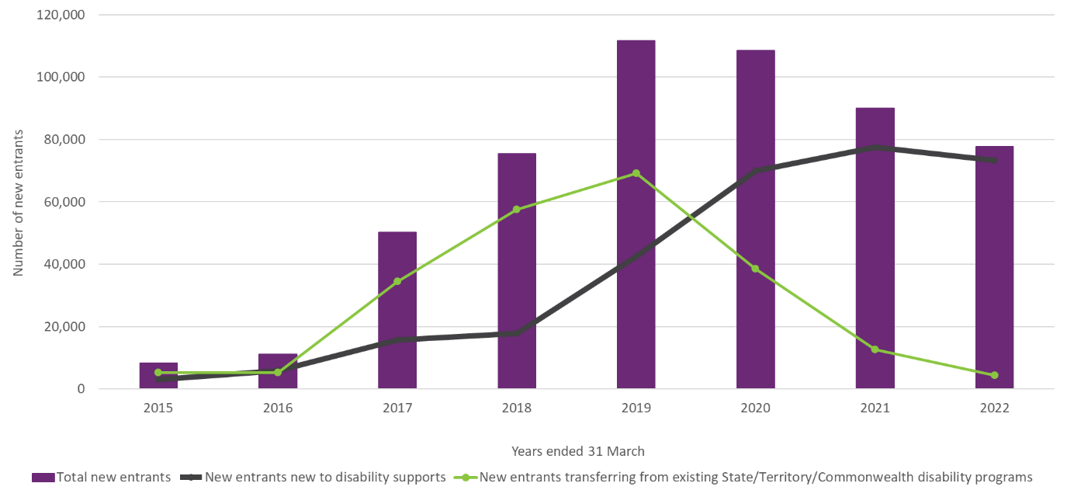

The Steady Intake Date represents the estimated future date at which point in time where the vast majority of participant intake consists of new incidence to disability (in other words, when the level of previously unmet needs has become immaterial). The Steady Intake Date is assumed to occur around 30 June 2024 and there exists uncertainty associated with this assumed date. In particular, it is possible that the Steady Intake Date later than 30 June 2024. Section 6.1 of this report therefore includes a scenario of the Steady Intake Date occurring three years later than the currently assumed date of 30 June 2024.
Previously unmet need (PUN) proportions
Analysis
In setting future assumptions relating to new entrants using the direct method it is necessary to estimate, the proportional split of recently observed new incidence rates between new incidence to disability and PUN. To assist in determining this split, a sample of 1,001 recent new entrants from the geographic areas that phased into the Scheme at 31 December 2018 and prior, was analysed by the Agency’s Performance Management and Quality Branch. This analysis is summarised in Table H1. Key findings were:
- 78% of the sample are regarded as likely to be new incidence to disability. This figure comprises participants who:
  - acquired their disability in the past 12 months; or
  - acquired a disability more than 12 months previously but where there was a recent event, or change in circumstances giving rise to their gaining access to the Scheme.
- 22% of the sample are regarded as likely to be previously unmet need. This figure comprises participants who generally took more than 12 months to apply to the Scheme since acquiring their disability because they:
  - were unaware of the NDIS and the supports available; or
  - because they did not have the capacity to apply or follow up on their application, and did not receive the appropriate support to do so.
Many of these participants have interacted with the justice and/or mental health systems for years, and it is plausible to expect that it has taken some time for participants such as these to access the Scheme, and that the number of such new entrants will gradually reduce to an immaterial level. However this expectation is uncertain, and to test the potential impact on projection results, the variability in the assumed level of previously unmet need in the currently observed new entrant rates has been modelled as scenarios which are included in Section 6.1 of this report. The scenarios have been generated by analysing the variability in the new entrant rates, and using this variability to estimate 95% confidence intervals around the new entrant rate assumptions estimated at this review. These confidence intervals are then treated as lower and upper bounds of the selected new entrant rate assumptions in the scenario analysis.
The detailed categories shown in Table H.1 do not determine directly whether a participant is regarded as new incidence to disability or previously unmet need. However, a correlation between the categories and the new incidence/ PUN split can be observed. In other words, the participants in each individual category tend to be mostly new incidence to disability or mostly previously unmet need rather than being spread evenly across both. For example 126 of the 145 participants with ‘Substantial functional impairment now reached’ are regarded as likely to be new incidence to disability.
Table H.1: Analysis of sample of new entrants analysed by the Agency’s Performance Management and Quality Branch
 |  |  | Number | Percentage
Likely to be new incidence to disability
 | Disability acquired within past 12 months |  | 295 | 29%
 | Disability acquired prior to past 12 months
 |  | Actual/potential loss of informal supports | 54
 |  | Previous application denied | 53
 |  | Substantial functional impairment now reached | 126
 |  | Involvement with child protective services | 8
 |  | Involvement with the Health system | 27
 |  | Involvement with the Justice system | 17
 |  | Involvement with the Mental Health system | 73
 |  | Involvement with Social or Community Services | 16
 |  | Recent life-stage event (employment, education) | 33
 |  | Previous support system now transitioned to NDIS | 29
 |  | Other | 46
 | Sub-total |  | 482 | 48%
Total likely to be new incidence to disability |  |  | 777 | 78%
Likely to be previously unmet need
 | Actual/potential loss of informal supports |  | 15
 | Previous application denied |  | 11
 | Substantial functional impairment now reached |  | 19
 | Involvement with child protective services |  | 3
 | Involvement with the Health system |  | 22
 | Involvement with the Justice system |  | 6
 | Involvement with the Mental Health system |  | 76
 | Involvement with Social or Community Services |  | 13
 | Recent life-stage event (employment, education) |  | 9
 | Previous support system now transitioned to NDIS |  | 2
 | Other |  | 48
Total likely to be previously unmet need |  |  | 224 | 22%
Grand Total |  |  | 1,001 | 100%

Results
Based on the analysis of the sample, approximately 12% of the entire recently observed new entrant experience across all participants is estimated to be previously unmet need. This comprises an assumed rate of 19% for participants aged 7 and over and 0% for participants aged 0 to 6, for whom the assumed rate of previously unmet need is effectively zero given that the Scheme has been in existence for at least three years across all of Australia.
The overall proportion of 19% for ages 7 and over differs from the 22% of the sample figure referred to in Table H.1 due to differences in the mix of participants in the sample compared with all new entrants.
In relation to the previously unmet need proportions:
- the PUN proportion for both males and females were observed to increase with age; and
- a higher proportion of PUN participants was observed for psychological disability (in particularly for males) compared to all other disability types.
Accordingly PUN assumptions were fitted separately by age, for males and females, and for participants with psychosocial disability, and for all other disability types excluding psychosocial disability. The selected PUN proportions by age group, disability type and gender are summarised in Table H.2.
Table H.2: Selected previously unmet need proportions by age group, disability type and gender
 | Selected previously unmet need proportion
Age | Psychosocial disability |  | All disabilities excluding psychosocial disability
Group | Female | Male | Female | Male
0-6 | 0% | 0% | 0% | 0%
7-18 | 1% | 1% | 10% | 5%
19-24 | 23% | 28% | 17% | 22%
25-34 | 38% | 46% | 17% | 24%
35-44 | 38% | 46% | 17% | 24%
45-54 | 38% | 46% | 17% | 24%
55-64 | 38% | 46% | 17% | 24%

Estimated new entrant rate assumptions
Applying the above PUN assumptions to the observed new entrant experience for the 12 months ended 31 March 2022, results in an updated long-term new entrant rate assumption of 308.4 participants per 100,000 population. This is 14% higher than the new entrant rate assumption adopted in the 2020-21 AFSR of 271.6 participants per 100,000 population.

New entrant rate assumptions by disability type
Table H.3 shows the new entrant rate assumptions adopted in the 2020-21 AFSR, as well as the new entrant rates adopted in the 2021-22 AFSR using the direct method and after applying the PUN adjustment.
Table H.3: Adopted new entrant rate (new entrants per 100,000 population aged 0 to 64) by disability type, in the 2020-21 AFSR and in the 2021-22 AFSR
Disability Type | 2020-21 AFSR new entrant rate (1) | 2021-22 AFSR new entrant rate (2) | Change (2) - (1)
Disability Type | 2020-21 AFSR new entrant rate (1) | 2021-22 AFSR new entrant rate (2) | # | %
Acquired Brain Injury | 6.0 | 7.2 | 1.2 | 19%
Autism | 55.1 | 94.1 | 39.0 | 71%
Cerebral Palsy | 3.1 | 2.2 | -0.9 | -28%
Developmental Delay | 112.4 | 110.5 | -1.9 | -2%
Hearing Impairment | 12.3 | 11.2 | -1.1 | -9%
Intellectual Disability | 17.0 | 21.0 | 4.0 | 23%
Multiple Sclerosis | 2.9 | 4.0 | 1.1 | 36%
Other | 4.3 | 7.9 | 3.6 | 86%
Other Neurological | 11.6 | 9.9 | -1.7 | -15%
Other Physical | 11.4 | 6.7 | -4.6 | -41%
Other Sensory/Speech | 1.9 | 0.4 | -1.5 | -79%
Psychosocial Disability | 24.2 | 24.4 | 0.1 | 1%
Spinal Cord Injury | 1.8 | 1.7 | -0.1 | -7%
Stroke | 4.6 | 4.7 | 0.1 | 2%
Visual Impairment | 3.0 | 2.6 | -0.3 | -12%
Total All Disabilities | 271.6 | 308.4 | 36.8 | 14%
Total All Disabilities (excluding Other) | 267.3 | 300.5 | 33.2 | 12%
The increase in the overall new entrant rate compared to the previous review can be primarily attributed to an increase in the new entrant rate for participants with autism, with smaller movements in absolute terms for other disability categories.
The increase in the new entrant rate for autism is large, and is driven by the emerging experience of higher levels of intake than expected for participants with autism.
New entrant rates by gender and age group
Table H.4 details the change in new entrant rates (across all disability types) by gender and age group, which further highlights the impact of the emerging experience on the new entrant rates in particular for participants between the ages of 7 and 18 years.
Table H.4: Adopted new entrant rate (new entrants per 100,000 population aged 0 to 64) by gender and age group, in the 2020-21 AFSR and in the 2021-22 AFSR
Gender and age group | 2020-21 AFSR new entrant rate (1) | 2021-22 AFSR new entrant rate (2) | Change (2) - (1)
Gender and age group | 2020-21 AFSR new entrant rate (1) | 2021-22 AFSR new entrant rate (2) | # | %
Male / 0 to 6 years old | 1,892.2 | 1,784.0 | -108.2 | -6%
Male / 7 to 18 years old | 353.3 | 523.7 | 170.4 | 48%
Male / 19 to 64 years old | 118.5 | 132.9 | 14.4 | 12%
Total Male | 352.8 | 387.7 | 35.0 | 10%
Female / 0 to 6 years old | 803.4 | 783.5 | -20.0 | -2%
Female / 7 to 18 years old | 194.3 | 326.3 | 132.0 | 68%
Female / 19 to 64 years old | 102.2 | 124.0 | 21.9 | 21%
Total Female | 190.1 | 228.8 | 38.7 | 20%
All Persons / 0 to 6 years old | 1,363.1 | 1,298.2 | -64.9 | -5%
All Persons / 7 to 18 years old | 275.9 | 427.6 | 151.7 | 55%
All Persons / 19 to 64 years old | 110.3 | 128.4 | 18.1 | 16%
Total All Persons | 271.6 | 308.4 | 36.8 | 14%
New entrant rates have increased by 55% for all participants between the ages of 7 and 18, and this represents a major shift in the age profile of new entrants compared to the results estimated at the previous review. The increase in new entrant rates adopted for participants between the ages of 7 and 18 was higher for females (+68%) than for males (+48%). The disability type that accounts for most of this increase is autism, with significantly smaller increases adopted for developmental delay, other, hearing impairment, and intellectual disability. Partially offsetting these increases were small reductions in new entrant rates adopted for other sensory/speech, psychosocial disability and other neurological.
Adopted new entrant rates have also increased (though to a much smaller degree) for all participants between the ages of 19 and 64 (+16%). The increase in new entrant rates adopted for participants between the ages of 19 and 64 was higher for females (+21%) than for males (+12%). The disability type that accounts for most of this increase is autism, with significantly smaller increases adopted for intellectual disability, other, acquired brain injury and multiple sclerosis. Partially offsetting these increases were reductions in new entrant rates adopted for other physical, other neurological and hearing impairment.
A reduction in new entrant rates has been adopted for children aged between 0 and 6 years (-5%). The disability type that accounts for most of this reduction in new entrant rates is developmental delay, with smaller contributions to the reduction in new entrant rate coming from cerebral palsy, other sensory/speech, hearing impairment, other physical and other neurological. Partially offsetting these decreases were increases in new entrant rates for autism, other, and intellectual disability.
Table H.5 shows the estimated annual number of new entrants by gender and age group resulting from the previous and revised assumptions, using Australian population data for people aged 0 to 64 years as at 30 June 2021.
Table H.5: Estimated annual number of new entrants by gender and age group in the 2020-21 AFSR and in the 2021-22 AFSR
Gender and age group | Estimated annual number of new entrants using Australian population data as at 30 June 2021 and: |  | Change (2) - (1)
Gender and age group | 2020-21 AFSR new entrant rate assumptions (1) | 2021-22 AFSR new entrant rate assumptions (2) | # | %
Male / 0 to 6 years old | 22,495 | 21,209 | -1,287 | -6%
Male / 7 to 18 years old | 6,955 | 10,309 | 3,354 | 48%
Male / 19 to 64 years old | 9,007 | 10,101 | 1,093 | 12%
Total Male | 38,457 | 41,618 | 3,161 | 8%
Female / 0 to 6 years old | 9,022 | 8,798 | -224 | -2%
Female / 7 to 18 years old | 3,626 | 6,089 | 2,463 | 68%
Female / 19 to 64 years old | 7,883 | 9,570 | 1,687 | 21%
Total Female | 20,532 | 24,457 | 3,926 | 19%
All Persons / 0 to 6 years old | 31,518 | 30,007 | -1,511 | -5%
All Persons / 7 to 18 years old | 10,581 | 16,398 | 5,817 | 55%
All Persons / 19 to 64 years old | 16,891 | 19,671 | 2,780 | 16%
Total All Persons | 58,989 | 66,075 | 7,086 | 12%
The changes in adopted new entrant rates discussed above can also be seen in Figure H.2 and Figure H.3, which show the estimated new entrant rates for all disabilities in the Scheme by age. Individual rates have been fitted to produce a smooth progression by age. The solid lines show the new entrant rates for all disabilities selected at this review for the 2021-22 AFSR, whilst the dashed lines show the equivalent new entrant rates used in the 2020-21 AFSR. The purple line shows the results for males, the green line the results for females, and the dark grey line shows the combined result.
These figures show that most people enter the Scheme during the first decade of childhood. The most common age to enter the Scheme is age 4, with 3.0% of males (approximately 3,000 new entrants per 100,000 population), and 1.1% of females entering the Scheme. The new entrant rate decreases steeply after age 4 to about age 7, where the new entrant decreases more slowly until age 18, before dropping off again until age 27. After age 27, the new entrant rates begin to increase steadily with age. This reflects increasing rates of new entry for most non-congenital disabilities in these older ages.
The new entrant rate for all disabilities is 69% higher for males compared to females. This reflects a higher new entrant rate for a number of conditions, particularly autism, among males. In the previous AFSR the adopted new entrant rate was 86% higher for males than for females.
Figure H.2: Estimated new entrant rate of all disabilities for ages 0 to 18

Figure H.3: Estimated new entrant rate of all disabilities for ages 19 to 64

Estimated new entrant rates compared to recent experience
The rate of new entrants to the Scheme continues to be very high, even in the geographical areas where the Scheme has been operating for several years. This can be seen in Figure H.4, which shows the observed new entrant rate by phasing financial year as well as the long-term new entrant rate assumptions adopted at the previous and current new entrant reviews. As an example, the rate of new entrants in geographical areas that commenced phasing into the Scheme in the 2014 financial phasing year was 380 participants per 100,000 population for the 12 months ended 31 March 2022. This is 40% higher than the long-term new entrant projection assumption used in the 2020-21 AFSR, and 23% higher than the long-term rate adopted in this review. Although some of the new entrants during the past year would be classified as PUN, this variance indicates that there remains upside risk in the new entrant assumption (that is, the risk that participant numbers will be higher).
Figure H.4: Observed new entrant rate by phasing financial year and long-term new entrant rate assumptions estimated at previous and current new entrant reviews
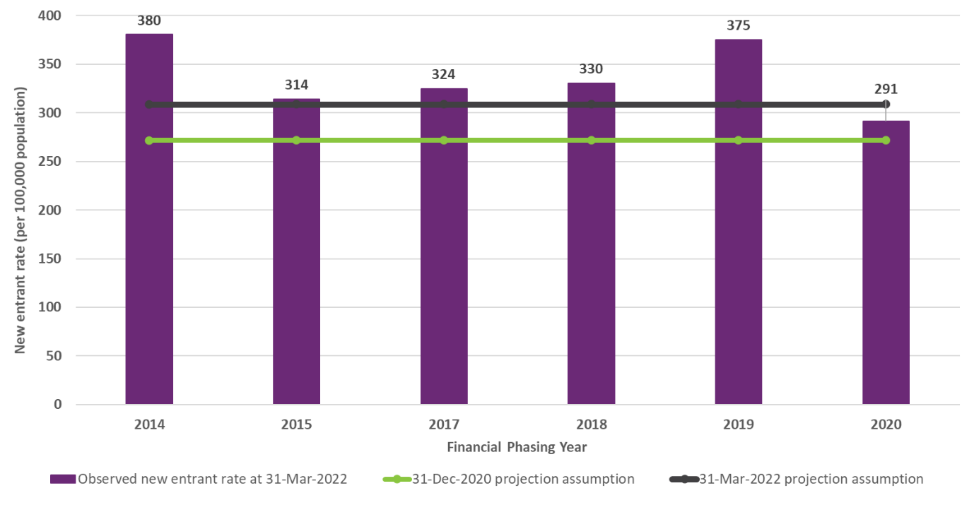
The adopted long-term new entrant rate assumption has increased significantly over the past several AFSRs, in response to observed new entrant experience remaining higher than previously assumed. This higher than expected new entrant experience was observed in all geographic areas including those which were earliest in phasing into the Scheme, and which therefore would be expected to be the most representative of longer-term expected new entrant experience.

Participation rates projected to increase primarily due to autism
Participation rates refer to the proportion of the general population that have a disability and are accessing Scheme supports. Figure H.5 shows the implied participation rates for people aged 0 to 64 years. The chart shows that the participation rate is projected to increase significantly over the next few years, with a 41% increase in the participation rate expected over the 5 year period between 30 June 2022 (2.43% participation rate) and 30 June 2027 (3.42% participation rate). Over the 5 year period between 30 June 2027 and 30 June 2032, the participation rate is expected to increase a further 23% to 4.21%. These participation rates imply that about 1 in 41 people in Australia aged between 0 and 64 years was a participant in the NDIS at 30 June 2022, and by 30 June 2032 this will increase to about 1 in 24 people.
Figure H.5: Implied participation rates for people aged 0 to 64 years
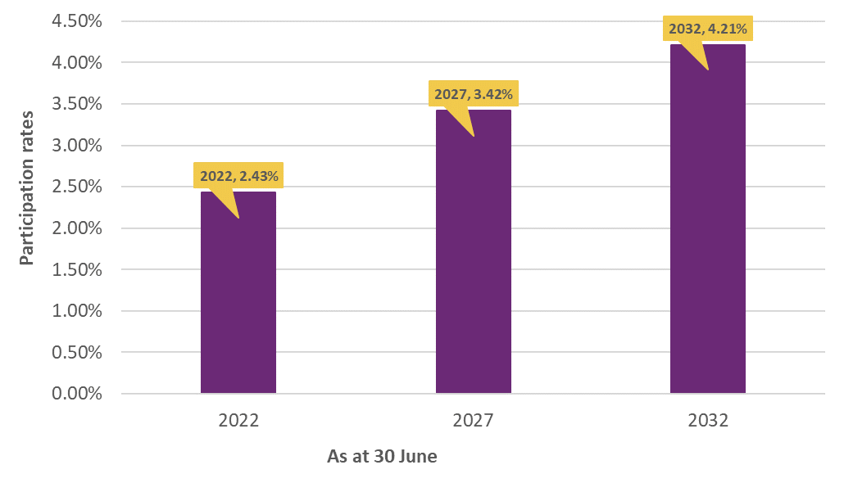
Figure H.6 shows the implied participation rates for major disability groups at this review, for people aged 0 to 64 years. This chart highlights that the main driver of the increase in participation rate is autism, which increases from a participation rate of 0.85% at 30 June 2022 to 1.47% at 30 June 2027 (a 73% increase over this 5 year period), and to a participation rate of 2.03% at 30 June 2032 (a 38% increase over this 5 year period). These participation rates imply that about 1 in 118 people in Australia aged between 0 and 64 years was a participant of the NDIS with a primary disability of autism at 30 June 2022, and by 30 June 2032 this will increase to about 1 in 49 people.
Figure H.6: Implied participation rates for major disability groups for people aged 0 to 64 years
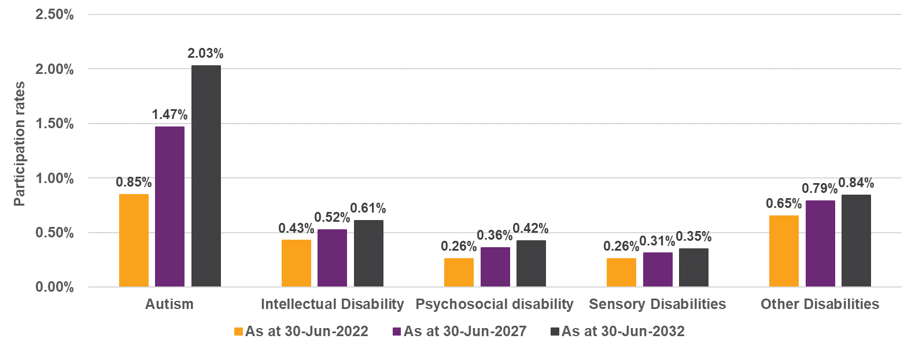
Figure H.7 shows the implied participation rates at this review, for people aged 0 to 64 years. This chart highlights that the main driver of the increase in participation rate between 30 June 2022 and 30 June 2032 are participants between the ages of 7 and 24. These participation rates imply that about 1 in 19 people in Australia aged between 7 and 14 years was a participant of the NDIS at 30 June 2022, and by 30 June 2032 this will become approximately 1 in 12 people.
Figure H.7: Implied participation rates for all disability types by age band
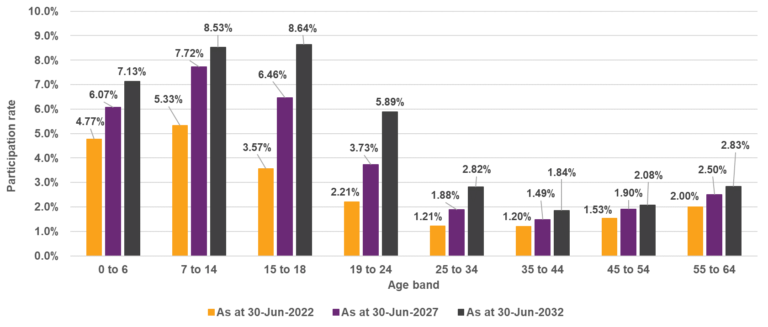

Figure H.8 shows the implied participation rates for autism by age band at this review, for people aged 0 to 64 years. These participation rates imply that about 1 in 27 people in Australia aged between 7 and 14 years was a participant of the NDIS with a primary disability of autism at 30 June 2022, and by 30 June 2032 this will become approximately 1 in 16 people.
Figure H.8: Implied participation rates for autism by age band
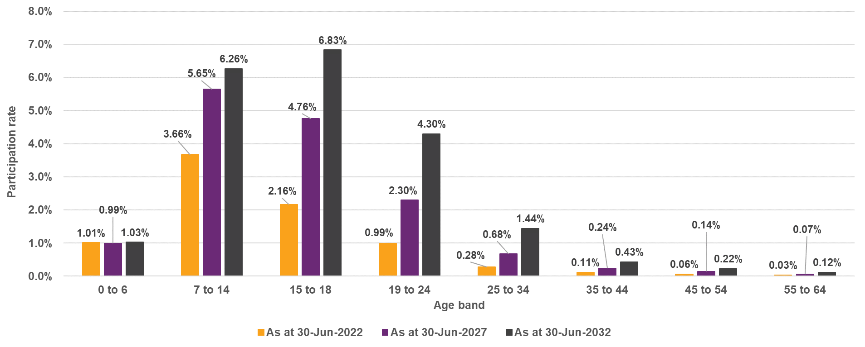
Comparison of implied participation rates from the 2021-22 AFSR model to the 2018 ABS Survey of Disability, Aging and Carers (ABS SDAC)
In order to assess the reasonableness of the projected participant numbers from the AFSR model, a comparison has been carried out between the implied participation rates from the 2021-22 AFSR model and those from the 2018 Australian Bureau of Statistics Survey of Disability, Aging and Carers (ABS SDAC). It should be noted that this comparison is subject to limitations, as the severity classifications adopted in the 2018 ABS SDAC do not align directly to NDIS eligibility. Figure H.9 shows the comparison to the ABS SDAC Severe or Profound Core Activity Limitation grouping (SDAC SPCAL) as this grouping is regarded as most likely to be relevant to the NDIS population.

Figure H.9: Comparison of participation rates between 2018 ABS SDAC SPCAL and the 2021-22 AFSR model by age band
Key observations are:
- For all age bands except for 0 to 14 years, the participation rates estimated from the 2018 ABS SDAC SPCAL data are higher than those projected as at 30 June 2022; and
- The participation rates estimated from the 2018 ABS SDAC Severe SPCAL data are only slightly higher than those projected as at 30 June 2022, for the 15 to 44 age bands. For the 45 to 54 and 55 to 64 age band and older, the participation rates estimated from the 2018 ABS SDAC SPCAL become increasingly larger compared to those projected as at 30 June 2022. For the age band 55 to 64 years, the participation rate estimated from the 2018 ABS SDAC SPCAL data (5.9% participation rate) is just under three times those projected as at 30 June 2022 (2.0% participation rate).

Impacts of change in assumptions
Table H.6 shows the impact of adopting the updated long-term future new entrant assumptions on the projected participant numbers, based on the revised assumptions adopted at this review. As expected, adopting the higher updated long-term new entrant assumptions results in an increase in the participant numbers projected for the year ended 30 June 2023 and onwards.
Table H.6: Impact on projected participant numbers of adopting the updated long-term new entrant assumptions
Impact on projected participant numbers | Participants at 30 June:
Impact on projected participant numbers | 2023 | 2024 | 2025 | 2026 | 2032
Baseline projection from 2020-21 AFSR | 586,433 | 630,327 | 670,400 | 709,645 | 931,591
Change in participant numbers | 4,126 | 8,236 | 12,017 | 15,879 | 44,863
%Change in participant numbers | 0.7% | 1.3% | 1.8% | 2.2% | 4.8%

Appendix I: Analysis of experience of participants leaving the Scheme
Background and Purpose
This appendix sets out the experience of participants leaving the Scheme (for any reason other than death) which was analysed to select the assumptions used in the 2021-22 AFSR projections.
The appendix outlines the data available for analysis as well as the limitations of the data, describes the modelling approach used, sets out recent experience of participants leaving the Scheme and the selected assumptions.
A summary of previous analysis was included in Section 4.1 of the 2020-21 AFSR, noting that at the previous review, the experience of participants leaving the Scheme was referred to as “non-mortality exit” experience.
The analysis documented in this appendix will continue to be updated regularly to monitor the experience of participants leaving the Scheme and adopted assumptions for AFSR purposes.
Modelling approach
Participants may leave the Scheme for one of several reasons:
- Participant initiated: They have chosen to leave the Scheme of their own accord;
- Scheme initiated: They have had their eligibility revoked by the Agency. A large proportion of these leaving relates to ‘early intervention’, relating to those participants who met access under section 25 of the NDIS Act but are deemed to have received sufficient early intervention supports from the Scheme such that they can transition out with continued supports from mainstream settings.
- Other: those who no longer meet the permanent disability requirements under section 24 of the NDIS Act. This also includes participants who have moved into the community or aged care system if over age 65.
- Death of the participant: This is excluded from the analysis set out in this appendix. A separate analysis of the mortality experience and selection of mortality assumptions is included in Appendix J.
Similar to previous reviews, participants leaving the Scheme are organised in groups for modelling purposes, with each group based on the following characteristics (in order of the modelling hierarchy): primary disability, gender, level of function, age group and duration in the Scheme. Reason for leaving the Scheme is not explicitly modelled given the quantity and stability of available data, but is monitored at an overall level for insights into changes in trends over time.
Phasing of short-term experience to long-term rates of leaving in previous AFSR
The last major review of participants leaving the Scheme was carried out in December 2018. Observed experience has varied since 2019, impacted by a variety of operation and environmental factors. These include the suspension of Eligibility Reassessments (ERs) in 2019 and its recommencement after revision in 2020, impacts of COVID-19 since 2020, and ongoing refinement to Scheme rules and processes. The expectation over this period was that in the longer term, rates of people leaving the Scheme would increase. To avoid a discontinuity between recent experience and long-term assumptions, different short-term and long-term assumptions were adopted, with those in the short term close to recently observed experience, being lower than the longer-term adopted assumptions.
Long-term assumptions regarding participants leaving the Scheme were held largely unchanged over this period.
Review of recent Scheme experience to derive assumptions for 2021-22 AFSR
With ERs relaunched under the new operational guidelines since March 2020, the gradual lifting of COVID-19 lockdown restrictions and the increase in volume of participants leaving increasing the credibility of observed experience in assumption selection, a full review of assumptions about participants leaving the Scheme was therefore carried out using data covering the 12 months to September 2021.
However, significant uncertainty about the levels of future experience remain due to significant variance in experience across different cohorts, as well as ongoing variability arising from changes to operational processes relating to people leaving the Scheme.
Accordingly, at this review, experience for the 12-month to 30 September 2021 has been blended with the previous long-term assumptions to derive the adopted assumptions for the 2021-22 AFSR. Equal weighting is given to the actual experience and to the previous assumptions and no phasing of short-term experience to separate long-term rates has been applied.
The shape of the curve of leaving rates by age is unchanged from the previous assumptions for each primary disability/ gender/ level of function combination (for each ‘blending group’). A scaling factor is then derived for each of these blending groups. The scaling factor is then applied to the curve such that the assumed rate of leaving for the cohort is mid-way between experience and the previous assumptions.
An exception to this is for participants 65 and over. Blending for these participants applies at the gender and level of function level only, i.e. combining all primary disabilities together due to the small numbers of participants leaving the Scheme within this age group.
Analysis of Recent Experience
In order to project future participants leaving the Scheme, this report compares the actual experience of participants leaving the Scheme against expectations using the long-term rates adopted in the 2020-21 AFSR.
Figure I.1 shows observed rates of participants leaving the Scheme each calendar year from 2017 to 2021 by reason for leaving, along with the expected rate in each year. The change in overall expected rate of participants leaving the Scheme is driven by the change in participant mix.
Figure I.1: Experience of participants leaving the Scheme by reason (Duration 0 to 1 years excluded)
The observed rate of participants leaving the Scheme has been lower than expected since 2019. Observed rates were only one third of those expected in 2019, due primarily to the pausing of ERs from March 2019 for 12 months. Actual experience in 2020 remained very low although rates increased compared with 2019. COVID-19 lockdowns and restrictions led to the Agency focusing on maintaining supports for participants and timely new entry to the Scheme rather than ERs. The small increase was driven by the re-launch of ERs in March 2020. Actual participants leaving for Scheme initiated reasons increased to 0.34%.
The increase in rates of participants leaving the Scheme in 2021 reflects the resumption of more normal operations, as COVID-19 restrictions eased. This was enabled by an increase in agency workforce to clear the backlog of ERs.
Selected Assumptions
Overall, the actual rate of participants leaving the Scheme for the 12 months to 30 September 2021 (0.93% per annum) is only half of the expected long-term rate from the 2020-21 AFSR (1.86% per annum). Experience by disability type, gender and level of function exhibit more volatility.
There is continued uncertainty around future rates of participants leaving the Scheme which have varied over time and are affected by administrative and operational changes. Therefore, the selected assumptions are midway between the experience for the 12 months to 30 September 2021 and the assumptions used for the 2020-21 AFSR. It is reasonable to expect that actual rates of participants leaving the Scheme may increase temporarily in the 12 months post September 2021 as COVID-19 restrictions continue to be eased and the ER backlogs are cleared. A comparison of actual experience to March 2022 with the proposed assumptions are shown later in this appendix. However, rates of participants would be expected to reduce when all backlogs are cleared. Future experience of participants leaving will also however be affected by the ongoing operational Scheme improvements and so any such future changes will be not reflected in the experience analysed. To reflect these considerations a credibility weighting of 50% has been assigned to the experience for the 12 months to 30 September 2021 in setting revised base rates (with 50% credibility assigned to the previous assumptions).

Table I.1: Actual vs expected base rates of participants leaving the Scheme by age group, normalised level of function and gender
Age | Actual Rates of Participants Leaving the Scheme |  |  |  |  |  | Expected Rates from 2020-21 AFSR
Age | Total |  |  | F | M | Total | Total |  |  | F | M | Total
Age | High | Med | Low | Total | Total | Total | High | Med | Low | Total | Total | Total
0 to 6 | 2.42% | 0.27% | 0.13% | 1.55% | 1.50% | 1.51% | 6.32% | 0.82% | 0.52% | 4.01% | 4.02% | 4.01%
7 to 14 | 5.58% | 0.33% | 0.20% | 1.71% | 2.10% | 1.99% | 7.74% | 0.60% | 0.43% | 2.74% | 2.90% | 2.85%
15 to 18 | 1.18% | 0.41% | 0.17% | 0.40% | 0.54% | 0.50% | 2.88% | 0.67% | 0.26% | 0.99% | 1.02% | 1.01%
19 to 24 | 1.44% | 0.54% | 0.06% | 0.45% | 0.62% | 0.56% | 2.82% | 0.78% | 0.20% | 0.95% | 0.98% | 0.97%
25 to 34 | 0.88% | 0.27% | 0.03% | 0.22% | 0.31% | 0.27% | 2.34% | 0.48% | 0.22% | 0.62% | 0.65% | 0.64%
35 to 44 | 0.59% | 0.24% | 0.05% | 0.15% | 0.27% | 0.21% | 2.35% | 0.67% | 0.32% | 0.74% | 0.76% | 0.75%
45 to 54 | 0.51% | 0.20% | 0.08% | 0.18% | 0.21% | 0.19% | 2.67% | 0.84% | 0.51% | 0.94% | 0.92% | 0.93%
55 to 64 | 0.42% | 0.21% | 0.10% | 0.23% | 0.15% | 0.18% | 2.86% | 1.06% | 0.63% | 1.08% | 1.09% | 1.08%
65+ | 0.80% | 1.06% | 1.21% | 1.22% | 0.98% | 1.10% | 5.20% | 2.90% | 2.60% | 3.04% | 3.06% | 3.05%
Total | 2.98% | 0.34% | 0.17% | 0.72% | 1.05% | 0.93% | 5.55% | 0.79% | 0.54% | 1.68% | 1.97% | 1.86%
0 to 18 | 3.90% | 0.34% | 0.18% | 1.43% | 1.69% | 1.61% | 6.69% | 0.65% | 0.40% | 2.74% | 2.85% | 2.82%
19 to 34 | 1.19% | 0.40% | 0.05% | 0.32% | 0.47% | 0.41% | 2.61% | 0.63% | 0.21% | 0.77% | 0.82% | 0.80%
35 to 64 | 0.50% | 0.22% | 0.08% | 0.19% | 0.20% | 0.19% | 2.65% | 0.87% | 0.51% | 0.94% | 0.94% | 0.94%
0 to 64 | 3.03% | 0.31% | 0.11% | 0.70% | 1.05% | 0.92% | 5.55% | 0.72% | 0.41% | 1.60% | 1.94% | 1.82%
Table I.2: Revised selections for rates of participants leaving the Scheme by age group, normalised level of function and gender
 | Revised Selections
 | Total |  |  | F | M | Total
Age | High | Med | Low | Total | Total | Total
0 to 6 | 5.08% | 0.64% | 0.38% | 3.10% | 3.27% | 3.21%
7 to 14 | 6.10% | 0.46% | 0.31% | 2.07% | 2.30% | 2.23%
15 to 18 | 2.01% | 0.50% | 0.17% | 0.69% | 0.73% | 0.72%
19 to 24 | 1.97% | 0.59% | 0.13% | 0.66% | 0.72% | 0.70%
25 to 34 | 1.52% | 0.35% | 0.14% | 0.40% | 0.45% | 0.43%
35 to 44 | 1.56% | 0.47% | 0.19% | 0.48% | 0.53% | 0.51%
45 to 54 | 1.74% | 0.56% | 0.30% | 0.59% | 0.60% | 0.60%
55 to 64 | 1.83% | 0.67% | 0.36% | 0.66% | 0.68% | 0.67%
65+ | 3.00% | 1.98% | 1.90% | 2.13% | 2.02% | 2.07%
Total | 4.26% | 0.57% | 0.36% | 1.20% | 1.51% | 1.40%
0 to 18 | 5.28% | 0.49% | 0.28% | 2.07% | 2.27% | 2.21%
19 to 34 | 1.77% | 0.47% | 0.13% | 0.52% | 0.59% | 0.56%
35 to 64 | 1.72% | 0.57% | 0.30% | 0.59% | 0.61% | 0.60%
0 to 64 | 4.29% | 0.51% | 0.26% | 1.15% | 1.49% | 1.37%

Figure I.2: Actual vs expected base rates of participants leaving the Scheme and revised selections by age group
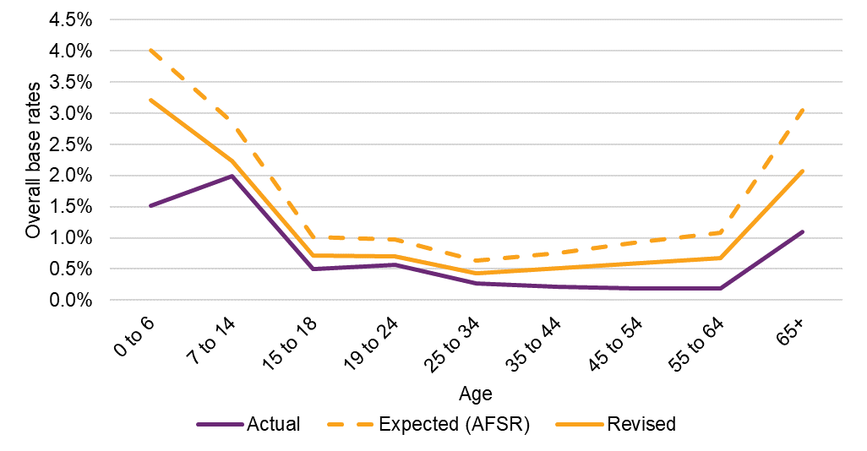
Adjustments for Development Delay
Adjustment to rates of participants leaving the Scheme for development delay are made after the re-mapping of reported level of function from the normalised assessment score (0 to 15) to AFSR specific level of function. DEL_1 includes participants with developmental delay with normalised assessment score 1 to 8, while DEL_2 includes participants with developmental delay with normalised assessment score 9 to 15.
Actual rates of participants leaving by individual ages for age 0 to 14 are very volatile for both DEL_1 and DEL_2. These rates have been smoothed by pooling the experience of specific age groups, ensuring that the average rates increase with age, while retaining the overall shape of the actual experience.
The smoothed rates of participants leaving are then blended with previous assumptions, with 50% credibility assigned to the actual experience. Tables I.3 and I.4 show the rates used in this process for ages 0 to 14.
Rates of participants leaving the Scheme for several ages above 14 have also been adjusted to ensure that the rates increase with age.

Table I.3: Adjustments for Developmental Delay (age 0 to 14) for DEL_1, excluding duration 0-1 year
DEL_1 | Rates of Leaving the Scheme |  | Difference |  | Pooled Actual Rate | 2021-22 AFSR Assumption
Age | Actual | Expected (2020-21 AFSR) | % | % Change | Pooled Actual Rate | 2021-22 AFSR Assumption
0 |  |  |  |  | 0.8% | 2.6%
1 | 1.4% | 4.4% | -3.0% | -68.5% | 0.8% | 2.6%
2 | 0.8% | 4.4% | -3.6% | -80.8% | 0.8% | 2.6%
3 | 1.6% | 4.4% | -2.9% | -64.6% | 0.8% | 2.6%
4 | 0.5% | 4.4% | -3.9% | -87.7% | 0.8% | 2.6%
5 | 0.8% | 4.4% | -3.6% | -81.9% | 0.8% | 2.6%
6 | 9.4% | 28.6% | -19.2% | -67.2% | 17.8% | 23.2%
7 | 31.7% | 40.7% | -9.0% | -22.1% | 17.8% | 29.3%
8 | 29.7% | 40.7% | -11.1% | -27.2% | 24.9% | 32.8%
9 | 20.3% | 40.7% | -20.4% | -50.2% | 24.9% | 32.8%
10 | 17.6% | 40.7% | -23.1% | -56.7% | 24.9% | 32.8%
11 | 16.3% | 43.6% | -27.3% | -62.7% | 24.9% | 34.3%
12 | 11.3% | 61.4% | -50.0% | -81.5% | 24.9% | 43.2%
13 | 0.0% | 61.3% | -61.3% | -100.0% | 24.9% | 43.2%
14 | 14.1% | 61.3% | -47.3% | -77.1% | 24.9% | 43.2%
Table I.4: Adjustments for Developmental Delay (age 0 to 14) for DEL_2, excluding duration 0-1 year
DEL_2 | Rates of Leaving the Scheme |  | Difference |  | Pooled Actual Rate | 2021-22 AFSR Assumption
Age | Actual | Expected (2020-21 AFSR) | % | % Change | Pooled Actual Rate | 2021-22 AFSR Assumption
0 |  |  |  |  | 0.7% | 1.9%
1 | 0.0% | 3.0% | -3.0% | -100.0% | 0.7% | 1.9%
2 | 0.0% | 3.0% | -3.0% | -100.0% | 0.7% | 1.9%
3 | 0.0% | 3.0% | -3.0% | -100.0% | 0.7% | 1.9%
4 | 0.0% | 3.0% | -3.0% | -100.0% | 0.7% | 1.9%
5 | 0.0% | 3.0% | -3.0% | -100.0% | 0.7% | 1.9%
6 | 3.8% | 8.6% | -4.8% | -55.7% | 0.7% | 4.7%
7 | 11.9% | 8.6% | 3.4% | 39.5% | 9.0% | 8.8%
8 | 8.7% | 9.5% | -0.8% | -8.0% | 9.0% | 9.3%
9 | 4.9% | 12.9% | -8.0% | -61.8% | 9.0% | 11.0%
10 | 5.1% | 12.9% | -7.8% | -60.3% | 9.0% | 11.0%
11 | 27.0% | 12.9% | 14.1% | 108.8% | 21.8% | 17.4%
12 | 23.1% | 12.9% | 10.1% | 78.4% | 21.8% | 17.4%
13 | 13.6% | 12.9% | 0.7% | 5.6% | 21.8% | 17.4%
14 | 25.6% | 12.9% | 12.7% | 98.2% | 21.8% | 17.4%
Scaling for new entrants
Participants who have recently entered the Scheme are less likely to leave than those who have been in the Scheme for longer. The base rates of participants leaving the Scheme set out in the sections above are used to project the numbers of participants who have been in the Scheme for more than one year (or mature participants). A scaling factor is applied to those base rates to arrive at assumed rates of participants leaving who are in their first year. This scaling factor was 20% in the 2020-21 AFSR. This is based on the observed rate of participants leaving with a duration of 0 to 1 years fluctuating between 19% and 30% since 2017.
Table I.5: Rates of participants leaving by duration in the Scheme and scaling factor for first year rate of participants leaving
Duration | Jan-Dec 17 | Jan-Dec 18 | Jan-Dec 19 | Jan-Dec 20 | Jan-Sep 21 | Overall
0 to 1 year | 0.25% | 0.30% | 0.19% | 0.19% | 0.19% | 0.22%
1+ years | 2.05% | 1.65% | 0.57% | 0.68% | 1.04% | 0.93%
Overall | 0.88% | 1.00% | 0.42% | 0.54% | 0.88% | 0.69%
0 to 1 / 1+ ratio | 12.44% | 18.05% | 33.12% | 27.39% | 17.98% | 23.46%
Selected ratio |  |  |  |  |  | 20.00%
In Table I.6, the change in the selected rate of participants leaving the Scheme is driven by the change in mix of participants in their first year over time.
Table I.6: Actual vs selected rates of participants leaving the Scheme in their first year
Rates for 0-1 year | Jan-Dec 17 | Jan-Dec 18 | Jan-Dec 19 | Jan-Dec 20 | Jan-Sep 21 | Overall
Actual | 0.25% | 0.30% | 0.19% | 0.19% | 0.19% | 0.22%
Selected | 0.41% | 0.33% | 0.11% | 0.14% | 0.21% | 0.19%
Difference | -0.16% | -0.03% | 0.07% | 0.05% | -0.02% | 0.03%
Proposed rates vs previous assumptions
Taking into account the recommended assumptions (excluding new entrants), the overall rate of participants leaving assumption has decreased from 1.67% to 1.19% per annum, a reduction of 29%, based on the participant mix at June 2021. The proposed assumption is broadly consistent with the experience in the September 2021 and December 2021 quarters, where the volume of participants leaving increased as the clearing of backlogs progressed.
Figure I.3: Proposed rates of participants leaving the Scheme (all ages)
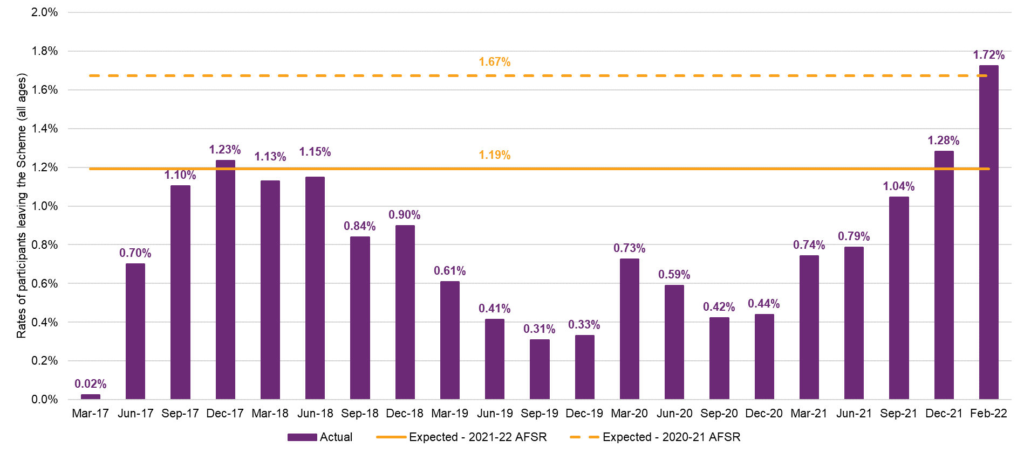
Figure I.4 and Figure I.5 show the quarterly experience and overall assumed rates separately for participants aged 0 to 6 year, and those aged 7 and over respectively. The proposed rate for those aged 0 to 6 is slightly higher than the September 2021 quarter experience, while that for age 7 or above is very close to the September 2021 quarter experience.
Figure I.4: Proposed rates of participants leaving the Scheme (age 0 to 6)
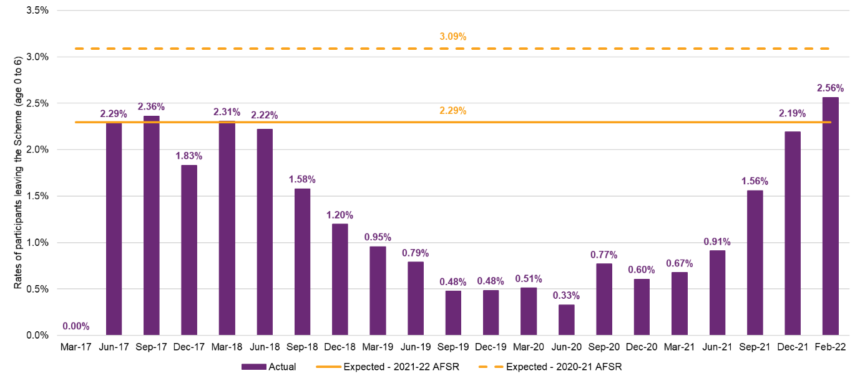
Figure I.5: Proposed rates of participants leaving the Scheme (age 7+)
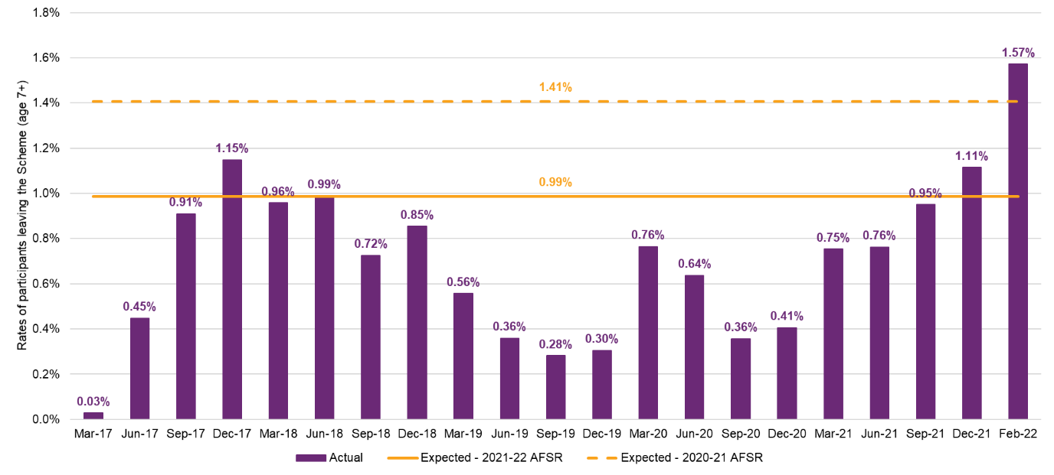
The increase in actual rate of participants leaving the Scheme in the September 2021 quarter for age 0 to 6 is more significant than that for age 7 and above. This is because the overall increase is driven largely by ERs which have been conducted for participants who met access requirements for early intervention.
Discussion of experience subsequent to September 2021
This section reviews the five months of additional experience to 28 February 2022, since completion of the preliminary recommendations based on experience to 30 September 2021 and assesses the soundness of these recommendations relative to the more recent experience.
Actual rates of participants leaving the Scheme have increased materially since September 2021. Figure I.6 sets out quarterly actual rates of participants leaving up to February 2022 and compares this with the long-term assumption in the 2020-21 AFSR based on the average participant mix for the year to 30 June 2021 (dotted orange line) as well as the rate adopted at this review based on the same average participant mix (solid orange line).
There was a moderate increase in rate of participants leaving from 1.04% per annum to 1.28% per annum over the December 2021 quarter, with further increase over the next two months to 1.72% per annum.
Figure I.6: Rates of participants leaving the Scheme up to February 2022 (all ages)
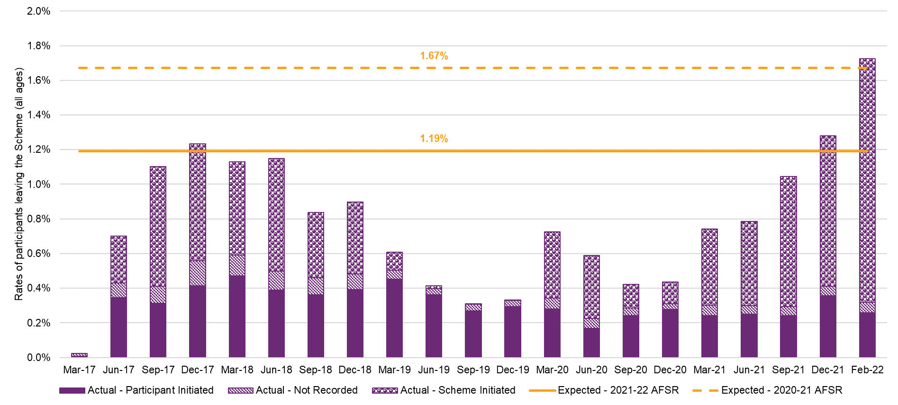
The appropriateness of the proposed assumptions depends on the extent to which the higher rates of participants leaving the Scheme in the months since September 2021 are likely to reflect a permanent increase to the underlying rates, or whether they are driven by short-term factors.
Advice provided by National Access and Review Branch (NARB) is that the level of participants leaving the Scheme in the early months of 2022 will not be maintained, based on the following:
- Since Eligibility Reassessments (ERs) were relaunched in March 2020, extra resources have been deployed in clearing the backlogs of scheduled ERs. The rate of progress in working through backlogs has varied with the Agency’s capacity to undertake ERs, which in turn has been impacted by responses to COVID-19 and other high priority initiatives;
- The increased level of participants leaving in January and February 2022 was primarily a catch-up from a pause in operations over the shutdown period in December 2021; and
- The lower numbers of requests for access received in January and February 2022 has allowed for a greater focus on ERs, leading to an increase in the rate of participants leaving the Scheme.
Given the various factors with the potential to impact the level of future participants leaving the Scheme, it is considered reasonable that the assumptions selected for the 2021-22 AFSR are higher than the experience in the 12 months to September 2021 but lower than the ‘spike’ in experience observed in early 2022.
Figure I.7 and Figure I.8 show similar detail as Figure I.6 above, separated for participants aged 0 to 6 and those aged 7 and over, respectively. The experience since September 2021 is broadly similar for both groups, although the increase attributable to ‘Scheme initiated’ cases for participants aged 7 or above is larger than that for participants aged 0 to 6.
Figure I.7: Rates of participants leaving up to February 2022 (age 0 to 6)
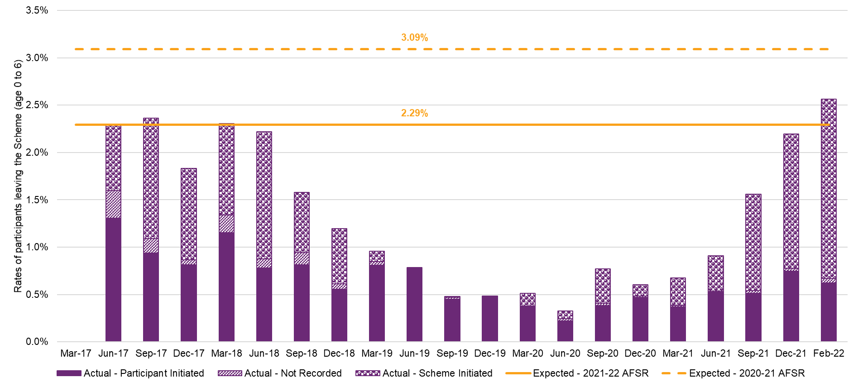
Figure I.8: Rates of participants leaving up to February 2022 (age 7+)
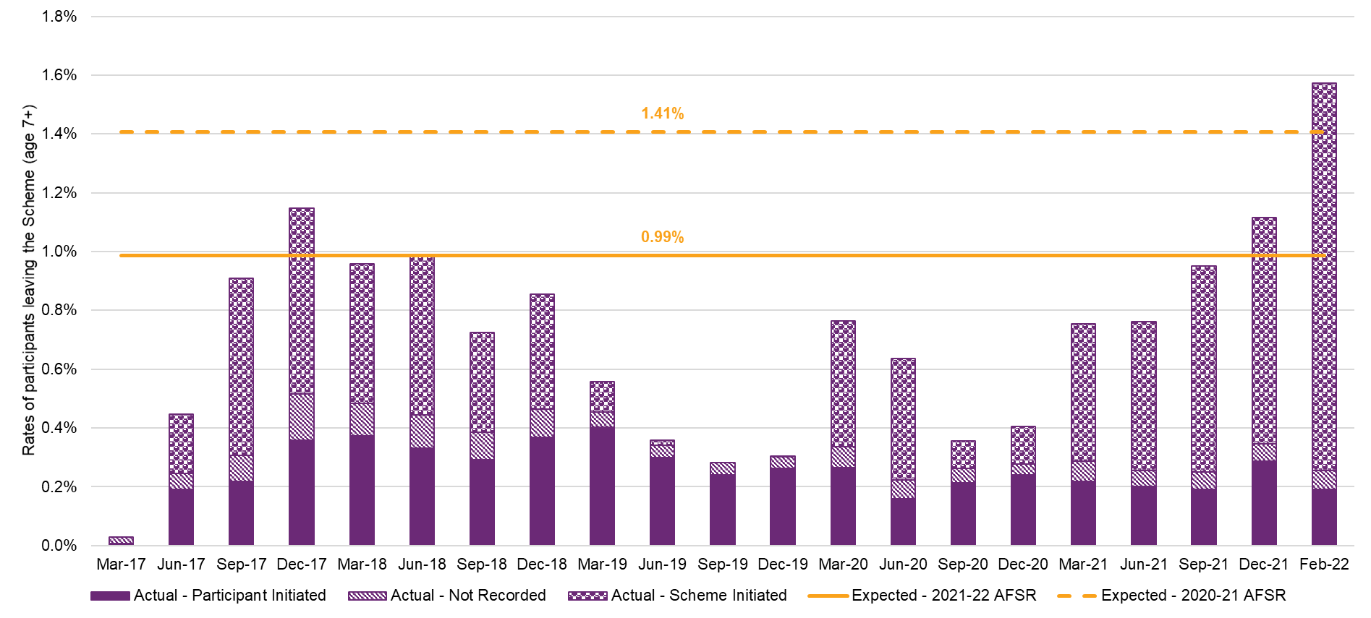
Impact of Changes to Assumptions
Table I.7 shows the impact of adopting the new assumptions of participants leaving the Scheme on projected participant numbers (with other assumptions based on the 2020-21 AFSR). It shows a small reduction in participant numbers at June 2023 but increases from June 2024 onwards.
Table I.7: Impact on projected participant numbers of adopting new assumptions for participants leaving the Scheme
Impact | Participants at 30 June
Impact | 2023 | 2024 | 2025 | 2026 | 2032
Baseline projection from 2020-21 AFSR | 586,433 | 630,327 | 670,400 | 709,645 | 931,591
Change in participant numbers | -631 | 1,064 | 5,197 | 9,095 | 33,634
%Change in participant numbers | -0.1% | 0.2% | 0.8% | 1.3% | 3.6%

Appendix J: Analysis of Scheme mortality experience
Purpose
This appendix sets out the analysis of Scheme mortality experience and the selection of mortality assumptions used in the 2021-22 AFSR projections.
More specifically, this appendix:
- outlines the data available for analysis as well as the limitations of the data;
- describes the modelling approach adopted for recalibration of mortality assumptions;
- analyses actual experience against expectations;
- presents the high-level results from the analysis and modelling;
The analysis documented in this appendix will continue to be updated regularly to monitor the mortality experience and adopted assumptions for AFSR purposes.
Modelling approach
As was the case with previous reviews, an experience-based model is used to project mortality of participants in the Scheme, drawing on the experience during 13 months to February 2022.
The initial mortality assumptions outlined in the 2016-17 Annual Financial Sustainability Report (AFSR) were with reference to epidemiological data, the ABS SDAC and data from the Commonwealth aged care system. These assumptions have been updated subsequently at each review based on the actual experience of the Scheme and the level of credibility assigned to the data used.
The 2020-21 AFSR mortality assumptions were calibrated by taking standard population mortality rates from the Australian Life Table 2016-18 (ALT16-18) and using disability specific loadings to arrive at rates in line with future expectations of Scheme experience. The Australian Life Table 2018-20 (ALT18-20) was published by the Australian Bureau of Statistics in late 2021. The rates based on the new ALT18-20 are marginally lower than those from ALT16-18, reflecting mortality improvements in the general population over time because of better public health and advances in medical science. Mortality assumptions adopted at this review were based on the new ALT18-20, as described below.
Separate mortality rate assumptions are selected by primary disability, gender, level of function and age group. The level of function grouping used are consistent with those used in the projection of participants.
The approach adopted to select the mortality assumptions is as follows:
- The actual versus expected experience (where expected is based on the assumptions adopted in the 2020-21 AFSR) is determined for each primary disability type.
- The variation between experience and expected mortality rates is measured and explicitly allowed for in the mortality model through a credibility approach, applied at the level of primary disability, gender and AFSR level of function
- This impact of experience variation at disability, gender and level of function level is spread across age groups based on size of the variations and corresponding participant exposure years.
Recent experience for groups with more participants and higher mortality rates were given greater weighing when selecting initial mortality rates. The resulting mortality rates by age groups from the above steps are then smoothed (and recalibrated, if necessary) to ensure consistency between age groups, gender and level of function.
- Consistency checks are performed and adjustments are made within each participant group. For example, mortality rates are generally expected to increase by level of function for each age, increase by age for adults, and be higher for males compared to females. Adjustments may be made to ensure the adopted mortality rates preserve these broad expectations.
- The ratio of the smoothed mortality rates by age groups to those in the previous review are applied to the previous mortality rates by single year of age to derive an initial set of selected mortality rates.
- The initial selected rates are updated by replacing the base mortality tables from the ALT16-18 to those from the ALT18-20.
- These initial estimates are then smoothed and fine-tuned using a number of methods, including cubic smoothing of divided differences across age and moving averages across age.
- Further consistency checks and adjustments are applied again after smoothing, but at the single year of age instead of age groups.
Analysis of Recent Experience
This section presents actual and expected mortality rates by the participant characteristics modelled in the AFSR. The expected mortality rates are based on those from the 2020-21 AFSR for all years analysed, noting that the expected rates vary over time due to changes in the mix of participants.
Overall, the actual mortality rate decreased by 0.05% from 0.99% (expected: 0.95%) in 2020 to 0.94% (expected: 0.93%) in 2021; predominantly driven by mortality improvement for male participants aged 45 to 64, especially those with medium and low levels of function.
As noted above, the expected rates vary between years due to changes in participant mix, although the differences are generally minor. A higher degree of variability in experience from expected was observed for small participant cohorts.
The tables and charts in the sections below show actual and expected mortality rates by calendar year and by each participant characteristic analysed.
Age group
Table J.1: Actual vs expected mortality rates by age group
Age | Actual
Age | Jan-Dec 17 | Jan-Dec 18 | Jan-Dec 19 | Jan-Dec 20 | Jan-Dec 21 | Jan-Feb 22 | Overall
0 to 6 | 0.07% | 0.10% | 0.16% | 0.10% | 0.09% | 0.09% | 0.11%
7 to 14 | 0.13% | 0.09% | 0.10% | 0.05% | 0.06% | 0.05% | 0.07%
15 to 18 | 0.29% | 0.20% | 0.17% | 0.18% | 0.14% | 0.20% | 0.18%
19 to 24 | 0.34% | 0.25% | 0.31% | 0.21% | 0.19% | 0.24% | 0.24%
25 to 34 | 0.54% | 0.49% | 0.51% | 0.47% | 0.47% | 0.61% | 0.49%
35 to 44 | 0.87% | 0.94% | 0.92% | 0.94% | 0.87% | 0.82% | 0.91%
45 to 54 | 1.61% | 1.74% | 1.75% | 1.98% | 1.81% | 2.02% | 1.83%
55 to 64 | 3.23% | 3.47% | 3.45% | 3.82% | 3.47% | 3.91% | 3.57%
65+ | 4.61% | 3.67% | 4.92% | 4.43% | 4.90% | 4.50% | 4.64%
Overall | 0.81% | 0.89% | 0.97% | 0.99% | 0.94% | 1.01% | 0.95%

Age | Expected
Age | Jan-Dec 17 | Jan-Dec 18 | Jan-Dec 19 | Jan-Dec 20 | Jan-Dec 21 | Jan-Feb 22 | Overall
0 to 6 | 0.10% | 0.09% | 0.09% | 0.10% | 0.10% | 0.11% | 0.10%
7 to 14 | 0.11% | 0.10% | 0.09% | 0.08% | 0.07% | 0.07% | 0.08%
15 to 18 | 0.21% | 0.20% | 0.19% | 0.16% | 0.15% | 0.14% | 0.17%
19 to 24 | 0.29% | 0.29% | 0.28% | 0.26% | 0.24% | 0.23% | 0.26%
25 to 34 | 0.51% | 0.49% | 0.49% | 0.47% | 0.45% | 0.44% | 0.47%
35 to 44 | 0.95% | 0.93% | 0.93% | 0.92% | 0.89% | 0.86% | 0.91%
45 to 54 | 1.91% | 1.89% | 1.87% | 1.84% | 1.79% | 1.75% | 1.84%
55 to 64 | 3.55% | 3.57% | 3.54% | 3.50% | 3.39% | 3.32% | 3.47%
65+ | 4.50% | 4.69% | 4.74% | 4.75% | 4.75% | 4.73% | 4.73%
Overall | 0.87% | 0.94% | 0.98% | 0.95% | 0.93% | 0.92% | 0.94%

Figure J.1: Actual vs expected mortality rate by calendar year by age group
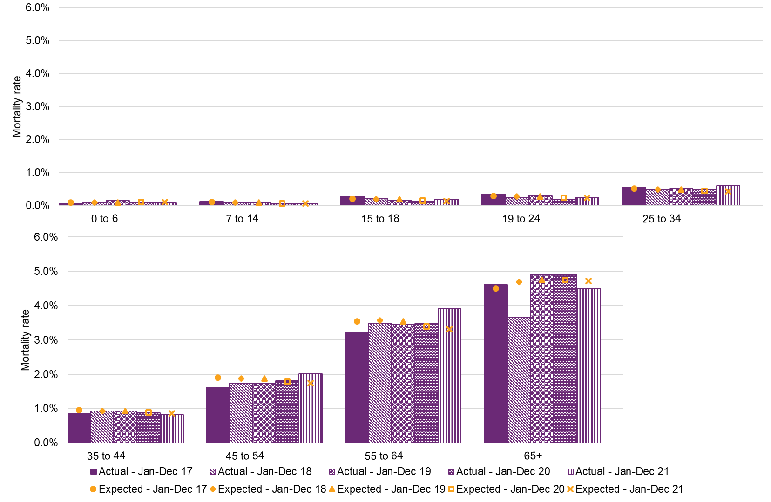

Table J.2: Actual exposure by age group, measured by the number of years participants were active in the Scheme
Age | Actual Exposure
Age | Jan-Dec 17 | Jan-Dec 18 | Jan-Dec 19 | Jan-Dec 20 | Jan-Dec 21 | Jan-Feb 22 | Overall
0 to 6 | 12,348 | 22,471 | 38,756 | 60,994 | 72,643 | 12,653 | 219,866
7 to 14 | 25,330 | 43,687 | 70,491 | 97,696 | 120,572 | 21,314 | 379,090
15 to 18 | 8,179 | 14,245 | 21,591 | 29,017 | 35,909 | 6,524 | 115,465
19 to 24 | 8,765 | 16,928 | 25,990 | 32,892 | 38,461 | 6,740 | 129,775
25 to 34 | 8,528 | 17,107 | 27,435 | 35,321 | 41,614 | 7,253 | 137,258
35 to 44 | 7,948 | 15,802 | 25,741 | 33,099 | 38,649 | 6,699 | 127,939
45 to 54 | 9,758 | 19,452 | 32,220 | 41,178 | 47,253 | 8,084 | 157,945
55 to 64 | 9,829 | 20,882 | 35,652 | 47,236 | 55,463 | 9,537 | 178,598
65+ | 1,343 | 3,355 | 6,978 | 11,459 | 16,660 | 3,198 | 42,994
Total | 92,030 | 173,927 | 284,854 | 388,893 | 467,224 | 82,003 | 1,488,931

Age | Actual % Exposure
Age | Jan-Dec 17 | Jan-Dec 18 | Jan-Dec 19 | Jan-Dec 20 | Jan-Dec 21 | Jan-Feb 22 | Overall
0 to 6 | 13.42% | 12.92% | 13.61% | 15.68% | 15.55% | 15.43% | 14.77%
7 to 14 | 27.52% | 25.12% | 24.75% | 25.12% | 25.81% | 25.99% | 25.46%
15 to 18 | 8.89% | 8.19% | 7.58% | 7.46% | 7.69% | 7.96% | 7.75%
19 to 24 | 9.52% | 9.73% | 9.12% | 8.46% | 8.23% | 8.22% | 8.72%
25 to 34 | 9.27% | 9.84% | 9.63% | 9.08% | 8.91% | 8.85% | 9.22%
35 to 44 | 8.64% | 9.09% | 9.04% | 8.51% | 8.27% | 8.17% | 8.59%
45 to 54 | 10.60% | 11.18% | 11.31% | 10.59% | 10.11% | 9.86% | 10.61%
55 to 64 | 10.68% | 12.01% | 12.52% | 12.15% | 11.87% | 11.63% | 12.00%
65+ | 1.46% | 1.93% | 2.45% | 2.95% | 3.57% | 3.90% | 2.89%
Total | 100.00% | 100.00% | 100.00% | 100.00% | 100.00% | 100.00% | 100.00%
The previous analysis shows that mortality rates generally increased with age (after the age of 6).
Between 2020 and 2021, decreases were observed in actual mortality rates for all age bands except age bands 7 to 14 and 65+. Age bands 45 to 54 and 55 to 64 were the largest contributors to the overall decrease in mortality rates.
The general trend (with exceptions) of marginally lower than expected rates in the younger participants (age 24 or below) and slightly higher than expected rates in the older participants (age 45 to 64) in 2020 prevailed in 2021, although rates for the older participants were closer to expected in 2021. Actual rates for participants 65 or above switched from being higher than expected in 2020 to lower than expected in 2021.

Gender
Table J.3: Actual vs expected mortality rates by gender
Gender | Actual
Gender | Jan-Dec 17 | Jan-Dec 18 | Jan-Dec 19 | Jan-Dec 20 | Jan-Dec 21 | Jan-Feb 22 | Overall
Female | 0.95% | 1.04% | 1.04% | 1.08% | 1.06% | 1.08% | 1.05%
Male | 0.73% | 0.80% | 0.93% | 0.93% | 0.87% | 0.97% | 0.89%
Overall | 0.81% | 0.89% | 0.97% | 0.99% | 0.94% | 1.01% | 0.95%

Gender | Expected
Gender | Jan-Dec 17 | Jan-Dec 18 | Jan-Dec 19 | Jan-Dec 20 | Jan-Dec 21 | Jan-Feb 22 | Overall
Female | 0.97% | 1.03% | 1.06% | 1.03% | 1.01% | 0.99% | 1.02%
Male | 0.81% | 0.90% | 0.93% | 0.90% | 0.89% | 0.87% | 0.89%
Overall | 0.87% | 0.94% | 0.98% | 0.95% | 0.93% | 0.92% | 0.94%

Figure J.2: Actual vs expected mortality rate by calendar year by gender
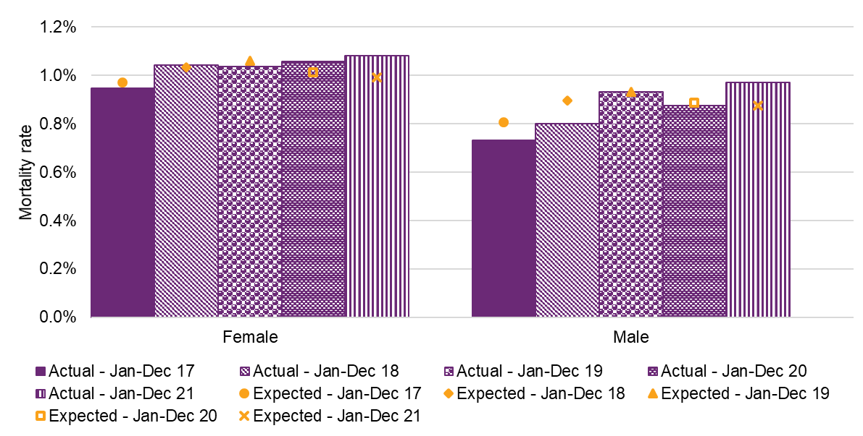

Table J.4: Actual exposure by gender, measured by the number of years participants were active in the Scheme
Gender | Actual Exposure
Gender | Jan-Dec 17 | Jan-Dec 18 | Jan-Dec 19 | Jan-Dec 20 | Jan-Dec 21 | Jan-Feb 22 | Overall
Female | 33,572 | 64,024 | 105,623 | 144,051 | 173,884 | 30,590 | 551,744
Male | 58,097 | 108,338 | 176,411 | 240,840 | 288,301 | 50,490 | 922,477
Other | 361 | 1,566 | 2,820 | 4,002 | 5,040 | 923 | 14,710
Total | 92,030 | 173,927 | 284,854 | 388,893 | 467,224 | 82,003 | 1,488,931

Gender | Actual % Exposure
Gender | Jan-Dec 17 | Jan-Dec 18 | Jan-Dec 19 | Jan-Dec 20 | Jan-Dec 21 | Jan-Feb 22 | Overall
Female | 36.48% | 36.81% | 37.08% | 37.04% | 37.22% | 37.30% | 37.06%
Male | 63.13% | 62.29% | 61.93% | 61.93% | 61.70% | 61.57% | 61.96%
Other | 0.39% | 0.90% | 0.99% | 1.03% | 1.08% | 1.13% | 0.99%
Total | 100.00% | 100.00% | 100.00% | 100.00% | 100.00% | 100.00% | 100.00%
The overall actual mortality rates of female participants are consistently higher than those of male participants (1.05% vs 0.89%). This is primarily driven by a larger proportion of female participants being in participant groups with very high mortality rates (and often at the lowest levels of function), e.g. other neurological, intellectual disability, other physical, other disabilities, psychosocial disability and multiple sclerosis. For other disability types, mortality rates for males in the cohort are higher than those of female in the same cohort. The change in age distribution as a result of ageing and the longer life expectancy of females in the Australian general population also contributes to higher rates of mortality for females.
The actual mortality rate for female participants decreased slightly from 1.08% in 2020 to 1.06% in 2021. The mortality rate in 2021 was 0.05% higher than expected, a similar variation to 2020.
Mortality rates for males decreased from 0.93% in 2020 to 0.87% in 2021; 0.02% lower than expected as compared with 0.03% higher than expected in 2020.

Disability type
Table J.5: Actual vs expected mortality rates by primary disability
Disability | Expected
Disability | Jan-Dec 17 | Jan-Dec 18 | Jan-Dec 19 | Jan-Dec 20 | Jan-Dec 21 | Jan-Feb 22 | Overall
Acquired brain injury | 2.31% | 2.50% | 2.61% | 2.66% | 2.69% | 2.71% | 2.62%
Autism | 0.06% | 0.06% | 0.06% | 0.06% | 0.06% | 0.06% | 0.06%
Cerebral Palsy | 0.71% | 0.71% | 0.73% | 0.71% | 0.71% | 0.71% | 0.71%
Developmental delay | 0.31% | 0.37% | 0.21% | 0.14% | 0.07% | 0.02% | 0.12%
Hearing Impairment | 0.29% | 0.34% | 0.19% | 0.26% | 0.27% | 0.18% | 0.25%
Intellectual Disability | 0.69% | 0.73% | 0.77% | 0.77% | 0.77% | 0.80% | 0.76%
Multiple Sclerosis | 1.31% | 1.35% | 1.39% | 1.43% | 1.46% | 1.47% | 1.41%
Psychosocial disability | 0.96% | 1.02% | 1.05% | 1.07% | 1.09% | 1.10% | 1.06%
Spinal Cord Injury | 1.70% | 1.74% | 1.75% | 1.77% | 1.80% | 1.81% | 1.77%
Stroke | 2.59% | 2.62% | 2.65% | 2.71% | 2.77% | 2.79% | 2.71%
Visual Impairment | 0.88% | 0.96% | 1.03% | 1.09% | 1.16% | 1.20% | 1.07%
Other Neurological | 4.48% | 4.98% | 5.17% | 5.24% | 5.22% | 5.16% | 5.13%
Other Physical | 3.63% | 3.71% | 3.74% | 3.84% | 3.90% | 3.90% | 3.82%
Other Sensory/Speech | 0.16% | 0.16% | 0.17% | 0.17% | 0.17% | 0.18% | 0.17%
Other | 1.72% | 1.88% | 1.93% | 2.12% | 2.46% | 2.58% | 2.24%
Missing | 0.01% | 0.00% | 0.00% | 0.00% | 0.00% | 0.00% | 0.01%
Overall | 0.85% | 0.94% | 0.97% | 0.94% | 0.92% | 0.90% | 0.93%

Disability | Actual
Disability | Jan-Dec 17 | Jan-Dec 18 | Jan-Dec 19 | Jan-Dec 20 | Jan-Dec 21 | Jan-Feb 22 | Overall
Acquired brain injury | 1.68% | 2.30% | 2.10% | 2.44% | 2.62% | 3.16% | 2.40%
Autism | 0.06% | 0.04% | 0.05% | 0.05% | 0.04% | 0.05% | 0.05%
Cerebral Palsy | 0.74% | 0.62% | 0.83% | 0.57% | 0.82% | 1.06% | 0.73%
Developmental delay | 0.31% | 0.37% | 0.21% | 0.14% | 0.07% | 0.02% | 0.12%
Hearing Impairment | 0.29% | 0.34% | 0.19% | 0.26% | 0.27% | 0.18% | 0.25%
Intellectual Disability | 0.69% | 0.73% | 0.77% | 0.77% | 0.77% | 0.80% | 0.76%
Multiple Sclerosis | 1.16% | 1.25% | 1.26% | 1.07% | 1.18% | 1.15% | 1.17%
Psychosocial disability | 0.88% | 1.00% | 1.13% | 1.45% | 1.23% | 1.32% | 1.23%
Spinal Cord Injury | 1.15% | 1.55% | 2.15% | 2.01% | 2.13% | 2.64% | 1.99%
Stroke | 2.56% | 2.21% | 3.05% | 3.20% | 3.07% | 3.71% | 3.02%
Visual Impairment | 1.00% | 0.98% | 1.15% | 1.22% | 1.14% | 0.79% | 1.12%
Other Neurological | 3.80% | 4.52% | 5.18% | 5.12% | 4.83% | 6.06% | 4.94%
Other Physical | 4.23% | 3.68% | 3.76% | 4.19% | 3.73% | 3.66% | 3.88%
Other Sensory/Speech | 0.24% | 0.10% | 0.13% | 0.23% | 0.19% | 0.00% | 0.17%
Other | 1.10% | 1.75% | 1.70% | 3.08% | 5.48% | 5.36% | 3.90%
Missing | 0.00% | 0.00% | 0.00% | 0.00% | 0.00% | 0.00% | 0.00%
Overall | 0.81% | 0.89% | 0.97% | 0.99% | 0.94% | 1.01% | 0.95%
Figure J.3: Actual vs expected mortality rate by calendar year by primary disability
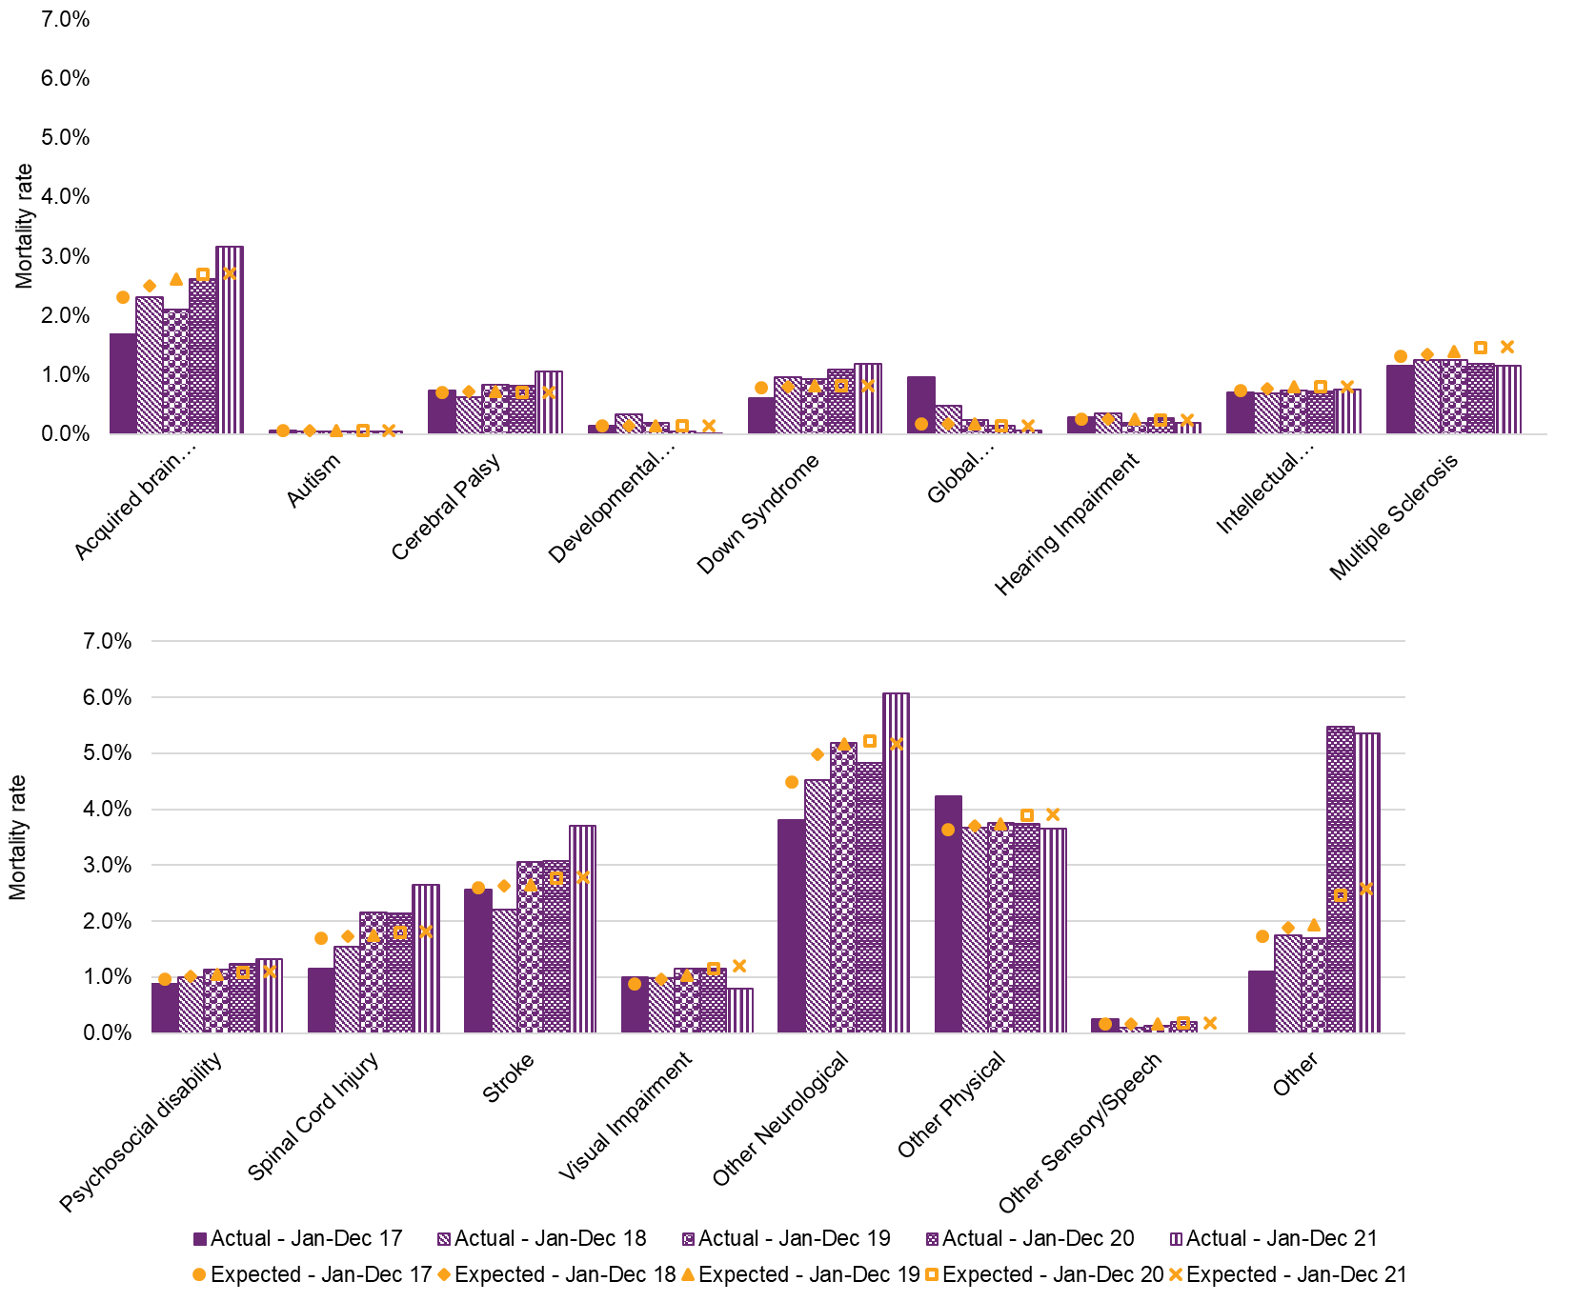

Table J.6: Actual exposure by primary disability, measured by the number of years participants were active in the Scheme
Disability | Actual Exposure
Disability | Jan-Dec 17 | Jan-Dec 18 | Jan-Dec 19 | Jan-Dec 20 | Jan-Dec 21 | Jan-Feb 22 | Overall
Acquired brain injury | 3,040 | 6,204 | 10,275 | 13,057 | 15,060 | 2,595 | 50,232
Autism | 29,765 | 55,541 | 92,705 | 130,503 | 156,672 | 27,490 | 492,674
Cerebral Palsy | 5,154 | 9,134 | 13,583 | 15,738 | 16,676 | 2,744 | 63,029
Developmental delay | 2,547 | 4,638 | 10,198 | 24,248 | 41,833 | 8,581 | 92,045
Hearing Impairment | 2,381 | 5,239 | 10,852 | 18,372 | 22,176 | 3,836 | 62,856
Intellectual Disability | 27,052 | 49,226 | 72,811 | 85,120 | 91,744 | 15,285 | 341,238
Multiple Sclerosis | 1,897 | 3,759 | 6,047 | 7,490 | 8,567 | 1,482 | 29,242
Psychosocial disability | 6,700 | 14,207 | 25,520 | 37,773 | 48,512 | 8,666 | 141,378
Spinal Cord Injury | 1,130 | 2,323 | 3,818 | 4,685 | 5,156 | 870 | 17,983
Stroke | 1,131 | 2,398 | 4,062 | 5,682 | 7,001 | 1,240 | 21,513
Visual Impairment | 1,899 | 3,998 | 6,586 | 8,144 | 8,999 | 1,519 | 31,144
Other Neurological | 3,997 | 8,028 | 13,211 | 17,046 | 19,459 | 3,315 | 65,057
Other Physical | 3,216 | 6,339 | 11,364 | 16,074 | 18,390 | 3,086 | 58,470
Other Sensory/Speech | 1,662 | 2,034 | 2,353 | 2,623 | 2,604 | 398 | 11,673
Other | 454 | 859 | 1,470 | 2,338 | 4,378 | 896 | 10,395
Missing | 2 | 0 | 0 | 0 | 0 | 0 | 2
Total | 92,030 | 173,927 | 284,854 | 388,893 | 467,224 | 82,003 | 1,488,931

Disability | Actual % Exposure
Disability | Jan-Dec 17 | Jan-Dec 18 | Jan-Dec 19 | Jan-Dec 20 | Jan-Dec 21 | Jan-Feb 22 | Overall
Acquired brain injury | 3.30% | 3.57% | 3.61% | 3.36% | 3.22% | 3.16% | 3.37%
Autism | 32.34% | 31.93% | 32.54% | 33.56% | 33.53% | 33.52% | 33.09%
Cerebral Palsy | 5.60% | 5.25% | 4.77% | 4.05% | 3.57% | 3.35% | 4.23%
Developmental delay | 2.77% | 2.67% | 3.58% | 6.24% | 8.95% | 10.46% | 6.18%
Hearing Impairment | 2.59% | 3.01% | 3.81% | 4.72% | 4.75% | 4.68% | 4.22%
Intellectual Disability | 29.39% | 28.30% | 25.56% | 21.89% | 19.64% | 18.64% | 22.92%
Multiple Sclerosis | 2.06% | 2.16% | 2.12% | 1.93% | 1.83% | 1.81% | 1.96%
Psychosocial disability | 7.28% | 8.17% | 8.96% | 9.71% | 10.38% | 10.57% | 9.50%
Spinal Cord Injury | 1.23% | 1.34% | 1.34% | 1.20% | 1.10% | 1.06% | 1.21%
Stroke | 1.23% | 1.38% | 1.43% | 1.46% | 1.50% | 1.51% | 1.44%
Visual Impairment | 2.06% | 2.30% | 2.31% | 2.09% | 1.93% | 1.85% | 2.09%
Other Neurological | 4.34% | 4.62% | 4.64% | 4.38% | 4.16% | 4.04% | 4.37%
Other Physical | 3.49% | 3.64% | 3.99% | 4.13% | 3.94% | 3.76% | 3.93%
Other Sensory/Speech | 1.81% | 1.17% | 0.83% | 0.67% | 0.56% | 0.49% | 0.78%
Other | 0.49% | 0.49% | 0.52% | 0.60% | 0.94% | 1.09% | 0.70%
Missing | 0.00% | 0.00% | 0.00% | 0.00% | 0.00% | 0.00% | 0.00%
Total | 100.00% | 100.00% | 100.00% | 100.00% | 100.00% | 100.00% | 100.00%
There are fifteen primary disability groups and mortality experience varies significantly by primary disability due to differences in age and functional distributions.
By exposure, the primary disability types of autism, intellectual disability, psychosocial disability and developmental delay are the largest categories, accounting for over 70% of all participants. However, the primary disability types of other neurological, other physical and stroke (and others) have the highest mortality rates in 2021; approximately three times the overall mortality rate. This is driven by the older age profile and lower average level of function for these participant groups.
Between 2020 and 2021, there was mortality improvement in most disability types, partly offset by the deterioration in other and cerebral palsy. When compared to other participant characteristics (e.g. age groups, gender or level of function groups) used for mortality analysis, mortality experience by primary disability type is more varied due to the higher number of categories (and hence statistically lower exposure and number of deaths per typical cohort).
Level of function (reported level based on normalised assessment score)
Table J.7: Actual vs expected mortality rates by level of function
Level of function | Actual
Level of function | Jan-Dec 17 | Jan-Dec 18 | Jan-Dec 19 | Jan-Dec 20 | Jan-Dec 21 | Jan-Feb 22 | Overall
High | 0.45% | 0.26% | 0.26% | 0.20% | 0.18% | 0.20% | 0.22%
Medium | 0.51% | 0.57% | 0.54% | 0.61% | 0.55% | 0.56% | 0.56%
Low | 1.13% | 1.64% | 2.01% | 2.20% | 2.33% | 2.67% | 2.07%
Missing | 12.35% | 7.11% | 2.43% | 1.30% | 0.00% | 0.00% | 6.23%
Overall | 0.81% | 0.89% | 0.97% | 0.99% | 0.94% | 1.01% | 0.95%

Level of function | Expected
Level of function | Jan-Dec 17 | Jan-Dec 18 | Jan-Dec 19 | Jan-Dec 20 | Jan-Dec 21 | Jan-Feb 22 | Overall
High | 0.25% | 0.27% | 0.28% | 0.27% | 0.26% | 0.26% | 0.27%
Medium | 0.47% | 0.50% | 0.53% | 0.54% | 0.56% | 0.57% | 0.54%
Low | 1.73% | 1.92% | 2.04% | 2.13% | 2.20% | 2.22% | 2.08%
Missing | 0.72% | 0.62% | 0.60% | 0.58% | 0.62% | 0.64% | 0.65%
Overall | 0.87% | 0.94% | 0.98% | 0.95% | 0.93% | 0.92% | 0.94%

Figure J.4: Actual vs expected mortality rate by calendar year by level of function
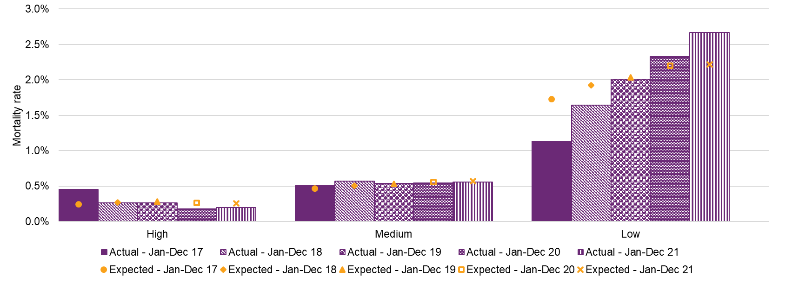

Table J.8: Actual exposure by level of function, measured by the number of years participants were active in the Scheme
Level of function | Actual Exposure
Level of function | Jan-Dec 17 | Jan-Dec 18 | Jan-Dec 19 | Jan-Dec 20 | Jan-Dec 21 | Jan-Feb 22 | Overall
High | 19,959 | 36,988 | 61,650 | 94,914 | 124,774 | 22,939 | 361,224
Medium | 38,943 | 76,535 | 128,426 | 177,092 | 213,510 | 37,527 | 672,033
Low | 32,383 | 60,024 | 94,448 | 116,581 | 128,646 | 21,489 | 453,572
Missing | 745 | 380 | 330 | 307 | 294 | 47 | 2,102
Total | 92,030 | 173,927 | 284,854 | 388,893 | 467,224 | 82,003 | 1,488,931

Level of function | Actual % Exposure
Level of function | Jan-Dec 17 | Jan-Dec 18 | Jan-Dec 19 | Jan-Dec 20 | Jan-Dec 21 | Jan-Feb 22 | Overall
High | 21.69% | 21.27% | 21.64% | 24.41% | 26.71% | 27.97% | 24.26%
Medium | 42.32% | 44.00% | 45.08% | 45.54% | 45.70% | 45.76% | 45.14%
Low | 35.19% | 34.51% | 33.16% | 29.98% | 27.53% | 26.21% | 30.46%
Missing | 0.81% | 0.22% | 0.12% | 0.08% | 0.06% | 0.06% | 0.14%
Total | 100.00% | 100.00% | 100.00% | 100.00% | 100.00% | 100.00% | 100.00%
Generally, mortality rates increase with decreasing level of function, reflecting a correlation with severity of disability. There is a shift in exposure from low to high level of function in 2021, and this contributed to the overall reduction in mortality rates.
The mortality rate for participants with a high level of function decreased slightly from 0.20% in 2020 to 0.18% in 2021, 0.08% lower than expected in 2021 and a similar variation as in 2020. However, there were approximately 1.50% more participants with a high level of function in 2021 than 2020. These two effects broadly offset each other, and thus those with high levels of function did not contribute materially to the change in overall mortality rate.
The bulk of the decrease in the overall mortality rate arose from participants with a medium level of function. The rate for this cohort decreased from 0.61% to 0.55%, and was 0.01% lower than expected in 2021 compared with 0.07% above expected in 2020.
The mortality rate for participants with a low level of function has increased significantly from year to year. It increased from 2.20% in 2020 to 2.33% in 2021, 0.13% higher than expected. However, across the Scheme the proportion of participants with a low level of function was approximately 1.50% lower in 2021 than in 2020. In terms of the aggregate Scheme mortality rate, the lower proportion of participants with a low level of function outweighed the increase in mortality rate for the cohort, thus contributing to the overall reduction.
Selected Assumptions
The section sets out the mortality rates selected for the 2021-22 AFSR. The selected rates are presented as one-way summaries by primary disability, gender and age group. One-way summary at the level of function by AFSR grouping is not possible, since the AFSR groupings vary with disability type (with 57 disability type and level of function cohorts in all).
In each of these one-way summaries, the impact of each step in determining the proposed rates are shown via the contribution to the overall average rate weighted by participant exposure years. There are five steps in the process:
- Actual rates – The actual rates in the 13 months to February 2022.
- 2020-21 AFSR Expected rates – The assumptions adopted in the previous AFSR.
- Initial Selected rates – Raw proposed rates were set at the level of primary disability, gender, AFSR level of function and age, using the credibility approach described in the section above. Preliminary consistency checks were done at participant group level to minimize changes at smoothing.
- Selected rates after adopting new life table – The initial selected rates were scaled using the ratio of new ALT18-20 to previous ALT16-18 population mortality table for each age and gender.
- 2021-22 AFSR Expected rates after smoothing – The mortality rates based on the new ALT18-20 were first smoothed using cubic functions at selected age ranges, followed by moving averages and manual adjustments to achieve a smooth progression of mortality rates between each individual age.
Overall, the average expected mortality rate selected for the 2021-22 AFSR is unchanged at 0.93%. Comparing the final rates adopted for the 2021-22 AFSR with those from the previous review, the impact of marginally lower base mortality rates by using the new ALT18-20 was largely offset by the slightly higher than expected experience.
There was also very little change in the contribution to overall mortality by disability type, as shown in Table J.10.
By primary disability
Table J.9: Actual and expected mortality rates by primary disability
 |  | Mortality Rates
Disability Type | Exposure (participant years) | Actual | 2020-21 AFSR Expected | Selected (Initial) | Selected  (new ALT) | 2021-22 AFSR Expected
Acquired brain injury | 16,311 | 2.71% | 2.70% | 2.71% | 2.65% | 2.69%
Autism | 169,244 | 0.04% | 0.06% | 0.06% | 0.06% | 0.06%
Cerebral Palsy | 17,888 | 0.86% | 0.71% | 0.77% | 0.75% | 0.77%
Developmental delay | 47,135 | 0.06% | 0.14% | 0.14% | 0.13% | 0.13%
Hearing Impairment | 23,894 | 0.26% | 0.24% | 0.24% | 0.24% | 0.24%
Intellectual Disability | 98,635 | 0.76% | 0.81% | 0.80% | 0.78% | 0.79%
Multiple Sclerosis | 9,269 | 1.21% | 1.46% | 1.51% | 1.46% | 1.50%
Psychosocial disability | 52,765 | 1.27% | 1.09% | 1.17% | 1.14% | 1.11%
Spinal Cord Injury | 5,531 | 2.12% | 1.80% | 1.84% | 1.79% | 1.81%
Stroke | 7,622 | 3.27% | 2.78% | 2.90% | 2.83% | 2.77%
Visual Impairment | 9,693 | 1.05% | 1.16% | 1.16% | 1.13% | 1.15%
Other Neurological | 21,009 | 5.06% | 5.21% | 5.15% | 5.07% | 5.17%
Other Physical | 19,725 | 3.72% | 3.90% | 3.82% | 3.73% | 3.79%
Other Sensory/Speech | 2,722 | 0.18% | 0.04% | 0.04% | 0.06% | 0.05%
Other | 4,924 | 5.42% | 2.49% | 3.39% | 3.31% | 3.37%
Total | 506,367 | 0.95% | 0.93% | 0.94% | 0.92% | 0.93%

Table J.10: Contribution to total mortality rates by primary disability
 |  | Contribution to total mortality rate
Disability Type | Exposure (mix of participants) | 2020-21 AFSR Expected | 2021-22 AFSR Expected
Acquired brain injury | 3.22% | 0.09% | 0.09%
Autism | 33.42% | 0.02% | 0.02%
Cerebral Palsy | 3.53% | 0.02% | 0.03%
Developmental delay | 9.31% | 0.01% | 0.01%
Hearing Impairment | 4.72% | 0.01% | 0.01%
Intellectual Disability | 19.48% | 0.16% | 0.15%
Multiple Sclerosis | 1.83% | 0.03% | 0.03%
Psychosocial disability | 10.42% | 0.11% | 0.12%
Spinal Cord Injury | 1.09% | 0.02% | 0.02%
Stroke | 1.51% | 0.04% | 0.04%
Visual Impairment | 1.91% | 0.02% | 0.02%
Other Neurological | 4.15% | 0.22% | 0.21%
Other Physical | 3.90% | 0.15% | 0.15%
Other Sensory/Speech | 0.54% | 0.00% | 0.00%
Other | 0.97% | 0.02% | 0.03%
Total | 100.00% | 0.93% | 0.93%
Mortality rates vary significantly across disability types, with other neurological, other physical, other and stroke having the highest rates due to the age profile and average level of function of these participant cohorts. This is partly driven by the older age profile of participants in these cohorts as well as lower levels of function on average.
The largest cohorts in terms of numbers of participants are autism, intellectual disability, psychosocial disability and developmental delay and each of these groups have lower mortality than the Scheme average except for psychosocial disability.
The contribution to Scheme mortality takes both the average rates of mortality and participant mix into account. The largest expected impact (number of participant deaths) is for participants with a primary disability of other neurological, other physical, intellectual disability, psychosocial disability and acquired brain injury.
By gender
Table J.11: Actual and expected mortality rates by gender
 |  | Mortality Rates
Gender | Exposure (participant years) | Actual | 2020-21 AFSR Expected | Selected (Initial) | Selected  (new ALT) | 2021-22 AFSR Expected
Female | 190,649 | 1.06% | 1.01% | 1.03% | 1.00% | 1.03%
Male | 315,719 | 0.89% | 0.88% | 0.89% | 0.87% | 0.88%
Total | 506,367 | 0.95% | 0.93% | 0.94% | 0.92% | 0.93%
Table J.12: Contribution to total mortality rates by gender
 |  | Contribution to total mortality rate
Gender | Exposure (mix of participants) | 2020-21 AFSR Expected | 2021-22 AFSR Expected
Female | 37.65% | 0.38% | 0.39%
Male | 62.35% | 0.55% | 0.55%
Total | 100.00% | 0.93% | 0.93%
The mortality rates for females selected for the 2021-22 AFSR are again higher than those for males, reflecting the higher proportion of females being in disability type and level of function cohorts with relatively high mortality rates. Both the actual and percentage changes were very small for both male and female.
Males continue to comprise a larger proportion of expected Scheme mortality as they represent a greater number of participants.

By age group
Table J.13: Actual and expected mortality rates by age group
 |  | Mortality Rates
Age | Exposure (participant years) | Actual | 2020-21 AFSR Expected | Selected (Initial) | Selected  (new ALT) | 2021-22 AFSR Expected
0 to 6 | 78,864 | 0.09% | 0.11% | 0.11% | 0.10% | 0.10%
7 to 14 | 130,463 | 0.06% | 0.07% | 0.07% | 0.06% | 0.07%
15 to 18 | 39,145 | 0.14% | 0.14% | 0.15% | 0.15% | 0.14%
19 to 24 | 41,618 | 0.20% | 0.24% | 0.24% | 0.25% | 0.24%
25 to 34 | 45,041 | 0.49% | 0.45% | 0.45% | 0.44% | 0.44%
35 to 44 | 41,809 | 0.86% | 0.88% | 0.88% | 0.85% | 0.86%
45 to 54 | 50,999 | 1.84% | 1.78% | 1.81% | 1.76% | 1.77%
55 to 64 | 59,966 | 3.54% | 3.37% | 3.43% | 3.37% | 3.41%
65+ | 18,462 | 4.90% | 4.74% | 4.86% | 4.73% | 4.82%
Total | 506,367 | 0.95% | 0.93% | 0.94% | 0.92% | 0.93%

Table J.14: Contribution to total by age group
 |  | Contribution to total mortality rate
Age | Exposure (mix of participants) | 2020-21 AFSR Expected | 2021-22 AFSR Expected
0 to 6 | 15.57% | 0.02% | 0.02%
7 to 14 | 25.76% | 0.02% | 0.02%
15 to 18 | 7.73% | 0.01% | 0.01%
19 to 24 | 8.22% | 0.02% | 0.02%
25 to 34 | 8.90% | 0.04% | 0.04%
35 to 44 | 8.26% | 0.07% | 0.07%
45 to 54 | 10.07% | 0.18% | 0.18%
55 to 64 | 11.84% | 0.40% | 0.40%
65+ | 3.65% | 0.17% | 0.18%
Total | 100.00% | 0.93% | 0.93%
As expected, mortality rates increase with age group except for ages 7 to 14 having a marginally lower rate of mortality compared with ages 0 to 6. While a large proportion of participants are aged 0 to 14 compared with other age groups, higher mortality rates at older ages mean that the majority of expected mortality arises from participants aged 45 and older.
Discussion of experience subsequent to February 2022
There were more deaths than expected from March 22 to June 22, contributing to an overall higher number of deaths for the full financial year of 2021-22. Despite this variation compared with historic experience, it is arising from a period of only four months, and therefore no adjustment was made to the selected assumptions which were based on the review of experience to the end of February 2022. Mortality experience will continue to be monitored closely going forward.
Impacts of Changes to Assumptions
Table J.15 shows the impact of adopting the new assumptions of participants leaving the Scheme on the projected participant numbers.
Table J.15: Impact on projected participant numbers of adopting new mortality assumptions
 | Participants at 30 June
Impact | 2023 | 2024 | 2025 | 2026 | 2032
Baseline projection from 2020-21 AFSR | 586,433 | 630,327 | 670,400 | 709,645 | 931,591
Change in participant numbers | -267 | -553 | -848 | -1,150 | -2,997
%Change in participant numbers | 0.0% | -0.1% | -0.1% | -0.2% | -0.3%
The projected participant numbers reduce marginally over time. While the overall mortality rates remain largely the same as 2020-21 AFSR, rate changes among different participant groups (i.e. disability, gender, level of function, age group) do vary. The marginal increase in projected participant numbers and Scheme expenses are driven by this change of participant mix.

Appendix K: Investment Effectiveness Program
Since the Scheme's commencement, the Agency has undertaken considerable work to understand and projected NDIS expenditure. The Agency also analyses the outcomes of participants and their families and carers using comprehensive questionnaire data as described in section 7 of this report. While existing outcomes reporting has considered the relationship between certain types of Scheme expenditure and outcomes further work is needed to comprehensively explain the causal link between a broader range of outcomes and funding types. The Investment Effectiveness Program (IEP) has been undertaken to understand the relationship between funding and outcome attainment.
Developing a deeper understanding of participant outcomes has the potential to generate important insights into both the overall impact of Government investment in the Scheme and to inform participants and planners on the types of supports that are most likely to support them to achieve their goals. Extensive longitudinal data has been collected over the life of the NDIS which (through detailed analysis) can be used to make sense of the complex links between a diverse cohort of participants, their budgets, and long-term outcomes. This understanding is critical to the continuous improvement of the Scheme, and it can guide the Agency’s efforts to fund the most effective supports, build confidence in the Scheme and help ensure its long-term sustainability.
The IEP responds in part to the 2020-21 AFSR, which identified that further work was required to measure the impact of different supports on participant outcomes, recommending “the NDIA should continue work on prioritising, implementing and measuring the impact of initiatives that aim to improve participant outcomes.” As more participants enter the Scheme, it becomes increasingly important for the Agency to demonstrate how the NDIS is successfully supporting participants to maintain and increase their independence and economic and social participation.
This appendix introduces basic descriptive statistics for selected outcomes, comparing median payments and changes in outcomes for participants across the Scheme. The next step, which is now in progress, is to demonstrate how the relationship between these two elements might be better understood. This will be conducted through statistical modelling for a pilot cohort, quantifying the marginal effect of funding on outcomes while controlling for a range of other factors.

Comparisons of funding and outcomes - Overview
The following section presents a series of summary data tables comparing median participant payment data (by age and disability cohort) with outcome attainment at two points in time: from Scheme entry (baseline) to latest plan review. These tables intend to demonstrate a basis for the IEP going forward. They allow the reader to gauge current levels of funded supports and outcome trends side-by-side, with the caveat that (as yet) a causal connection cannot be made between the two. Throughout the course of the IEP, the project aims to answer the question of what this causal relationship is for different cohorts and ultimately to provide meaningful information to participants, their family and carers, planners, policymakers, and the Australian community.
Data in this section concerning participant outcomes is derived from the Short Form outcomes questionnaire (SFOF), asked by planners at each participant plan review point (including at Scheme entry to establish a baseline for measuring progress). Further details on the Short Form outcomes questionnaire can be found in Section 7 of this report. Data concerning participant payments includes NDIS support payments made to participants or service providers and in-kind payments for existing state/territory programs.
Comparisons of funding and outcomes - Results
Outcomes selected for inclusion in this report are intended to demonstrate the central objectives of the Scheme and the types of outcomes where changes in funding are more likely to lead to changes in participant outcomes. While the tables below provide useful insights into the Scheme, there is limited operational or policy value in the comparisons made above without further context, investigation, and analysis due to the existence of confounding factors.
The tables show the percentage of participants with the outcome at baseline and at latest plan review, as well as the change between the two time points. The overall change is also split by baseline outcome status, showing the percentage with the outcome at latest review separately for those who had the outcome at baseline (“maintenance”) and for those who did not have the outcome at baseline (“improvement”).
The results below are impacted by a range of participant factors that will be crucial to inspect for the purposes of IEP modelling. For example, an important factor influencing participant outcomes is the time they spend in the NDIS and the role of average annualised payments over varying periods of time. Going forward, IEP modelling will explore these factors in greater depth to accurately determine their relationship to participant outcomes.
Participants currently working in a paid job
Employment has a significant impact on the overall wellbeing of participants and overcoming barriers to employment can lead to positive changes in many aspects of life including social participation, economic security and mental wellbeing. However not all participants of working age are actively seeking work. The data in Table K.1 includes all participants asked about their employment status in the SFOF, whether or not they are actively seeking work. The 15-24 year old age group were selected for inclusion in this report to reflect the important transitional nature of this time in life, and indeed a time when many participants will first start seeking work and utilising Scheme funding to achieve this goal.
Table K.1: % participants 15-24 years old who are currently working in a paid job
Disability group | Number of participants in baseline cohort | Median capacity building payment (yearly) | Median total payment (yearly) | % participants with outcome at baseline | % participants with outcome at latest review | Maintenance of 'yes' response: baseline to latest review | Improvement from 'no' response: baseline to latest review
Autism | 16,066 | $8.0k | $21.2k | 14.5% | 20.6% (+6.1%) | 73.8% | 12.9%
Intellectual Disability | 14,336 | $8.9k | $30.6k | 16.8% | 20.9% (+4.1%) | 73.7% | 12.5%
Psychosocial disability | 1,837 | $8.8k | $21.1k | 10.9% | 13.1% (+2.2%) | 60.0% | 8.2%
Sensory disability | 2,856 | $3.5k | $6.2k | 42.0% | 48.2% (+6.3%) | 87.0% | 22.7%
Other | 6,603 | $8.5k | $43.6k | 15.6% | 19.5% (+3.9%) | 81.3% | 10.6%
Total | 41,698 | $8.2k | $26.0k | 17.2% | 22.1% (+4.9%) | 76.7% | 12.6%

Participants choose what they do each day
Individual choice and self-determination are central objectives of the Scheme. Maintenance and attainment of outcomes looking at choice are good indicators that funded supports provide participants at any age with the flexibility and time to exercise choice.
Table K.2: % 15–24 year-old participants who choose what they do each day
Disability group | Number of participants in baseline cohort | Median capacity building payment (yearly) | Median total payment (yearly) | % participants with outcome at baseline | % participants with outcome at latest review | Maintenance of 'yes' response: baseline to latest review | Improvement from 'no' response: baseline to latest review
Autism | 16,597 | $8.0k | $21.2k | 43.8% | 45.8% (+2.0%) | 88.4% | 14.2%
Intellectual Disability | 14,858 | $8.9k | $30.6k | 39.5% | 40.4% (+0.9%) | 85.6% | 12.9%
Psychosocial disability | 1,875 | $8.8k | $21.1k | 62.8% | 62.4% (-0.4%) | 90.2% | 20.9%
Sensory disability | 2,922 | $3.5k | $6.2k | 79.1% | 83.5% (+4.4%) | 97.6% | 30.9%
Other | 6,851 | $8.5k | $43.8k | 43.2% | 44.2% (+1.0%) | 89.2% | 12.3%
Total | 43,103 | $8.2k | $26.0k | 45.4% | 46.9% (+1.5%) | 88.9% | 14.0%
NDIS helped with daily living
Outcomes shown in Table K.3, Table K.4 and Table K.5 were selected for their importance in understanding the direct impact of the NDIS on improving typical daily activities. Early on in life, participants may draw upon funded specialist services for children to gradually acquire the knowledge and skills to function in different settings and cope with daily activities. As people gain independence through life, the Scheme may play a more practical role in supporting participants with daily living activities – for example through assistive technology, individual support, counselling and advice.
Table K.3: % of parents/carers of children (birth to school-aged) who say that specialist services help their child gain skills she/he needs to participate in everyday life
Disability group | Number of participants in baseline cohort | Median capacity building payment (yearly) | Median total payment (yearly) | % participants with outcome at baseline | % participants with outcome at latest review | Maintenance of 'yes' response: baseline to latest review | Improvement from 'no' response: baseline to latest review
Autism | 12,848 | $12.2k | $14.3k | 90.1% | 93.8% (+3.8%) | 99.1% | 62.7%
Developmental delay* | 16,707 | $10.8k | $11.6k | 87.1% | 93.1% (+6.1%) | 98.8% | 53.1%
Intellectual Disability | 1,463 | $11.6k | $14.6k | 89.5% | 93.7% (+4.2%) | 98.2% | 65.6%
Sensory disability | 2,689 | $8.5k | $9.4k | 89.4% | 95.1% (+5.7%) | 96.6% | 64.3%
Other | 3,738 | $11.9k | $15.4k | 89.9% | 94.7% (+4.8%) | 98.8% | 62.6%
Total | 37,445 | $11.2k | $12.7k | 88.6% | 93.7% (+5.1%) | 98.7% | 58.7%
*Includes Global Developmental Delay
Participants completing the SFOF are only asked if the NDIS helped them with daily living activities at first and subsequent reviews (since the Scheme has not had an opportunity to help at Scheme entry). For age cohorts 15 and over presented in Table K.4 and Table K.5 (where aggregate responses to these questions are presented) the first review response effectively takes the role of “baseline”. This explains the smaller numbers of participants in baseline cohorts compared to elsewhere in this section.
Table K.4: % participants 15-24 years old who say the NDIS helped them with daily living activities
Disability group | Number of participants in baseline cohort | Median capacity building payment (yearly) | Median total payment (yearly) | % participants with outcome at first review | % participants with outcome at latest review | Maintenance of 'yes' response: baseline to latest review | Improvement from 'no' response: baseline to latest review
Autism | 11,595 | $8.9k | $24.6k | 66.1% | 69.1% (+2.9%) | 94.6% | 37.9%
Intellectual Disability | 9,614 | $10.0k | $35.2k | 66.8% | 69.9% (+3.0%) | 94.7% | 40.4%
Psychosocial disability | 854 | $9.9k | $27.0k | 61.8% | 64.9% (+3.0%) | 93.7% | 37.1%
Sensory disability | 1,457 | $4.5k | $8.4k | 57.8% | 57.6% (-0.2%) | 92.7% | 29.8%
Other | 4,635 | $9.7k | $49.7k | 71.5% | 76.3% (+4.8%) | 96.1% | 44.9%
Total | 28,155 | $9.2k | $30.3k | 66.7% | 69.5% (+2.9%) | 94.7% | 39.2%

Table K.5: % participants 25 years and over who say the NDIS helped them with daily living activities
Disability group | Number of participants in baseline cohort | Median capacity building payment (yearly) | Median total payment (yearly) | % participants with outcome at first review | % participants with outcome at latest review | Maintenance of 'yes' response: baseline to latest review | Improvement from 'no' response: baseline to latest review
Autism | 3,788 | $10.2k | $50.4k | 76.3% | 79.1% (+2.8%) | 93.3% | 51.1%
Intellectual Disability | 17,800 | $10.2k | $67.2k | 78.5% | 81.9% (+3.4%) | 96.3% | 50.4%
Psychosocial disability | 12,196 | $8.9k | $34.1k | 75.9% | 78.9% (+3.0%) | 96.4% | 43.7%
Sensory disability | 5,931 | $4.0k | $13.8k | 67.4% | 70.1% (+2.7%) | 95.3% | 36.6%
Other | 28,616 | $9.5k | $66.6k | 81.2% | 84.5% (+3.3%) | 97.6% | 50.9%
Total | 68,331 | $9.2k | $51.2k | 78.1% | 81.1% (+3.0%) | 96.6% | 47.9%

Relationships
The NDIS plays an important role in enabling young participants to participate socially with the supports needed to engage, learn and build important social bonds that typically form at this time. Table K.6 looks at median funding provided to participants in this age group and whether they have friends they enjoy playing with.
Table K.6: % children (birth to school-aged) who have friends that he/she enjoys playing with
Disability group | Number of participants in baseline cohort | Median capacity building payment (yearly) | Median total payment (yearly) | % participants with outcome at baseline | % participants with outcome at latest review | Maintenance of 'yes' response: baseline to latest review | Improvement from 'no' response: baseline to latest review
Autism | 18,092 | $11.9k | $13.7k | 36.3% | 30.3% (-6.1%) | 89.8% | 13.2%
Developmental delay* | 32,918 | $10.2k | $10.8k | 41.6% | 43.6% (+2.0%) | 94.8% | 16.2%
Intellectual Disability | 2,059 | $10.9k | $13.7k | 44.6% | 40.5% (-4.2%) | 89.3% | 20.4%
Sensory disability | 4,797 | $7.5k | $8.3k | 51.4% | 53.9% (+2.5%) | 95.7% | 31.2%
Other | 4,791 | $11.3k | $14.4k | 46.8% | 42.2% (-4.6%) | 90.8% | 20.4%
Total | 62,657 | $10.6k | $11.7k | 41.3% | 40.8% (-0.6%) | 93.4% | 17.1%
*Includes Global Developmental Delay

NDIS Publications
Insurance Principles and Financial Sustainability Manual (PDF Download)
Scheme expenses relate to the payments made for participant supports and does not include operating expenses. It is based on when the service was provided to the participant recognising some services are paid for after the end of the period.
The projected Scheme expenses for 2029-30 on an accrual basis are projected to be $74.1 billion, in comparison with $59.3 billion reported in the 2020-21 AFSR.
A stochastic model is used to estimate probability distributions of potential outcomes by allowing for random variation in one or more inputs over time. In this case, the inputs which are varied are the assumptions and risks which are most uncertain in the projection of Scheme expenses.
The 2020-21 AFSR was adopted in the 2022-23 Portfolio Budget Statement estimates (PBS) and therefore reflects the most recent budget estimates. Hence, no separate comparison with the PBS is shown.
At the previous review, additional inflation was referred to as “superimposed inflation”.
SAP is a software company that makes enterprise software. Also known as Systems, Applications and Products in Data Processing.
Participant cohorts are based on age, primary disability type, recorded level of function, gender, whether a participant is in supported independent living arrangements, and duration in the Scheme.
A stochastic model is used to estimate probability distributions of potential outcomes by allowing for random variation in one or more inputs over time. In this case, the inputs which are varied are the assumptions and risks which are most uncertain in the projection of Scheme expenses.
No new entrant rate is shown for the 2016 year as no geographic region phased into the Scheme in that year.
The ongoing process of reviewing participant eligibility to the Scheme.
Due to operational changes since July 2020, there has been a known issue with identifying participants with SIL. From May 2022 onwards, an automated and a more accurate method has been applied in identifying participants with SIL, leading to restatement of both the actual and expected number of participants with SIL from July 2020 to April 2022. This issue is now resolved; therefore no further restatement is expected going forward.
Participants new to SIL supports includes both new entrants to the Scheme with SIL supports and existing participants who transitioned to SIL arrangements during the period. The numbers of participants new to SIL supports up to 2020-21 are based on the previous method to identifying participants with SIL. The number for 2021-22 is based on the new method used from May 2022 and so includes a restatement of the prior periods to 2021-22.
Payments on an accrual basis include an expense of $476m for one-off provider payments and $91m for the cost of residential aged care.
Calculated as $126m minus $15m or 10% minus 1%
Average annualised payments have been calculated on a cash basis using the 12 months over each year ending 30 June.
The result for additional inflation in 2018-19 may be impacted by the high number of new entrants in the Scheme during transition.
Change in mix refers to the impact on inflation of changes in the profile of the participant population (i.e. more new entrants in cohorts with a lower than average payment per participant would lead to a negative impact) rather than changes in the average payment per participant within specific cohorts. This is excluded from additional inflation as it is explicitly modelled in the AFSR. In this table, change in mix excludes the inflation impact of change in reported level of function over time. This impact is included in additional inflation.
Additional inflation in 2021-22 has been impacted by COVID-19 and by workforce shortages and the supply of disability support workers.
Under the NDIS legislation amendments, from 1 July 2022 ’plan review’ will be referred to as ’plan reassessment’. An internal review of decisions at the request of a participant will continue to use the word ’review’. The terminology as it applied up until 30 June 2022 is used in this report.
Intraplan inflation tends to occur when a participant’s needs and situation change before a plan is due to be renewed. Often the plan is ended early and a new plan is put in place, and if the participant has spent more than expected, the value of the first plan is adjusted retrospectively. Intraplan inflation can also occur when the expected cost of a high value capital item is used in a plan but is then updated with an actual quote.
This result was partly driven by plan indexation of approximately 11.9% applied in July 2019 to reflect NDIS price increases.
An example is the ACC (Accident Compensation Corporation) in New Zealand (https://www.acc.co.nz/assets/corporate-documents/3360178450/financial-condition-report-2012.pdf).
https://www.rba.gov.au/publications/smp/2022/aug/economic-outlook.html
Total expected inflation shown is lower than normal inflation plus additional inflation because the change in mix of participants is expected to lead to reductions in average payment per participant (before allowing for normal inflation and additional inflation). The historic average shown implicitly includes change in mix, and so the most appropriate comparison to experience is the total including change in mix.
https://www.dss.gov.au/sites/default/files/documents/01_2022/review-ndia-actuarial-forecast-model-and-drivers-scheme-costs.pdf
Productivity Commission 2017, National Disability Insurance Scheme (NDIS) Costs, Study Report, Canberra (page 412).
Model specification risk is the risk that the inputs and parameters of the model used to estimate future experience is not a true representation of Scheme processes or participant behaviour, and that this leads to biases in the projections. This risk is high at this review, given the NDIS processes are still evolving, meaning a limited history for assumption setting, as well as some limitations in the data available for analysis.
Corporate Plan | NDIS - The NDIS Corporate Plan 2022-26 has also been released and includes the same Aspiration 1. However, the 2021-25 version is referenced in this report, as it includes targets for 2021-22 on outcomes-based performance metrics against which experience for the 2021-22 year can be measured.
Insurance Principles and Financial Sustainability Manual (PDF Download)
Quarterly Reports | NDIS
NDIS outcomes and goals
Service charter | NDIS
Participant Service Improvement Plan | NDIS
NDIA Data and Insights Website
Under the NDIS legislation amendments, from 1 July 2022 ’plan review’ will be referred to as ’plan reassessment’. An internal review of decisions at the request of a participant will continue to use the word ’review’. The terminology as it applied up until 30 June 2022 is used in this report.
At 30 June 2022, it is estimated that 2% of participants who have ever had an approved plan have a missing or default level of function.
SAP is a software company that makes enterprise software. Also known as Systems, Applications and Products in Data Processing.
Participant cohorts are based on age, primary disability type, recorded level of function, gender, whether a participant is in supported independent living arrangements, and duration in the Scheme.
A stochastic model is used to estimate probability distributions of potential outcomes by allowing for random variation in one or more inputs over time. In this case, the inputs which are varied are the assumptions and risks which are most uncertain in the projection of Scheme expenses.
Participants who acquired their disability some years prior who only accessed the Scheme recently (for various reasons).
The estimated future date at which point in time where participant intake primarily represents new incidence to disability (in other words when all participants with previously unmet needs have entered the Scheme).
Plan budgets represent the dollar amount of support that has been made available to participants in their plan. The proportion of plan budgets which are used is referred to as the ‘utilisation rate’, and the dollar amount of the plan budget used is referred to as ‘payments’. Payments are modelled as this is the actual cost to the Scheme.
The 15 support categories include four core support categories (Transport, Consumables, Daily Activities and Social Community Civic), two capital support categories (Assistive Technology and Home Modifications) and nine capacity building (CB) support categories (Support Coordination, CB Relationships, CB Lifelong Learning, CB Home Living, CB Health and Wellbeing, CB Employment, CB Daily Activities, CB Choice and Control and CB Social Community Civic).
The expected number of participants in this comparison is based on the estimates from the previous review.
As a result, the actual number at June 2021, as well as the projected number (from the previous review) of participants with SIL at both June 2021 and 2022 have been adjusted downwards by 778 to reflect the updated identification method implemented in May 2022. There is no change to the difference between the actual and expected experience as both actual and expected for both June 2021 and 2022 were adjusted by the same amount.
For further information, refer to Addendum 1 to NDIA’s Quarterly Report to Disability Ministers at 30 June 2021
This chart only considers participants that were active at 30 June 2017. For further information, refer to Addendum 1 to NDIA’s Quarterly Report to Disability Ministers at 30 June 2021: https://www.ndis.gov.au/media/3476/download?attachment
The number of new SIL participants shown in 2020-21 implicitly includes a reduction of 778 participants due to a reclassification of certain participants from SIL to non-SIL.
The negative expected net increase for ages 45 to 54 is the result of offsetting movements due to age increases, leaving, dying and transitions into SIL arrangements.
Participation rate refers to the proportion of general population that are NDIS participants. Prevalence is defined as the proportion of the general population that have a disability, regardless of whether they are participants of the NDIS.
The regions that commenced phasing during the Scheme’s trial and early transition period.
Time period relates to when the payment was made, rather than when the support was provided.
Payments on an accrual basis include an expense of $476m for one-off provider payments and $91m for the cost of residential aged care as well as an increase in the allowance for payments yet to be made for services already received.
Expected payments are based on the 2020-21 AFSR.
Expected payments are based on the 2020-21 AFSR.
These characteristics are first or subsequent year in the Scheme, SIL status, age group, level of function and primary disability.
This impact is measured by comparing average annualised payments on a mix-adjusted and unadjusted basis. Mix-adjusting standardises expected payments to the actual mix of participant characteristics observed over the financial year.
An auto regressive integrated moving average (ARIMA) model is a forecasting algorithm that predicts future values of a time series variable based on its past values.
50th percentile means mid-range of the estimated range and 80th percentile means the upper end of the estimated range.
Average annualised payments have been calculated on a cash basis using the 12 months over each year ending 30 June.
Average annualised payments have been calculated on a cash basis using the 12 months over each year ending 30 June.
11% for 25-34, 17% for 35 to 44, 21% for 45-54 and 25% for 55 to 64.
Average annualised payments have been calculated on a cash basis using the 12 months over each year ending 30 June.
The mix-adjusted average payment shows the average payment for each cohort on a comparable basis, i.e., based on a consistent mix of participants by age, disability type and level of function. The variance in average payment between all participants and recent entrants therefore relates purely to lower payments per participant, and not due to any change in mix.
Change in mix refers to the impact on inflation of changes in the profile of the participant population (i.e., more new entrants in cohorts with lower expected payments per participant would lead to a reduction). In this table, change in mix excludes the inflation impact of change in reported level of function over time. This impact is included in additional inflation.
Additional inflation refers to inflation other than normal inflation. Normal inflation refers to the increases in the prices paid for supports and reflects both average increases to wage inflation and CPI over the period analysed. Additional increases in prices paid for NDIS supports due to changes in price limits over time are allowed for in the ‘Pricing impacts’ item and not in additional inflation. Inflation due to change in mix has also been excluded from additional inflation as it is accounted for in the projection model.
The results in this table are calculated as rates of inflation of average payments for the given support category or categories, whereas the results numbered 3-5 in the previous table are calculated as the contribution of the given support category to the overall inflation rate.
By types of support, price increases at 1 July 2022 consist of 9.05% for attendant care (mainly core daily activities and social, community and civic participation), 5.1% for transport, consumables and capital items, and 0% for Therapy and other capacity building supports.
The reduced average annualised payment is anticipated in the AFSR projection model due to the relatively higher number of children assumed to enter the Scheme over the period and the entry of participants with a previously unmet need for funded disability supports who are relatively higher functioning (and hence have a lower expected average payment) than those currently in the Scheme.
This result was partly driven by plan indexation of approximately 11.9% applied in July 2019 to reflect NDIS price increases.
Total inflation consists of intraplan inflation and interplan inflation. Intraplan inflation refers to a change in plan budget that occurs within a plan between reviews, while interplan inflation refers to a change of plan budget that occurs at plan review.
Under the NDIS legislation amendments, from 1 July 2022 ’plan review’ will be referred to as ’plan reassessment’. An internal review of decisions at the request of a participant will continue to use the word ’review’. The terminology as it applied up until 30 June 2022 is used in this report.
Changing your plan | NDIS
An example is the ACC (Accident Compensation Corporation) in New Zealand (https://www.acc.co.nz/assets/corporate-documents/3360178450/financial-condition-report-2012.pdf).
The utilisation rates shown are based on payments to date (i.e., payments already made) and plan budgets to date.
That is, a utilisation rate of 71% across all plans, in relation to Scheme experience between 1 October 2020 and 31 March 2021 (based on data to 30 June 2021)
Utilisation for all plans include both cash and in-kind supports. However, the calculation of utilisation by plan number excludes participants with in-kind supports as it is not possible to accurate separate in-kind payments and plan budgets between plans. Only utilisation of plan budgets between 1 October 2021 and 31 March 2022 is shown, as experience in the most recent quarter is still emerging.
The estimated future date at which point in time where participant intake primarily represents true new incidence (in other words when all participants with previously unmet needs have entered the Scheme). For this report 30 June 2024 has been assumed.
The 2020-21 AFSR was adopted in the 2022-23 PBS estimates and therefore reflects the most recent budget estimates. Hence, no separate comparison with the PBS is shown.
Higher new entrant rate assumptions compounded with a lower rate of participants leaving the Scheme assumptions leads to increases in the Scheme expense projection
The implied growth rate is the percentage change in average plan budget across all Scheme participants.
The assumed inflation rate is effectively the percentage change in average plan budget which would occur if the mix of participants in the Scheme did not change from year to year. It is higher than the implied growth rate because there is an increasing proportion of Scheme participants who are children or are high functioning over time and these cohorts tend to have lower than average plan budgets.
Figures are shown to the nearest hundred dollars. Blanks mean there are no or few participants in that age/disability cohort.
In particular, participants with spinal cord injury, cerebral palsy and acquired brain injury.
This includes hearing impairment, visual impairment and other sensory/speech disabilities.
Note, the utilisation rate for 2021-22 includes estimates of payments for supports which were received during the 12 month period but were not yet paid for as at 30 June 2022. It also includes an estimate of how plan budget amounts 2021-22 may change retrospectively.
The indirect method utilised participation rates, which are defined as the proportion of the general population who have an existing disability and are in the Scheme. The indirect method presumed that the participation rate for any age (say X) is equal to the participation rate at the previous age (X-1), plus the new entrant rate (for age X), minus the rate of leaving or dying (for age X). From this relationship, an indirect estimate of the new entrant rate for each age can be calculated.
New entrants are new to disability supports if they have not transferred from existing State/ Territory or Commonwealth disability programs.
No new entrant rate is shown for the 2016 year as no geographic region phased into the Scheme in that year.
Increased prevalence rates of autism in Australia are reported by the Australian Institute of Health and Welfare (https://www.aihw.gov.au/reports/disability/autism-in-australia/contents/autism), whilst increased prevalence rates of autism in the United States of America are reported by the Centers for Disease Control and Prevention (https://www.cdc.gov/ncbddd/autism/data.html).
It is noted that the new entrant numbers in this chart are for years ended 30 June, whereas those in Figure 5.3 are for years ended 31 March.
At the previous review differential assumptions were adopted for people leaving the Scheme in the short and long term.
Life tables are produced to show the probabilities of an individual living or dying at a particular age, based on the experience over the period analysed. The Australian Life Table 2018-20 (ALT18-20) is based on mortality experience in Australia over the period 2018 to 2020.
Life tables, 2018 - 2020 | Australian Bureau of Statistics (abs.gov.au)
Participants new to SIL supports includes both new entrants to the Scheme with SIL supports and existing participants who transitioned to SIL arrangements during the period. The numbers of participants new to SIL supports up to 2020-21 are based on the previous method to identifying participants with SIL. The number for 2021-22 is based on the new method used from May 2022 and so includes a restatement of the prior periods to 2021-22.
In particular, participants with spinal cord injury, cerebral palsy and acquired brain injury.
This includes hearing impairment, visual impairment and other sensory/speech disabilities.
Figures are shown to the nearest hundred dollars. Blanks mean there are no or few participants in that age/ disability cohort.
Figures shown the nearest hundreds. Blanks mean averages are lower than 100.
At the previous review, additional inflation was referred to as “superimposed inflation”.
This includes CB Choice and Control, CB Daily Activities, CB Employment, CB Health Wellbeing, CB Relationships and Support Coordination.
Other Supports include Consumables, Transport, Assistive Technology and Home Modifications
Inflation associated with increased use of attendant care is primarily applied to Core Daily Activities and Social, Community and Civic Participation. Inflation associated with increased use of therapies is applied to Capacity Building Daily Activities. ‘Other supports’ includes Consumables, Transport and capital items.
Total expected inflation shown is lower than normal inflation plus additional inflation because the change in mix of participants is expected to lead to reductions in average payment per participant (before allowing for normal inflation and additional inflation). The historic average shown implicitly includes change in mix, and so the most appropriate comparison to experience is the total including change in mix.
In particular, participants with spinal cord injury, cerebral palsy and acquired brain injury.
This includes hearing impairment, visual impairment and other sensory/speech disabilities.
Figures are shown to the nearest hundred dollars. Blanks mean there are no or few participants in that age/disability cohort.
Figures shown are to the nearest hundred dollars. Blanks mean averages are lower than 100.
Productivity Commission 2017, National Disability Insurance Scheme (NDIS) Costs, Study Report, Canberra (Page 412).
There is considerable uncertainty in the calculation of lifetime expense estimates in this section. There is limited longitudinal experience within the Scheme to inform assumptions, with most participants having been in the Scheme for five years or less. These estimates therefore reflect emerging experience, assuming the same average payments and rates of leaving and mortality were to continue over the lifetime of participants.
The adopted long-term discount rate of 5.0% corresponds to the long-term expectation for nominal GDP growth, which is the combination of average long-term productivity growth of 1 per cent per annum, employment growth of 1.5 per cent per annum (noting employment growth is expected to fall over time due to the impact of ageing and slowing population growth on the labour force) and price inflation of 2.5 per cent per annum. This assumption is consistent with the long-term discount rate used for Australian government superannuation liability valuations.
A stochastic model is used to estimate probability distributions of potential outcomes by allowing for random variation in one or more inputs over time. In this case, the inputs which are varied are the assumptions and risks which are most uncertain in the projection of Scheme expenses.
High level analysis indicates that the ongoing Scheme expense in respect of new entrants is approximately 17% lower than of existing participants, after allowing for difference in participant mix. A credibility weighting of 50% is applied to this figure to arrive at the baseline assumption of 8.4%, due to the high level of uncertainty regarding future experience.
Coefficient of variation (CoV) has been used to measure uncertainty. It is defined as the standard deviation divided by the mean of a distribution. A higher CoV implies a higher level of uncertainty.
The 2020-21 AFSR was adopted in the 2022-23 PBS estimates and therefore reflects the most recent budget estimates. Hence, no separate comparison with the PBS is shown.
Released on 3 July 2021
Projections have been adjusted from a cash basis to an accrual basis using accrual factors from the 30 June 2019 AFSR
http://www.comlaw.gov.au/Details/C2019C00332/Download
Part 2, section 4, (11).
Further, the National Disability Insurance Scheme forms part of the broader Australia’s Disability Strategy 2021-2031. The strategy is a commitment from all governments to a shared vision of an inclusive Australian society that enables people with disability to fulfil their potential as equal citizens. In particular, the strategy emphasises the need for improved performance of mainstream services in delivering outcomes for people with disability.
Part 2, section 4, (12) and (12A).
Outcomes Framework Pilot Study: Summary Report 2015 | NDIS
Participant and family/carer outcomes: COVID-19 impact | Executive summary, to 30 June 2020
Employment outcomes - participants, their families and carers | NDIS
Corporate Plan | NDIS The NDIS Corporate Plan 2021-25 also includes the same Aspiration 1. The targets for 2021-22 set out in this report are from the 2021-25 version.
More details can be found here: The NDIS Participant Employment Strategy 2019-22
Also available on the same webpage as the NDIS Participant Employment Strategy 2019-22
Under the NDIS legislation amendments, from 1 July 2022 ’plan review’ will be referred to as ’plan reassessment’. An internal review of decisions at the request of a participant will continue to use the word ’review’. The terminology as it applied up until 30 June 2022 is used in this report.
Employment outcomes - participants, their families and carers | NDIS
Social inclusion and community access - our research | NDIS
Figures in this section have been rounded to the nearest whole percentage.
Noting that the education and housing systems have a major role to play in the lifelong learning and home domains.
Noting that the education and housing systems have a major role to play in the lifelong learning and home domains.
Family and Carer Outcomes 30 June 2020 | NDIS
See also Volume 1 - Inquiry report - Disability Care and Support (pc.gov.au) pp. 54-55,131
From paragraph 8b of the Rules for the Scheme Actuary. National Disability Insurance Scheme—Rules for the Scheme Actuary 2013 (legislation.gov.au).
Insurance Principles and Financial Sustainability Manual (PDF Download)
Would we fund it | NDIS
Reasonable and necessary supports | NDIS
Home and living supporting evidence form | NDIS
This approach was taken to remove any timing bias related to payments, given that there is a general lag between when supports are provided and when data is received from States/Territory and Commonwealth governments.
“Mature participants” are defined as those who were active at both 28 February 2022 and 31 May 2022, and had their first plan approved on or prior to 28 February 2021.
Separate projections are performed for primary disability, level of function, age, gender and whether or not a participant has SIL supports.
For example, payments tend to exhibit a higher peak during May and June. This is likely to be due to providers finalising accounts in the lead up to the end of the financial year.
Payment relativity is defined as average annualised payments for the period relative to the overall average annualised payments for the financial year.
Those participants who had been in the Scheme for at least one year as at 30 June 2021
The top 10% is equivalent to ventiles 19 and 20
The bottom 40% is equivalent to ventiles 1 to 8
The reduction in projected Scheme expenses for Capacity Building Employment is because some employment related supports have been reclassified under Core supports since the 2020-21 AFSR.
The percentages are calculated using the projected GDP at the time of each review.
The assumption relating to new entrant rates is 15% higher than those assumed in the baseline projections, whilst the projected number of previously unmet need participants remains unchanged from the baseline projections. For this reason, the change in new participant numbers shown here is less than 15%.
The quoted new entrant rate in the 2020-21 AFSR of 267.3 participants per 100,000 population excluded the new entrant rate for the other disability type, despite it being included in the projections shown in that report. The new entrant rate adopted in the 2020-21 AFSR (including the other disability type) was 271.6 participants per 100,000 population.
No new entrant rate is shown for the 2016 year as no geographic region phased into the Scheme in that year.
While the intention would be to conduct a review of participants leaving the Scheme annually, the actual period between reviews may be more or less than 12 months depending on factors such as upcoming changes to data definitions, changes to operational process or unanticipated changes in the emerging experience.
This report also addresses the recommendation made by Taylor Fry in their independent review of the AFSR model to undertake comprehensive reviews of the experience of participants leaving the Scheme.
There are small differences between the rates of participants leaving shown in Figure I.6, which is based on data as at 28 February 2022, and Figure I.3, due to retrospective changes and corrections to data since 30 September 2021. This also applies to Figure I.7 and Figure I.8 compared with Figure I.4 and Figure I.5 respectively.
Since this advice was provided the NARB has been renamed as the ‘National Access and Reassessment Branch’ in line with NDIS legislation amendments which came into effect from 1 July 2022.
While the intention would be to conduct a review of the mortality of Scheme participants annually, the actual period between reviews may be more or less than 12 months depending on factors such as upcoming changes to data definitions, changes to operational process or unanticipated changes in the emerging experience.
Australian Bureau of Statistics Survey of Disability, Ageing and Caring (ABS SDAC)
Life Tables 2016-18 | Australian Bureau of Statistics (abs.gov.au) Life tables are produced to show the probabilities of an individual living or dying at a particular age, based on the experience over the period analysed. The Australian Life Table 2016-18 (ALT16-18) is based on mortality experience in Australia over the period 2016 to 2018.
Life tables, 2018 - 2020 | Australian Bureau of Statistics (abs.gov.au)
The Limited Fluctuation method was applied to number of deaths, where the credibility (Z) of an estimate is defined by the probability (P) that it is within a tolerance (k) of the true value. The selected value of P was 95% and k was 5%. Based on this, the number of deaths required for full credibility within each group is 1,537. To calculate the credibility factor, the “square root rule” was used; this formula is Z = SQRT(N/1537) where N is the observed number of deaths.
Due to small number of deaths, credibility factors are determined at level of function groups (i.e. including all ages).
However, no credibility has been given to the actual experience for small participant groups (by age group, gender, primary disability and level of function) with less than 10 exposure years.
Each chart includes bars showing the actual number of deaths and dots showing the expected number of deaths. Results are presented by calendar year. For 2022, only the data for the first two months of 2022 have been considered and, as is normal, significant levels of random fluctuations in experience occur over such a short period. Accordingly, calendar years 2020 and 2021 are referred to as recent experience at the review date. The reported level of function in regular monitoring is grouped in High / Medium / Low based on the normalised assessment scores of the participants, and the results shown here follow this grouping.
Comparison of actual and expected mortality experience also includes participants whose gender is recorded as “other”, however this group has a very small exposure and has not been studied in greater detail.
Note this includes a revision to the rates for male participants with a primary disability type of other sensory/ speech which was applied incorrectly in the 2020-21 AFSR. This had an immaterial impact on the 2020-21 AFSR projection results.
NDIS, Employment outcomes for NDIS participants as at 31 December 2020. https://data.ndis.gov.au/media/2815/download?attachment
NDIS, Annual Financial Sustainability Report 2020-21, p99-100. https://www.ndis.gov.au/about-us/publications/annual-financial-sustainability-reports
This does not apply to questions asking how the NDIS has helped participants. For these questions, responses are collected from participants at first review and compared over time when asked at subsequent plan reviews.
More about the Short Form and Long Form outcomes questionnaires can be found on this page: https://data.ndis.gov.au/reports-and-analyses/outcomes-and-goals
Outcomes metrics presented in Section 8 may vary slightly from that presented in Section 7 of this report. This is due to minor differences in methodology. Participants who have mismatched ages and questionnaire forms by more than two years (e.g. the participant's age is 12 and their answered questionnaire form is "15 to 24") are omitted. Results shown (excluding the ‘NDIS helped’ questions) compare outcomes at baseline to the latest review. ‘NDIS helped’ questions are compared from first review to the latest review, instead of baseline to the latest review. Median payments data are calculated only for participants with complete responses a question presented in the table. Of this subset, they represent the annualised average payment over the participant’s time in the Scheme from baseline to latest review, lagged to account for payment and outcome recording timings.
Percentages indicate both participants in open employment as well as Australian Disability Enterprises (ADE).
It is important to note that outcomes for children such as those in the relationships domain will improve due to normal age-related development.

