
Effectiveness and safe ty of physical activity interventions on quality of life and activities of daily living for children with progressive neuromuscular disorders: a systematic review and meta-analysis
April 2022
Research and Evaluation Branch
Version 1.0
Dr Nicole Hill, Dr Amit Lampit
ndis.gov.au


Contents
About the report 3
Summary 3
Introduction 3
What did we do? 5
Objectives 5
Overview of methods used 5
What we found 7
Summary of studies 7
Characteristics of physical activity interventions 7
Quality of the available evidence 8
Table 1: Description of included studies 9
Quality of life 12
Activities of daily living 12
Safety of physical activity interventions 12
Types of instruments used to measure participant outcomes 13
Summary and conclusions 14
Limitations of this report 15
References 16
Appendix 1: Detailed study methodology 18
Study objectives 18
Electronic search strategy 19
Study selection and eligibility criteria 21
Data collection and coding 23
Risk of bias and study quality 23
Data Analysis 23
Investigations of heterogeneity 24
Appendix 2: Results 25
Study selection 25
Characteristics of included studies 26
Study quality 28
Overall efficacy on quality of life 29
Overall efficacy on activities of daily living 33
Overall safety of physical activity interventions 36
Appendix references 37

About the report
This report summarises findings from a systematic review and meta-analysis of the effectiveness and safety of intensive and non-intensive physical activity interventions on quality of life and activities of daily living in children and young people aged 7 to 16 years with a diagnosis of progressive neuromuscular disease. Intensive physical activity interventions typically include mobility-related interventions such as MEDEK therapy, NeuroSuit, SpiderCage therapy and Lokomat training. Non-intensive interventions include conventional physiotherapy and low-impact exercises such as resistance training and stretching. The age group included in this report was selected due to the limited number of eligible studies reporting outcomes in children aged 7 years or less.

Summary
- Participation in physical activity interventions delivered over 1 to 12 months is associated with a small improvement in activities of daily living (i.e., everyday functioning).
- There is insufficient evidence from the peer-reviewed literature to support benefits of these interventions for quality of life.
- There is insufficient evidence to determine the benefits or harmful effects of intensive physical activity interventions.
- It is likely that the benefits of such interventions for NDIS participants with progressive NMD should be reviewed at least every 12 months due to limited number of studies that deliver interventions beyond 12 months.
- The gaps in evidence identified in this report ought to be considered key areas for future research.

Introduction
Progressive neuromuscular disease (NMD) is characterised by progressive loss of muscle and nerve tissue resulting in loss of strength and muscle endurance; loss of voluntary and involuntary muscle control (e.g., respiratory failure); involuntary muscle activity (e.g., stiffness, cramps); sensory loss; and reductions in mobility, range of motion, and function. Progressive NMDs in childhood are rare. The most common diagnosed NMDs, Charcot Marie Tooth and Duchenne Muscular Dystrophy (DMD), affect approximately 6.9 and 2.8 per 100,000 people in the general population, respectively [1, 2], whereas the prevalence of other NMDs such as Spinal Muscular Atrophy (SMA) is approximately 1.8 per 100,000 [3].

Although the prognosis and progression of NMD varies considerably across diagnosis, children diagnosed with NMD experience adverse outcomes including fatigue, pain, a decrease in activities of daily living and increased disability. NMD may or may not occur alongside significant intellectual disability [4-6].
In Australia, there are 517 children under 7 years and 1892 young people aged 7 to 14 years who receive support from the NDIS scheme. The average annualised committed support budget for participants under 7 years is $58,000 per participant and $49,000 per participant for young people aged 7 to 14 years[7].
Currently in Australia it is common practice for service providers working with children with progressive NMD to regularly recommend and implement intensive physiotherapy blocks to children with progressive NMD. Intensive physiotherapy involves an hour of physiotherapy delivered up to 5 days a week for a minimum of 3 weeks.
This review adds to the evidence relating to the risks, benefits and optimal dosage of intensive and non-intensive physical activity interventions in this cohort of young children and support guidance provided by Early Childhood Services (ECS) to participants with progressive NMD.
Whilst existing best practice guidelines recommend multidisciplinary management of NMDs, which typically includes pharmacological interventions, surgery, psychosocial support, and physical therapy [8-10]. Intensive physical activity interventions are frequently prescribed to children diagnosed with NMD to delay the progression of the disease, to improve quality of life (QoL) and life expectancy [10]. However, evidence supporting the safety and effectiveness of an intensive level of physical activity interventions in children and young people is limited and has not been synthesised through a systematic review of the literature.
Although systematic reviews of physical activity interventions in adult populations with progressive NMD have demonstrated positive results in terms of physical outcomes, quality of life, and activities of daily living [11-15], it is unclear whether these findings translate to children with NMD who, due to developmental difference, may experience different risks and benefits. Moreover, it is unclear whether engagement in intensive physical activity interventions cause harm to the child’s neuromuscular system due to factors such as fatigue and overuse. Understanding the risks associated with both intensive and non-intensive physical activity interventions is important since there is the chance that any damage sustained may become permanent due to the progressive loss of neuromuscular components in this population.

What did we do?
The following section provides an overview of the systematic review and
meta-analysis approach. A full description of the study methods is available in Appendix 1.

Objectives
The objectives of the systematic review and meta-analysis was to examine the evidence for the effectiveness of physical activity interventions in children and young people with progressive NMD on activities and participation outcomes (quality of life and activities of daily living) and to examine the safety of engaging in intensive and non-intensive physical activity interventions (adverse events, retention, and adherence to the intervention).

Overview of methods used
Findings included in this report were identified through a systematic review and meta-analysis. A systematic review is a process to locate and summarise the results of all studies that ask a particular research question, usually by using different methods with a common underlying question (e.g., does physical activity improve quality of life in children with progressive NMD?). A meta-analysis is a statistical procedure that combines results from the studies identified in a systematic review to find a common estimate of effect between studies, as well as how effects might vary across settings.
We searched five databases to identify studies that were published from 1990 onwards that examined the impact of any physical activity intervention on quality of life, activities of daily living or safety outcomes in children or young people under the age of 16 years with a progressive neuromuscular disorder.
We included studies with a comparison group (e.g., children and young people who did not receive the physical activity intervention) as well as single arm studies with at least 5 participants who received at least one physical activity intervention (i.e., studies without a comparison group). Experimental laboratory-based studies (i.e., examining impact of a single-session intervention) were excluded as results from such studies cannot be generalised to clinical services.
We defined physical activity broadly and included any interventions that promote physical activity of muscle structures and joints including exercise, sports, stretching, resistance training and weight bearing, hydrotherapy, and physiotherapy. The assessment of safety outcomes included changes in symptoms; direct and indirect adverse events; retention, adherence, and compliance to the intervention.
Risk of bias and study quality was assessed using the Revised Cochrane Risk of Bias tool (RoB 2)[16] for randomised trials or the Risk Of Bias In Non-randomised Studies of Interventions (ROBINS-I)[17] for other study designs. These are common tools that measure the adequacy of the methods used in each study to address its aims using a standardised checklist. Studies with ‘low’ risk of bias are generally considered as higher quality and thus more reliable. However, studies that are found as having ‘some concerns’ or ‘high’ risk of bias should not be considered as flawed, as choice of methods in individual studies depend on factors such as pragmatic considerations (e.g., when dealing with rare conditions) or research standards in the field.
Quality of life, activities of daily living, and safety (retention rates) outcomes were pooled across studies analysed using meta-analysis. Retention rates were included under safety outcomes as it is possible that participants who experience adverse outcomes are more likely to discontinue participation. Outcomes were first examined from randomised controlled trials (RCTs) with comparison groups, and again using a single arm approach that compared changes in outcomes from before and after the intervention.
For quality of life and activities of daily living outcomes, the intervention effect was measured using standardised mean difference, calculated as Hedges’ g with 95% confidence interval (CI). Hedges’ g provides the difference (effect) between two groups or timepoint in standard deviation units. A positive Hedges’ g means that the intervention was beneficial. By convention, Hedges’ g values of 0.2, 0.5 and 0.8 are considered small, moderate or large effect sizes, respectively. The confidence interval (CI) estimated the precision of the estimate of effect. When the CI includes the null, the effect estimate is too imprecise to be considered statistically significant, meaning that we don’t have enough information to determine whether the intervention is beneficial or not. For retention outcomes (a proxy of safety outcomes), the intervention effect was measured using odds ratios with 95% CI.

What we found
The following section highlights the key findings from the review. A detailed description of results from the meta-analysis are available in Appendix 2.

Summary of studies
Eight clinical studies [18-25], encompassing 1095 participants (598 whom received the intervention and 497 controls) were included in the systematic review and meta-analysis. [18, 20, 21, 23, 26]. The characteristics of included studies are shown in Table 1. Eligible studies were from Australia [19, 24], India [20], Netherlands [21, 23], Spain [22], Turkey [18, 26], and the US [25]. The mean age of study participants ranged between 7 to 12.8-years.
Four studies involved children or young people diagnosed with Duchenne muscular dystrophy [18, 20, 21, 23]; two with Charcot Marie-Tooth [19, 24]; one with muscular dystrophy [25]; and one study included participants with multiple diagnoses including Steinert muscular dystrophy, congenital myopathy, non-hereditary neuromuscular disorder and Spinal Muscular Atrophy [22].
Six studies reported quality of life outcomes [18-22, 25], 4 studies reported activity of daily living outcomes [18, 21-23], adverse events was reported in 4 studies [19, 21, 23, 24] and 6 studies reported retention rates [18-21, 23, 24].

Characteristics of physical activity interventions
No studies reported outcomes for intensive physical activity interventions (e.g., SpiderCage or Lokomat). The 8 interventions covered by the systematic review and meta-analysis were all considered non-intensive physical activities including arm ergometer training, resistance training, hydrotherapy, yoga and physiotherapy, and upper extremity training through virtual reality gaming. A detailed description of the physical activity interventions included in each study in shown in Appendix Table 1. The duration of the physical activity interventions ranged between 4 weeks and 12 months the frequency of delivery ranged between 15-minute sessions delivered 3 to 5 times per week to 90-minute sessions delivered 5 times per week.
The examination of trends across studies suggests a possible association between frequency and intensity of the intervention and a decline in outcomes. In particular, the largest decline in quality of life was observed in a study that involved yoga and physiotherapy delivered twice per day, 7 days a week, over a 12-month period [20]. However, due to limited between study variance (heterogeneity, see Appendix 2) this association was not investigated using meta-analysis.

Quality of the available evidence
Risk of bias was high in 50% of studies, 25% of studies had some concern and 25% were found as having low risk of bias (Appendix Figure 2). Overall, the quality of evidence regarding the effectiveness of physical activity interventions in children and young people with progressive NMD can be considered as low. There was some evidence that effect sizes for quality of life were larger in smaller studies, which can be indicative of over-estimation of treatment effect for this outcome.

Table 1: Description of included studies
NB: The studies reported in Table 1. are considered non-intensive interventions.
RCT= Randomised controlled trial; DMD= Duchenne Muscular Dystrophy; CMT= Charcot Marie Tooth; MD= Muscular Dystrophy; QOL= Quality of Life; ADL= Activities of Daily Living; PedsQL= Pediatric Quality of Life instrument; NSAA= North Star Ambulatory Assessment; PEDI= Pediatric Evaluation of Disability; Abilhand= Ability and Managing Daily Activities instrument; CHQ= Child Health Questionnaire.
Study name and design | Diagnosis;  Sex (% male);  Age (mean) | Outcome | Intervention description | Comparison group description | Settings and mode of delivery | Summary of results | Risk of Bias
Jansen 2013 [23]; Netherlands; RCT | DMD; 100%;  10.5 years | ADL; PEDI- clinician reported | N=17; Bicycle mobility training;  Session: 21 mins  Frequency: 5 p/wk  Duration: 24 weeks | N=13; Treatment as usual | Home or school, supervised by parents or teachers | ADL: No significant differences were observed in the intervention versus control group. | Some concerns
Burns 2017 [19]; Australia;  RCT | CMT; 56.6%;  11.5 years | QOL; CHQ- parent reported | N=30; Adaptive ankle resistance training  Session: 35 mins  Frequency: 3 p/wk  Duration: 26 weeks | N=30; Sham training, an identical procedure was at a very low intensity (<10% of one repetition maximum) and non-adaptive | Clinic and home, supervised by physiotherapist and parent | QOL: No significant differences were observed in the intervention versus control group.  Safety: No significant differences were observed in muscle or fat volume in the intervention versus control group. | Low
Heutinck 2018 [21]; Netherlands; RCT | DMD; 100%; 12.8 years | ADL, Abilhand- parent and child reported | N=9; Gravity-compensated 3D-training for the arms using virtual-reality computer games.  Session: 15 mins  Frequency: 3 to 5 p/wk  Duration: 20 weeks | N=10; Waitlist control | Home, supervised by parent | ADL: No significant differences were observed in the intervention versus control group for both the child and parent reported outcomes. | High
Alemdaroglu 2015 & 2014 [18, 26]; Turkey; RCT | DMD; 100%;  9.4 years | ADL;  NSAA- parent and child reported | N=12; Adaptive upper extremity training using an arm ergometer.  Session: 40 mins  Frequency: 3 p/wk  Duration: 8 weeks | N=12; Non-adaptive range of motion exercises | Clinic, supervised by physiotherapist | ADL: No significant differences were observed in the intervention versus control group for both the child and parent reported outcomes. | High
Rose 2010 [24]; Australia; RCT | CMT; 46.5%; 10.5 years | Safety, Self-report falls- child reported | N=15; Four weeks of night casting followed by four weeks of passive stretching.  Session: NR  Frequency: NR  Duration: 4 weeks | n=15; Waitlist control | Home, supervised by parent | Safety: No significant differences were observed in falls in the intervention versus control group. | Some concerns
Dhargave 2018 [20]; India; RCT | DMD; 100%;  7.9 years | QOL- PedsQL- child reported | N= 62; Physiotherapy and yoga  Session: 90 mins  Frequency: 7 p/wk  Duration: 52 weeks | N=62; Physiotherapy TAU | Home, supervised by parent | QOL: No significant differences were observed in the intervention versus control group. | High
Huguet-Rodriguez 2020 [22]; Spain; Single-arm | Mixed; 54.54%;  8.4 years | QOL- PedsQL- parent and child reported | N=11; Aquatic therapy  Session: 45 mins  Frequency: 1 p/wk  Duration: 10 weeks | None | Clinic, supervised by physiotherapist | QOL: No significant differences were observed in pre-post scores. | Low
Zelikovich 2017 [25]; USA; Single-arm | MD; NR;  7.0 years | QOL- PedsQL- child reported | N=12; Adaptive exercise games program  Session: 45 mins  Frequency: 3 p/wk  Duration: 4 weeks | None | Home, supervised by parent | QOL: No significant differences were observed in pre-post scores. | High

Quality of life
Six studies reported findings on quality of life (4 RCTs and 2 single-arm studies). There was no evidence that engaging in physical activity interventions improved quality of life outcomes (Appendix Figure 3). Results from both the meta-analysis of RCTs and single-arm studies were statistically non-significant, meaning that we don’t have enough evidence to conclude whether a benefit for quality of life should be expected (Appendix Figure 4).
The examination of trends reported in individual studies suggest that quality of life tended to decline among study participants in both the intervention and control group. In contrast, interventions that include game-based components (e.g., video games and virtual reality) were associated with improvements in quality of life, whereas the remaining interventions showed a general decline in quality of life. Additionally, differences in parent versus child ratings suggest that quality of life outcomes may differ according to parent and child perceptions, with children reporting higher scores in quality of life compared to parent ratings. However, at this stage we are unable to formally investigate the link between specific design elements and effects. Such investigations may be possible in the future as more studies will be available for analysis.

Activities of daily living
Four studies reported activities of daily living outcomes (3 RCTs and 1 single-arm study). The results suggest that low-intensity physical activity interventions produce statistically significant improvements in activities of daily living in children and young people with progressive NMD, with a small effect size (g = 18, 95% CI 0.01 to 0.35). These results are robust across RCTs (Appendix Figure 7) and pre-post measures from the single-arm analysis (Appendix Figure 9).
The examination of trends reported in individual studies showed that activities of daily living tended to improve among those who participated in the intervention, with larger improvement reported in studies that used game-based components. As noted above, due to limited data these findings cannot be further investigated statistically at this stage.

Safety of physical activity interventions
There was an absence of evidence to reliably assess the safety of intensive physical interventions (e.g., SpiderCage, Lokomat training) in children and young people with progressive neuromuscular disorder. In other words, the effectiveness and safety of these interventions remain inconclusive.
For low-intensity physical activity interventions:
Results from the meta-analysis showed there was no difference in study retention rates among those who received the intervention compared to those who did not, suggesting that engagement in physical activity interventions did not correspond with higher rates of participant drop-outs.
There was insufficient data to compare adherence in participants who received the intervention to those who did not. However, 72% to 100% of people who participated in the physical activity intervention adhered to the treatment program, suggesting that participants were able to complete the physical activities that they were assigned.
All adverse events reported across studies were indirect and did arise due to participation in the intervention, suggesting that low-intensity physical activity was not associated with serious physical complications for children and young people who received the intervention.
Subjective discomfort related to the intervention was reported in 3 studies. These symptoms were remedied by postural adjustments that occurred during the trial.
One study used quantitative methods (Magnetic Resonance Imaging- MRI) to assess increase in intramuscular fat volume and found no evidence of adverse effects in children with Charcot-Marie-Tooth who engaged in lower extremity adaptive resistance training.

Types of instruments used to measure participant outcomes
Five validated instruments were used to assess quality of life and activities of daily living outcomes in participants including:
- Pediatric Evaluation of Disability Inventory-PEDI (ADL)
- ABILHAND (ADL)
- North Star Ambulatory Assessment- NSAA (ADL)
- Pediatric Quality of Life Inventory- PedsQL (QoL)
- Child Health Questionnaire- CHQ (QoL)
Results of individual outcome measures are provided in Appendix Figures 3, 5, 6, 7, 9 and 10. There was no evidence to suggest that difference in choice of outcome measures skewed the results or led to heterogeneity of the pooled effect estimates.

Summary and conclusions
Engagement in low-intensity interventions is associated with small improvements in activities of daily living. It is not currently known whether the outcomes from low intensity interventions differ from intensive physical activity interventions. Conversely, there is an absence of published evidence demonstrating whether engagement in intensive physical interventions will lead to improved outcomes in activities and participation (e.g., quality of life or activities of daily living), nor is there conclusive evidence concerning the safety of these interventions.

Twelve months is the longest period for which children and young people have participated in physical activity interventions from which quality of life, activities of daily living and safety outcomes are available. In other words, there is no evidence available for physical activity interventions that continue beyond 12-months. For this reason, annual review of the effectiveness of physical activity interventions may be valuable to monitor the impact of physical activity interventions on participants.
There is some preliminary evidence from individual studies suggesting:
Participation in multiple low intensity physical activity interventions at one time (e.g., physical therapy and yoga) was associated with less improvements in quality of life compared to participants who received a single intervention (e.g., physiotherapy). Together, these findings suggest that engagement in more physical activities does not correspond with a net improvement in quality of life.

Children and their parents/caregivers may report different responses to quality of life and activities of daily living surveys. For example, there was a small but non-significant tendency for children to report higher quality of life scores compared to their parents. Given many children and young people with progressive NMD do not have intellectual disability, service providers should provide children with an opportunity to report their own perceived changes in quality of life, activities of daily living, and safety outcomes, if they can do so. This recommendation aligns with the inclusive and participatory practice recommendations outlined in the National guidelines for best practice in early childhood intervention [27].

Physical activity interventions that incorporate game-based learning opportunities through virtual reality and video-game technology may be linked to improved quality of life outcomes in children and young people. Consideration of these findings in the development and delivery of physical activity interventions for children and young people aligns with the principles of inclusive and participatory practice outlined in the National guidelines for best practice in early childhood intervention, in particular engaging he child in their natural environment through activities that engage the child’s interests [27].

Limitations of this report
This report is informed by a systematic search of the peer reviewed literature published between 1990 to present. The evidence cited in this report is sensitive to potential sources of bias including study quality, type of control and the availability of evidence. It is noteworthy, that 50% of studies included in the report were considered to have high risk of bias, driven primarily by attrition (loss of study participants to follow-up).
Due to low heterogeneity an examination of the moderators of the safety, quality of life and activities of daily living outcomes was not warranted. In other words, the factors that influence the size of the effect reported (e.g., duration and frequency of treatment) are not currently known.
Given the limited availability of high-quality studies, the use of validated and reliable quality of life, activities of daily living, and safety outcomes should be reported and recorded (in addition to physiological and physical outcomes) on a regular basis by providers to facilitate future evaluation and effectiveness studies.
Lastly, the physical activity interventions included in the report do not necessarily reflect the types of interventions that are provided to participants in clinical settings (e.g., physiotherapy sessions). Interventions targeting improvements in activities of daily living, for example often involve goal-oriented tasks (e.g., sit to stand exercises) that differ significantly to the structured physical exercise interventions included in the current systematic review and meta-analysis. Although we sought to assess all physical activity interventions, the absence of available peer reviewed literature prohibited further investigation into the impact of different types of physical interventions in young people with progressive NMD.

References
1. Crisafulli, S., et al., Global epidemiology of Duchenne muscular dystrophy: an updated systematic review and meta-analysis. Orphanet Journal of Rare Diseases, 2020. 15(1): p. 141.
2. Theadom, A., et al., Prevalence of Charcot-Marie-Tooth disease across the lifespan: a population-based epidemiological study. BMJ Open, 2019. 9(6): p. e029240.
3. Pearn, J., Incidence, prevalence, and gene frequency studies of chronic childhood spinal muscular atrophy. J Med Genet, 1978. 15(6): p. 409-13.
4. Kilmer, D.D., et al., Profiles of neuromuscular diseases. Facioscapulohumeral muscular dystrophy. Am J Phys Med Rehabil, 1995. 74(5 Suppl): p. S131-9.
5. McDonald, C.M., et al., Profiles of neuromuscular diseases. Becker's muscular dystrophy. Am J Phys Med Rehabil, 1995. 74(5 Suppl): p. S93-103.
6. McDonald, C.M., et al., Profiles of neuromuscular diseases. Duchenne muscular dystrophy. Am J Phys Med Rehabil, 1995. 74(5 Suppl): p. S70-92.
7. National Disability Insurance Agency. NDIA Data insights- Explore data: neurological disorders aged 0-6 and 7-14. [cited 2022 04 April]; Available from: https://data.ndis.gov.au/explore-data.
8. Association of Paediatric Chartered Physiotherapists, Guidance for Paediatric Physiotherapists Managing Neuromuscular Disorders. 2017.
9. Colvin, M.K., et al., Psychosocial Management of the Patient With Duchenne Muscular Dystrophy. Pediatrics, 2018. 142(Supplement 2): p. S99-S109.
10. Johnson, N.E., et al., Consensus-based care recommendations for congenital and childhood-onset myotonic dystrophy type 1. Neurology: Clinical Practice, 2019. 9(5): p. 443-454.
11. Corrado, B. and G. Ciardi, Facioscapulohumeral distrophy and physiotherapy: a literary review. Journal of Physical Therapy Science, 2015. 27(7): p. 2381-5.
12. Corrado, B., G. Ciardi, and C. Bargigli, Rehabilitation Management of the Charcot-Marie-Tooth Syndrome: A Systematic Review of the Literature. Medicine, 2016. 95(17): p. e3278.
13. Gianola, S., et al., Efficacy of muscle exercise in patients with muscular dystrophy: a systematic review showing a missed opportunity to improve outcomes. PLoS ONE [Electronic Resource], 2013. 8(6): p. e65414.
14. Green, E., et al., Systematic Review of Yoga and Balance: Effect on Adults With Neuromuscular Impairment. American Journal of Occupational Therapy, 2019. 73(1): p. 7301205150p1-7301205150p11.
15. Cup, E.H., et al., Exercise therapy and other types of physical therapy for patients with neuromuscular diseases: a systematic review. Archives of Physical Medicine & Rehabilitation, 2007. 88(11): p. 1452-64.
16. Sterne, J.A.C., et al., RoB 2: a revised tool for assessing risk of bias in randomised trials. BMJ, 2019. 366: p. l4898.
17. Sterne, J.A., et al., ROBINS-I: a tool for assessing risk of bias in non-randomised studies of interventions. BMJ, 2016. 355: p. i4919.
18. Alemdaroğlu, I., et al., Different types of upper extremity exercise training in Duchenne muscular dystrophy: effects on functional performance, strength, endurance, and ambulation. Muscle Nerve, 2015. 51(5): p. 697-705.
19. Burns, J., et al., Safety and efficacy of progressive resistance exercise for Charcot-Marie-Tooth disease in children: a randomised, double-blind, sham-controlled trial. Lancet Child Adolesc Health, 2017. 1(2): p. 106-113.
20. Dhargave, P., et al., Effect of yoga on overall quality of life in children with duchenne muscular dystrophy. Muscle & nerve, 2018. 58: p. S48‐.
21. Heutinck, L., et al., Virtual Reality Computer Gaming with Dynamic Arm Support in Boys with Duchenne Muscular Dystrophy. J Neuromuscul Dis, 2018. 5(3): p. 359-372.
22. Huguet-Rodríguez, M., et al., Impact of Aquatic Exercise on Respiratory Outcomes and Functional Activities in Children with Neuromuscular Disorders: Findings from an Open-Label and Prospective Preliminary Pilot Study. Brain Sci, 2020. 10(7).
23. Jansen, M., et al., Assisted bicycle training delays functional deterioration in boys with Duchenne muscular dystrophy: the randomized controlled trial "no use is disuse". Neurorehabil Neural Repair, 2013. 27(9): p. 816-27.
24. Rose, K.J., et al., Serial night casting increases ankle dorsiflexion range in children and young adults with Charcot-Marie-Tooth disease: a randomised trial. J Physiother, 2010. 56(2): p. 113-9.
25. Zelikovich, A.S., T. Oswald, and N.L. Kuntz, A Pilot Study to Assess the Feasibility and Impact of a Home Exercise Program on Heart Rate and Heart Rate Variability in Children with Muscular Dystrophy (P4.163). Neurology, 2017. 88(16 Supplement): p. P4.163.
26. Alemdarotlu I, K.A., Yilmaz O, Topalotlu H,, Effects of upper extremity dynamic exercise on respiratory function and quality of life in Duchenne Muscular Dystrophy. Turkish Journal of Physiotherapy and Rehabilitation, 2014. 25(2): p. 78-85.
27. Early Childhood Intervention Australia [ECIA], National guidelines best practice in early childhood intervention. .
28. Page, M.J., et al., PRISMA 2020 explanation and elaboration: updated guidance and exemplars for reporting systematic reviews. BMJ, 2021. 372: p. n160.

Appendix 1: Detailed study methodology
This systematic review adheres to guidelines from the 2020 update of the Preferred Reporting Items for Systematic reviews and Meta-Analyses statement (PRISMA 2020 [28]). The protocol for the systematic review and meta-analysis was submitted to PROSPERO on 29 November 2021 (registration pending). Deviations in the protocol include the exclusion of outcomes related to on Neuromusculoskeletal and Movement-Related Functions and Structure. All eligible studies reporting these outcomes were recorded in laboratory settings which were not considered generalisable to NDIS participants.

Study objectives
The review sought to synthesise the available evidence for the effectiveness and safety of physical activity interventions on activities and participation outcomes (e.g., quality of life and activities of daily living) in children, aged 16 years or younger, with a diagnosis of NMD.
The following objectives were examined in the current systematic review and meta-analysis:
- What is the evidence for the general efficacy and effectiveness of physical activity interventions on quality of life and activities of daily living in children and young people with NMD?
  - What effect sizes should be expected on quality of life and activities of daily living outcomes?
  - How do effect sizes vary across outcome measures, domains, and settings?
  - To what extent are any observed effects confounded by common sources of bias within and between studies?
  - Is there a difference in quality of life and activities of daily living outcomes according to intervention type and study design factors (e.g., duration and frequency of delivery)?
- What is the evidence for the safety of physical activity interventions in children with NMD?
  - Is there a difference in the frequency of adverse events according to intervention type and study design factors (e.g., duration and frequency of delivery)?

NB: Low heterogeneity prohibit formal investigation into the association between outcome effects and outcome measures, domains, settings, and study design factors.

Electronic search strategy
A single search of MEDLINE, EMBASE and PsycINFO via OVID; AND CINAHL was conducted on 11 November 2022 for studies examining the effects of physical activity interventions in children and young people aged 16 years or less diagnosed with progressive NMD on at least one outcome involving quality of life, activities of daily living and safety. The Medline search strategy is shown in Appendix Table 1. The search was not limited by time, location or language. Articles written in a language other than English were translated. Additional articles were identified by scanning the reference lists of existing reviews. One author (Nicole TM Hill, NTMH) conducted the initial search. Screening of title and abstracts and the review of full texts was conducted by two reviewers (NTMH and Ivana Randjelovic, IR). Discrepancies were resolved by Amit Lampit (AL) who also contacted corresponding authors for additional information when required.

Table 1. MEDLINE Search strategy
Ovid MEDLINE(R) ALL <1946 to November 08, 2021>
1. exp Glycogen Storage Disease/
2. exp Muscular dystrophy/
3. Muscular Diseases/cn, ge [Congenital, Genetics]
4. Muscular Atrophy, Spinal/
5. exp motor neuron disease/
6. "metabolic disease*".ab,kw,ti.
7. muscular disease.ab,kw,ti.
8. 1 or 6
9. 3 and 8
10. ((metabolic or congenital) adj2 myopath*).ab,kw,ti.
11. (inflammatory adj2 myopath*).ab,kw,ti.
12. (motor neuron disease* or motor nerurone disease*).ab,kw,ti.
13. (motoneuron disease* or motoneurone disease*).ab,kw,ti.
14. (motorneuron disease* or motorneurone disease*).ab,kw,ti.
15. Amytrophic lateral sclerosis.ab,kw,ti.
16. ALS.ab,kw,ti.
17. 3 and 16
18. (poliomyelitis or "muscular dystroph*" or "myotonic dystroph*" or myasthen* or myelopath*).ab,kw,ti.
19. (dystroph* adj3 (becker or duchenne or "limb girdle" or "emery dreifuss" or facioscaphulohumeral)).ab,kw,ti.
20. Peripheral Nervous System Diseases/cn, ge [Congenital, Genetics]
21. (neuropathy or neuropathies or polyneuropathy or polyneuropathies).ab,kw,ti.
22. ("neuromuscular disease*" or "neuromuscular weakness" or "neuromuscular degenerat*").ab,kw,ti.
23. "degenerat* neuromuscular ".ab,kw,ti.
24. (dystroph* adj3 (becker or duchenne or "limb girdle" or "emery dreifuss" or facioscaphulohumeral or
Ulrich or Bethlem or Fukuyama or Walker-warburg or steinert or Landouzy-Dejerine)).ab,kw,ti.
25. (Charcot marie tooth or charcot disease).ab,kw,ti.
26. "Friedreich* ataxia".ab,kw,ti.
27. Giant axonal neuropathy.ab,kw,ti.
28. laing-distal.ab,kw,ti.
29. exp Neuromuscular junction diseases/
30. 4 or 5 or 9 or 10 or 11 or 12 or 14 or 15 or 17 or 18 or 19 or 20 or 21 or 22 or 23 or 24 or 25 or 26 or 27 or 28 or 29
31. exp Child/
32. (child* or youth or young* or pediatric* or paediatric* or infant or infancy or offspring or juvenile).ab,kw,ti.
33. 31 or 32
34. exp behaviour therapy/
35. Physical Therapy Modalities/
36. exp Exercise therapy/
37. Health Promotion/
38. "Physical Education and Training"/
39. (activity tracking or functional activit* or motor learning).ab,kw,ti.
40. (physical therap* or physiotherap* or physical intervention* or occupation* therap*).ab,kw,ti.
41. (lifestyle intervention* or daily living).ab,kw,ti.
42. ((Excess* or intens* or Lifestyle) adj (training or exercise or therap* or intervention* or activity or activities or program)).ab,kw,ti.
43. ((circuit or resistance or resistive or weight or aerobic or strength or cardio or isometric or isotonic or isokinetic or endurance or stretch*)
adj3 (training or exercise or therap* or intervention* or activity or activities or program)).ab,kw,ti.
44. ambulatory care.ab,kw,ti.
45. (sport or game or gaming or cuevas medek).ab,kw,ti.
46. exp Hydrotherapy/
47. 34 or 35 or 36 or 37 or 38 or 39 or 40 or 41 or 42 or 43 or 44 or 45 or 46
48. 30 and 33 and 47
49. (lokomat or loko mat or neurosuit or the multifunction* therapy unit or Spider cage or Spidercage or therasuit or universal exercise unit).ab,kw,ti.
50. 47 or 49
51. 30 and 33 and 50
52. 30 and 33 and 49

Study selection and eligibility criteria

Types of studies
Eligible studies included in the meta-analysis were randomised or non-randomised, and single arm studies. Eligible studies must have been published in peer-reviewed journals or included in previous systematic reviews, but data extracted from those studies may have been unpublished (e.g., obtained from study authors).

Types of participants
Studies were eligible if they included children or young people (mean age ≤16 years at baseline) with a diagnosis of a progressive NMD (any aetiology), established using clinical assessments or standardised diagnostic measures. Progressive NMD comorbid with other conditions (including established or evident intellectual disability) will be eligible. Studies combining Progressive NMD with other conditions (e.g.,
non-progressive neurological disorders such as cerebral palsy) were included if >75% of the sample have a diagnosed NMD or if data for participants with NMD is available separately from other conditions. The following Progressive NMDs were eligible:
- Congenital myasthenic syndromes (CMS)
- Lambert-Eaton myasthenic syndrome (LEMS)
- Myasthenia gravis (MG)
- Charcot-Marie-Tooth disease (CMT)
- Giant axonal neuropathy (GAN)
- Myotonic muscular dystrophy OR Steinert's disease OR myotonic dystrophy
- Bethlem CMD
- Fukuyama CMD, MDDGA4
- Ullrich CMD
- Walker-Warburg syndromes CMD
- Duchenne Muscular Dystrophy (DMD)
- Emery-Dreifuss muscular dystrophy (EDMD)
- Limb-girdle muscular dystrophies (LGMD)
- Facioscapulohumeral muscular dystrophy OR FSH OR FSHD
- Becker muscular dystrophy
- Spinal muscular atrophy

Types of interventions
Physical activity interventions included those which: Required the physical movement, manipulation, training, or exercise of at least one limb, muscle, or joint structure in the following regions: (1) head and neck region; (2) shoulder region; (3) Upper extremity (arm, hand); (4) lower extremity (leg, foot); and (5) trunk. Studies of eligible interventions combined with other approaches (e.g., splinting, or surgical prosthetics) will be included if ≥50% of intervention time meets the criteria above. Lab-specific interventions that were delivered in a single experimental study were excluded.

Types of outcome measures
Outcomes assessed at two time points (before and after the intervention) were eligible. Eligible outcomes included any validated quality of life or activities of daily living measure. Safety outcomes included:
Symptom exacerbation: Describes the onset of new or worsening neurological or muscular symptoms lasting over 24hours. Includes terms such as ‘increased symptoms’ or ‘symptom exacerbation.’
Adverse event: Describes an unfavourable outcome that occurs during or after participation in the intervention, resulting in discontinuation of participation in the intervention. The adverse effect is one which occurs during any point during participation in the intervention delivery time-period. The adverse effect may have a direct or indirect causal relationship to the intervention.
Serious adverse event: Describes an event that results in death or is life-threatening, requires hospitalisation, or results in significant or permanent disability during or after the intervention.
Retention rate: Describes the completion of outcome measurements following the intervention. Will be reported on number completed first post-intervention follow-up data collection/number recruited.
Adherence rate: Describes the extent to which the participant follows the intervention corresponding with the agreed recommendations of the study; we consider adherence as attendance to the exercise/lifestyle intervention. Will be reported on number of attended sessions for the intervention.
Data on compliance was included in the protocol but insufficient data precluded it from inclusion in the current report.

Data collection and coding
Coding of outcome measures was conducted by NTMH who double-checked all data for accuracy. Data was coded into an excel spreadsheet for analysis in R. Data from all studies were entered as means and standard deviations (SDs) for single-arm pre-post measures, and for the intervention and control group in RCTs. For retention outcomes, data was entered as events for the intervention and control group in RCTs only. Outcome measures were extracted at baseline (pre-intervention) and immediately after the intervention (post-intervention). If a study had multiple follow-up points, data from the first time-point, immediately after completion of the intervention was collected. Reports from the same study were combined into a single unit of analysis. In addition to the primary outcome measures information on the study design and characteristics were extracted for each eligible article which included, author, publication year, country, study design, intervention description, control description, intervention settings, intervention dose (duration and frequency), mode of delivery (e.g., parent or clinical supervised), overall risk of bias rating.

Risk of bias and study quality
Formal assessment of risk of bias within studies was performed using the Revised Cochrane Risk of Bias tool (RoB 2 [16]) for randomised trials or the risk of bias in non-randomised studies - of Interventions (ROBINS-I [17]) for other study designs. Studies that did not provide sufficient information to determine its methods were determined as having high risk of bias.

Data Analysis
The primary outcome was standardised mean difference (SMD, calculated as Hedges' g) of post-intervention change between those who received the physical activity intervention and control groups. Separate analysis of SMD was conducted for single-arm studies among the intervention group and control group. Precision of the SMD was calculated for each outcome measure by the 95% CI. A positive SMD implies better therapeutic effects over time in the intervention group compared to the control group. For the analysis of retention outcomes, effect sizes based on events were expressed using odds ratios ratios an 95% CI.
When studies provided multiple effect sizes or subgroups, all eligible effect sizes and subgroups were pooled using robust variance estimation models. Heterogeneity across studies was quantified using the τ² statistic.
Small-study effect (‘publication bias’) will be assessed by visually inspecting funnel plots of effect sizes vs standard error. There was no formal investigation of funnel plot asymmetry due to the small number of studies.
All analyses were conducted using the R packages metafor and robumeta.

Investigations of heterogeneity
Due to low heterogeneity, planned analysis of effect moderators was not conducted.

Appendix 2: Results

Study selection
The initial search identified 2670 records, of which 564 were duplicates. A total of 2106 records were screened based on title an abstract (Appendix Figure 1). The full-text of 2017 records were assessed, of which 207 full-texts were reviewed. Authors from five studies were contacted, for which additional information was provided for one study [1-5]. A total of 10 records, met the eligibility criteria, however one study was excluded because significant attrition led to outcomes being reported in less than five participants [6]. Two records [7, 8] reported data from the same study and was therefore combined into a single study. The final dataset included 8 independent studies comprising six RCTs and two single-arm studies [1, 3, 7-13].
Appendix Figure 1. Summary of study selection
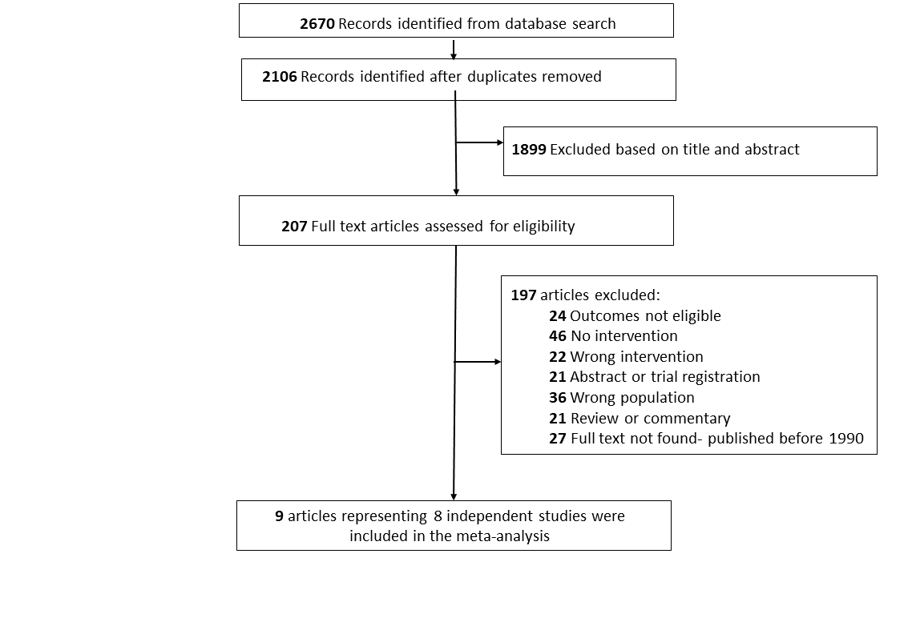

Characteristics of included studies
Nine records representing eight studies were included in the meta-analysis (N=1095; 598 received the intervention and 497 controls). The mean age of participants was 7 years (range 7 to 12.75). Eligible studies were from Australia [9, 13], India [3], Netherlands [10, 12], Spain [11], Turkey [7, 8], and US [1]. Four studies involved children or young people diagnosed with Duchenne muscular dystrophy [3, 7, 10, 12]; two with Charcot Marie-Tooth [9, 13]; one with muscular dystrophy [1]; and one study included participants with multiple diagnoses including Steinert muscular dystrophy, congenital myopathy, non-hereditary neuromuscular disorder, and Spinal Muscular Atrophy [11]. Six studies reported quality of life outcomes [1, 3, 7, 9-11], and four studies reported activity of daily living outcomes [7, 10-12], information on adverse events was reported in four studies [9, 10, 12, 13] and retention rates in six [3, 7, 9, 10, 12, 13].
A detailed description of the physical activity interventions is shown in Appendix Table 2. All studies included adaptive physical activity interventions, but the characteristics of the interventions varied largely across studies. Two studies involved game-based interventions: one via virtual reality video games[10] and one involving interaction with family members [1]. One study involved multiple interventions including both yoga and physiotherapy [3]. The duration of physical activity interventions per day ranged between 15 to 90 minutes, delivered over 4 to 52 weeks, with the longest intervention occurring 7 days per week over 12-months [3]. Three out of six RCT studies involved passive waitlist controls or treatment as usual [10, 12, 13], the remaining studies involved active controls.
Five validated instruments were used to assess quality of life and activities of daily living outcomes in participants including:
- Pediatric Evaluation of Disability Inventory-PEDI (ADL)
- ABILHAND (ADL)
- North Star Ambulatory Assessment- NSAA (ADL)
- Pediatric Quality of Life Inventory- PedsQL (QoL)
- Child Health Questionnaire- CHQ (QoL)
Results of the meta-analysis justified the pooling of different outcome measure instruments (i.e., low heterogeneity indicated that the outcomes were not likely to be influenced by differences in the types of outcome measures pooled in the analysis).

Appendix Table 2. Detailed intervention description
Study | Intervention description
Jansen 2013 [12]; Netherlands | Participants trained with an assisted bicycle training program. Participants cycled 15 minutes with both their legs and arms using a mobility trainer with electrical motor support (KPT Cycla, Kinetic, France). The mobility trainer could be used with a participant’s own (electric) wheelchair. Participants were instructed to cycle at a constant speed (65 rpm) and to keep this up for 15 minutes without getting overexerted as assessed with the OMNI scale for perceived exertion (OMNI > 6).
Burns 2017 [9]; Australia | Participants trained with a purpose-built adjustable (in weight) exercise cuff, similar to ankle weights commonly available in sports stores. For the exercise group, intensity of dorsiflexion was initially set at 50% and progressed to 70% of the most recent one repetition maximum.
Heutinck 2018 [10]; Netherlands | Participants practiced reaching and lifting exercises with their arms by playing virtual-reality computer games (PlayStation II) while using dynamic arm support. Participants were instructed to play the first 10 minutes of each training session one or more of the following games: Kung Foo, Wishi-washi, Keep-ups, Plate spinner, Ghost catcher, Mirror time, Rocket rumble and Beatfreak. During the last 5 minutes participants were free to choose any game to make training more attractive.
Alemdaroglu 2015 & 2014 [7, 8]; Turkey | Participants trained on an arm ergometer (RECK Motomed Viva 2 Movement Therapy Systems). Participants were required to make repetitions at approximately 50% of the maximum resistance level during each training session.
Rose 2010 [13]; Australia | Participants received 4 weeks of night casting followed by four weeks of stretching. The 4-week stretching program consisting of standardised weight-bearing stretches for the gastrocnemius and soleus. To stretch the gastrocnemius, participants were instructed to stand facing a wall or bench with feet shoulder width apart and perpendicular to the wall. They were then instructed to lean forward, keeping the back knee straight and the heel grounded. To stretch the soleus, participants were instructed to bend both knees, keeping both feet flat on the floor. Participants were asked to hold each stretch for one minute and to perform each stretch three times daily.
Dhargave 2018 [3]; India | Participants received 45 minutes of physiotherapy and 45 minutes of yoga per day. The yoga session comprised (1) Sukshma and Sthula Vyayama in standing position; (2) breathing exercises; (3) Asanas; (4) Pranayama and Kriya; (4) Meditation.
Huguet-Rodriguez 2020 [11]; Spain | Participants received aquatic therapy comprising physical and psychological adjustment to the aquatic environment, free movement, rotational axis control, loading exercises, balance control and proprioception, and immersion activities.
Zelikovich 2017 [1]; USA | Participants trained using an adaptive games-based exercise program. The Twelve games were adapted with suggested directions and modifications for multiple levels of functional ability. The games included paper airplane race, cup stacking, racing cars, red light/green light, musical chairs, fruit curls, bowling, Simon says, active reading, bubble game, kick a ball, and memory game. The families received a one-page laminated game sheet with 12 games. Each game had the following information provided on a separate instruction sheet: suggested directions, tips, and time to complete.

Study quality
Risk of bias was high in 50% of studies [1, 3, 7, 10], 25% of studies had some concern [12, 13] and 25% were of good quality [9, 11]. Overall, the quality of evidence regarding the effectiveness of physical activity interventions in children and young people with progressive NMD is low quality. Results from the Risk of Bias assessment for the six RCT’s is shown in Appendix Figure 2.

Appendix Figure 2. Risk of bias results from randomised controlled trials
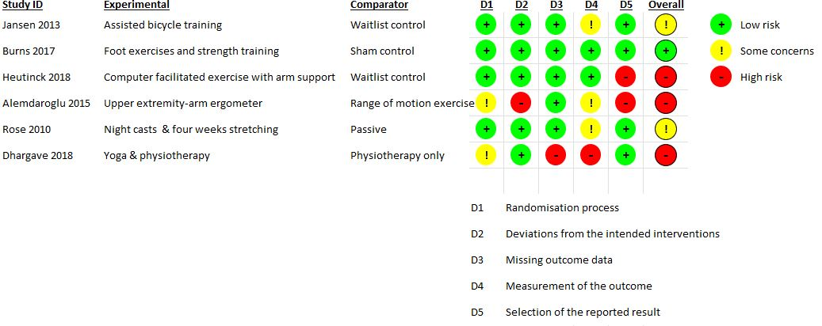

Overall efficacy on quality of life

Randomised controlled trials
Four RCTs reported quality of life outcomes. The combined effect size was small and statistically non-significant (g= -0.14, 95% CI = -0.73 to 0.44, p= 0.39, I² = 1.94; Appendix Figure 3). The funnel plot indicated evidence of asymmetry with smaller studies reporting larger study effects (Appendix Figure 4), but formal testing was not conducted due to limited studies.

Appendix Figure 3. Forest plot of quality of life outcomes in randomised controlled trials

Appendix Figure 4. Funnel plot of quality of life outcomes in randomised controlled

Single Arm analysis
Six studies reporting quality of life outcomes were included in the single-arm analysis. The combined effect size for participants who received the intervention was negligible and statistically non-significant (g= -0.01, 95% CI= -0.25 to 0.23, Appendix Figure 5). Additional analysis of control participants was also negligible and non-significant (g= 0.16. 95% CI =-0.08 to 0.39).

Appendix Figure 5. Forest plot of quality of life outcomes in the single-arm analysis of intervention participants

Appendix Figure 6. Forest plot of quality of life outcomes in the single-arm analysis of control participants
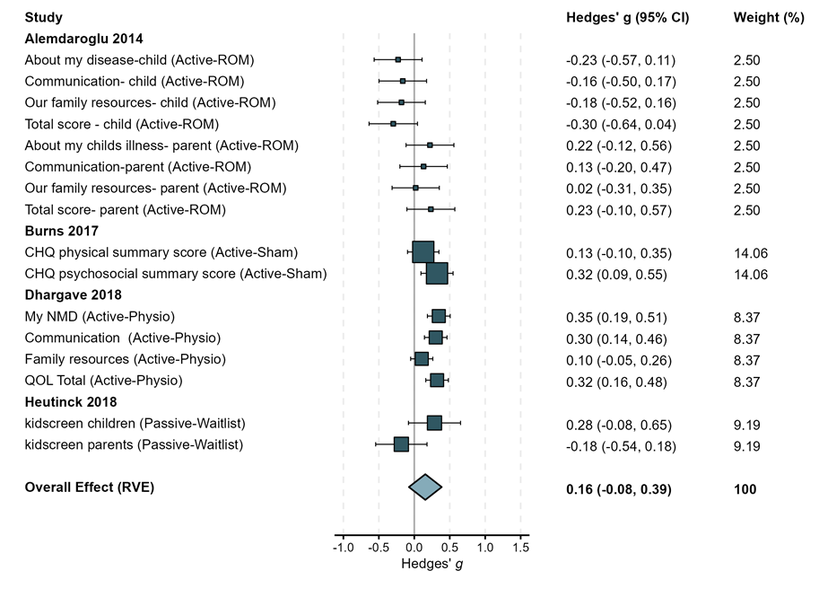

Overall efficacy on activities of daily living

Randomised controlled trials
Three RCTs reported activities of daily living outcomes. The combined effect size was small and significant, and heterogeneity was low (g= 0.18, 95% CI = 0.01 to 0.0.35; Appendix Figure 7). The funnel plot did not indicate evidence of small study effect (Appendix Figure 8), but formal testing was not conducted due to limited studies.

Appendix Figure 7. Forest plot of activities of daily living outcomes in randomised controlled trials
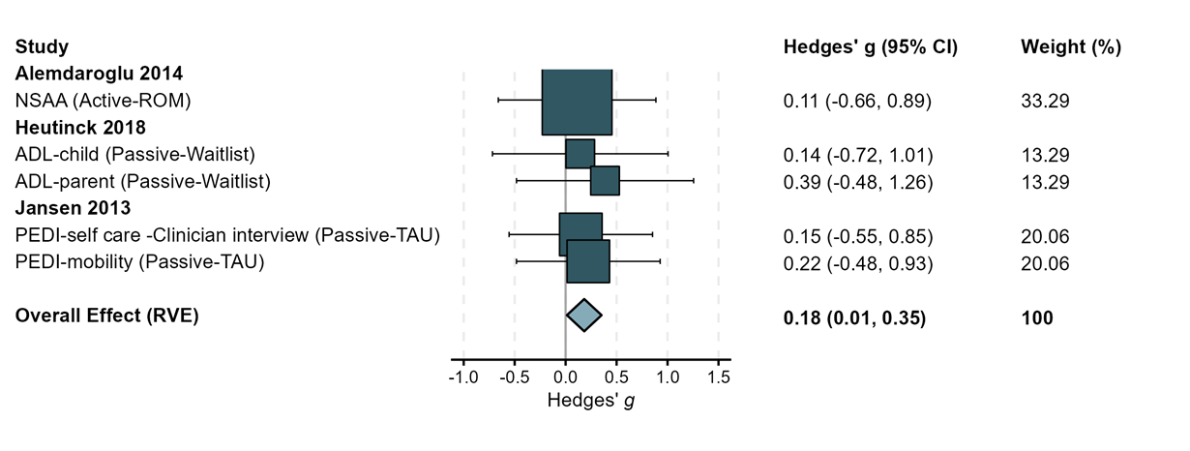

Appendix Figure 8. Funnel plot of activities of daily living outcomes in randomised controlled trials
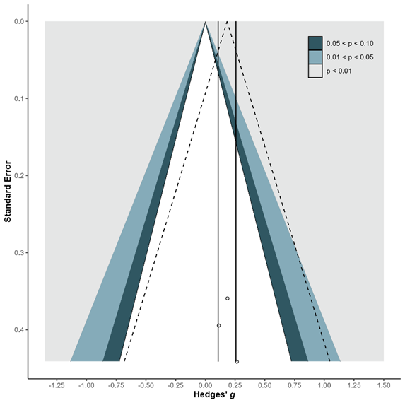

Single-arm analysis
Four studies reporting activities of daily living outcomes were included in the single-arm analysis. The combined effect size for participants who received the intervention was small and statistically significant (g= 0.23, 95% CI= 0.09 to 0.36; Appendix Figure 9). Additional analysis of control participants was non-significant (g= 0.11, 95% CI =-14 to 0.35; Appendix Figure 10).

Appendix Figure 9. Forest plot of activities of daily living outcomes in single arm analysis of intervention participants
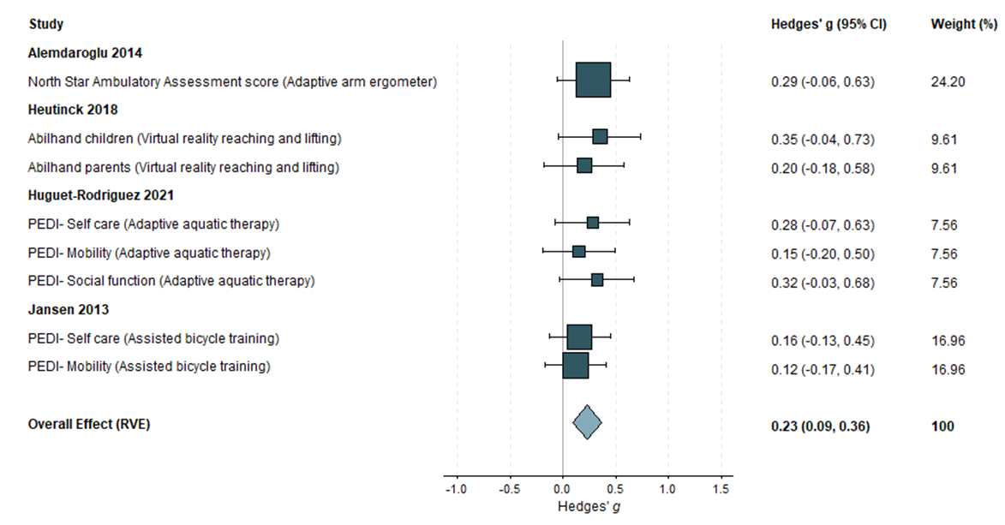

Appendix Figure 10. Forest plot of activities of daily living outcomes in single arm analysis of control participants
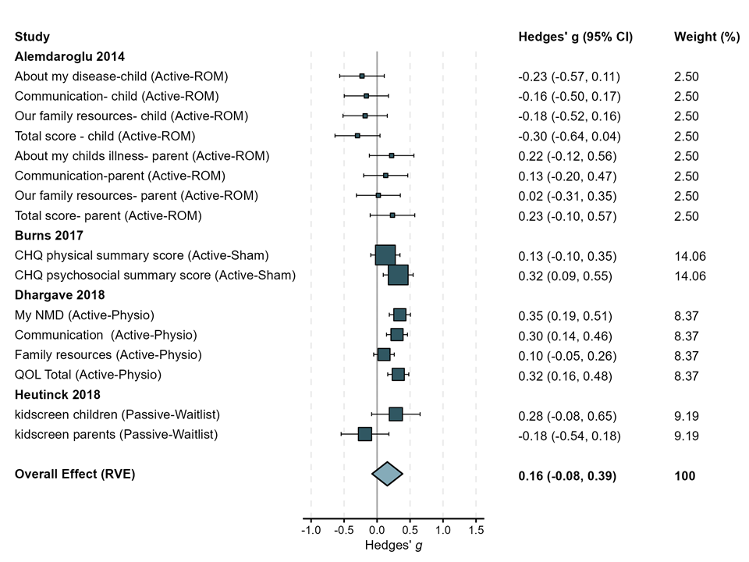

Overall safety of physical activity interventions
Results from the meta-analysis showed there was no difference in study retention rates among those who received the intervention compared to those who did not (OR=1.13, 95% CI= 0.58 to 2.21, p=0.58, I^²=0).
There were insufficient data to compare adherence in participants who received the intervention to those who did not. However, 72% to 100% of people who participated in the physical activity intervention adhered to the treatment program, suggesting that participants were able to complete the physical activities that they were assigned.
All adverse events reported across studies were indirect and were not linked to participation in the intervention. One study used quantitative methods (Magnetic Resonance Imaging - MRI) to assess increase in intramuscular fat volume and found no evidence of adverse effects in children with Charcot-Marie-Tooth who engaged in lower extremity adaptive resistance training. Subjective discomfort was reported in three studies as a result of participating in the intervention. These symptoms were remedied by postural adjustments that occurred during the trial.

Appendix references
1. Zelikovich, A.S., T. Oswald, and N.L. Kuntz, A Pilot Study to Assess the Feasibility and Impact of a Home Exercise Program on Heart Rate and Heart Rate Variability in Children with Muscular Dystrophy (P4.163). Neurology, 2017. 88(16 Supplement): p. P4.163.
2. Gorni K, M.V., Toretta E, Grandi C, Baiardi V, Sansone V, Early management intervention and parent empowerment in neuromuscular diseases: the clinical center NEMO experience. XV CONGRESS OF THE ITALIAN SOCIETY OF MYOLOGY Naples, Italy. Acta Myologica, 2014. 34(1): p. 37-89.
3. Dhargave, P., et al., Effect of yoga on overall quality of life in children with duchenne muscular dystrophy. Muscle & nerve, 2018. 58: p. S48‐.
4. Grieshofer P , S.R., Nowak T, Ranner S, Tanzer 1, Abstract id: 610 the paediatric lokomat: a possibility to treat children with a robotic-assisted locomotor training experiences after 190 patients. Neurorehabilitation and Neural Repair. 26(6).
5. Martinuzzi A, V.M., Paparella G, Comiotto J, Armellin M, Merotto V, Forni F, Piais J, Petacchi E, Rosati E, Rehabilitation Programs in Severity-Dependent Stratification in Friedreich’s Ataxia Patients. Neurorehabilitation and Neural Repair 2018. 32: p. 448.
6. Hind, D., et al., Aquatic therapy for children with Duchenne muscular dystrophy: a pilot feasibility randomised controlled trial and mixed-methods process evaluation. Health Technol Assess, 2017. 21(27): p. 1-120.
7. Alemdaroğlu, I., et al., Different types of upper extremity exercise training in Duchenne muscular dystrophy: effects on functional performance, strength, endurance, and ambulation. Muscle Nerve, 2015. 51(5): p. 697-705.
8. Alemdarotlu I, K.A., Yilmaz O, Topalotlu H, Effects of upper extremity dynamic exercise on respiratory function and quality of life in Duchenne Muscular Dystrophy. Turkish Journal of Physiotherapy and Rehabilitation, 2014. 25(2): p. 78-85.
9. Burns, J., et al., Safety and efficacy of progressive resistance exercise for Charcot-Marie-Tooth disease in children: a randomised, double-blind, sham-controlled trial. Lancet Child Adolesc Health, 2017. 1(2): p. 106-113.
10. Heutinck, L., et al., Virtual Reality Computer Gaming with Dynamic Arm Support in Boys with Duchenne Muscular Dystrophy. J Neuromuscul Dis, 2018. 5(3): p. 359-372.
11. Huguet-Rodríguez, M., et al., Impact of Aquatic Exercise on Respiratory Outcomes and Functional Activities in Children with Neuromuscular Disorders: Findings from an Open-Label and Prospective Preliminary Pilot Study. Brain Sci, 2020. 10(7).
12. Jansen, M., et al., Assisted bicycle training delays functional deterioration in boys with Duchenne muscular dystrophy: the randomized controlled trial "no use is disuse". Neurorehabil Neural Repair, 2013. 27(9): p. 816-27.
13. Rose, K.J., et al., Serial night casting increases ankle dorsiflexion range in children and young adults with Charcot-Marie-Tooth disease: a randomised trial. J Physiother, 2010. 56(2): p. 113-9.

