0Contentsontents
Provider sentiment and satisfaction survey

Fourth national collection
September 2020

Executive summary 3
1. Survey participation rates 5
2. Survey responses 8
4. Survey responses – qualitative 19
5. Conclusion 20

Executive summary
The NDIA monitors provider sentiment and satisfaction annually as part of the 2020-21 annual goals set out in the NDIS 2020-24 Corporate Plan.
In addition to measuring sentiment and satisfaction, we use the survey responses to identify and prioritise actions that would improve the provider experience.
Providers are essential to participants achieving their goals and the NDIA continues to make a significant effort to resolve concerns raised by providers to improve the Scheme.

Survey Design
All providers registered to provide support at 31 August and had supplied a valid email address were invited to complete the fourth Provider Sentiment and Satisfaction Survey. A distinction was made between providers who had ever claimed payment from the NDIS (“active providers”) and those who had never claimed payment (“inactive providers”).
It is important to note that the criterion used to distinguish active and inactive providers has limitations. In particular, providers who support participants with a self-managed plan or a plan manager receive payments directly from the participant or the plan manager. As a result, these providers may be classified as “inactive”.
Furthermore, some self-managing participants may use a provider who is not registered, and these providers cannot be surveyed.
Slightly different surveys were developed for active and inactive provider groups. Providers deemed inactive were asked to share their intention to enter the market in the next three months and their views on any barriers to entry they may be facing. Active providers were asked an additional question about claim processing times.
The latest survey has taken place in the midst of the global COVID-19 pandemic, providing an opportunity to ask about providers’ experiences during this period. Three additional questions were included, focusing on business disruption, changes to the business model, and opinions on the NDIA response to the COVID-19 pandemic.

Participation rates
The fourth Provider Sentiment and Satisfaction Survey (Q1 2020-21) was open from 17 September 2020 to 4 October 2020. A total of 14,563 registered providers were invited to participate, including 11,498 active and 3,065 inactive providers.
2,842 responses were received: 2,580 from active providers and 262 from inactive providers. The participation rates were 20% overall, 22% for active providers and 9% for inactive providers. For the previous survey undertaken in September 2019 (Q1 2019-20), participation rates were 18% overall, 23% for active providers and 10% for inactive providers. Whilst the participation rates were marginally lower for both active and inactive providers in the latest survey, the overall participation rate was slightly higher, due to a higher proportion of active providers, who are more likely to respond.
Providers receiving higher payments from the NDIS in the last three months prior to the survey were found to be more likely to participate.

Headline indicator - sentiment
The headline indicator for provider sentiment is “I am optimistic about the health of the NDIS market”.
Following a slight dip for the second survey, opinions have improved considerably over the most recent two surveys. Overall, 59% of providers agreed or strongly agreed that they were optimistic about the health of the NDIS market, up 12 percentage points from 47% in Q1 2019-20. This follows a 9 percentage point increase between Q2 2018-19 and Q1 2019-20. Conversely, 20% of providers disagreed or strongly disagreed, down 11 percentage points since the previous survey.
The extent of improvement was slightly greater for active providers, where the percentage strongly agreeing or agreeing increased by 13 percentage points, from 46% to 59%. For inactive providers there was an 11 percentage point increase, from 50% to 61%.

Headline indicator – satisfaction
The headline indicator for provider satisfaction is “On a scale of 1 to 10, with 1 being the least positive and 10 being the most positive, how would you rate your overall experience of interacting with the NDIA?”
For all providers who responded in Q1 2020-21, the average score was 6.2 (the same for both active providers and inactive providers), an increase of 0.9 (from 5.3) in Q1 2019-20.

Provider experiences during the COVID-19 pandemic
The following 3 additional questions were included in the Q1 FY2020-21 survey:
- Has your business experienced disruption due to the coronavirus?
- Do you have plans to or have you made changes to your business model to adapt to market conditions created by the coronavirus?
- On a scale of 1 to 10, with 1 being the least positive and 10 being the most positive, how would you rate the NDIA’s response throughout the COVID-19 situation?
Overall, 46% of providers said their business was trading as normal or higher, but this percentage was higher for active providers (48%) than for inactive providers (36%). Around 50% of providers (the same for both active and inactive providers) said their business was trading but at a reduced rate.
1.8% of providers said they had chosen to close their business due to the coronavirus, and 2.1% said they had been forced to close due to coronavirus restrictions. In almost all cases the closure was temporary, with only a few providers saying they were not planning to reopen.
Overall, 62% of providers said they had either made changes or planned to make changes to their business model to adapt to market conditions created by the coronavirus: 63% of the active providers compared to 55% of the inactive providers surveyed.
Regarding the NDIA’s response throughout the COVID-19 situation, on a scale of 1 to 10, with 1 being the least positive and 10 being the most positive, the average score was 6.8 for both active providers and overall, and 6.6 for inactive providers. 62% of active providers and 59% of inactive providers gave a score of 7 or more.

Survey participation rates
The fourth Provider Sentiment and Satisfaction Survey was open from 17 September 2020 to 4 October 2020.
As shown in Figure 1, a total of 14,563 registered providers were invited to participate: 11,498 active and 3,065 inactive providers. All providers registered as at 31 August 2020 and for whom the NDIA had a valid email address were contacted.
The number of providers has decreased since the last survey conducted in September 2019: active providers from 12,569 to 11,498 and inactive providers from 8,583 to 3,065. This change was due to registration lapses, and was most pronounced for inactive providers. As a result, the proportion of active providers has increased, from 59% in September 2019 to 79% in September 2020.
Figure 1 Number of providers by status
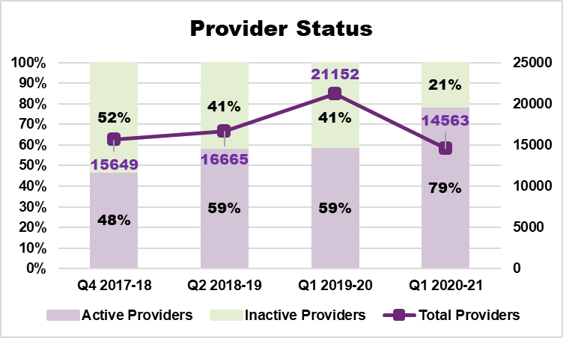
2,842 responses were received: 2,580 from active providers and 262 from inactive providers.
The overall response rate was 20%. Active providers have a higher response rate than inactive providers. The participation rate for active providers has remained relatively stable at 22%, compared to 23% for Q1 2019-20. The participation rate for inactive providers was 9%, compared to 10% in Q1 2019-20 and 9% Q2 2018-19. Whilst the participation rates were marginally lower for both active and inactive providers in the latest survey, the overall participation rate was slightly higher, due to a higher proportion of active providers, who are more likely to respond.
The number of responses received from providers in the inactive group is much lower than for the previous survey (262 responses in Q1 2020-21 versus 870 in Q1 2019-20). This will increase the variability of survey results for inactive providers relative to previous surveys. This should be taken into account when comparing the latest survey results for inactive providers to the previous surveys.
Figure 2 shows the participation rates across the three national surveys, split by fully answered and partially answered responses.
Figure 2 Participation rates by provider status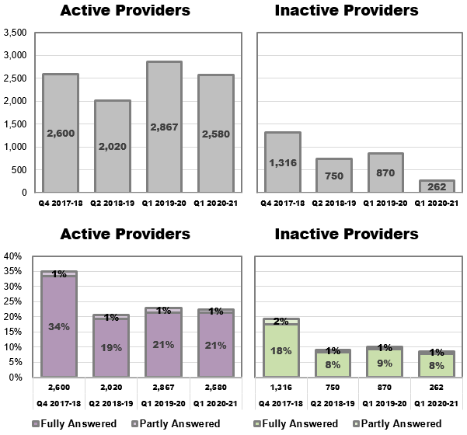
After a decline following the first survey, participation rates have remained relatively stable for the latest three surveys, for both active and inactive providers.
Most submitted surveys have been fully answered, with partially answered surveys accounting for 5% of all responses from active providers and 12% of inactive providers.
Figure 3 shows participation rates by provider status (active/inactive) and State/Territory of registration. Since a provider can be registered in multiple States/Territories, each response is counted towards all States/Territories the provider is registered in.
There is some variation in participation rates by State/Territory, with active providers in WA (30%), TAS, ACT and the NT having higher participation rates, and providers in NSW (19%) having the lowest participation rate. For inactive providers, those based in ACT, SA and WA have higher participation rates, while no providers from TAS responded.

Figure 3 Participation rates by State/Territory and status
Note: percentages under the bars are the percentages of providers with registrations in the State/Territory

Figure 4 displays participation rates by entity type (organisation vs sole trader) separately for active and inactive providers. Organisations appear to have higher participation rates than sole traders, across both active and inactive providers.
Figure 4 Legal entity type distributions and participation rates

Survey responses

Business characteristics
The following graphs summarise the business characteristics for providers who responded to the fourth survey.
Figure 5 Business characteristics of the fourth survey respondents
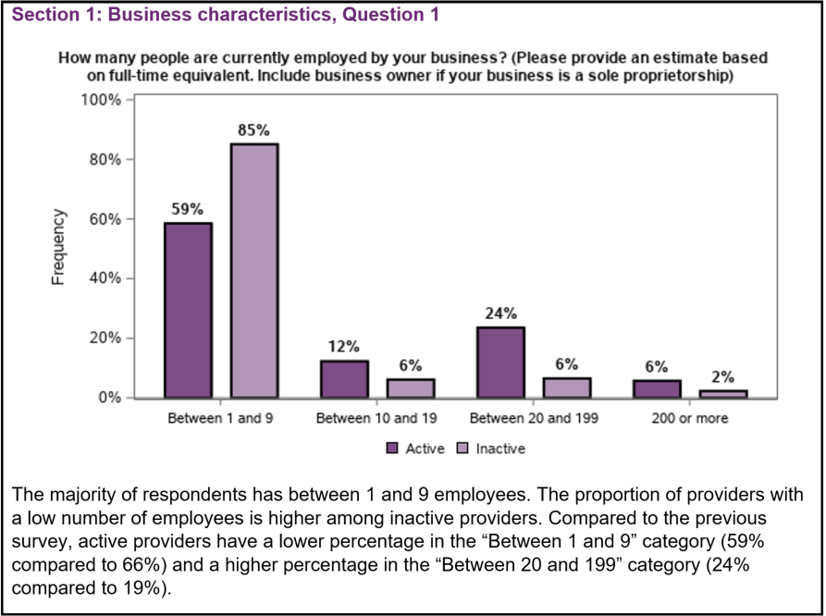

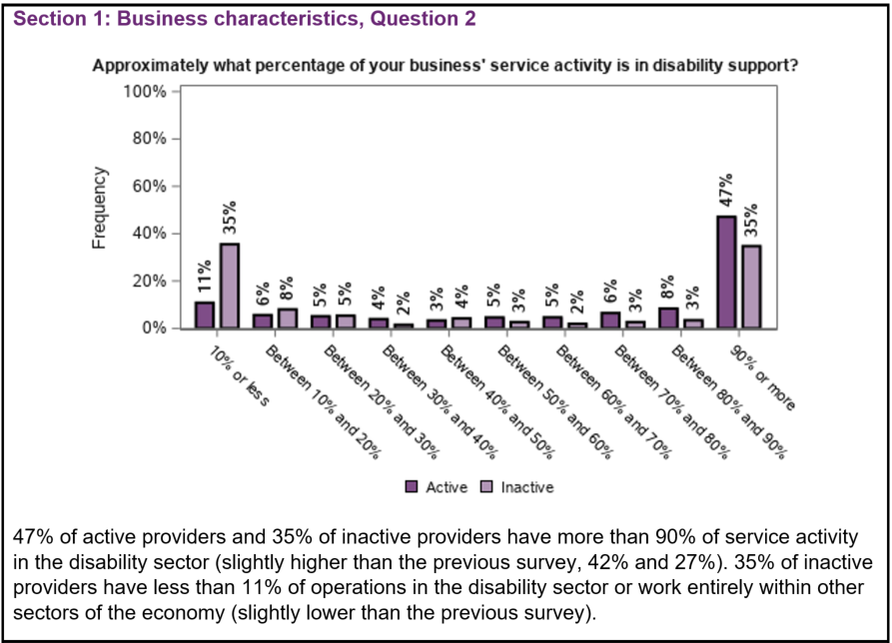
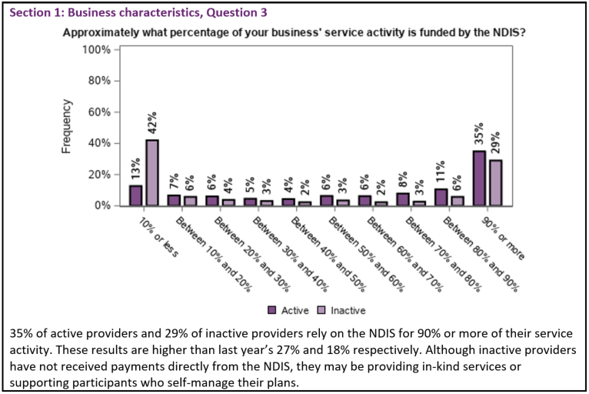

Business conditions (in general)
The following graphs summarise the responses of the last four national provider surveys.
Though the results from the previous three surveys are displayed to facilitate comparison of responses over time, it is important to note that responses from each collection displayed in the graphs are not based on the same providers. To the extent that active and inactive providers respond differently, overall results will also reflect changes in the mix of active and inactive providers over time.
The unanswered responses and categories “Don’t know” and “Not applicable” were removed. Categories “Strongly agree and “Agree” were combined, and categories “Disagree” and “Strongly disagree” were also combined.
Figure 6 Business conditions
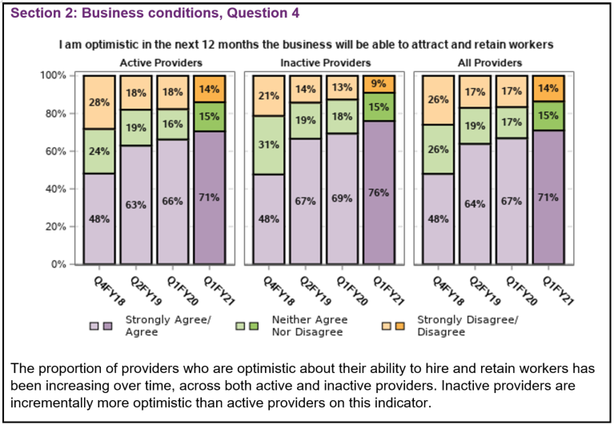
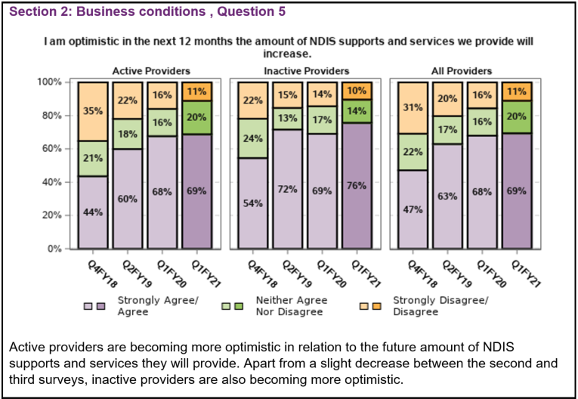
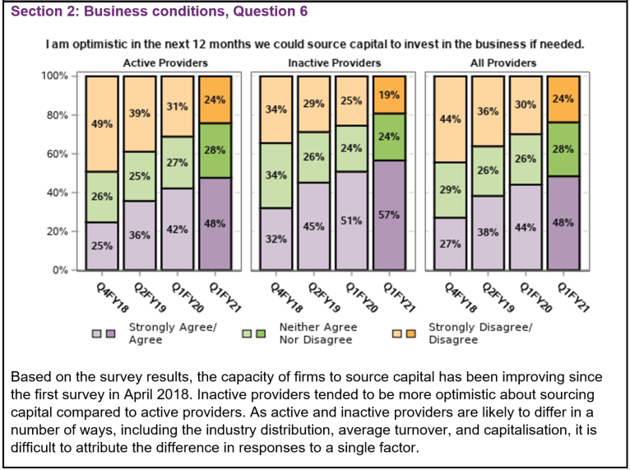
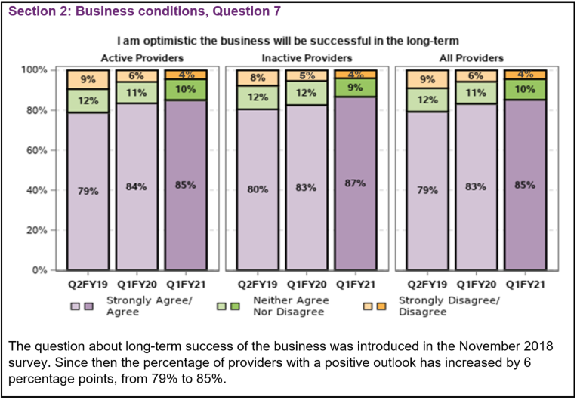

Business conditions (COVID-19)
The latest survey included three additional questions asking about providers’ experiences during the COVID-19 pandemic:
- Has your business experienced disruption due to the coronavirus?
- Do you have plans to or have you made changes to your business model to adapt to market conditions created by the coronavirus?
- On a scale of 1 to 10, with 1 being the least positive and 10 being the most positive, how would you rate the NDIA’s response throughout the COVID-19 situation?

Section 2: Business conditions, Question 8
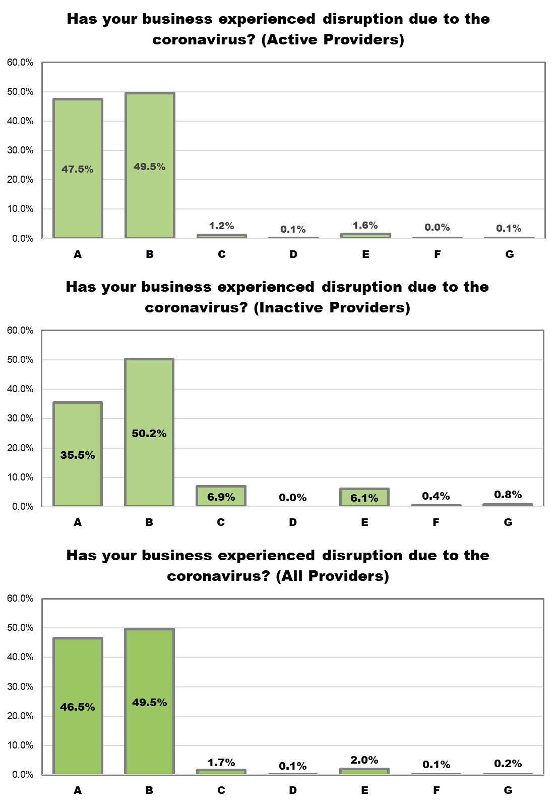
Response category | Question | Active Providers | Inactive Providers | All Providers
A | Our business is trading as normal or higher. | 47.5% | 35.5% | 46.5%
B | Our business is trading but at a reduced rate. | 49.5% | 50.2% | 49.5%
C | We have chosen to temporarily close our business due to the coronavirus. We plan to reopen. | 1.2% | 6.9% | 1.7%
D | We have chosen to permanently close our business due to the coronavirus. We do not plan to reopen. | 0.1% | 0.0% | 0.1%
E | We have had to close our business due to coronavirus restrictions and not by choice. We plan to reopen. | 1.6% | 6.1% | 2.0%
F | We have had to close our business due to coronavirus restrictions and not by choice. We do not plan to reopen. | 0.0% | 0.4% | 0.1%
G | We have closed our business but unrelated to the coronavirus. | 0.1% | 0.8% | 0.2%
Almost half (47.5%) of active providers have not been negatively affected by the pandemic. Inactive providers are somewhat more affected as only 35.5% reported no negative impact. For both active and inactive providers, around 50% say that their business, despite remaining afloat, has been trading at a reduced rate.
4.0% of active providers and 14.3% of inactive providers have closed their business, mostly as a result of COVID-19, either temporarily or permanently. The most commonly cited reasons for shutdown are: temporary shutdown due to COVID-19 (1.7% of all respondents) and permanent shutdown because of coronavirus restrictions (2.0 of all respondents).
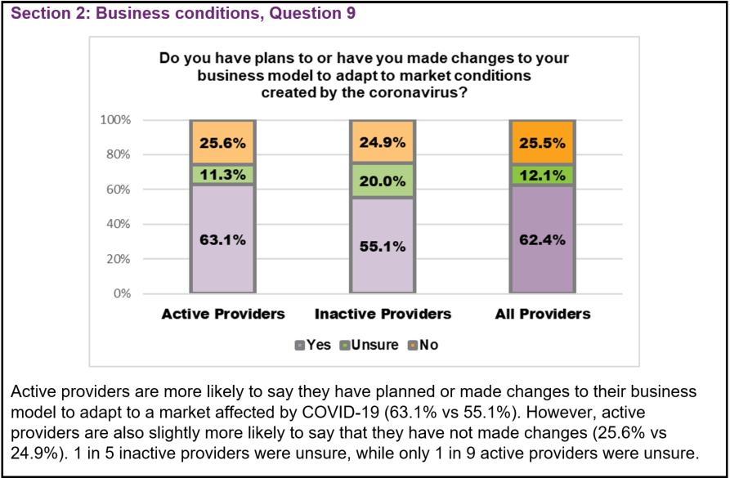
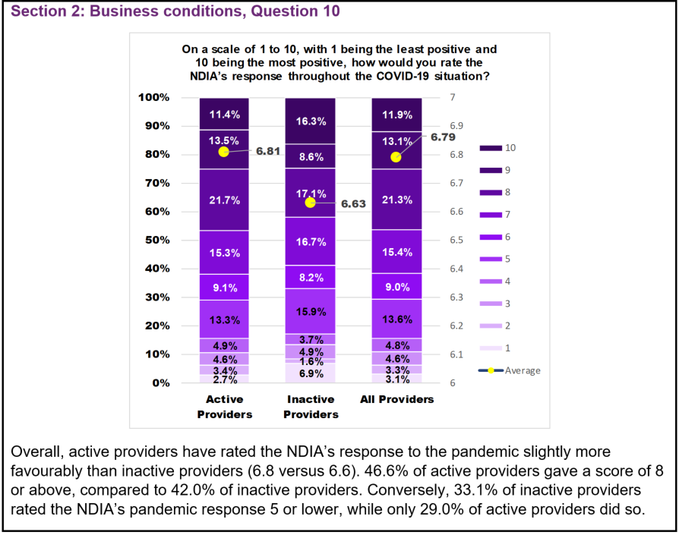

Market conditions
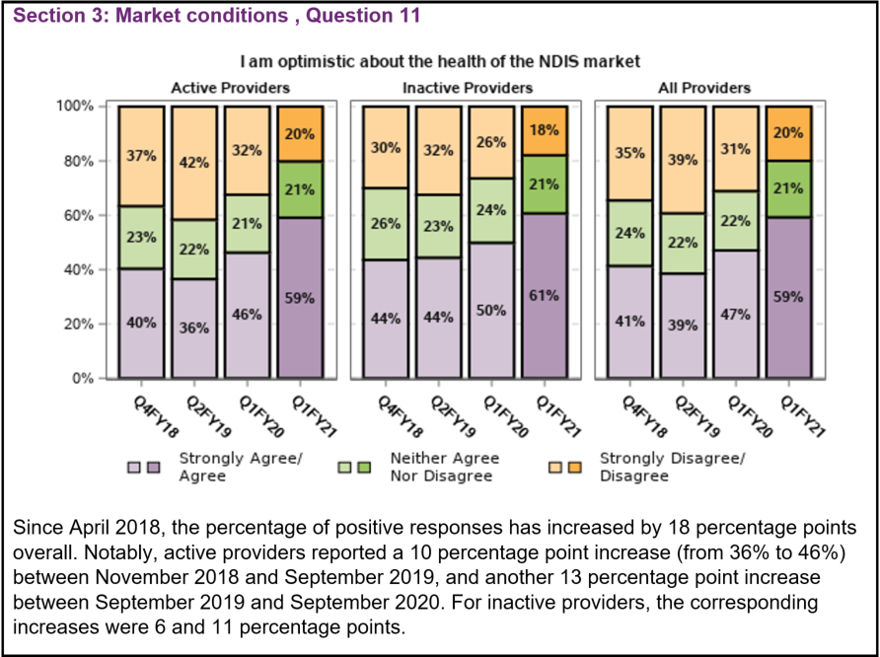
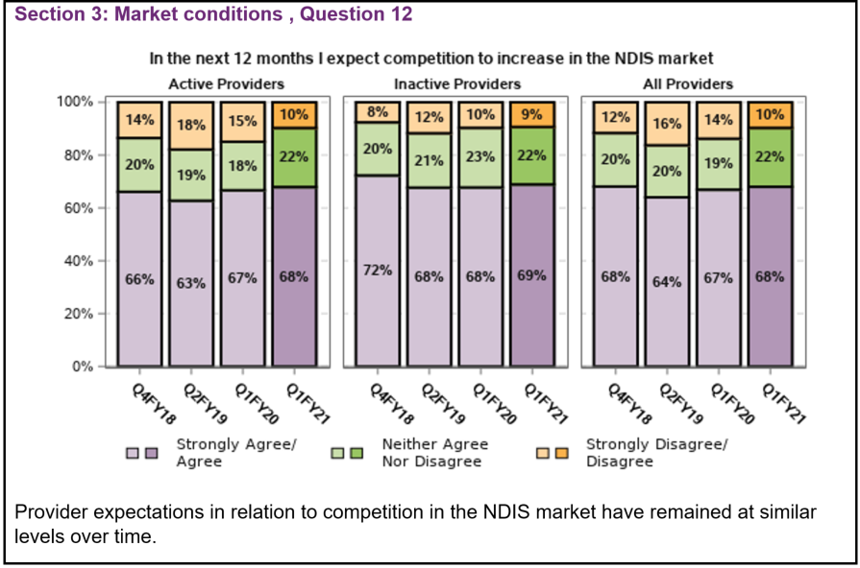
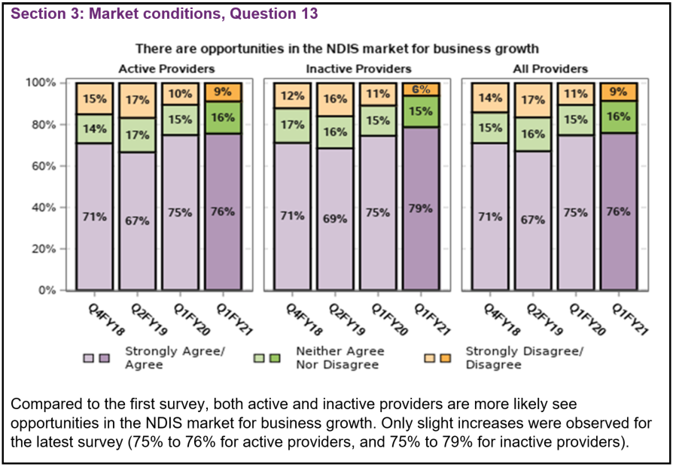

The NDIA is reliable
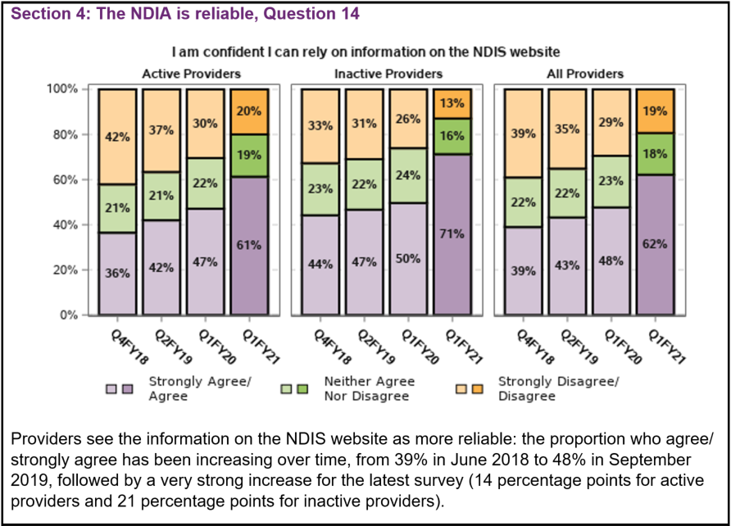
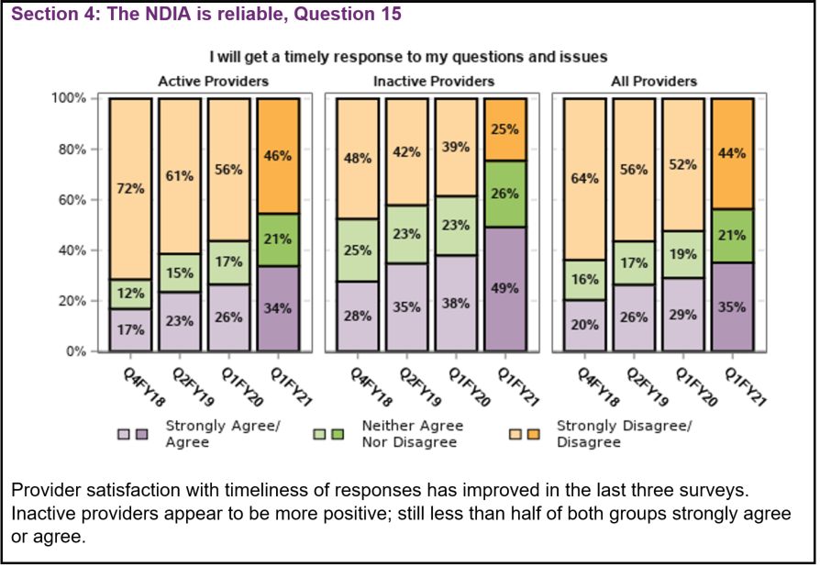
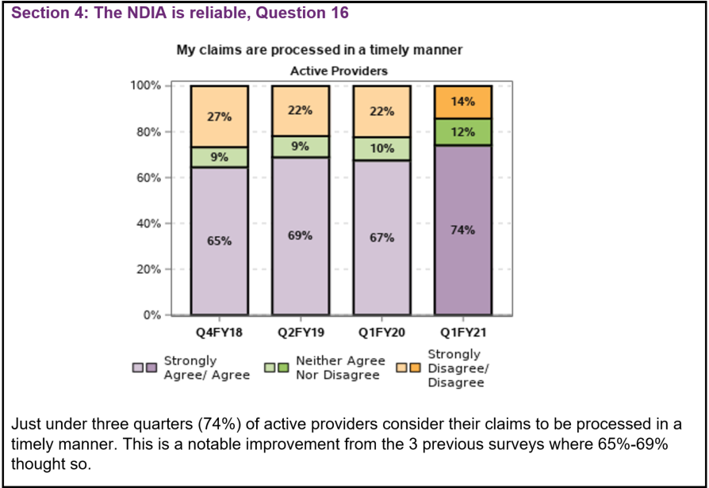
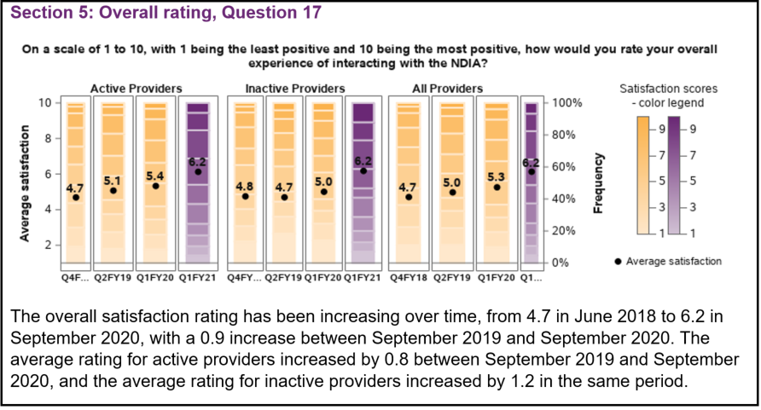

Survey responses – qualitative
Active providers were also invited to respond to the question: Do you have any other comments about your interactions with the NDIS or the NDIA? A total of 1412 responses were received.
Inactive providers were also asked to provide additional information. 44 responses were received to this question.

Continued opportunities to improve interactions
Similar to last year, provider communications with the NDIA remains a concern. 26% of responses were negative in relation to communications. Many providers mentioned a lack of clear and consistent information.
Analysis showed that other areas have moved in the right direction as there were proportionally fewer concerns about wait times, being on hold, and not getting any response at all. While there is still room for improvement, analysis showed concerns about provider speed of payment and not being paid have decreased from the previous survey.
A few generalised comments also noted improvements from previous experiences in interactions with the NDIA, including with the contact centre.

COVID-19 was a common topic
Not surprisingly, many providers mentioned the COVID-19 pandemic in their responses. The most common theme that emerged across all responses was changes providers have made to their service delivery methods, in order to adapt.
A large proportion of providers noted they now deliver services through telehealth or have increased this service. Other providers noted they had diversified the products and services they offered and adapted their programs to offer more choice and flexibility to clients, or respond to changes in demand and supply.
The next most common set of changes providers reported was having to make their businesses COVID-safe, including the implementation of safety plans, increased hygiene protocols and staff training. Impacts on staffing were also reported.
Only a few providers mentioned temporary closures of business or partial closures of some sites.

Conclusion
Survey participation rates remain strong, indicating providers continue to be willing to share their time and feedback. The results from this year’s survey demonstrate providers are feeling more confident and optimistic about the market and their future in it, despite the impact of the COVID-19 pandemic.
Both market confidence and optimism have risen considerably over the time the survey has been administered, with the biggest increase in sentiment ever seen this year.
Business conditions have remained steady or seen a slight improvement across the four surveys.
Provider confidence in the long-term health of the NDIS market saw the biggest jump since the surveys began in 2018, an increase of 12 percentage points over last year.
Through the survey, the NDIA continues to see areas of improvement and also identify areas of focus, as responses highlight the need for the NDIA to focus on its interactions and support its staff.

